**Report**

**(Day 1&2)**

Reported by: P. PRUDVI REDDY (BU21EECE0100361)

Mail Id: [ppoli@gitam.in](mailto:ppoli@gitam.in)

**Objective:**

* To design and simulate a system using the AT89C51 microcontroller to control the blinking of LEDs based on input from two switches.

Inputs:

* Using the Switch’s as the input and connected to the AT89C51 Microcontrollers at P2.0 and P2.1 connected with a power supply

Outputs:

* Using the LED’S as the ouput and connected to the AT89C51 Microcontroller from the P1.0 to P1.7 with 8 number of them with common ground

**Logic:**

* if switch at P2.0 and at P2.1 both are OFF then all the LED’s from P1.0 TO P1.7 are not blink
* if switch at P2.0 is ON and at P2.1 are OFF then the LED’s from P1.0 TO P1.3 blink as a Output
* if switch at P2.0 is OFF and at P2.1 are ON then the LED’s from P1.4 TO P1.7 blink as a Output
* if switch at P2.0 and at P2.1 both are ON then all the LED’s from P1.0 TO P1.7 blink as a Ouput

Results:

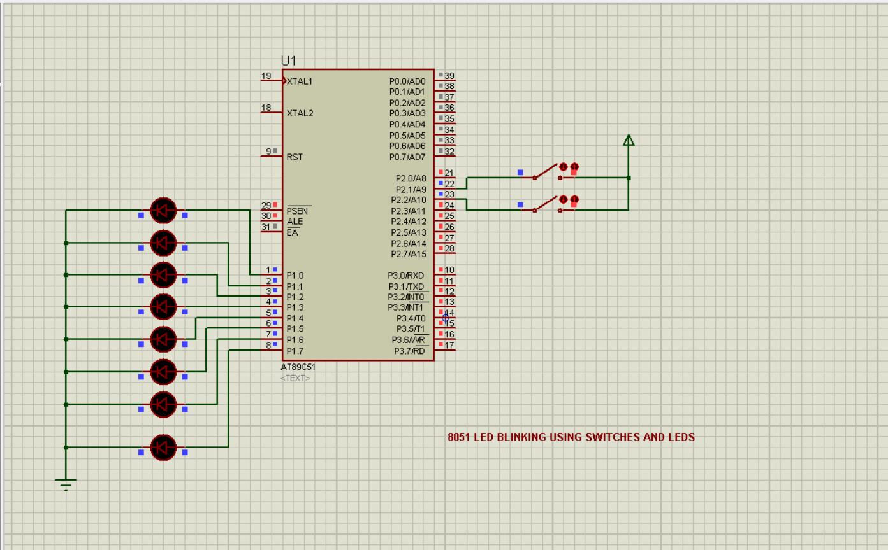

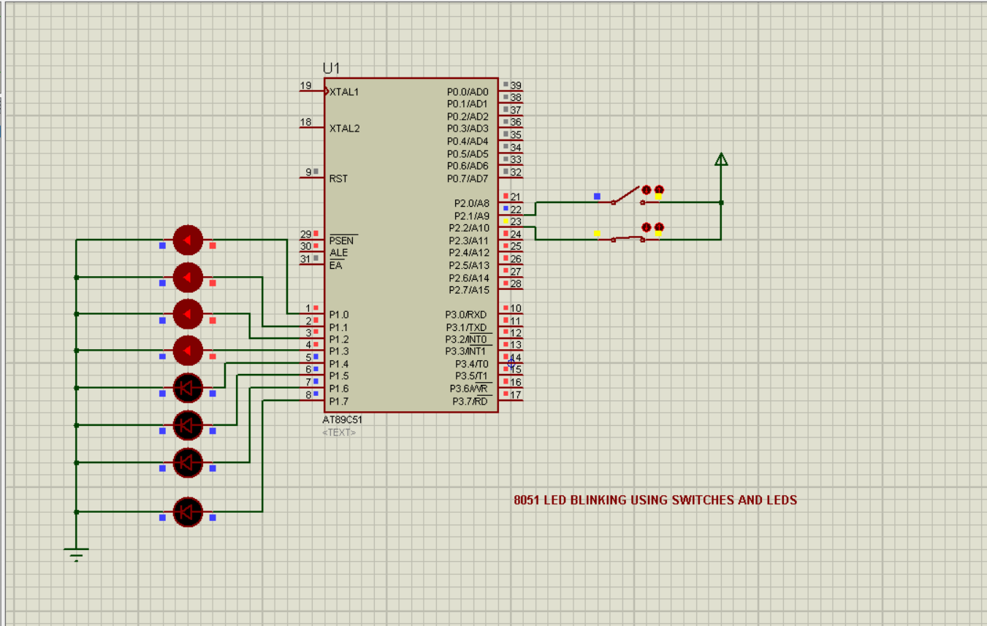

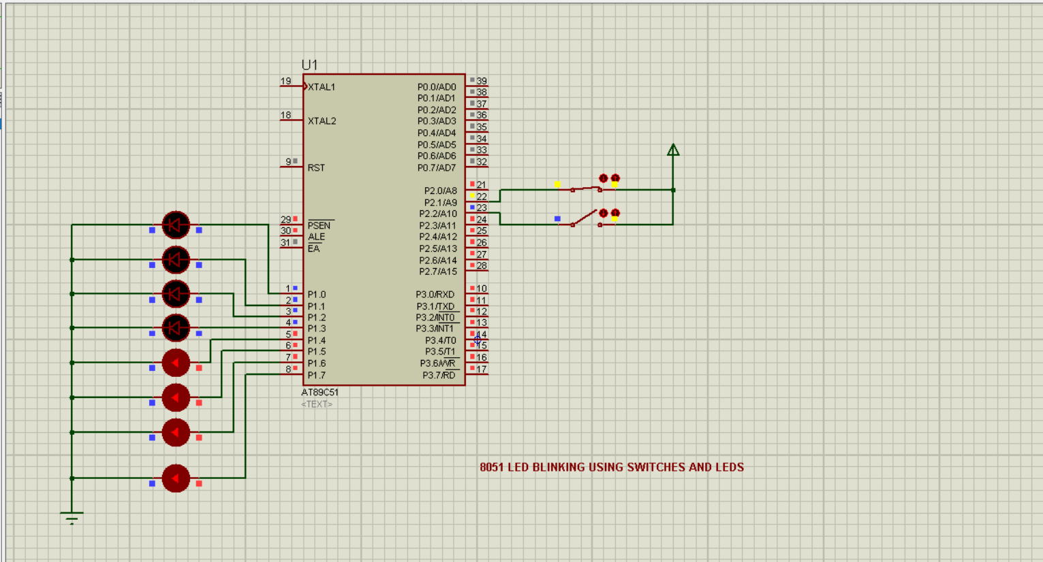

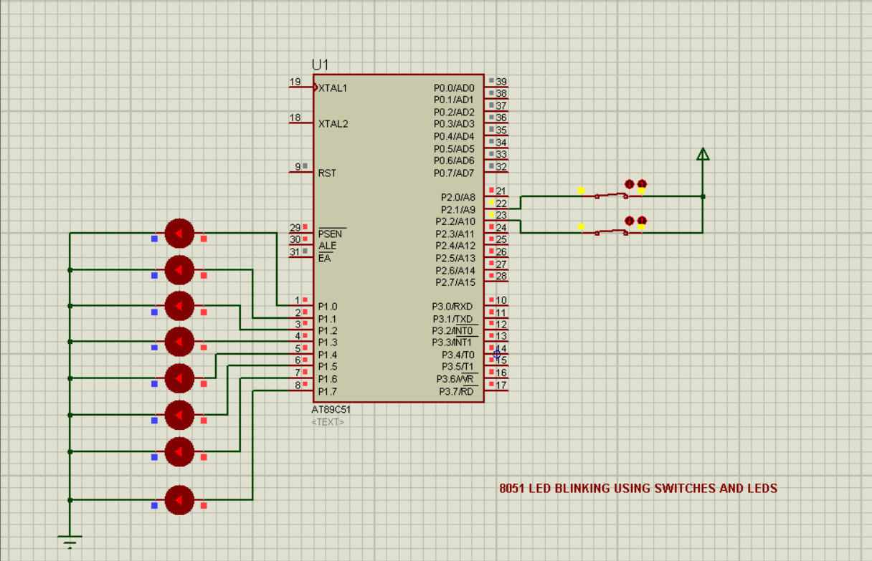

Code:

* Normal:

#include <reg51.h>

sbit sw1 = P2^1;

sbit sw2 = P2^2;

void delay(unsigned int);

void main(void)

{

sw1 = 0;

sw2 = 0;

while(1)

{

if(sw1==0 && sw2==0)

{

P1=0x00;

}

else if(sw1==0 && sw2==1)

{

P1=0x0F;

delay(500);

P1=0x00;

delay(500);

}

else if(sw1==1 && sw2==0)

{

P1=0xF0;

delay(500);

P1=0x00;

delay(500);

}

else if(sw1==1 && sw2==1)

{

P1=0xFF;

delay(500);

P1=0x00;

delay(500);

}

}

}

void delay(unsigned int t)

{

unsigned int i,j;

for(i=0;i<t;i++)

for(j=0;j<1275;j++); // For 1ms, for loop need to iterate 1275 times.

}

Common mistakes How do I overcome:  
  
the common mistakes I made during this design that is problem in finding the location of components because this is the first design in proteus and also connecting the wires in between the components   
  
the solution that I overcome of this problem is exploring the tutorial of the proteus basics how they are connected and how to find the availability of the components in the proteus