Design and Development of 4G Private Network using USRP N321 and SRSRAN 4G

Submitted by
P. Prudvi reddy BU21EECE0100361
MC.Mokshith BU21EECE0100391
B. Gopal BU21EECE0100377

Under the Guidance of
Dr. T Nagarjuna
Assistant Professor

01/06/24 to 30/11/24



Department of Electrical, Electronics and Communication Engineering
GITAM School of Technology
GITAM
(DEEMED TO BE UNIVERSITY)
(Estd. u/s 3 of the UGC act 1956)
NH 207, Nagadenehalli, Doddaballapur taluk, Bengaluru-561203 Karnataka, INDIA.



Department of Electrical, Electronics and Communication Engineering
GITAM School of Technology

DECLARATION

I/We declare that the project work contained in this report is original and it has been done by me under the guidance of my project guide.

Date:

Registration No. Student Name Signature

BU21EECE0100361 P. Prudvi reddy
BU21EECE0100391 MC.Mokshith
BU21EECE0100377 B. Gopal

Department of Electrical, Electronics and Communication Engineering
GITAM School of Technology, Bengaluru-561203



CERTIFICATE
This is to certify that P. Prudvi reddy bearing BU21EECE0100361, MC.Mokshith bearing BU21EECE0100391, B.Gopal bearing BU21EECE0100377 has satisfactorily completed Mini Project Entitled in partial fulfillment of the requirements as prescribed by University for VIIth semester, Bachelor of Technology in “Electrical, Electronics and Communication Engineering” and submitted this report during the academic year 2024-2025.

[Signature of the Guide] [Signature of HOD]

Table of contents

Chapter 1: Introduction 1
1.1 Overview of the problem statement 1
1.2 Objectives and goals 1
Chapter 2 : Literature Review 2
Chapter 3 : Strategic Analysis and Problem Definition 3
3.1 SWOT Analysis 3
3.2 Project Plan - GANTT Chart 3

3.3 Refinement of problem statement 3
Chapter 4 : Methodology 4
4.1 Description of the approach 4
4.2 Tools and techniques utilized 4
4.3 Design considerations 4
Chapter 5 : Implementation 5
5.1 Description of how the project was executed 5
5.2 Challenges faced and solutions implemented 5
Chapter 6:Results 6
6.1 outcomes 6
6.2 Interpretation of results 6
6.3 Comparison with existing literature or technologies 6
Chapter 7: Conclusion 7
Chapter 8 : Future Work 8
Here write Suggestions for further research or development Potential improvements or extensions 8
References 9

Chapter 1: Introduction

1.1 Overview of the problem statement
The problem statement of this study revolves around the growing demand for reliable and customizable private LTE networks, which are crucial for various industries requiring secure and dedicated communication infrastructures. However, designing and deploying such networks is challenging due to the need for robust integration between software-defined radio platforms and LTE protocol stacks, as well as the requirement to meet stringent performance, reliability, and security standards. The study aims to address these challenges by exploring the implementation of a 4G private network using the USRP N321 platform and srsRAN software, while benchmarking the network's performance and identifying any obstacles encountered during the process.

1.2 Objectives and goals

Objectives:
To design and develop a 4G Private Network using USRP N321 AND SRSRAN 4G

Goals:
- Implement and optimise the eNodeb functionality (configure the USRP n321 to operate as eNodeb, handling radio communications with user equipment
- Setup and configure the EPC components (MME, HSS, SGW, PGW)
- Setup and configure the user equipment with 5G mobile Phone and Programmable Sim
- Verify the performance and functionality of Private Network (coverage and Performance Test)

Chapter 2: Literature Review

Key Publications
- Implementation and performance analysis of software defined radio (SDR) based LTE platform for truck connectivity application - BILAL MAQSOOD
- Implementation of a 4G/5G Base Station Using the srsRAN Software and the USRP Software Radio Module - Wojciech Flakowski, Maciej Krasicki, and Rafał Krenz
- Testing Performance for Several Use Cases with an Indoor Open Air Interface USRP-Based Base Station- Gcina Dludla, Mla Vilakazi, Chris R. Burger, Albert A. Lysko, Lwando Ngcama, Lawrence Mboweni, Moshe Masonta, Hlabi Kobo, Lusani Mamushiane
Existing Implementations – Products| Opensource| GitHub etc
- https://github.com/srsran/srsran_4g
- https://github.com/EttusResearch/uhd
- https://github.com/srsran/srsgui
- https://wiki.gnuradio.org/index.php/Tutorials
- https://www.ettus.com/all-products/usrp-n321/

Chapter 3 : Strategic Analysis and Problem Definition

3.1 SWOT Analysis

Strengths:
- Open-source (S1):
  - The network implementation uses open-source tools like srsRAN, which promotes transparency, customization, and community-driven improvements.
- Cost-effective and Flexible (S2):
  - The solution is designed to be both cost-effective and adaptable, making it accessible to a wider range of users and applications.
- Educational and Community Support (S3):
  - The use of educational resources and active community support provides valuable knowledge-sharing opportunities and continuous development.

Weaknesses:
- Complex Setup (W1):
  - The integration of hardware and software components can be intricate, requiring significant technical expertise to deploy successfully.
- Lacks Commercial Support (W2):
  - As an open-source solution, it may not have the robust commercial support that proprietary systems offer, potentially leading to challenges in maintenance and troubleshooting.
- Performance Can Vary with Hardware (W3):
  - The performance of the network might be inconsistent depending on the hardware used, which can affect reliability and user experience.
- Expertise Required (W4):
  - Implementing and managing the network may demand specialized skills and knowledge, limiting its accessibility to those with the necessary expertise.

Opportunities:
- Expansion to 5G (O1):
  - The existing 4G LTE network could be expanded or upgraded to support 5G technology, tapping into the growing market for next-generation networks.
- Growing IoT Market (O2):
  - The increasing demand for Internet of Things (IoT) devices presents an opportunity to deploy private LTE networks in various industries.
- Collaboration with Other Projects (O3):
  - The open-source nature allows for collaboration with other projects, fostering innovation and potentially leading to new features or improvements.
- Educational Partnerships (O4):
  - There is potential for partnerships with educational institutions, which could use the network as a learning tool and further develop the technology.

Threats:
- Rapid Technological Changes (T1):
  - The fast-paced evolution of telecommunications technology could make the current 4G LTE network less competitive or relevant.
- Potential Security Vulnerabilities (T2):
  - Despite strong security measures, open-source solutions may still be vulnerable to evolving cyber threats, posing risks to network integrity and data privacy.

3.2 Project Plan - GANTT Chart

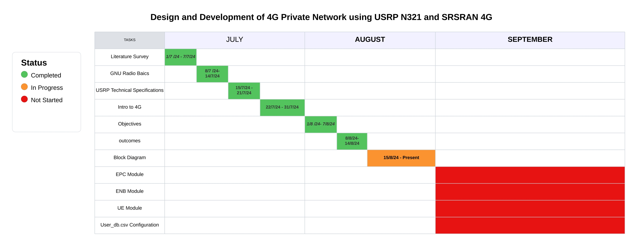

3.3 Refinement of problem statement
This paper discusses the growing demand for private LTE networks. It is very crucial for the industries in need of safe and dedicated communication systems. The hardest work primarily lies in the job of designing and setting up these systems. There is a requirement to smoothen integration with LTE protocol stacks and SDR platforms. A high-performance network should have reliability and security. The study looks at setting up a 4G private network using the USRP N321 SDR platform and the srsRAN software. It wants to check how well this network works, see if it can be used in real life, and find any technical problems that could come up during installation and use.

Chapter 4: Methodology

4.1 Description of the approach
1. Initialization of the Project:
- Start Configuration: The process begins with starting the configuration.
- Configuration of Necessary Files: This includes setting up important configuration files like epc.conf, enb.conf, and user_db.csv.
- Check Mobile Phone SIM Parameters: Verify the parameters of the mobile phone SIM, specifically the APN (Access Point Name), MNC (Mobile Network Code), and MCC (Mobile Country Code).

2. Validation of Parameters:
- Are Parameters Correct?
- If Yes: Proceed to run srsEPC in Terminal 1.
- If No: Reconfigure the parameters, recheck them, and then run the next steps.

3. Execution of Terminals:
- Run srsEPC in Terminal 1: Initiate the execution of the EPC in Terminal 1.
- Run srsENB in Terminal 2: Execute the eNodeB in Terminal 2 after the EPC is running.

4. Mobile Phone Status Check:
- Does Mobile Phone Show "srsRAN 4G" Operator?:
- If Yes: Continue the process to check if srsENB shows a connection.
- If No: Verify the EPC and eNodeB configurations, check logs for any errors, and reconfigure or restart the srsEPC and srsENB. Retry checking the mobile phone's connection status.

5. srsENB Connection Verification:
- Does srsENB Show a Connection?
- If Yes: Monitor the uplink/downlink and end the process if everything is functioning properly.
- If No:
    - Check the configuration and srsEPC status.
    - Verify if there are any network or signal issues.
    - Recheck and test the connection.

6. Downloading or Building the Software:
- In case of initializing the project, there are two primary paths for obtaining the necessary software:
- Build from Source: If the user prefers to use a custom or latest version.
- Download Precompiled Packages: If the user does not need customization and prefers using basic applications.

End of Process:
- After successful uplink/downlink monitoring and connection verification, the configuration is completed, and the process concludes.

4.2 Tools and techniques utilized
1. Tools:
- USRP N321 or USRP B210(optional):
- The hardware platform used to build the radio part of the private LTE network.
- Provides the software-defined radio interface required for transmitting and receiving LTE signals.
- srsRAN Software (srsEPC, srsENB, srsUE):
- srsEPC (Evolved Packet Core): Manages the core network functions, handling mobile phone registration, session management, and data routing.
- srsENB (eNodeB): Provides the radio access interface for mobile devices to connect to the network, coordinating communication between the UE (User Equipment) and the EPC.
- srsUE: An optional component representing the software for emulating user equipment in tests.
- Configuration Files:
- epc.conf, enb.conf, user_db.csv: Critical configuration files that define network parameters like APN, MNC, MCC, and other operational details for the EPC and eNodeB.
- Mobile Phone:
- The actual user device that connects to the LTE network, used to verify the network’s functionality by checking whether it registers as "srsRAN 4G" on the operator display.
- Terminals/Command Line Interface (CLI):
- The Linux/Unix terminal is used to run srsEPC, srsENB, and issue network monitoring commands.
- The terminal is essential for interacting with the srsRAN software, verifying logs, and troubleshooting.
- Network Logs & Error Logs:
- Logs generated during the execution of srsEPC and srsENB help track errors, verify network stability, and debug issues.

- Monitoring Tools:
- These are built into the srsRAN software to monitor network traffic (uplink/downlink) and performance metrics to ensure that the network is operating as expected.

2. Techniques:
- Software Configuration & Parameter Setup:
- The configuration of network parameters, including APN, MNC, and MCC, ensures the mobile phone can correctly identify and register with the network.
- Verification and Validation:
- Parameters are double-checked before proceeding to the next steps.
- Network connectivity is verified by checking if the mobile device shows the operator "srsRAN 4G".
- Connection status is validated through srsENB, ensuring a stable link between the mobile device and the network.
- Building from Source vs. Precompiled Packages:
- Building from Source: Allows for customization or using the latest features by compiling the software directly from source code.
- Downloading Precompiled Packages: If no custom modifications are needed, precompiled binaries can be downloaded for ease of use.
- Debugging and Troubleshooting:
- If issues arise, logs are checked for errors in configuration or connectivity.
- The flowchart emphasizes iterative checking and reconfiguring if problems are detected, making sure the configurations (like EPC and eNodeB) are correct before rerunning the services.
- Signal and network issues are identified through srsRAN's monitoring and diagnostic features.

- Uplink/Downlink Monitoring:
- Once the network is operational, traffic between the mobile device and the network is monitored to ensure smooth data transmission.

4.3 Design considerations

- Hardware Selection:
  - SDR Platforms: Use compatible SDR hardware (e.g., USRP N321) for necessary frequency bands and processing power.
  - Antenna Configuration: Choose antennas based on range requirements and environmental conditions to optimize signal quality.

- Software Configuration:
  - srsRAN Customization: Tailor srsRAN settings for EPC and eNodeB to meet deployment needs like user capacity and QoS.
  - APN and SIM Management: Support programmable APNs and SIMs for flexible subscriber identity management.

- Network Architecture:
  - EPC Design: Optimize the EPC for efficient data routing and user authentication, ensuring scalability.
  - Backhaul Connectivity: Ensure reliable backhaul connections for data traffic between eNodeB and core network.

- Security Considerations:
  - Encryption Protocols: Implement strong encryption (e.g., IPSec) to secure data transmission.
  - Access Control: Design secure authentication for user devices and SIM provisioning.

- Performance Optimization:
  - Quality of Service (QoS): Integrate QoS parameters to prioritize critical applications.
  - Monitoring and Diagnostics: Include real-time monitoring tools for performance issues.

- Environmental Considerations:
  - Site Survey: Conduct surveys to assess interference and obstacles for optimal antenna placement.
  - Regulatory Compliance: Ensure adherence to local regulations on frequency usage and transmission power.

- Scalability and Future Growth:
  - Modular Design: Create a modular architecture for easy upgrades and expansions.
  - Upgradability: Plan for future hardware and software advancements to adapt to changing needs.

Chapter 5: Implementation

5.1 Description of how the project was executed
The execution of the project involved setting up and configuring a private 4G LTE network using the srsRAN open-source software suite and the USRP N321 hardware platform. The process included various stages, from configuring network parameters to verifying the final connection. Here's a detailed step-by-step description of how the project was executed, following the flowchart:
1. Project Initialization:
- Choice of Build Method:
- The first step in the project was determining whether to build the srsRAN software from source or download precompiled packages.
- Depending on the requirements (customization or basic setup), the appropriate choice was made:
      - Build from Source: If custom features or the latest version of srsRAN was needed.
      - Download Precompiled Packages: If the default version of srsRAN was sufficient for the project.

2. Network Configuration:
- Configuration Files Setup:
- Once the software was set up, the next step was to configure essential files for the LTE network. This included:
      - epc.conf: Configuration file for the Evolved Packet Core (EPC), which defines the mobile network’s core components.
      - enb.conf: Configuration for the eNodeB, which controls the radio interface between mobile phones and the network.
      - user_db.csv: A file that stores user-specific information like SIM card details.
- SIM Parameters Configuration:
- The project required configuring the mobile phone's SIM card parameters, specifically:
      - APN (Access Point Name): The network identifier allowing the mobile phone to access the network.
      - MNC (Mobile Network Code) and MCC (Mobile Country Code): To identify the network operator and the country in which the network operates.
3. Parameter Verification:
- Checking Parameters:
- After configuring the files, the parameters were verified to ensure correctness. If any parameters were incorrect (e.g., wrong APN, MNC, or MCC), they were reconfigured and verified again.
- Running the EPC and eNodeB:
- srsEPC was started in Terminal 1 to initialize the core network services.
- srsENB was started in Terminal 2 to provide the radio access interface between mobile phones and the network.
4. Mobile Phone Connection Validation:
- Checking Mobile Phone Network Registration:
- After starting the EPC and eNodeB services, the project team checked whether the mobile phone showed the network name "srsRAN 4G" under its operator settings.
- If the mobile phone failed to show the network, the EPC and eNodeB configurations were reviewed, and any errors identified in the logs were resolved. Services were restarted if necessary.
5. Network Connection Testing:
- Verifying eNodeB Connection:
- The next step was to verify whether the srsENB (eNodeB) showed a stable connection between the mobile phone and the LTE network.
- If there were issues (e.g., the connection was unstable or didn’t show up), the project team:
      - Checked the configuration files and revalidated the srsEPC status.
      - Diagnosed signal/network issues and rechecked the mobile device's connection status.

- Troubleshooting:
- If errors were identified, the project followed iterative steps of:
      - Checking network logs.
      - Fixing incorrect configurations in epc.conf, enb.conf, or SIM parameters.
      - Restarting the EPC and eNodeB services until the mobile phone registered successfully with the network.

6. Uplink/Downlink Monitoring:
- Monitoring Network Traffic:
- Once the mobile phone successfully registered with the private LTE network, the project team monitored uplink and downlink traffic to ensure proper data transmission.
- This involved tracking data sent from the mobile device to the network (uplink) and from the network to the mobile device (downlink), ensuring that communication was smooth and reliable.
7. Final Connection Test and Project Completion:
- Connection Verification:
- After the network became operational, the final step was testing the network's overall stability and connection quality.
- The connection was tested for stability over a period, ensuring it met performance standards in terms of reliability, signal strength, and data throughput.
- End of Process:
- The project was deemed successful once the uplink/downlink traffic was consistently monitored, and no critical issues were detected in the connection between the mobile phone and the private LTE network.

5.2 Challenges faced and solutions implemented

During the implementation of a private 4G LTE network using the srsRAN software and the USRP N321 hardware, several challenges were encountered. These challenges, along with the solutions that were implemented, are outlined below:

- Configuration Complexity
- Challenge: Incorrect network parameters (APN, MNC, MCC) caused registration failures.
- Solution: A step-by-step validation process and automated scripts rechecked configurations to ensure correct setup.
- Mobile Device Fails to Register
- Challenge: Phones failed to register due to incorrect SIM or EPC configuration.
- Solution: Logs were analyzed to identify misconfigurations, which were corrected, and devices were reset for successful registration.
- Unstable Connection Between eNodeB and Mobile Phone
- Challenge: Intermittent connections between mobile and eNodeB disrupted testing.
- Solution: Signal strength was optimized by adjusting transmit power, frequency, and antenna placement, while network logs were monitored for real-time troubleshooting.
- Synchronization and Timing Issues
- Challenge: Timing mismatches led to dropped connections.
- Solution: GPS synchronization and external reference clocks ensured timing accuracy, with system clocks synced to prevent protocol drift.
- Network Performance Degradation (Uplink/Downlink)
- Challenge: Low throughput during testing affected performance benchmarks.
- Solution: Frequency tuning, power adjustments, QoS prioritization, and optimized antenna setup enhanced data throughput and network stability.
- Debugging and Log Analysis
- Challenge: Analyzing extensive network logs was time-consuming.
- Solution: Automated log parsing scripts filtered and highlighted errors, speeding up the debugging process.

- Building from Source vs. Precompiled Packages
- Challenge: Deciding between customization (source build) and stability (precompiled packages).
- Solution: A hybrid approach used precompiled packages for stability, while selective components were built from source for customization.

- Signal Interference and Environmental Constraints
- Challenge: Interference and physical obstructions affected performance.
- Solution: RF analysis identified interference sources, and frequency adjustments and optimized antenna placement improved signal quality.

- Security Configuration
- Challenge: Ensuring network security in industrial environments.
- Solution: IPSec tunnels, encryption, and regular penetration testing secured the network, protecting data integrity.

Chapter 6: Results

6.1 outcomes:
- Successful eNodeB Deployment: An eNodeB (eNB) was successfully deployed using srsRAN 4G and USRP, showcasing the ability to create a functional cellular network in a Linux environment using open-source tools.
- APN Configuration: The Access Point Name (APN) was properly configured, enabling secure data transmission between the mobile device and the eNB.
- Programmable SIM Customization: A programmable SIM card was customized with a specific mobile number, demonstrating effective control over network authentication and subscriber management.
- Mobile Device Connection: The mobile device successfully connected to the eNB via the configured APN and SIM card, verifying the network's overall functionality.
- Uplink and Downlink Communication: Both uplink and downlink communication were achieved, confirming proper data transmission between the mobile device and the eNB.

6.2 Interpretation of results

Structural diagram
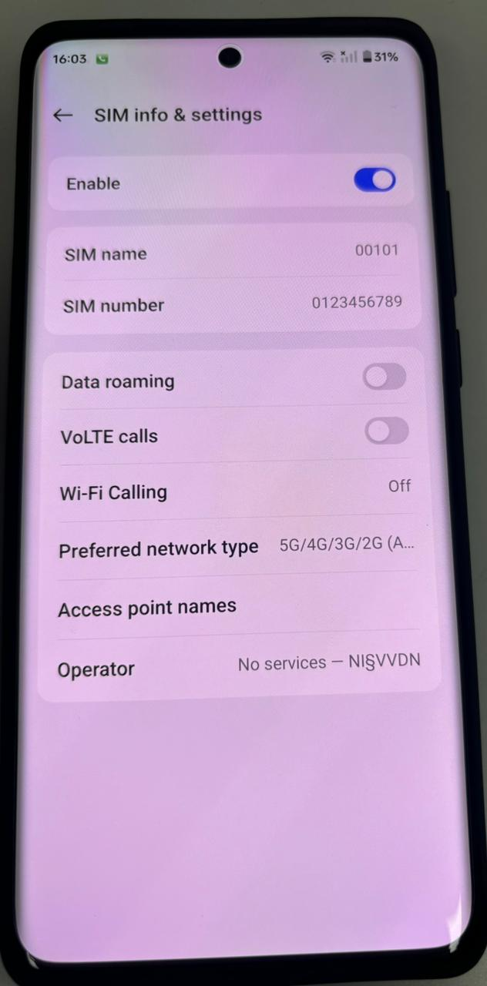
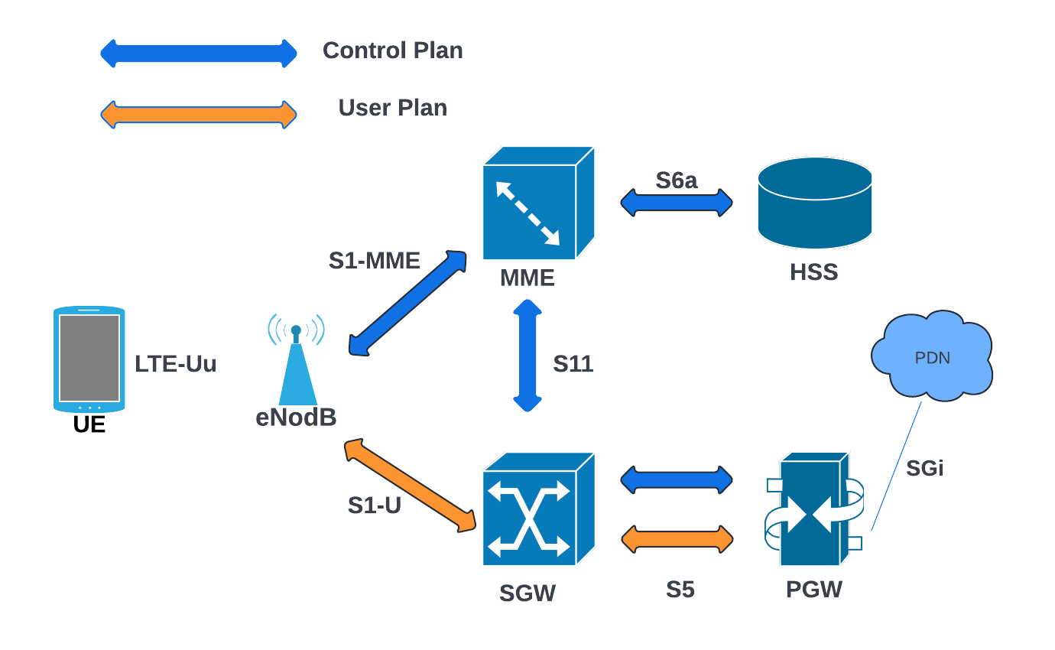
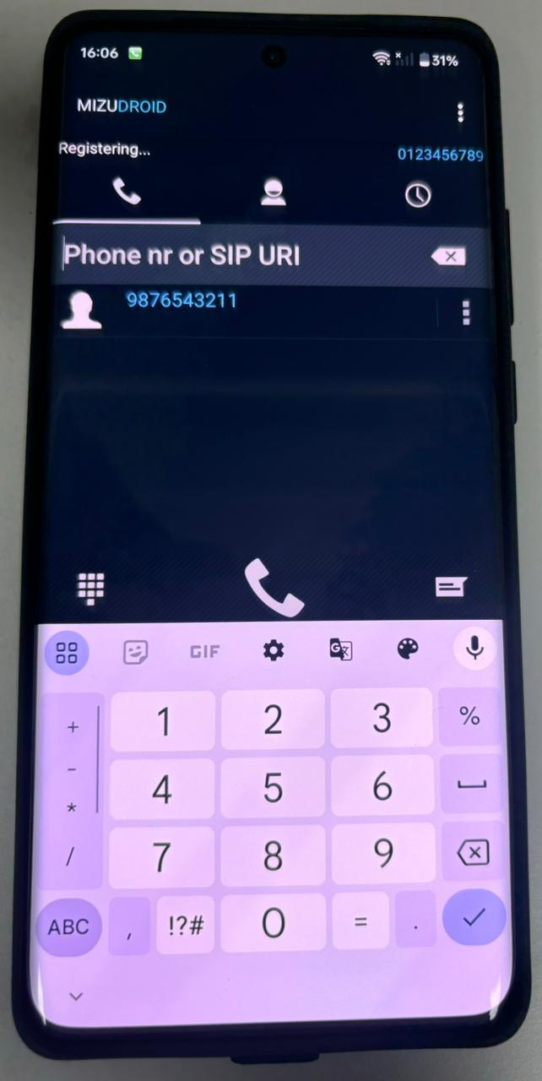
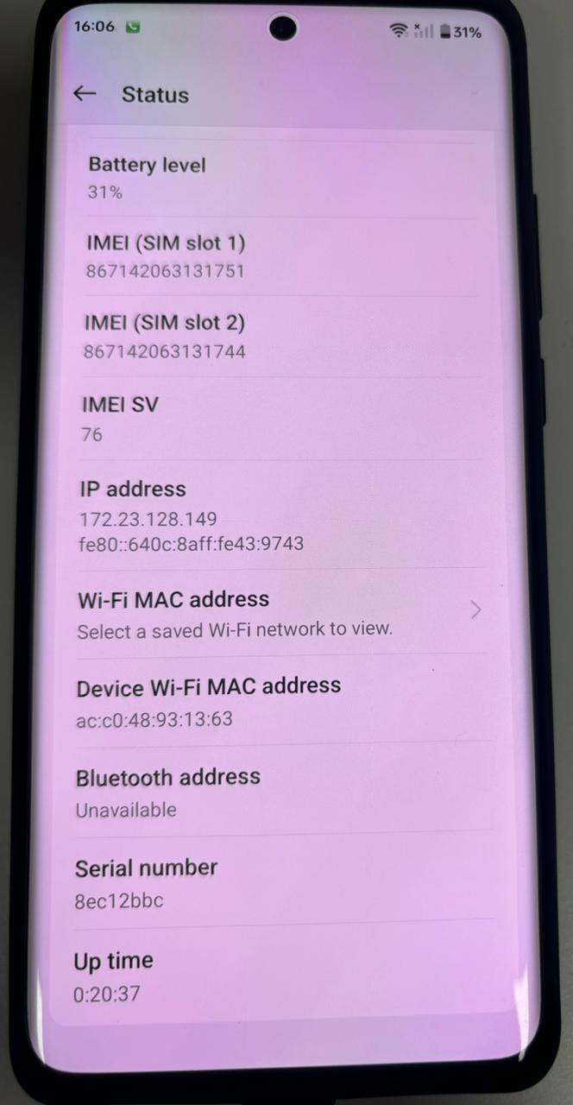
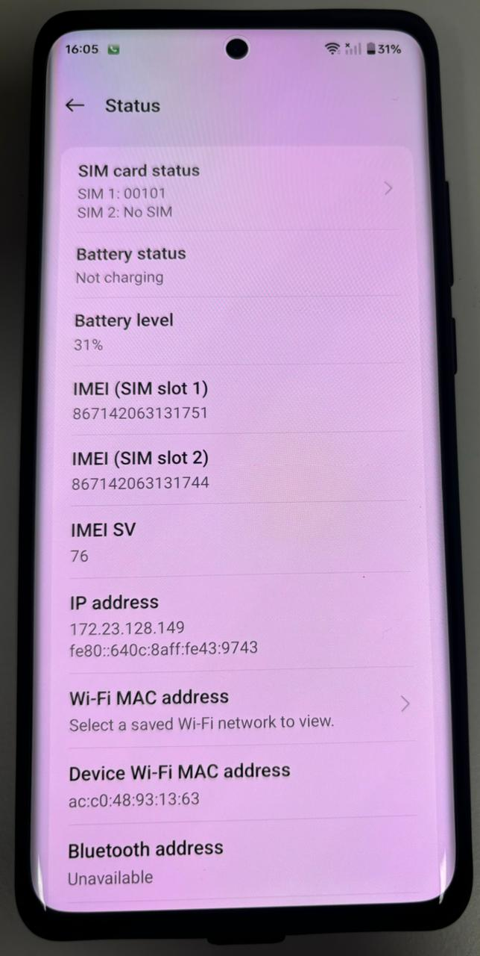
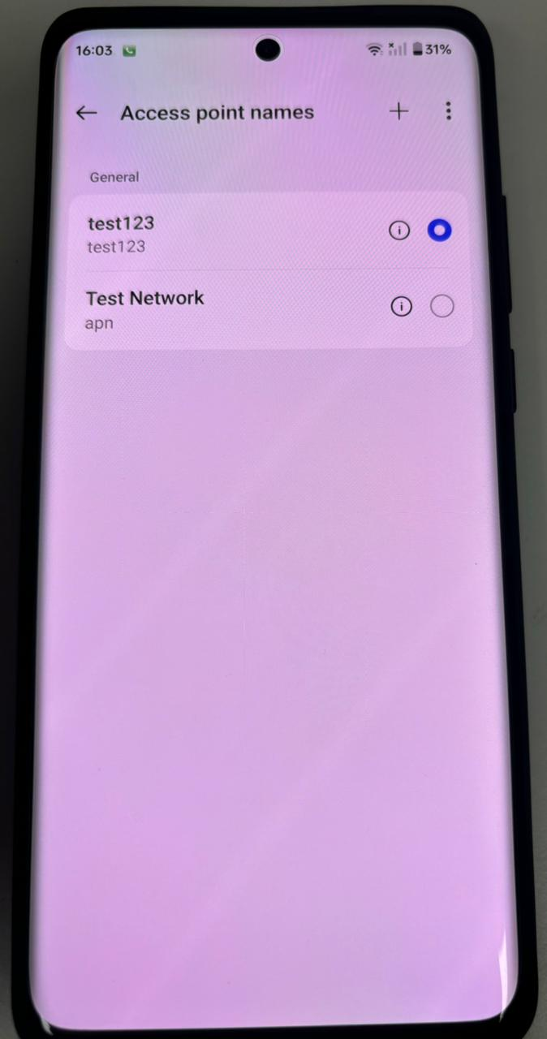

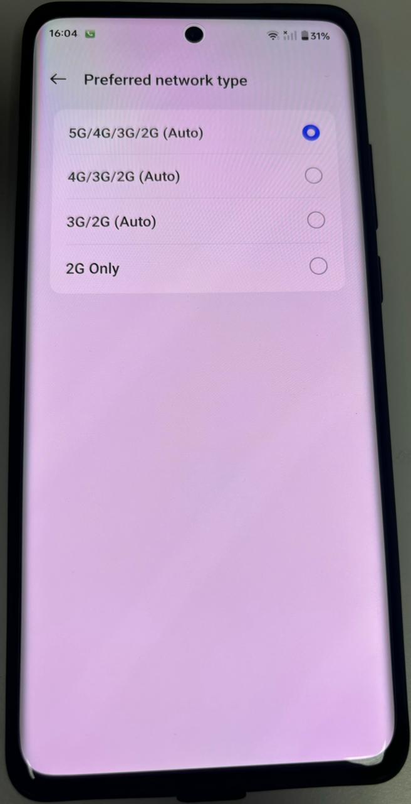

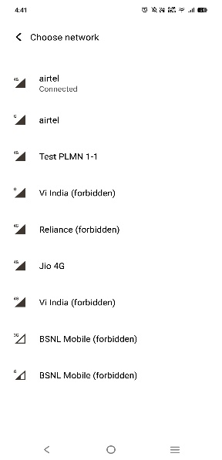
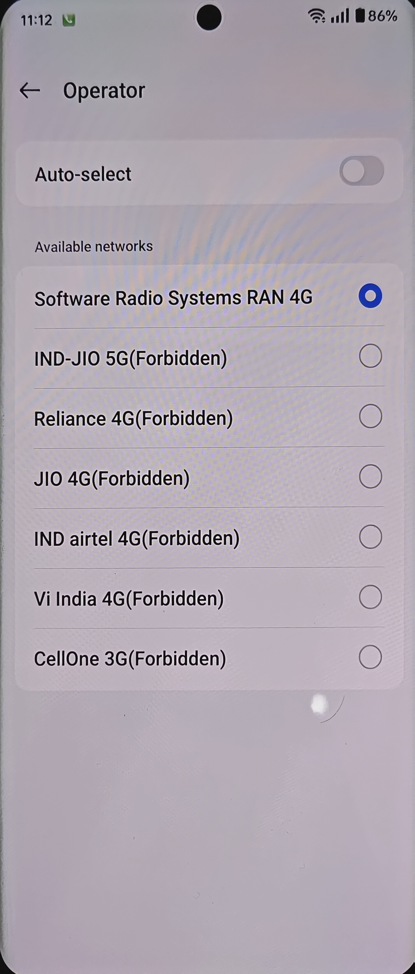

Simulation setup (in murti labs)

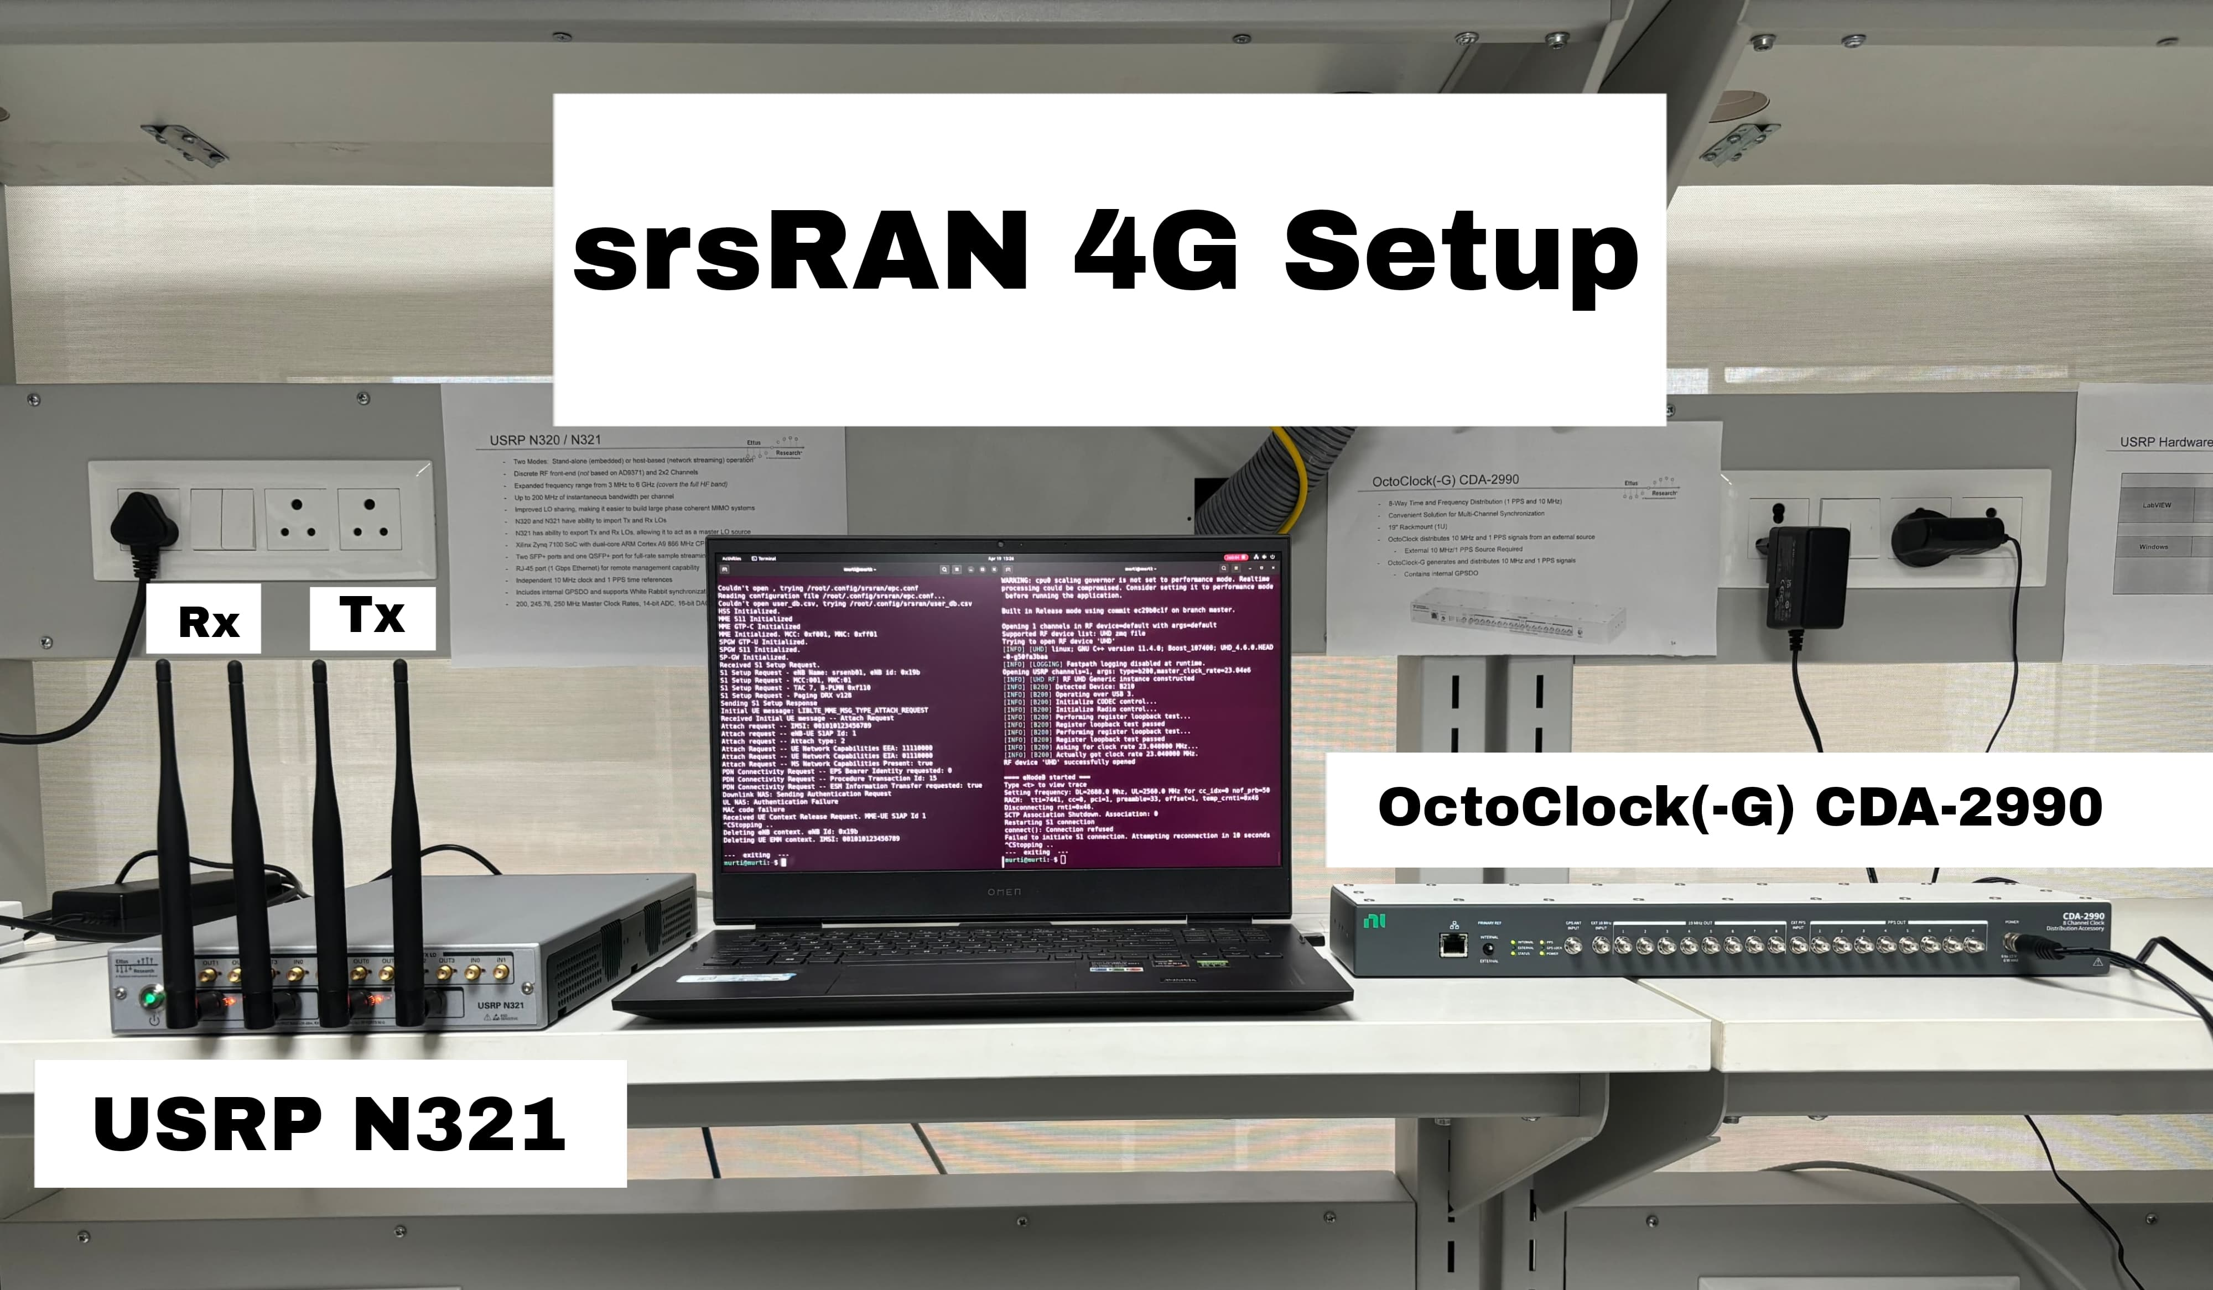

6.3 Comparison with existing literature or technologies

- Open-Source vs. Proprietary Solutions:
- This project used srsRAN and USRP, offering flexibility and lower costs compared to proprietary systems (e.g., Nokia, Ericsson), which are more expensive but offer better stability and support. Literature supports open-source platforms for research and customization, in contrast to closed-source alternatives.

- Network Customization:
- The ability to program SIM cards in this project highlights greater control over subscriber management, unlike commercial systems. Similar studies emphasize the lack of customization in proprietary solutions, while open-source platforms allow more flexibility.

- Security Features:
- The project implemented APN configuration and SIM customization for security, but lacks some advanced built-in security seen in proprietary systems. Literature notes commercial solutions excel in robust security, while open-source systems need manual configurations to reach similar levels.

- Performance:
- Uplink and downlink communication were successful, though performance may not match proprietary systems optimized for large-scale use. Literature suggests that while proprietary LTE systems perform better, open-source solutions are sufficient for research and small-scale deployments.

- Cost Efficiency:
- Using free software and affordable hardware, this project reduced costs compared to proprietary LTE systems. Studies confirm that open-source solutions offer a more cost-effective option, especially for research and smaller networks.

Chapter 7: Conclusion

We have properly configured an eNodeB using srsRAN 4G on the USRP running on the Linux system. This is one demonstration of how powerful these open-source tools are in building cellular networks. Beyond setting up an APN, we also used a programmable SIM card to present network authentication and user IDs more effectively. Now everything was set up, and we were eager to see a mobile device connect smoothly through the APN and programmable SIM because it would give us an indication that our network functioned correctly. Successful uplink and downlink communication indicated that all data had been transmitted successfully from the mobile device to the eNB, so it demonstrated the reliability of our setup. It not only deepened our understanding of how cellular networks are deployed but also reminded us of how open source solutions are quite adaptable and full of potential in the telecom world. Great to dig up further advancements in 5G technology!

Chapter 8: Future Work
- Connecting Asterisk on a Linux server will allow mobile devices hooked up to an eNodeB in an LTE network to make voice calls over VoIP. Each device is considered a SIP client; this is managed by Asterisk to configure and route calls. The calls connect via the LTE core, and voice calls are handled just like over any other telecom system. This is pretty useful for private LTE networks, as it will provide flexible, reliable communication. It is a useful answer for research, business, or special communication needs.

- Vehicles communicate with each other, road systems, and networks through cellular technology using C-V2X signaling. This results in sharing information swiftly to make roads safer and control traffic better, giving a longer reach and more dependability than old ways. It does play a very significant role in smart transport, connected cars, and self-driving systems, changing the future of transportation.

- The open-source tool, srsRAN, makes it possible to develop and test advanced networks with much cheaper costs while migrating to 5G. It is similar in configuration processes to LTE but offers faster speeds and more improved connectivity. Therefore, it is important in supporting new technologies such as IoT and smart cities in helping it meet the demand that it faces today with future evolutions.

References
- Implementation and performance analysis of software defined radio (SDR) based LTE platform for truck connectivity application - BILAL MAQSOOD

- Implementation of a 4G/5G Base Station Using the srsRAN Software and the USRP Software Radio Module - Wojciech Flakowski, Maciej Krasicki, and Rafał Krenz

- Testing Performance for Several Use Cases with an Indoor OpenAirInterface USRP-Based Base Station- Gcina Dludla, Mla Vilakazi, Chris R. Burger, Albert A. Lysko, Lwando Ngcama, Lawrence Mboweni, Moshe Masonta, Hlabi Kobo, Lusani Mamushiane

