**Problem – 1:**

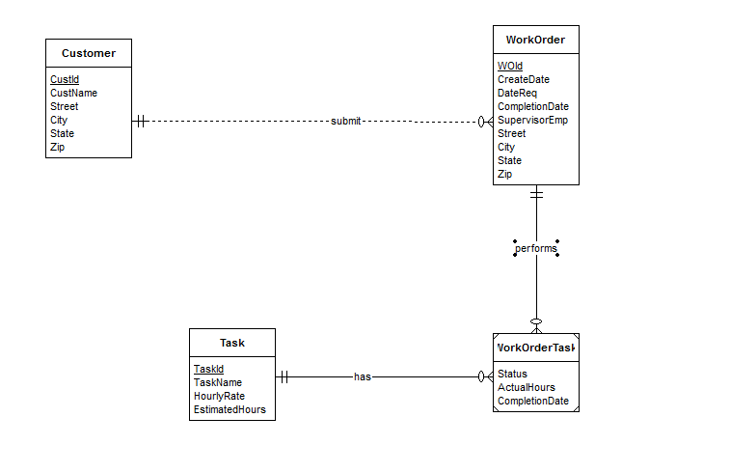

The Customer, Work Order, Task, Work Order Task entity types follow directly from the narrative. The narrative statement clearly indicates attributes and a primary key for each entity type. The statement “A customer has a collection of submitted work orders” indicates that there should 1-M relationship between Customers and Work Order. A customer can submit a collection of (many) work orders. Since a work order is placed by a customer each work order will be associated with 1 customer.

The statement “A work order has a set of tasks” indicates that each work order is associated with a set of tasks(many). The statement “Tasks are standardized across work orders so that the same task can be performed on many work orders” indicates that each task can be associated with many work orders. So, there will a M-N relationship between WorkOrder and Task. The minimum cardinalities are not clearly specified in the narrative.

The statement “Each task on a work order has a status (not started, in progress, or completed), actual hours, and a completion date” indicates that a combination of a WorkOrder and Task will have 3 attributes status, actual hours, completion date. So, we define a weak entity WorkOrderTask which will store status, actual hours, completion date for each Task of a Workorder. It will take the primary keys from WorkOrder and Task.

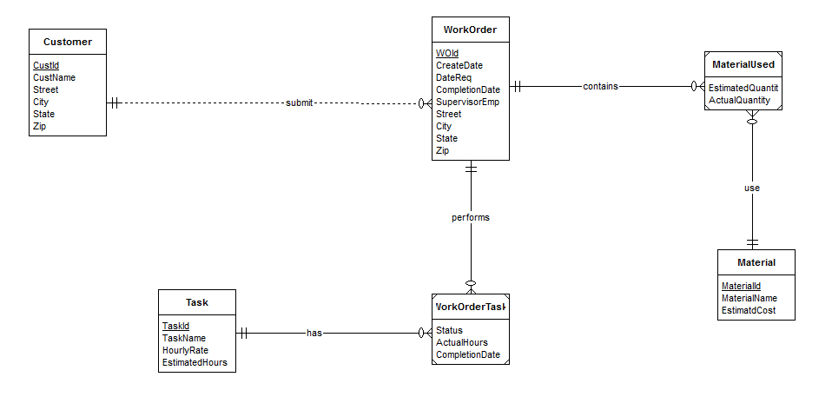

**Revised ERD**

A new entity type Material is defined. Its primary key and other attributes are specified in the narrative. The statements “ Each work order uses a collection of materials and A material can appear on multiple work orders” indicates a M-N relationship between WorkOrders and Materials. A material used on a work order includes the estimated quantity of the material and the actual quantity of the material used indicates that a combination of material and work order will have 2 attributes estimated quantity, actual quantity. So we define a weak entity set MaterialUsed which will store estimated quantity, actual quantity for a combination of Material and WorkOrder. It will take the primary keys from WorkOrder and Material.

Each task of a work order includes an estimated number of hours indicates that a new attribute Estimated Hours should be added to WorkOrderTask.