**Problem -4 :**

1. Emissions per capita of Canada: 17.72

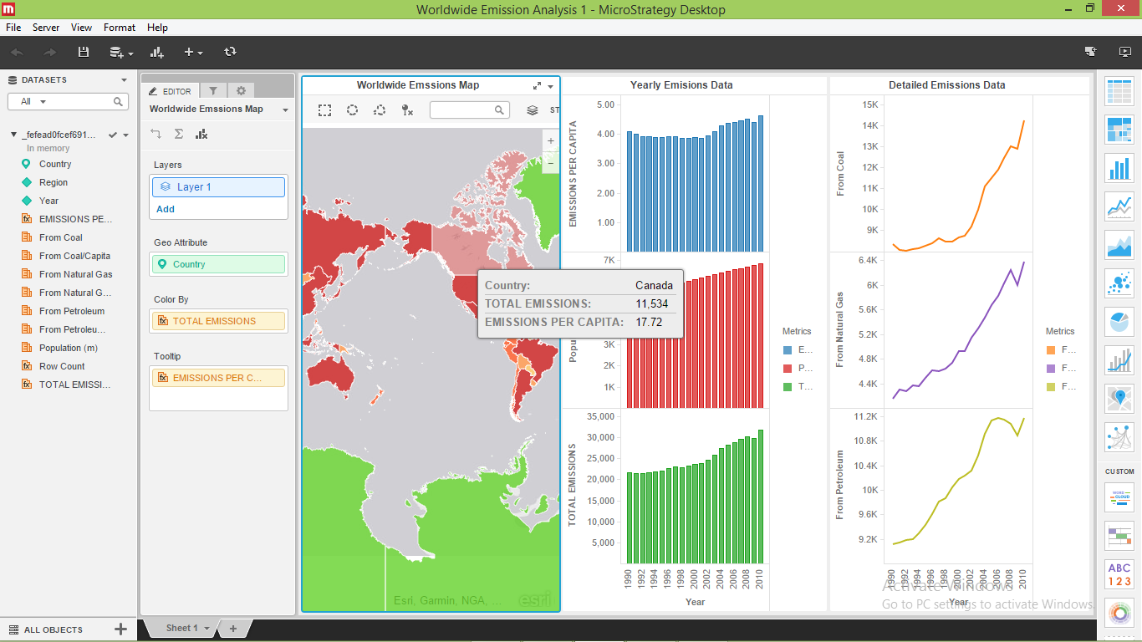

1. The overall worldwide emissions are gradually increasing from year to year. But in year 2009 there was a decrease in world wide emissions. The overall population is also increasing.

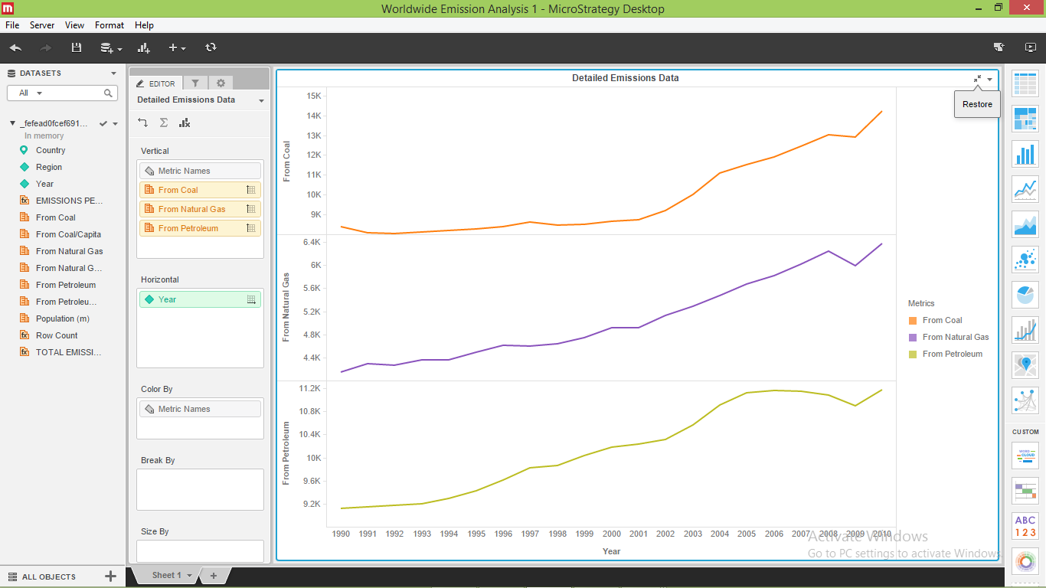

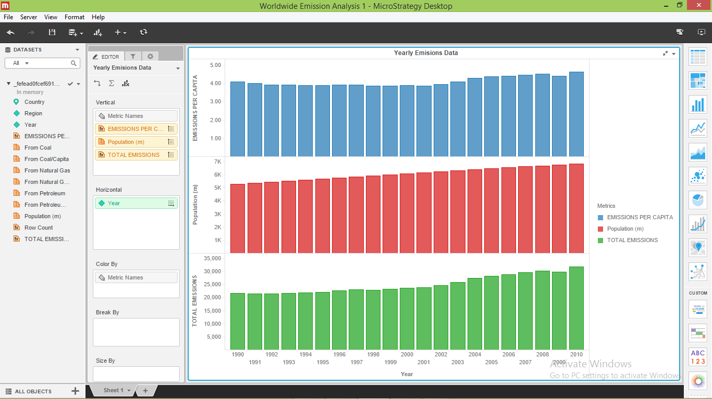

1. Due to the impact of the recession on industrial production and overall energy use emissions of carbon dioxide and other climate-altering gases fell in 2009. This is due to the shift from coal to cleaner-burning natural gas to produce electricity as the price of natural gas has declined.

