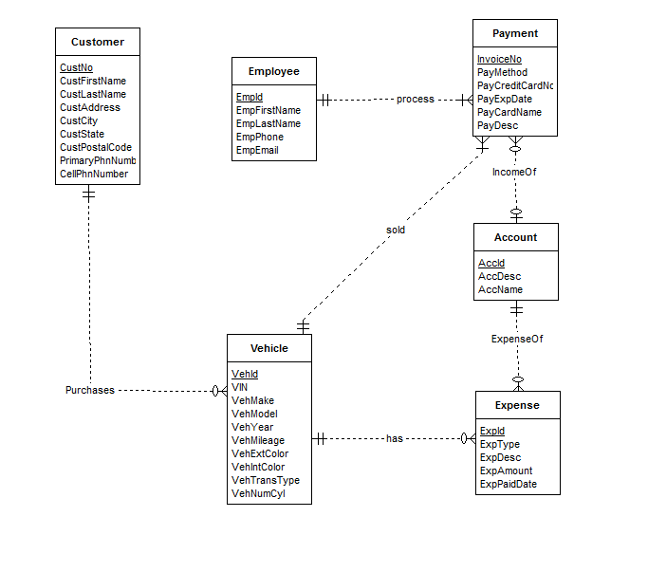

The ERD below fixes the errors in the original ERD. The following list describes the problem resolutions.

* The minimum cardinality in the *has* relationship for Vehicle should be 0, not 1 so that a vehicle has 0 or many expenses (cardinality design error).
* *Account* should not be a weak entity type (weak entity type diagram error).
* The *IncomeOf* *and ExpenseOf* relationships should not be identifying (identifying relationship diagram error).
* The minimum cardinality in the *ExpenseOf* relationships for Account should be 0, not 1 so that an account has no expense (cardinality design error).
* The *MakeSale* relationship is redundant since the employee associated with the payment can be known from *process* relationship between Payment and Employee.
* The specification is incomplete about attribute constraints such as null value allowed and data types.