Use Cases and Logical Architecture

* **XID**: x00127907
* **Name**: Daniel Maguire
* **Project Title**: GroceryMate

**Provide at least 6 Use-cases describing the functionality of the proposed system**

## Section 1: For Each Use Case:

|  |  |
| --- | --- |
| Title (goal) | **Sign up and Sign in** |
| Primary Actor | User |
| Story | As a User, upon downloading and opening the app, I expect to be prompted with a sign up or sign in screen and proceed to either sign up using an email and password, or sign. |

|  |  |
| --- | --- |
| Title (goal) | **Profile household questionnaire** |
| Primary Actor | Users |
| Story | As an administrator, I expect to have customers fill out a small household questionnaire to help feed the algorithms that will determine food consumption, wastage and |

|  |  |
| --- | --- |
| Title (goal) | **Hook up database** |
| Primary Actor | Administrator |
| Story | As an Administrator I want to persist simple data to a database hosted in Microsoft azure from the android application |

|  |  |
| --- | --- |
| Title (goal) | **Create Database schema** |
| Primary Actor | Administrator |
| Story | Determine all data streams and what to store and how, in the Microsoft SQL azure database deployed on Azure |

|  |  |
| --- | --- |
| Title (goal) | **Retrieve product data** |
| Primary Actor | Customer |
| Story | I want to be able to search for an item and have a list of items related to my search term returned in a scrollable product list |

|  |  |
| --- | --- |
| Title (goal) | **Item cart** |
| Primary Actor | Customer |
| Story | When I search for an item, I expect to be able to add that item to my cart and continue shopping |

|  |  |
| --- | --- |
| Title (goal) | **Cart checkout** |
| Primary Actor | Customer |
| Story | When I have items in my cart and I am ready to place an order, I can press a button and have an order created and submitted to the database linked to my user account |

|  |  |
| --- | --- |
| Title (goal) | **Machine learning/Algorithmic – Food consumption** |
| Primary Actor | Admin |
| Story | As an administrator, I want the app to make an estimate of how much food will be wasted, based on the current cart and household questionnaire |

|  |  |
| --- | --- |
| Title (goal) | **Machine learning/Algorithm – Items to be suggested to cart** |
| Primary Actor | Customer |
| Story | As an administrator, I want the app to make an estimate of when particular items the customer has ordered will run out, and then mark that item to be added to a push notification sent to the customer every two days. |

|  |  |
| --- | --- |
| Title (goal) | **Product catalogue categorization** |
| Primary Actor | Administrator |
| Story | I want to be able to automatically distinguish between grocery types (bread, milk, vegetables, cheese, uncooked meat, cooked meat, spreads, frozen) to be able to predict item usage and spoilage more accurately |

**Stretch goals (COMPLETE ATLEAST 1)**

|  |  |
| --- | --- |
| Title (goal) | ***Deployable camera for fridge*** |
| Primary Actor | Customer |
| Story | As a customer I wish to be able to place a camera in my fridge so the app’s machine learning algorithms can more accurately detect when I will be low on some items |

|  |  |
| --- | --- |
| Title (goal) | ***Alexa app functionality*** |
| Primary Actor | Customer |
| Story | As a customer who also has an amazon Alexa, I want to be able to ask Alexa what’s missing from the fridge and have her tell me Items I may be low or out of and have her add them to my cart |

## Section 2: Prototype Schedule, Winter Semester 2017

Completion dates

|  |  |
| --- | --- |
| Iteration #1 24/10/2018 | **Sign up and Sign in**  **Hook up database**  **Retrieve product data** |
| Iteration #2 21/11/2018 | **Create Database schema**  **Item cart**  **Cart checkout**  **Profile household questionnaire (May be better next release)** |
| Iteration #3 12/12/2018 | **Product catalogue categorization**  **Machine learning/Algorithm – Items to be suggested to cart** |

|  |  |
| --- | --- |
| Iteration #4  TBC | List the use cases to be delivered for this prototype |
| Iteration #5  TBC | List the use cases to be delivered for this prototype |
| Iteration #6  TBC | List the use cases to be delivered for this prototype |

## Section 3: Logical Architecture

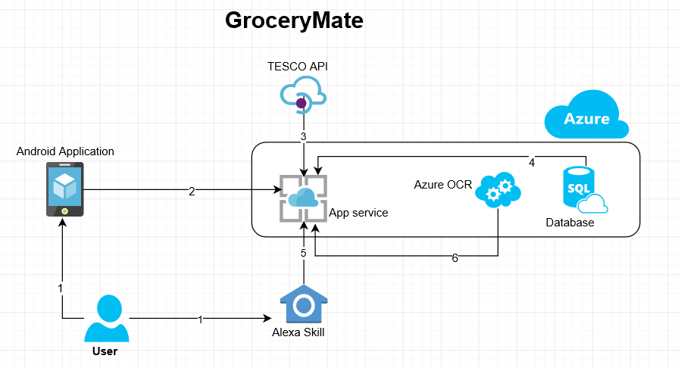

## 

## Logical Architecture Discussion

1. The user will interact primarily with an android application however it will be possible to also utilize an Amazon Alexa skill to query what food items you may need.
2. The android application will be hosted by azure app service.
3. When the user searches for an item on the android application, the app service will query the TESCO API and retrieve partially matched products from their product list.
4. When the user places orders using the application, that order data will be stored in Azure SQL database for future use.
5. The Amazon Alexa skill will be able to interact with the app service to see what items are likely low or missing from the fridge/pantry.
6. The user will also be able to scan their physical Tesco receipts via Azure Optical Character Recognition to create an order data instance in the database which will maintain and improve accuracy of the machine learning algorithms in the app used for suggesting items to add to cart, and estimated food wastage prior to ordering.