

**Hawassa University**

**Institute of Technology**

**Faculty of Electrical Engineering**

**School of Electrical and Computer Engineering**

**Internship Report**

Stream: Computer Engineering

Hosting Company: OMO Bank

Duration of Internship: 12 Dec 2022 - 2022 G.C

Name of advisor: Mr. Mussa

Name ID

1. Dagim Alemayehu 1342/11
2. Kidist Tesfaye 0583/11
3. Yared Fekade 1073/11

Submission Date: 2022 G.C

**DECLARATION**

We declare that this document entitled Internship Report is an authentic record of our work carried out at OMO Bank as required for the two-month internship semester for the award of ‘’Internship evaluation’’ under the guidance of Mr. Goythom from November to February. This report has not been submitted earlier either to this university or to any other institute for the partial fulfillment of the requirement of a course of study.

Name of Student Signature

1. Yared Fekade _______________
2. Dagim Alemayehu _______________
3. Kidist Tesfaye _______________

APPROVAL

This report is done to the best of my knowledge and has to be submitted to the department of electrical and computer engineering (computer stream) which is approved by our advisor and supervisor.

Advisor’s name signature date

Supervisor’s name signature date

**ACKNOWLEDGMENT**

First of all, we would like to give our deepest thanks to the Almighty God for his uncountable support and everything that he did for us. Secondly, we would like to give our gratitude to OMO Bank for accepting us and giving us the space needed for our practice. And we are further thankful for the technical department team for understanding and giving us a role that best suits us. We also would like to send our deepest gratitude to Mr. Goythom who was our supervisor at OMO Bank under IT division directory for his encouragement, guidance, and support from the initial to the final level, enabling us to develop an understanding of the subject. We feel the same amount of gratitude toward Mr. Aklilu and Mr. Firew who were following our work closely and generous with their time. Thirdly, we would like to express our gratitude to our advisor Mr. Mussa for his continuous guidance. There are also many others at the company including secretaries and staff who helped us during our internship period with their respectful approach, and kindness and by sharing their valuable experiences.

**EXECUTIVE SUMMARY**

This paper is a written report about our internship program which is arranged for students that have completed their four-year courses according to the program of the Ethiopian Ministry of Education. This internship aims to make students more familiar with the work environment and to make them understand and develop practical skills by relating them to their theoretical knowledge. Here in this report, we have explained and described our internship experience from start to end. The report has several chapters, the first chapter of the report is mainly concerned with the background of our hosting company, OMO Bank, which includes its brief history, main products and services, main customers or the end users of its products, and lastly the overall organization and workflow of the company. The second chapter of the report mainly describes our overall internship experience, including how we got accepted into the company, in which section of the company we have been assigned, what the workflow in the section looks like, the tasks that we have been executing, challenges that we faced while executing our tasks. In the third chapter, we tried to explain the overall benefits that we gained during the period of the internship program. In the fourth chapter, we tried to explain the project we have been working on, and the last chapter contains the conclusion and recommendation.

**List of Figures**

Figure 1: Organization Structure and work Flow of OMO bank 10

Figure 2: work flow of IT division 12

Figure 3: Use case diagram 27

Contents

**1.** **BACKGROUND** 6

**CHAPTER ONE**

1. **BACKGROUND**
   1. **Historical background of OMO Bank**

OMO Bank Institution is one of the strongest and most competent institutions in Ethiopia. It was founded on August 14th of 1996 by four shareholders with an initial capital of Birr 2,000,000. It began its operation in four pilot areas of Southern Nations Nationalities, and people’s Regional State with the objective of providing efficient, effective, and sustainable financial services to low-income society in the region. Currently, it has 17 districts, 165 branches, and 30 sub-branch offices. OMO Bank coined its name from OMO River. Which is found in South West Ethiopia; it is home to thousands of fishermen and others who use the lake water for their agriculture and livestock. It is also a guarantee for food security for the society. Similarly, OMO Micro Finance Institution has an indispensable role in serving and encouraging saving for low-income society by providing savings and loan services, many are changing their lives working with the institution.

**Success story**

OMO Micro Finance institution is established in 1997 registering with the national bank of Ethiopia. Since its establishment, the institution has been providing savings and loan services to low-income societies in its operational areas. During the last two decades, the institution has captured the need for both social and financial success stories. At the very beginning, it starts with limited pilot operational areas in four branches. It begins with 3.2 million of total capital and deposited net saving of birr 26,654. The total capital asset and deposited net savings rise between at the mid of one decades reached at about 523 million, total asset 5 billion as of net saving 2 billion correspondingly. The institution has passed many challenges related to with outreach, operational and financial performance issues. From these points of view, it has come openly learning from the challenges which it faces as the best experience for its future long vision and vast mission accomplishment. Its mission statement reads that OMFI strives to contribute its part in poverty alleviation efforts in the region by providing efficient ,effective ,and sustainable financial services to the economically active but financially poor people both in rural and urban areas through community demand-driven approach. This commitment brings it forward to operational, financial, and like outreach good achievements in large. As of march 31/2020 net saving reached 3 billion birr and number of active borrowers close to 1.5 million. It records more than 9 billion of total assets and total capita1of 659 million as its net profit of 68 million. The institution has been undergoing through different change activities to be excelling in financial and operational performances in general .OMFI record good achievements by implementing technological project like core banking. As of march 31/2020 the institution has disbursed close to 18 billion birr in loan. During the periods of pilot service delivering engagement of women starting from non around 33 of the clients of the institution are women while 75 of them are found in the rural areas. Nowadays, OMFI appears with different successes which able to give verities of benefit packages for its customers. Based on this fact savings at OMFI can give an interest rate of 7% to 9%, while this loan can cost somewhere between 8 and 18 percent based on kind of loan which is affordable for customers. OMFI can functionally operating more than 50 program loans and vast regular loan services in its operational scope. Currently, having headquartered in Hawassa, it has 17 districts 165 branches and more than 80 sub-branches with in its operational areas. As of March 31/2020 the total number of staff reached at about 6760, from this figure at Head office 160, at district offices 404, at branches 2610, at sub-branch 319 and the remaining 3269 staffs in kebeles level, this indicates how the institution is vast and largely outreached. The coverage of females staff is 1803(26.7%) and the number of males is 4957(73.3%).It has strategically planned to enlarge the number of staff to 8500 and the coverage of females to 35%.

* 1. **Vision, Mission and Objective of OMO Bank**

**Vision**

To see socially sound and competitive financial institute that responds to effective demands for financial services to economically active but financially poor people in the region.

**Mission**

OMO Bank strives to contribute its part in the poverty alleviation efforts in the region by providing efficient, effective and sustainable financial services to the economically active but financially poor people both in rural and urban areas through community demand-driven approach.

**Objectives**

• Deliver financial services to low income society, particularly to the rural and urban area

• Empower poor women by improving access to financial services

• Increase agricultural productivity and production by improving access to financial services

• Reduce exploitation by illegal money lenders increase self-employment and entrepreneurial skill.

* 1. **Working Sector of OMO Bank**

**Saving**

Saving is one of the core services they offer for their customers. They encourage their customers to save money by understanding basic concepts what it mean saving by itself? The amount remaining after a person’s consumer spending is subtracted from his or her disposable income. The importance of saving basically is because we cannot predict the future saving money can help become financially secure and provides safety-net in case of emergency. And they have different types of saving programs like voluntary saving, compulsory saving, non-interest bearing, saving box savings, commission based savings, time deposit.

**Loan**

OMFI provide valuable loan services for consumers and businesses firms to better manage their financial situation. It pursues a saving-led credit provision services. The institution as financial service provider offering and affordable credit and savings services for targeted groups in rural and urban areas. They have many loan providing programs like agricultural loan, micro business loan, small investment loan and working capital loan.

**M-BIRR**

It is the fastest, most convenient and reliable way of sending money to anywhere in Ethiopia and it can be done any time day or night form your mobile phone. And we can use it by dialing on *818 #.

* 1. **Organizational Structure and Work Flow of OMO Bank**

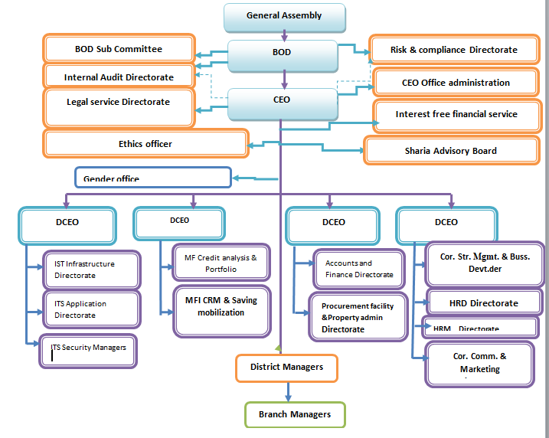

Figure 1: Organization Structure and work Flow of OMO bank

**CHAPTER TWO**

1. **OVERALL INTERNSHIP EXPEREIANCE**
   1. **Getting Accepted as Interns in the Company**

After we complete fourth year class we took a holistic exam in the campus and then the faculty made placement through companies only found in Hawassa in that placement we were placed at South ICT Center we went there and they told us there is very crowded number of students applied there before us from other universities and suggests us to find another company to apply then we started to go to different companies it was hard to get acceptance as the time was gone due to new education policy of Ethiopia 12th students took entrance exam in campus so we can’t start our session on time. But finally we got accepted by OMO Bank. On the first day we went to the hosting company and talk to the HR director of the company and IT division head (Mr. Ambaye) he told us the available division sections related to our field and asked in which division section do we want to join and we decided to join system division. On the second day the system director (Mr.Samson) assigned a mentor (Mr. Goythom) for the overall internship program and he introduced us with system department team members and they gave us orientation about how we can perform our internship within the given time and we officially become part of company and we started working.

* 1. **Section of the Company we Have Been Assigned to**

OMO Bank has different Division sections among them there is IT Division. Below IT Division there are different Directories and teams among them Information systems directorate is one of the directories. It contains two sections which are system development team and database team. As a Computer stream students we were directed to the system development Team which is responsible for designing and developing different websites and systems to make easy and fast the whole working system.

* 1. 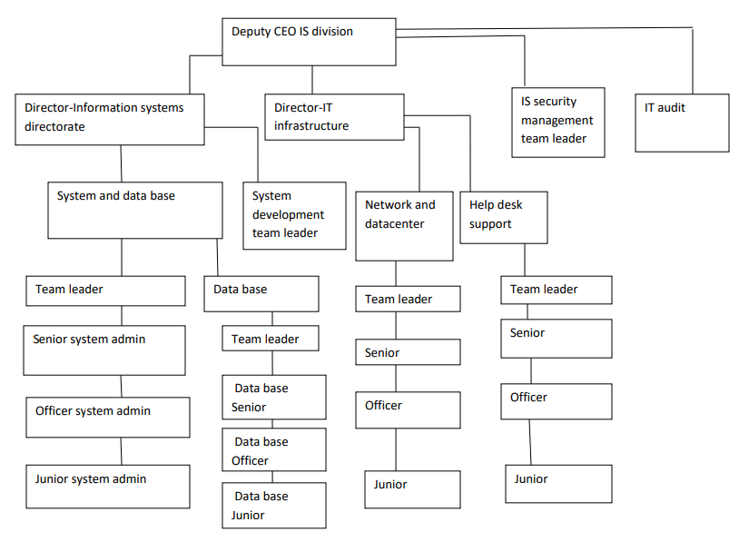**Workflow of IT Division Department at OMO Bank**

Figure 2: work flow of IT division

The work flow at IT division department follows the hierarchy listed above from the lower level to the higher level.

* 1. **Work Tasks We Have Been Executing**
     1. **UI Design for the Website**

We have been designing the UI of the website using Adobe XD.

**2.4. 2. Frontend Development**

**2.4. 3. Backend Development**

* 1. **Procedures Followed while Performing Tasks**

During the two-month internship period we have been using different procedures while performing our tasks that have been given to us. But generally we have been following these steps

1. Build our UI/UX design using Adobe XD
2. Develop frontend using React
3. Develop backend using Django framework
4. Connect frontend with backend
5. Merge all file components
   1. **Technical Challenges** **Faced**

We faced some technical challenges starting from transportation to internet access. As OMO Bank is some how far we must use transportation while we have no enough budget. As system projects need internet access to access that together most of the time we went to the company where LAB’s in the campus is very busy with other students which is not comfortable. Also we have had not enough time given in case of some new policies.

**2.7 Challenges we have been facing while performing our work tasks**

There are challenges throughout any real-world task so there were some challenges that we have been facing while performing our work tasks throughout the whole apparent session and to list some, one challenge we faced was that there were many additional new concepts which we did not learn during the time we took related courses like Database, Software engineering and programming languages so at first it was hard and also time consuming to catch up to those lessons and it was also difficult Becoming new to the working environment. As the course we took is much of introductory we needed extra referring many things to do our tasks this is also another challenge because we had to learn in different way from scratch that was not easy for us.

**2.8. Measures we have taken in order to overcome our challenges**

In order to overcome the above challenges first we accepted all happened things then think how to figure out it and decided to do each and every thing as team with helping each other by sharing ideas by referring different helping websites by asking staffs around our environment starting from our supervisor and also practicing more, increasing our communication skill to become familiar to the working environment, by asking, seeing how professionals work without any hesitation respectively.

**2.9. How good we have been in performing our task**

When we learned related courses in different semesters in campus we got theoretical and some practical ideas and last year second semester we had semester project that helps us to upgrade our knowledge that makes our internship session tasks easy to understand. But there were also some additional lessons and skills we didn’t know But we read hardly through different ways and also with the help of our supervisor and the whole teams we were able to catch up with the task that has been given to us and remedy the situation so we can say we were good at doing our tasks properly.

**CHAPTER THREE**

1. **Overall Benefit We Gained From The Internship**

Internship is method of making opportunity for University students on job training, potentially valuable and explores general career avenues as well as specific. Such arrangements can provide us with valuable work experience both practical and for resume enhancement and an opportunity to line up a job before graduation, In addition to securing good work experience. Participating in the internship allows us to acquire knowledge, experience and gain training in our field of choice. Acquiring knowledge and experience allows us to be a step ahead of others competing for the job we want. Being in an internship puts us in the job environment already and gives all sorts of experience that we can use to our advantage, and having an advantage to get a job easily is our major benefit. The major benefits that we got from the internship are classified and stated as below briefly.

* 1. **In terms of Improving our practical skills**

Before the internship period, we learned courses regarding software development and some programming languages on software engineering, database, c++ and java. These courses were given based on theoretical approach and few lab sessions. This indicates in pre internship we didn’t have that much practical knowledge. In the internship we had also improve our skill in terms of how to correct the errors procedurally and responsibly. When problems occurred there are some procedures we have to follow to solve the problem easily. Opportunities to converse and interact with talented experienced IT department members provided a deeper insight to the overall operations, as well as provided good internet connection to assist us in completion of internship program. This internship program was exactly what we needed to nurture the lack of practical skill that we had before. We have acquired practical experience to complement the theoretical content of our studies.

* 1. **In terms of Upgrading our theoretical knowledge**

This internship program helps us to strengthen our theoretical knowledge and gain meaningful way of engineering experience to complement academic studies. The academically theoretical and practical knowledge is combined and practiced, in order to compose them together throughout the intern. An internship can be seen as the pinnacle (the most successful point) of our aim of education and give us the chance to use the skills we have learned in the classroom to apply on a real-world setting. It’s a chance to prove the worth of our qualifications and to show that we can perform in the role we have been given.

* 1. **In terms of Improving our interpersonal communication skills**

Since website development needs divide and conquer work by its nature we faced different individuals with different professions and personality. The time of internship is the most powerful to develop our interpersonal skill. Individuals often learn different things from colleagues (team) through communication. For any individual, communication is an important way of learning, which can be defined formally as the act, process, or experience of gaining knowledge or skills. Communication and the subsequent learning help us from novices (lack of experience in a job or situation) to experts and allow them to gain new professional knowledge and abilities. Good communication skill has many advantages. The following are a few one:

* Making productivity more fruitful.
* To become easier to work with staff members.
* To persuade people.
* To improve relationship with others.
* To understand workers‟ attitude.
* To know the work characteristics in the company
  1. **In terms of Improving our team playing skills**

Team playing skill is upgraded throughout the internship since it is a great time to get together with our fellows as a result the way collaborating with the fellows are highly developed. So the internship was highly important for us to develop the team working skill. The most important point in team working skill is just reach an agreement from different points on the work to be done. Team works are essential to involve in every piece of task. This skill is essential for effective completion of tasks and increasing productivity. Good team workers possesses the following skill:

* Communicates constructively
* Listen actively
* Functions as an active participant
* Shares openly and willingly
* Cooperates and help others
* Shows commitment to the team
* Works as a problem solver
* Treats others in a respectful and supportive manner
  1. **In terms of Improving our leadership skills**

Leadership is a process of leading the careers of the company. Problems in the company come in all size, shape and color in different period time. Thus, a person who is in the position of leadership seeks solution to problems and should be smart enough to manage those individuals whom he/she is leading .Even though we didn’t get any chance for leadership we were able to see how team leaders in the office lead . The only way to learn in this area was by observing persons in leadership position. What i grasp is Becoming a leader isn’t easy because it takes a conscious commitment and consistent effort to develop one’s leadership skills. But on the positive side, anyone who is willing to make the effort can become a good leader. Thus, a person who is in the position of leadership seeks solution to the problems and should be smart enough to manage those individuals whom he/she is leading. For effective leadership we understood that personal values like:

* Technically proficient.
* Seek responsibility for action.
* Make sound and timely decision.
* Know peoples and look out for their well-being.
* Develop a sense of responsibility in workers.
* Ensure the tasks were understanding, supervise and accomplished.
  1. **In terms of Understanding about work ethics related issues**

Ethical conduct of workers is very important for developing healthy working environment and increasing productivity. Ethical work conduct enables workers to posses’ appropriate behaviors in their work and so as to develop proper relationships with co-workers and it helps them to create good industrial environment. There are two common types of ethics. These are Personal ethics and Professional ethics. All human beings as rational creatures are expected to exhibit certain personal principles of ethics. These principles of personal ethics are values which are expected to be possessed by all individuals in their life, and contribute a lot for a smooth interaction among individuals and peaceful coexistence of a society. Professional ethics refers to the standards or a set of moral principles for regulating behaviors of a certain defined profession. Someone has profession work ethics if he fulfills the following points:

* Punctuality:-means being on time which is companies working time and to complete a given task within the given period.
* Cooperation:–worker should interact and cooperate with each other while working. That is because it is through each system problems could be easily solved.
* Reliability:–the worker should be qualified for the part he/she is supposed to be performing.
* Integrity:- He/she must have appropriate skill and knowledge for the task assigned.
* Be responsible in analyzing and interpreting gathering of data.
  1. **Entrepreneurship skills**

As we are a technology student rather than depending on governmental job there is opportunities to open broad door and develop our interested goal. There are many skills Entrepreneur must have before opening their doors for working. Successful entrepreneurs have to start with these main skills. Those are:

* Management skills - the ability to manage time, people (both ourselves and others)
* The ability to work both as part of a team and independently.
* Able to take responsibility.

The most important skills we gained from this internship include: -

* Provides work experience in a field of interest
* Creates a springboard from campus life to career life
* Provides a "real life" experience with a short term commitment
* Strengthens background in field of choice
* Creates the potential for future work with the company

**CHAPTER FOUR**

**4. Project:** **OMO Bank Recruitment Site**

**4.1. Introduction**

OMO Bank is a financial institution that was founded in 1996 E.C. with a vision to be a sound financial institution that responds to effective demands for financial services to economically active but financially poor people in the region. Coining its name from the great OMO River in the south west of Ethiopia, it operates in the South nations, nationalities, and people regional state with a mission to contribute its part in poverty alleviation effort in the region providing efficient, effective and sustainable financial services. Starting with initial capital of 3.2 million of total capital and deposited net saving birr 26,654. The total capital asset and deposited net savings rise between at the mid of one decade reached at about 523 million, total asset 5 billion as of net saving 2 billion correspondingly. This project brings the company a way to facilitate the hiring and vacancy posting process by automating the system and increases the company’s reach to recruit new talent from all over the country for its human resource needs, given its large size.

**4.2. Statement of Problem**

The company has a huge human resources need given its current size and its inevitable need for expansion in the foreseeable future. It needs a way to post its vacancies and be able to reach recruits all over the country and even the world. At the same time, the company needs a way to view and assess the credentials and documents of the recruits and schedule an appointment.

**4.3. Objective**

**4.3.1. General Objective**

The objective of the project is to provide OMO Bank with a system to post its vacant positions and receive documents, credentials and applications from its recruits via a website.

**4.3.2. Specific Objective**

• Build a responsive site which adapts to users’ devices.

• Authenticate users whether it could be applicants or recruiters.

• Allow new recruits to register to the site.

• Notify applicants through email when a vacancy in their respective field is newly available in the site.

• Allow applicants to search for vacancies with search filtration option, apply for vacancies and follow the progress of their application(s).

• Display well categorized applications to recruiters and vacancies to recruits.

• Allow recruiters to schedule job interview.

• Show applicants the appointment to their job interview.

• Allow recruiters to categorize applications.

• Allow recruits to upload files (qualification, resume and such) to their accounts and edit their account details.

**4.4. Scope**

The project focuses on providing a recruitment page where the company posts its vacant positions, a page where recruiters can review applications and schedule appointments for applications of their choice, and a page where recruits can view, apply and send their credentials and documents through.

**4.5. Methodology**

**4.5.1. Data Collection Tools/Techniques**

The data collection process for this project is done through the following techniques:- Observations

The data gathering process involves viewing from universally adopted procedures of a vacancy posting and recruitment processes of different companies like Ethiopian commercial bank and other huge firms.

Interviews

The data gathering process involves interviewing HR personnel and the clients about questions we have on the recruitment process that are necessary for the development of the module.

Document analysis

Analyzing the current process using the company’s usual vacancy postings to understand the client's current situation. Reviewing the available company documentation, charts, recruitment analysis statistics and past recruitment patterns and get an idea about the requirements of the new system.

**4.5. 2. Requirements**

**4.**5.2.1. Functional Requirements

• Allow recruiters to post vacancies and display them to applicants.

• Receive applications from recruits and display it to recruiters in an organized fashion.

• Allow recruiters to schedule an appointment for job interview.

• Allow recruiters to Send email notifications

**4.**5.2.2. Non-Functional Requirements

• Put a limit to the size of the files uploaded by applicants.

• Expired or filled vacancies will not be completely removed from the site.

• Simple and easy to use interface.

• A module that can easily integrate to a bigger system.

For this project, we plan on following traditional design approach where structured designing of the site proceeds after careful elicitation and analysis of requirements.

**4.5.3. System Development Model**

The Rad development approach is the first choice of development model, given the short period of time to develop the site. However, incorporating the RAD model to the Incremental development model proved to be the better option. This is achieved by using component-based development for each increment in the development process as much as possible. In other words, for each increment in the development of the site, we try to outsource functionalities rather than developing every feature from scratch.

**4.5.3.1 Development Tools and Technologies**

Frontend Technologies

For the Front-End development, we use React frame work. Which allows us a much-needed flexibility.

Backend Technologies

Our Back-End is built using Django python Frame work. Which helps us automate the fundamental systems.

Documentation and Modeling Tools For documentation

we use MS Word and for modeling we are use Adobe XD which we found better suited for offline use.

Deployment Environment

This module is developed with an intention that it be part of the already existing website of the bank. Hence, the site makes efficient use of the hosting servers already in use by the bank’s official website

**4.5.4. Software Development Approach**

At first glance, the RAD (Rapid Application Development) model seems like the perfect development approach given the short period of time to develop the site. However, incorporating the RAD model to the Incremental development model would be a reasonable choice. This can be achieved by using component-based development for each increment in the development process as much as possible. In other words, for each increment in the development of the site, we will try to outsource functionalities rather than developing every feature from scratch.

**4.5.5. Project Requirements**

**4.5.5.1. Software Requirements**

The project requires

• Python with Django framework

• Node with react framework

• Visual studio code

• Pycharm

• Adobe XD

We chose these technologies because of their ability to scale, their flexibility, and their capacity to be built independently from each other. Meaning that part of the team can work on the front end and the rest of the team can work on developing the backend without having to wait for the other team. Secondly, modules developed with these languages/frameworks tend to integrate into a bigger system without a need to make a lot of modifications. And finally, because we found it necessary to familiarize ourselves with the programming languages and frameworks that businesses prefer working with, we found these languages/frameworks ideal.

**4.5.5.2. Hardware Requirements**

• Computers

• Good internet connection

**4.6. SYSTEM ANALYSIS**

**4.6.1. System Model**

**4.6.1.1. Use Case Model**

The use case model of these project contains three actors which are directly involved with the software being developed. These are, namely:

* The Human Resources
* The Recruit and
* The System

The Human Resources is the one responsible for managing and uploading of vacancies and recruiting the employees. Their role involves vacant position posting, viewing and analyzing the recruit data and also scheduling appointment with the recruits. The Recruit can upload their credentials, view and edit their profiles and credentials. And the system can also manage every individuals account logs, and sends mail accordingly.

**4.6.1.1.1 Use Case Diagram**

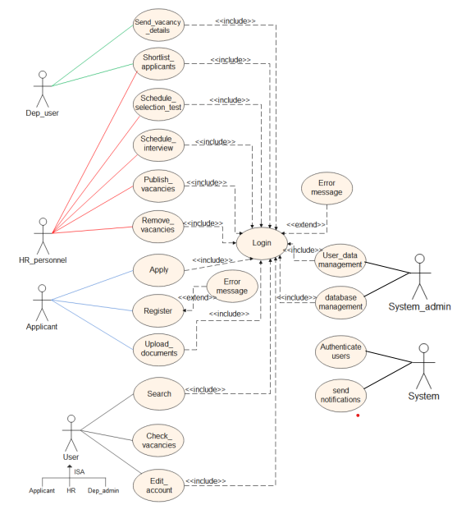

Figure 3: Use case diagram

**4.6.2. Object Model**

The Object Model has six different classes with their own relationships. The Classes are normalized to a degree that befits the project.

The classes are: -

• The user class

• The user Extension class

• The Education class

• The Experience class

• The Vacant Position Class

• The Vacant Requirements Class

The user class has a one to many relationship with the Education and Experience class and a one to one relationship with the user Extension class. And also the vacant position class has a one to many relationship with the vacant requirements class.

**4.6.2.1. Class Diagram**

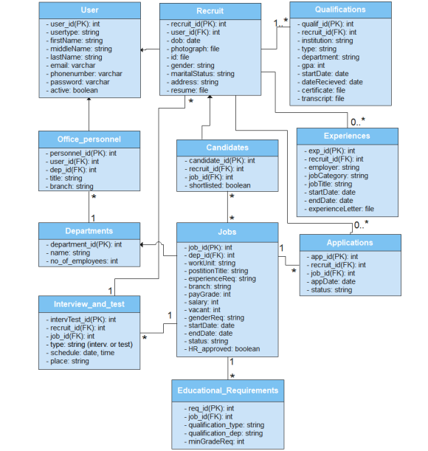

Figure 4: Class diagram

**4.7. System Design**

**4.7.1 User Interface Design**

The UI/UX has been designed using Adobe XD as mentioned above. In the design, the theme of the existing official website of the bank has been preserved. Below are provided sample screenshots of the designed pages for the site.

1. **Landing page**

The landing page has two sections, slider section, to give visitors the background of the site and jobs section where available jobs are listed with vague details and users are required to log in for details.

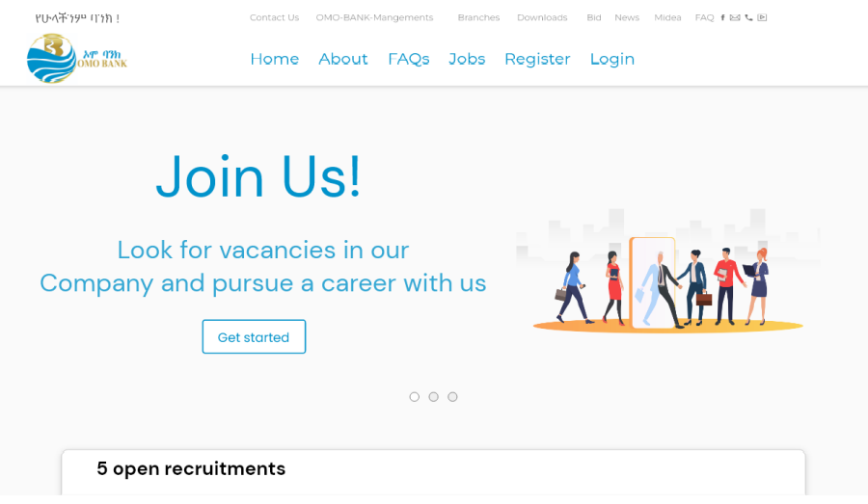

Figure 5: Landing page section 1 screenshot

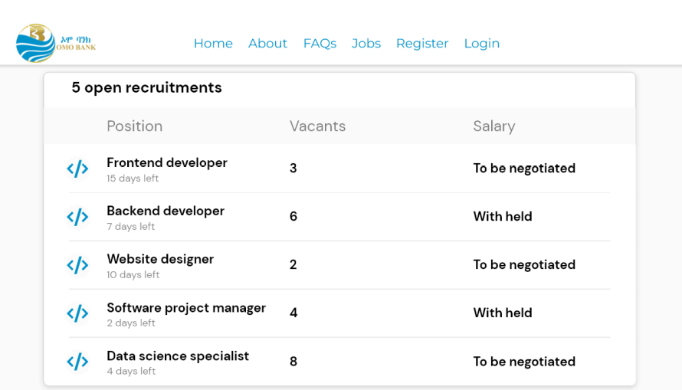

Figure 6: Landing page section 2 screenshot

1. **Login page**

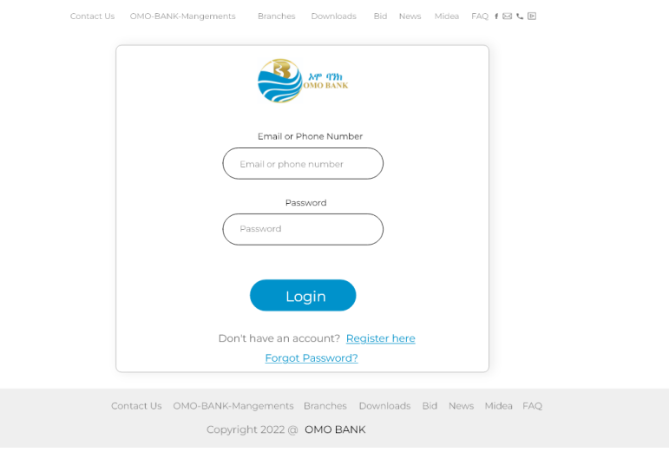

Figure 7: Login page screenshot

1. **Registration page**

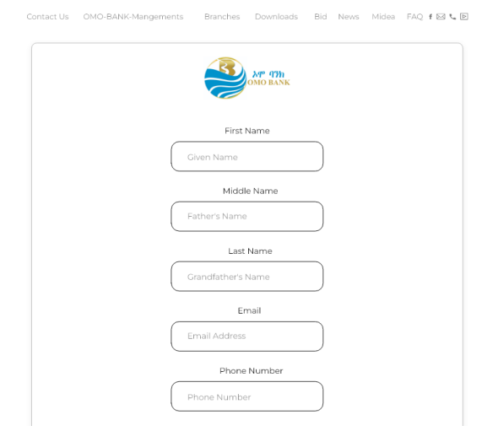

Figure 8: Registration page screenshot 1

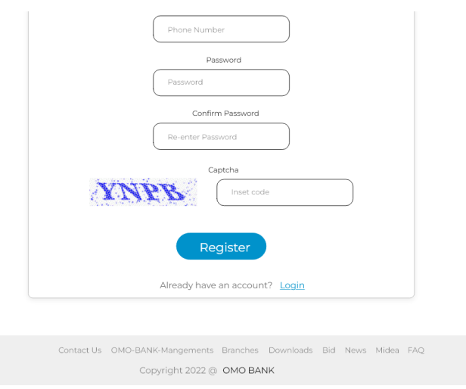

Figure 9: Registration page screenshot 2

1. **Recruiter’s home page**

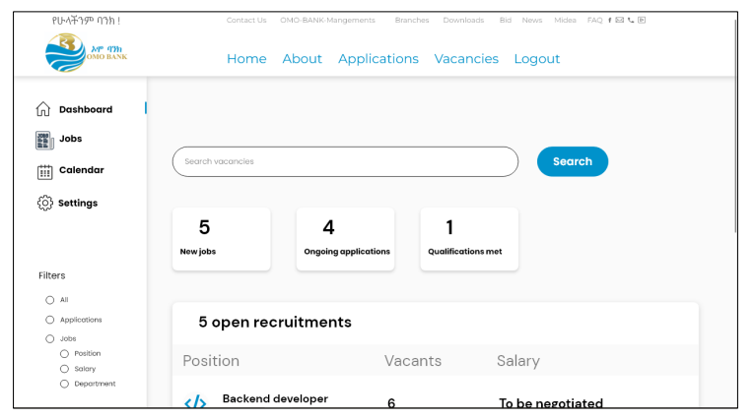

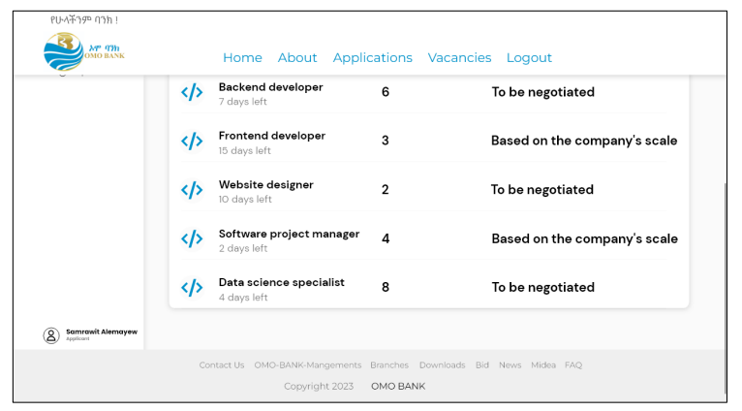

Figure 10: Applicant/Recruit homepage

1. **Department user homepage**

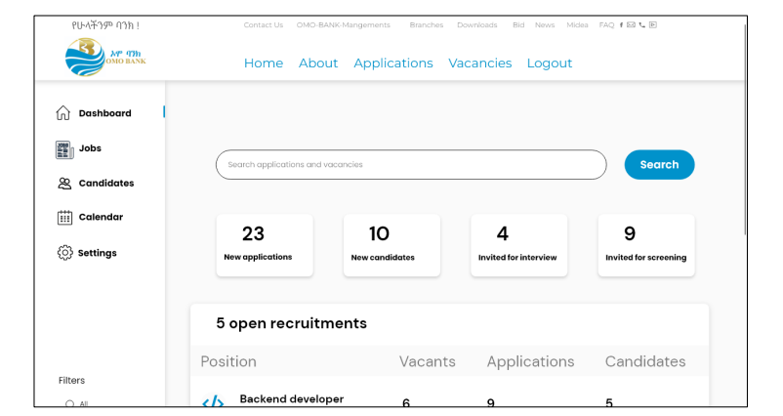

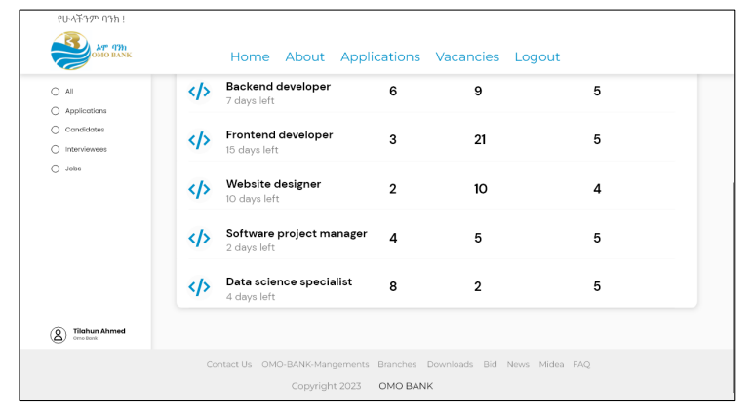

Figure 11: Department user homepage

**Vi. HR personnel homepage**

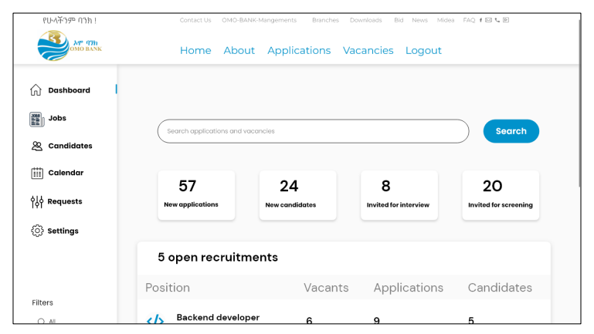

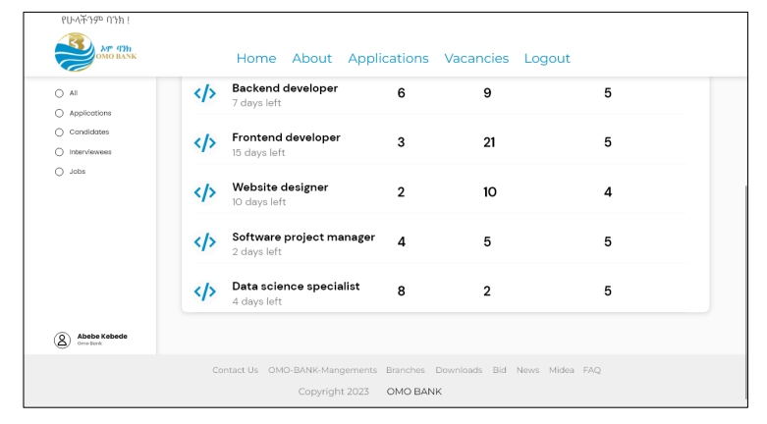

Figure 12: HR personnel homepage

**Vii. System admin homepage**

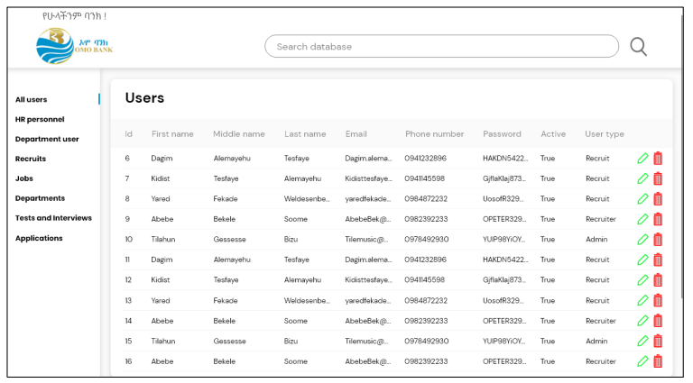

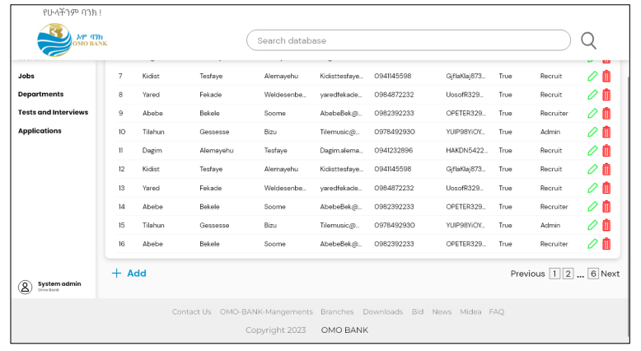

Figure 13: System admin homepage

**4.8. Conclusion and Recommendation**

**4.8.1. Conclusion**

In General, the system has an improved solution to the presented problem in a way that integrates technology and digital world which makes it open to further improvements and also makes the system more manageable. After completion the project will provide the bank with up-to-Date way of recruiting its employees from all over the country.

**4.8.2. Recommendation**

However, there are some improvement and future ideas that can be applied to make a fully functional website. Some of them are:

• Intergrade smart interview room by adding Skype facility.

• Intergrade existing notification facility by adding SMS facility.

• Mobile App.

• Add social media plugins to the system to get more publicity for vacancies.

• Integrated existing online test module with a time limit.

• Applicant tracking facility

**CHAPTER FIVE**

**5. Conclusion and Recommendation**

**5.1 Conclusion**

This internship report contains the overall experiences that we gain from the internship program and we concluded that the program is very good to upgrade the theoretical knowledge into practical skill. On the internship period we have understood so many skills about the job environment and what it meant to be a worker, What ethics we need to have at the work place and outside. Again we have seen the real working conditions and understand what services are delivered from OMO Bank and practical skills. Generally, we got satisfactory knowledge and more benefited at internship period. This internship program is necessary and important to computer engineering students

**5.2 Recommendation**

**5.2.1 Recommendation to the company**

**5.2.2 Recommendation to Hawassa University**

It is necessary for Hawassa university to deal with the hosting companies how the companies will be ready for the students to upgrade their theoretical knowledge in practice after the trainers are hosted to the assigned company. It is important for Hawassa University to communicate with the hosting companies in order to increase the relation between the university and companies and allocate the intern students to the companies those have enough resources, but the availability of resources doesn’t mean creating comfort for the internees but creating willingness of the companies is the most crucial issue. Finally, it is important if Hawassa University knows the background of companies that the company have enough understanding on internship program, which means in which company the trainers develops their skill as well as be beneficial of the program.

**Reference**

[1] OMO Bank official website

[2]

**Appendices**