

Week 05 – Class Exercises

Katragadda, Jayasri
Oshiro, Renato Hiroyuki
Pemmasani, Sridevi
Prumucena, Fabio

Fall 2025 Machine Learning (DAMO-640-10) – GROUP 3
Module 6 — SVM Classification: Linear vs RBF Kernel Comparison
University of Niagara Falls
Professor: Ahmed Eltahawi

CONTENT
1. Dataset and Preprocessing 3

Dataset and Preprocessing
The experiment used the Module 6 health dataset, containing normalized biomedical features for binary outcome prediction (patient health class). All predictors were standardized using Standard Scaler to ensure that the SVM’s margin optimization was not biased by differing feature scales.
A stratified 70/30 train–test split (random_state = 42) preserved class proportions, and all preprocessing was embedded in model pipelines to prevent leakage during cross-validation.

Model Configuration
Two Support Vector Machine (SVM) models were compared using GridSearchCV with 5-fold Stratified CV, optimizing for ROC-AUC as the primary metric, and F1 and Accuracy as secondary tie-breakers.
Kernel | Tuned Parameters | Role and Interpretation
Linear | C ∈ {0.1, 1, 10} | Controls regularization and margin width (lower C → softer margin).
RBF | C ∈ {0.1, 1, 10}, γ ∈ {scale, 0.1, 0.01} | C governs margin hardness; γ defines the curvature and locality of the decision boundary.
All fitting was encapsulated in pipelines (StandardScaler → SVC(kernel)), ensuring consistent scaling and reproducibility.

Results and Evaluation
Both kernels achieved high accuracy, confirming that the dataset is almost linearly separable with slight non-linear curvature captured by RBF.
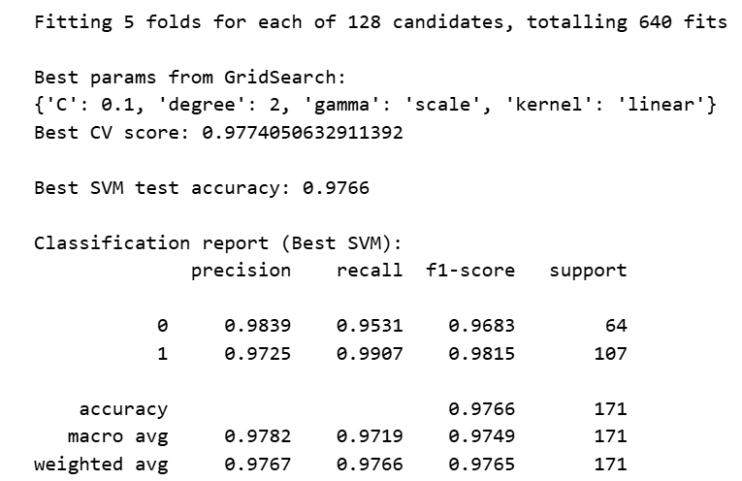
The linear kernel achieved the highest scores across all metrics, particularly improving recall for the minority (positive) class.

