**ABSTRACT**

RECRUITER HUB is web based application to enable the Human Resources department to create a vacancy and attach an applicant to a specific vacancy. This project is aimed at developing a web-based and central Recruitment Process System for the HR Group for a company. Some features of this system will be creating vacancies, storing Applicants data, Interview process initiation, Scheduling Interviews, Storing Interview results for the applicant. Finally after completing all the process the Hiring of the applicant should be done. Reports may be required to be generated for the use of HR group. We can also have the functionality of online interviews in this project. The future enhancement for this project is that we can create the functionality of video interview.

**Project Summary**

|  |  |
| --- | --- |
| Project Title | Recruiter Hub |
| Organization | Cygnet Infotech Pvt. Ltd., Ahmedabad. |
| External Project Guide | Mr. Ashishpal Singh. |
| Internal Project Guide | Mr. Bhavin Panchal. |
| Project Duration | 1 year. |
| Team | Pruthvisinh Raj(080390107048)  Nilkamal Purohit(080390107047) |
| Submitted To. | S.P.B Patel Engineering College, Mehsana. |

**Hardware and Software Requirements**

* Development Framework: Struts 2.0 and Hilbernate 3.0
* Programming language: Jsp/Servlet
* Application Design Architecture: MVC
* Front end tool: Eclipse Galileo 3.5
* Back end tool: MySql Query Browser
* Back End: MySql 5.0

**Time Line chart**

Part-I

|  |  |  |  |  |
| --- | --- | --- | --- | --- |
| **July** | **August** | **September** | **October** | **November** |
| Requirement Gathering |  |  |  |  |
|  |  | Analysis |  | Part-I Report |

Part – II

|  |  |  |  |  |
| --- | --- | --- | --- | --- |
| **December** | **January** | **February** | **March** | **April** |
| Designing and coding |  |  |  |  |
|  | Testing |  |  |  |
|  |  |  | Final Report |  |
|  |  |  |  | Submit |

COMPLETED: STILL RUNNING:

Status of Report

|  |  |
| --- | --- |
| Task | Status |
| Requirement Gathering | Completed |
| Analysis | Completed |
| Designing | 60% Completed |
| Coding | 50% Completed |

**E-R Diagram**

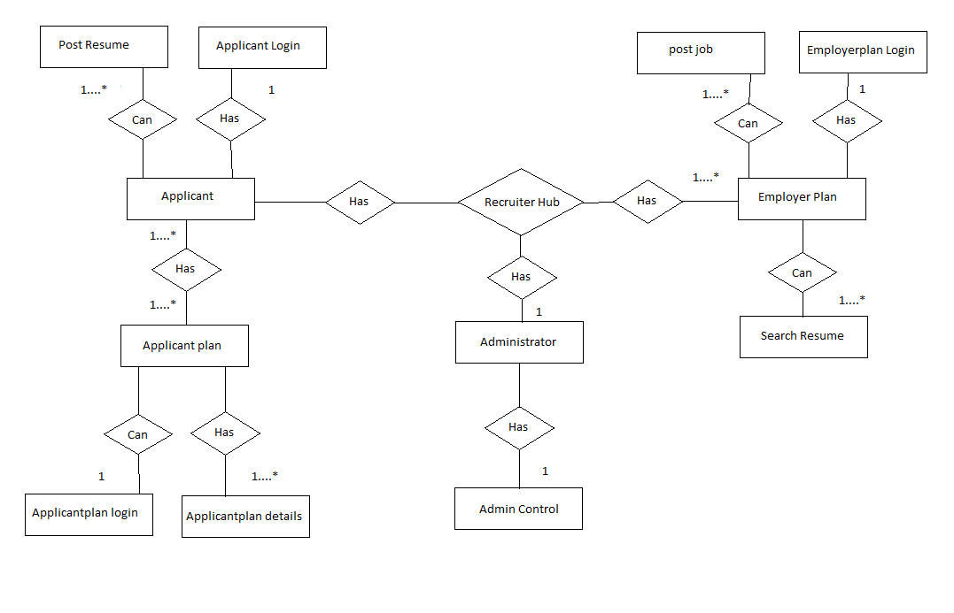

**UML Diagram**

**Use Case Diagram**

Use case diagram of “Applicant Login”



Use Case Diagram of “Posting Resume”



Use Case Diagram of “Applicant Login”



Class Diagram of “System”

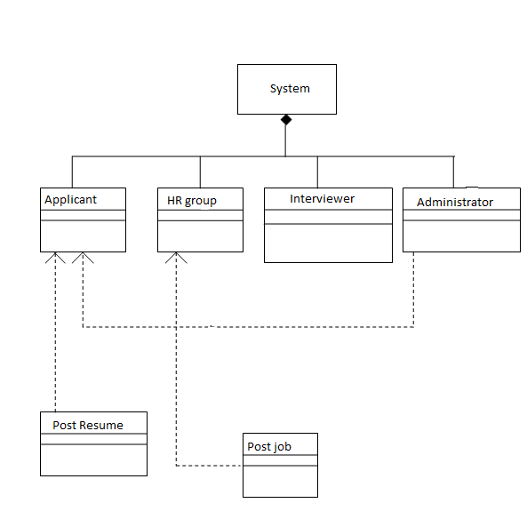

**Activity Diagram**s



**Sequence Diagram**







**Conclusion**

Now a days manual process of searching a job of the appropriate choice and searching the appropriate candidate for a specific job has become a huge task.And so for realizing the need of easy management of this process the site has been developed.It’s very easy to update and maintain information through this site.The main features of this site includes flexibility, easy to manipulate information’s, easy access searching, storage, reduce manual work in an efficient manner, a quick, convenient, reliable, timely and effective way to reach recruiting, search and employment professionals worldwide and most economical.The project could very well be enhanced further as per the requirements.

**Future Enhancement**

This web based application would be used in the company for help the HR to recruit the specific applicant as needed.The recruitment process should be become very easy for the HR to hire a well experienced and skilled employee.The applicant would also get the easy way to apply for the specific job as per his/her skill for the particular task. So, by this recruitment process the applicant can easily find their job as per their skill and the HR should easily recruit the skilled person for the specific post.

**References**

1. Black book JAVA 6
2. Complete Referance of J2EE