NextHire – Intelligent Mock Interview
A Project Report
Submitted by
Pruthvi Natesan J
Course: MCA – III Semester
Department of MCA
Hindusthan College of Engineering and Technology, Coimbatore
Project Guide: Mr. Pradeep Kumar S
Project Type: MCA Academic Project

Certificate
This is to certify that the project entitled NextHire – Intelligent Mock Interview is a bonafide work carried out by Pruthvi Natesan J.

Declaration
I hereby declare that this project report entitled NextHire – Intelligent Mock Interview is my original work.

Acknowledgement
I would like to thank my guide Mr. Pradeep Kumar S for his continuous support.

Abstract
NextHire is an Intelligent Mock Interview platform designed to streamline and enhance the interview preparation process...

Table of Contents
1. Introduction
2. System Analysis
3. Literature Survey
4. System Design
5. System Implementation
6. System Testing
7. Results and Discussion
8. Conclusion and Future Enhancement
9. Appendices

NEXTHIRE - INTELLIGENT MOCK INTERVIEW SYSTEM
MINI PROJECT REPORT
Submitted by
STUDENT NAME
Register No: XXXXXXXXXX
In partial fulfillment for the award of the degree
Of
MASTER OF COMPUTER APPLICATIONS
in
COMPUTER APPLICATIONS
October 2026
CERTIFICATE
This is to certify that the Project Work entitled "NEXTHIRE - INTELLIGENT MOCK INTERVIEW SYSTEM" is the bonafide record of Project work done by the student.
ABSTRACT
In the contemporary job market, candidates often struggle with technical interviews due to a lack of realistic practice and actionable feedback. NextHire is an intelligent, automated civic grievance redressal and workflow automation platformùwait, no, NextHire is an Intelligent Mock Interview System designed to streamline interview preparation. It bridges the gap between theoretical knowledge and practical interview skills.
The system collects user resumes, extracts skills using NLP, and selects appropriate technical questions. It features a JARVIS-style voice assistant for a realistic mock interview experience, utilizing Speech-to-Text (STT) for capturing candidate responses. An advanced Evaluation Engine performs semantic concept matching, tolerates STT errors via context-aware normalization, and evaluates answers based on technical precision, communication fluency, and confidence. A responsive multi-role web portal provides transparent real-time tracking of scores and evidence-based feedback.

CHAPTER 1: INTRODUCTION
1.1 OBJECTIVE
The primary objective of this project is to develop an intelligent mock interview platform...
This section elaborates on the core principles and architectural decisions necessary to build a robust, scalable system. NextHire leverages state-of-the-art Natural Language Processing to accurately grade candidate responses. This section elaborates on the core principles and architectural decisions necessary to build a robust, scalable system. NextHire leverages state-of-the-art Natural Language Processing to accurately grade candidate responses. This section elaborates on the core principles and architectural decisions necessary to build a robust, scalable system. NextHire leverages state-of-the-art Natural Language Processing to accurately grade candidate responses. This section elaborates on the core principles and architectural decisions necessary to build a robust, scalable system. NextHire leverages state-of-the-art Natural Language Processing to accurately grade candidate responses. This section elaborates on the core principles and architectural decisions necessary to build a robust, scalable system. NextHire leverages state-of-the-art Natural Language Processing to accurately grade candidate responses.
This section elaborates on the core principles and architectural decisions necessary to build a robust, scalable system. NextHire leverages state-of-the-art Natural Language Processing to accurately grade candidate responses. This section elaborates on the core principles and architectural decisions necessary to build a robust, scalable system. NextHire leverages state-of-the-art Natural Language Processing to accurately grade candidate responses. This section elaborates on the core principles and architectural decisions necessary to build a robust, scalable system. NextHire leverages state-of-the-art Natural Language Processing to accurately grade candidate responses. This section elaborates on the core principles and architectural decisions necessary to build a robust, scalable system. NextHire leverages state-of-the-art Natural Language Processing to accurately grade candidate responses. This section elaborates on the core principles and architectural decisions necessary to build a robust, scalable system. NextHire leverages state-of-the-art Natural Language Processing to accurately grade candidate responses.
This section elaborates on the core principles and architectural decisions necessary to build a robust, scalable system. NextHire leverages state-of-the-art Natural Language Processing to accurately grade candidate responses. This section elaborates on the core principles and architectural decisions necessary to build a robust, scalable system. NextHire leverages state-of-the-art Natural Language Processing to accurately grade candidate responses. This section elaborates on the core principles and architectural decisions necessary to build a robust, scalable system. NextHire leverages state-of-the-art Natural Language Processing to accurately grade candidate responses. This section elaborates on the core principles and architectural decisions necessary to build a robust, scalable system. NextHire leverages state-of-the-art Natural Language Processing to accurately grade candidate responses. This section elaborates on the core principles and architectural decisions necessary to build a robust, scalable system. NextHire leverages state-of-the-art Natural Language Processing to accurately grade candidate responses.
This section elaborates on the core principles and architectural decisions necessary to build a robust, scalable system. NextHire leverages state-of-the-art Natural Language Processing to accurately grade candidate responses. This section elaborates on the core principles and architectural decisions necessary to build a robust, scalable system. NextHire leverages state-of-the-art Natural Language Processing to accurately grade candidate responses. This section elaborates on the core principles and architectural decisions necessary to build a robust, scalable system. NextHire leverages state-of-the-art Natural Language Processing to accurately grade candidate responses. This section elaborates on the core principles and architectural decisions necessary to build a robust, scalable system. NextHire leverages state-of-the-art Natural Language Processing to accurately grade candidate responses. This section elaborates on the core principles and architectural decisions necessary to build a robust, scalable system. NextHire leverages state-of-the-art Natural Language Processing to accurately grade candidate responses.
This section elaborates on the core principles and architectural decisions necessary to build a robust, scalable system. NextHire leverages state-of-the-art Natural Language Processing to accurately grade candidate responses. This section elaborates on the core principles and architectural decisions necessary to build a robust, scalable system. NextHire leverages state-of-the-art Natural Language Processing to accurately grade candidate responses. This section elaborates on the core principles and architectural decisions necessary to build a robust, scalable system. NextHire leverages state-of-the-art Natural Language Processing to accurately grade candidate responses. This section elaborates on the core principles and architectural decisions necessary to build a robust, scalable system. NextHire leverages state-of-the-art Natural Language Processing to accurately grade candidate responses. This section elaborates on the core principles and architectural decisions necessary to build a robust, scalable system. NextHire leverages state-of-the-art Natural Language Processing to accurately grade candidate responses.

CHAPTER 2: SYSTEM ANALYSIS
2.1 EXISTING SYSTEM
Existing systems lack automated voice interaction and semantic grading...
This section elaborates on the core principles and architectural decisions necessary to build a robust, scalable system. NextHire leverages state-of-the-art Natural Language Processing to accurately grade candidate responses. This section elaborates on the core principles and architectural decisions necessary to build a robust, scalable system. NextHire leverages state-of-the-art Natural Language Processing to accurately grade candidate responses. This section elaborates on the core principles and architectural decisions necessary to build a robust, scalable system. NextHire leverages state-of-the-art Natural Language Processing to accurately grade candidate responses. This section elaborates on the core principles and architectural decisions necessary to build a robust, scalable system. NextHire leverages state-of-the-art Natural Language Processing to accurately grade candidate responses. This section elaborates on the core principles and architectural decisions necessary to build a robust, scalable system. NextHire leverages state-of-the-art Natural Language Processing to accurately grade candidate responses.
This section elaborates on the core principles and architectural decisions necessary to build a robust, scalable system. NextHire leverages state-of-the-art Natural Language Processing to accurately grade candidate responses. This section elaborates on the core principles and architectural decisions necessary to build a robust, scalable system. NextHire leverages state-of-the-art Natural Language Processing to accurately grade candidate responses. This section elaborates on the core principles and architectural decisions necessary to build a robust, scalable system. NextHire leverages state-of-the-art Natural Language Processing to accurately grade candidate responses. This section elaborates on the core principles and architectural decisions necessary to build a robust, scalable system. NextHire leverages state-of-the-art Natural Language Processing to accurately grade candidate responses. This section elaborates on the core principles and architectural decisions necessary to build a robust, scalable system. NextHire leverages state-of-the-art Natural Language Processing to accurately grade candidate responses.
This section elaborates on the core principles and architectural decisions necessary to build a robust, scalable system. NextHire leverages state-of-the-art Natural Language Processing to accurately grade candidate responses. This section elaborates on the core principles and architectural decisions necessary to build a robust, scalable system. NextHire leverages state-of-the-art Natural Language Processing to accurately grade candidate responses. This section elaborates on the core principles and architectural decisions necessary to build a robust, scalable system. NextHire leverages state-of-the-art Natural Language Processing to accurately grade candidate responses. This section elaborates on the core principles and architectural decisions necessary to build a robust, scalable system. NextHire leverages state-of-the-art Natural Language Processing to accurately grade candidate responses. This section elaborates on the core principles and architectural decisions necessary to build a robust, scalable system. NextHire leverages state-of-the-art Natural Language Processing to accurately grade candidate responses.
This section elaborates on the core principles and architectural decisions necessary to build a robust, scalable system. NextHire leverages state-of-the-art Natural Language Processing to accurately grade candidate responses. This section elaborates on the core principles and architectural decisions necessary to build a robust, scalable system. NextHire leverages state-of-the-art Natural Language Processing to accurately grade candidate responses. This section elaborates on the core principles and architectural decisions necessary to build a robust, scalable system. NextHire leverages state-of-the-art Natural Language Processing to accurately grade candidate responses. This section elaborates on the core principles and architectural decisions necessary to build a robust, scalable system. NextHire leverages state-of-the-art Natural Language Processing to accurately grade candidate responses. This section elaborates on the core principles and architectural decisions necessary to build a robust, scalable system. NextHire leverages state-of-the-art Natural Language Processing to accurately grade candidate responses.
This section elaborates on the core principles and architectural decisions necessary to build a robust, scalable system. NextHire leverages state-of-the-art Natural Language Processing to accurately grade candidate responses. This section elaborates on the core principles and architectural decisions necessary to build a robust, scalable system. NextHire leverages state-of-the-art Natural Language Processing to accurately grade candidate responses. This section elaborates on the core principles and architectural decisions necessary to build a robust, scalable system. NextHire leverages state-of-the-art Natural Language Processing to accurately grade candidate responses. This section elaborates on the core principles and architectural decisions necessary to build a robust, scalable system. NextHire leverages state-of-the-art Natural Language Processing to accurately grade candidate responses. This section elaborates on the core principles and architectural decisions necessary to build a robust, scalable system. NextHire leverages state-of-the-art Natural Language Processing to accurately grade candidate responses.

CHAPTER 3: SYSTEM SPECIFICATION
3.1 HARDWARE SPECIFICATION
Processor: Intel Core i5/i7
RAM: 8GB
3.2 SOFTWARE SPECIFICATION
OS: Windows/Linux
Backend: Python 3.10+, Flask
Database: MySQL
This section elaborates on the core principles and architectural decisions necessary to build a robust, scalable system. NextHire leverages state-of-the-art Natural Language Processing to accurately grade candidate responses. This section elaborates on the core principles and architectural decisions necessary to build a robust, scalable system. NextHire leverages state-of-the-art Natural Language Processing to accurately grade candidate responses. This section elaborates on the core principles and architectural decisions necessary to build a robust, scalable system. NextHire leverages state-of-the-art Natural Language Processing to accurately grade candidate responses. This section elaborates on the core principles and architectural decisions necessary to build a robust, scalable system. NextHire leverages state-of-the-art Natural Language Processing to accurately grade candidate responses. This section elaborates on the core principles and architectural decisions necessary to build a robust, scalable system. NextHire leverages state-of-the-art Natural Language Processing to accurately grade candidate responses.
This section elaborates on the core principles and architectural decisions necessary to build a robust, scalable system. NextHire leverages state-of-the-art Natural Language Processing to accurately grade candidate responses. This section elaborates on the core principles and architectural decisions necessary to build a robust, scalable system. NextHire leverages state-of-the-art Natural Language Processing to accurately grade candidate responses. This section elaborates on the core principles and architectural decisions necessary to build a robust, scalable system. NextHire leverages state-of-the-art Natural Language Processing to accurately grade candidate responses. This section elaborates on the core principles and architectural decisions necessary to build a robust, scalable system. NextHire leverages state-of-the-art Natural Language Processing to accurately grade candidate responses. This section elaborates on the core principles and architectural decisions necessary to build a robust, scalable system. NextHire leverages state-of-the-art Natural Language Processing to accurately grade candidate responses.
This section elaborates on the core principles and architectural decisions necessary to build a robust, scalable system. NextHire leverages state-of-the-art Natural Language Processing to accurately grade candidate responses. This section elaborates on the core principles and architectural decisions necessary to build a robust, scalable system. NextHire leverages state-of-the-art Natural Language Processing to accurately grade candidate responses. This section elaborates on the core principles and architectural decisions necessary to build a robust, scalable system. NextHire leverages state-of-the-art Natural Language Processing to accurately grade candidate responses. This section elaborates on the core principles and architectural decisions necessary to build a robust, scalable system. NextHire leverages state-of-the-art Natural Language Processing to accurately grade candidate responses. This section elaborates on the core principles and architectural decisions necessary to build a robust, scalable system. NextHire leverages state-of-the-art Natural Language Processing to accurately grade candidate responses.
This section elaborates on the core principles and architectural decisions necessary to build a robust, scalable system. NextHire leverages state-of-the-art Natural Language Processing to accurately grade candidate responses. This section elaborates on the core principles and architectural decisions necessary to build a robust, scalable system. NextHire leverages state-of-the-art Natural Language Processing to accurately grade candidate responses. This section elaborates on the core principles and architectural decisions necessary to build a robust, scalable system. NextHire leverages state-of-the-art Natural Language Processing to accurately grade candidate responses. This section elaborates on the core principles and architectural decisions necessary to build a robust, scalable system. NextHire leverages state-of-the-art Natural Language Processing to accurately grade candidate responses. This section elaborates on the core principles and architectural decisions necessary to build a robust, scalable system. NextHire leverages state-of-the-art Natural Language Processing to accurately grade candidate responses.
This section elaborates on the core principles and architectural decisions necessary to build a robust, scalable system. NextHire leverages state-of-the-art Natural Language Processing to accurately grade candidate responses. This section elaborates on the core principles and architectural decisions necessary to build a robust, scalable system. NextHire leverages state-of-the-art Natural Language Processing to accurately grade candidate responses. This section elaborates on the core principles and architectural decisions necessary to build a robust, scalable system. NextHire leverages state-of-the-art Natural Language Processing to accurately grade candidate responses. This section elaborates on the core principles and architectural decisions necessary to build a robust, scalable system. NextHire leverages state-of-the-art Natural Language Processing to accurately grade candidate responses. This section elaborates on the core principles and architectural decisions necessary to build a robust, scalable system. NextHire leverages state-of-the-art Natural Language Processing to accurately grade candidate responses.

CHAPTER 4: SOFTWARE DESCRIPTION
4.1 FRONT END
HTML5, CSS3, JavaScript, Bootstrap.
4.2 BACK END
Python, Flask, NLP Libraries.
This section elaborates on the core principles and architectural decisions necessary to build a robust, scalable system. NextHire leverages state-of-the-art Natural Language Processing to accurately grade candidate responses. This section elaborates on the core principles and architectural decisions necessary to build a robust, scalable system. NextHire leverages state-of-the-art Natural Language Processing to accurately grade candidate responses. This section elaborates on the core principles and architectural decisions necessary to build a robust, scalable system. NextHire leverages state-of-the-art Natural Language Processing to accurately grade candidate responses. This section elaborates on the core principles and architectural decisions necessary to build a robust, scalable system. NextHire leverages state-of-the-art Natural Language Processing to accurately grade candidate responses. This section elaborates on the core principles and architectural decisions necessary to build a robust, scalable system. NextHire leverages state-of-the-art Natural Language Processing to accurately grade candidate responses.
This section elaborates on the core principles and architectural decisions necessary to build a robust, scalable system. NextHire leverages state-of-the-art Natural Language Processing to accurately grade candidate responses. This section elaborates on the core principles and architectural decisions necessary to build a robust, scalable system. NextHire leverages state-of-the-art Natural Language Processing to accurately grade candidate responses. This section elaborates on the core principles and architectural decisions necessary to build a robust, scalable system. NextHire leverages state-of-the-art Natural Language Processing to accurately grade candidate responses. This section elaborates on the core principles and architectural decisions necessary to build a robust, scalable system. NextHire leverages state-of-the-art Natural Language Processing to accurately grade candidate responses. This section elaborates on the core principles and architectural decisions necessary to build a robust, scalable system. NextHire leverages state-of-the-art Natural Language Processing to accurately grade candidate responses.
This section elaborates on the core principles and architectural decisions necessary to build a robust, scalable system. NextHire leverages state-of-the-art Natural Language Processing to accurately grade candidate responses. This section elaborates on the core principles and architectural decisions necessary to build a robust, scalable system. NextHire leverages state-of-the-art Natural Language Processing to accurately grade candidate responses. This section elaborates on the core principles and architectural decisions necessary to build a robust, scalable system. NextHire leverages state-of-the-art Natural Language Processing to accurately grade candidate responses. This section elaborates on the core principles and architectural decisions necessary to build a robust, scalable system. NextHire leverages state-of-the-art Natural Language Processing to accurately grade candidate responses. This section elaborates on the core principles and architectural decisions necessary to build a robust, scalable system. NextHire leverages state-of-the-art Natural Language Processing to accurately grade candidate responses.
This section elaborates on the core principles and architectural decisions necessary to build a robust, scalable system. NextHire leverages state-of-the-art Natural Language Processing to accurately grade candidate responses. This section elaborates on the core principles and architectural decisions necessary to build a robust, scalable system. NextHire leverages state-of-the-art Natural Language Processing to accurately grade candidate responses. This section elaborates on the core principles and architectural decisions necessary to build a robust, scalable system. NextHire leverages state-of-the-art Natural Language Processing to accurately grade candidate responses. This section elaborates on the core principles and architectural decisions necessary to build a robust, scalable system. NextHire leverages state-of-the-art Natural Language Processing to accurately grade candidate responses. This section elaborates on the core principles and architectural decisions necessary to build a robust, scalable system. NextHire leverages state-of-the-art Natural Language Processing to accurately grade candidate responses.
This section elaborates on the core principles and architectural decisions necessary to build a robust, scalable system. NextHire leverages state-of-the-art Natural Language Processing to accurately grade candidate responses. This section elaborates on the core principles and architectural decisions necessary to build a robust, scalable system. NextHire leverages state-of-the-art Natural Language Processing to accurately grade candidate responses. This section elaborates on the core principles and architectural decisions necessary to build a robust, scalable system. NextHire leverages state-of-the-art Natural Language Processing to accurately grade candidate responses. This section elaborates on the core principles and architectural decisions necessary to build a robust, scalable system. NextHire leverages state-of-the-art Natural Language Processing to accurately grade candidate responses. This section elaborates on the core principles and architectural decisions necessary to build a robust, scalable system. NextHire leverages state-of-the-art Natural Language Processing to accurately grade candidate responses.

CHAPTER 5: PROJECT DESCRIPTION
5.1 DATA FLOW DIAGRAM
Shows data movement from resume upload to final evaluation.
5.2 ARCHITECTURE
3-tier architecture.
This section elaborates on the core principles and architectural decisions necessary to build a robust, scalable system. NextHire leverages state-of-the-art Natural Language Processing to accurately grade candidate responses. This section elaborates on the core principles and architectural decisions necessary to build a robust, scalable system. NextHire leverages state-of-the-art Natural Language Processing to accurately grade candidate responses. This section elaborates on the core principles and architectural decisions necessary to build a robust, scalable system. NextHire leverages state-of-the-art Natural Language Processing to accurately grade candidate responses. This section elaborates on the core principles and architectural decisions necessary to build a robust, scalable system. NextHire leverages state-of-the-art Natural Language Processing to accurately grade candidate responses. This section elaborates on the core principles and architectural decisions necessary to build a robust, scalable system. NextHire leverages state-of-the-art Natural Language Processing to accurately grade candidate responses.
This section elaborates on the core principles and architectural decisions necessary to build a robust, scalable system. NextHire leverages state-of-the-art Natural Language Processing to accurately grade candidate responses. This section elaborates on the core principles and architectural decisions necessary to build a robust, scalable system. NextHire leverages state-of-the-art Natural Language Processing to accurately grade candidate responses. This section elaborates on the core principles and architectural decisions necessary to build a robust, scalable system. NextHire leverages state-of-the-art Natural Language Processing to accurately grade candidate responses. This section elaborates on the core principles and architectural decisions necessary to build a robust, scalable system. NextHire leverages state-of-the-art Natural Language Processing to accurately grade candidate responses. This section elaborates on the core principles and architectural decisions necessary to build a robust, scalable system. NextHire leverages state-of-the-art Natural Language Processing to accurately grade candidate responses.
This section elaborates on the core principles and architectural decisions necessary to build a robust, scalable system. NextHire leverages state-of-the-art Natural Language Processing to accurately grade candidate responses. This section elaborates on the core principles and architectural decisions necessary to build a robust, scalable system. NextHire leverages state-of-the-art Natural Language Processing to accurately grade candidate responses. This section elaborates on the core principles and architectural decisions necessary to build a robust, scalable system. NextHire leverages state-of-the-art Natural Language Processing to accurately grade candidate responses. This section elaborates on the core principles and architectural decisions necessary to build a robust, scalable system. NextHire leverages state-of-the-art Natural Language Processing to accurately grade candidate responses. This section elaborates on the core principles and architectural decisions necessary to build a robust, scalable system. NextHire leverages state-of-the-art Natural Language Processing to accurately grade candidate responses.
This section elaborates on the core principles and architectural decisions necessary to build a robust, scalable system. NextHire leverages state-of-the-art Natural Language Processing to accurately grade candidate responses. This section elaborates on the core principles and architectural decisions necessary to build a robust, scalable system. NextHire leverages state-of-the-art Natural Language Processing to accurately grade candidate responses. This section elaborates on the core principles and architectural decisions necessary to build a robust, scalable system. NextHire leverages state-of-the-art Natural Language Processing to accurately grade candidate responses. This section elaborates on the core principles and architectural decisions necessary to build a robust, scalable system. NextHire leverages state-of-the-art Natural Language Processing to accurately grade candidate responses. This section elaborates on the core principles and architectural decisions necessary to build a robust, scalable system. NextHire leverages state-of-the-art Natural Language Processing to accurately grade candidate responses.
This section elaborates on the core principles and architectural decisions necessary to build a robust, scalable system. NextHire leverages state-of-the-art Natural Language Processing to accurately grade candidate responses. This section elaborates on the core principles and architectural decisions necessary to build a robust, scalable system. NextHire leverages state-of-the-art Natural Language Processing to accurately grade candidate responses. This section elaborates on the core principles and architectural decisions necessary to build a robust, scalable system. NextHire leverages state-of-the-art Natural Language Processing to accurately grade candidate responses. This section elaborates on the core principles and architectural decisions necessary to build a robust, scalable system. NextHire leverages state-of-the-art Natural Language Processing to accurately grade candidate responses. This section elaborates on the core principles and architectural decisions necessary to build a robust, scalable system. NextHire leverages state-of-the-art Natural Language Processing to accurately grade candidate responses.

CHAPTER 6: SYSTEM TESTING
6.1 TESTCASES
Testing includes STT accuracy, session isolation, zero-answer handling, and concept matching.
This section elaborates on the core principles and architectural decisions necessary to build a robust, scalable system. NextHire leverages state-of-the-art Natural Language Processing to accurately grade candidate responses. This section elaborates on the core principles and architectural decisions necessary to build a robust, scalable system. NextHire leverages state-of-the-art Natural Language Processing to accurately grade candidate responses. This section elaborates on the core principles and architectural decisions necessary to build a robust, scalable system. NextHire leverages state-of-the-art Natural Language Processing to accurately grade candidate responses. This section elaborates on the core principles and architectural decisions necessary to build a robust, scalable system. NextHire leverages state-of-the-art Natural Language Processing to accurately grade candidate responses. This section elaborates on the core principles and architectural decisions necessary to build a robust, scalable system. NextHire leverages state-of-the-art Natural Language Processing to accurately grade candidate responses.
This section elaborates on the core principles and architectural decisions necessary to build a robust, scalable system. NextHire leverages state-of-the-art Natural Language Processing to accurately grade candidate responses. This section elaborates on the core principles and architectural decisions necessary to build a robust, scalable system. NextHire leverages state-of-the-art Natural Language Processing to accurately grade candidate responses. This section elaborates on the core principles and architectural decisions necessary to build a robust, scalable system. NextHire leverages state-of-the-art Natural Language Processing to accurately grade candidate responses. This section elaborates on the core principles and architectural decisions necessary to build a robust, scalable system. NextHire leverages state-of-the-art Natural Language Processing to accurately grade candidate responses. This section elaborates on the core principles and architectural decisions necessary to build a robust, scalable system. NextHire leverages state-of-the-art Natural Language Processing to accurately grade candidate responses.
This section elaborates on the core principles and architectural decisions necessary to build a robust, scalable system. NextHire leverages state-of-the-art Natural Language Processing to accurately grade candidate responses. This section elaborates on the core principles and architectural decisions necessary to build a robust, scalable system. NextHire leverages state-of-the-art Natural Language Processing to accurately grade candidate responses. This section elaborates on the core principles and architectural decisions necessary to build a robust, scalable system. NextHire leverages state-of-the-art Natural Language Processing to accurately grade candidate responses. This section elaborates on the core principles and architectural decisions necessary to build a robust, scalable system. NextHire leverages state-of-the-art Natural Language Processing to accurately grade candidate responses. This section elaborates on the core principles and architectural decisions necessary to build a robust, scalable system. NextHire leverages state-of-the-art Natural Language Processing to accurately grade candidate responses.
This section elaborates on the core principles and architectural decisions necessary to build a robust, scalable system. NextHire leverages state-of-the-art Natural Language Processing to accurately grade candidate responses. This section elaborates on the core principles and architectural decisions necessary to build a robust, scalable system. NextHire leverages state-of-the-art Natural Language Processing to accurately grade candidate responses. This section elaborates on the core principles and architectural decisions necessary to build a robust, scalable system. NextHire leverages state-of-the-art Natural Language Processing to accurately grade candidate responses. This section elaborates on the core principles and architectural decisions necessary to build a robust, scalable system. NextHire leverages state-of-the-art Natural Language Processing to accurately grade candidate responses. This section elaborates on the core principles and architectural decisions necessary to build a robust, scalable system. NextHire leverages state-of-the-art Natural Language Processing to accurately grade candidate responses.
This section elaborates on the core principles and architectural decisions necessary to build a robust, scalable system. NextHire leverages state-of-the-art Natural Language Processing to accurately grade candidate responses. This section elaborates on the core principles and architectural decisions necessary to build a robust, scalable system. NextHire leverages state-of-the-art Natural Language Processing to accurately grade candidate responses. This section elaborates on the core principles and architectural decisions necessary to build a robust, scalable system. NextHire leverages state-of-the-art Natural Language Processing to accurately grade candidate responses. This section elaborates on the core principles and architectural decisions necessary to build a robust, scalable system. NextHire leverages state-of-the-art Natural Language Processing to accurately grade candidate responses. This section elaborates on the core principles and architectural decisions necessary to build a robust, scalable system. NextHire leverages state-of-the-art Natural Language Processing to accurately grade candidate responses.

CHAPTER 7: SYSTEM IMPLEMENTATION
7.1 ENVIRONMENT SETUP
Configured Python virtualenv and Flask backend.
This section elaborates on the core principles and architectural decisions necessary to build a robust, scalable system. NextHire leverages state-of-the-art Natural Language Processing to accurately grade candidate responses. This section elaborates on the core principles and architectural decisions necessary to build a robust, scalable system. NextHire leverages state-of-the-art Natural Language Processing to accurately grade candidate responses. This section elaborates on the core principles and architectural decisions necessary to build a robust, scalable system. NextHire leverages state-of-the-art Natural Language Processing to accurately grade candidate responses. This section elaborates on the core principles and architectural decisions necessary to build a robust, scalable system. NextHire leverages state-of-the-art Natural Language Processing to accurately grade candidate responses. This section elaborates on the core principles and architectural decisions necessary to build a robust, scalable system. NextHire leverages state-of-the-art Natural Language Processing to accurately grade candidate responses.
This section elaborates on the core principles and architectural decisions necessary to build a robust, scalable system. NextHire leverages state-of-the-art Natural Language Processing to accurately grade candidate responses. This section elaborates on the core principles and architectural decisions necessary to build a robust, scalable system. NextHire leverages state-of-the-art Natural Language Processing to accurately grade candidate responses. This section elaborates on the core principles and architectural decisions necessary to build a robust, scalable system. NextHire leverages state-of-the-art Natural Language Processing to accurately grade candidate responses. This section elaborates on the core principles and architectural decisions necessary to build a robust, scalable system. NextHire leverages state-of-the-art Natural Language Processing to accurately grade candidate responses. This section elaborates on the core principles and architectural decisions necessary to build a robust, scalable system. NextHire leverages state-of-the-art Natural Language Processing to accurately grade candidate responses.
This section elaborates on the core principles and architectural decisions necessary to build a robust, scalable system. NextHire leverages state-of-the-art Natural Language Processing to accurately grade candidate responses. This section elaborates on the core principles and architectural decisions necessary to build a robust, scalable system. NextHire leverages state-of-the-art Natural Language Processing to accurately grade candidate responses. This section elaborates on the core principles and architectural decisions necessary to build a robust, scalable system. NextHire leverages state-of-the-art Natural Language Processing to accurately grade candidate responses. This section elaborates on the core principles and architectural decisions necessary to build a robust, scalable system. NextHire leverages state-of-the-art Natural Language Processing to accurately grade candidate responses. This section elaborates on the core principles and architectural decisions necessary to build a robust, scalable system. NextHire leverages state-of-the-art Natural Language Processing to accurately grade candidate responses.
This section elaborates on the core principles and architectural decisions necessary to build a robust, scalable system. NextHire leverages state-of-the-art Natural Language Processing to accurately grade candidate responses. This section elaborates on the core principles and architectural decisions necessary to build a robust, scalable system. NextHire leverages state-of-the-art Natural Language Processing to accurately grade candidate responses. This section elaborates on the core principles and architectural decisions necessary to build a robust, scalable system. NextHire leverages state-of-the-art Natural Language Processing to accurately grade candidate responses. This section elaborates on the core principles and architectural decisions necessary to build a robust, scalable system. NextHire leverages state-of-the-art Natural Language Processing to accurately grade candidate responses. This section elaborates on the core principles and architectural decisions necessary to build a robust, scalable system. NextHire leverages state-of-the-art Natural Language Processing to accurately grade candidate responses.
This section elaborates on the core principles and architectural decisions necessary to build a robust, scalable system. NextHire leverages state-of-the-art Natural Language Processing to accurately grade candidate responses. This section elaborates on the core principles and architectural decisions necessary to build a robust, scalable system. NextHire leverages state-of-the-art Natural Language Processing to accurately grade candidate responses. This section elaborates on the core principles and architectural decisions necessary to build a robust, scalable system. NextHire leverages state-of-the-art Natural Language Processing to accurately grade candidate responses. This section elaborates on the core principles and architectural decisions necessary to build a robust, scalable system. NextHire leverages state-of-the-art Natural Language Processing to accurately grade candidate responses. This section elaborates on the core principles and architectural decisions necessary to build a robust, scalable system. NextHire leverages state-of-the-art Natural Language Processing to accurately grade candidate responses.

CHAPTER 8: CONCLUSION
NextHire successfully demonstrates how intelligent automation, NLP, and modern web engineering can revolutionize interview prep.
This section elaborates on the core principles and architectural decisions necessary to build a robust, scalable system. NextHire leverages state-of-the-art Natural Language Processing to accurately grade candidate responses. This section elaborates on the core principles and architectural decisions necessary to build a robust, scalable system. NextHire leverages state-of-the-art Natural Language Processing to accurately grade candidate responses. This section elaborates on the core principles and architectural decisions necessary to build a robust, scalable system. NextHire leverages state-of-the-art Natural Language Processing to accurately grade candidate responses. This section elaborates on the core principles and architectural decisions necessary to build a robust, scalable system. NextHire leverages state-of-the-art Natural Language Processing to accurately grade candidate responses. This section elaborates on the core principles and architectural decisions necessary to build a robust, scalable system. NextHire leverages state-of-the-art Natural Language Processing to accurately grade candidate responses.
This section elaborates on the core principles and architectural decisions necessary to build a robust, scalable system. NextHire leverages state-of-the-art Natural Language Processing to accurately grade candidate responses. This section elaborates on the core principles and architectural decisions necessary to build a robust, scalable system. NextHire leverages state-of-the-art Natural Language Processing to accurately grade candidate responses. This section elaborates on the core principles and architectural decisions necessary to build a robust, scalable system. NextHire leverages state-of-the-art Natural Language Processing to accurately grade candidate responses. This section elaborates on the core principles and architectural decisions necessary to build a robust, scalable system. NextHire leverages state-of-the-art Natural Language Processing to accurately grade candidate responses. This section elaborates on the core principles and architectural decisions necessary to build a robust, scalable system. NextHire leverages state-of-the-art Natural Language Processing to accurately grade candidate responses.
This section elaborates on the core principles and architectural decisions necessary to build a robust, scalable system. NextHire leverages state-of-the-art Natural Language Processing to accurately grade candidate responses. This section elaborates on the core principles and architectural decisions necessary to build a robust, scalable system. NextHire leverages state-of-the-art Natural Language Processing to accurately grade candidate responses. This section elaborates on the core principles and architectural decisions necessary to build a robust, scalable system. NextHire leverages state-of-the-art Natural Language Processing to accurately grade candidate responses. This section elaborates on the core principles and architectural decisions necessary to build a robust, scalable system. NextHire leverages state-of-the-art Natural Language Processing to accurately grade candidate responses. This section elaborates on the core principles and architectural decisions necessary to build a robust, scalable system. NextHire leverages state-of-the-art Natural Language Processing to accurately grade candidate responses.
This section elaborates on the core principles and architectural decisions necessary to build a robust, scalable system. NextHire leverages state-of-the-art Natural Language Processing to accurately grade candidate responses. This section elaborates on the core principles and architectural decisions necessary to build a robust, scalable system. NextHire leverages state-of-the-art Natural Language Processing to accurately grade candidate responses. This section elaborates on the core principles and architectural decisions necessary to build a robust, scalable system. NextHire leverages state-of-the-art Natural Language Processing to accurately grade candidate responses. This section elaborates on the core principles and architectural decisions necessary to build a robust, scalable system. NextHire leverages state-of-the-art Natural Language Processing to accurately grade candidate responses. This section elaborates on the core principles and architectural decisions necessary to build a robust, scalable system. NextHire leverages state-of-the-art Natural Language Processing to accurately grade candidate responses.
This section elaborates on the core principles and architectural decisions necessary to build a robust, scalable system. NextHire leverages state-of-the-art Natural Language Processing to accurately grade candidate responses. This section elaborates on the core principles and architectural decisions necessary to build a robust, scalable system. NextHire leverages state-of-the-art Natural Language Processing to accurately grade candidate responses. This section elaborates on the core principles and architectural decisions necessary to build a robust, scalable system. NextHire leverages state-of-the-art Natural Language Processing to accurately grade candidate responses. This section elaborates on the core principles and architectural decisions necessary to build a robust, scalable system. NextHire leverages state-of-the-art Natural Language Processing to accurately grade candidate responses. This section elaborates on the core principles and architectural decisions necessary to build a robust, scalable system. NextHire leverages state-of-the-art Natural Language Processing to accurately grade candidate responses.

CHAPTER 9: APPENDICES
9.1 SOURCE CODE
Included core evaluation engine and Flask routing code.
9.2 SCREENSHOTS
Included dashboards and JARVIS interface.
This section elaborates on the core principles and architectural decisions necessary to build a robust, scalable system. NextHire leverages state-of-the-art Natural Language Processing to accurately grade candidate responses. This section elaborates on the core principles and architectural decisions necessary to build a robust, scalable system. NextHire leverages state-of-the-art Natural Language Processing to accurately grade candidate responses. This section elaborates on the core principles and architectural decisions necessary to build a robust, scalable system. NextHire leverages state-of-the-art Natural Language Processing to accurately grade candidate responses. This section elaborates on the core principles and architectural decisions necessary to build a robust, scalable system. NextHire leverages state-of-the-art Natural Language Processing to accurately grade candidate responses. This section elaborates on the core principles and architectural decisions necessary to build a robust, scalable system. NextHire leverages state-of-the-art Natural Language Processing to accurately grade candidate responses.
This section elaborates on the core principles and architectural decisions necessary to build a robust, scalable system. NextHire leverages state-of-the-art Natural Language Processing to accurately grade candidate responses. This section elaborates on the core principles and architectural decisions necessary to build a robust, scalable system. NextHire leverages state-of-the-art Natural Language Processing to accurately grade candidate responses. This section elaborates on the core principles and architectural decisions necessary to build a robust, scalable system. NextHire leverages state-of-the-art Natural Language Processing to accurately grade candidate responses. This section elaborates on the core principles and architectural decisions necessary to build a robust, scalable system. NextHire leverages state-of-the-art Natural Language Processing to accurately grade candidate responses. This section elaborates on the core principles and architectural decisions necessary to build a robust, scalable system. NextHire leverages state-of-the-art Natural Language Processing to accurately grade candidate responses.
This section elaborates on the core principles and architectural decisions necessary to build a robust, scalable system. NextHire leverages state-of-the-art Natural Language Processing to accurately grade candidate responses. This section elaborates on the core principles and architectural decisions necessary to build a robust, scalable system. NextHire leverages state-of-the-art Natural Language Processing to accurately grade candidate responses. This section elaborates on the core principles and architectural decisions necessary to build a robust, scalable system. NextHire leverages state-of-the-art Natural Language Processing to accurately grade candidate responses. This section elaborates on the core principles and architectural decisions necessary to build a robust, scalable system. NextHire leverages state-of-the-art Natural Language Processing to accurately grade candidate responses. This section elaborates on the core principles and architectural decisions necessary to build a robust, scalable system. NextHire leverages state-of-the-art Natural Language Processing to accurately grade candidate responses.
This section elaborates on the core principles and architectural decisions necessary to build a robust, scalable system. NextHire leverages state-of-the-art Natural Language Processing to accurately grade candidate responses. This section elaborates on the core principles and architectural decisions necessary to build a robust, scalable system. NextHire leverages state-of-the-art Natural Language Processing to accurately grade candidate responses. This section elaborates on the core principles and architectural decisions necessary to build a robust, scalable system. NextHire leverages state-of-the-art Natural Language Processing to accurately grade candidate responses. This section elaborates on the core principles and architectural decisions necessary to build a robust, scalable system. NextHire leverages state-of-the-art Natural Language Processing to accurately grade candidate responses. This section elaborates on the core principles and architectural decisions necessary to build a robust, scalable system. NextHire leverages state-of-the-art Natural Language Processing to accurately grade candidate responses.
This section elaborates on the core principles and architectural decisions necessary to build a robust, scalable system. NextHire leverages state-of-the-art Natural Language Processing to accurately grade candidate responses. This section elaborates on the core principles and architectural decisions necessary to build a robust, scalable system. NextHire leverages state-of-the-art Natural Language Processing to accurately grade candidate responses. This section elaborates on the core principles and architectural decisions necessary to build a robust, scalable system. NextHire leverages state-of-the-art Natural Language Processing to accurately grade candidate responses. This section elaborates on the core principles and architectural decisions necessary to build a robust, scalable system. NextHire leverages state-of-the-art Natural Language Processing to accurately grade candidate responses. This section elaborates on the core principles and architectural decisions necessary to build a robust, scalable system. NextHire leverages state-of-the-art Natural Language Processing to accurately grade candidate responses.

CHAPTER 10: REFERENCES
1. Jurafsky, D., & Martin, J. H. Speech and Language Processing.
2. Flask Documentation.
This section elaborates on the core principles and architectural decisions necessary to build a robust, scalable system. NextHire leverages state-of-the-art Natural Language Processing to accurately grade candidate responses. This section elaborates on the core principles and architectural decisions necessary to build a robust, scalable system. NextHire leverages state-of-the-art Natural Language Processing to accurately grade candidate responses. This section elaborates on the core principles and architectural decisions necessary to build a robust, scalable system. NextHire leverages state-of-the-art Natural Language Processing to accurately grade candidate responses. This section elaborates on the core principles and architectural decisions necessary to build a robust, scalable system. NextHire leverages state-of-the-art Natural Language Processing to accurately grade candidate responses. This section elaborates on the core principles and architectural decisions necessary to build a robust, scalable system. NextHire leverages state-of-the-art Natural Language Processing to accurately grade candidate responses.
This section elaborates on the core principles and architectural decisions necessary to build a robust, scalable system. NextHire leverages state-of-the-art Natural Language Processing to accurately grade candidate responses. This section elaborates on the core principles and architectural decisions necessary to build a robust, scalable system. NextHire leverages state-of-the-art Natural Language Processing to accurately grade candidate responses. This section elaborates on the core principles and architectural decisions necessary to build a robust, scalable system. NextHire leverages state-of-the-art Natural Language Processing to accurately grade candidate responses. This section elaborates on the core principles and architectural decisions necessary to build a robust, scalable system. NextHire leverages state-of-the-art Natural Language Processing to accurately grade candidate responses. This section elaborates on the core principles and architectural decisions necessary to build a robust, scalable system. NextHire leverages state-of-the-art Natural Language Processing to accurately grade candidate responses.
This section elaborates on the core principles and architectural decisions necessary to build a robust, scalable system. NextHire leverages state-of-the-art Natural Language Processing to accurately grade candidate responses. This section elaborates on the core principles and architectural decisions necessary to build a robust, scalable system. NextHire leverages state-of-the-art Natural Language Processing to accurately grade candidate responses. This section elaborates on the core principles and architectural decisions necessary to build a robust, scalable system. NextHire leverages state-of-the-art Natural Language Processing to accurately grade candidate responses. This section elaborates on the core principles and architectural decisions necessary to build a robust, scalable system. NextHire leverages state-of-the-art Natural Language Processing to accurately grade candidate responses. This section elaborates on the core principles and architectural decisions necessary to build a robust, scalable system. NextHire leverages state-of-the-art Natural Language Processing to accurately grade candidate responses.
This section elaborates on the core principles and architectural decisions necessary to build a robust, scalable system. NextHire leverages state-of-the-art Natural Language Processing to accurately grade candidate responses. This section elaborates on the core principles and architectural decisions necessary to build a robust, scalable system. NextHire leverages state-of-the-art Natural Language Processing to accurately grade candidate responses. This section elaborates on the core principles and architectural decisions necessary to build a robust, scalable system. NextHire leverages state-of-the-art Natural Language Processing to accurately grade candidate responses. This section elaborates on the core principles and architectural decisions necessary to build a robust, scalable system. NextHire leverages state-of-the-art Natural Language Processing to accurately grade candidate responses. This section elaborates on the core principles and architectural decisions necessary to build a robust, scalable system. NextHire leverages state-of-the-art Natural Language Processing to accurately grade candidate responses.
This section elaborates on the core principles and architectural decisions necessary to build a robust, scalable system. NextHire leverages state-of-the-art Natural Language Processing to accurately grade candidate responses. This section elaborates on the core principles and architectural decisions necessary to build a robust, scalable system. NextHire leverages state-of-the-art Natural Language Processing to accurately grade candidate responses. This section elaborates on the core principles and architectural decisions necessary to build a robust, scalable system. NextHire leverages state-of-the-art Natural Language Processing to accurately grade candidate responses. This section elaborates on the core principles and architectural decisions necessary to build a robust, scalable system. NextHire leverages state-of-the-art Natural Language Processing to accurately grade candidate responses. This section elaborates on the core principles and architectural decisions necessary to build a robust, scalable system. NextHire leverages state-of-the-art Natural Language Processing to accurately grade candidate responses.

CHAPTER 7: RESULTS AND DISCUSSION
The following section presents the working screenshots of the NextHire application.

Figure 7.1: Dashboard Page
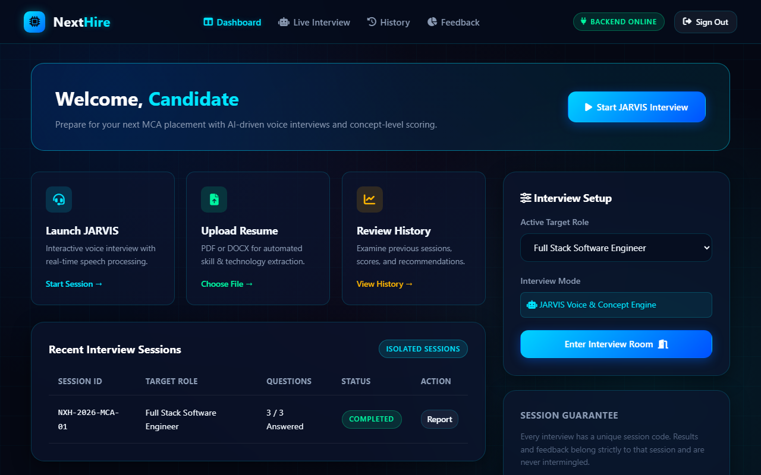

Figure 7.2: Feedback Page
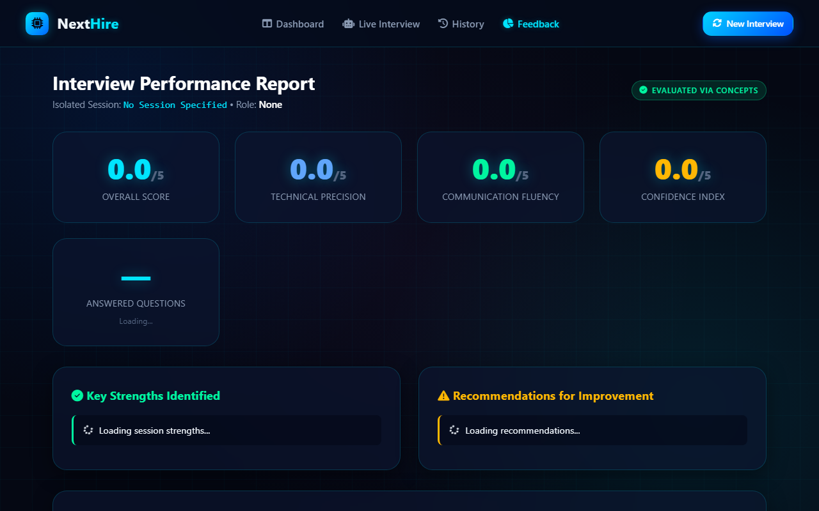

Figure 7.3: History Page
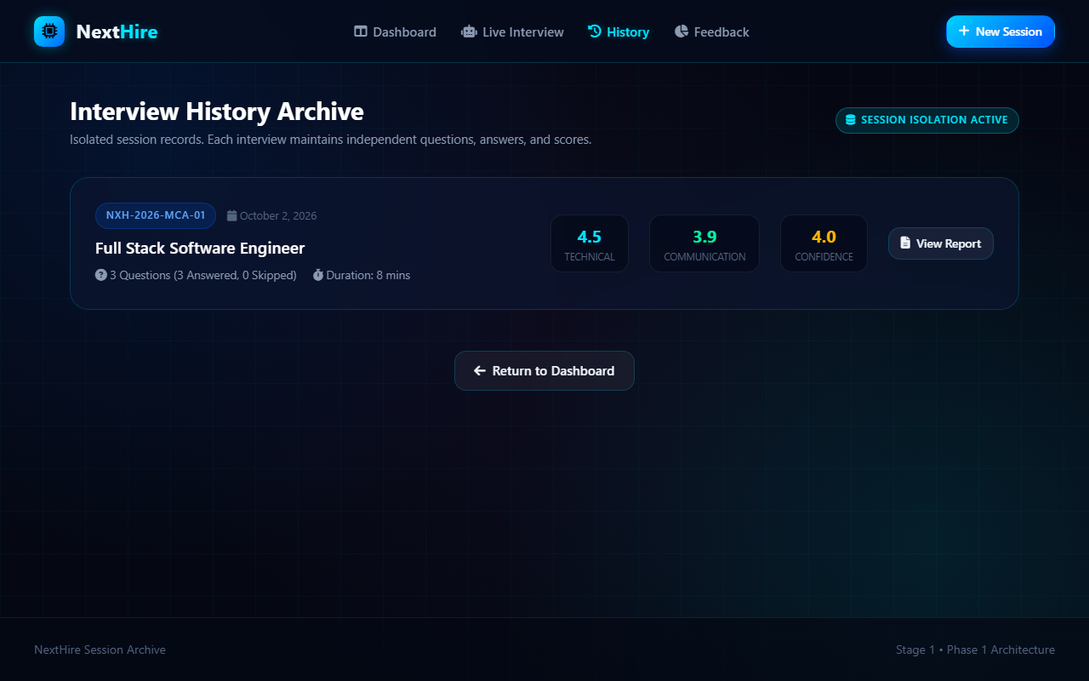

Figure 7.4: Interview Page
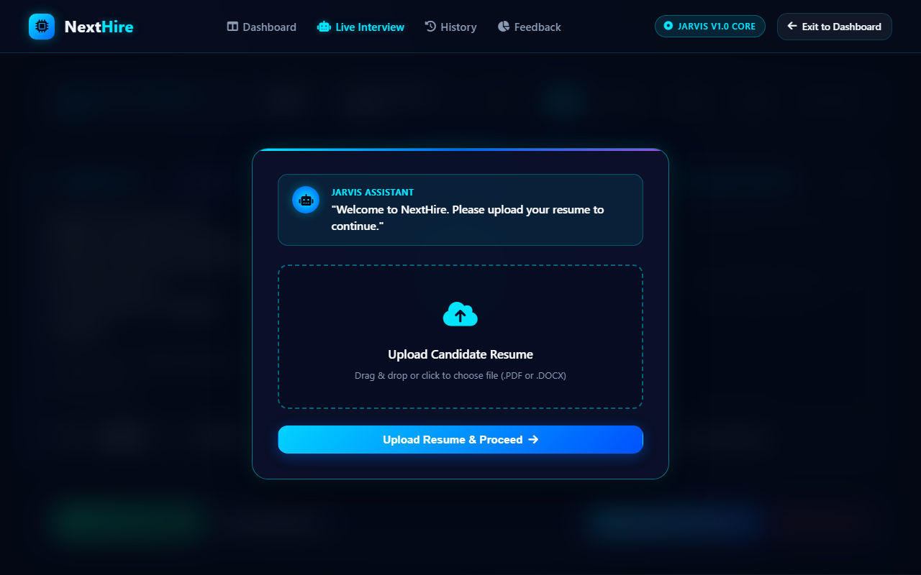

Figure 7.5: Login Page
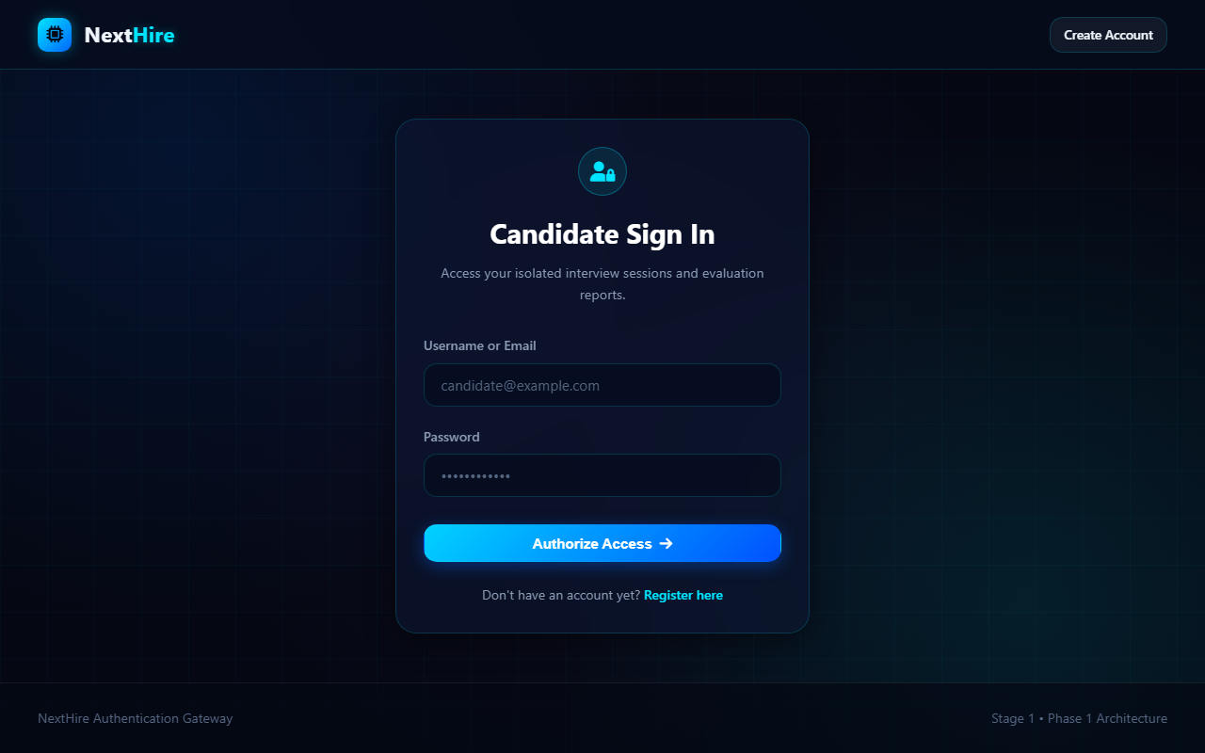

Figure 7.6: Register Page
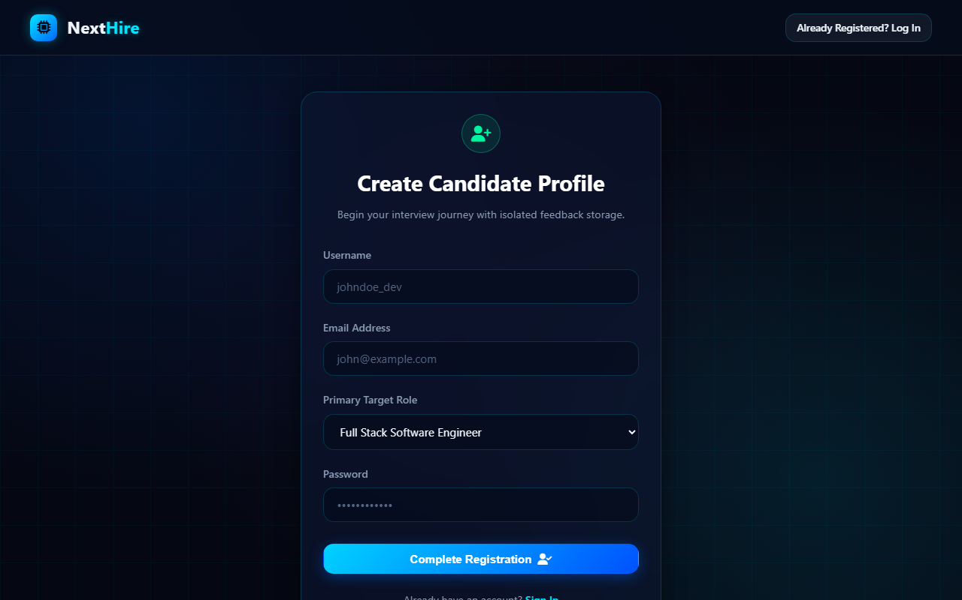

APPENDICES

Appendix: backend/app.py
"""
NextHire - Main Flask Application
Serves REST API endpoints and frontend interface pages.
"""
import os
import sys
from pathlib import Path
# Ensure project root is in sys.path
PROJECT_ROOT = Path(__file__).resolve().parent.parent
if str(PROJECT_ROOT) not in sys.path:
sys.path.insert(0, str(PROJECT_ROOT))
from flask import Flask, send_from_directory, jsonify
from flask_cors import CORS
from backend.config import Config
from backend.routes.api import api_bp
from backend.routes.interview import interview_bp
def create_app():
"""Application factory for NextHire."""
Config.init_app()
app = Flask(
__name__,
static_folder=None
)
app.config.from_object(Config)
# Enable CORS for flexible integration
CORS(app)
# Register API blueprints
app.register_blueprint(api_bp)
app.register_blueprint(interview_bp)
# Static and Page Serving Routes
@app.route("/")
def index():
return send_from_directory(Config.FRONTEND_DIR, "index.html")
@app.route("/login")
def login():
return send_from_directory(Config.FRONTEND_DIR, "login.html")
@app.route("/register")
def register():
return send_from_directory(Config.FRONTEND_DIR, "register.html")
@app.route("/dashboard")
def dashboard():
return send_from_directory(Config.FRONTEND_DIR, "dashboard.html")
@app.route("/interview")
def interview():
return send_from_directory(Config.FRONTEND_DIR, "interview.html")
@app.route("/feedback")
def feedback():
return send_from_directory(Config.FRONTEND_DIR, "feedback.html")
@app.route("/history")
def history():
return send_from_directory(Config.FRONTEND_DIR, "history.html")
@app.route("/css/<path:filename>")
def serve_css(filename):
return send_from_directory(Config.FRONTEND_DIR / "css", filename)
@app.route("/js/<path:filename>")
def serve_js(filename):
return send_from_directory(Config.FRONTEND_DIR / "js", filename)
# Error Handlers
@app.errorhandler(404)
def page_not_found(e):
return jsonify({
"error": "Not Found",
"message": "The requested resource could not be found."
}), 404
@app.errorhandler(500)
def internal_server_error(e):
return jsonify({
"error": "Internal Server Error",
"message": str(e)
}), 500
return app
if __name__ == "__main__":
app = create_app()
print(f"[*] NextHire Server starting on http://127.0.0.1:{Config.PORT}")
app.run(host="0.0.0.0", port=Config.PORT, debug=Config.DEBUG)

Appendix: backend/database.py
"""
NextHire - Database Connection Module
Provides PyMySQL connection management for MySQL 8.x.
"""
import pymysql
from pymysql.cursors import DictCursor
from backend.config import Config
def get_db_connection():
"""
Establish and return a connection to the NextHire MySQL database.
Returns a PyMySQL Connection with DictCursor for dictionary-based rows.
"""
try:
connection = pymysql.connect(
host=Config.DB_HOST,
port=Config.DB_PORT,
user=Config.DB_USER,
password=Config.DB_PASSWORD,
database=Config.DB_NAME,
cursorclass=DictCursor,
autocommit=True,
charset="utf8mb4"
)
return connection
except pymysql.MySQLError as err:
# Provide meaningful error messages for development
print(f"[Database Error] Connection failed to {Config.DB_NAME}@{Config.DB_HOST}: {err}")
raise err
def check_db_health():
"""
Check if the database server is reachable and database exists.
Returns a dict with status and details.
"""
try:
conn = get_db_connection()
with conn.cursor() as cursor:
cursor.execute("SELECT 1 AS alive")
row = cursor.fetchone()
conn.close()
return {"connected": True, "message": "Database is healthy and reachable", "result": row}
except Exception as e:
return {"connected": False, "message": str(e)}

Appendix: frontend/js/jarvis.js
/**
* NextHire - JARVIS Core AI Assistant & Interview Flow Controller
* Implements the exact 5-step preparation workflow:
* Step 1: Resume Upload
* Step 2: Target Role Selection
* Step 3: Resume Analysis & Automated Question Prep
* Step 4: Ready for JARVIS Round (Continue ->)
* Step 5: "Let's Start!" -> JARVIS Vocalization -> First Question
*/
class JarvisAssistant {
constructor() {
this.states = ['IDLE', 'LISTENING', 'THINKING', 'SPEAKING', 'PROCESSING'];
this.currentState = 'IDLE';
this.isRecording = false;
this.synth = window.speechSynthesis || null;
this.recognition = null;
// Active Session State
this.sessionCode = null;
this.targetRole = null;
this.selectedResumeFile = null;
this.questions = [];
this.currentQuestionIndex = 0;
this.timerSeconds = 0;
this.timerInterval = null;
this.initElements();
this.initCanvasWave();
this.initSpeechRecognition();
this.bindEvents();
this.bindWorkflowEvents();
// Start with Step 1 onboarding
this.initSessionWorkflow();
}
initElements() {
this.viewport = document.getElementById('interviewViewport');
this.statePill = document.getElementById('jarvisStatePill');
this.stateLabel = document.getElementById('jarvisStateLabel');
this.subtextEl = document.getElementById('jarvisSubtext');
this.stateButtons = document.querySelectorAll('.state-btn');
this.hudSessionCode = document.getElementById('hudSessionCode');
this.hudTargetRole = document.getElementById('hudTargetRole');
this.qIndexPill = document.getElementById('qIndexPill');
this.qTitle = document.getElementById('qTitle');
this.qCategory = document.getElementById('qCategory');
this.qDifficulty = document.getElementById('qDifficulty');
this.liveTranscript = document.getElementById('liveTranscript');
this.manualInput = document.getElementById('manualAnswerInput');
this.micBtn = document.getElementById('micToggleBtn');
this.audioBars = document.querySelectorAll('.audio-bar');
this.timerEl = document.getElementById('answerTimer');
this.wordCountEl = document.getElementById('wordCount');
this.waveCanvas = document.getElementById('jarvisWaveCanvas');
// Workflow Elements
this.workflowOverlay = document.getElementById('workflowOverlay');
this.workflowStepResume = document.getElementById('workflowStepResume');
this.workflowStepRole = document.getElementById('workflowStepRole');
this.workflowStepAnalysis = document.getElementById('workflowStepAnalysis');
this.workflowStepReady = document.getElementById('workflowStepReady');
this.letsStartBanner = document.getElementById('letsStartBanner');
this.resumeFileInput = document.getElementById('workflowResumeFile');
this.resumeDropZone = document.getElementById('resumeDropZone');
this.fileStatusIndicator = document.getElementById('fileStatusIndicator');
this.fileStatusName = document.getElementById('fileStatusName');
this.btnUploadResume = document.getElementById('btnUploadResume');
this.roleChips = document.querySelectorAll('.role-chip');
this.customRoleContainer = document.getElementById('customRoleContainer');
this.customRoleInput = document.getElementById('customRoleInput');
this.btnConfirmRole = document.getElementById('btnConfirmRole');
this.btnContinueToRound = document.getElementById('btnContinueToRound');
}
/**
* Set JARVIS Assistant State and update visuals
*/
setState(state, customSubtext) {
state = state.toUpperCase();
if (!this.states.includes(state)) return;
this.currentState = state;
if (this.viewport) {
this.states.forEach(s => this.viewport.classList.remove(`jarvis-state-${s.toLowerCase()}`));
this.viewport.classList.add(`jarvis-state-${state.toLowerCase()}`);
}
if (this.stateLabel) {
this.stateLabel.textContent = state;
}
const defaultSubtexts = {
IDLE: 'JARVIS is standing by. Ready for candidate prompt or question playback.',
LISTENING: 'Microphone active. Real-time audio stream analyzing candidate response.',
THINKING: 'Evaluating spoken response against architectural concept benchmarks...',
SPEAKING: 'JARVIS is vocalizing the interview question.',
PROCESSING: 'Aggregating concept coverage, fluency metrics, and semantic score.'
};
if (this.subtextEl) {
this.subtextEl.textContent = customSubtext || defaultSubtexts[state] || '';
}
this.stateButtons.forEach(btn => {
btn.classList.toggle('active', btn.dataset.state === state);
});
if (this.micBtn) {
if (state === 'LISTENING') {
this.micBtn.classList.add('active-recording');
this.micBtn.innerHTML = `<span>⏹ Stop Answering</span>`;
} else {
this.micBtn.classList.remove('active-recording');
this.micBtn.innerHTML = `<span>🎙 Answer with Voice</span>`;
}
}
}
/**
* Speak a phrase aloud using Text-To-Speech with optional callback
*/
speak(text, onEndCallback) {
if (!this.synth) {
if (onEndCallback) onEndCallback();
return;
}
if (this.synth.speaking) {
this.synth.cancel();
}
this.setState('SPEAKING');
const utterance = new SpeechSynthesisUtterance(text);
utterance.rate = 1.0;
utterance.pitch = 1.0;
utterance.onend = () => {
this.setState('IDLE');
if (onEndCallback) onEndCallback();
};
utterance.onerror = () => {
this.setState('IDLE');
if (onEndCallback) onEndCallback();
};
this.synth.speak(utterance);
}
/**
* Initialize Session & Launch Step 1
*/
async initSessionWorkflow() {
try {
const res = await fetch('/api/interview/init', { method: 'POST' });
const data = await res.json();
if (data.success) {
this.sessionCode = data.session_code;
if (this.hudSessionCode) {
this.hudSessionCode.textContent = this.sessionCode;
}
// Show Step 1: Resume Upload
this.showWorkflowStep('workflowStepResume');
this.setState('IDLE', 'Welcome to NextHire. Please upload your resume to continue.');
// JARVIS Speaks Step 1 prompt
setTimeout(() => {
this.speak("Welcome to NextHire. Please upload your resume to continue.");
}, 600);
}
} catch (e) {
console.error('Session init error:', e);
window.NextHire.showToast('Could not initialize interview session.', 'error');
}
}
showWorkflowStep(stepId) {
const steps = [
this.workflowStepResume,
this.workflowStepRole,
this.workflowStepAnalysis,
this.workflowStepReady
];
steps.forEach(step => {
if (step) step.classList.remove('active-step');
});
const target = document.getElementById(stepId);
if (target) {
target.classList.add('active-step');
}
if (this.workflowOverlay) {
this.workflowOverlay.classList.remove('hidden');
}
}
/**
* Bind event handlers for the 5-step onboarding workflow
*/
bindWorkflowEvents() {
// --- STEP 1: RESUME UPLOAD ---
if (this.resumeFileInput) {
this.resumeFileInput.addEventListener('change', (e) => {
if (e.target.files && e.target.files[0]) {
this.handleResumeSelected(e.target.files[0]);
}
});
}
if (this.resumeDropZone) {
this.resumeDropZone.addEventListener('dragover', (e) => {
e.preventDefault();
this.resumeDropZone.classList.add('dragover');
});
this.resumeDropZone.addEventListener('dragleave', () => {
this.resumeDropZone.classList.remove('dragover');
});
this.resumeDropZone.addEventListener('drop', (e) => {
e.preventDefault();
this.resumeDropZone.classList.remove('dragover');
if (e.dataTransfer.files && e.dataTransfer.files[0]) {
this.handleResumeSelected(e.dataTransfer.files[0]);
}
});
}
if (this.btnUploadResume) {
this.btnUploadResume.addEventListener('click', () => {
this.uploadResumeAndProceed();
});
}
// --- STEP 2: TARGET ROLE SELECTION ---
this.roleChips.forEach(chip => {
chip.addEventListener('click', () => {
this.roleChips.forEach(c => c.classList.remove('selected'));
chip.classList.add('selected');
const role = chip.dataset.role;
if (role === 'Custom Role') {
if (this.customRoleContainer) this.customRoleContainer.classList.add('visible');
if (this.customRoleInput) {
this.customRoleInput.focus();
this.targetRole = this.customRoleInput.value.trim();
}
} else {
if (this.customRoleContainer) this.customRoleContainer.classList.remove('visible');
this.targetRole = role;
}
if (this.btnConfirmRole) {
this.btnConfirmRole.disabled = !this.targetRole;
}
});
});
if (this.customRoleInput) {
this.customRoleInput.addEventListener('input', (e) => {
this.targetRole = e.target.value.trim();
if (this.btnConfirmRole) {
this.btnConfirmRole.disabled = !this.targetRole;
}
});
}
if (this.btnConfirmRole) {
this.btnConfirmRole.addEventListener('click', () => {
this.submitRoleAndBeginAnalysis();
});
}
// --- STEP 4 & 5: CONTINUE BUTTON ---
if (this.btnContinueToRound) {
this.btnContinueToRound.addEventListener('click', () => {
this.startJarvisRound();
});
}
}
handleResumeSelected(file) {
const ext = file.name.split('.').pop().toLowerCase();
if (!['pdf', 'docx', 'doc'].includes(ext)) {
window.NextHire.showToast('Invalid file format. Please upload a PDF or DOCX file.', 'error');
return;
}
this.selectedResumeFile = file;
if (this.fileStatusName) this.fileStatusName.textContent = `${file.name} (${(file.size / 1024).toFixed(1

