|  |
| --- |
| Northern Games |
| Space Verse |
| Game Design Document |
| Version #1.0  All work Copyright © 2019 by Northern Games.  All rights reserved. |
| **Pruthvisinh Sodha**  *Student# 300965826* |
|  |

|  |
| --- |
| January 15th , 2019 |

# Table of Contents

### **Version History**

### **Game Overview**

### **Game Play Mechanics**

### **Camera**

### **Controls**

### **Interface Sketch**

### **Menu and Screen Descriptions**

### **Levels**

### **Game Progression**

### **Scoring**

### **Sound Index**

### **Art / Multimedia Index**

### **Future Features**

# Game Overview

A

3 life,

# Game Play Mechanics

A

# Camera

Asteroids has Side View camera.

# Controls

A

# Saving and Loading

A

# Interface Sketch

A

# Menu and Screen Descriptions

A

# Game World

A

# Levels

A

# Game Progression

A

# Characters

A

# Non-player Characters

A

# Enemies

A

# Weapons

A

# Items

A

# Abilities

A

# Vehicles

A

# Script

A

# Scoring

A

# Puzzles/Mini-games

A

# Bonuses

A

# Cheat Codes

A

# Sound Index

Asteroids has 10 different sound effects:

1. Fire Sound Effect
2. Large Flying Saucer
3. Small Flying Saucer
4. Thrust Sound Effect
5. Small Explosion
6. Medium Explosion
7. Large Explosion
8. Extra Player
9. Wavy Beat 1
10. Wavy Beat 2

# Art / Multimedia Index

A

# Design Notes

A

# Future Features

A

# Version History

1. 29-09-2017 Created Basic Structure.
2. 05-10-2017 Completed Contents.

# Game Overview

Game contains multiple rows of bricks on the top, a ball and a paddle which can be moved left or right at the bottom. A ball move downwards and is needed to be hit on the paddle which bounces the ball and destroying the bricks at the top. When a brick is eliminated, the ball moves back to down side. If the player misses the ball touching the paddle five times, he or she loses the game. If all the bricks are destroyed, player wins the game.

# Game Play Mechanics

Initially, Game starts as the ball starts to fall down side. Player need to make the ball touch the bottom paddle and doesn’t not allow it to pass it. When the ball touches the paddle, it bounces upwards to hit the bricks. There are eight rows of bricks with each of different rainbow colors. Player can miss the paddle maximum of five times, after which he loses the game. If all the bricks at the top are destroyed, player wins the game.

# Camera

Breakout has Side point of view.

# Controls

Atari CX30-04 paddle were mainly used as controller for Breakout in Atari 2600.

Physical Paddle on the controller was rotated to move the bat or paddle on the game screen.

# Interface Sketch

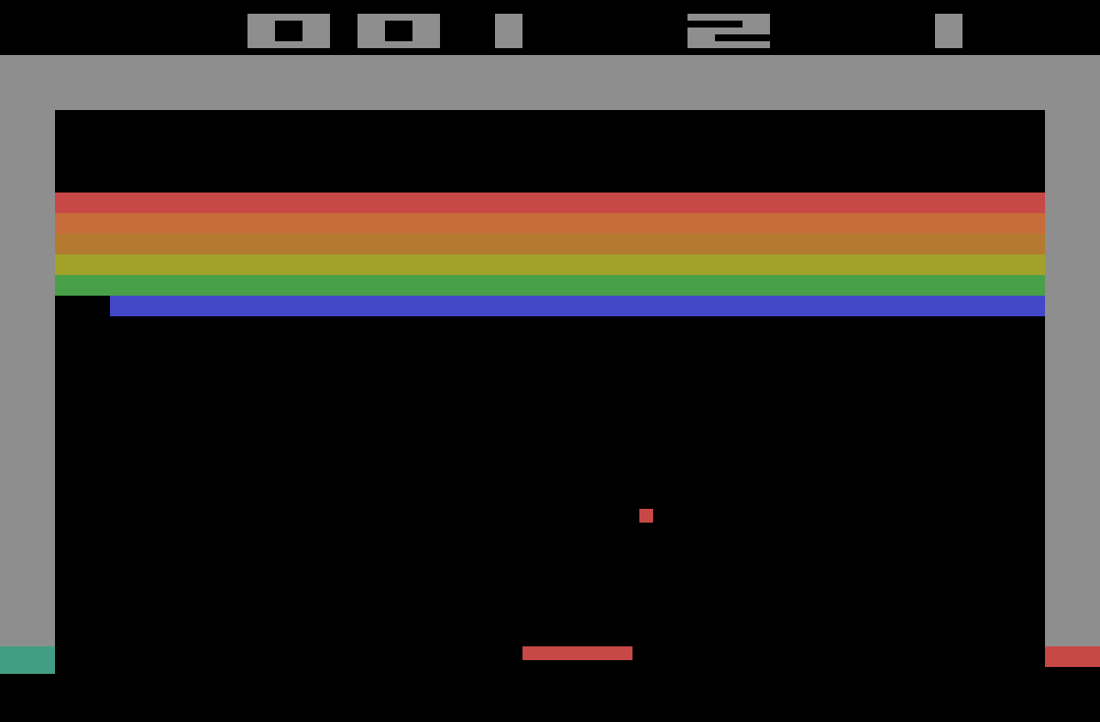

# Menu and Screen Descriptions

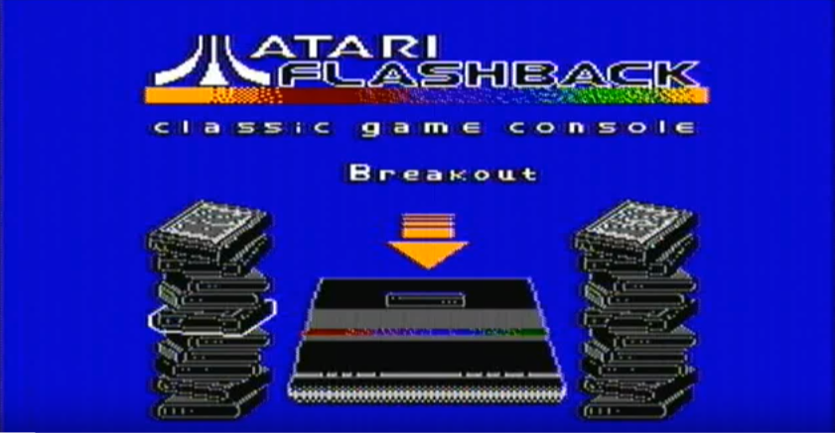

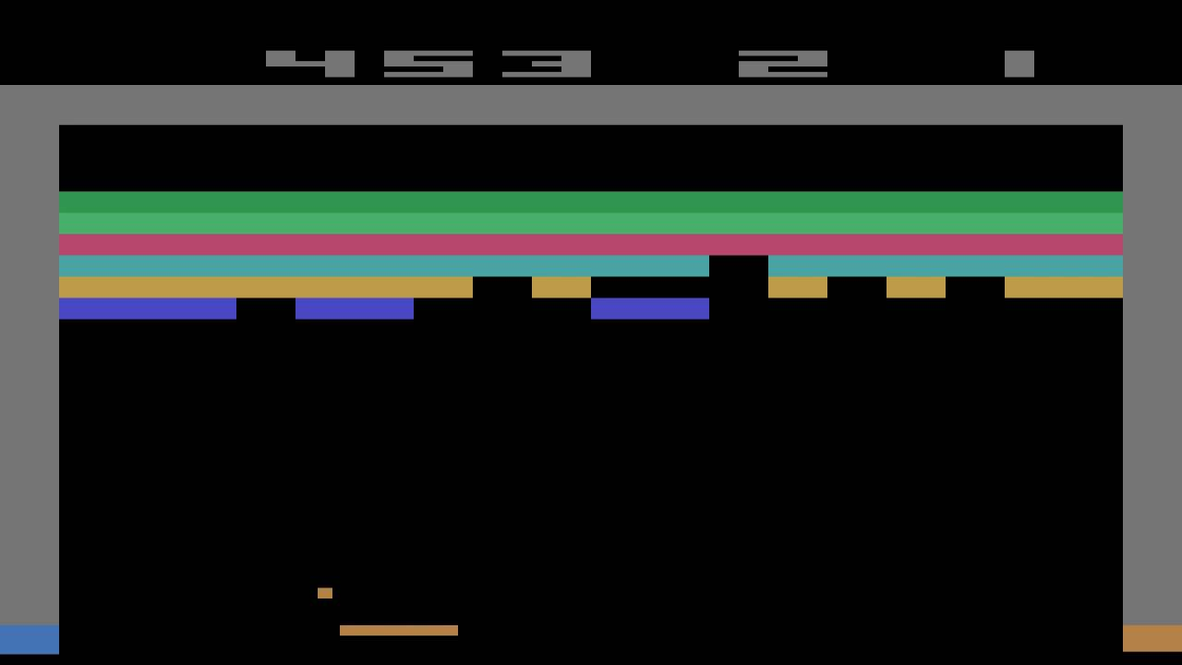

Top Menu contains 3 elements:

1. Score
2. Life
3. Number of Players

# Levels

Breakout has two same levels. Once a level is cleared, player is provided a new same level.

# Game Progression

As the ball hits the brick, the speed of the ball increases. Once ball misses the bottom paddle, new ball again starts with a slow speed.

# Scoring

First two bottom rows of brick gives 1 point to the player (Blue and Light Green brick).

Third and fourth row provides 4 points for each brick eliminated.

Fifth row gives 6 points.

Top level bricks earn 7 points.

A player can make maximum of 448 points in each level, making the highest score as 896.

# Sound Index

Breakout included two main sound clips:

1. When the ball touches the brick.
2. When the ball touch the side wall or the paddle.

# Art / Multimedia Index

Four coloured bricks

Paddle

Ball

Top Menu

# Future Features

Addition of more visually appealing effects when ball collides with the brick. Ripple effects when ball touches the paddle.

Addition of more level which increases ball speed from initial stage itself.

Improvement in graphic of game elements, including top menu.