# Software Requirements Specification

# for

# TEMPORARY JOB PORTAL

# Version 1.0 approved

Prepared by K.PRUTHVI(18CS10024)

12TH FEBRUARY 2020

Table of Contents

Table of Contents ii

Revision History ii

1. Introduction 1

1.1 Purpose

1.2 Intended Audience and Reading Suggestions 1

1.3 Product Scope 1

2. Overall Description 2

2.1 Product Perspective 2

2.2 Product Functions 2

2.3 User Classes and Characteristics 2

2.4 Operating Environment 2

2.5 Design and Implementation Constraints 2

2.6 User Documentation 2

2.7 Assumptions and Dependencies 3

3. External Interface Requirements 3

3.1 User Interfaces 3

3.2 Hardware Interfaces 3

3.3 Software Interfaces 3

3.4 Communications Interfaces 3

4. System Features 4

4.1 System Feature 1 4

4.2 System Feature 2 (and so on) 4

5. Other Nonfunctional Requirements 4

5.1 Performance Requirements 4

5.2 Safety Requirements 5

5.3 Security Requirements 5

5.4 Software Quality Attributes 5

5.5 Business Rules 5

6. Other Requirements 5

Appendix A: Glossary 5

Appendix B: Analysis Models 5

Appendix C: To Be Determined List 6

Revision History

|  |  |  |  |
| --- | --- | --- | --- |
| **Name** | **Date** | **Reason For Changes** | **Version** |
|  |  |  |  |
|  |  |  |  |

# Introduction

## Purpose

A job portal will be useful to many people who are looking for a job and earn money. The purpose of this document is to explain features, process and the constraints by which this software development proceed, so that it will be easy for anyone to read and understand the process.

## User and Reading Suggestions

This document is intended to assist the users when they use the software and for developers and the project managers to plan their project and implement the software required. This Software Requirement Specification document is divided into five subsections.

Section 1: Introduction

Section 2: Overall Description of the Software giving information about functions, user classes, operating environment, constraints and documentation.

Section 3: External Interface Requirements giving a brief introduction to user, hardware, software and communications interfaces.

Section 4: Gives functional requirements of different features.

Section 5: Provides a list of non-functional requirements

Section 6: Other requirements

## Product Scope

The aim of this project is to design a temporary job portal where users can seach and apply for jobs.

companies can post their required job qualifications to find people suitable for that job. Job seekers can search for a job according to salary.Companies can post jobs with specific information to applicant.this website asks for 100/- for applying for a job.

# Overall Description

## Product Perspective

This job portal makes people find jobs easily according to their qualification.

This product even makes companies easier for finding their employee with a required specification.

## Product Functions

**Job seeker:**

* Sign in
* Save job
* Search jobs.
* Applying for job

**Job provider:**

* Sign in
* Change username/password.
* Upload jobs.
* Accept(call for interview)/reject people applied for a job

.

## User Classes and Characteristics

* Job seeker: job seeker means person who is interested to do a job.They must have a login account to access this portal.
* Job provider:job provider means person who offers a job.They must have their login account.
* Customer care: group of persons helping job seekers with their problems.

## Operating Environment

**Operating System**: Windows 7,8, 8.1, 10

**Language:** Java

Whole system should be given by internet connection.

## Design and Implementation Constraints

* Only language used in the implementation of this software is English.
* Any person is allowed to create his/her login account and register themselves on this portal.
* A company must have an account to post their jobs in this portal.
* Any user who wants to have an account on this portal must have an email.
* Only registered(who have an account) persons can apply for jobs.

## User Documentation

* License and User Manual will be provided along with the software.

## Assumptions and Dependencies

* Active Internet Connection.
* A desktop system or a cell phone to work on.
* User knows English language.

# External Interface Requirements

## User Interfaces

There will exist an interactive Graphical User Interface. Text boxes and button events will be created where ever possible. All errors to be displayed using dialog boxes. All the main menu and settings options such as account settings etc. will always be available to the user. Most of the button events will have additional selections to be made, this will be done through an interactive dialog box.

## Hardware Interfaces

Desktop or Mobile on which the user uses.

## Software Interfaces

The graphical user interface will be constructed using HTML5 and CSS and javascript.

The Backend will be made using java.

## Communications Interfaces

The communication interfaces include e-mail and web browser. E-mail is required for carrying out the necessary communications with the user and the web browser is required to send the notifications to the user.

# Functional requirements

**4.1 FUNCTION – REGISTRATION**

**4.1.1 FUNCTION--Registration(creating account)for job seeker**

**INPUT:**

* His/Her full name.
* His/Her gender.
* His/Her address.
* His/Her age.
* His/Her phone number.
* His/Her email address.
* Username and password.

**OUTPUT:** succesfull or unsuccesfull.

**JUSTIFICATION:** used to register a new job seeker.

**4.1.2 FUNCTION-registration for job provider**

**INPUT:**

* Employer name
* Employer post
* Company name
* Company address
* Working aim of the company
* email id
* username and password

**OUTPUT:** succesfull or unsuccesfull

**JUSTIFICATION:** used to register a new job provider.

**4.2 FUNCTION- sign in**

**INPUT:**

* Username.
* Password.

**OUTPUT:** succesfull or unsuccesfull.

**JUSTIFICATION:** used to make a registered user to do his task.

**4.3 FUNCTION- search option for job seeker**

**INPUT:**

* Search by location
* Search by job title.
* Search by salary.

**OUTPUT:**results to the related search.

**JUSTIFICATION:**used to search for jobs on various factors.search bar will be present on top of the webpage.

### 4.4 FUNCTION—Apply for job

**INPUT:**  click apply on a job

**OUTPUT:** if profile is complete(all colums filled) screen will be directed to payment screen. Or page will be redirected to profile

### 4.6 FUNCTION-- job posting on portal by job provider

**INPUT:**

* provide job category.
* provide job title.
* job timings.
* provide location of the job
* provide salary for the job.
* provide qualification for the job.
* Provide required experience for the job.
* Provide description of the job.

**OUTPUT:** Job will be posted on the portal which will be available for all job seekers to apply for it.apply button will be present below the job name on the portal.

**JUSTIFICATION:** used for uploading a job on the portal by job provider.

## 4.7 FUNCTION- update profile(for job seekers)

**4.7.1—FUNCTION – Upload Qualification.**

**INPUT-**  qualifications.

**OUTPUT-** returns to the profile page

**4.7.2—FUNCTION – Upload skills**

**INPUT-**  skills

**OUTPUT-** returns to the profile page

**4.7.3—FUNCTION – Upload information**

**INPUT-**  name, email,phone number

**OUTPUT-** returns to the profile page

**4.8 FUNCTION- inbox(for job providers)**

**OUTPUT:** details of all the persons who have applied for the job.

**4.9 FUNCTION –JOB APPROVAL**

**INPUT:** selecting a job posted by the company

**OUTPUT:** job will be approved.

**JUSTIFICATION:** to approve a job and post it on the poratal.

**4.10 FUNCTION – ADD COMPAINT**

**INPUT:** Txt messege of a complain.

**OUTPUT :** complain successfully sent.

**4.11 FUNCTION – record of jobs applied**

**OUTPUT -**  list of all the jobs job seeker has applied for.

**4.12 Function – save job(by job seeker)**

**OUTPUT –** saves job;

**4.13 FUNCTION – edit job details(job provider)**

**OUTPUT-** we can edit details of the job

# Other Nonfunctional Requirements

## Performance Requirements

* The job seekers are provided with the details of the company but not vice-versa.
* The performance of the program varies due to number of factors like active internet connection, hardware.

## Safety Requirements

* We are not responsible for any false information provided by the job seeker or by the job provider.

## Security Requirements

The application software will have secure password authentication and will prevent illegal access to user accounts.

## Software Quality Attributes

**Maintainability**

Different versions of the product should be easy to maintain. For development it should be easy to add code to existing system, should be easy to upgrade for new features and new technologies time to time. Maintenance should be cost effective and easy.

**Usability**

This can be measured in terms of ease of use. Application should be user friendly. Should be easy to learn. Navigation should be simple.

**Flexibility**

Should be flexible enough to modify. Adaptable to other products with which it needs interaction. Should be easy to interface with other standard 3rd party components.

## Business Rules

The software should not be used without any prior permission or agreement. All the rights will be held by the developing organization. In case of any issue or bugs the user should contact the project manager.

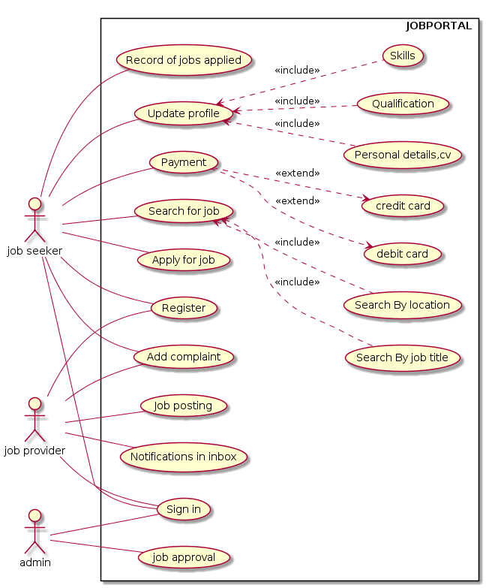

USE CASE DIAGRAM

SEQUENCE DIAGRAMS

