--->

Name:PRUTHVI RAJ MUTHYAM

Last 4 digits ID:0715

Computer IP address:

CSE 6331, Cloud Computing

Quiz Q6, Spring 2018 (c) DL, UTA, 2018

C&P means cut and paste only those relevant lines from your program(s) into this quiz.

Summary: initial bottom question 1, rename this as described in question 3, show functionality

through web interface of cloud implementation. Read (entire) quiz before writing.

1. I understand that I am on my honor during this quiz, I will not collaborate, use

non-allowed sources, and I will not discuss or share this quiz with anyone for the next

4 hours.

You MAY: use Google to search, use previous source code,

YOU MAY NOT use:

Email, Facebook, Hangouts, IM, chats, Skype or ANY other human connection.

This is a timed test. Late tests will have points deducted for being late.

Very late tests will not be graded.

When you are complete, with any part, please raise your hand, so we may visually inspect that part.

The second part of the test, you should electronically submit, you will need to copy and paste

only those lines of code to implement that part of the test, usually a few (two to eight) lines of code.

Place it immediately after the question.

Submit this Quiz (renamed) with code cut and pasted, ONLY text. DO NOT submit zips, binaries, libraries,

or anything other than text.

When any parts(questions) are complete, submit this test, you may make multiple submissions.

If you have computer, or other, problems, please raise your hand immediately.

--->

If you understand and agree, please initial here:

_________PM________

2. Get files from this same folder.

3. Name your program with your name and last digits of your ID.

4. The cloud provider is either MicroSoft Azure or AWS, your choice, all functionality possible

should be implemented on that provider.

(Of course, displaying web pages through a browser and the user interface is "local")

Please show a web page and interface (which resides on the cloud provider) with your name and

student ID in large font at the top of every web page displayed (for this quiz)

<h2 style = "text-align: center">PRUTHVI RAJ MUTHYAM</h2>

<h2 style = "text-align: center">1001400715</h2>

5. You will create two, seperate instances, on the cloud service provider. One is a producer (P)

the other is a consumer (C). Each will have it's own name/address.

The P instance will Produce an entry into a DB table of it's time and address (or name).

The consumer (C) will read that and display that information as well as it's address/name and

it's time on a web interface to a user.

Show and submit code for the following:

6. Create P which writes every 2 seconds. Create C which reads every 5 seconds. Show us your instances running.

-> show us, put code here

cursor = myConn.cursor()

addr = '13.91.121.2'

time = strftime("%Y-%m-%d %H:%M:%S", gmtime())

sqlq = "INSERT INTO producer (address, time) VALUES (%s,%s)"

cursor.execute(sqlq,(addr,time))

myConn.commit()

cursor.close()

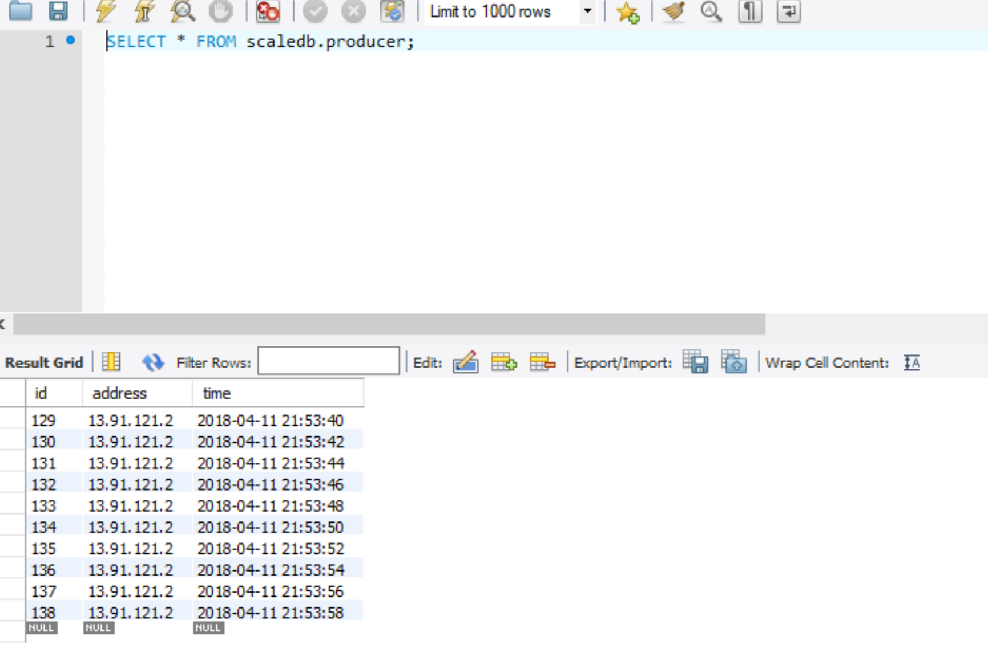

**Consumer**

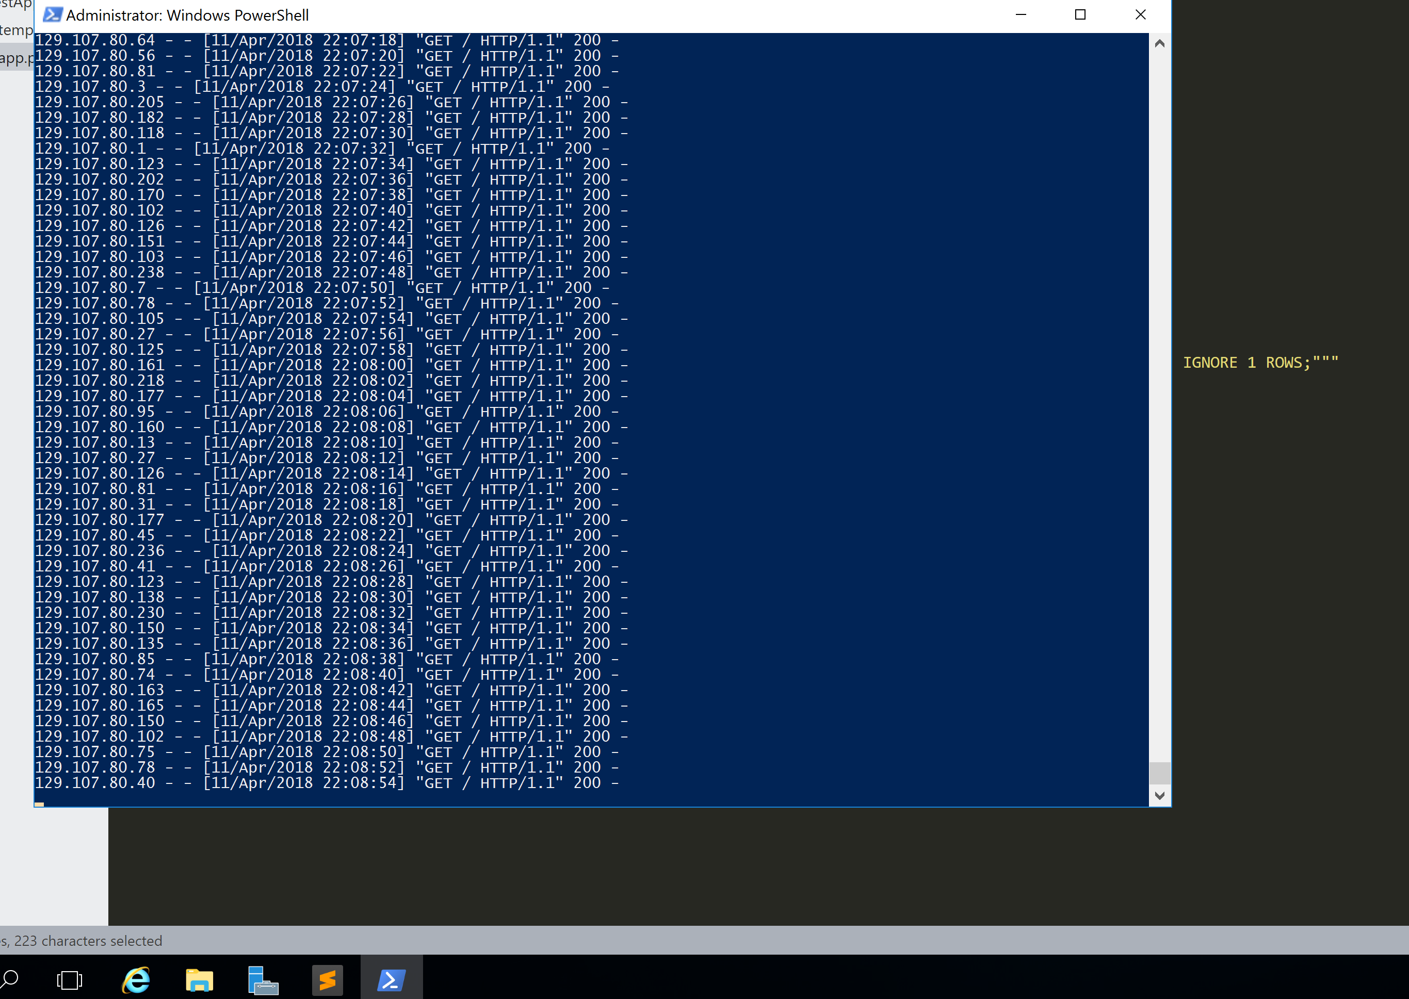

cursor = myConn.cursor()

query2 = "Select * from producer limit 5"

cursor.execute(query2)

data = cursor.fetchall()

cursor.close()

return render_template('index.html',data = data)

7. Modify C to accept requests from jmeter (or similar) we will give you number of users (or threads),

show us that C accepts requests, allow us to change the rate which C accepts requests (not always 5 seconds)

and show us C running.

-> show us, put code here

8. Create multiple instances of C, automatically, up to 3 in total, where the traffic exceeds a threshold

(which you may set).

-> show us, put code here

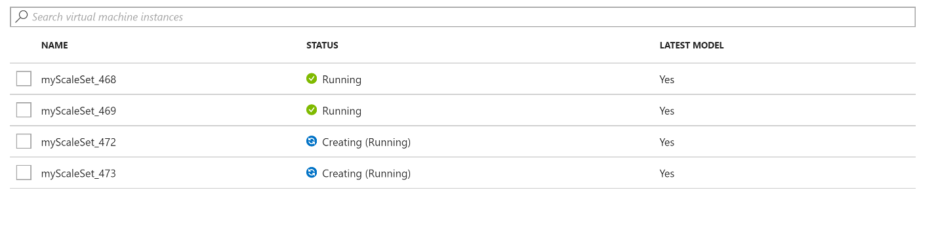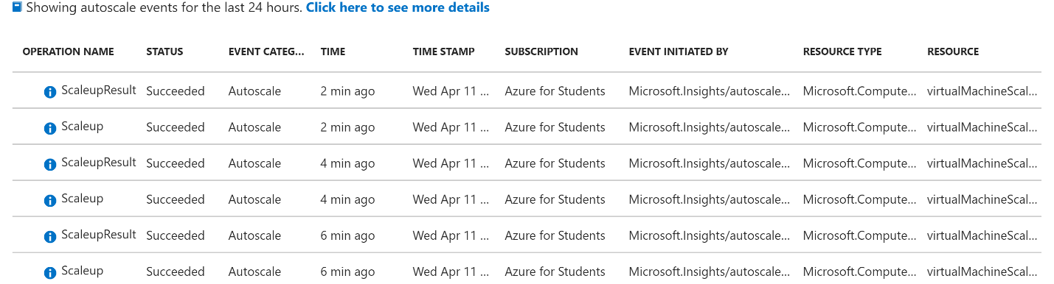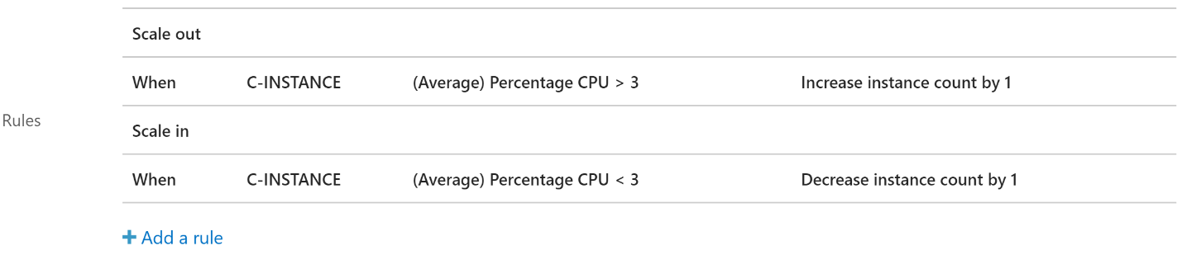

Done. When complete, return (send) this quiz

If you finish early, send this immediately, otherwise send between

the end of class and no more than 1 minute after that.