**Ordering System**

Ordering System

The new system is designed so that the user can place orders for the auto parts of his choice available in the database from the comfort of his couch. The user needs to provide few details and his credit card information when he decides on what to buy from the company. An admin is assigned who sets the shipping and handling charges for the auto parts ordered. When the credit card details are authorized. The company ships the auto parts to the customers. The warehouse worker controls the packing and shipping of the auto parts.

The additional feature we are adding to the system is that, the customers can register with our system and then all his details are saved in the system and the user can purchase auto parts from the system without having to provide his and credit card details all the time.

Actor Dictionary

|  |  |  |
| --- | --- | --- |
| Actor | Description | Use case(s) |
| Internet Customers | Internet customers can view, select and order auto parts from catalogue of the website. | Buy auto parts online Sign-up |
| Warehouse worker | Warehouse worker prints packing lists, retrieves items, packs them up and adds invoice and shipping label. Warehouse worker also adds newly received auto parts to the inventory. | Deliver auto parts Maintain Inventory |
| Credit card authorization | Authorizes credit card details provided by the customer for purchasing auto parts. | Buy auto parts online. |
| Product Database | Maintains information about the auto parts available in the inventory. | Buy auto parts online Maintain Inventory |
| Admin | Sets shipping and handling charges of the ordered auto parts. | Pricing |

Use Case Diagram

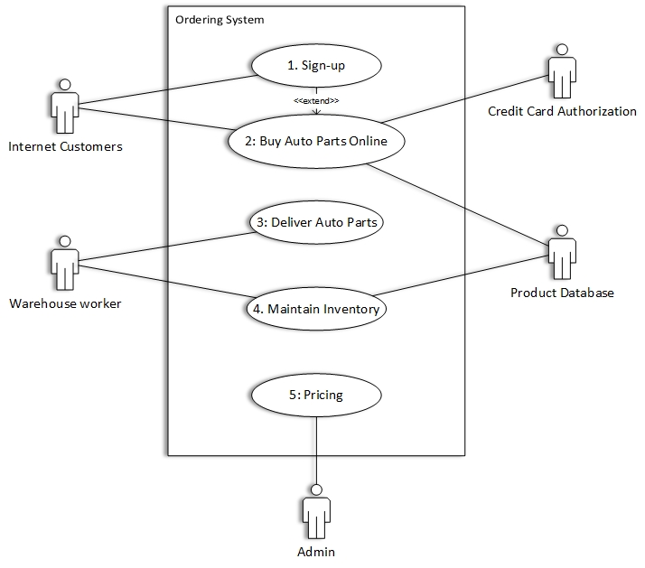

## Use Case Specification

|  |  |
| --- | --- |
| Name | Sign-up |
| id | 1 |
| Scope | Ordering system |
| Priority | High |
| Summary | Internet Customer creates account by signing up, so profile is maintained by the system. |
| Primary Actor | Internet Customer |
| Supporting Actor(s) |  |
| Stakeholders |  |
| Generalization |  |
| Include |  |
| Extend | Extends “Buy Auto Parts Online” use case. |
| Precondition | Internet Customer has an option to create account |
| Trigger |  |
| Normal Flow | 1. Internet Customer enters details to sign-up |
| Sub-Flows | 1. Internet Customer details are updated in system |
| Alternate Flow/Exceptions | 1. Internet Customer provides details already in use 2. Internet Customer provides invalid details |
| Post condition | Internet Customer is registered on the system |
| Open Issues |  |
| Source |  |
| Author | Author |
| Revision and Date | 1.0 and 2-24-2015 |

## Use Case Specification

|  |  |
| --- | --- |
| Name | Buy auto parts online |
| id | 2 |
| Scope | Order System |
| Priority | High |
| Summary | Customer views catalogue and orders desired quantity of auto parts |
| Primary Actor | Internet customers |
| Supporting Actor(s) | Product Database, Credit card authorization |
| Stakeholders |  |
| Generalization |  |
| Include |  |
| Extend |  |
| Precondition | Website is working |
| Trigger | Internet customer enters Website address in address bar. |
| Normal Flow | 1. Internet Customer views auto parts in catalogue of the Product Database. 2. Internet Customer orders auto parts of desired quantity from the Product Database. 3. Internet Customer enter credit card information to Credit card authorization. |
| Sub-Flows | 1. Internet customers provide name and mailing address to the system. 2. Internet Customer can alter quantity of his order. 3. The system computes the total price, adds shipping, handing charge and tax and displays cost to the Internet customer |
| Alternate Flow/Exceptions | 1. Internet customer is shown error message when his credit card details are not authorized by Credit card authorization. |
| Post condition | Website homepage is displayed |
| Open Issues |  |
| Source |  |
| Author | Team 11 |
| Revision and Date | 1.0, 2-24-2015 |

## Use Case Specification

|  |  |
| --- | --- |
| Name | Deliver auto parts |
| id | 3 |
| Scope | Ordering system |
| Priority | High |
| Summary | The warehouse worker packs the orders and ships them to the Customers. |
| Primary Actor | Warehouse worker |
| Supporting Actor(s) |  |
| Stakeholders |  |
| Generalization |  |
| Include |  |
| Extend |  |
| Precondition | Internet customer places the order for the auto parts. |
| Trigger | Warehouse worker receives orders. |
| Normal Flow | 1. Warehouse worker prints the packing lists for completed orders. 2. Warehouse worker retrieves the auto parts from the ware house. 3. Warehouse worker packs the auto parts to be shipped. 4. Warehouse worker adds invoice and shipping label to the auto parts to be shipped. |
| Sub-Flows | 1. The order status is updated. |
| Alternate Flow/Exceptions | 1. Warehouse worker does not receive order list. |
| Post condition | Auto parts ready to be shipped to Customers |
| Open Issues |  |
| Source |  |
| Author | Author |
| Revision and Date | 1.0, 2-24-2015 |

## Use Case Specification

|  |  |
| --- | --- |
| Name | Maintain Inventory |
| id | 4 |
| Scope | Ordering system |
| Priority | High |
| Summary | Warehouse worker maintains the Auto parts inventory. |
| Primary Actor | Warehouse worker |
| Supporting Actor(s) | Product Database |
| Stakeholders |  |
| Generalization |  |
| Include |  |
| Extend |  |
| Precondition | New auto parts sent to the Inventory |
| Trigger | Products delivered to receiving desk. |
| Normal Flow | 1. The Warehouse workers receives new auto parts at receiving desk.   1. The Warehouse worker adds the items to the inventory. 2. The Warehouse worker records the event. |
| Sub-Flows | 1. Quantity on hand is updated on the Product Database. |
| Alternate Flow/Exceptions |  |
| Post condition |  |
| Open Issues |  |
| Source |  |
| Author | Author |
| Revision and Date | 1.0 and 2-24-2015 |

## Use Case Specification

|  |  |
| --- | --- |
| Name | Pricing |
| id | 5 |
| Scope | Ordering system |
| Priority | High |
| Summary | Admin sets the shipping and handling charges for the auto parts ordered. |
| Primary Actor | Admin |
| Supporting Actor(s) |  |
| Stakeholders |  |
| Generalization |  |
| Include |  |
| Extend |  |
| Precondition | Internet Customer makes a selection and orders auto parts. |
| Trigger |  |
| Normal Flow | 1. Admin sets shipping and handling charges. |
| Sub-Flows |  |
| Alternate Flow/Exceptions |  |
| Post condition | Admin receives list of orders. |
| Open Issues | Local tax rate? (may vary) |
| Source |  |
| Author | Author |
| Revision and Date | 1.0 and 2-24-2015 |