AI ASSISTED CODING
LAB-03
Name: J.Pruthvi raj
Batch:42
Hll.no:2303A52181

Lab 3: Application for TGNPDCL – Electricity Bill Generation Using Python & AI Tools
Task 1: Reading Consumer Details
Objective:
To read consumer details and calculate the units consumed.
AI Prompt Used:
"Generate Python code to read previous units, current units and calculate units consumed"
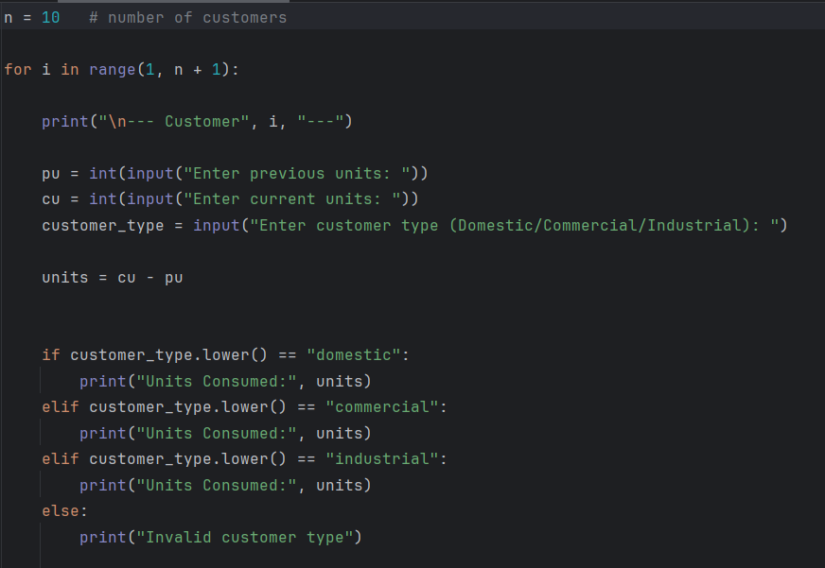
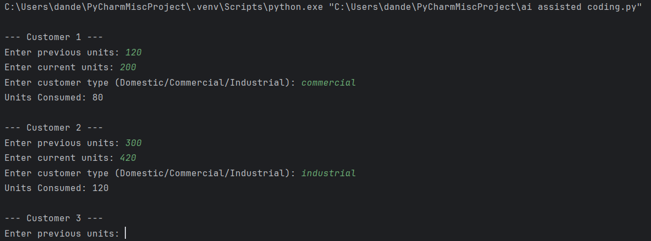
Task 2: Energy Charges Calculation Based on Units Consumed
Objective
To calculate energy charges based on units consumed and customer type.
AI Prompt Used
"Simplify energy charge calculation logic using if-else conditions"
Logic Explanation
Energy charges are calculated using conditional statements based on customer type:
- Domestic: ₹5 per unit
- Commercial: ₹8 per unit
- Industrial: ₹10 per unit
Code:
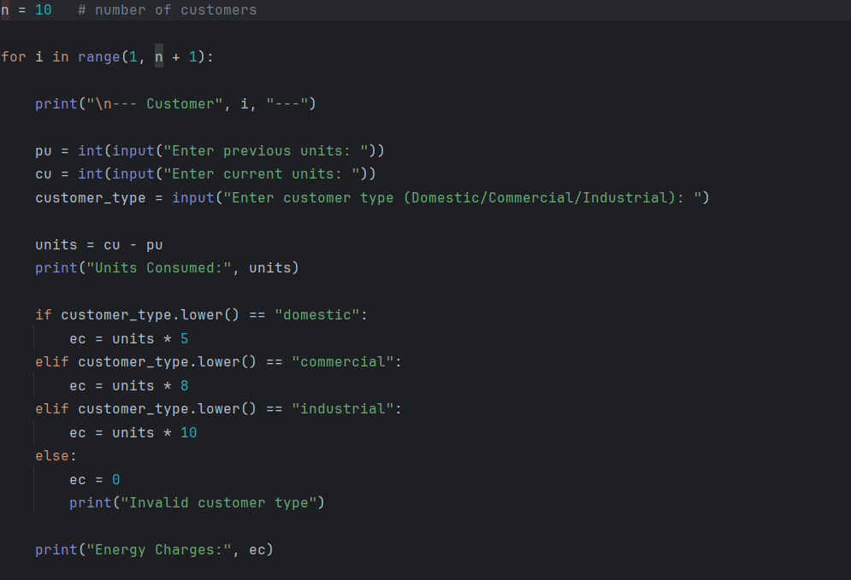
Output:
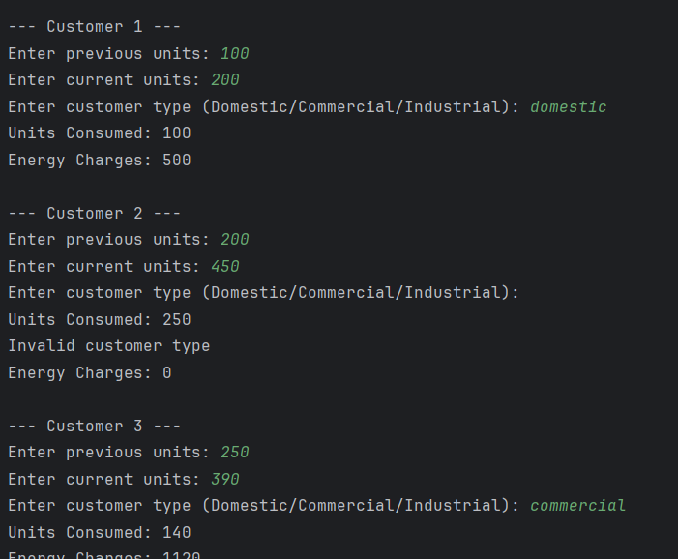
Task 3: Modular Design Using Functions
Objective
To improve code readability and reusability using functions.
AI Prompt Used
"Create a Python function to calculate energy charges based on units and customer type"
Logic Explanation
A user-defined function is used to calculate energy charges. This makes the program modular and easy to maintain.
Code:

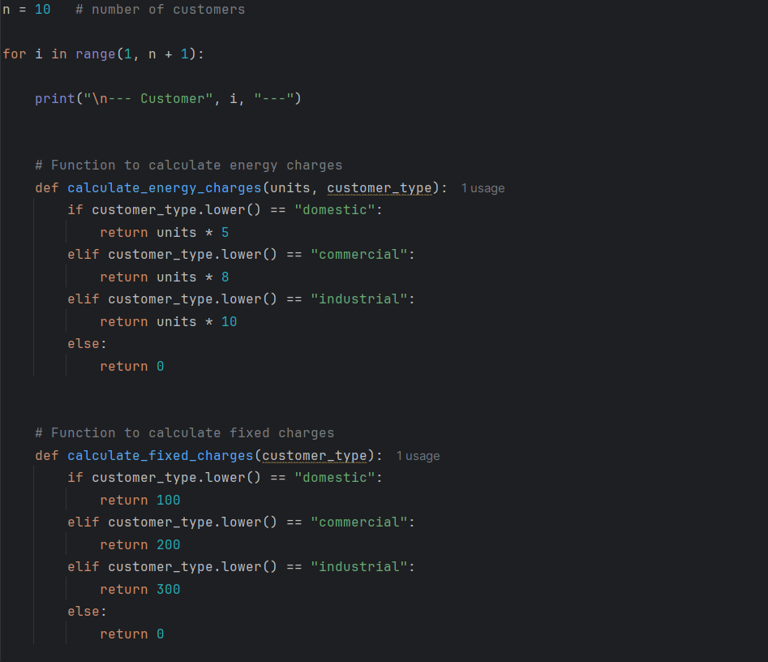

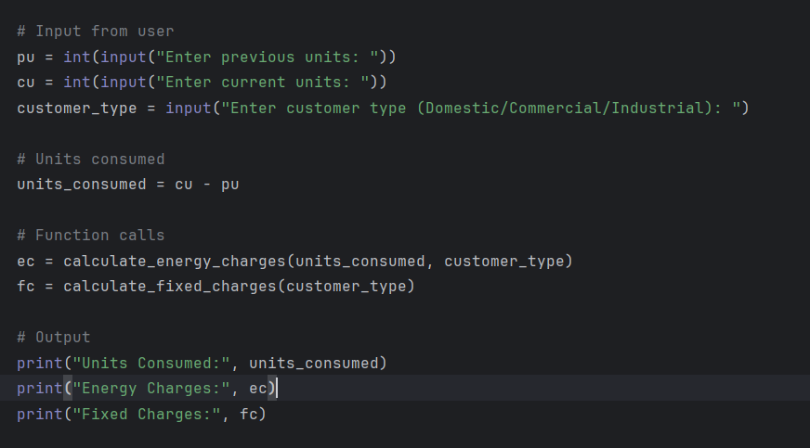
Output:
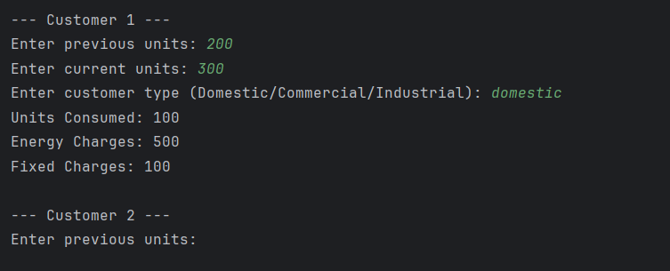

Task 4: Calculation of Additional Charges
Objective
To calculate fixed charges, customer charges and electricity duty.
AI Prompt Used
"Add electricity duty and fixed charges calculation to the program"
Logic Explanation
Additional charges include:
- Fixed Charges (FC): ₹100
- Customer Charges (CC): ₹50
- Electricity Duty (ED): 5% of Energy Charges
Code:
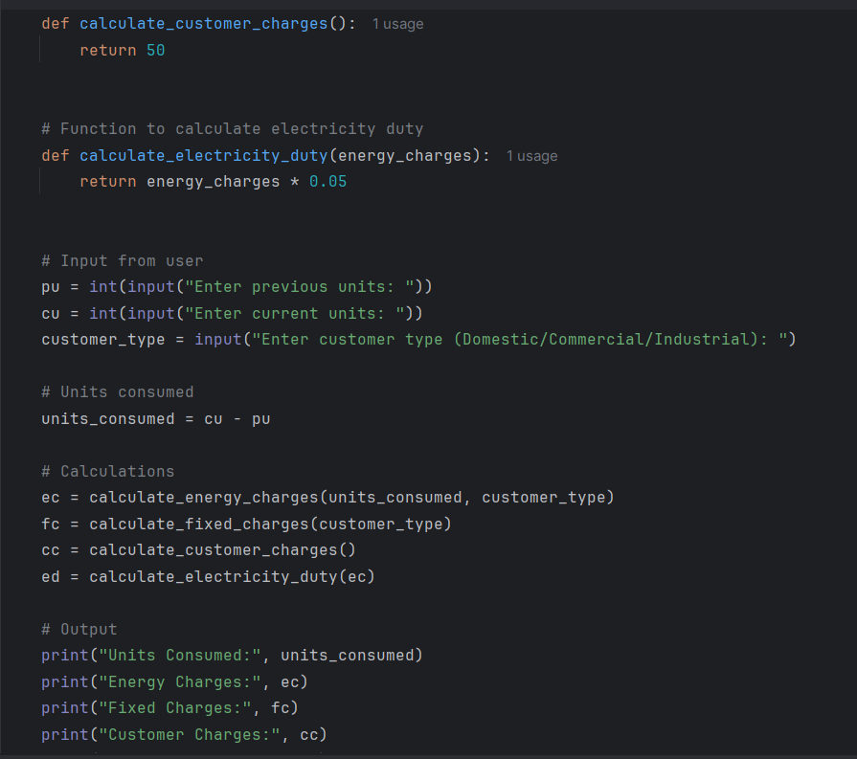
Output:
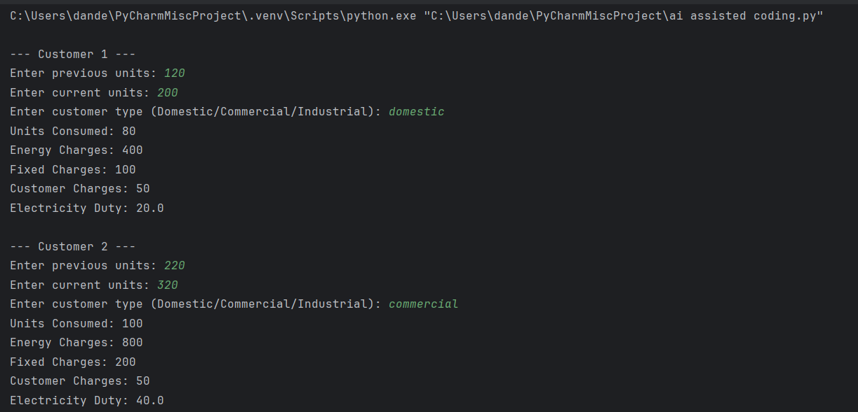
Task 5: Final Bill Generation
Objective
To calculate and display the final electricity bill.
Logic Explanation
The total bill amount is calculated by adding all charges.
Formula
Total Bill = EC + FC + CC + ED

Code:
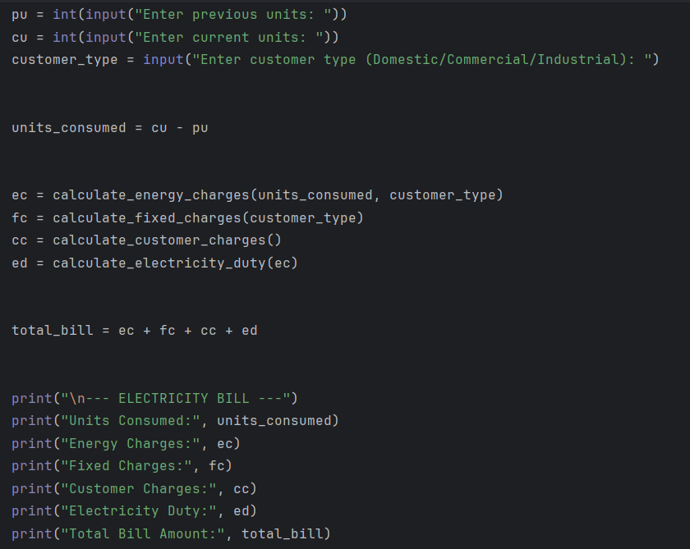
Output:
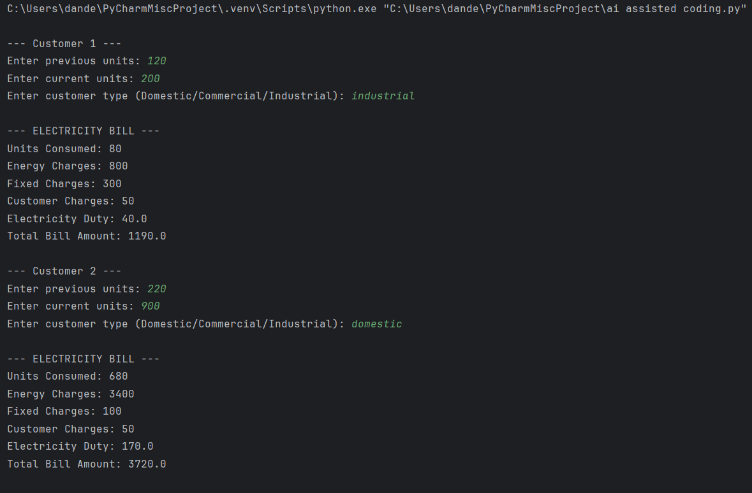
Analysis
The electricity billing application accurately calculates charges using conditional logic and modular programming. AI-assisted prompts helped in optimizing the logic and improving readability. The program closely resembles real-world electricity billing systems and is easy to extend for future enhancements.

Conclusion
This lab helped in understanding how Python and AI tools can be used to build real-world applications. The implementation of functions and conditional logic improved coding efficiency and clarity.

