**VEHICLE INSURANCE DATABASE**

Prepared by:

**DBMS(CS310)**

**Group-1:**

Akash Chaurasiya(20bcs001) Devansh Mahant (20bcs039)

Abhishake Dubey(20bcs002) Tushar Dhotre(20bcs042)

Aditya Tiwari(20bcs007) Anup Jujagar(20bcs065)

Ankit Kumar(20bcs017) Kartik Bhamare (20bcs064)

Mahendra Puniya (20bcs088) Pruthviraj Kamble (20bcs104)

**Under the Guidance of**

**Dr. Uma Seshadri,**

Professor,

HOD, Department of Computer Science

Indian Institute of Information Technology Dharwad

**Dr. Pramod Yelmewad**

Assistant Professor, Department of Computer Science

Indian Institute of Information Technology Dharwad

**Dr. Supriya Nadiger**

Assistant Professor, Department of Computer Science

****Indian Institute of Information Technology Dharwad

**Acknowledgement**

We would like to sincerely and profusely thank Dr Pramod Yelmewad, for his able guidance and support in completing the Project. We would also like to thank Dr Uma Seshadri for her guidance and giving us the opportunity to take up this project.

- Group-1 students

**AIM:**

This project provides an overall understanding of theoretical and practical concepts of DBMS, this project helpus in learning advanced modelling, normalization, transactional relational database design, SQL and Procedural language and SQL coding. In this project we get an experience to work on ‘MYSQL WORKBENCH’.

**APPROACH:**

After reading the pdf of vehicle insurance company, we tried to understand all the requirements which are needed to create an error free database. We created a conceptual data model to understand the relationship between different entities. We also created an entity relationship diagram (ER-Diagram) and created all the tables and inserted all relevant data to execute all queries.

**TIMELINE:**

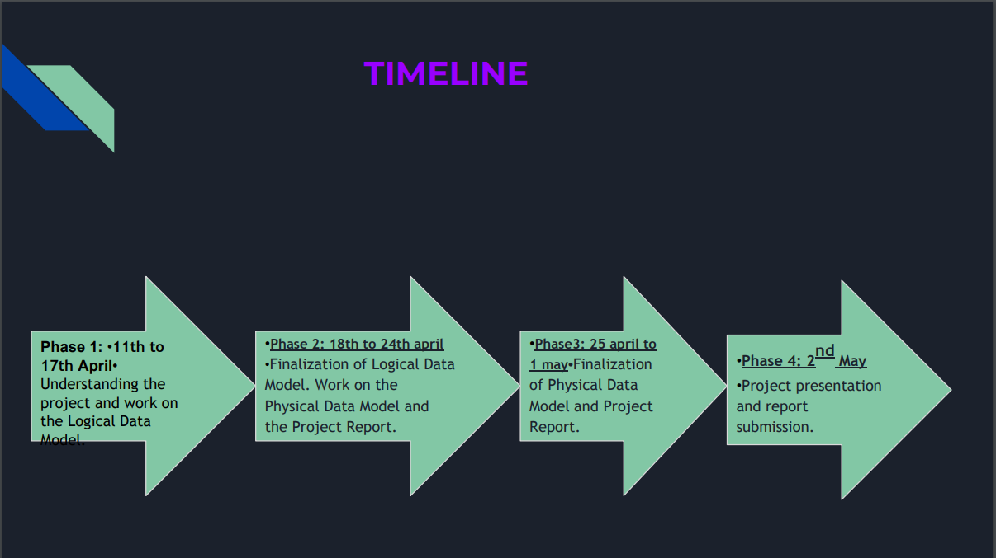

**E-R DIAGRAM:**

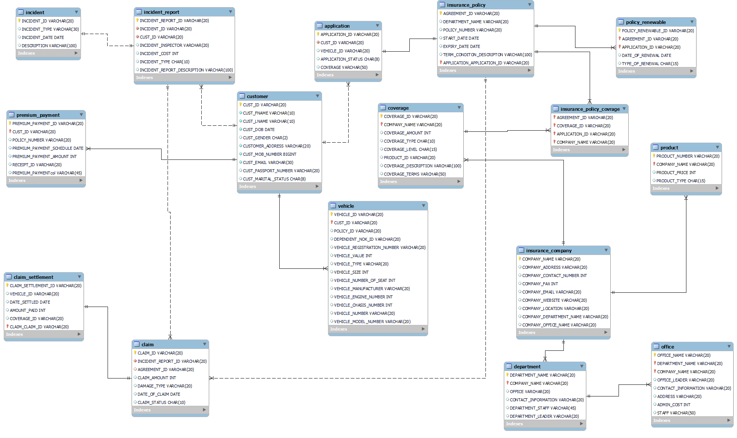

**QUERIES:**

1. Retrieve Customer and Vehicle details who has been involved in an incident and claim status is pending – Customer, vehicle, claim status, incident.

SELECT t1_customer.CUST_ID, t1_customer.CUST_FNAME, t1_customer.CUST_LNAME, t1_customer.CUSTOMER_ADDRESS,

t1_customer.CUST_EMAIL, t1_customer.CUST_MOB_NUMBER, t1_vehicle.VEHICLE_ID,

t1_vehicle.VEHICLE_REGISTRATION_NUMBER, t1_vehicle.VEHICLE_TYPE,

t1_incident_report.INCIDENT_REPORT_ID, t1_claim.CLAIM_STATUS FROM T1_CLAIM

INNER JOIN T1_INCIDENT_REPORT ON T1_CLAIM.INCIDENT_REPORT_ID=T1_INCIDENT_REPORT.INCIDENT_REPORT_ID

INNER JOIN T1_CUSTOMER ON T1_INCIDENT_REPORT.CUST_ID=T1_CUSTOMER.CUST_ID

INNER JOIN T1_VEHICLE ON T1_CUSTOMER.CUST_ID=T1_VEHICLE.CUST_ID WHERE T1_CLAIM.CLAIM_STATUS='Pending';

Output :

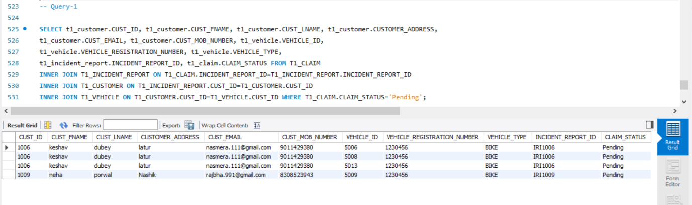

1. Retrieve customer details who has premium payment amount greater than the sum of all the Customer Ids in the database – premium payment, customer

SELECT SUM(t1_customer.CUST_ID) AS SUM_CUST_ID, t1_customer.CUST_ID,

t1_customer.CUST_FNAME, t1_customer.CUST_LNAME, t1_customer.CUSTOMER_ADDRESS,

t1_customer.CUST_EMAIL, t1_customer.CUST_MOB_NUMBER, t1_premium_payment.PREMIUM_PAYMENT_AMOUNT

FROM t1_premium_payment RIGHT JOIN t1_customer ON t1_premium_payment.CUST_ID =t1_customer.CUST_ID

GROUP BY t1_customer.CUST_ID HAVING SUM(t1_premium_payment.PREMIUM_PAYMENT_AMOUNT)>SUM_CUST_ID;

Output:

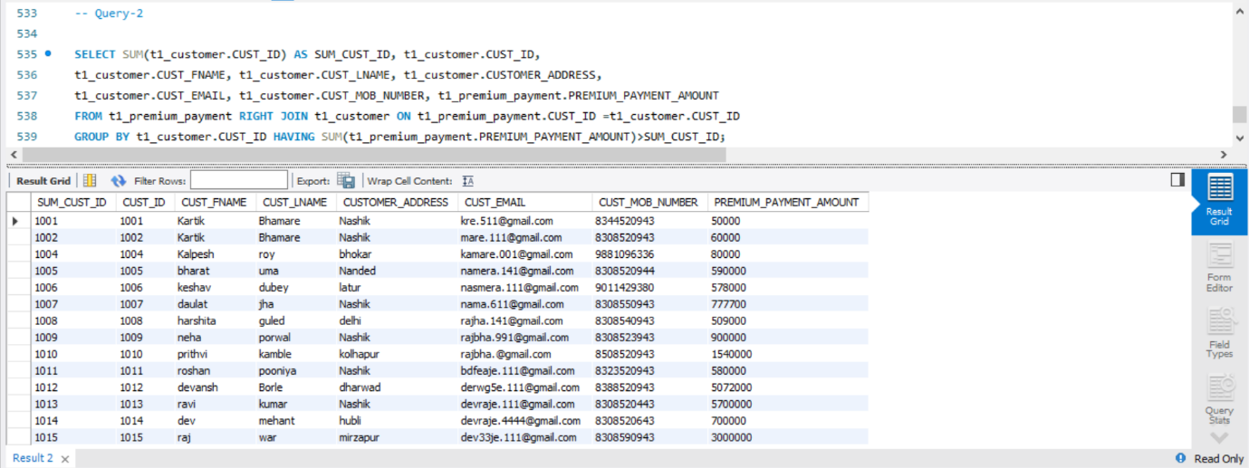

1. Retrieve Company details whose number of products is greater than departments, where the departments are located in more than one location—company, product, departments, office

SELECT * FROM t1_INSURANCE_COMPANY

WHERE Company_Name IN

(SELECT t1_DEPARTMENT.Company_Name

FROM t1_PRODUCT INNER JOIN t1_DEPARTMENT ON t1_DEPARTMENT.Company_Name = t1_PRODUCT.Company_Name

GROUP BY t1_DEPARTMENT.Company_Name

HAVING COUNT(DISTINCT (Product_Number)) > COUNT(DISTINCT (Department_Name)));

Output:

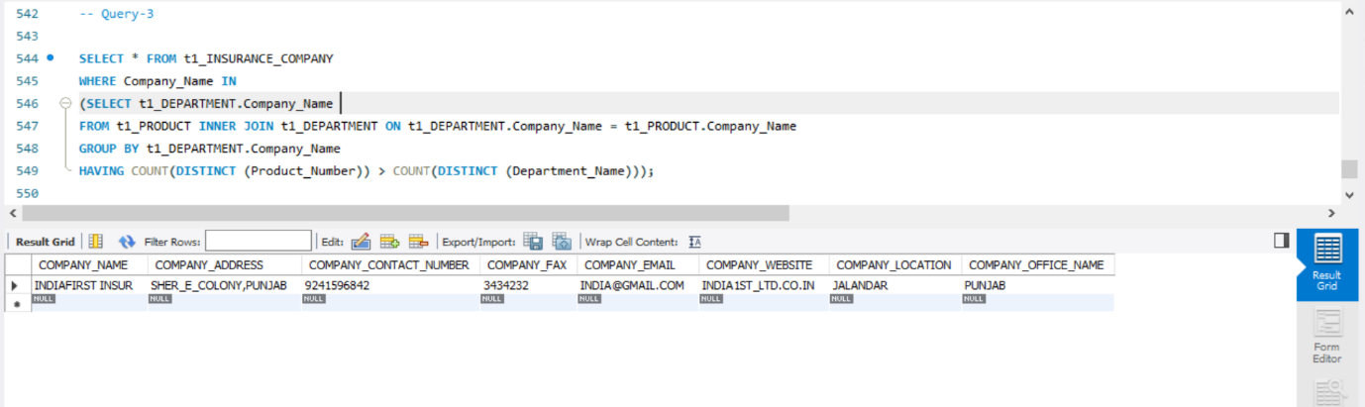

1. Select Customers who have more than one Vehicle, where the premium for one of the Vehicles is not paid and it is involved in accident

select * from t1_customer

inner join t1_vehicle on t1_customer.cust_id = t1_vehicle.cust_id

inner join t1_premium_payment on t1_vehicle.policy_number = t1_premium_payment.policy_number

inner join t1_incident_report on t1_incident_report.policy_number = t1_premium_payment.policy_number group by (t1_vehicle.CUST_ID) having count(t1_vehicle.CUST_ID) > 1 and t1_premium_payment.CUST_ID is null ;

Output:

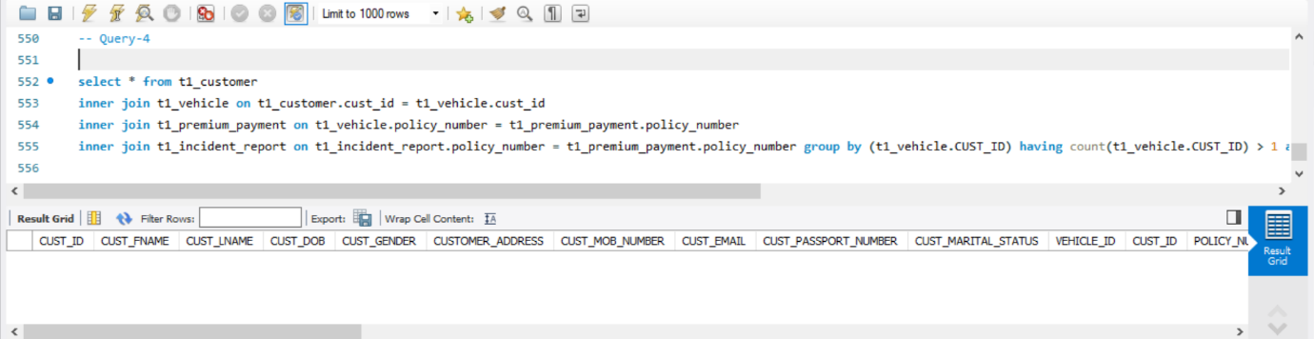

1. Select all vehicles which have premium more than its vehicle number.

SELECT t1_vehicle.VEHICLE_ID,

t1_vehicle.VEHICLE_REGISTRATION_NUMBER, t1_vehicle.VEHICLE_TYPE , t1_vehicle.VEHICLE_NUMBER , t1_premium_payment.PREMIUM_PAYMENT_AMOUNT

FROM t1_VEHICLE

INNER JOIN t1_premium_payment

ON t1_premium_payment.CUST_ID = t1_vehicle.CUST_ID

WHERE PREMIUM_PAYMENT_AMOUNT > VEHICLE_NUMBER;

Output:

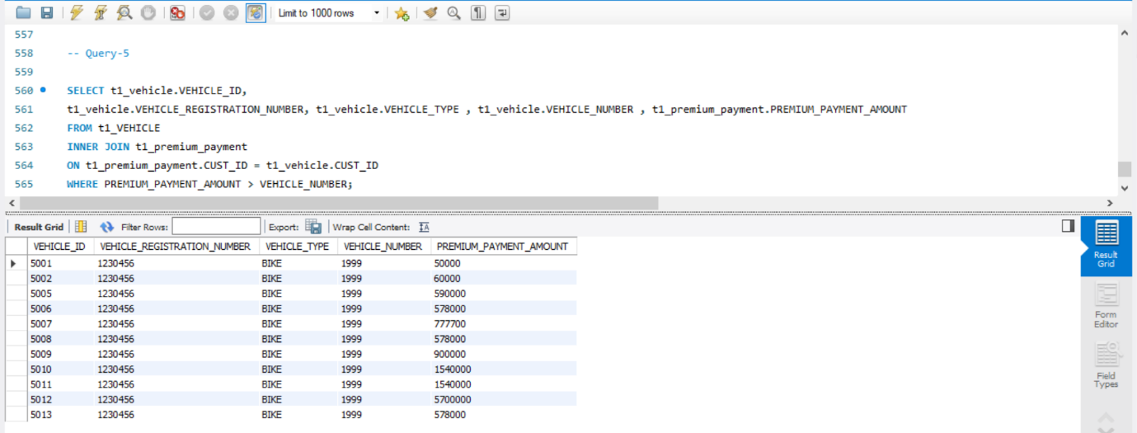

1. Retrieve Customer details whose Claim Amount is less than Coverage Amount and Claim Amount is greater than Sum of (CLAIM_SETTLEMENT_ID, VEHICLE_ID, CLAIM_ID, CUST_ID)

SELECT t1_customer.CUST_ID, t1_customer.CUST_FNAME, t1_customer.CUST_LNAME, t1_customer.CUST_EMAIL,

t1_customer.CUST_MOB_NUMBER, t1_claim.CLAIM_ID, t1_claim_settlement.CLAIM_SETTLEMENT_ID,

t1_vehicle.VEHICLE_ID, t1_coverage.COVERAGE_AMOUNT, t1_claim.CLAIM_AMOUNT

FROM t1_customer JOIN t1_incident_report ON t1_customer.CUST_ID=t1_incident_report.CUST_ID

JOIN t1_claim ON t1_incident_report.INCIDENT_REPORT_ID=t1_claim.INCIDENT_REPORT_ID

JOIN t1_claim_settlement ON t1_claim.CLAIM_ID=t1_claim_settlement.CLAIM_ID

JOIN t1_vehicle ON t1_vehicle.CUST_ID=t1_customer.CUST_ID

JOIN t1_application ON t1_customer.CUST_ID=t1_application.CUST_ID

JOIN t1_insurance_policy ON t1_application.APPLICATION_ID=t1_insurance_policy.APPLICATION_ID

JOIN t1_insurance_policy_coverage ON (t1_insurance_policy.AGREEMENT_ID,t1_insurance_policy.APPLICATION_ID)=(t1_insurance_policy_coverage.AGREEMENT_ID,t1_insurance_policy_coverage.APPLICATION_ID)

JOIN t1_coverage ON t1_insurance_policy_coverage.COVERAGE_ID=t1_coverage.COVERAGE_ID

WHERE (t1_coverage.COVERAGE_AMOUNT > t1_claim.CLAIM_AMOUNT) AND (t1_claim.CLAIM_AMOUNT > (t1_claim_settlement.CLAIM_SETTLEMENT_ID + t1_vehicle.VEHICLE_ID + t1_claim.CLAIM_ID + t1_customer.CUST_ID));

Output:

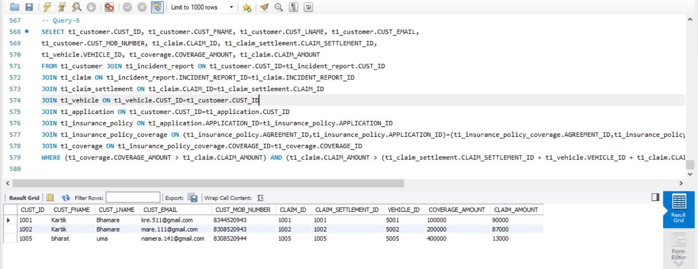

**CHALLENGES:**

1. **FOREIGN KEY CONSTRAINT:**

We have to change the sequence of table while creating their schema to ensure that is foreign key used has

been initialised as primary key.

1. **REWORKING THE DATABASE:**

We have to rework on database to satisfies the queries.

1. **Discrepancy in values between team members.**

**CONCLUSION:**

We have successfully created the database for vehicle insurance company and executed all the given queries.