# INTRODUCTION

#### About Project

The “NERSARY MANAGEMENT SYSTEM (Online Plant Order Module)” has been developed to override the problems prevailing in the practicing manual system. This software is supported to eliminate and in some cases, reduce the hardship faced by this existing system. Moreover, this system is designed for the particular need of the company to carry out operations in a smooth and effective manner.

The web application is reduced as much as possible to avoid errors while entering the data. It also provides error message while entering invalid data. No formal knowledge is needed for the user this system. Thus, by this all it proves it is user- friendly. As described above, can lead to error free, secure, reliable and fast management system. Every organization, whether big or small, has challenges to overcome and managing the information of Category, Plant Item, Order, Payment,. Every Online Plant Ordering System has different Plant Item needs; This is designed to assist in strategic planning and will help you ensure that your organization is equipped with the right level of information and details for your future goals.

#### Existing System

The existing system for placing plant orders typically involves calling a nersary or visiting the nersary in person to place an order.

While this method can be effective, it can also be time-consuming and inconvenient for customers.

Customers may have difficulty reaching a nersary by phone during peak hours, and may have to wait in line to place an order in person.

Additionally, there is a risk of misheard or misunderstood orders, which can lead to errors and customer dissatisfaction.

The existing system also lacks the convenience and efficiency of an online ordering platform, where customers can easily browse menus, customize their orders, and pay for their meals online.

Overall, the existing system for placing plant orders has room for improvement in terms of convenience and efficiency.

##### Disadvantages of existing system:

* + 1. System is quite tedious.
    2. Registrations done manually in the system.
    3. It is time consuming process.
    4. It is difficult and complicated task to maintain heavy registers.
    5. Lack of accuracy and efficiency since records are maintained manually

#### Need and Scope of Computer System

A computer system is essential for an online plant ordering system project because it enables customers to place orders electronically, facilitates communication between the nersary and the customer, and streamlines the process of tracking and fulfilling orders.

The scope of a computer system in an online plant ordering system project would typically include the following components:

A website through which customers can browse menus, place orders and receipt.

A database to store information about typs, prices, customer orders, and receipt information.

A system for processing and fulfilling orders, including interfaces with nersary point-of-sale systems and delivery partners.

A system for handling customer inquiries and complaints.

Overall, the computer system plays a central role in an online plant ordering system project, enabling nersarys to efficiently manage orders and deliveries and providing a convenient and seamless experience for customers.

# PROPOSED SYSTEM

#### Objectives

Here are some potential objectives for an online plant ordering system project:

* + 1. To provide a convenient and efficient way for customers to place plant orders online, without having to call or visit the nersary in person.
    2. To streamline the ordering process for nersarys, by automating the process of receiving and tracking orders.
    3. To improve the accuracy of orders by allowing customers to review their selections and make changes before submitting their order.
    4. To reduce the risk of errors or misunderstandings during the ordering process, by clearly presenting menu items, prices, and special requests to customers.
    5. To improve the overall customer experience by offering a user-friendly interface and fast, reliable service.
    6. To generate additional revenue for the nersary by attracting new customers and encouraging repeat business through the online ordering system.
    7. To integrate with the nersary's existing point-of-sale (POS) and inventory management systems, to ensure that orders are accurately reflected in the nersary's records.
    8. To enhance the security and privacy of the online ordering system, by protecting sensitive customer and financial data through appropriate measures such as encryption and secure servers.
  1. **Requirement Engineering**

#### Feasibility Study

A feasibility analysis usually involves a thorough assessment of the operational (need), financial and technical aspects of a proposal. Feasibility study is the test of the system proposal made to identify whether the user needs may be satisfied using the current software and hardware technologies, whether the system will be cost effective from a business point of view and whether it can be developed with the given budgetary constraints. A feasibility study should be relatively cheap and done at the earliest possible time. Depending on the study, the decision is made whether to go ahead with a more detailed analysis.

When a new project is proposed, it normally goes through feasibility assessment. Feasibility study is carried out to determine whether the proposed system is possible to develop with available resources and what should be the cost consideration.

Facts considered in the feasibility analysis were:

* + Technical Feasibility.
  + Economic Feasibility.
  + Operational Feasibility.

#### Technical Feasibility

Technical feasibility includes whether the technology is available in the market for development and its availability. The assessment of technical feasibility must be based on an outline design of system requirements in terms of input, output, files, programs, and procedures. This can be qualified in terms of volumes of data, trends, frequency of updating, cycles of activity etc. in order to give an introduction of technical system.

#### Economic Feasibility

This feasibility study present tangible and intangible benefits from the project by comparing the development and operational cost. The technique of cost benefit analysis is often used as a basis for assessing economic feasibility. This system needs some more initial investment than the existing system, but it can be justifiable that it will improve quality of service.

Thus, feasibility study should center along the following points :

* + Improvement resulting over the existing method in terms of accuracy, timeliness.
  + Cost comparison.
  + Estimate on the life expectancy of the hardware.
  + Overall objective.

Our project is economically feasible. It does not require much cost to be involved in the overall process. The overall objective is in easing out the recruitment processes.

#### Operational Feasibility

This analysis involves how it will work when it is installed and the assessment of political and managerial environment in which it is implemented. People are inherently resistant to change and computers have been known to facilitate change. The new proposed system is very much useful to the users and therefore it will accept broad audience from around the world.

## Requirement Gathering

Requirement gathering is the process of collecting and documenting the requirements for a software system. It is an important step in the requirement engineering process as it helps to ensure that the final product meets the needs of the users and stakeholders.

For an online plant order project, the requirement gathering process might involve a number of different activities, such as:

Conducting user research to understand the needs and preferences of customers who will be using the system. This may include interviews, surveys, focus groups, or other methods of gathering feedback.

Gathering input from nersary staff, such as customer service representatives, to understand their needs and how the system can support them. Analyzing the business requirements and goals of the online plant order project,

including any financial or operational constraints that may impact the system.

Identifying any regulatory or compliance requirements that must be met by the system.

Once all of the requirements have been gathered, they should be carefully documented and organized to create a clear and comprehensive set of specifications for the project. This documentation can then be used to guide the design and development of the system, and to ensure that all stakeholders are on the same page about the desired features and functionality.

## Software Requirements

Software requirements are the specific features and functions that a software system must have in order to meet the needs of the users and stakeholders. In the context of an online plant order project, the software requirements would define what the system needs to do and how it should behave in order to enable customers to place orders and nersarys to fulfill those orders.

Some examples of software requirements for an online plant order project might include:

A user registration and login system that allows customers to create accounts and place orders.

A menu system that displays the available plant items and their prices, as well as any relevant nutritional or allergen information.

A shopping cart feature that allows customers to add items to their order and view the total cost.

A payment system that processes orders and collects payment from customers.

Integration with a nersary's inventory and kitchen systems to ensure that orders can be accurately prepared and delivered in a timely manner.

Mobile compatibility to allow customers to place orders using their smartphones.

A customer support system to handle inquiries, complaints, and feedback from

users.

It is important to carefully define and document the software requirements for

an online plant order project in order to ensure that the final product meets the needs of the business, the customers, and any other relevant parties. This may involve gathering input from users, and other stakeholders, and working with developers to design and implement the system.

# SYSTEM ANALYSIS

### System Diagram

#### Data Flow Diagram

DFD is also known as ‘Bubble Chart’. Its purpose is to classify system requirement and identifying major transformation that will become program in a system design. So, it is a starting point of the design phase that functionality decomposes the requirements specifications down to the lowest level of the detail. A DFD consists of series of bubbles joined by lines. The bubble represents data transmission and line represents data flow in the system.

#### Entity Relationship Diagram (ERD)

Entity relationship diagram graphically represent overall logical structure of database which includes interactions between entity of various ways. Entity relationship (ERD) illustrates the logical structure of database. Entity relationship ERD’s in 1976 since then Charles Bachman and James Martin have added some slight refinements to the basic ERD principles.

**System Diagrams**

* 1. **Data Flow Diagram (DFD)**

#### Level 0.0:

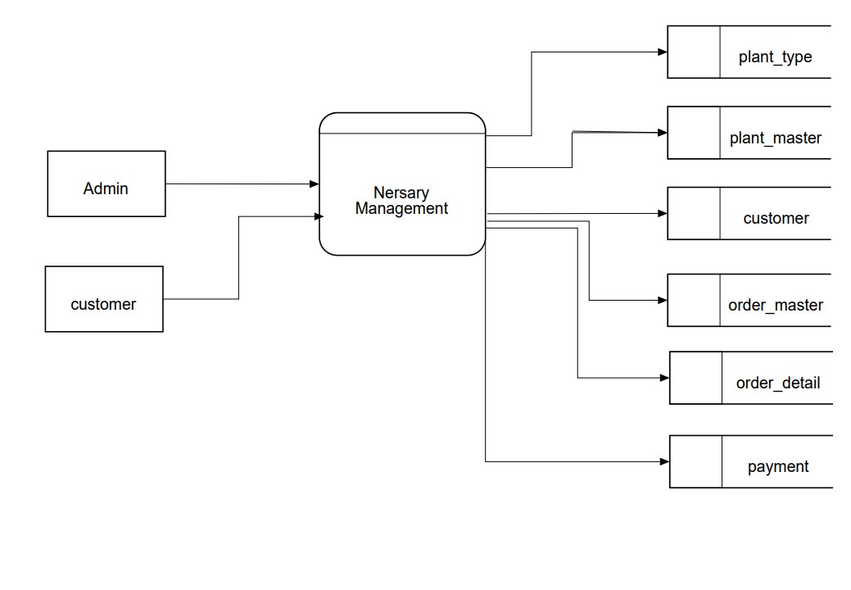

**DFD 1.0:**

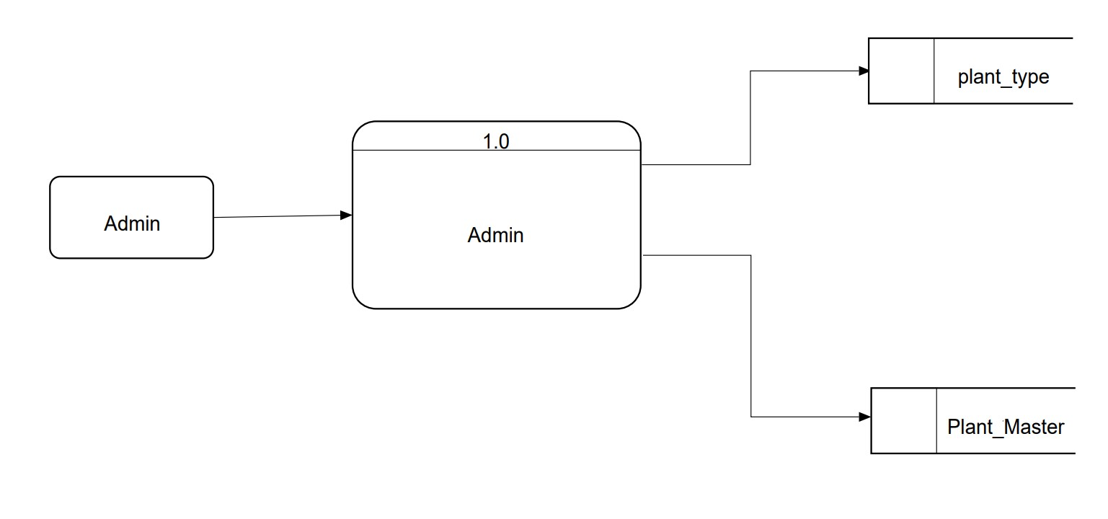

**DFD 2.0:**

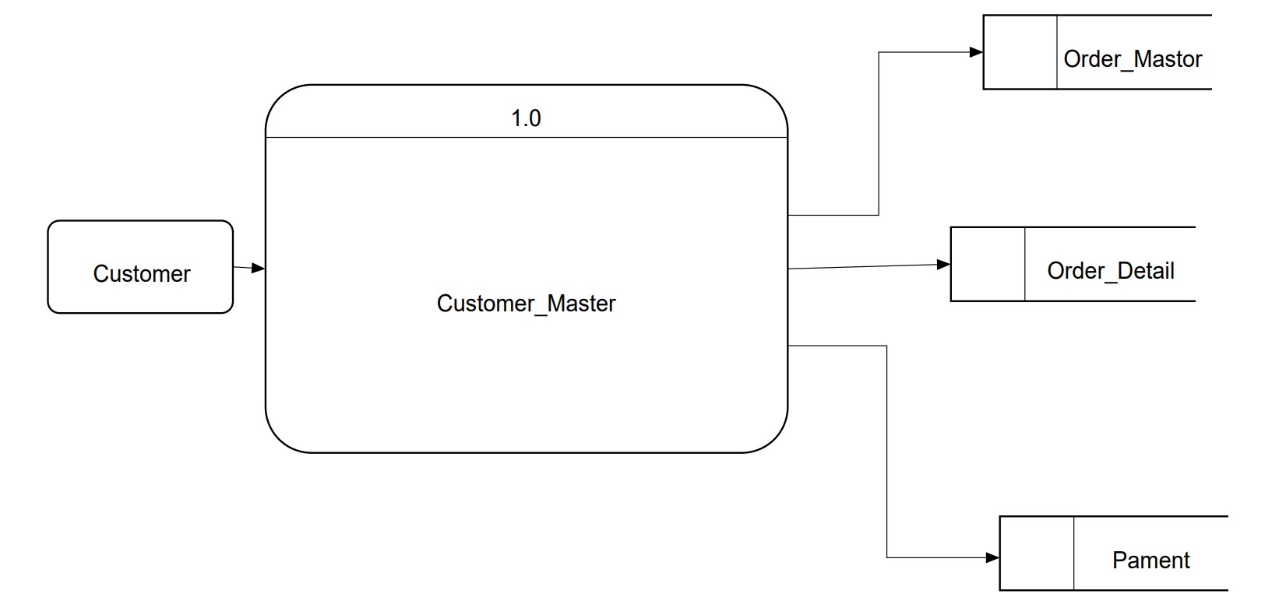

* 1. **Entity Relationship Diagram (ERD)**

#### E-R Model

E-R model is detailed logical representation of entities, Association and elements for an organization and business area.

#### E-R Diagram

E-R diagram is a graphical representation of an E-R Model.

This model uses 3 features to describe data. These are as follows:

#### Entity

1. **Relationship**

#### Attribute

* **Entity**

An entity is a person, place, object, event or concept which system wants to store data.

#### Relationship

It connects entities and represents meaningful dependency between them.

#### Attributes

It specifies properties of entities and relationship. Entity Relationship Diagram consists of different entities like supplier, owner, customer and stock. This ERD is very easy to understand. Because, in this ERD every entity has different attributes. In ERD these attributes can give the total work or total information of the system. In this candidate registered on the website. Then candidate apply for the job. Admin view job applied by candidate.

## Entity Relationship Diagram (ERD)

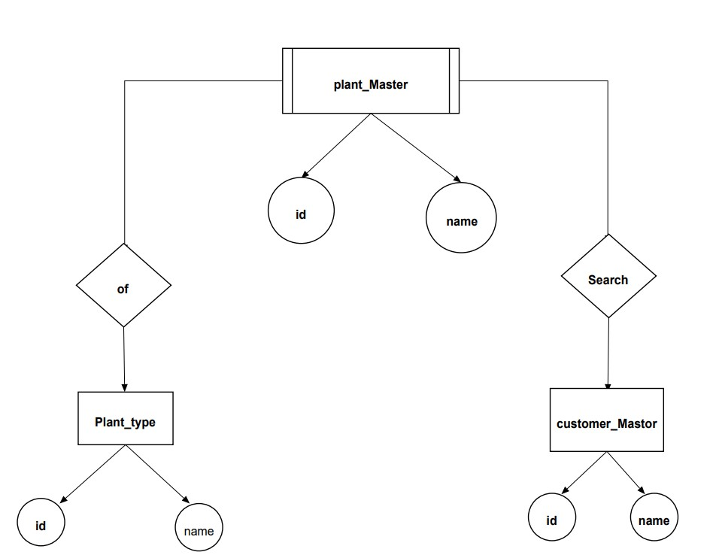

# SYSTEM DESIGN

#### DATABASE DESIGN:

The general theme behind a database is to handle information as an integrated whole. A database is a collection of interrelated data stored with minimum redundancy to serve many users quickly and effectively. After designing input and output, the analyst must concentrate on database design or how data should be organized around user requirements. The general objective is to make information access, easy quick, inexpensive and flexible for other users.

During database design the following objectives are concerned

* + - Controlled Redundancy
    - Data independence
    - Accurate and integrating
    - More information at low cost
    - Recovery from failure
    - Privacy and security
    - Performance
    - Ease of learning and use

#### Database Name: nersary_mangment

Table Name: Customer_master

|  |  |  |  |
| --- | --- | --- | --- |
| **Column Name** | **Data Type** | **NULL** | **Constraint** |
| cust_id | Int | Not null | Primary key |
| cust_nm | Varchar(90) | Not null |  |
| cust_addr | Varchar(90) | Not null |  |
| cust_email | Varchar(90) | Not null |  |
| cust_password | Varchar (90) | Not null |  |
| cust_mobile | Varchar(90) | Not null |  |

Table Name:Plant_Master

|  |  |  |  |
| --- | --- | --- | --- |
| **Column Name** | **Data Type** | **NULL** | **Constraint** |
| plant_id | Int | Not null | Primary key |
| plant_nm | Varchar(90) | Not null |  |
| type_id | Int | Not null | Unique key |
| plant_height | Varchar(90) | Not null |  |
| description | Varchar(max) | Not null |  |
| rate | Int | Not null |  |
| stock | Int | Not null |  |
| photo | Varchar(100) | Not null |  |

Table Name: Plant_type

|  |  |  |  |
| --- | --- | --- | --- |
| **Column Name** | **Data Type** | **NULL** | **Constraint** |
| type_Id | Int | Not null | Primary Key |
| type_nm | Varchar(90) | Not null |  |

Table Name: Order_Detail

|  |  |  |  |
| --- | --- | --- | --- |
| **Column Name** | **Data Type** | **NULL** | **Constraint** |
| ord_det_id | Int | Not null | Primary key |
| ord_id | Int | Not null | Unique key |
| plant_id | Int | Not null |  |
| rate | Int | Not null |  |
| qty | Int | Not null |  |
| amt | Int | Not null |  |
| GST | float | Not null |  |
| Total | Int | Not null |  |

Table Name: Order_Master

|  |  |  |  |
| --- | --- | --- | --- |
| **Column Name** | **Data Type** | **NULL** | **Constraint** |
| ord_id | Int | Not null | Primary key |
| ord_date | Varchar(90) | Not null |  |
| cust_id | Int | Not null |  |
| grand_total | Float | Not null |  |

Table Name: Payment

|  |  |  |  |
| --- | --- | --- | --- |
| **Column Name** | **Data Type** | **NULL** | **Constraint** |
| pay_id | Int | Not null | Primary key |
| ord_id | Int | Not null |  |
| pay_amt | Int | Not null |  |
| pay_date | Varchar(90) | Not null |  |
| Card_no | Int | Not null |  |

#### INPUT DESIGN: Customer Login:

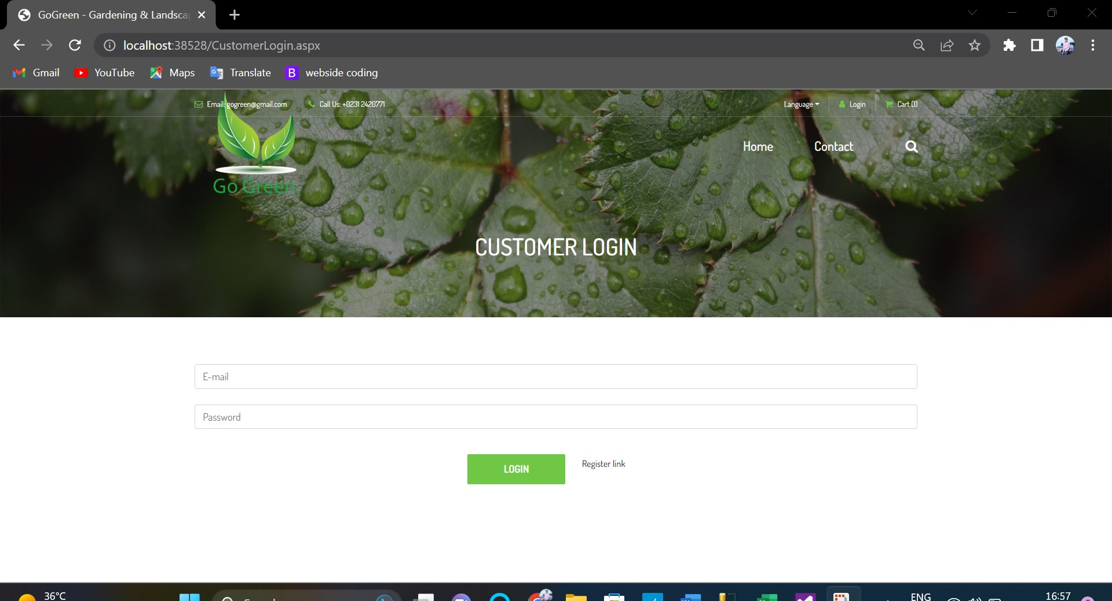

**Admin Login:**

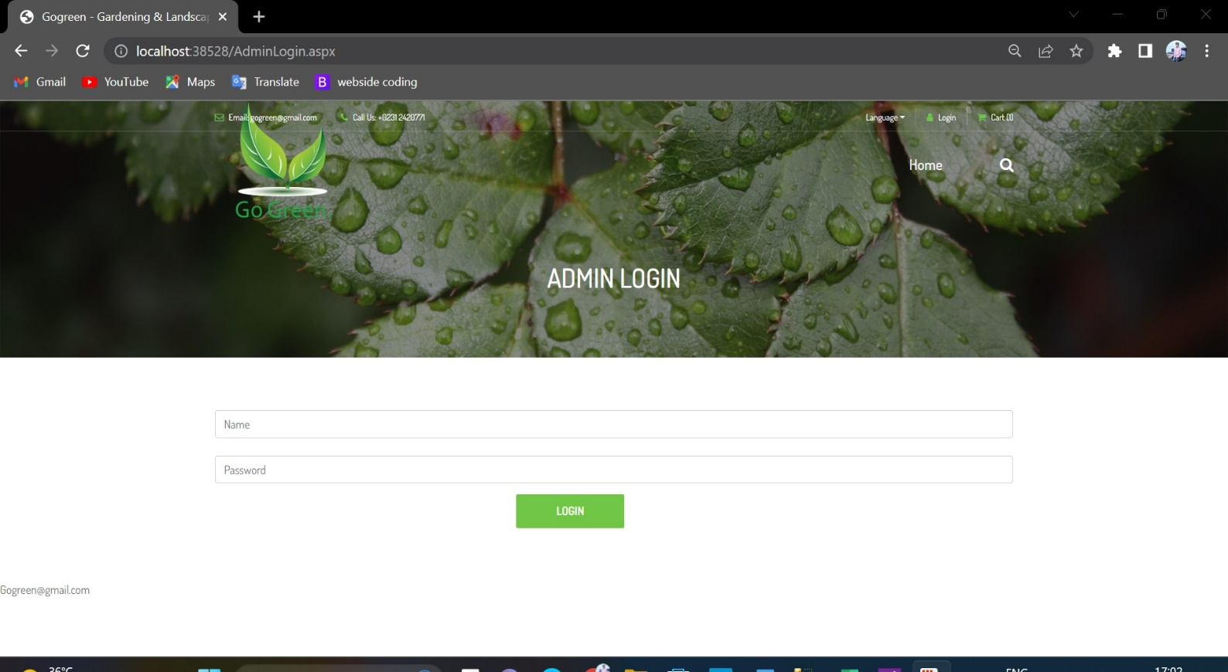

#### CUSTOMER INFORMATION:

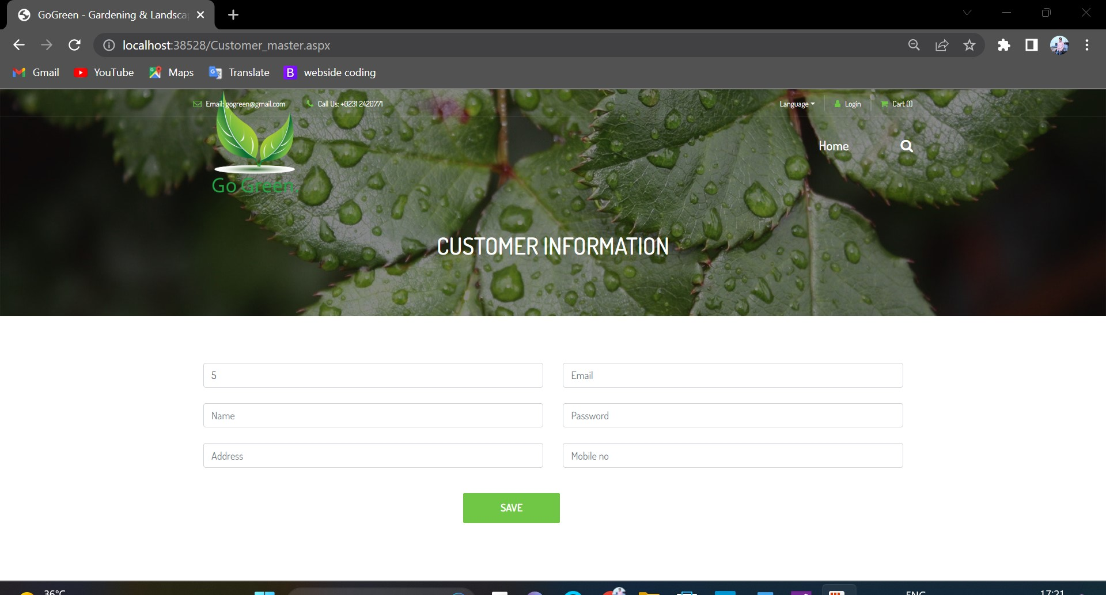

**Plant Type:**

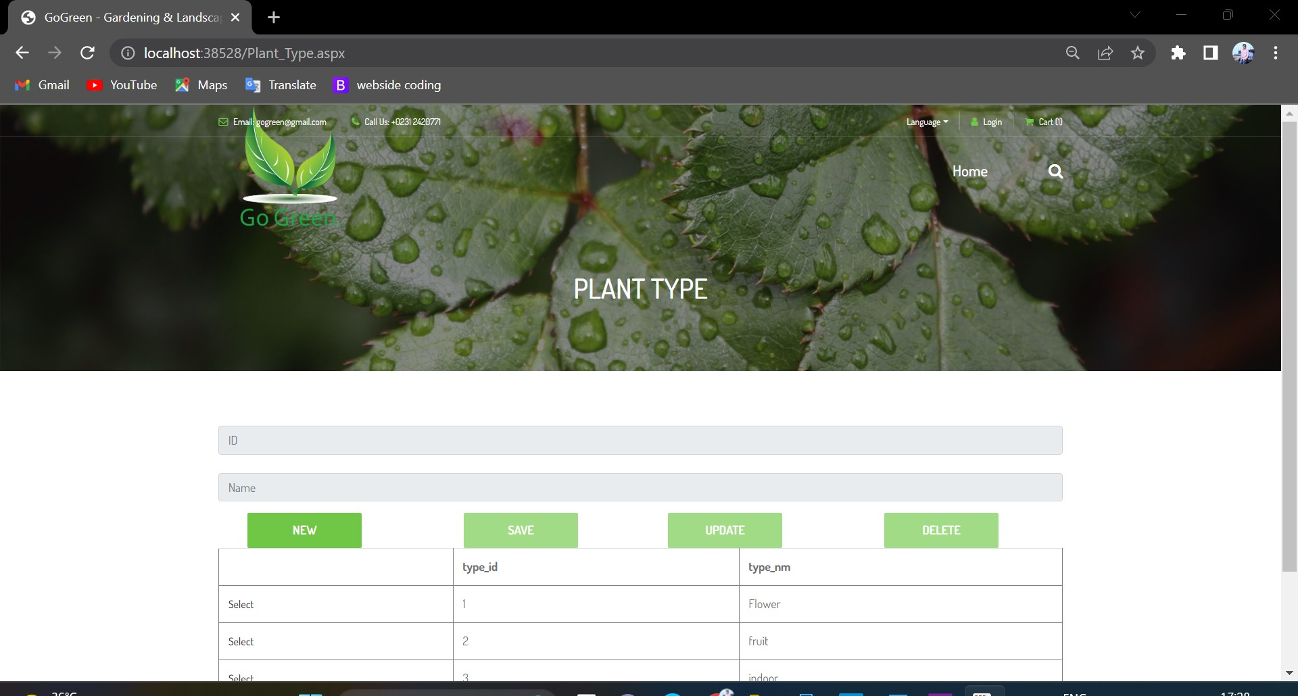

#### Add Plant Item:

#### 

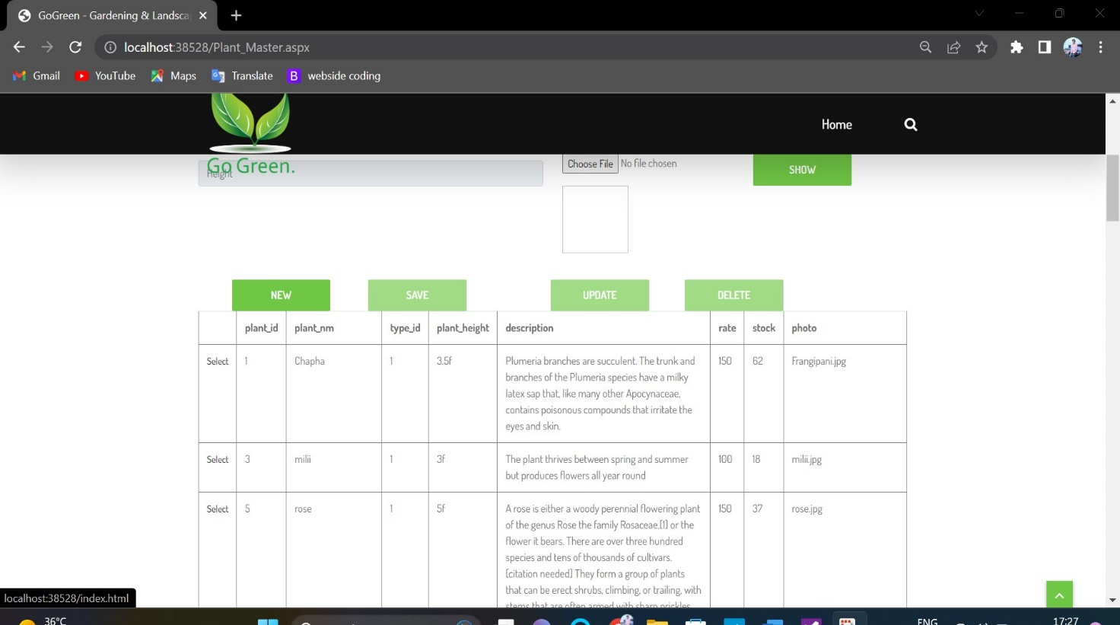

* 1. **Output Design:**

#### Customer Registration Details:

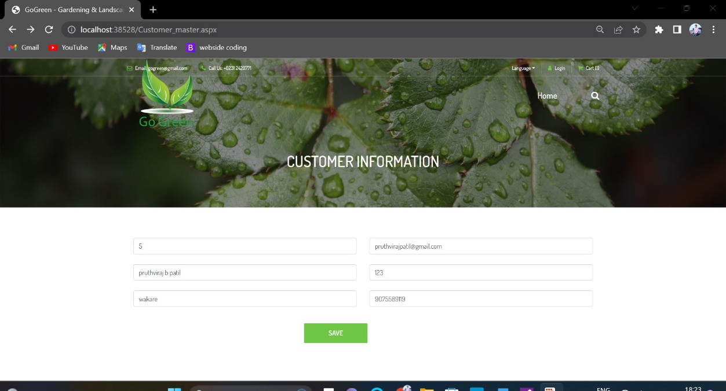

**Admin Login Details:**

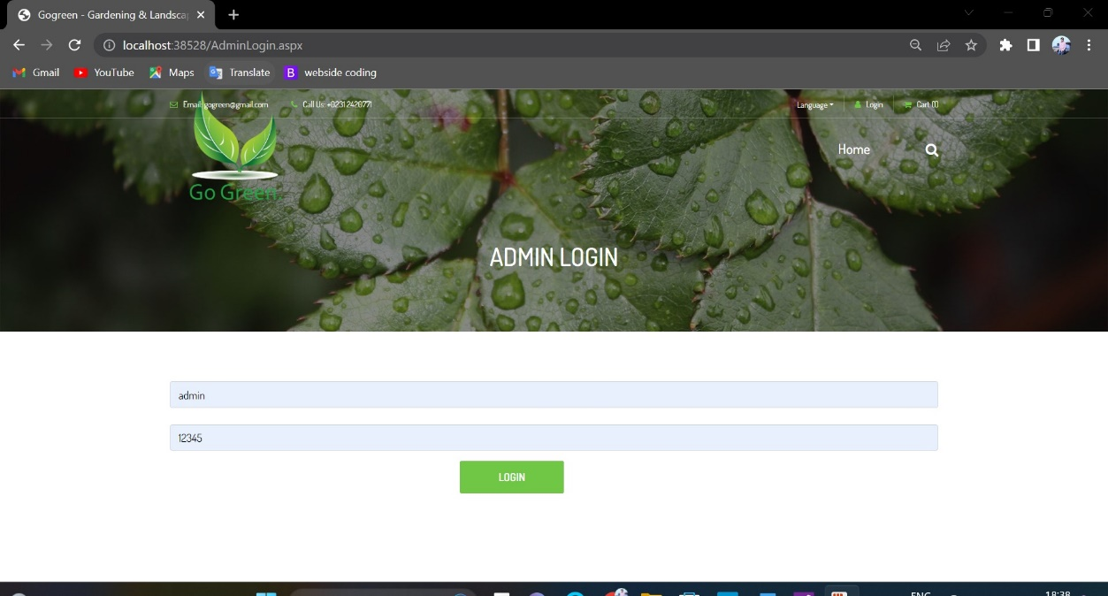

#### Customer Login Details:

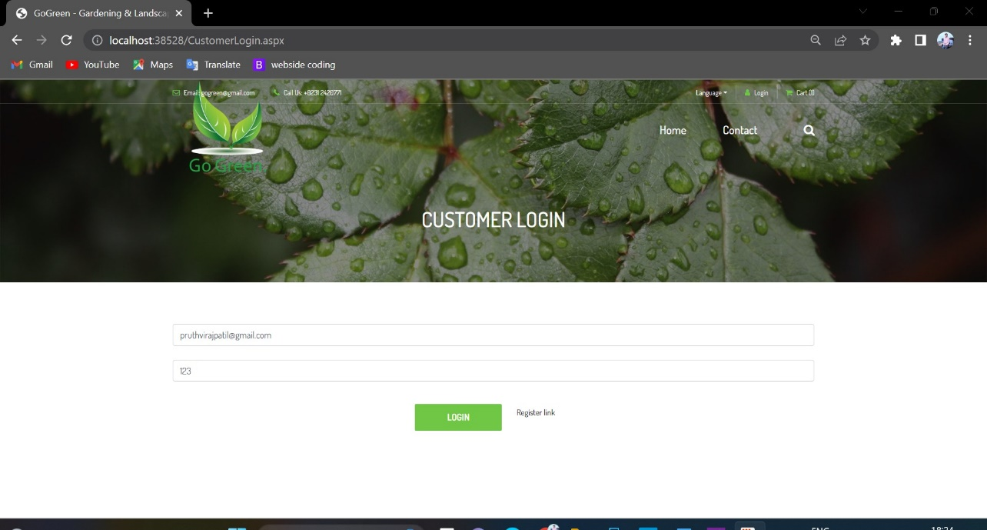

**Add Plant Item Details:**

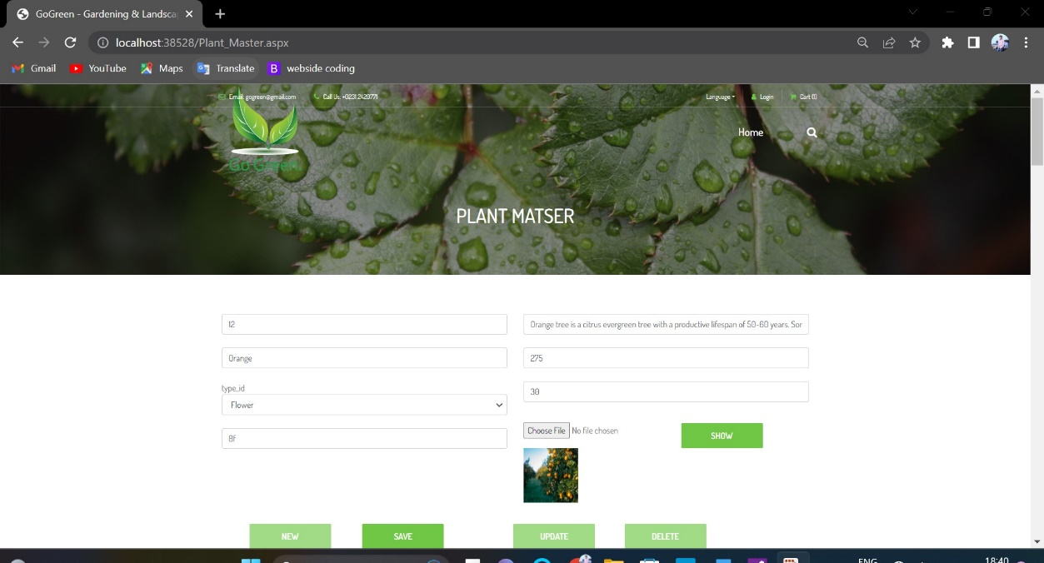

#### Show Plant Item:

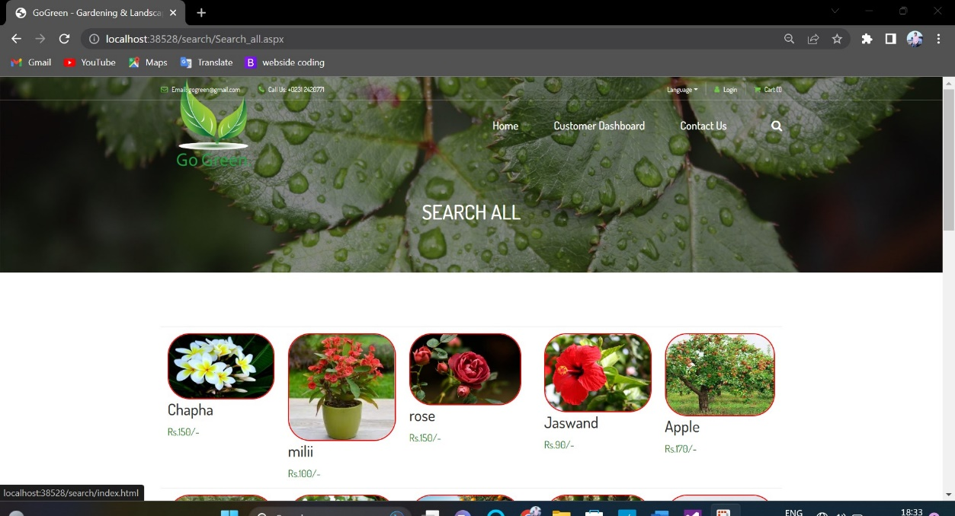

**Show Plant Item (Description):**

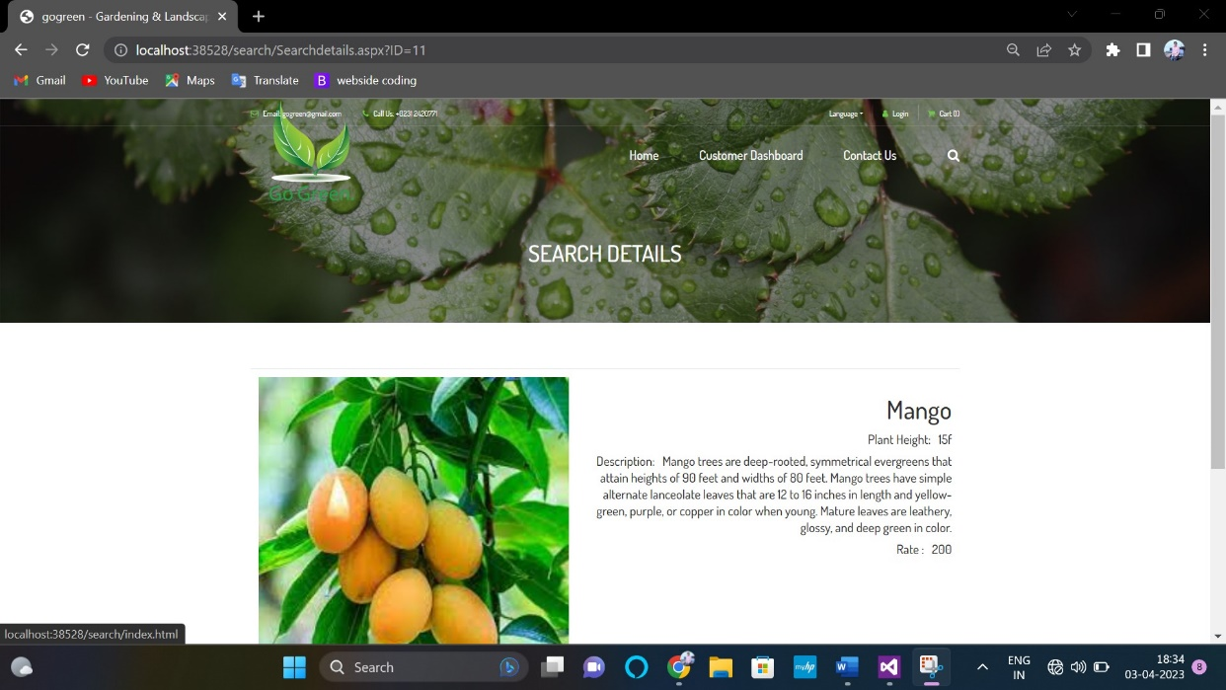

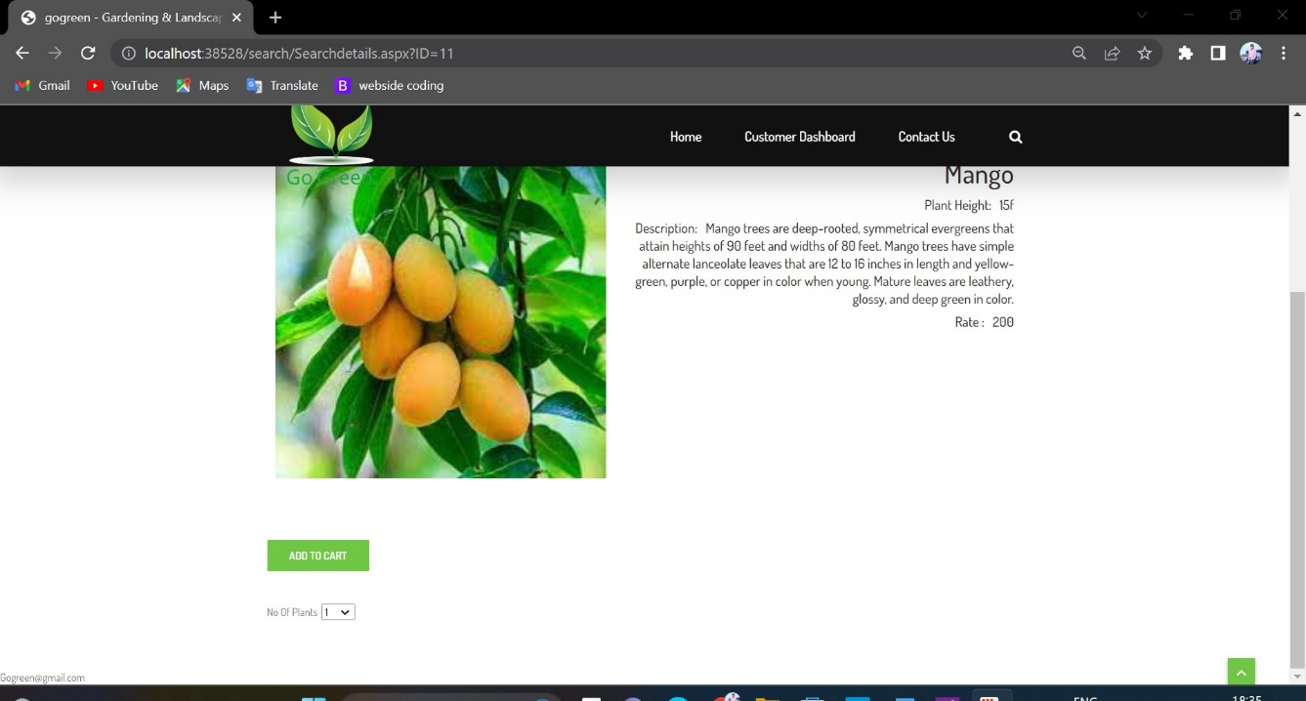

#### Add to Cart:

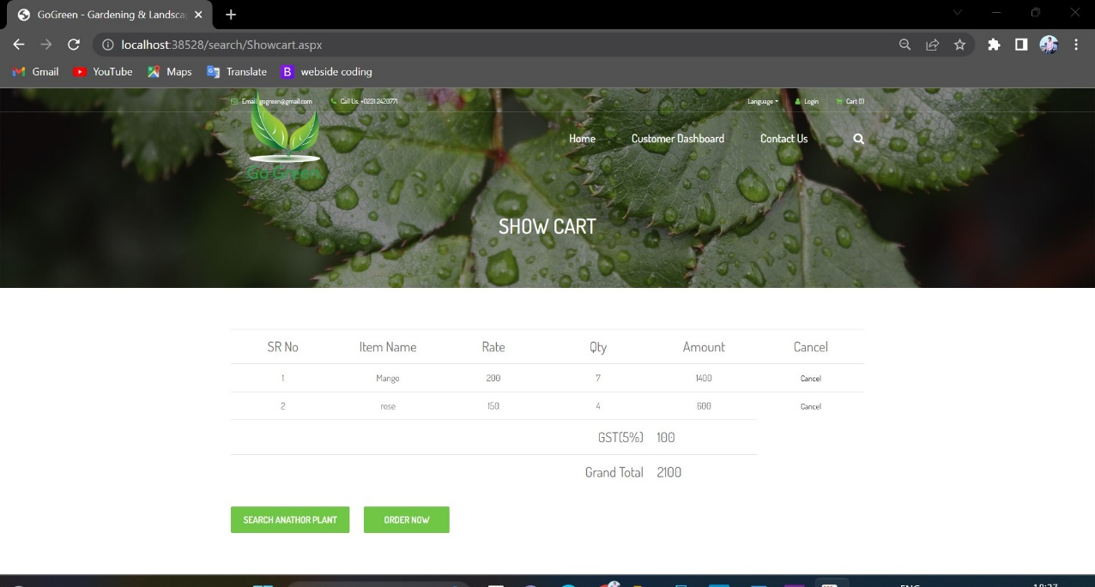

**Receipt Detail:**

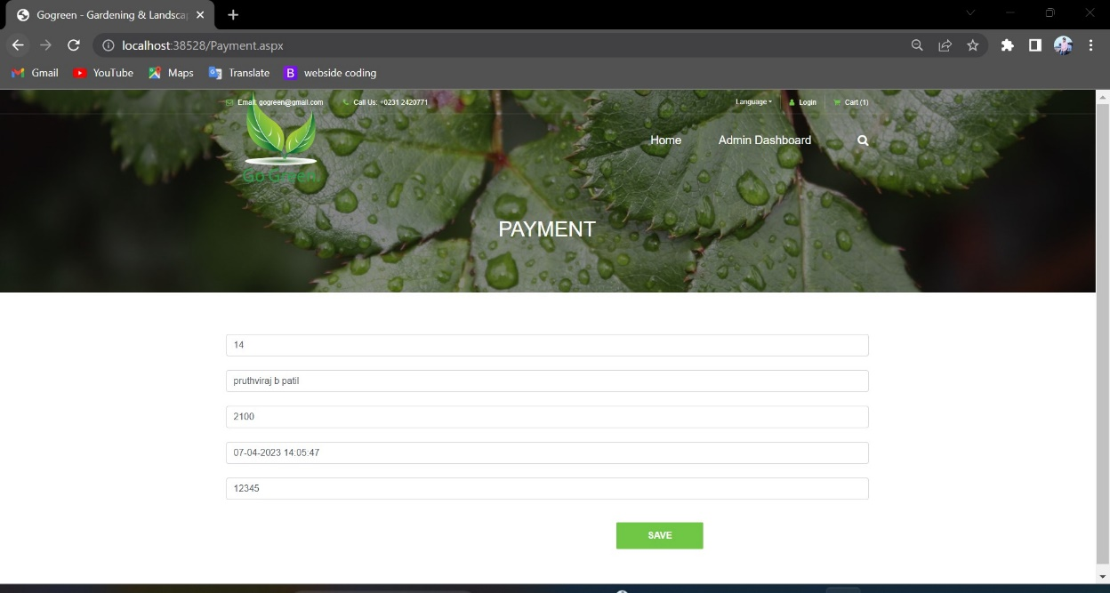

**Invoice (PDF):**

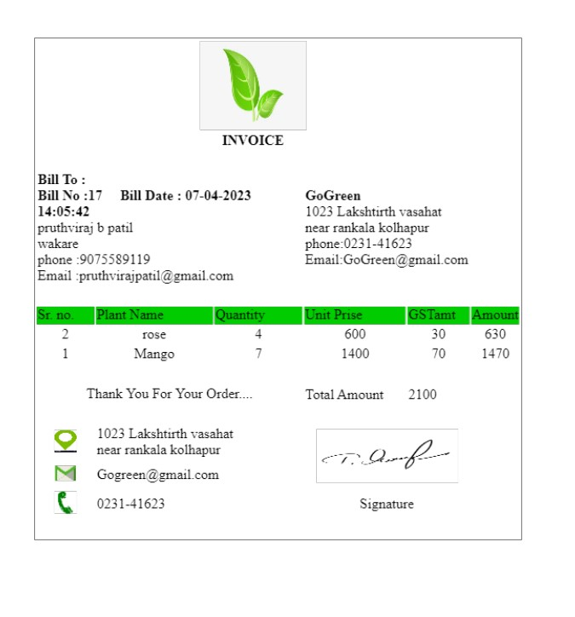

**IMPLEMENTATION**

**Hotel Management System (Online Plant Order Module)**

* 1. **System Requirement**

Requirement analysis for web applications encompasses three major tasks: formulation,requirements gathering and analysis modeling. During formulation, the basic motivation and goals for the web application are identified, and the categories of users are defined. In the requirements gathering phase, the content and functional requirements are listed and interaction scenarios written from end-user’s point-of-view are developed. This intent is to establish a basic understanding of why the web application is built, who will use it, and what problems it will solve for its users.

##### SOFTWARE REQUIREMENT SPECIFICATION

Operating System : Windows XP/7

Presentation layer : C#, ASP.net, HTML, JS, CSS,

Bootsrap.

Database : SQLServer.

##### HARDWARE REQUIREMENT SPECIFICATION

Processor : Standard processor with a speed of 2.0GHz

RAM : 2BG

Hard Disk : 50 GB or more

Monitor : Standard color monitor

Keyboard : Standard keyboard

Mouse : Standard mouse

* 1. **Installation process**

Computer programs can be executed by simply copying them into a folder stored on a computer and executing them. Other programs are supplied in a form unsuitable for immediate execution and therefore need an installation procedure. Once installed, the program can be executed again and again, without the need to reinstall before each execution.

Operations performed during software installations include:

* + - Making sure that necessary system requirements are met • Checking for existing versions of the software
    - Creating or updating program files and folders
    - Adding configuration data such as configuration files, Windows registry entries or environment variables
    - Making the software accessible to the user, for instance by creating links, shortcuts or bookmarks
    - Configuring components that run automatically, such as daemons or Windows services

These operations may require some charges or be free of charge. In case of payment, installation costs means the costs connected and relevant to or incurred as a result of installing the drivers or the equipment in the customers' premises.

## User Guidelines

##### Admin:

1. Admin should have to login to this system by providing log in user name and password.
2. Admin can add Plant Item to Menu bar by defining plant Category.

* Admin can generate Reports.

##### User:

1. User should have to login to this system by providing log in user name and password.

* User will get the Plant Items on Menu.
* Click on Plant Item to Add to Cart.
* Click on search another to add more items to Shopping cart..
* Click on Proceed to checkout to get Receipt Details.
* Click on Save button to get Invoice.

# REPORTS

#### List Reports:

**Plant Category:**

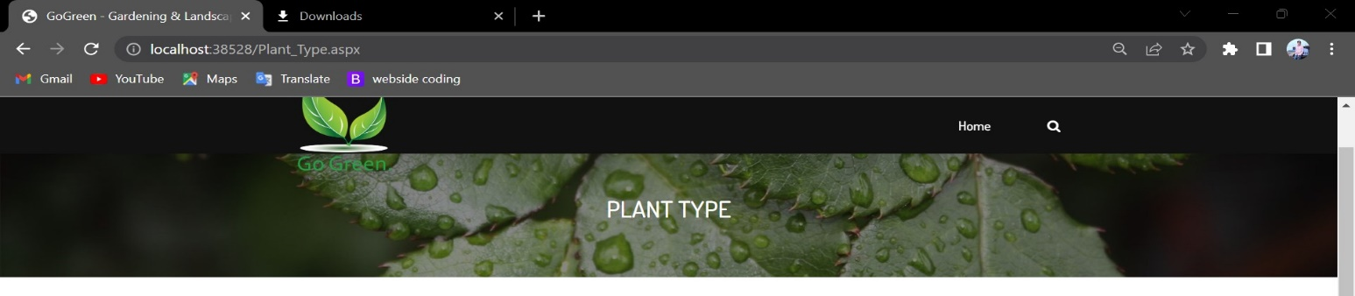

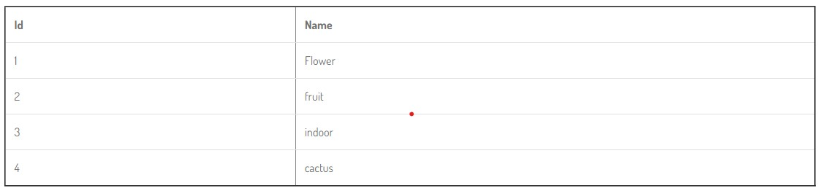

#### Order List:

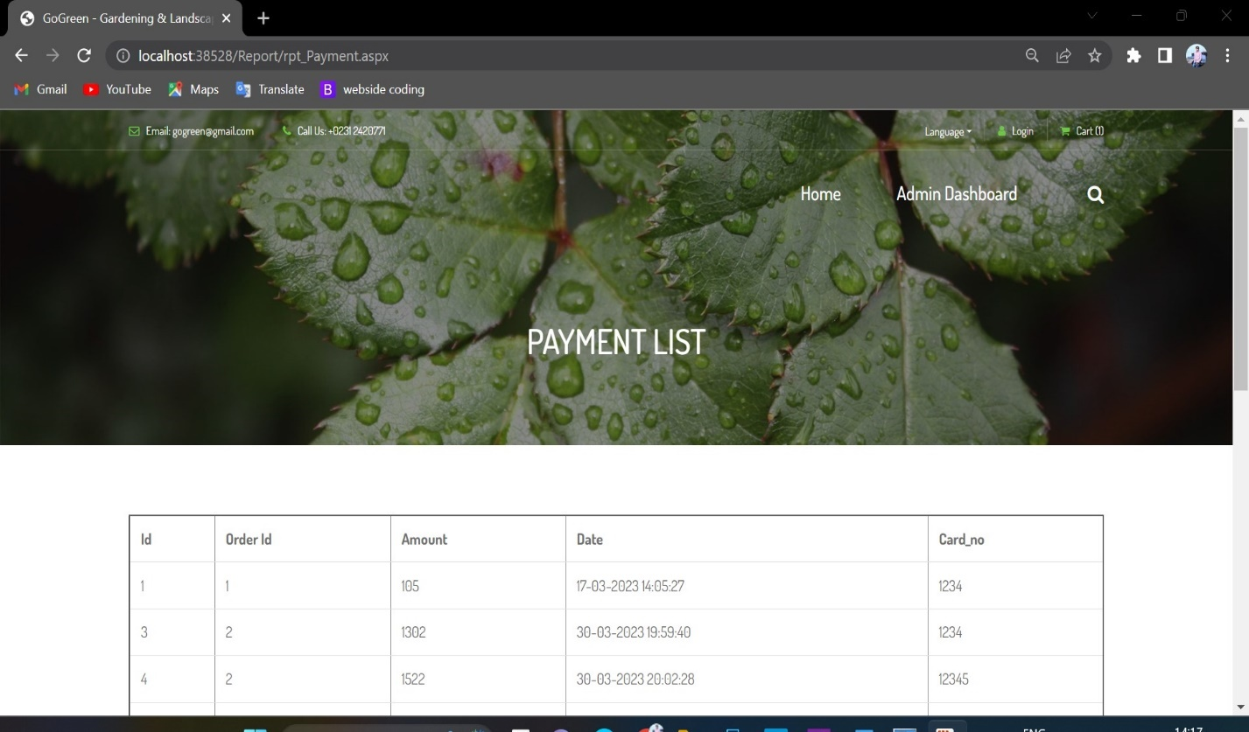

**Payment list:**

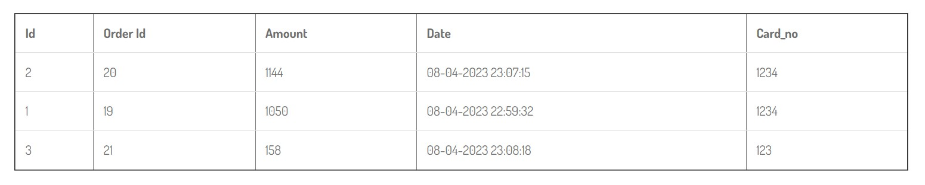

#### Customer List:

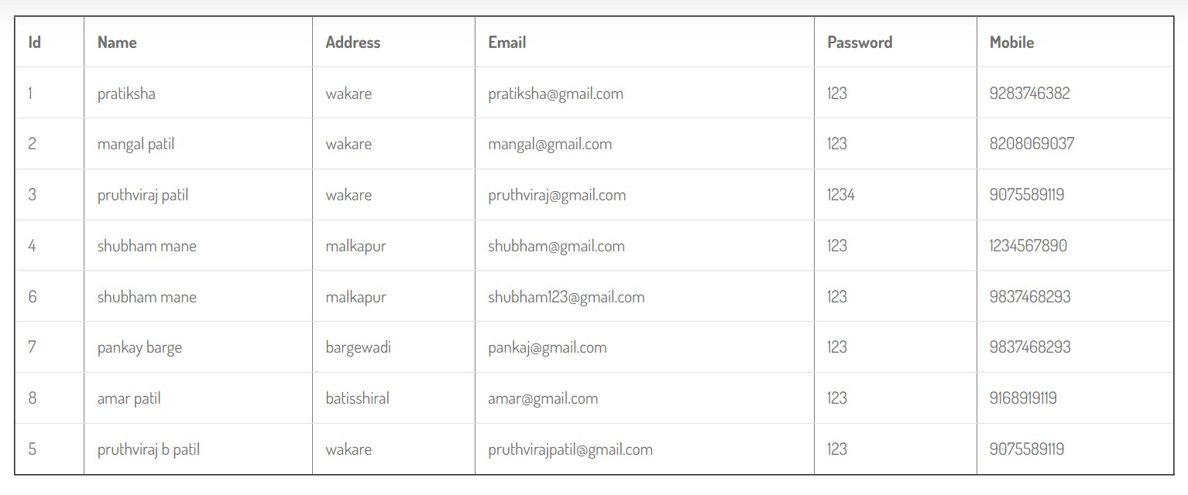

**Dynamic Reports:**

#### Plant Category wise Plant Master:

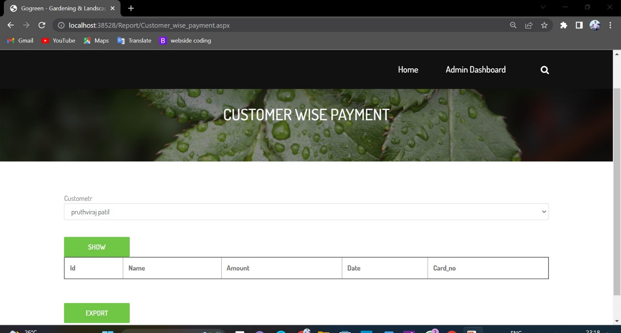

**Customer wise Order Master:**

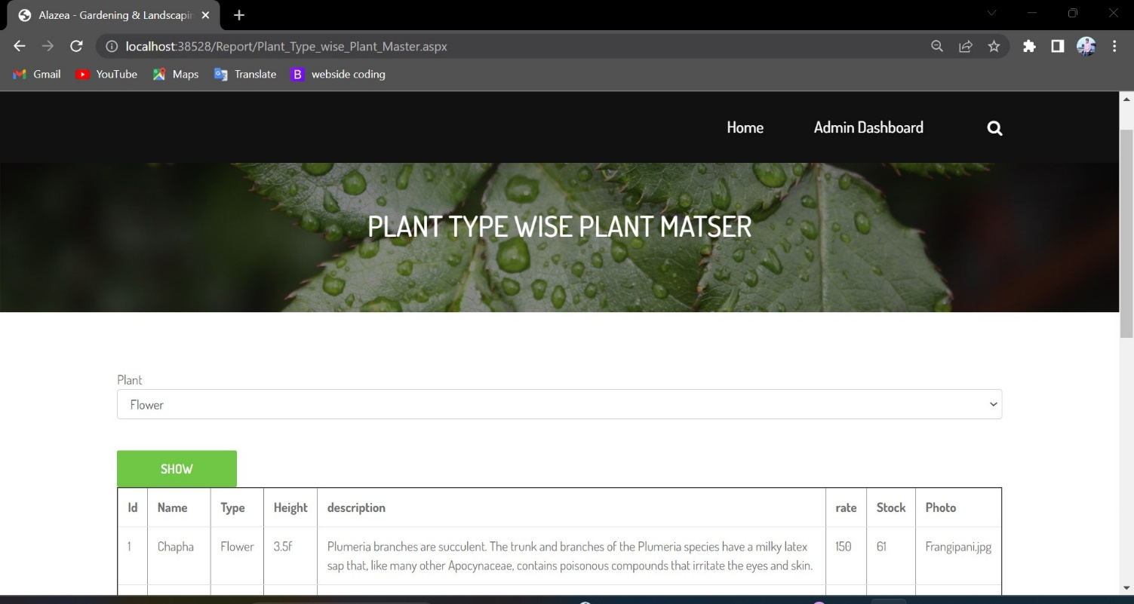

#### Plant Master Wise Order Detail:

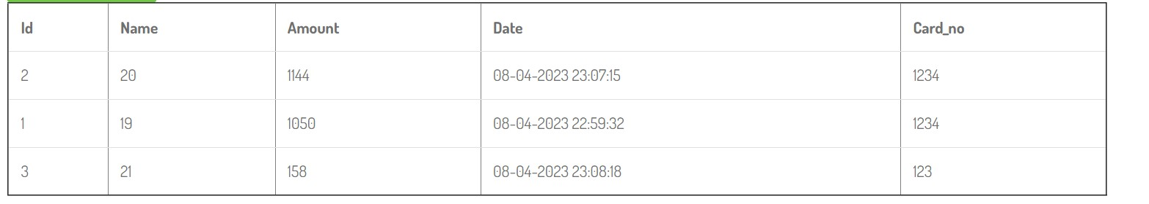

**Date Wise Reports: Order Master:**

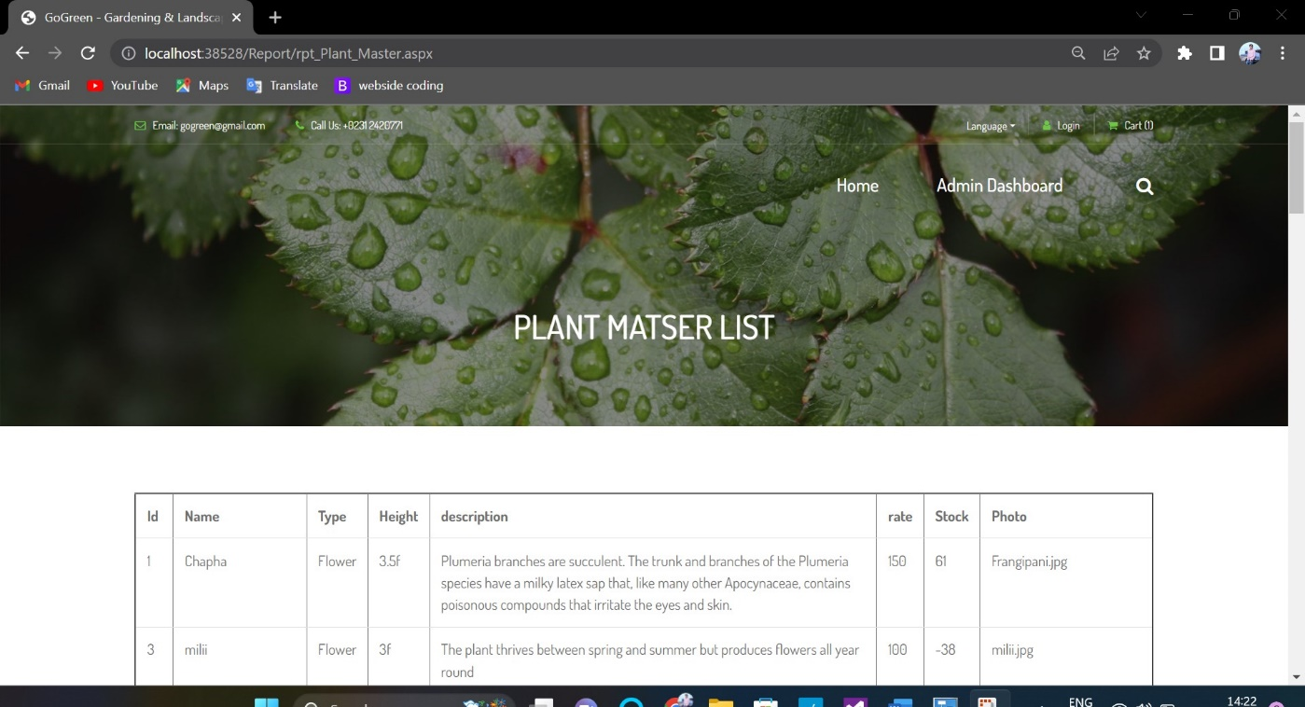

**CONCLUSION & SUGGESTIONS**

**Hotel Management System (Online Plant Order Module)**

* 1. **Conclusion**

The software development is never completed. There is always a need for modification.There could have been other approaches to implement the system. I have tried to my level best to make the system an interactive as possible. The system has been developed with muchcare and free of errors and at the same time it is efficient and less time consuming. The purpose of this project was to develop a web application for purchasing items from a shop.

This project helped us in gaining valuable information and practical knowledge on several topics like designing web pages using html & css, usage of responsive templates, designingof android applications, and management of database using mysql. The entire system is secured. Also the project helped us understanding about the development phases of a project and software development life cycle. We learned how to test different features of a project.

This project has given us great satisfaction in having designed an application which can be implemented to any nearby shops or branded shops selling various kinds of products by simple modification.

#### Limitations

Although I have put my best efforts to make the software flexible, easy to operate but limitations cannot be ruled out even by me. Though the software presents a broad range of options to its users some intricate options could not be covered into it; partly because of logistic and partly due to lack of sophistication. Paucity of time was also major constraint, thus it was not possible to make the software foolproof and dynamic. Lack of time also compelled me to ignore some part such as storing old result of the candidate etc. Considerable efforts have made the software easy to operate even for the people not related to the field of computers but it is acknowledged that a layman may find it a bit problematic at the first instance. The user is provided help at each step for his convenience in working with the software.

#### List of limitations :

Excel export has not been developed for Plant Item, Category due to some criticality.

The transactions are executed in off-line mode, hence on-line data for Customer, Order capture and modification is not possible.

Off-line reports of Plant Item, Confirm Order, Customer cannot be generated due to batch mode execution.

#### Suggestions

* + - **Expand integration with other systems:** One potential suggestion is to enhance the system's ability to integrate with other healthcare systems or platforms. This could help to reduce data silos and improve the flow of information between different systems.
    - **Implement advanced security measures:** To protect against security and privacy risks, it may be beneficial to implement advanced security measures such as encryption, authentication, and access controls.
    - **Increase scalability:** As the system grows and the volume of users and data increases, it may be necessary to enhance the system's scalability to ensure that it can handle theincreased load.
    - **Enhance data analysis and reporting capabilities:** To better support decision-making and continuous improvement in patient care, it may be beneficial to expand the system's data analysis and reporting capabilities. This could include the ability to generate more advanced reports, analyse data in real-time, and visualize data in interactive charts or graphs.
    - Chat feature can be included in the web application to chat with customer care.

# ANNEXURE

**REFERENCES**

## References

These are the following links which assist me at each and every step in completing this project, without them

* [www.google.com](http://www.google.com/)
* [www.mysql.com](http://www.mysql.com/)
* [www.w3schools.com](http://www.w3schools.com/)
* [www.google.co.in](http://www.google.co.in/)
* [www.geeksforgeeks.com](http://www.geeksforgeeks.com/)