12/6/2025
Submitted by: Vipul Sonawane
- Live Web App (Streamlit):
https://telcoguard-churn-prediction-dc4vzjut8kxuuppszhhvqv.streamlit.app/
- GitHub Repository:
https://github.com/pruthvirajtarode/TelcoGuard-Churn-Prediction

PROJECT REPORT
Project Title: “AI-Powered Customer Churn Prediction & Explainability System”
Abstract
Customer churn is one of the biggest challenges faced by telecom and service-based companies. Retaining existing customers is significantly more cost-effective than acquiring new ones.
TelcoGuard is an AI-powered churn prediction system that helps businesses:
- Predict which customers are likely to leave.
- Understand why they may leave using explainable AI (SHAP).
- Take proactive retention actions through a live web dashboard.
This system integrates Machine Learning, Data Analytics, and Explainable AI (XAI) and is deployed as a real-time web application using Streamlit Cloud.

Problem Statement
Telecom companies lose huge revenue due to unexpected customer churn. Traditional methods fail to:
- Predict churn early.
- Explain the reason behind churn.
- Provide actionable business insights.
Hence, there is a strong need for a smart AI-based churn prediction system with explainability.

Objectives
- Predict customer churn using Machine Learning
- Provide real-time predictions via a web application
- Explain predictions using SHAP
- Visualize customer behavior trends
- Enable business teams to take preventive actions
- Deploy the system on cloud for real-time usage

Technologies Used
Category | Tools
Programming | Python
ML Algorithms | Logistic Regression, Random Forest
Explainable AI | SHAP
Data Handling | Pandas, NumPy
Visualization | Matplotlib, Seaborn
Web Framework | Streamlit
Deployment | Streamlit Cloud
Version Control | Git & GitHub

System Architecture (High-Level)
User → Streamlit Web App → ML Prediction Engine → SHAP Explainability → Results Dashboard

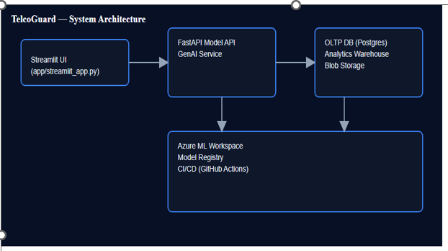
8. UML & System Diagrams (Add These Images in Report)

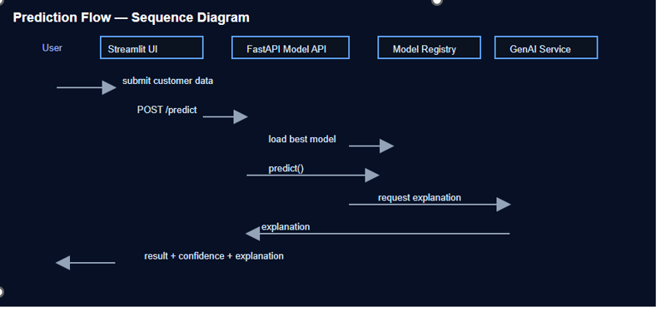
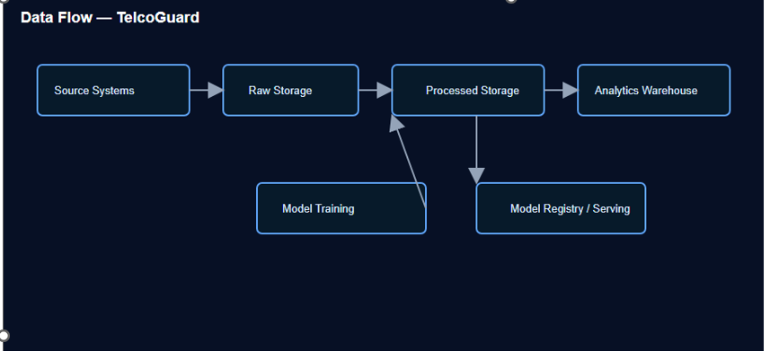
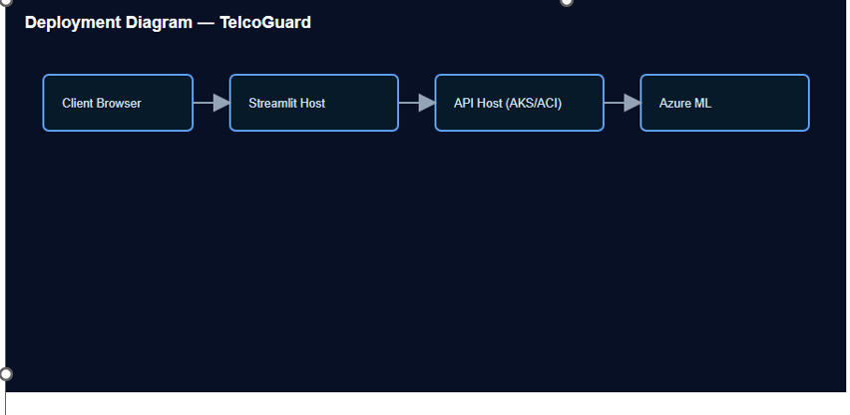
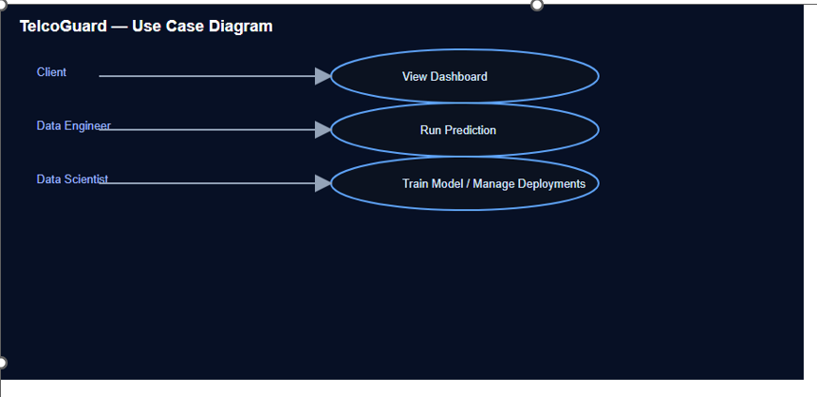



9. Dataset Description
The system uses a Telecom Customer Churn Dataset containing:
- Customer demographics
- Subscription details
- Payment information
- Service usage metrics
- Churn status (Target Variable)
Target Output:
- 1 → Customer will churn
- 0 → Customer will not churn

10. Machine Learning Model Details
- Data Preprocessing:
  - Missing value handling
  - Encoding categorical variables
  - Feature scaling
- Algorithms Used:
  - Logistic Regression
  - Random Forest Classifier
- Evaluation Metrics:
  - Accuracy
  - Precision
  - Recall
  - F1-Score
The model with the best performance is selected for deployment.

11. Explainable AI (SHAP Integration)
TelcoGuard integrates SHAP (SHapley Additive exPlanations) to:
- Show feature importance
- Explain individual customer predictions
- Improve business trust in AI decisions
SHAP outputs clearly show which factors contribute most to churn.

12. Web Application Features
✅ Customer data input
✅ Live churn prediction
✅ Probability score
✅ SHAP explanation graph
✅ Customer behavior visualizations
✅ Business insights dashboard
✅ Fully cloud deployed

13. Deployment Architecture
Client Browser → Streamlit Cloud → ML Model → SHAP Engine → Result Output
The system is fully accessible via the cloud with no local setup required for users.

14. Results & Performance
- Achieved high prediction accuracy
- Real-time prediction speed
- Visual interpretability using SHAP
- Smooth UI experience for business users

15. Business Benefits
- ✅ Reduces customer churn
- ✅ Improves customer retention strategies
- ✅ Enhances business revenue
- ✅ Builds trust through explainable AI
- ✅ Supports data-driven decisions

16. Future Enhancements
- Deep Learning integration
- CRM system integration
- Automated retention recommendations
- API for mobile applications
- Live database connection

17. Conclusion
TelcoGuard is a powerful, real-time, cloud-deployed AI solution that helps telecom and service companies:
- Predict churn accurately
- Understand customer behavior
- Make smarter retention decisions
This project successfully demonstrates:
- Machine Learning
- Explainable AI
- Data Visualization
- Cloud Deployment
- Real-World Industry Application

