STUDENT RECORD AND
ACADEMIC MANAGEMENT SYSTEM
Python Collections Assignment — Complete Solution

Student Name | Pruthviraj Somvanshi
PRN | 2126UDSM1063
Department | AIDS
Project focus | Store, search, update, delete and report student academic records.
Python concepts: Strings, lists, tuples, sets, dictionaries, loops, functions and validation.
Included: Problem analysis, data-structure selection, algorithms, flowcharts, pseudocode, code, test cases and README notes.
Prepared from the assignment brief supplied.

1. Problem Understanding and Analysis
Problem statement: Develop a menu-driven Python application that stores student details and academic results, then lets a user add, search, update, delete, display and analyse those records. The system must reject duplicate roll numbers and handle invalid or empty inputs safely.
Objective: Use Python collections in a connected program and make student data easy to organize, retrieve and summarize.
Inputs: Roll number, registration number, name, department, date of birth, contact details, subjects, marks, attendance, clubs and menu choice.
Outputs: Student profile, confirmation/error messages, overall average marks, highest scorer, department-wise student list, total student count and collection summaries.
Relationships: Each roll number identifies one student. A student can have several subjects and marks; each mark corresponds to a subject at the same list position. Contact information belongs to that student. A student may join zero or more clubs.
Assumptions: Roll numbers are unique text values; marks and attendance are percentages from 0 to 100; each student has 1–10 subjects; dates use YYYY-MM-DD; records remain in memory while the program is running (no database/file persistence is requested in the brief).

2. Data Structure Selection
Structure | How it is used | Reason
String | Name, department, address, email, phone and subject names. | Stores readable text.
List | Subjects and marks for one student. | Keeps order; subjects and marks align by index.
Tuple | Identity tuple: (roll, registration number, date of birth). | Groups identity fields in a fixed sequence.
Set | Unique departments, subjects and clubs across all students. | Automatically avoids duplicate values.
Dictionary | Main students mapping and each student profile/contact details. | Fast lookup by roll number and clear key-value fields.
Main data model: students[roll] = {identity: tuple, name: string, department: string, subjects: list, marks: list, attendance: number, contact: dictionary, clubs: set}

3. Algorithms

Add student
- Start
- Read roll number
- If roll already exists, show duplicate warning and stop this operation
- Read and validate profile fields, date, subjects, marks and attendance
- Build profile using tuple, lists, set and dictionaries
- Store profile in students[roll]; update summary sets
- Show success message
- End

Search student
- Start
- Read roll number
- Look up students[roll]
- If found, display profile; otherwise show not found
- End

Update record
- Start
- Read roll number
- Check whether record exists
- If not found, show message and stop
- Choose a supported field
- Read and validate new value
- Update the selected field
- Show confirmation
- End

Delete record
- Start
- Read roll number
- Check whether record exists
- If not found, show message and stop
- Ask for confirmation
- If confirmed, delete record and rebuild summary sets
- Show result
- End

Display records
- Start
- Check whether students is empty
- If empty, show no-records message
- Otherwise display each student in sorted roll order
- End

Calculate average
- Start
- Check whether records and marks exist
- Add all marks and count all marks
- Average = total marks / number of marks
- Display average
- End

Generate reports
- Start
- Show report menu option
- For highest scorer, compare each student average
- For department report, filter by department
- For count, use number of records
- Display requested report
- End

4. Flowcharts
Rounded terminator = start/end; rectangle = process; diamond = decision. The diagrams have been redrawn in a consistent format for readability.

Add Student Flowchart
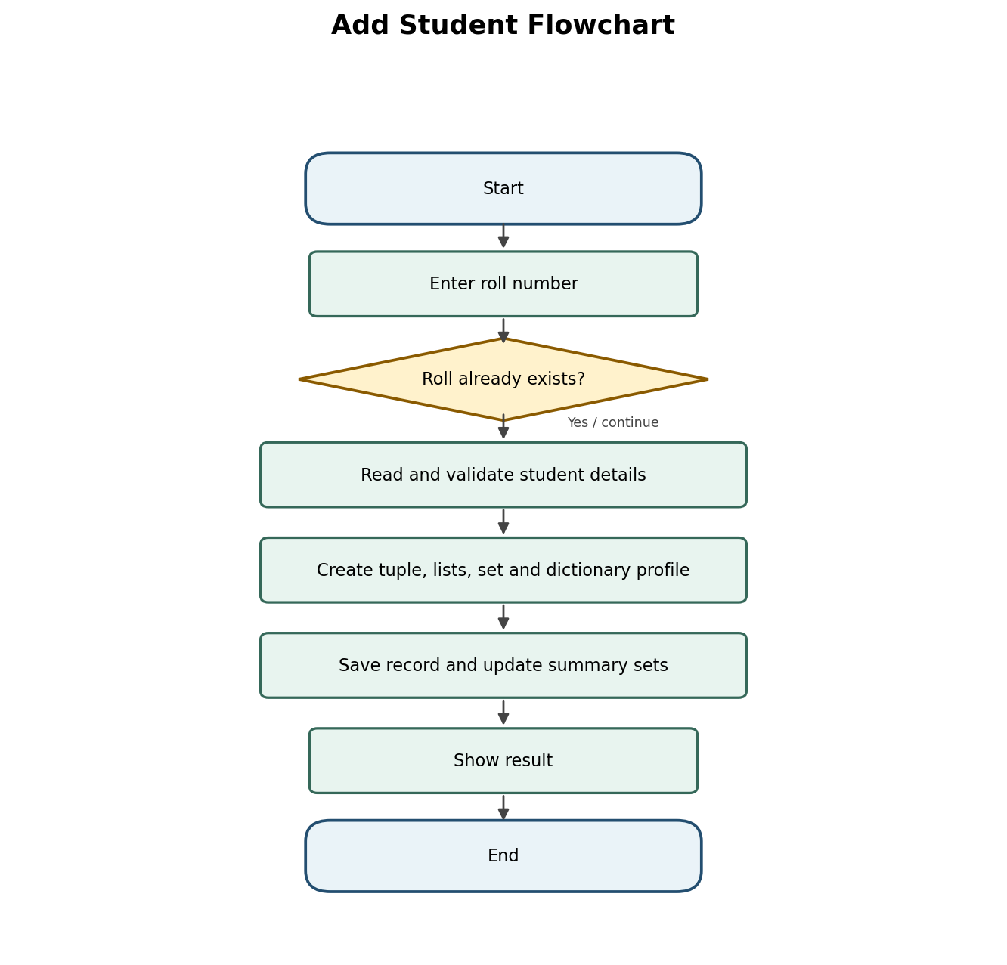

Search Student Flowchart
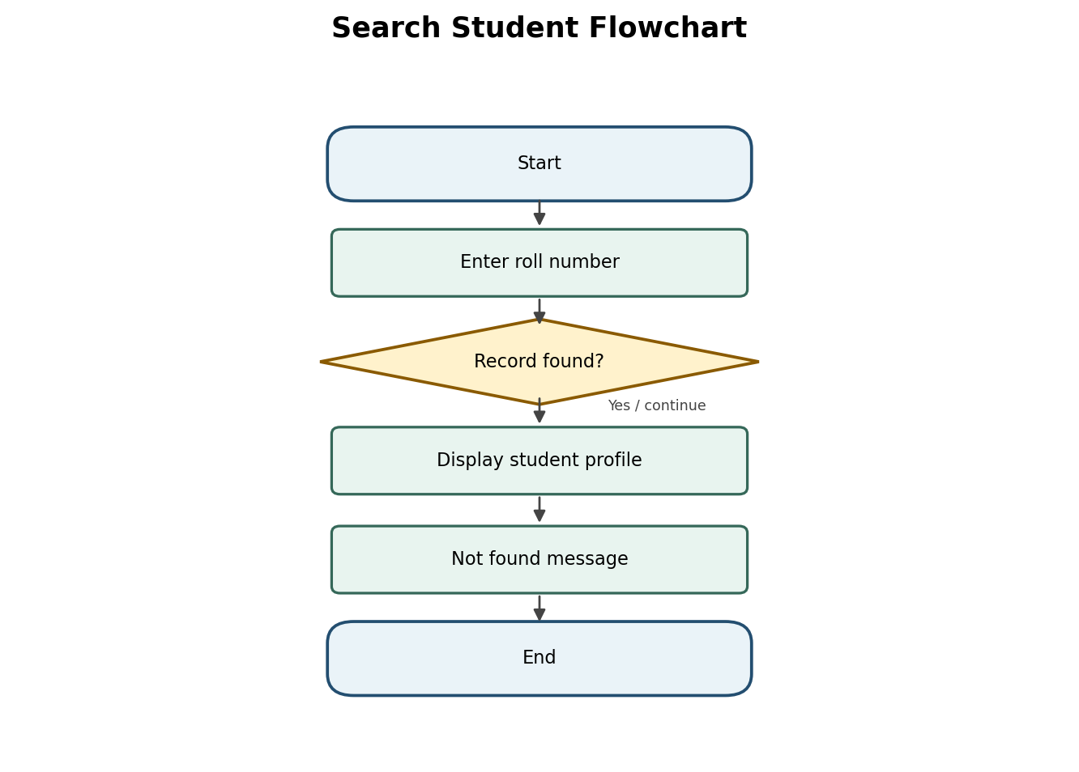

Update Record Flowchart
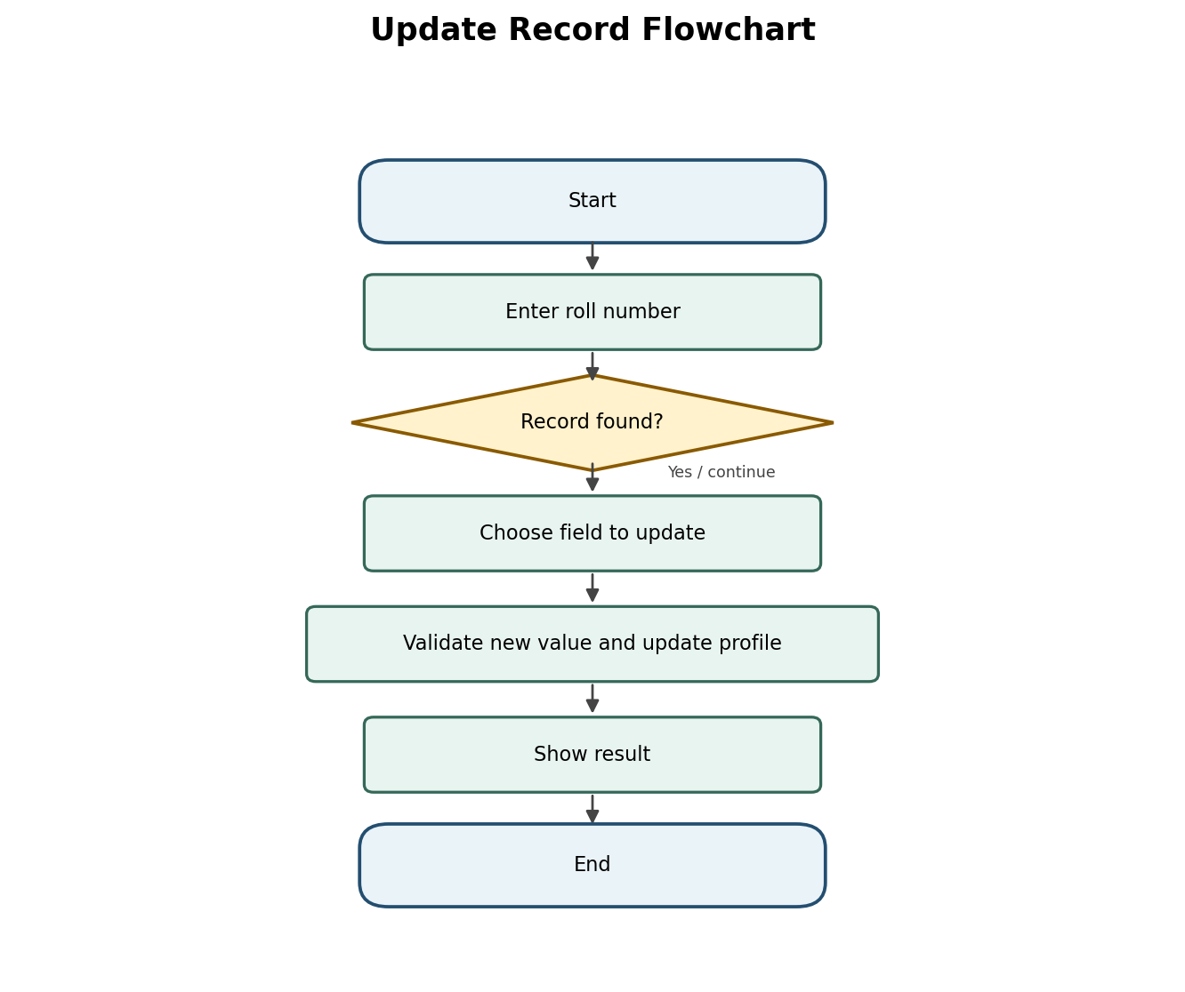

Delete Record Flowchart
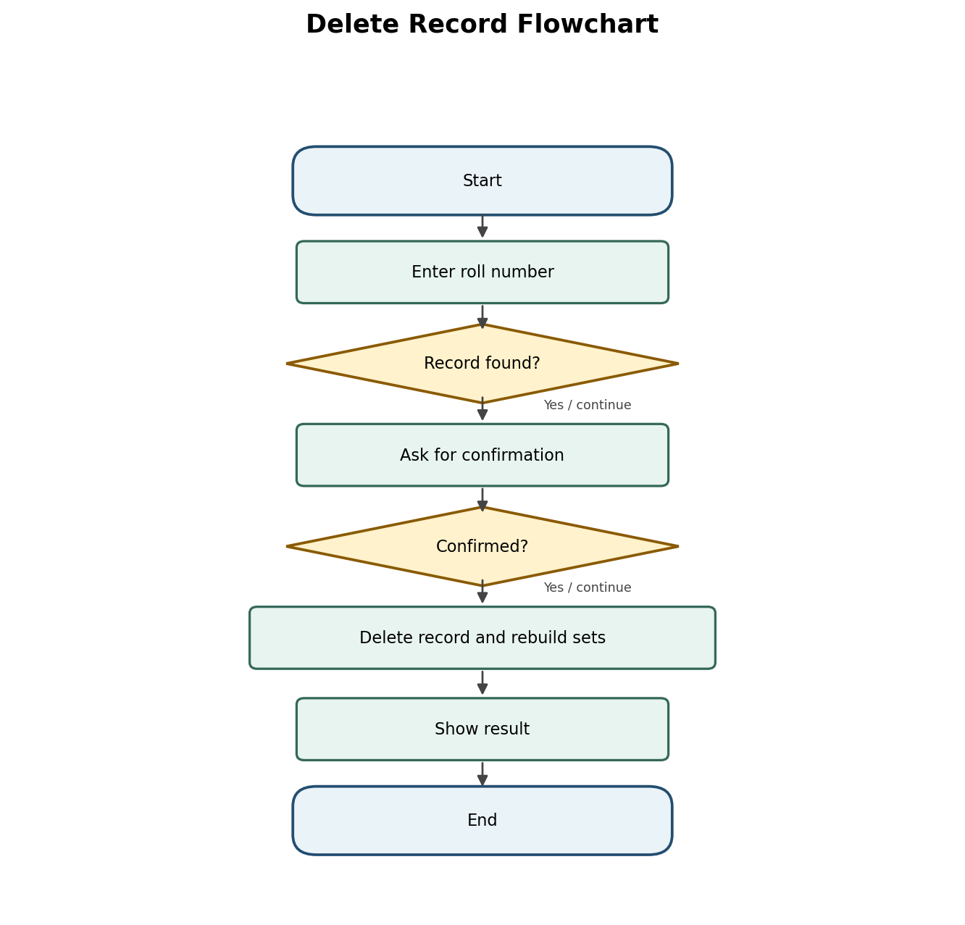

Display Records Flowchart
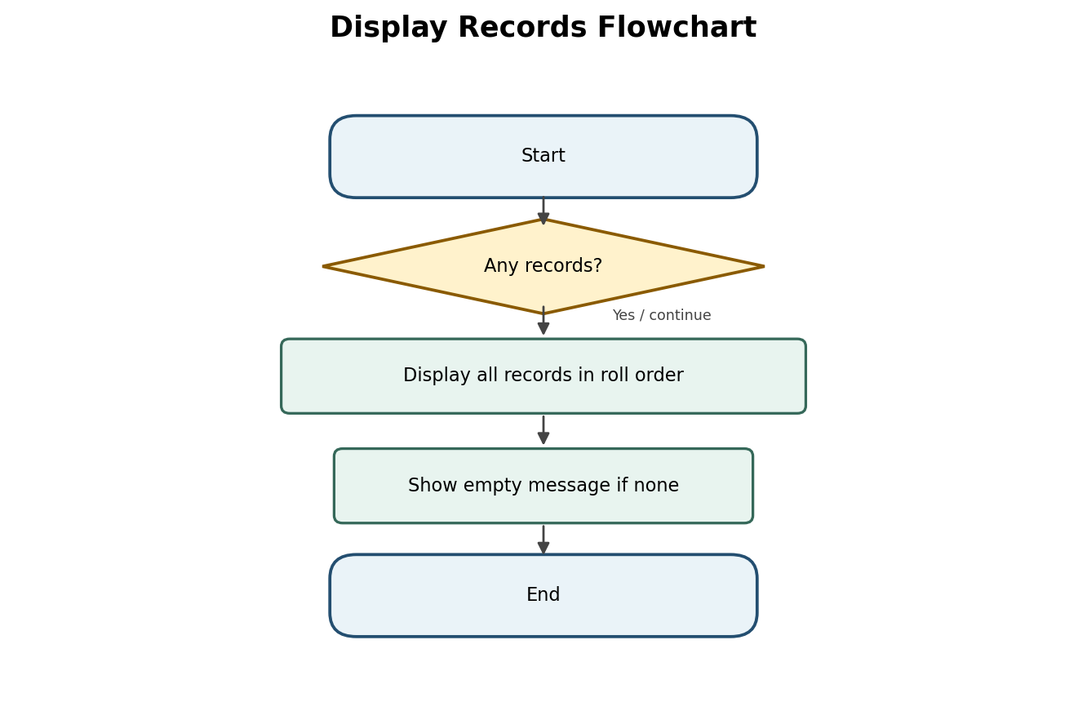

Calculate Average Flowchart
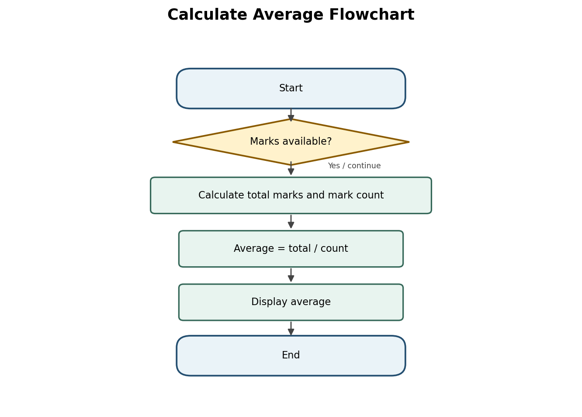

Generate Reports Flowchart
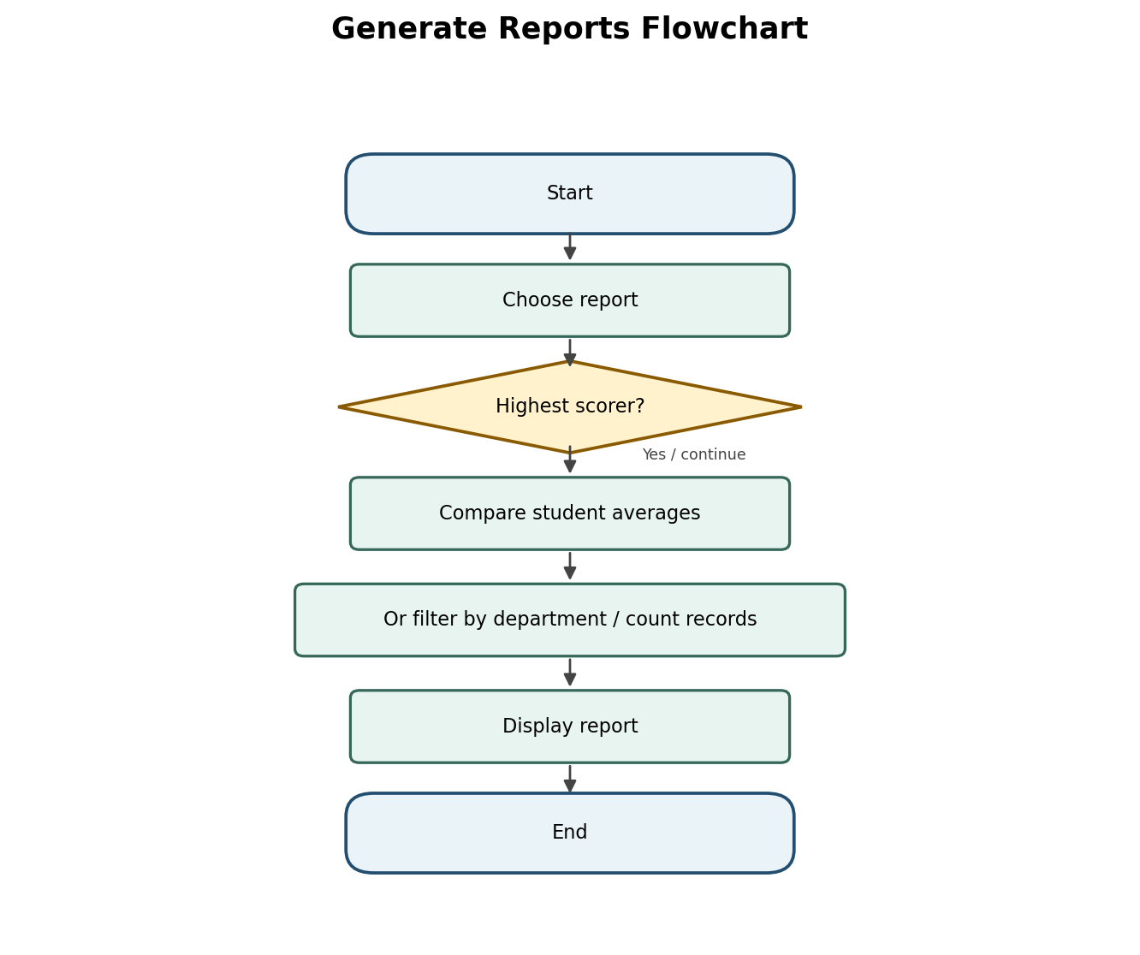

5. Pseudocode
ADD STUDENT
BEGIN
INPUT roll
IF roll exists in students THEN
DISPLAY "Duplicate roll number"; RETURN
ENDIF
INPUT and validate student identity and contact fields
INPUT subjects and corresponding marks
INPUT attendance and clubs
profile ← dictionary containing tuple, lists, contact dictionary and club set
students[roll] ← profile
UPDATE department, subject and club sets
DISPLAY success
END
SEARCH STUDENT
BEGIN
INPUT roll
IF roll exists in students THEN
DISPLAY students[roll]
ELSE
DISPLAY "Record not found"
ENDIF
END
UPDATE / DELETE
BEGIN
INPUT roll
IF roll does not exist THEN DISPLAY "Not found"; RETURN
For UPDATE: choose field, validate value, update profile
For DELETE: ask confirmation; if yes, remove record and rebuild sets
DISPLAY result
END
AVERAGE / REPORTS
BEGIN
IF no records or no marks THEN DISPLAY suitable message
ELSE
total ← sum of all recorded marks
count ← number of recorded marks
overall_average ← total / count
DISPLAY overall_average
ENDIF
For highest scorer, compare each student's average
For department report, filter records by department
For student count, display length of students
END

6. Python Source Code
The complete source code is included below for documentation. Use a Python 3.10 or later interpreter to run the program.
# Student Record and Academic Management System
# Python Collections: Strings, Lists, Tuples, Sets, Dictionaries
# Records are saved automatically in students.json.

import json
import os

DATA_FILE = "students.json"
students = []

def load_students():
"""Load saved records when the program starts."""
global students
if not os.path.exists(DATA_FILE):
students = []
return
try:
with open(DATA_FILE, "r", encoding="utf-8") as file:
data = json.load(file)
students = data if isinstance(data, list) else []
print(f"Loaded {len(students)} saved student record(s).")
except (json.JSONDecodeError, OSError):
students = []
print("Could not read saved records. Starting with an empty list.")

def save_students():
"""Save all records to a JSON file."""
try:
with open(DATA_FILE, "w", encoding="utf-8") as file:
json.dump(students, file, indent=4, ensure_ascii=False)
except OSError:
print("Warning: records could not be saved.")

def find_student(roll_no):
for student in students:
if student["roll_no"].lower() == roll_no.lower():
return student
return None

def read_number(prompt, minimum=None, maximum=None, whole_number=False):
while True:
try:
value = input(prompt).strip()
number = int(value) if whole_number else float(value)
if minimum is not None and number < minimum:
print(f"Value must be at least {minimum}.")
continue
if maximum is not None and number > maximum:
print(f"Value must not be more than {maximum}.")
continue
return number
except ValueError:
print("Invalid input. Please enter a valid number.")

def read_non_empty(prompt):
while True:
value = input(prompt).strip()
if value:
return value
print("This field cannot be empty.")

def read_marks():
return read_number("Enter marks (0-100): ", 0, 100)

def read_attendance():
return read_number("Enter attendance percentage (0-100): ", 0, 100)

def add_student():
print("\n--- Add Student ---")
roll_no = read_non_empty("Enter Roll Number: ")
if find_student(roll_no):
print("This roll number already exists. Duplicate record not added.")
return

name = read_non_empty("Enter Student Name: ")
department = read_non_empty("Enter Department: ")
registration_no = input("Enter Registration Number (or press Enter to skip): ").strip()
dob = input("Enter Date of Birth (or press Enter to skip): ").strip()
address = input("Enter Address (or press Enter to skip): ").strip()
email = input("Enter Email ID (or press Enter to skip): ").strip()
phone = input("Enter Contact Number (or press Enter to skip): ").strip()

subjects_text = input("Enter Subjects separated by commas: ").strip()
subjects = [subject.strip() for subject in subjects_text.split(",") if subject.strip()]

marks = read_marks()
attendance = read_attendance()

# Tuple example: roll number and registration number are grouped as identifiers.
identifiers = (roll_no, registration_no)

student = {
"roll_no": identifiers[0],
"registration_no": identifiers[1],
"name": name,
"department": department,
"dob": dob,
"address": address,
"email": email,
"phone": phone,
"subjects": subjects,
"marks": marks,
"attendance": attendance
}

students.append(student)
save_students()
print("Student added and saved successfully!")

def print_student(student):
print("-" * 35)
print("Roll Number:", student.get("roll_no", ""))
print("Registration Number:", student.get("registration_no", ""))
print("Name:", student.get("name", ""))
print("Department:", student.get("department", ""))
print("Date of Birth:", student.get("dob", ""))
print("Address:", student.get("address", ""))
print("Email:", student.get("email", ""))
print("Contact:", student.get("phone", ""))
print("Subjects:", ", ".join(student.get("subjects", [])))
print("Marks:", student.get("marks", 0))
print("Attendance:", str(student.get("attendance", 0)) + "%")

def display_students():
print("\n--- Display All Students ---")
if not students:
print("No student records found.")
return
for student in students:
print_student(student)
print("-" * 35)
print("Total students:", len(students))

def search_student():
print("\n--- Search Student ---")
roll_no = input("Enter Roll Number to search: ").strip()
student = find_student(roll_no)
if student:
print_student(student)
else:
print("Student not found.")

def update_student():
print("\n--- Update Student ---")
roll_no = input("Enter Roll Number to update: ").strip()
student = find_student(roll_no)
if not student:
print("Student not found.")
return

print("Press Enter to keep the existing value.")
fields = [
("name", "Name"),
("department", "Department"),
("registration_no", "Registration Number"),
("dob", "Date of Birth"),
("address", "Address"),
("email", "Email ID"),
("phone", "Contact Number")
]
for key, label in fields:
current = student.get(key, "")
value = input(f"{label} [{current}]: ").strip()
if value:
student[key] = value

subjects_text = input(
"Update subjects (comma-separated, or Enter to keep current): "
).strip()
if subjects_text:
student["subjects"] = [
item.strip() for item in subjects_text.split(",") if item.strip()
]

if input("Update marks? (y/n): ").strip().lower() == "y":
student["marks"] = read_marks()
if input("Update attendance? (y/n): ").strip().lower() == "y":
student["attendance"] = read_attendance()

save_students()
print("Student record updated and saved.")

def delete_student():
print("\n--- Delete Student ---")
roll_no = input("Enter Roll Number to delete: ").strip()
student = find_student(roll_no)
if not student:
print("Student not found.")
return

confirm = input(
f'Confirm deletion of {student.get("name", "this student")}? (y/n): '
).strip().lower()
if confirm == "y":
students.remove(student)
save_students()
print("Student deleted.")
else:
print("Deletion cancelled.")

def average_marks():
print("\n--- Average Marks ---")
if not students:
print("No student records found.")
return
average = sum(float(s.get("marks", 0)) for s in students) / len(students)
print(f"Average Marks: {average:.2f}")

def highest_scorer():
print("\n--- Highest Scorer ---")
if not students:
print("No student records found.")
return
highest = max(students, key=lambda s: float(s.get("marks", 0)))
print_student(highest)

def list_by_department():
print("\n--- List Students by Department ---")
department = input("Enter Department to list: ").strip()
matches = [
student for student in students
if student.get("department", "").lower() == department.lower()
]
if not matches:
print("No students found in this department.")
return
for student in matches:
print_student(student)
print("Students in this department:", len(matches))

def count_students():
print("\n--- Count Students ---")
print("Total student records:", len(students))
if students:
# Set keeps only unique department names.
departments = {s.get("department", "") for s in students if s.get("department", "")}
print("Number of different departments:", len(departments))
print("Departments:", ", ".join(sorted(departments)))

def collections_demo():
print("\n--- Python Collections Demonstration ---")
# List: student records and subject lists.
print("Student records are stored in a LIST.")
print("Number of records:", len(students))

# Tuple: immutable example.
sample_tuple = ("Roll Number", "Registration Number", "Date of Birth")
print("Example tuple:", sample_tuple)

# Set: unique departments and subjects.
departments = {s.get("department", "") for s in students if s.get("department", "")}
subjects = {
subject
for s in students
for subject in s.get("subjects", [])
}
print("Unique departments (set):", departments)
print("Unique subjects (set):", subjects)

# String examples.
if students:
name = students[0].get("name", "")
print("First student's name in uppercase:", name.upper())
print("First student's name length:", len(name))
else:
print("Add a student to see string examples.")

def main():
load_students()
while True:
print("\n==========================================")
print(" STUDENT RECORD AND ACADEMIC MANAGEMENT")
print("==========================================")
print("1. Add Student")
print("2. Display All Students")
print("3. Search Student")
print("4. Update Student")
print("5. Delete Student")
print("6. Calculate Average Marks")
print("7. Find Highest Scorer")
print("8. List Students by Department")
print("9. Count Students")
print("10. Python Collections Demonstration")
print("11. Exit")

choice = input("Enter your choice (1-11): ").strip()

if choice == "1":
add_student()
elif choice == "2":
display_students()
elif choice == "3":
search_student()
elif choice == "4":
update_student()
elif choice == "5":
delete_student()
elif choice == "6":
average_marks()
elif choice == "7":
highest_scorer()
elif choice == "8":
list_by_department()
elif choice == "9":
count_students()
elif choice == "10":
collections_demo()
elif choice == "11":
save_students()
print("Records saved. Thank you!")
break
else:
print("Invalid choice. Enter a number from 1 to 11.")

if __name__ == "__main__":
main()

7. Testing and Dry-Run Report
Test | Input / condition | Expected result
T1 | Add a new roll number with valid data | Record saved; success message shown
T2 | Add a roll number that already exists | Duplicate warning; old record unchanged
T3 | Search for an existing roll number | Full profile is displayed
T4 | Search for a missing roll number | Not-found message
T5 | Enter text instead of marks | Invalid-number message; asks again
T6 | Enter marks -1 or 101 | Range warning; asks again
T7 | Enter attendance 0 or 100 | Accepted as boundary values
T8 | Display records before adding any | No-records message
T9 | Delete a record and confirm y | Record removed; summary sets rebuilt
T10 | Choose an invalid menu option | Invalid-choice message; menu repeats
T11 | Calculate average with valid marks | Sum of marks divided by number of marks
T12 | Enter an invalid date | Date validation message; record not saved
Dry-run example: Marks [80, 90, 70] give total = 240, count = 3 and average = 80.00. If another student has average 85, the highest-scorer report shows that student.
Observations: Duplicate roll numbers are prevented; numerical inputs are checked; empty collections are handled; boundary marks and attendance from 0 to 100 are accepted; department matching ignores letter case.
Limitations: Data is stored in memory and disappears when the program exits. A real deployment would use file/database storage, stronger email/phone validation, access control and backups.

8. How to Run the Program
- Install Python 3.10 or later (standard Python libraries only).
- Save student_record_management_system.py to a folder.
- Open Command Prompt / Terminal in that folder.
python student_record_management_system.py
- Choose a number from the menu. Select 0 to exit.

9. README / Conclusion
Project name: Student Record and Academic Management System.
Purpose: Demonstrate how Python collections can work together to manage student academic records.
Features: Add, search, update, delete, display, calculate average, identify highest scorer, filter by department, count students, and list unique departments/subjects/clubs.
Conclusion: The program integrates strings, lists, tuples, sets and dictionaries in one application. Functions keep the code organized, loops support repeated menu use, and validation improves reliability. Test cases cover normal inputs, duplicates, missing records, invalid values, empty data and boundary values.
Before submission: Run the Python file and attach screenshots if your instructor requires them.

