Privacify: single-click local AI redaction
Install flow, UI screenshots, smoke test, and everyday usage
Positioning: Privacify is a Windows clipboard assistant for redacting sensitive text with local models, plus deterministic fallback rules for predictable safety.

Smoke test result: the local manager UI loaded at http://127.0.0.1:8787, the Privacify test completed, and sample PII was replaced with placeholders such as [EMAIL], [PHONE], [SSN], [PAYMENT_CARD], and [ADDRESS].
Area | Current behavior
Single-click installer | Install Privacify.cmd prepares app files, bundled Node runtime for the UI, AutoHotkey hotkeys, desktop shortcut, optional startup entry, Ollama, and the default model.
Manager UI | Local web UI manages models, Ollama URL, branding, hotkeys, prompts, examples, test runs, and logs.
Hotkey flow | Copy text, press Ctrl+Alt+4, wait for the ready sound/tray notification, then paste the redacted result.
Local/distributed AI angle | The sensitive text can be processed on the user machine first, with the architecture leaving room for local, edge, and cloud routing by policy.

- Download or unzip the Privacify Windows package.
- Double-click Install Privacify.cmd.
- Open Privacify Manager from the desktop shortcut or http://127.0.0.1:8787/.
- Copy sensitive text from any app, press Ctrl+Alt+4, then paste the redacted output after the ready signal.
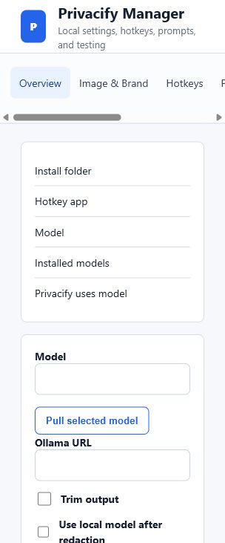
Manager overview: local install path, model selection, Ollama URL, and model toggle.

UI Surface
The UI is intentionally not just a demo box. It exposes the controls a user will actually need after install: hotkeys, prompts, examples, model selection, and test runs.
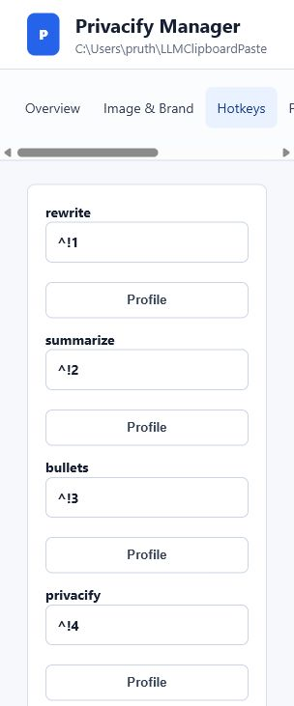 | 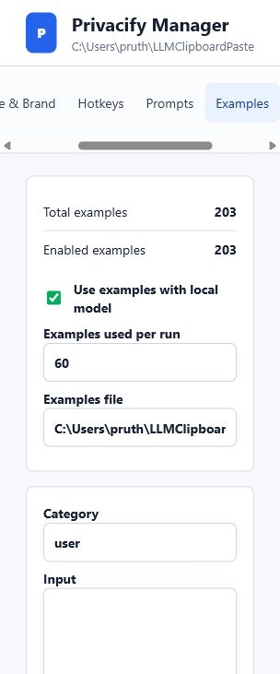
Hotkeys: rewrite, summarize, bullets, and privacify profiles. | Examples: 203 examples available, 60 used per run.

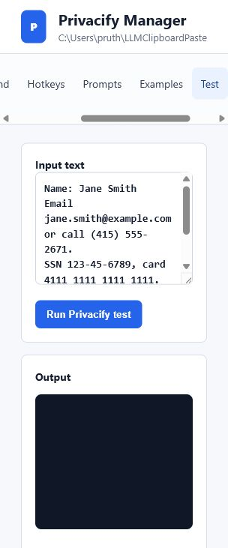 | 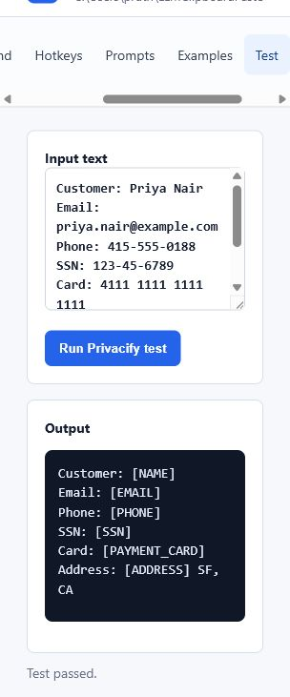
Test input: realistic mixed PII in one paste. | Test result: local model-backed redaction completed.

One-Click Install Checklist
- Create a GitHub Release with Privacify-Windows.zip.
- Zip should contain Install Privacify.cmd, install.ps1, README.md, and src/.
- README should say: unzip, double-click Install Privacify.cmd, use Ctrl+Alt+4, manage at http://127.0.0.1:8787/.
- The installer should avoid requiring users to install Node manually; the current script bundles Node into the install directory.

