Q-1. Write an SQL query to fetch “FIRST_NAME” from Worker table using the alias

name as <WORKER_NAME>;.

**Table used for this Assignment:**

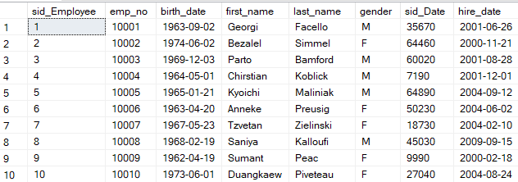

**Query**:

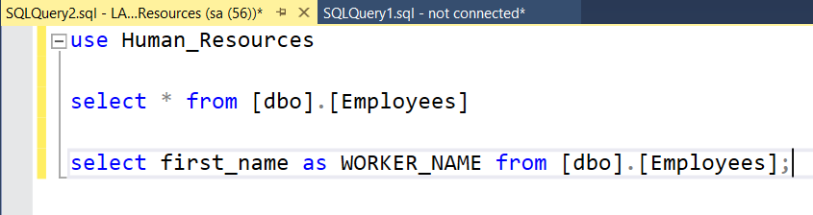

**Output**:

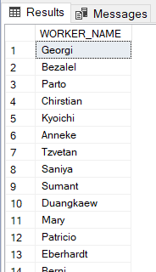

Q-2. Write an SQL query to fetch unique values of DEPARTMENT from Worker table.

**Table used for this Assignment:**

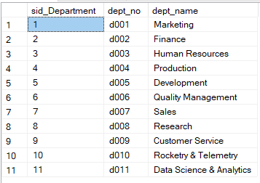

**Query**:

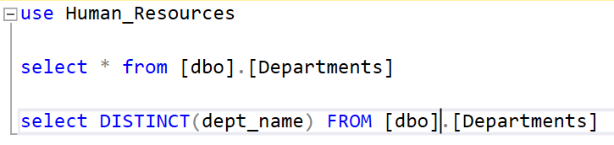

**Output**:

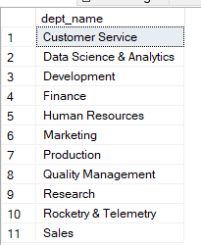

Q-3. Write an SQL query to show the last 5 record from a table.

**Table used for this Assignment:**



**Query**:

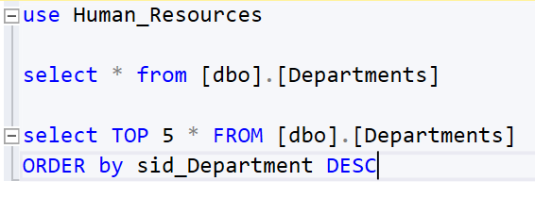

**Output**:

