Sexology of Tantra
Uday Dokras Ph D
Not spitefully binding or beating someone,
Not cruelly stabbing someone with a spear;
Passion is offered to a passionate human.
It may not be a virtue, but how could it be a sin?
From A Treatise on Passion (1967) by Gendun Chopel
In both the Buddhist and Saiva contexts, the sexual practices are often seen as a way to expand one's consciousness through the use of bliss.
There is also a fundamental philosophical disagreement between Śaiva Siddhānta and the non-dualistic schools like the Trika regarding ritual. In Śaiva Siddhānta, only ritual can do away with "innate impurities" (anavamala) that bind individual Selfs, though the ritual must be performed with an understanding of their nature and purpose as well as with devotion. In the view of the Trika school (especially in the work of Abhinavagupta), only knowledge (jñana) which is a "recognition" (pratyabhijña) of our true nature, leads to liberation. According to Padoux, "this is also, with nuances, the position of the Pñcaratra and of other Vaisnava Tantric traditions."

Yoga, mantra, meditation
Tantric yoga is first and foremost an embodied practice, which is seen as having a divine esoteric structure. As noted by Padoux, tantric yoga makes use of a "mystic physiology" which includes various psychosomatic elements sometimes called the "subtle body". This imaginary inner structure includes chakras ("wheels"), nadis ("channels"), and energies (like Kundalini, Chandali, different pranas and vital winds, etc.). The tantric body is also held to be a microcosmic reflection of the universe, and is thus seen as containing gods and goddesses.[ According to Padoux, the "internalized image of the yogic body" is a fundamental element for nearly all meditative and tantric ritual practices.
The use of mantras is one of the most common and widespread elements of tantric practice. They are used in rituals as well as during various meditative and yogic practices. Mantra recitation (japa) is often practiced along with nyasa ("depositing" the mantra), mudras ("seals", i.e. hand gestures) and complex visualizations involving divine symbols, mandalas and deities. Nyasa involves touching various parts of the body while reciting mantra, which is thought to connect the deity with the yogis body and transform the body into that of the deity.
Mantras are also often visualized as being located within the yogi's body as part of tantric meditations. For example, in the "Yogini Heart" tantra, a Śrī Vidyā text, the yogi is instructed to imagine the five syllables (HA SA KA LA HRIM) of the deity's mantra in the muladhara chakra. The next set of five syllables (HA SA KA HA LA HRIM) is visualized in the heart chakra and the third cluster (SA KA LA HRIM) in the cakra between the eyebrows. The yogi is further instructed to lengthen the enunciation of the M sound at the end of the HRIM syllable, a practice called nada (phonic vibration). This practice goes through various increasingly subtle stages until it dissolves into the silence of the Absolute.
Another common element found in tantric yoga is the use of visionary meditations in which tantrikas focus on a vision or image of the deity (or deities), and in some cases imagine themselves as being the deity and their own body as the body of the deity. The practitioner may use visualizations, identifying with a deity to the degree that the aspirant "becomes" the Ishta-deva (or meditational deity). In other meditations, the deities are visualized as being inside the tantrika's body. For example, in Abhinavagupta's Tantraloka (chapter 15), the Trika "trinity" of goddesses (Parā, Parāparā, and Aparā) are visualized on the ends of the three prongs of a trident (located above the head). The rest of the trident is imagined positioned along the central axis of the yogi's body, with the blazing corpse of Shiva visualized in the head.

Mandalas and yantras
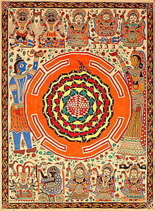
Sri Yantra diagram with the Ten Mahavidyas. The triangles represent Shiva and Shakti; the snake represents Spanda and Kundalini.

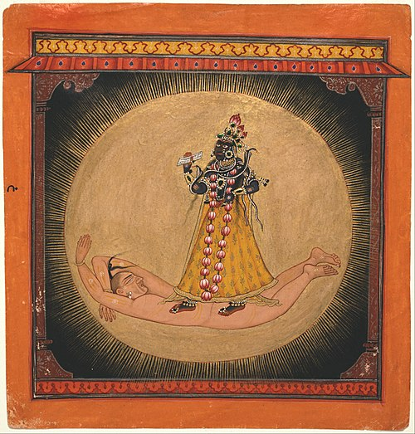
Yantra are mystical diagrams which are used in tantric meditation and ritual. They are usually associated with specific Hindu deities such as Shiva, Shakti, or Kali. Similarly, a puja may involve focusing on a yantra or mandala associated with a deity, Geometrical mandalas are a key element of Tantra. They are used to represent numerous tantric ideas and concepts as well as used for meditative focus. Mandalas symbolically communicate the correspondences between the "transcendent-yet-immanent" macrocosm and the microcosm of mundane human experience. The godhead (or principal Buddha) is often depicted at the center of the mandala, while all other beings, including the practitioner, are located at various distances from this center.] Mandalas also reflected the medieval feudal system, with the king at its centre.
Mandalas and Yantras may be depicted in various ways, on paintings, cloth, in three dimensional form, made out of colored sand or powders, etc. Tantric yoga also often involves the mental visualization of a mandala or yantra. This is usually combined with mantra recitation and other ritual actions as part of a tantric sadhana (practice).

Sex and eroticism While tantra involves a wide range of ideas and practices which are not always of a sexual nature, Flood and Padoux both note that in the West, Tantra is most often thought of as a kind of ritualized sex or a spiritualized yogic sexuality. According to Padoux, "this is a misunderstanding, for though the place of sex in Tantra is ideologically essential, it is not always so in action and ritual." Padoux further notes that while sexual practices do exist and were used by certain tantric groups, they "lost their prevalence when Tantra spread to other larger social groups."
In the tantric traditions which do use sex as part of spiritual practice (this refers mainly to the Kaulas, and also Tibetan Buddhism), sex and desire are often seen as a means of transcendence that is used to reach the Absolute. Thus, sex and desire are not seen as ends in themselves. Because these practices transgress orthodox Hindu ideas of ritual purity, they have often given tantra a bad image in India, where it is often condemned by the orthodox. According to Padoux, even among the traditions which accept these practices, they are far from prominent and practiced only by a "few initiated and fully qualified adepts"
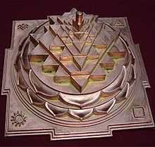
The Sri Yantra (shown here in the three-dimensional projection known as Sri Meru or Maha Meru, used primarily by Srividya Shakta sects).

John Woodroffe
The first Western scholar to seriously study Tantra was John Woodroffe (1865–1936), who wrote about Tantra under the pen name Arthur Avalon and is known as the "founding father of Tantric studies". Unlike previous Western scholars Woodroffe advocated for Tantra, defending and presenting it as an ethical and philosophical system in accord with the Vedas and Vedanta. Woodroffe practised Tantra and, while trying to maintain scholastic objectivity, was a student of Hindu Tantra (the Shiva-Shakta tradition).

Further development
Following Woodroffe, a number of scholars began investigating Tantric teachings, including scholars of comparative religion and Indology such as Agehananda Bharati, Mircea Eliade, Julius Evola, Carl Jung, Alexandra David-Néel, Giuseppe Tucci and Heinrich Zimmer. According to Hugh Urban, Zimmer, Evola and Eliade viewed Tantra as "the culmination of all Indian thought: the most radical form of spirituality and the archaic heart of aboriginal India", regarding it as the ideal religion for the modern era. All three saw Tantra as "the most transgressive and violent path to the sacred".
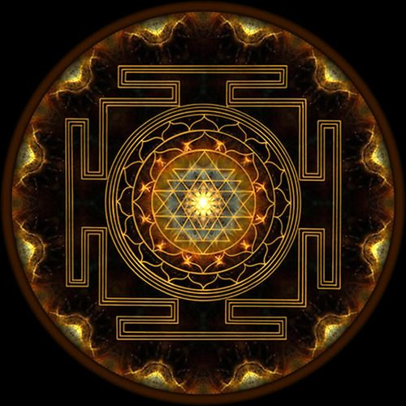
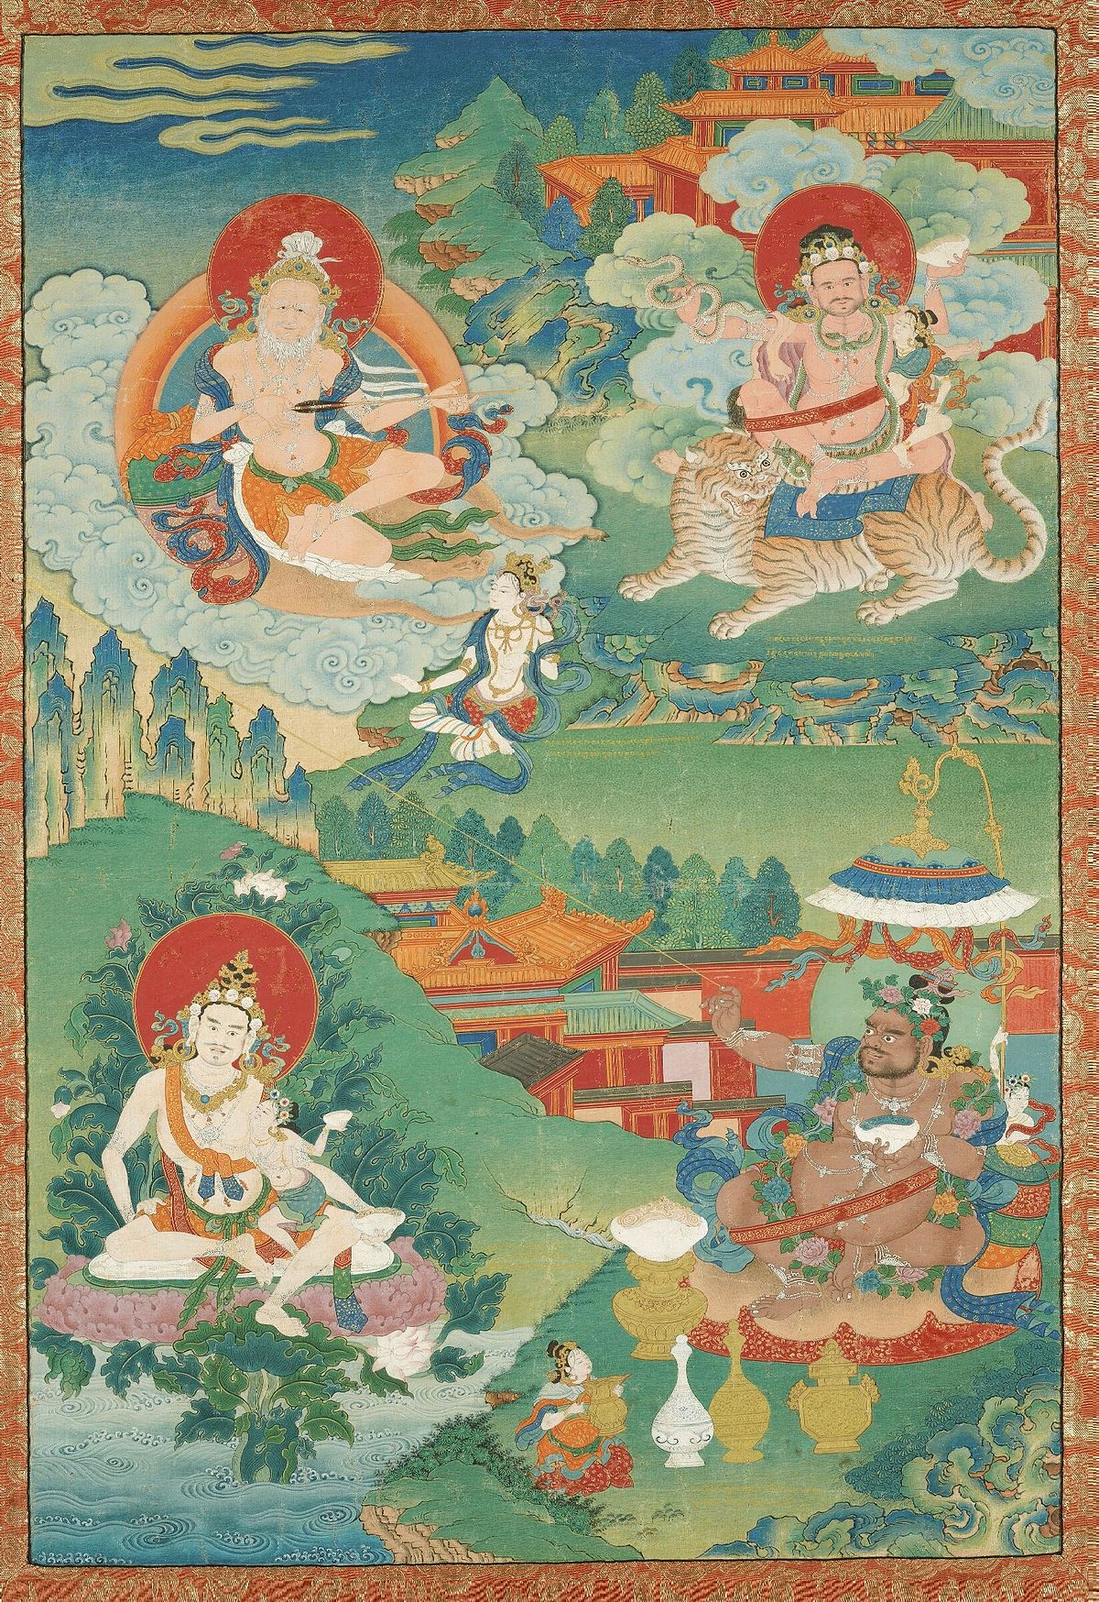
Indian Adept (siddha) - (multiple figures),18th century, Boston MFA


3 Angles by GYPSY H

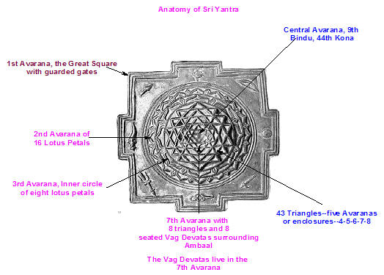
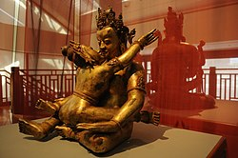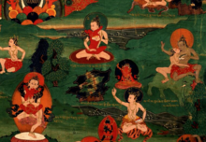
Jambhala (Kubera) deity in Tibet (18th-19th century)./Buddhist Mahasiddhas practicing tantric yoga
Tantric sex or sexual yoga refers to a wide range of practices carried on in Hindu and Buddhist tantra to exercise sexuality in a ritualized or yogic context, often associated with antinomian or impure elements, like consumption of alcohol, and offerings of impure substances like meat to fierce deities. In particular, sexual fluids have been viewed as "power substances" and used ritualistically, either externally or internally.^{[1][2]}
The actual terms used in the classical texts to refer to this practice include "Karmamudra" (Tibetan: ལས་ཀྱི་ཕྱག་རྒྱ las kyi phyag rgya, "action seal") in Buddhist tantras and "Maithuna" (Devanagari: मैथुन, "coupling") in Hindu sources. In Hindu Tantra, Maithuna is the most important of the five makara (five tantric substances) and constitutes the main part of the Grand Ritual of Tantra variously known as Panchamakara, Panchatattva, and Tattva Chakra. In Tibetan Buddhism, karmamudra is often an important part of the completion stage of tantric practice.
While there may be some connection between these practices and the Kāmashāstra literature (which include the Kāmasūtra), the two practice traditions are separate methods with separate goals. As the British Indologist Geoffrey Samuel notes, while the kāmasāstra literature is about the pursuit of sexual pleasure (kāmā), sexual yoga practices are often aimed towards the quest for liberation (moksha).^{[3]}
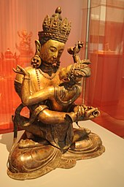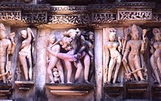
Vajradhara in union with consort/Maithuna, Lakshmana Temple, Khajuraho, Madhya Pradesh, India.
According to Samuel, late Vedic texts like the Jaiminiya Brahmana, the Chandogya Upanisad, and the Brhadaranyaka Upanisad, "treat sexual intercourse as symbolically equivalent to the Vedic sacrifice, and ejaculation of semen as the offering." The Brhadaranyaka Upanishad contains various sexual rituals and practices which are mostly aimed at obtaining a child which are concerned with the loss of male virility and power.^{[4]} One passage from the Brhadaranyaka Upanishad states:
Her vulva is the sacrificial ground; her pubic hair is the sacred grass; her labia majora are the Soma-press; and her labia minora are the fire blazing at the centre. A man who engages in sexual intercourse with this knowledge obtains as great a world as a man who performs a Soma sacrifice, and he appropriates to himself the merits of the women with whom he has sex. The women, on the other hand, appropriate to themselves the merits of a man who engages in sexual intercourse with them without this knowledge. (Brhadaranyaka Upanishad 6.4.3, trans. Olivelle 1998: 88)
One of the earliest mentions of sexual yoga is in the Mahayana Buddhist Mahāyānasūtrālamkāra of Asanga (c. 5th century). The passage states:
"Supreme self-control is achieved in the reversal of sexual intercourse in the blissful Buddha-poise and the untrammelled vision of one's spouse."
According to David Snellgrove, the text's mention of a ‘reversal of sexual intercourse’ might indicate the practice of withholding ejaculation. Snellgrove states:
It is by no means improbable that already by the fifth century when Asanga was writing, these techniques of sexual yoga were being used in reputable Buddhist circles, and that Asanga himself accepted such a practice as valid. The natural power of the breath, inhaling and exhaling, was certainly accepted as an essential force to be controlled in Buddhist as well as Hindu yoga. Why therefore not the natural power of the sexual force? [...] Once it is established that sexual yoga was already regarded by Asanga as an acceptable yogic practice, it becomes far easier to understand how Tantric treatises, despite their apparent contradiction of previous Buddhist teachings, were so readily canonized in the following centuries.
According to Geoffrey Samuel, while it is possible that some kind of sexual yoga existed in the fourth or fifth centuries,
Substantial evidence for such practices, however, dates from considerably later, from the seventh and eighth centuries, and derives from Saiva and Buddhist Tantric circles. Here we see sexual yoga as part of a specific complex of practices. On the Saiva side this is associated with a series of named teachers in South and North India, the Cittar (Siddha) teachers in the south, including Tirumülar and Bogar, and the so-called Nath teachers in the north, where the principal names are Matsyendra (Matsyendranath) and Gorakh (Gorakhnath). On the Buddhist side, it is associated with so-called Mahayoga Tantras. These developments appear to be happening at more or less the same time in all three areas.
Jayanta Bhatta, the 9th-century scholar of the Nyaya school of Hindu philosophy and who commented on Tantra literature, stated that the Tantric ideas and spiritual practices are mostly well placed, but it also has "immoral teachings" such as by the so-called "Nilambara" sect where its practitioners "wear simply one blue garment, and then as a group engage in unconstrained public sex" on festivals. He wrote, this practice is unnecessary and it threatens fundamental values of society.[
Douglas Renfrew Brooks states that the antinomian elements such as the use of intoxicating substances and sex were not animistic, but were adopted in some Kaula traditions to challenge the Tantric devotee to break down the "distinctions between the ultimate reality of Brahman and the mundane physical and mundane world". By combining erotic and ascetic techniques, states Brooks, the Tantric broke down all social and internal assumptions, became Shiva-like.^{[9]} In Kashmir Shaivism, states David Gray, the antinomian transgressive ideas were internalized, for meditation and reflection, and as a means to "realize a transcendent subjectivity".
Tantric sexual practices are often seen as exceptional and elite, and not accepted by all sects. They are found only in some tantric literature belonging to Buddhist and Hindu Tantra, but are entirely absent from Jain Tantra.^{[11]} In the Kaula tradition and others where sexual fluids as power substances and ritual sex are mentioned, scholars disagree in their translations, interpretations and practical significance. Yet, emotions, eroticism and sex are universally regarded in Tantric literature as natural, desirable, a means of transformation of the deity within, to "reflect and recapitulate the bliss of Shiva and Shakti". Pleasure and sex is another aspect of life and a "root of the universe", whose purpose extends beyond procreation and is another means to spiritual journey and fulfillment.
This idea flowers with the inclusion of kama art in Hindu temple arts, and its various temple architecture and design manuals such as the Shilpa-prakasha by the Hindu scholar Ramachandra Kulacara.
Tantric sex is strongly associated with the practice of semen retention, as sexual fluids are considered an energetical substance that must be reserved. However, while there is already a mention of ascetics practicing it in the 4th century CE Mahabharata, those techniques were rare until late Buddhist Tantra. Up to that point, sexual emission was both allowed and emphasized.
In its earliest forms, Tantric intercourse was usually directed to generate sexual fluids that constituted the "preferred offering of the Tantric deities." Some extreme texts would go further, such as the 9th century Buddhist text Candamaharosana-tantra, which advocated consumption of bodily waste products of the practitioner's sexual partner, like wash-water of her anus and genitalia. Those were thought to be "power substances", teaching the waste should be consumed as a diet "eaten by all the Buddhas.’”
Around the first millennium, Tantra registered practices of semen retention, like the penance ceremony of asidharavrata and the posterior yogic technique of vajroli mudra. They were probably adopted from ancient, non-Tantric celibate schools, like those mentioned in Mahabharata. Buddhist Tantric works further directed the focus away from sexual emission towards retention and intentionally prolonged bliss, thus "interiorizing" the tantric offering of fluids directed to the deities.

Tibetan Buddhism
In Tibetan Buddhism, as usual in tantra, semen must be retained in order to attain enlightenment. This is accomplished either through mental discipline or by pressuring the perineum at the point of orgasm, through which the spermatic duct is blocked. If the practitioner nonetheless ejaculates, he must retrieve the semen and drink it. Emission of semen is reserved only to those who are already enlightened, who can perform ejaculation as long as they don't lose awareness.
As in Indian alchemy, menstrual blood is also utilized as a ritual substance, as it is part of the mix of male and female sexual fluids (sukra) the yogi must consume. He can obtain the woman's fluid during intercourse, by absorbing it into his own body with vajroli mudra after ejaculation, or even without ejaculation if he is skilled enough. It is also possible to recover the sukra out of her body in a vase or human skull (kapala) in order to consume it. The Candamaharosana Tantra even recommends not to drink it, but to suck it up with a tube through the nose. Several women can be employed one after another.
Female practitioners or yogini can also perform a reverse of this technique by obtaining their partners' semen. The dakinis are described to entertain themselves by stealing the male sperm both in waking and in dream.^{[16]}

Kalachakra Tantra
Kalachakra Tantra, an 11th-century Tibetan Buddhist tradition, is divided in fifteen stages. Seven are public and ceremonial, while the remnant eight are secret and reserved to a handful of initiates, containing practices of sexual yoga. The master officiant becomes symbolically an androginous being who is both Kalachakra and Vishvamata, male and female.
Out of the eight higher stages, for the first four the apprentice must bring the lama a young woman of ten, twelve, sixteen, or twenty years of age as karmamudrā.
- In the eighth, the woman is touched in the breasts in a sexual manner to stimulate the apprentice, during which the latter must avoid ejaculation.
- In the ninth, the apprentice is blindfolded or made to leave temporally. The master has intercourse with the woman and ejaculates, and the resultant mixture of both male and female sexual fluids (sukra) is tasted by the apprentice. In another version, the apprentice tastes the master's semen (bodhicitta) directly from his penis.
- In the tenth, the apprentice is offered a woman. He must have intercourse with her without ejaculating.
- The eleventh stage is internal, referring to the apprentice's resultant enlightening.
The rest take place in a ganachakra, where ten young women of between twelve and twenty form a circle. They adopt the names and roles of the apprentice's female relatives, with one of them becoming symbolically his wife, and other being chosen by the master as his own wife (shabdavajra). The women perform naked and with their hair loose, and hold hkapala with taboo substances. They are considered sacrifices, who die to be reborn as dakinis. After the ceremony, they are given presents.^{[16]}
- In the twelfth stage, the master has intercourse with his woman in the center of the circle, after which places his penis filled with bodhicitta in the apprentice's mouth. Then he gives the apprentice his own wife.
- In the thirteenth, the master places his penis in the mouth of the apprentice's wife. He then orally stimulates his own wife's clitoris (naranasika).
- In the fourteenth, the master gives the women to the apprentice. The latter must have intercourse with as many of them as possible, for at least 24 minutes each.
- In the fifteenth, the apprentice is considered to have attained perfection.

Japanese Buddhism
12th century Japanese school Tachikawa-ryu didn't discourage ejaculation in itself, considering it a "shower of love that contained thousands of potential Buddhas".[ They employed emission of sexual fluids in combination with worshipping of human skulls, which would be coated in the resultant mix in order to create honzon. However, those practices were considered heretic, leading to the sect's suppression.
A quote from a Tantra text on Hindu temple arts, sex and eroticism
In this context, hear the rationale for erotic sculpture panels,  I will explain them according to the received tradition among sculptors.  Kama is the root of the world's existence. All that is born originates from Kama,  it is by Kama also that primordial matter and all beings eventually dissolve away.  Without [passion of] Shiva and Shakti, creation would be nothing but a figment,  nothing from birth to death occurs without activation of Kama.  Shiva is manifest as the great linga, Shakti essential form is the yoni,  By their interaction, the entire world comes into being; this is called the activity of Kama.  Canonical erotic art is an extensive subject in authoritative scriptures,  as they say, a place devoid of erotic imagery is a place to be shunned.  By Tantric authority, such places are considered inferior and to be avoided,  as if tantamount to the lair of death, of impenetrable darkness.  — Shilpa-prakasha 2.498–503, 11th-12th century,  Hindu Tantra text, Translated by Michael D. Rabe | 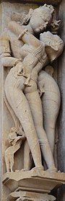  Kamabandha at Khajuraho^{[24]}
In the Buddha's first discourse, he identifies craving (tanha) as the cause of suffering (dukkha). He then identifies three objects of craving: the craving for existence; the craving for non-existence and the craving for sense pleasures (kama). Kama is identified as one of five hindrances to the attainment of jhana according to the Buddha's teaching. Throughout the Sutta Pitaka the Buddha often compares sexual pleasure to arrows or darts. So in the Kama Sutta (4.1) from the Sutta Nipata the Buddha explains that craving sexual pleasure is a cause of suffering.
If one, longing for sensual pleasure, achieves it, yes, he's enraptured at heart. The mortal gets what he wants. But if for that person — longing, desiring — the pleasures diminish, he's shattered, as if shot with an arrow.
The Buddha then goes on to say:
So one, always mindful, should avoid sensual desires. Letting them go, he will cross over the flood like one who, having bailed out the boat, has reached the far shore.
The 'flood' refers to the deluge of human suffering. The 'far shore' is nirvana, a state in which there is no sensual desire.
The meaning of the Kama Sutta is that sensual desire, like any habitual sense pleasure, brings suffering. To lay people the Buddha advised that they should at least avoid sexual misconduct (See Theravada definition below). From the Buddha's full-time disciples, the ordained monks and nuns, strict celibacy (called brahmacarya) had always been required.
Former Vice President of the Buddhist Society and Chairman of the English Sangha Trust, Maurice Walshe, wrote an essay called 'Buddhism and Sex' in which he presented Buddha's essential teaching on human sexuality and its relationship to the goal (nibbana). The third of the five precepts states:
Kamesu micchacara veramani sikkhapadam samadiyami,
The literal meaning of this statement is, "I undertake the course of training in refraining from wrong-doing in respect of sensuality." Walshe comments,
There is, in the Buddhist view, nothing uniquely wicked about sexual offenses or failings. Those inclined to develop a guilt-complex about their sex-life should realize that failure in this respect is neither more, nor, on the other hand, less serious than failure to live up to any other precept. In point of fact, the most difficult precept of all for nearly everybody to live up to is the fourth — to refrain from all forms of wrong speech (which often includes uncharitable comments on other people's real or alleged sexual failings!)...What precisely, then, does the Third Precept imply for the ordinary lay Buddhist? Firstly, in common with all the other precepts, it is a rule of training. It is not a "commandment" from God, the Buddha, or anyone else saying: "Thou shalt not..." There are no such commandments in Buddhism. It is an undertaking by you to yourself, to do your best to observe a certain type of restraint, because you understand that it is a good thing to do. This must be clearly understood. If you don't think it is a good thing to do, you should not undertake it. If you do think it is a good thing to do, but doubt your ability to keep it, you should do your best, and probably, you can get some help and instruction to make it easier. If you feel it is a good thing to attempt to tread the Buddhist path, you may undertake this and the other precepts, with sincerity, in this spirit.
The Buddha's teaching arises out of a wish for others to be free from dukkha. According to the doctrine he taught, freedom from suffering involves freedom from sexual desires and the training (Pali: sikkha) to get rid of the craving involves to a great extent abstaining from those desires.

Mainstream views
Sex is seen as a serious monastic transgression. Within Theravada Buddhism there are four principal transgressions which entail expulsion from the monastic Sangha: sex, theft, murder, and falsely boasting of superhuman perfections.^{[4]} Sexual misconduct for monks and nuns includes masturbation.^{[5]} In the case of monasticism, abstaining completely from sex is seen as a necessity in order to reach enlightenment. The Buddha's criticism of a monk who broke his celibate vows—without having disrobed first—is as follows:
Worthless man, [sexual intercourse] is unseemly, out of line, unsuitable, and unworthy of a contemplative; improper and not to be done... Haven't I taught the Dhamma in many ways for the sake of dispassion and not for passion; for unfettering and not for fettering; for freedom from clinging and not for clinging? Yet here, while I have taught the Dhamma for dispassion, you set your heart on passion; while I have taught the Dhamma for unfettering, you set your heart on being fettered; while I have taught the Dhamma for freedom from clinging, you set your heart on clinging.
Worthless man, haven't I taught the Dhamma in many ways for the fading of passion, the sobering of intoxication, the subduing of thirst, the destruction of attachment, the severing of the round, the ending of craving, dispassion, cessation, unbinding? Haven't I in many ways advocated abandoning sensual pleasures, comprehending sensual perceptions, subduing sensual thirst, destroying sensual thoughts, calming sensual fevers? Worthless man, it would be better that your penis be stuck into the mouth of a poisonous snake than into a woman's vagina. It would be better that your penis be stuck into the mouth of a black viper than into a woman's vagina. It would be better that your penis be stuck into a pit of burning embers, blazing and glowing, than into a woman's vagina. Why is that? For that reason you would undergo death or death-like suffering, but you would not on that account, at the break-up of the body, after death, fall into deprivation, the bad destination, the abyss, hell...
Worthless man, this neither inspires faith in the faithless nor increases the faithful. Rather, it inspires lack of faith in the faithless and wavering in some of the faithful.^{[6]}

Japanese Buddhism
Conversely to most tenets of Buddhism, Japanese Buddhist monks were strongly associated to the partaking of pleasure and sexual relationships. Many of them were known to maintain relationships with prostitutes and geishas, often maintaining long term liaisons with them. While those aspects were a popular target of criticism and satire as charge of moral corruption, both "by Japanese who often were ideologically hostile to Buddhism themselves or by Western observers inclined to view Buddhism as an obstacle to Christian missionary success in Japan", as well as other orthodox Buddhists, some adherents to this lifestyle sometimes claimed it to be actually part of their religious practice.^{[7]} As such, there were currents of local esoteric Buddhism, possibly influenced by non-Buddhist folk tradition, that valued sexuality positively
The Japanese deva Kangiten, a Buddhicized form of the Hindu god Ganesha, was considered sexually symbolic, being represented as dual figures embracing.^{[7]} It received a wide worship, especially among geishas and people in the business of pleasure, and its esoteric sexuality meant its image had to be usually covered from public eyes.^{[8]} The 12th century saw the rise of the infamous Tachikawa-ryu sect, an extreme tantric sex school where human skulls and emission of sexual fluids were used in ritual, for which they were later persecuted and suppressed by mainstream Buddhists.^{[9]} Finally, even in non-tantric Buddhism, influential 15th century monk Ikkyu preached for sex and love as valid ways to reach Enlightenment. He is considered both a heretic and a saint within Zen.

Lay Buddhism[edit]
The most common formulation of Buddhist ethics are the Five Precepts and the Eightfold Path, which say that one should neither be attached to nor crave sensual pleasure. These precepts take the form of voluntary, personal undertakings, not divine mandate or instruction. The third of the Five Precepts is "To refrain from committing sexual misconduct.^{[11][12]}
Celibacy or Brahmacariya rules pertain only to the Eight precepts or the 10 monastic precepts.
According to the Theravada traditions there are some statements attributed to Gautama Buddha on the nature of sexual misconduct. In Everyman's Ethics, a collection of four specific suttas compiled and translated by Narada Thera, it is said that adultery is one of four evils the wise will never praise.^{[13]} Within the Anguttara Nikaya on his teachings to Cunda the Silversmith this scope of misconduct is described: "...one has intercourse with those under the protection of father, mother, brother, sister, relatives or clan, or of their religious community; or with those promised to someone else, protected by law, and even with those betrothed with a garland" (etc- child/underage).
Bhikkhu Nyanamoli has provided an English Translation of the Majjhima Nikaya 41, "He is given over to misconduct in sexual desires: he has intercourse with such (women) as are protected by the mother, father, (mother and father), brother, sister, relatives, as have a husband, as entail a penalty, and also with those that are garlanded in token of betrothal."
Tantric sex
According to some Tibetan authorities, the physical practice of sexual yoga is necessary at the highest level for the attainment of Buddhahood.^{[16]} The use of sexual yoga is highly regulated. It is only permitted after years of training. The physical practice of sexual yoga is and has historically been extremely rare.^{[18]} A great majority of Tibetans believe that the only proper practice of tantric sex is metaphorically, not physically, in rituals and during meditative visualizations. The dominant Gelug sect of Tibetan Buddhism holds that sexual yoga as an actual physical practice is the only way to attain Buddhahood in one lifetime. The founder of the sect Tsongkhapa did not, according to tradition, engage in this practice, but instead attained complete enlightenment at the moment of death, that being according to this school the nearest possible without sexual yoga. The school also taught that they are only appropriate for the most elite practitioners, who had directly realized emptiness and who had unusually strong compassion. The next largest school in Tibet, the Nyingma, holds that this is not necessary to achieve Buddhahood in one lifetime.^{[19]} The fourteenth Dalai Lama of the Gelug sect, holds that the practice should only be done as a visualization
The situation is different for monastics. For them, the Vinaya (code of monastic discipline) bans all sexual activity, but does so in purely physiological terms, making no moral distinctions among the many possible forms of intercourse.

The Problem With Sex According to Buddhism
According to the Vinaya Pitaka, the Buddha laid down the first rule for his monastic followers in response to the behavior of a monk named Sudinna, who gave in to his mother’s pleas to sire a male heir with his former wife to replace himself so that the family fortune would not fall to others. That the first rule has to do with sexual intercourse speaks to the primacy of sexual matters in Buddhist doctrine and ethics.
This leads the Buddha to establish the monastic disciplinary code – vinaya – beginning with the first parajika rule (meaning “defeat,” as in being defeated by sensual desire), commission of which results in automatic forfeiture of monastic status: “Whatever monk should indulge in sexual intercourse is one who is defeated [parajika], he is no longer in communion [with the monastic order].”
But the issue goes even deeper than the act per se, to what sexual intercourse symbolizes for Buddhism doctrinally and what it means ethically in a monastic context. As Janet Gyatso explains, sexual intercourse is considered the “gold standard” for determining monastic sexual misconduct, since “what really made sex with a woman worse than any other kind was its practical upshot: marriage, children, the householder’s life; in short, samsara [the tanha-driven or desire-driven cycle of lifetimes].” “To have a house,” the commentary explains, “means to plough fields, to sow seeds, to make purchases and sales and such other various kinds of affairs.” The “houseless state means to have no such kinds of affairs, but to have perfect calmness and to have no desire.”
Those who join the Buddhist monastic order submit to an ethical code (the primary usage of the word vinaya) that will drive out or remove the lust, ill will, infatuation and other obstacles to liberation that characterize a tanha-driven life. The vinaya code is vigilant in ensuring that the ethical conduct of monks and nuns remains beyond the reproach of the laity, whose own behavior conforms to a lower ethical standard. The Buddha condemned Sudinna’s act of sexual intercourse as “village dhamma” and “low dhamma,” which contravened his own dhamma (teaching) about the holy or religious life (brahmacariya).
The vinaya created an institutional body of fulltime Path followers, subject to public scrutiny. The refrain that behavior like Sudinna’s is both unbefitting the order and scandalous to the laity runs throughout the parajika sections of the Vinaya Pitaka. Significantly, the parajika rules specify that a defeated monk is no longer in communion, which is explained in this way: “[C]ommunion is called one work, one rule, an equal training, this is called communion. He who is not together with this is therefore called not in communion.”
The section of the Vinaya Pitaka that deals with the first parajika rule is full of “spicy anecdotes,” to quote Bernard Faure’s diplomatic phrase. The Pali Text Society’s translator in 1938, I.B. Horner, considered some passages so embarrassing to reader sensibilities that she relegated them to an untranslated appendix. Virtually every conceivable permutation of sexual behavior is covered here — Bapat and Hirakawa’s undiplomatic phrase is “all sorts of imaginable perverted types of sex-acts” — leading scholars to question whether the text reflects actual cases in the early Buddhist order, casuistic anticipation of potential misdeeds or a combination of both.
Although it may be tempting, we should not conclude that ancient Buddhist monastics were more sexually depraved than other monastics, only that Buddhist doctrines compelled them to a vigorous examination of the intricacies of human sexual impulses and their implications for a celibate community.
The text lays out four levels of offense with decreasing penalties:
1) Parajika entails automatic surrender of monastic status
2) Sanghadisesa requires a formal meeting of the order to decide the appropriate disciplinary measures
3) Thullaccaya (a grave offense)
4) Dukkata (a wrongdoing) call for confession by the perpetrator
A monk commits parajika if he engages in consensual penetration of various orifices of a living female (human, animal or spirit), a person with non-conventional sexual characteristics, another monk or even himself (cases of one monk’s supple back and another’s pliable penis are cited).
It does not matter what the monk is wearing, whether monastic robes, lay garb, or any number of comical garments described in the text – such acts are parajika if consensual. If there is no consent, as when a woman satisfies herself by sitting on the erect penis of an unaware monk or when monks or nuns are forced to perform against their will, there is no offense. Penetration of a partially decomposed corpse is also parajika, but penetration of an almost fully decomposed corpse is only thullaccaya, a third level offense, while use of a plaster decoration or a wooden doll counts as dukkata, the lowest offense.
All of these sexual behaviors, if consensual, intend to satisfy the perpetrator’s desires. The commentary stresses this as one criterion for distinguishing parajika from lesser offenses: The presence of passion, pleasure or delight generally tips the scales toward parajika. Another criterion seems to appeal to the “gold standard” of sexual intercourse with a living human female, which draws the perpetrator back to householder status and a tanha-driven cycle of lifetimes. Thus, penetration of a human vagina and similar orifices is parajika, the latter perhaps seen as slippery slopes, so to speak, toward the former, whereas a wooden doll or a badly decomposed corpse is further removed from such temptation.

The Problem of Desire
Whether or not we can decipher the logic behind all the permutations of proscribed sexual behavior in the Vinaya Pitaka, it is clear that desire is the overriding problem being addressed at the individual level. Mohan Wijayaratna points to a non-vinaya text, the Methuna Sutta, that clarifies the full meaning of monastic chastity. There the Buddha criticizes purported religious virtuosi “who pretend to practice chastity” by refraining from sexual intercourse yet “consent to be massaged, rubbed, bathed and shampooed by women.” Wijayaratna notes: “[F]or Buddhist monasticism, abstention from sexual intercourse did not suffice to define chastity; involvement in any kind of sensual pleasure was thought to be a ‘fetter of sexuality.’ Sexual intercourse constituted thus only one subsection of ‘the desire for sensual pleasures.’”
The vinaya code differs for nuns, reflecting the patriarchal era in which the rules were first promulgated and then interpreted. The Buddha initially hesitated to establish an order for nuns but eventually set out Eight Important Rules for them that did not apply to the order of monks, such as requiring a nun to show deference to all monks, even those with less monastic tenure than the nun (monks show deference only to other monks with longer tenure). Nuns also have extra parajika rules on sexual behavior beyond the prohibition of sexual intercourse that apply equally to monks. These extend to physical contact with a man or making preparations for such physical contact out of sexual desire, which would be lesser offenses if committed by a monk.

Householder Sexual Ethics
The Buddha valorized the celibate life over family life, as we read in the Anguttara Nikaya: “Monks, there are two kinds of happiness. Which are they? The happiness of domestic life and that of monastic life. Of the two, the happiness of monastic life is superior.” A symbiotic relationship between the monastic order and lay adherents has characterized Buddhism from the beginning, with a dual sexual ethical track, as Peter Harvey explains: “Buddhism has traditionally held celibate monasticism in the highest regard, but it has also seen marriage and family life as highly suitable for those who cannot commit themselves to celibacy, and as an arena in which many worthwhile qualities are nurtured.”
Wife and husband should “minister” to each other in certain gender-specific ways — for instance, the husband should provide his wife with jewelry and other personal adornments, the wife should manage her husband’s earnings and the household affairs – but both are expected to be faithful to the marriage. Walpola Rahula comments: “[L]ove between husband and wife is considered almost religious or sacred. It is called sadara Brahmacariya, ‘sacred family life.’”
Even so, given the Buddha’s views on householder life, marriage never took on sacramental connotations in Buddhism, and thus marriage ceremonies and divorce proceedings are typically considered civil matters in Buddhist societies. Monogamous marriage is the norm in Buddhism, which can extend beyond a single lifetime: “[A] husband and wife, if matched in trustful confidence, virtue, generosity and wisdom, will be reborn together if they wish.”

Expectations and Procreation
The Third Precept, one of five basic moral vows incumbent upon all Buddhists, is interpreted according to one’s station in life. The precept reads, Kamesu micchacara veramani sikkhapadamsamadiyami, “I take upon myself the precept of abstention from sexual misconduct.” The Anguttara Nikaya explains that a virtuous marital relationship is like a marriage between deities, while an adulterous spouse is likened to a corpse. “Young unmarried people should wisely restrain themselves,” writes a contemporary monk about the Third Precept, “and not get involved in anything which may prove a bondage for them. Restraint is good, and it should be restraint not merely of outward action but of lustful desire.”
Again, Buddhism’s concern about desire (tanha) surfaces, now in the context of the laity. Note the following explanation of Buddhism’s perspective on procreation by a Buddhist bioethicist: “Union of man and woman or two physical bodies in sexual action is the result of this desire (tanha) to gratify the senses, including the mind. Even the need to have a child is an extension of the same major desire (tanha). Thus, no particular significance is attributed to procreation in Buddhism.”

Non-Conventional Sexual Categories
The familiar characterization of Buddhism as the most benign of the major world religions in its view of homosexuality may be correct per se, but it masks the complexity found in Buddhist texts, history and cultures. The ancient texts use terms that do not easily translate into modern equivalents. According to Leonard Zwilling, the Pali word pandaka and synonymous terms “are to be interpreted metaphorically as we do in English when it is said of a weak or pusillanimous person that he (or even she) ‘has no balls.’” The word pandaka typically refers to males who lack conventional qualities of “maleness,” such as those who suffer temporary impotence, satisfy their own sexual desires by watching others engage in sexual behavior or fellate other men.
The Buddha forbade the ordination of a pandaka into the monastic order and required the expulsion of one discovered after ordination. This kindof avoidance was not limited to pandakas, as hermaphrodites (ubhatobyanjanakas) were also excluded from the monastic order, for instance. As Zwilling explains, the vinaya code sought to maintain distance between the monastics and anyone who threatened their chastity, which also included female prostitutes and lay women. Homosexual behavior is condemned in the vinaya code, but it draws far less attention than heterosexual behavior, perhaps simply because of the prevalence of the latter. Either way, the sexual desire underlying the behavior is the primary issue.
Some Buddhist texts and commentaries approximate what would be considered sexual phobia today. The Milindapanha (1st century BCE – 1st century CE), for instance, counts pandakas and hermaphrodites among those incapable of fully understanding the Buddha’s teachings, while the commentators Vasubandhu (4th century CE) and Buddhaghosa (5th century CE) considered them morally and spiritually deficient. One Mahayana text predicts “endless varieties of punishments … for the wrong deed of sexual intercourse between two men. The one who commits misconduct with boys sees boys being swept away in the Acid River who cry out to him, and owing to the suffering and pain born of his deep affection for them, plunges in after them.” Here, phobia mixes with a measure of compassion. A common Buddhist explanation for homosexuality and other non-conventional sexual categories sees them as the karmic results of misdeeds in previous lifetimes.

Positive Portrayals
On the other hand, there are more positive textual portrayals of homosexuality. The medieval Japanese literary genre called chigo monogatari extols love relationships between elder monks and temple boys. These tales often include tragic deaths; and the practice conduced to “massive child abuse,” in Bernard Faure’s judgment, but the intended goal was spiritual redemption. In one tale called Chigo Kannon engi, a female bodhisattva (an enlightened and compassionate spiritual being) takes the role of a young male lover in order to show a monk the way to liberation. In the opinion of one scholar, “this text suggests a kind of sanctification of homosexual relationships within the Buddhist community.”
Indeed, sentiment about homosexuality varies across Buddhist societies, from “unenthusiastic toleration” in many contexts, to condemnation (without persecution) in some contexts, to “positive advocacy” in Japan.
The Dalai Lama, whose opinion weighs heavily with American Buddhists, has expressed the condemnatory position on homosexuality from traditional Tibetan Buddhism. In a 1997 visit to San Francisco, for instance, he made a distinction between Buddhist and societal viewpoints: “From a Buddhist point of view, men-to-men and women-to-women is generally considered sexual misconduct. From society’s viewpoint, mutually agreeable homosexual relations can be of mutual benefit, enjoyable and harmless.”
As Peter Harvey reports, “This concerned some liberal American Buddhists, especially gays, who had thought that Buddhism was non-judgemental on sexual matters.” Subsequent discussion between the Dalai Lama and a group of American Buddhists led to some rapprochement as the Dalai Lama intimated that since Buddhist sexual ethics arose in an ancient cultural context, they could be reassessed today.
The legacy of pain for many ex-Christian gays palpably informs their testimonies about their newfound sexual and spiritual integration through Buddhism. Wrote the late Roger Corless, scholar of Buddhism and gay Buddhist, “Many find that a spiritual community is more nurturing than a club or a bar and, having been deeply wounded by their contact with Christian homophobia, feel they have found a home in the Buddhist sangha.”

What does Buddhism say about sexual relationships?
Buddhists try to conduct themselves in a way that will not cause suffering to others and try to always be caring and loving.
The Five Precepts are important for Buddhists when considering their attitude to sex. The third Precept states that Buddhists should not engage in sexual misconduct. This might include adultery, as being unfaithful to a partner can cause suffering, and promiscuity, which can be seen as a negative expression of craving after sexual stimulation. Sex should form part of a loving relationship (eg marriage).
Buddhists can use contraception as long as they have the Right Intention. Good motives such as responsible family planning and disease control may be accepted. Indeed, if sexual intercourse may result in an unwanted pregnancy, such suffering needs to be avoided and contraception should therefore be used.

What does this mean in practice?
The Buddha taught that in many areas of life, depriving yourself of something or over indulging in something leads to suffering and dissatisfaction. He taught that The Middle Path should be followed. This can be applied to sex.
Buddhists are encouraged to enjoy sex responsibly, as a result, most Buddhists avoid being promiscuous. Chastity is not a requirement of leading a Buddhist life.
Buddhists do not see marriage as a duty and cohabitation is perfectly acceptable. As long as neither partner suffers, a Buddhist can enjoy a healthy sexual relationship.
Gendun Chopel is the most famous, and infamous, Tibetan intellectual of the 20th century. Ordained as a monk at the age of 12, he went on to excel at the highest levels of the Buddhist academy before leaving Tibet in 1934. He spent the next 12 years in India, in the state of Sikkim, and Sri Lanka, studying the classics of Sanskrit literature; at some point, he gave up his monastic vows. He wrote and painted extensively during this period, producing learned essays and translations, a travel guide and a newspaper article explaining to Tibetans that the world is round.
One of the Sanskrit classics that he studied was the Kama Sutra. Knowing that erotica was a genre of Indian literature unknown in Tibet, Gendun Chopel decided to compose his own treatise on passion – one that drew on Sanskrit sex manuals as well as from his own experience, much of it apparently drawn from the days and nights he spent in the brothels of Calcutta and with several lovers, whom he names, and thanks.
Having renounced the vow of celibacy just a few years before, his poetry shimmers with the wonder of someone discovering the joys of sex, all the more memorable because they were forbidden to him for so long. His verse is tinged with shades of irony, self-deprecating wit, and a love of women, not merely as sources of male pleasure, but as full partners in the play of passion. In the Treatise, Gendun Chopel seeks to understand the true nature of tantric bliss and how it relates to the pleasures of lovemaking:
The hills and valleys of a place add to its beauty.
The thorns of thought are the root of illness.
To stop thought without meditation,
For the common person, comes only in the bliss of sex.
Buddhist monks follow a lot of rules – 253 in one tradition, 200 in another. As the story goes, all of these rules were made by the Buddha himself. However, he did not announce them all at once, like Moses descending from Mount Sinai with the Ten Commandments. Instead, they’re said to have evolved organically, with the Buddha making a rule only after he judged a particular deed to be a misdeed. The first of the rules to be established was not against murder; it was against sex.
The inciting incident was when a man named Sudinna left his wife and parents to become a monk. Some time later, he came home and made love to his wife – not for love or lust, but at the urging of his mother. She worried that if she and her husband died without an heir, the king would seize their property. Although there was no rule against monks having sex at the time, Sudinna felt guilty and told some other monks what had happened. Those monks tattled to the Buddha, who summoned Sudinna for perhaps the worst scolding in Buddhist literature:
Worthless man, it would be better that your penis be stuck into the mouth of a poisonous snake than into a woman’s vagina. It would be better that your penis be stuck into the mouth of a black viper than into a woman’s vagina. It would be better that your penis be stuck into a pit of burning embers, blazing and glowing, than into a woman’s vagina. Why is that? For that reason you would undergo death or death-like suffering, but you would not on that account, at the breakup of the body, after death, fall into deprivation, the bad destination, the abyss, hell.
Over the long history of Buddhism, most of its vast literature has been composed by celibate monks. Sexual intercourse – defined as the penetration of an orifice even to the depth of a sesame seed – was the first transgression to entail permanent expulsion from the monastic order. Monks have written works of particular misogyny, such as the ‘Blood Bowl Sutra’ where the blood is menstrual blood. They’ve also sought to control the sex lives of Buddhist lay people by imposing a wide range of restrictions, such as prohibiting sex during the day or the penetration of any orifice other than the vagina. These rules have remained in place, cited in modern discussions of Buddhist attitudes toward gay and lesbian sex. Buddhist texts across Asia have presented monks as models of chastity. However, their depiction in the plays and novels of various Buddhist lands can be quite different – like in medieval Europe, monks were often portrayed as lechers.
An important counter-narrative about sex came with the rise of what is called tantra, a movement that began in India about a millennium after the Buddha’s death. While sex had long been seen as pollution, here it was transformed into a path to purity. Tantric texts made elaborate arguments about the sublime states of bliss available through orgasm, and set forth secret techniques that resulted in deep states of bodily bliss. Some would claim that sex was not only permissible but necessary – that all buddhas of the past had attained enlightenment and buddhahood through tantric sex.
Still, it wasn’t until the 20th century that we find a sustained critique of monastic norms and advocacy of sexual pleasure in Buddhist literature outside the tantric milieu. In 1939, the Tibetan writer (and former monk) Gendun Chopel composed a work that he called simply A Treatise on Passion. Written entirely in verse, it is one of only two works of erotica in the vast literature of Tibetan Buddhism.

Gendun Chopel arrived in India during the height of the independence movement, as Hindu and Muslim patriots sought to throw off the chains of British bondage. He was deeply sympathetic to their cause, taking many of its principles back to Tibet with him. Yet Gendun Chopel was also an apostle of another kind of freedom: sexual freedom. He condemned the hypocrisy of church and state, portraying sexual pleasure as a force of nature and a universal human right. The Kama Sutra was intended for the social elite; the tantric literature was intended for the spiritually advanced. And whether intended for the cultured gentleman or the tantric yogi, the instructions were provided for men. By contrast, in his Treatise, Gendun Chopel tried to wrest the erotic from the ruling class and give it to the workers of the world:
May all humble people who live on this broad earth
Be delivered from the pit of merciless laws
And be able to indulge, with freedom,
In common enjoyments, so needed and right.
Sexual liberation has since been championed in other lands and in other languages, often with dire consequences for the revolutionaries. And so it was for Gendun Chopel in Tibet, the site of another revolution. He had returned to Lhasa in 1945 after 12 years abroad. At first, he was the toast of the town, dining each night at the home of a different aristocrat. But soon he came under suspicion, likely instigated by the British delegation. In 1946, Gendun Chopel was arrested on trumped-up charges of distributing counterfeit currency. He was jailed for three years at the prison at the foot of the Dalai Lama’s palace, released as part of a general amnesty when the young (and current) Dalai Lama reached his majority. On 9 September 1951, when troops of the People’s Liberation Army marched into Lhasa, bearing banners proclaiming Tibet’s return to the motherland of China, Gendun Chopel was a broken man, who had to be lifted from his deathbed to watch the parade. His Treatise was not published until 1967, long after his death – and not in Tibet but in India, where so many Tibetans had followed the Dalai Lama into exile.
Gendun Chopel’s book did not contribute to the sexual revolution that occurred in Europe and the US in the 1960s. Still, reading his instructions for the play of passion, it’s clear that much remains to be done, both in the Buddhist world and beyond.

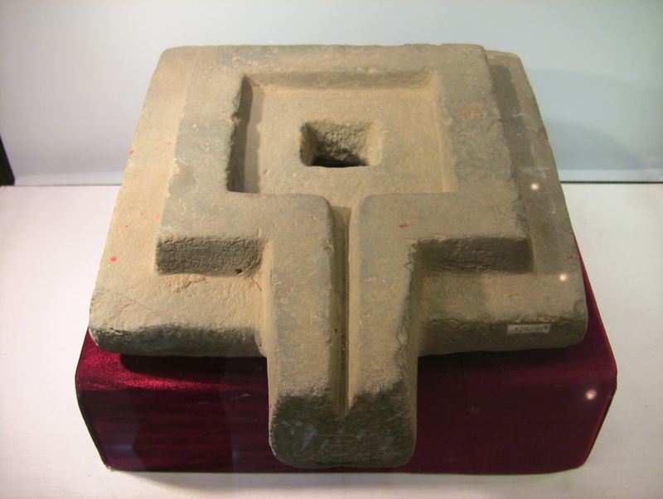
Yoni or Vulva
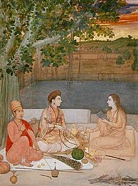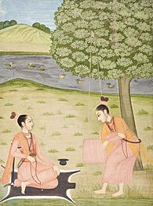
Nath yoginis,Rajasthan///17th century/Nath yoginis, Rajasthan,18th century

Tantra
Women in Tantra traditions, whether Hindu or Buddhist, are called yoginis. In Tantric Buddhism, Miranda Shaw states that many women like Dombiyogini, Sahajayogicinta, Lakshminkara, Mekhala, Kankhala Gangadhara, Siddharajni, and others, were respected yoginis and advanced seekers on the path to enlightenment.
Yogini is a female master practitioner of tantra and yoga, as well as a formal term of respect for female Hindu or Buddhist spiritual teachers in Indian subcontinent, Southeast Asia and Greater Tibet. The term is the feminine Sanskrit word of the masculine yogi, while the term "yogin" IPA: [ˈjoːɡɪn] is used in neutral, masculine or feminine sense.
A Yogini, in some contexts, is the sacred feminine force made incarnate, as an aspect of Parvati, and revered in the yogini temples of India as the Sixty-four Yoginis.
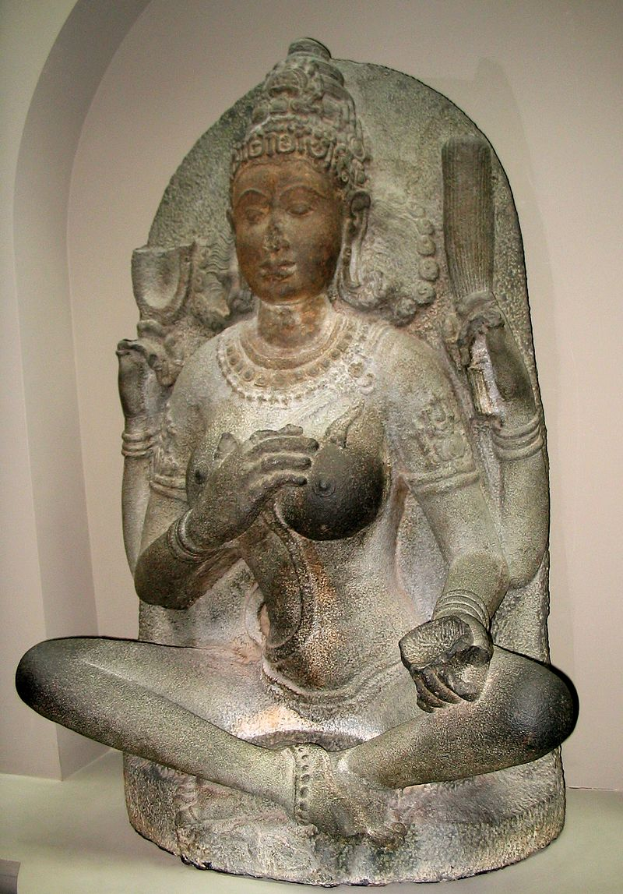
Yogini 10th century Chola dynasty Figure; granite (greenstone) H: 116.0 W: 76.0 D: 43.2 cm Kaveripakkam, Tamil Nadu, India Housed in the Arthur M. Sackler Gallery in the Smithsonian, Washington, D.C.
Yoni , sometimes referred to as pindika, is an abstract or aniconic representation of the Hindu goddess Shakti. It is usually shown with linga – its masculine counterpart. Together, they symbolize the merging of microcosmos and macrocosmos. the divine eternal process of creation and regeneration, and the union of the feminine and the masculine that recreates all of existence. The yoni is conceptualized as nature's gateway of all births, particularly in the esoteric Kaula and Tantra practices, as well as the Shaktism and Shaivism traditions of Hinduism.
Yoni is a Sanskrit word that has been interpreted to literally mean the "womb",the "source",and the female organs of generation. It also connotes the female sexual organs such as "vagina", "vulva", and "uterus", or alternatively to "origin, abode, or source" of anything in other contexts. For example, the Vedanta text Brahma Sutras metaphorically refers to the metaphysical concept Brahman as the "yoni of the universe".The yoni with linga iconography is found in Shiva temples and archaeological sites of the Indian subcontinent and southeast Asia, as well in sculptures such as the Lajja Gauri.
This particular massage is something you may not have come across in your regular spa salons or sessions. ‘Yoni’ originates from Sanskrit, which means 'a sacred place'. The word yoni represents a vulva symbolising goddess Shakti. We bring you the essential details about what exactly is a Yoni massage and why is it prevalent:
What Is A Yoni Massage?
Yoni or yonic is a tantric massage for primarily focusing on the labia, clitoris, G-spot, uterus, the breasts, and other erogenous zones often considered as therapeutic. A yoni masseuse or practitioner carefully massages while the recipient performs breathing exercises. The intention behind this massage is to not orgasm or any kind of erotic stimulation but to reconnect yourself with your body and to be comfortable with it.
Benefits Of Yoni Massage
Our body, as we all know, undergoes immense stress and pressure. We then resort to exercises that relieve us of the stress, which could be therapeutic massages, meditation, breathing exercises, or yoga. The idea of yoni massage also runs in the same lines – relieving mental and physical stress or tensions of your body or any pain in the vagina. The tantric massages help you just do the same. It also educates women about their erogenous zones.
Ambience matters as much as the accuracy and results of the massage. You can try mood lighting or have a relaxing bubble or aroma bath, which will ease you of the stress to some level. You can use flowers or petals to make the room as cosy as you wish.
Breathe During The Massage
If you are taking a session from a certified Yoni practitioner or your partner, understand the idea carefully behind receiving the massage. The practitioner will professionally guide you on the breathing techniques throughout. While with your partner, assess what you expect and communicate it. You can add this as one of the quick sessions in your foreplay that will rev you up for later. Remember, yoni is about the balance between manual massages and breathing from your end. Coordinating your breathing with your partner will enhance your sexual experience physically, mentally, emotionally and even spiritually while also relieving your bodily tensions.

