Tantric tradition and Greater India

Dr Uday Dokras

History of tantra
It is difficult to trace the history of tantra which is mostly obscure as in case of the history of religions. Many tantras offer mythical explanations for their origins, often setting themselves as the given word of either Siva or a goddess such as Devi. Scholarly depictions of their origins are often as varied, ascribing tantras to pre-Aryan, Indus Valley civilizations or similar aboriginal, tribal groups or as integral part of an Indian cultural fabric.

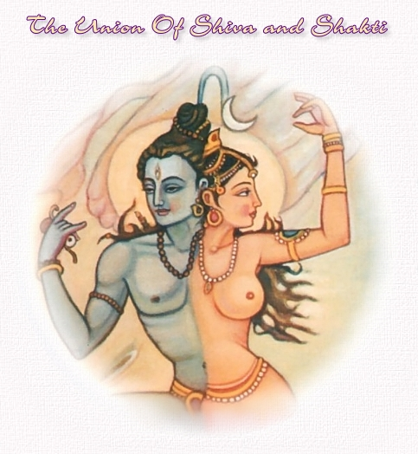

Hindu tantra
Tantra exists in Vaisnava, Shaiva, and Shakta forms, among others. Extolled as a short-cut to self-realization and spiritual enlightenment by some, left-hand tantric rites are often rejected as dangerous by most orthodox Hindus. The popular perception of tantra among Hindus espoused in Indian journalism, equates it with black magic.
Some tantric aspirants simply feel the union is accomplished internally and with spiritual entities of various kinds. For this reason, almost all tantric writing has a gross, higher and subtle meaning. This tripartite system of understanding readily obscures the true purport of many passages for those without the necessary background or deeper understandings so crucial to tantra. Thus, a 'union' could mean the actual act of sexual intercourse, ritual uniting of concepts through chanting and sacrifice, or realization of one's true self in the cosmic joining of the divine principles of Shiva and Shakti in Para Shiva.

Tantrism, which appears in both Buddhism and Hinduism, influenced many religious trends and movements from the 5th century CE, but some of it was meant for esoteric circles. Claiming to show in times of religious decadence a new way to the highest goal, Tantrism bases itself upon mystic speculations concerning divine creative energy (shakti). Tantrism is thought to be a method of conquering transcendent powers and realizing oneness with the highest principle by Yogic and ritual means—in part magical and orgiastic—which are also supposed to achieve other supranormal goals.
Tantrists take for granted that all factors in the macrocosm and the microcosm are closely connected. The adept (sadhaka) has to perform the relevant rites on his own body, transforming its normal, chaotic state into a “cosmos.” The macrocosm is conceived as a complex system of powers that by means of ritual-psychological techniques can be activated and organized within the individual body of the adept. Contrary to the ascetic emancipation methods of other groups, the Tantrists emphasize the activation and sublimation of the possibilities of their own body, without which salvation is believed to be beyond reach.
The Tantrists of the Vamchara (“the left-hand practice”) sought to intensify their own sense impressions by making enjoyment, or sensuality (bhoga), their principal concern: the adept pursued his spiritual objective through his natural functions and inclinations, which were sublimated and then gratified in rituals in order to disintegrate his normal personality. This implies that cultic life was largely interiorized and that the whole world was given a new and esoteric meaning.

Concentration on the body: Tantrikas generally see the body as a microcosm; thus in the Kaulajnana-nirnaya, for example, the practitioner meditates on the head as the moon, the heart as the sun and the genitals as fire. Many groups hold that the body contains a series of energy centers (chakra - "wheel"), which may be associated with elements, planets or occult powers (siddhi). The phenomenon of kundalini, a flow of energy through the chakras, is controversial; most writers see it as essential to Tantra, while others regard it as unimportant or as an abreaction. As it is, kundalini is nothing but the flow of the central sushumna nadi, a spiritual current, that, when moving, opens chakras, and is fundamental to the siddhi concept that forms a part of all tantra, including hatha yoga.
- Sahasrara
- Ajna
- Vishuddha
- Anahata
- Manipura
- Swadhisthana
- Muladhara
- Bindu

Tantric practices
Because of the wide range of groups covered by the term "tantra," it is hard to describe tantric practices definitively. The basic practice, the Hindu image-worship known as "puja" may include any of the elements below.

Mantra and Yantra: As in all of Hindu and Buddhist yogas, mantras play an important part in Tantra for focusing the mind, often through the conduit of specific Hindu gods like Shiva, Ma Kali (mother Kali, another form of Shakti) and even Ganesh, the elephant-headed god of wisdom (refer to the Ganesha Upanishad). Similarly, puja will often involve concentrating on a yantra or mandala.

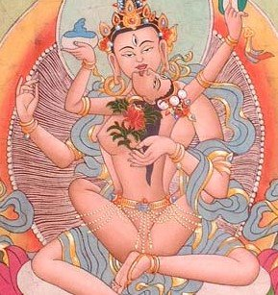

Identification with deities: Tantra, being a development of early Hindu-Vedic thought embraced the Hindu gods and goddesses, especially Shiva and Shakti, along the Advaita (nondualist Vedic) philosophy that each represents an aspect of the ultimate Para Shiva, or Brahman. These deities may be worshipped externally (with flowers, incense etc.) but, more importantly, are used as objects of meditation, where the practitioner imagines him- or herself to be experiencing the darshan or 'vision' of the deity in question. The ancient devadasi tradition of sacred temple-dance, seen in the contemporary Bharata Natyam is an example of such meditation in movement. The divine love is expressed in Sringara and Bhakti.

Taboo-breaking: The act of breaking taboos is the definitive feature of left-hand Tantra. While the breaking of sexual taboos is perhaps the most recognized of tantric practices, it is not considered generally beneficial. All tantras state that there are specific levels of preparation required for breaking taboos. Tantras practiced by inadequately prepared individuals are considered harmful rather than beneficial to the practitioner. The normal state of human preparation is referred to as pasu-bhava (animal disposition). A person in the state of pasu-bhava is one who regularly eats meat and indulges in intoxication. They are considered dishonest, promiscuous, greedy and violent. A fundamental requirement of all tantras is the initial transcendence beyond this base state.

Tantras prescribe a strict regimen of penance, meditation, sensory control, cleansing the self of negative thoughts and seeking truth and justice before an individual can hope to transcend from her or his natural state. An individual who successfully practices these tasks may eventually take a vow of viravrata (a hero's vow) to be of vira-bhava (heroic disposition). The demarcation vira is potentially transient as it is considered a state of being free of desires.
In the Kaula and Vamachara schools of tantra the pañca makara (5 M's) ritually/sacramentally broken in order to free the practitioner from binding convention are:
- madya (wine)
- mamsa (meat)
- matsya (fish)
- mudra (parched grain)
- maithuna (sex

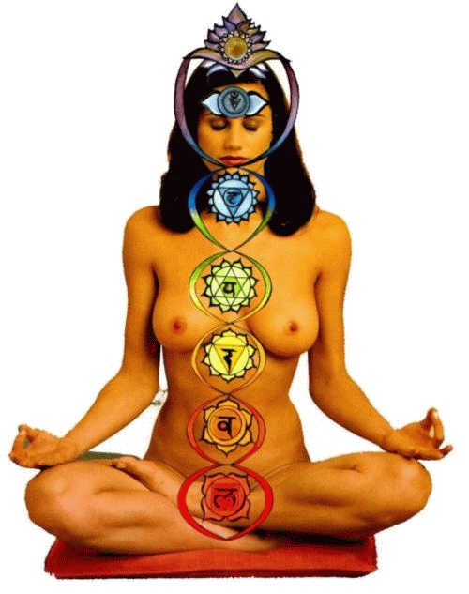The "sacramental" or ritual breaking was only for the vira practitioner, not the divya or pasu. The pasu would misunderstand and get caught up in the literal act while the divya will have already progressed beyond and not need the literal act to understand the inner meaning.
There also exist tantric schools that substitute innocuous items for the taboo substances and acts, claiming that literal interpretations of the pañca makara miss the inner truth of the rite.
The esoteric part of Tantric worship (puja) is complicated and in many respects different from the ceremonies that it has influenced. Tantric devotees interpret their texts by means of an ambiguous “twilight” language and distinguish between the texts’ “external” and their esoteric meaning. Tantrists describe states of consciousness with erotic terminology and describe physiological processes with cosmological terminology. They proceed from “external” to “internal” worship and adore the Goddess mentally, offering their hearts as her throne and their self-renunciation as “flowers.”
According to Tantrism, concentration is intended to evoke an internal image of the deity and to resuscitate the powers inherent in it so that the symbol changes into mental experience. This “symbolic ambiguity” is also much in evidence in the esoteric interpretation of ritual acts performed in connection with images, flowers, and other cult objects and is intended to bring about a transfiguration in the mind of the adept.

The mantras (sacred utterances, such as hum, hrim, and kleem) are believed to be indispensable means of entering into contact with the power they bear and of transcending mundane existence. Most potent are the monosyllabic, bija (“seed”) mantras, which constitute the main element of longer formulas and embody the essence of divine power as the eternal, indestructible prototypes from which anything phenomenal derives its existence. The cosmos itself owes its very structure and harmony to them. Also important is the introduction of spiritual qualities or divine power into the body (nyasa) by placing a finger on the relevant spot (accompanied by a mantra).
Tantrists who follow the “right-hand path” attach much value to the Yoga that developed under their influence and to bhakti and aspire to union with the Supreme by emotional-dynamic means. For them, Yoga is a self-abnegation in order to reach a state of ecstatic blissfulness in which the passive soul is lifted up by divine grace.

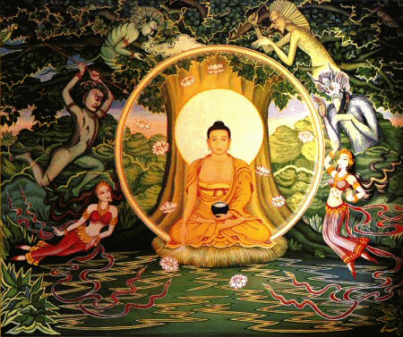There is also a Tantric mantra-yoga (discipline through spells), which operates with formulas, and a hatha-yoga, (Sanskrit: “union of force”). Hatha-yoga incorporates normal Yogic practices such as abstinences; observances; bodily postures; breath control; withdrawal of the mind from external objects; concentration, contemplation, and identification with the aid of mudras (i.e., ritual intertwining of fingers or gestures expressing the metaphysical aspect of the ceremonies or the transformation effected by the mantras); and muscular contractions. It also consists of internal purifications (e.g., washing out stomach and bowels), shaking the abdomen, and some forms of self-torture. The whole process is intended to “control the ‘gross body’ in order to free the ‘subtle body.’”

Some Tantrists employ laya-yoga (“reintegration by mergence”), in which the female nature-energy (representing the shakti), which is said to remain dormant and coiled in the form of a serpent (kundalini) representing the uncreated, is awakened and made to rise through the six centres (chakras) of the body, which are located along the central artery of the subtle body, from the root centre to the lotus of a thousand petals at the top of the head, where it merges into the Purusha, the male Supreme Being. Once the union of shakti and Purusha has become permanent, according to this doctrine, wonderful visions and powers come to the adept, who then is emancipated. Some of the Tantric texts also pursue worldly objectives involving magic or medicine.

Tantric and Shakta views of nature, humanity, and the sacred
The Tantric movement is sometimes inextricably interwoven with Shaktism, which assumes the existence of one or more shaktis. These are “creative energies” that are inherent in and proceed from God and are also capable of being imagined as female deities. Shakti is the deciding factor in the salvation of the individual and in the processes of the universe because God acts only through his energy—which, personified as a goddess, is his spouse. Her role is very different in the various systems: she may be considered the central figure in a philosophically established doctrine, the dynamic aspect of brahman, producing the universe through her maya, or mysterious power of illusion; a capricious demonic ruler of nature in its destructive aspects; a benign mother goddess; or the queen of a celestial court. One form of Shaktism identifies the goddess (usually Durga) with brahman and worships her as the ruler of the universe by virtue of whom even Shiva exists. As Mahayogini (“Great Mistress of Yoga”), she produces, maintains, and reabsorbs the world. As the Eternal Mother, she is exalted in the Devimahatmya (“Glorification of the Goddess”) section of the Markandeya-purana (an important Shakta encyclopaedic text). In the Bengal cult of the goddess Kali, she demands bloody sacrifices from her worshipers lest her creative potency fail her. This cult also propounds the belief that birth and death are inseparable, that joy and grief spring from the same source, and that the frightening manifestations of the divine should be faced calmly.
In all of his incarnations Vishnu is united with his consort, Lakshmi. The sacred tales of his various relations with her manifestations led his worshipers to view human devotion as parallel to divine love and hence as universal, eternal, and sanctified. In Vaishnava Tantrism, Lakshmi plays an important part as God’s shakti. In his supreme state, Vishnu and his shakti are indissolubly associated with one another and thus constitute the personal manifestation of the supreme brahman, also called Lakshmi-Narayana. In visual imagery, Lakshmi never leaves Vishnu’s bosom. In the first stage of creation, she awakens in her dual aspect of action-and-becoming, in which she is the instrumental and material cause of the universe; Vishnu himself is the efficient cause. In the second stage, her “becoming” aspect is manifested in the grosser forms of the souls and the power of maya, which is the immaterial source of the universe. In displaying her power, she takes into consideration the accumulated karma of the beings, judging mundane existence as merit and demerit. Presented in myth as God’s wife and the queen of the universe.
Pancharatra Vaishnavism emphasizes that Lakshmi—who in the mythological sphere intercedes with her husband for the preservation of the world—spontaneously and by virtue of her own power differentiates herself from Vishnu because she has in view the liberation of the souls. This current of thought complicated its explanation of the relation between God and the universe—which was at the same time an attempt at assigning to God’s manifestations a place in a harmonious theological and cosmological system—with an evolutionist theory of successive creations. God is assumed to manifest himself also in three other figures, mythologically his brothers, who, each with his own responsibility, have not only a creative but also an ethical function, by which they assist those who seek to achieve final emancipation.

Tantric ritual and magical practices
The ritual of the left-hand Tantrists was one in which all of the taboos of conventional Hinduism were conscientiously violated. Thus, in place of the traditional five elements (tattvas) of the Hindu cosmos, these Tantrists used the five m’s: mamsa (flesh, meat), matsya (fish), madya (fermented grapes, wine), mudra (frumentum, cereal, parched grain, or gestures), and maithuna (sexual union). This latter element was made particularly antinomian through the involvement of forbidden women—such as the wife of another man or a low-caste woman—who was identified with the Goddess. Menstrual blood, strictly taboo in conventional Hinduism, was also used in Tantric rites. Such rituals, which are described in Tantric texts and in tracts against Tantrists, made the Tantrists notorious. It is likely, however, that the rituals were not regularly performed except by a small group of highly trained adepts; the usual Tantric ceremony was purely symbolic and even more fastidious than the pujas in Hindu temples.
The cult of the Shaktas is based on the principle of the ritual sublimation of natural impulses to maintain and reproduce life. Shakta adepts are trained to direct all their energies toward the conquest of the Eternal. The sexual act and the consumption of consecrated meat or liquor are esoterically significant means of realizing the unity of flesh and spirit, of the human and the divine. They are considered not sinful acts but effective means of salvation. Ritual union—which may also be accomplished symbolically—is, for both partners, a form of sacralization, the act being a participation in cosmic and divine processes. The experience of transcending space and time, of surpassing the phenomenal duality of spirit and matter, of recovering the primeval unity, the realization of the identity of God and his Shakti, and of the manifested and unmanifested aspects of the All, constitute the very mystery of Shaktism.
The interpretation of doctrines and ritual practice is varied. Extreme Shakta communities, for example, are said to perform the secret nocturnal rites of the shrichakra (“wheel of radiance,” described in the Kularnava-tantra), in which they avail themselves of the natural and esoteric symbolic properties of colours, sounds, and perfumes to intensify their sensual experiences. Most Tantrists, however, eliminate all but the verbal ritual.
Individual and collective Yoga and worship, conducted daily, fortnightly, and monthly “for the delectation of the deity,” are of special importance. After elaborate purifications, the worshipers—who must be initiated, full of devotion toward the guru and God, have control over themselves, be well prepared and pure of heart, know the mysteries of the scriptures, and look forward to the adoration with eagerness—make the prescribed offerings, worship the power of the Divine Mother, and recite the relevant mantras. Having become aware of their own state of divinity, they are qualified to unite sexually with the Goddess. If a woman is, in certain rituals, made the object of sexual worship, the Goddess is first invoked into her; the worshiper is not to cohabit with her until his mind is free from impurity and he has risen to divine status. Union with a low-caste woman helps to transcend all opposites. Union with a woman who belongs to another man is often preferred because it is harder to obtain, nothing is certain in it, and the longing stemming from the separation of lover and beloved is more intense; it is pure preman (divine love). Adoration of a girl of age 16 aims at securing the completeness and perfection of which this number is said to be the expression. However, the texts reiterate how dangerous these rites are for those who are not initiated; those who perform such ritual acts without merging their minds in the Supreme are likely to go to one of the hells.
The esoteric Vaishnava-Sahajiya cult, which arose in Bengal in the 16th century, was another emotional attempt at reconciling the spirit and the flesh. Disregarding social opinion, its adherents, using the natural (sahaja, “born with”) qualities of the senses and stressing the sexual symbolism of Bengal Vaishnavism, reinterpreted the Radha-Krishna legend and sought for the perpetual experience of divine joy. Based on this understanding of the legend, members of the Vaishnava-Sahajiya cult held that, after arduous training, the realization of love can be experienced, because Krishna’s nature is love and the giving of love and because man is identical with Krishna. Women, as the embodiment of a theological principle, could even become spiritual guides, like Radha, conducting the worshipers in their search for realization. After reaching this state, a devotee remains in eternal bliss and can dispense with guru and ritual and be completely indifferent to the world, “steadfast amidst the dance of maya.”

Tantric and Shakta ethical and social doctrines
These ethical and social principles, though fundamentally the same as those promulgated in the classical dharma works, breathe a spirit of liberality: much value is set upon family life and respect for women (the image of the Goddess); no ban is placed on traveling (conventionally regarded as bringing about ritual pollution) or on the remarriage of widows. Although Tantric and Shakta traditions did not oblige their followers to deviate in a socially visible way from the established order, they provided a ritual and a way of life for those who, because of sex or caste, could not participate satisfyingly in the conventional rites.

The ancient Tantric tradition, based on the esoteric tantra literature, has become so interwoven with orthodox Hinduism that it is difficult to define precisely. Although it recognizes an identity between the soul and the cosmos, it emphasizes the internalization of the cosmos rather than the release of the soul to its natural state of unity. The body is the microcosm, and the ultimate state is not only omniscience but total realization of all universal and eternal forces. The body is real, not because it is the function or creation of a real deity but because it contains the deity, together with the rest of the universe. The individual soul does not unite with the One—it is the One, and the body is its function.
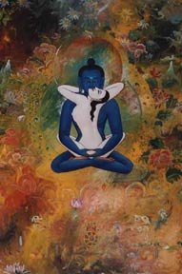
Tantrism, though not always in its full esoteric form, is a feature of much modern mystical thought. In Tantrism the consciousness is spoken of as moving—driven by repetition of the mantra and by other disciplines—from gross awareness of the material world to realization of the ultimate unity. The image is of a serpent, coiled and dormant, awakened and driven upward in the body through various stages of enlightenment until it reaches the brain, the highest awareness. The 19th-century mystic Ramakrishna describes the process, which is also what many Hindus seek in their quest for a spiritual experience:
When [the serpent] is awakened, it passes gradually through [various stages], and comes to rest in the heart. Then the mind moves away from [the gross physical senses]; there is perception, and a great brilliance is seen. The worshiper, when he sees this brilliance, is struck with wonder. The [serpent] moves thus through six stages, and coming to [the highest one], is united with it. Then there is samadhi.…When [the serpent] rises to the sixth stage, the form of God is seen. But a slight veil remains; it is as if one sees a light within a lantern, and thinks that the light itself can be touched, but the glass intervenes.…In samadhi, nothing external remains. One cannot even take care of his body any more; if milk is put into his mouth, he cannot swallow. If he remains for twenty-one days in this condition, he is dead. The ship puts out to sea, and returns no mo
Tantric Hindu traditions have also influenced other Eastern religious traditions such as Jainism, the Tibetan Bön tradition, Daoism, and the Japanese Shintō tradition.
Certain modes of non-Vedic worship such as Puja are considered tantric in their conception and rituals. Hindu temple building also generally conforms to the iconography of tantra. Hindu texts describing these topics are called Tantras, Āgamas or Samhitās. Rituals are most commonly associated with spiritual or religious activities and are considered an important part of that tradition. A ritual is a ceremony consisting of a series of actions performed by an ordained leader and according to a prescribed order. Weddings, funerals, birthdays, coming of age rites, mass, baptisms, communion and religious holidays are just a few examples of rituals that many of us are familiar with and can relate to. Essentially they mark important moments and serve as an initiation or a change in status.
Tantric rituals are a spectacular science stemming from the Indian tradition which have been known to produce supernatural phenomenon and provide a direct link to universal energies for participants. That is of course if the ritual is of the authentic kind. In order to benefit from the imprint tantric rituals can impart there are a few key elements that are necessary in order to receive this sacred rite of passage. What are these elements? Read further and learn more…
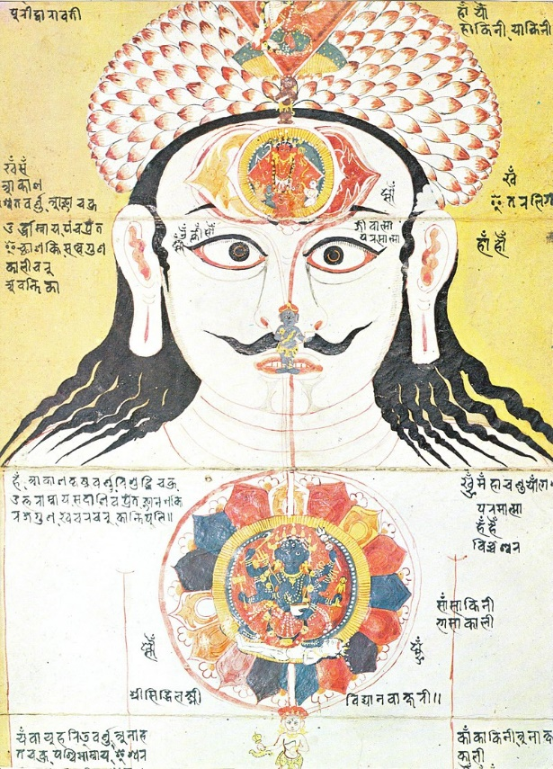 | “Tantra is that Asian body of beliefs and practices which, working from the principle that the universe we experience is nothing other than the concrete manifestation of the divine energy of the godhead that creates and maintains the universe, seeks to ritually appropriate and channel that energy, within the human microcosm, in creative and emancipatory.ways.”  David Gordon White  Tantric art. Clockwise from upper left: Vajrayogini (Buddhist), Sri Yantra (Hindu), Chakra illustration, Tibet deity Vajradhara (Holder of the Thunderbolt) in maithuna, Kalachakra Mandala, Dakini.

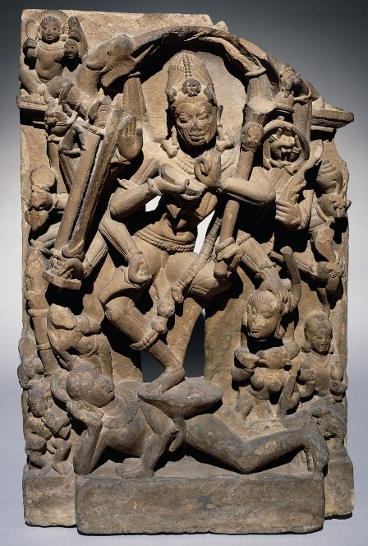

A temple relief, from Madya Pradesh in central India, showing the Tantric goddess Chamunda dancing on a corpse, 9th century AD. Sandstone. Size: 89 x 61x 21cm © Trustees of the British Museum

The science of tantric rituals
Tantra is the science and study of energy and there are countless different types of energy in the universe that can be controlled and utilized for spiritual gains. For every universal energy that exists there are various tantric rituals that train solely with that energy.Tantric rituals can be extremely potent if the right ingredients are involved and the knowledge is genuine. The secrecy of this occult science therefore preserves its integrity and esoteric nature.
There does not exist a ritual manual, so to speak, outlining and detailing all of the various rituals and accompanying effects. This is why it becomes more important than ever that such knowledge is transmitted via a lineage and ideally by an experienced master.

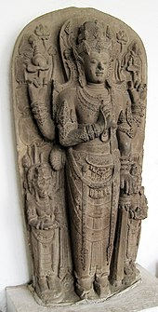 The statue of Harihara, the god amalgamation of Shiva and Vishnu, as the mortuary deified portrayal of King Kertarajasa of Majapahit. Revering the king as god incarnated on earth is the concept of devaraja. |  | 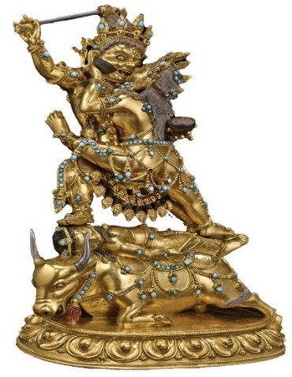  Sculpture of Raktayamari in union with Vajravetali, Tibet, 16th-17th century. Bronze with turquoise, gold, and pigment.Size: 21.8 x 15.8 x 11.4cm. © The Trustees of the British Museum

Tantric ritual and magical practices
The ritual of the left-hand Tantrists was one in which all of the taboos of conventional Hinduism were conscientiously violated. Thus, in place of the traditional five elements (tattvas) of the Hindu cosmos, these Tantrists used the five m’s: mamsa (flesh, meat), matsya (fish), madya (fermented grapes, wine), mudra (frumentum, cereal, parched grain, or gestures), and maithuna (sexual union). This latter element was made particularly antinomian through the involvement of forbidden women—such as the wife of another man or a low-caste woman—who was identified with the Goddess. Menstrual blood, strictly taboo in conventional Hinduism, was also used in Tantric rites. Such rituals, which are described in Tantric texts and in tracts against Tantrists, made the Tantrists notorious. It is likely, however, that the rituals were not regularly performed except by a small group of highly trained adepts; the usual Tantric ceremony was purely symbolic and even more fastidious than the pujas in Hindu temples.
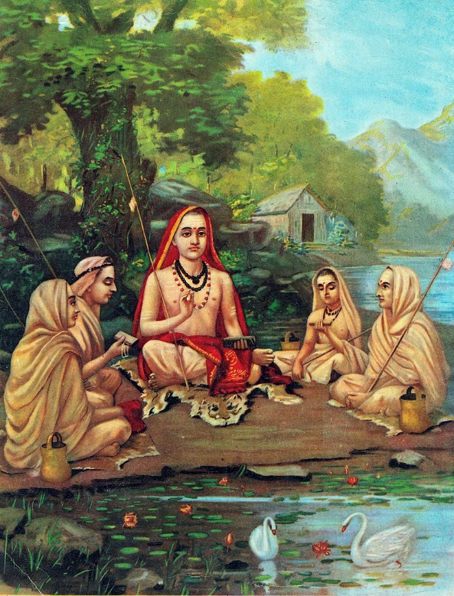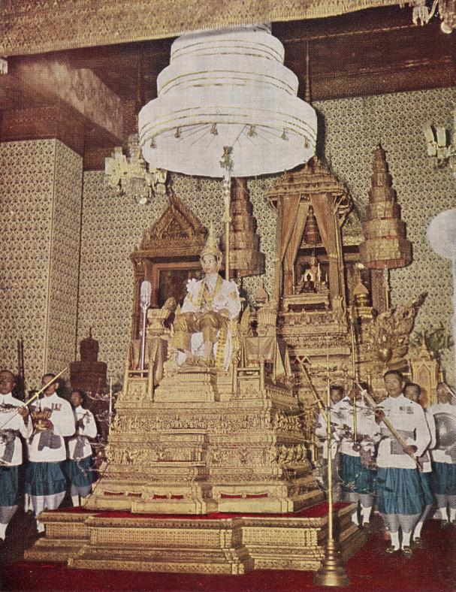
Adi Shankaracharya/ Coronation of Thai King
The cult of the Shaktas is based on the principle of the ritual sublimation of natural impulses to maintain and reproduce life. Shakta adepts are trained to direct all their energies toward the conquest of the Eternal. The sexual act and the consumption of consecrated meat or liquor are esoterically significant means of realizing the unity of flesh and spirit, of the human and the divine. They are considered not sinful acts but effective means of salvation. Ritual union—which may also be accomplished symbolically—is, for both partners, a form of sacralization, the act being a participation in cosmic and divine processes. The experience of transcending space and time, of surpassing the phenomenal duality of spirit and matter, of recovering the primeval unity, the realization of the identity of God and his Shakti, and of the manifested and unmanifested aspects of the All, constitute the very mystery of Shaktism.
The interpretation of doctrines and ritual practice is varied. Extreme Shakta communities, for example, are said to perform the secret nocturnal rites of the shrichakra (“wheel of radiance,” described in the Kularnava-tantra), in which they avail themselves of the natural and esoteric symbolic properties of colours, sounds, and perfumes to intensify their sensual experiences. Most Tantrists, however, eliminate all but the verbal ritual.
Individual and collective Yoga and worship, conducted daily, fortnightly, and monthly “for the delectation of the deity,” are of special importance. After elaborate purifications, the worshipers—who must be initiated, full of devotion toward the guru and God, have control over themselves, be well prepared and pure of heart, know the mysteries of the scriptures, and look forward to the adoration with eagerness—make the prescribed offerings, worship the power of the Divine Mother, and recite the relevant mantras. Having become aware of their own state of divinity, they are qualified to unite sexually with the Goddess. If a woman is, in certain rituals, made the object of sexual worship, the Goddess is first invoked into her; the worshiper is not to cohabit with her until his mind is free from impurity and he has risen to divine status. Union with a low-caste woman helps to transcend all opposites. Union with a woman who belongs to another man is often preferred because it is harder to obtain, nothing is certain in it, and the longing stemming from the separation of lover and beloved is more intense; it is pure preman (divine love). Adoration of a girl of age 16 aims at securing the completeness and perfection of which this number is said to be the expression. However, the texts reiterate how dangerous these rites are for those who are not initiated; those who perform such ritual acts without merging their minds in the Supreme are likely to go to one of the hells.
The esoteric Vaishnava-Sahajiya cult, which arose in Bengal in the 16th century, was another emotional attempt at reconciling the spirit and the flesh. Disregarding social opinion, its adherents, using the natural (sahaja, “born with”) qualities of the senses and stressing the sexual symbolism of Bengal Vaishnavism, reinterpreted the Radha-Krishna legend and sought for the perpetual experience of divine joy. Based on this understanding of the legend, members of the Vaishnava-Sahajiya cult held that, after arduous training, the realization of love can be experienced, because Krishna’s nature is love and the giving of love and because man is identical with Krishna. Women, as the embodiment of a theological principle, could even become spiritual guides, like Radha, conducting the worshipers in their search for realization. After reaching this state, a devotee remains in eternal bliss and can dispense with guru and ritual and be completely indifferent to the world, “steadfast amidst the dance of maya.”

Tantric and Shakta ethical and social doctrines
These ethical and social principles, though fundamentally the same as those promulgated in the classical dharma works, breathe a spirit of liberality: much value is set upon family life and respect for women (the image of the Goddess); no ban is placed on traveling (conventionally regarded as bringing about ritual pollution) or on the remarriage of widows. Although Tantric and Shakta traditions did not oblige their followers to deviate in a socially visible way from the established order, they provided a ritual and a way of life for those who, because of sex or caste, could not participate satisfyingly in the conventional rites.
The ancient Tantric tradition, based on the esoteric tantra literature, has become so interwoven with orthodox Hinduism that it is difficult to define precisely. Although it recognizes an identity between the soul and the cosmos, it emphasizes the internalization of the cosmos rather than the release of the soul to its natural state of unity. The body is the microcosm, and the ultimate state is not only omniscience but total realization of all universal and eternal forces. The body is real, not because it is the function or creation of a real deity but because it contains the deity, together with the rest of the universe. The individual soul does not unite with the One—it is the One, and the body is its function.
Tantrism, though not always in its full esoteric form, is a feature of much modern mystical thought. In Tantrism the consciousness is spoken of as moving—driven by repetition of the mantra and by other disciplines—from gross awareness of the material world to realization of the ultimate unity. The image is of a serpent, coiled and dormant, awakened and driven upward in the body through various stages of enlightenment until it reaches the brain, the highest awareness. The 19th-century mystic Ramakrishna describes the process, which is also what many Hindus seek in their quest for a spiritual experience:
When [the serpent] is awakened, it passes gradually through [various stages], and comes to rest in the heart. Then the mind moves away from [the gross physical senses]; there is perception, and a great brilliance is seen. The worshiper, when he sees this brilliance, is struck with wonder. The [serpent] moves thus through six stages, and coming to [the highest one], is united with it. Then there is samadhi.…When [the serpent] rises to the sixth stage, the form of God is seen. But a slight veil remains; it is as if one sees a light within a lantern, and thinks that the light itself can be touched, but the glass intervenes.…In samadhi, nothing external remains. One cannot even take care of his body any more; if milk is put into his mouth, he cannot swallow. If he remains for twenty-one days in this condition, he is dead. The ship puts out to sea, and returns no more.
Tantric Hinduism already had a significant presence in India by the middle of the first millennium CE, when scriptural texts (tantras) began to be compiled. “Tantras (texts) clearly state that scripture is the necessary complement to the oral teachings one receives from the mouth of one’s guru.” Little has been written about Khmer Tantric Hinduism, although tantrikas (practitioners) were already present in Cambodia by the medieval period. Unfortunately, no Khmer liturgical texts have survived to enlighten us as to what role Khmer Tantric Hindusim may have specifically played in the Khmer world, but a few tantalizing clues have resulted in surprising revelations. In the Khmer environment, there is an inherent minimization of the sexual in art, whether it is Tantric Buddhist or Hindu, and this kind of imagery seldom appears in the Khmer world. ¹
---------------------------------------------------------------------------------------------------------------------------------------------------------------------------------
1.Tantric Hinduism in Khmer Culture
by Emma C. Bunker, Asian Department, Denver Art Museum, https://www.asianart.com/articles/bunker/index.html
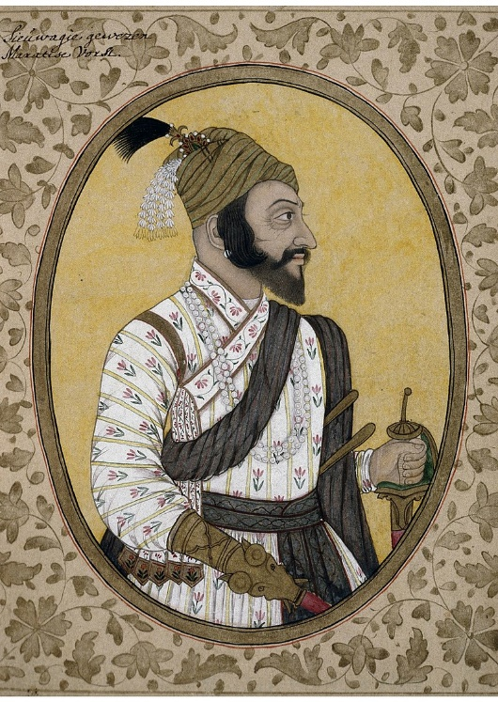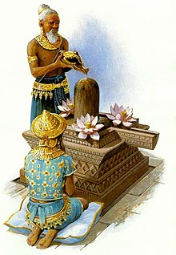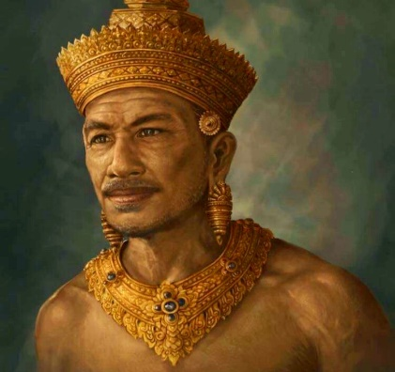
Shivaji left //// Jayavarman II, a Khmer Monarch pays homage to Lord Shiva while his personal priest pours offering of melted ghee and lotus.

The Janapadas ( 1500–600 BCE) from where Hiranyadarma was invited/ brought were the realms, republics (ganapada) and kingdoms (saamarajya) of the Vedic period on the Indian subcontinent. The Vedic period reaches from the late Bronze Age into the Iron Age: from about 1500 BCE to the 6th century BCE. With the rise of sixteen Mahajanapadas ("great janapadas"), most of the states were annexed by more powerful neighbours, although some remained independent.
Tantricism and Magic of the Janapadas
The Sanskrit term janapada is a tatpurusha compound term, composed of two words: janas and pada. Jana means "people" or "subject. The word pada means "foot" from its earliest attestation, the word has had a double meaning of "realm, territory" and "subject population" pedan, "place."Sanskrit padám, usually taken to mean "footprint, trail", diverges in accent from the PIE reconstruction. For the sense of "population of the land", padasya janas, the inverted padajana would be expected. A primary meaning of "place of the people," janasya padam, would not explain why the compound is of masculine gender. An original dvandva "land and people" is conceivable, but a dual inflection would be expected.
Literary evidence suggests that the janapadas flourished between 1500 BCE and 500 BCE. The earliest mention of the term "janapada" occurs in the Aitareya (8.14.4) and Shatapatha (13.4.2.17) Brahmana texts.

Sanskrit epics
The Bhishma Parva of the Mahabharata mentions around 230 janapadas, while the Ramayana mentions only a few of these. Unlike the Puranas, the Mahabharata does not specify any geographical divisions of ancient India, but does support the classification of certain janapadas as southern or northern India.

Whether the term devaraja refers to a central cult object, such as a Siva linga on one of Angkor's numerous pyramidal monuments, or to the ritual as such, and argues that the views advanced by such authorities as G. Coedes are commonly unsatisfactory or inconsistent. Tantra Sanskrit: तन्त्र, meaning to weave, warp' are the esoteric traditions of Hinduism and Buddhism that developed in India from the middle of the 1st millennium CE onwards. The term tantra, in the Indian traditions, also means any systematic broadly applicable "text, theory, system, method, instrument, technique or practice." Starting in the early centuries of the common era, newly revealed Tantras centering on Vishnu, Shiva or Shakti emerged. There are tantric lineages in all main forms of modern Hinduism, such as the Shaiva Siddhanta tradition, the Shakta sect of Sri-Vidya, the Kaula, and Kashmir Shaivism.
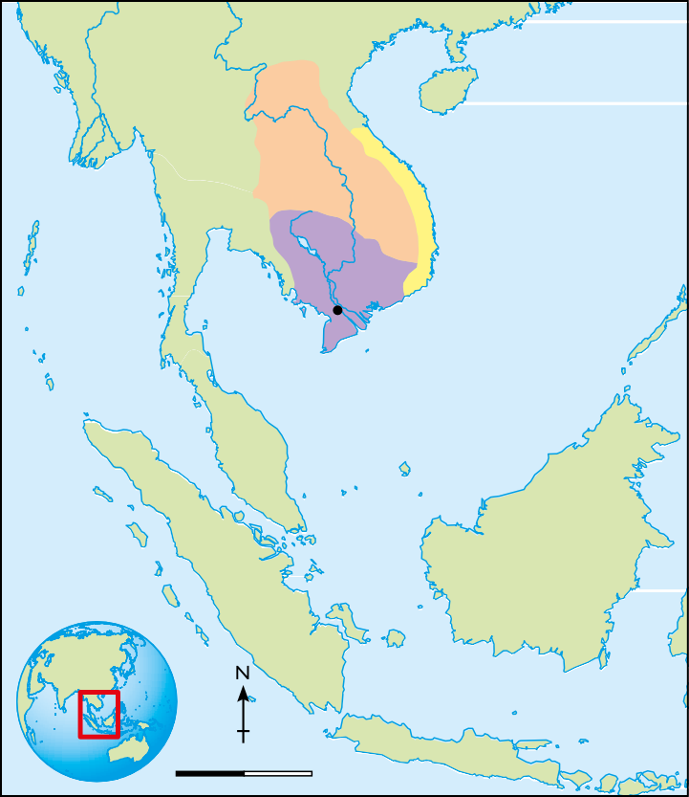
CHENLA
Tonle CHAMPA
Sap
FUNAN
Oc Eo
Mekong River Delta
Area of map
0
300
600 km
Java

