CRYPTEX: A REAL-TIME CRYPTOCURRENCY PAPER TRADING TERMINAL

A PROJECT BASED LEARNING (PBL) REPORT
Submitted
by
S BALAJI (2104251040800)
SURYA PRAKASH M (2104251041010)
Submitted in partial fulfilment of the requirements
for the
Project-Based Learning component of Java Programming

BACHELOR OF ENGINEERING

in

COMPUTER SCIENCE AND ENGINEERING


CHENNAI INSTITUTE OF TECHNOLOGY
(Autonomous)

Affiliated to Anna University, Chennai
October - 2026

Vision of the Institute:

To be an eminent centre for Academia, Industry and Research by imparting knowledge, relevant practices and inculcating human values to address global challenges through novelty and sustainability.

Mission of the Institute:

IM1. To creates next generation leaders by effective teaching learning
methodologies and in still Scientifics park in them to meet the global challenges.
IM2. To transform lives through deployment of emerging technology, novelty and sustainability.
IM3. To inculcate human values and ethical principles to cater the societal needs.
IM4. To contributes towards the research ecosystem by providing a suitable,
effective platform for interaction between industry, academia and R&D establishments.
IM5: To nurture incubation centers enabling structured entrepreneurship and start-ups

DEPARTMENT OF

COMPUTER SCIENCE AND ENGINEERING

Vision of the Department:

To Excel in the emerging areas of Computer Science and Engineering by imparting knowledge, relevant practices and inculcating human values to transform the students as potential resources to contribute innovatively through advanced computing in real time situations.

Mission of the Department:

DM1. To provide strong fundamentals and technical skills for Computer Science
applications through effective teaching learning methodologies.
DM2. To transform lives of the students by nurturing ethical values, creativity and novelty to become Entrepreneurs and establish start-ups.
DM3. To habituate the students to focus on sustainable solutions to improve the quality of life and the welfare of the society.
DM4: To enhance the fabric of research in computing through collaborative linkages with industry and academia.
DM5: To inculcate learning of the emerging technologies to pursue higher studies leading to lifelong learning.

PROGRAM EDUCATIONAL OBJECTIVES (PEO):

PEO 1: Contribute to the industry as an Engineer through sound knowledge acquired in core engineering to develop new processes and implement the solutions for industrial problems.
PEO 2: Establish an organization / industry as an Entrepreneur with professionalism, leadership quality, teamwork, and ethical values to meet the societal needs.
PEO 3: Create a better future by pursuing higher education / research and develop the sustainable products / solutions to meet the demand.

PROGRAM OUTCOMES (POS):
PO1: Engineering Knowledge: Apply knowledge of mathematics, natural science, computing, engineering fundamentals and an engineering specialization to develop to the solution of complex engineering problems.
PO2: Problem Analysis: Identify, formulate, review research literature and analyze complex engineering problems reaching substantiated conclusions with consideration for sustainable development.
PO3: Design/Development of Solutions: Design creative solutions for complex engineering problems and design/develop systems/components/processes to meet identified needs with consideration for the public health and safety, whole-life cost, net zero carbon, culture, society and environment as required
PO4: Conduct Investigations of Complex Problems: Conduct investigations of complex engineering problems using research-based knowledge including design of experiments, modelling, analysis & interpretation of data to provide valid conclusions
PO5: Engineering Tool Usage: Create, select and apply appropriate techniques, resources and modern engineering & IT tools, including prediction and modelling recognizing their limitations to solve complex engineering problems.
PO6: The Engineer and The World: Analyze and evaluate societal and environmental aspects while solving complex engineering problems for its impact on sustainability with reference to economy, health, safety, legal framework, culture and environment.
PO7: Ethics: Apply ethical principles and commit to professional ethics, human values, diversity and inclusion; adhere to national & international laws.
PO8: Individual and Collaborative Team work: Function effectively as an individual, and as a member or leader in diverse/multi-disciplinary teams.
PO9: Communication: Communicate effectively and inclusively within the engineering community and society at large, such as being able to comprehend and write effective reports and design documentation, make effective presentations considering cultural, language, and learning differences.
PO10: Project Management and Finance: Apply knowledge and understanding of engineering management principles and economic decision-making and apply these to one’s own work, as a member and leader in a team, and to manage projects and in multidisciplinary environments.
PO11: Life-Long Learning: Recognize the need for, and have the preparation and ability for i) independent and life-long learning ii) adaptability to new and emerging technologies and iii) critical thinking in the broadest context of technological change.

PROGRAM SPECIFIC OUTCOMES (PSOS):
PSO 1 : Analyze, design and develop solutions in the areas of Business Process Management to build the quality products for industry and social needs.
PSO 2 : Innovate ideas and solutions for real time problems in the field of Software Engineering and Mobile applications by adapting the emerging technologies and tools.

CHENNAI INSTITUTE OF TECHNOLOGY, CHENNAI
(Autonomous)
Affiliated to Anna University, Chennai

BONAFIDE CERTIFICATE

This is to certify that the Project–Based Learning report titled “CRYPTEX: A REAL-TIME CRYPTOCURRENCY PAPER TRADING TERMINAL” is a Bonafide record of work carried out by S BALAJI (2104251040800) and SURYA PRAKASH M (2104251041010) of the Department of Computer Science and Engineering, Chennai Institute of Technology, as part of the continuous, mentor–guided Project-Based Learning (PBL) component of the Java Programming course during the academic year 2026–2027 under my supervision.
SIGNATURE  Dr. S. Pavithra M.E., Ph. D  HEAD OF THE DEPARTMENT  Professor and Head,  Department of Computer Science and Engineering  Chennai Institute of Technology  Chennai - 69 | SIGNATURE  Dr. R. KAVITHA M.E., Ph. D  Supervisor  Associate Professor  Department of Computer Science and Engineering  Chennai Institute of Technology  Chennai - 69

Submitted for the final review held on …………………….

INTERNAL EXAMINER EXTERNAL EXAMINER

DECLARATION

We jointly declare that the PBL report on “CRYPTEX: A REAL-TIME CRYPTOCURRENCY PAPER TRADING TERMINAL” is the result of original work done by us and best of our knowledge, similar work has not been submitted to “ANNA UNIVERSITY CHENNAI” for the requirement of Degree of BACHELOR OF ENGINEERING. This PBL report is submitted on the partial fulfilment of the requirement of the award of Degree of COMPUTER SCIENCE AND ENGINEERING.

Signature

S BALAJI

SURYA PRAKASH M

Place: Chennai Date:

ACKNOWLEDGEMENT

We wish to express our sincere gratitude to our honourable Chairman
SHRI.P. SRIRAM for providing immense facilities at our institution.

We are very proudly rendering our thanks to our Principal Dr.A.RAMESH M.E, Ph.D., for the facilities and the encouragement given by him to the progress and completion of our project.
We would like to express special thanks of gratitude to our Dean Dr. V. SRINIVASA RAO, M.E., Ph.D., who has been the key spring of motivation to us throughout the completion of our course and project work.
We proudly render our immense gratitude to the Head of the Department Dr.S.PAVITHRA M.E, Ph.D., for her effective leadership, encouragement and guidance in the project.
We would like to extend our thanks to the Project Co-ordinator Dr.R KAVITHA M.E., Ph.D., Associate Professor. Department of Computer Science and Engineering, for their valuable suggestions throughout this project.
We wish to acknowledge the help received from the class advisors Dr.R KAVITHA M.E., Ph.D.,Associate Professor and Ms. A. Kalpana M.E., Assistant Professor of the Department of Computer Science and Engineering and others for providing valuable suggestions and for the successful completion of the project.

S BALAJI 2104251040800
SURYA PRAKASH M 2104251041010

ABSTRACT

Learning to trade financial markets carries real financial risk, and most available simulators conceal the mechanics that make a trading system interesting to a computer science student. This project develops CrypteX, a real-time cryptocurrency paper trading terminal in which every core mechanism is implemented in Core Java rather than delegated to a library. Live trade ticks for six currency pairs are ingested from the Binance public stream using the native java.net.http.WebSocket client. A custom RingBuffer maintains a rolling price window, SMA, EMA and Wilder RSI are computed from first principles, and a matching engine holds resting orders in four PriorityQueue books per symbol so that each tick needs only an O(1) boundary peek. A VirtualWallet guarded by a ReentrantLock prevents double-spending, and trades settle through explicit ACID transactions written in pure JDBC. Authentication uses PBKDF2 password hashing from the standard JDK. The system passes 17 JUnit tests; its RSI matches Wilder’s published reference series to within 0.01, and its indicators agree with an independent browser implementation to 0.000 after a data race was identified and fixed. The result is a working trading desk that also makes its own algorithms inspectable.
Keywords: Core Java, WebSocket Streaming, Priority Queue Matching Engine, Pure JDBC Transactions, Technical Indicators

TABLE OF CONTENTS
CHAPTER NO. | TITLE | PAGE NO.
 | ABSTRACT | ix
 | LIST OF TABLES | xii
 | LIST OF FIGURES | xiii
 | LIST OF ABBREVIATIONS | xiv
1 | INTRODUCTION | 1
 | 1.1 BACKGROUND | 1
 | 1.2 DRIVING QUESTION | 1
 | 1.3 OBJECTIVES | 2
 | 1.4 SCOPE AND LIMITATIONS | 3
2 | CONCEPT EXPLORATION | 4
 | 2.1 RELATED APPROACHES | 4
 | 2.1.1 TRADITIONAL JAVA APPLICATION APPROACH | 4
 | 2.1.2 JAVA FRAMEWORK-BASED APPROACH | 4
 | 2.2 SUMMARY TABLE | 5
 | 2.3 WHAT THIS TOLD US | 5
3 | PROJECT PLANNING AND TEAM ORGANISATION | 6
 | 3.1 WEEKLY PBL PROGRESS LOG | 6
 | 3.2 REQUIREMENTS | 7
 | 3.3 FEASIBILITY | 7
4 | ITERATIVE DESIGN AND DEVELOPMENT | 8
 | 4.1 SYSTEM ARCHITECTURE | 8
 | 4.2 BASELINE | 9
 | 4.3 PROJECT REFINEMENT | 9
 | 4.4 FINAL APPROACH | 9
 | 4.5 TESTING AND EXECUTION | 10
5 | IMPLEMENTATION | 11
 | 5.1 MODULE DESCRIPTION | 11
 | 5.2 KEY CODE SNIPPETS | 12
 | 5.3 USER INTERFACE / DEMO | 14
6 | RESULTS AND DISCUSSION | 16
 | 6.1 EVALUATION METRICS | 16
 | 6.2 RESULTS ACROSS ITERATIONS | 17
 | 6.3 DISCUSSION | 17
 | 6.4 LIMITATIONS | 18
7 | TEAM REFLECTION AND LEARNING OUTCOMES | 19
 | 7.1 INDIVIDUAL REFLECTIONS | 19
 | 7.2 TEAM LEARNING | 19
 | 7.3 COURSE OUTCOMES — EVIDENCE SUMMARY | 20
8 | CONCLUSION AND FUTURE SCOPE | 21
 | 8.1 CONCLUSION | 21
 | 8.2 FUTURE SCOPE | 21
 | REFERENCES | 22
 | APPENDIX | 23
 | A.1 FULL SOURCE CODE | 23
 | A.2 WEEKLY LOG AND MENTOR SIGN-OFFS | 23
 | A.3 SELF AND PEER ASSESSMENT | 23

LIST OF TABLES

TABLE NO. | TITLE | PAGE NO.
2.1 | Summary of Related Approaches | 5
3.1 | Weekly PBL Progress Log | 6
3.2 | Hardware and Software Requirements | 7
6.1 | Test and Defect Outcomes Across Iterations | 23
A.1 | Self and Peer Assessment | 23

LIST OF FIGURES

FIGURE NO. | TITLE | PAGE NO.
4.1 | System Architecture of CrypteX | 8
5.1 | Sign-in Screen | 14
5.2 | Registration Form with Inline Field Validation | 14
5.3 | Trading Terminal Dashboard | 15
6.1 | Maven Surefire Test Report | 17

LIST OF ABBREVIATIONS

Abbreviation | Full Form
JDK | Java Development Kit
OOP | Object-Oriented Programming
JDBC | Java Database Connectivity
API | Application Programming Interface
REST | Representational State Transfer
ACID | Atomicity, Consistency, Isolation, Durability
SMA | Simple Moving Average
EMA | Exponential Moving Average
RSI | Relative Strength Index
PBKDF2 | Password-Based Key Derivation Function 2

CHAPTER 1

INTRODUCTION

1.1 BACKGROUND
Cryptocurrency markets trade continuously and move quickly, which makes them an unusually good subject for a systems project: the data arrives without pause, arrives quickly enough to expose inefficient code, and is freely available without a paid subscription. They are also an expensive place to learn. A beginner who wants to understand how a limit order rests on a book, or what a stop-loss actually does when price gaps through it, has little choice but to risk money to find out.
Paper trading simulators remove the financial risk but introduce a different problem for a student. Commercial platforms are closed systems: the order book, the matching rules and the indicator mathematics all sit behind an interface. A learner sees that an order filled without ever seeing why it filled, or which data structure decided the ordering.
This project treats that opacity as the opportunity. Every mechanism that makes the system a trading system is written in Core Java and left open to inspection. The Java Collections Framework maps onto the domain unusually well: a price-ordered book is a PriorityQueue, a rolling indicator window is a circular buffer, and protecting a balance from two simultaneous orders is exactly the problem a ReentrantLock exists to solve.

1.2 DRIVING QUESTION
Can a real-time trading system — live market ingestion, an order matching engine, technical indicators and transactional settlement — be built from Core Java primitives alone, and will its behaviour stand up to being checked against an independent reference?
Narrowing this into a buildable task produced four concrete questions. Which Java Collection correctly models each kind of resting order, given that a buy limit and a stop-loss sell both trigger on a falling price but in opposite heap orders? How can indicators be updated on every tick without recomputing the whole history? How should a wallet be locked so that fifty simultaneous orders cannot overdraw one balance? And how can each claim be proven rather than asserted — which led the team to validate the RSI against Wilder’s published worked example [1] instead of judging whether the chart looked plausible.

1.3 OBJECTIVES
- To ingest live market data for multiple currency pairs using the native java.net.http.WebSocket client, with automatic reconnection and an offline fallback.
- To design an order matching engine using PriorityQueue books whose heap orientation is correct for each order type, and to prove that correctness with unit tests.
- To implement SMA, EMA and Wilder RSI from first principles over a custom RingBuffer, and to validate the RSI against a published reference series.
- To guarantee a thread-safe virtual wallet using ReentrantLock, and to persist every settled trade through explicit ACID transactions written in pure JDBC.
- To secure the application with session-based authentication and layered field validation implemented in plain Java, without a security framework.
- To reflect on the team’s iterative process and record honestly what each build-test-learn cycle revealed, including the defects it exposed.

1.4 SCOPE AND LIMITATIONS

The system covers six USDT currency pairs (BTC, ETH, SOL, BNB, XRP and ADA) streamed from Binance [2] and configured in a single property, and supports market, limit and stop-loss orders on both sides. It maintains a rolling 500-candle window per pair, computes three indicators, settles trades transactionally to SQLite [3] through pure JDBC, and serves a browser terminal over an internal WebSocket.
It is deliberately not a real exchange. Orders match against the incoming public trade price rather than against other users, so there is no multilateral matching and no market impact. Settlement is simulated with no fees, slippage or partial fills. Market data depends on Binance being reachable; the simulation fallback keeps the application running, but its ticks are synthetic. Balances use double precision rather than BigDecimal, acceptable for paper trading but not for real money, and the system has not been load-tested at scale.

CHAPTER 2

CONCEPT EXPLORATION

2.1 RELATED APPROACHES

2.1.1 Traditional Java Application Approach
Core Java with JDBC [6] and the Collections Framework was studied first, using the Java 17 API specification [4] and Bloch’s Effective Java [5]. This approach keeps the matching logic, the indicator mathematics and the SQL entirely in the team’s own code. The key finding was that java.util.PriorityQueue is a binary heap offering O(1) peek and O(log n) insertion, which matches an order book’s access pattern exactly. Java Concurrency in Practice [7] supplied the wallet design, where a ReentrantLock makes a check-then-act balance update atomic.

2.1.2 Java Framework-Based Approach
The framework route — Spring Boot with Spring Data JPA and Hibernate [8] — was examined next. It removes boilerplate and would have produced a working CRUD application faster, but it also removes precisely the parts the team set out to build: an ORM hides the transaction boundaries and repository abstractions hide the SQL. Spring Boot’s WebSocket and static resource handling, by contrast, solve a transport problem the project has no interest in solving itself.

2.2 SUMMARY TABLE

Table 2.1 summarises the two approaches reviewed in Section 2.1 and what each contributed to the design of CrypteX. For each approach it lists the references consulted and the result reported, showing why Core Java was chosen for the engine while Spring Boot was kept for transport only.
Table 2.1 Summary of Related Approaches
Ref. | Approach | Reported Result
[4], [7] | Core Java: Collections, JDBC, WebSocket, ReentrantLock | O(1) heap peek fits order-book access; chosen for the engine.
[8] | Spring Boot with JPA / Hibernate | ORM hides the SQL and transactions; used for transport only.

2.3 WHAT THIS TOLD US

The exploration led to a split decision rather than a choice between the two. Spring Boot is used strictly as transport — it routes HTTP requests, serves the terminal and carries the internal WebSocket — while every component that makes this a trading system is Core Java: the ingestion client, the RingBuffer, the indicator engine, the PriorityQueue books, the ReentrantLock wallet, the JDBC settlement code and the PBKDF2 authentication. No ORM is used. Iteration 1 therefore began with the matching and indicator engines as plain Java classes with no framework annotations, which made them straightforward to unit test in isolation.

CHAPTER 3

PROJECT PLANNING AND TEAM ORGANISATION

3.1 WEEKLY PBL PROGRESS LOG

Table 3.1 records the milestone plan agreed with the mentor over the twelve-week PBL cycle. For each block of weeks it lists the planned milestone, the work actually completed and the mentor’s remarks at the review, which set the direction for the next block.
Table 3.1 Weekly PBL Progress Log
Week | Milestone / Task | Work Done | Mentor Remarks
1–2 | Problem statement, Objective, Time plan of the project, Literature review and Technical background. | Studied Java 17 and concurrency references; chose Core Java for the engine, Spring Boot for transport. | Scope approved. Proceed with engine design.
3–4 | Data Handling, Methodology design. | Designed the RingBuffer and heap books; built WebSocket ingestion and the JDBC schema. | Design sound. Add unit tests before integration.
5–7 | Implementation & Testing | Built indicators, matching, locked wallet and ACID settlement; fixed three defects test-first. | Good test-first fixes. Check multi-symbol behaviour.
8–10 | Presentation with demo | Built the browser terminal and history backfill; validated RSI against Wilder’s series. | Demo satisfactory. Verify engine output independently.
11–12 | Final testing and documentation | Fixed the candle data race; added PBKDF2 login and validation; 17 of 17 tests passing. | Complete. Ready for final review.

3.2 REQUIREMENTS
Table 3.2 lists the hardware and software used to build, test and run CrypteX. The system needs only a standard laptop, a Java 17 runtime and an embedded SQLite database, so it can be reproduced without any external server or paid service.

Table 3.2 Hardware and Software Requirements

Category | Requirement
Processor / RAM | Intel i5 or equivalent, 8 GB RAM (minimum), Windows 11
Programming language | Java 17 (LTS)
Libraries / frameworks | Spring Boot 3.2 (HTTP and WebSocket transport only), HikariCP 5.0, Jackson, JUnit 5. No ORM — persistence is pure JDBC.
Database | SQLite 3.45 through pure JDBC
Development environment | Visual Studio Code / IntelliJ IDEA, Apache Maven 3.9.6
Version control | Git

3.3 FEASIBILITY
The project was achievable within the PBL window because its only external dependency is a public market data feed that needs no API key, account or payment, which removed the access delays that usually consume the first weeks of a data project. The stack required no paid licences, and SQLite needs no database server, so any team member could run the whole system with a single Maven command. Because the engine classes carry no framework annotations they could be tested without starting the application, keeping each build-test-learn cycle short enough to fit inside a weekly mentor review.
CHAPTER 4
ITERATIVE DESIGN AND DEVELOPMENT

4.1 SYSTEM ARCHITECTURE
Binance Feed → Ingestion → Indicator Engine → Order Trigger Engine → Virtual Wallet → JDBC Settlement → Browser Terminal
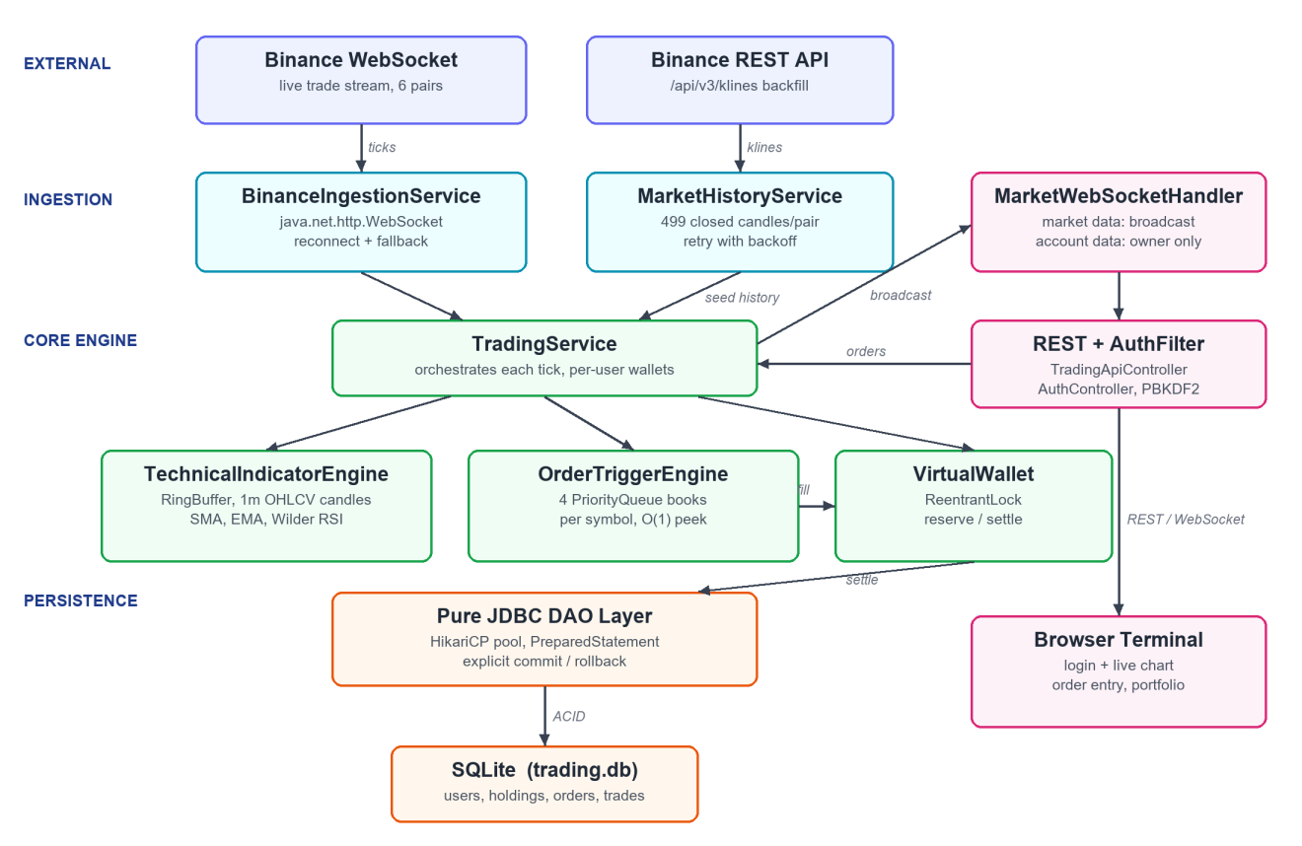
Figure 4.1 System Architecture of CrypteX
A single ingestion thread reads trade ticks from the Binance combined stream and hands each tick to the trading service. The service updates that symbol’s indicator engine, which folds the price into its RingBuffer and one-minute candle, then asks the order trigger engine whether the price has breached any resting order for that symbol. Triggered orders are settled against the owning trader’s wallet under a ReentrantLock and written to the database inside an explicit transaction. Only after settlement is the update broadcast: public market data to every browser, and account data to the owning user alone.

4.2 BASELINE
The first working version ingested a single hardcoded pair, computed indicators over the raw tick buffer, and kept all resting orders in three global PriorityQueues shared across symbols. It placed and filled orders, and was enough to demonstrate the idea. Its weaknesses appeared only once it was tested rather than watched: the chart started empty at every restart, and the indicator overlays smoothed ticks rather than candle closes, so a "14-period SMA" described about fourteen seconds of trading rather than fourteen one-minute bars.

4.3 PROJECT REFINEMENT
The second iteration was driven by writing tests before fixes. Adding a second pair exposed three matching-engine defects, each first captured as a failing unit test. Because the heaps were global and the scan stopped when the head belonged to another symbol, an unrelated order could starve every order behind it. Stop-loss sells were held in a min-heap, so with stops at 95,000 and 80,000 a fall to 90,000 triggered neither. Stop-loss buys had been placed in the falling-price book and so fired on crashes instead of breakouts. The engine was restructured to give every symbol its own four books, and indicators moved onto candle closes using Wilder’s smoothing.

4.4 FINAL APPROACH
The final iteration closed a defect that appeared only when the engine’s output was compared with an independent implementation. The indicator snapshot handed the live, mutable candle object into the broadcast while the ingestion thread kept updating it, so a message could carry a candle newer than the indicators computed beside it. A defensive copy inside the synchronized snapshot removed the discrepancy entirely. The same iteration added session-based authentication with PBKDF2 password hashing [9], per-user wallets, and a retry around the startup history backfill.

4.5 TESTING AND EXECUTION
Seventeen JUnit tests cover the RingBuffer, the indicator engine, the matching engine and wallet concurrency. Where a defect was found, a failing test was written first and kept as a regression guard: the three matching-engine tests added in Iteration 2 all failed against the old engine for exactly the predicted reasons, and pass now. RSI correctness was established against Wilder’s published worked example rather than by inspection, and the full suite is run before any change is considered complete.

CHAPTER 5

IMPLEMENTATION

5.1 MODULE DESCRIPTION
The application is divided into modules that follow the path a single market tick takes through the system.
- Ingestion Module: BinanceIngestionService keeps the native WebSocket connection open, parses trade messages, reconnects automatically and falls back to a simulated feed.
- Indicator Module: TechnicalIndicatorEngine and RingBuffer aggregate ticks into OHLCV (open-high-low-close-volume) candles and compute SMA, EMA and Wilder RSI incrementally.
- Matching Module: OrderTriggerEngine holds resting orders in four PriorityQueue books per symbol and triggers them on price breach using O(1) peeks.
- Wallet Module: VirtualWallet applies every balance change under a ReentrantLock, reserving funds when an order rests and releasing them on fill or cancel.
- Persistence Module: the pure JDBC DAOs settle trades inside explicit transactions with commit and rollback, using HikariCP and PreparedStatement throughout.
- Security Module: PasswordHasher, CredentialValidator, AuthService and AuthFilter provide PBKDF2 hashing, layered field validation and session-based access control.
- Presentation Module: TradingApiController and MarketWebSocketHandler expose REST endpoints and push market and account updates to the browser.

5.2 KEY CODE SNIPPETS

Four extracts follow: the heap orientation that fixed the matching defects, Wilder’s RSI smoothing, the locked wallet update, and the ACID settlement transaction.
Code 5.1 Per-symbol books, one heap per order type (OrderTriggerEngine.java)

private static final class SymbolBook {
final PriorityQueue<Order> buyLimits = new PriorityQueue<>(BY_PRICE_DESC);
final PriorityQueue<Order> sellLimits = new PriorityQueue<>(BY_PRICE_ASC);
final PriorityQueue<Order> stopSells = new PriorityQueue<>(BY_PRICE_DESC);
final PriorityQueue<Order> stopBuys = new PriorityQueue<>(BY_PRICE_ASC);
}

private void drain(PriorityQueue<Order> heap, List<Order> out,
double price, boolean fillsOnFall) {
while (!heap.isEmpty()) {
Order head = heap.peek(); // O(1) boundary peek
boolean breached = fillsOnFall ? price <= head.getTargetPrice()
: price >= head.getTargetPrice();
if (!breached) break; // ordered by proximity: nothing behind qualifies
out.add(heap.poll());
}
}
Code 5.2 Wilder RSI smoothing over candle closes (TechnicalIndicatorEngine.java)
private void commitClose(double close) {
Double prev = closes.peekLast();
closes.addLast(close);
if (prev != null) {
double delta = close - prev;
double gain = delta > 0 ? delta : 0.0;
double loss = delta < 0 ? -delta : 0.0;
if (avgGain == null) {
if (closes.size() >= rsiPeriod + 1) seedWilder();
} else { // Wilder smoothing
avgGain = (avgGain * (rsiPeriod - 1) + gain) / rsiPeriod;
avgLoss = (avgLoss * (rsiPeriod - 1) + loss) / rsiPeriod;
}
}
}
Code 5.3 Double-spend prevention under a ReentrantLock (VirtualWallet.java)
public boolean settleBuy(String symbol, double quantity,
double executionPrice, double reservedAmount) {
lock.lock();
try {
double totalCost = quantity * executionPrice;
double spendable = usdBalance - reservedBalance + reservedAmount;
if (spendable < totalCost) return false; // check and act are atomic
usdBalance -= totalCost;
return true;
} finally {
lock.unlock();
}
Mnbvcxzql;’
}
Code 5.4 Explicit ACID settlement in pure JDBC (TradeSettlementDAO.java)
conn.setAutoCommit(false); // begin transaction
try {
updateUserBalance(conn, userId, totalCost, reservedToRelease);
upsertHolding(conn, userId, symbol, quantity, executionPrice);
insertTradeHistory(conn, userId, symbol, quantity, executionPrice, totalCost);
conn.commit(); // all succeed together
} catch (SQLException e) {
conn.rollback(); // or none of them do
throw e;
}
The complete source code is referenced in Appendix A.1.

5.3 USER INTERFACE / DEMO
Figures 5.1 to 5.3 are captures of the running application; its charts are drawn with TradingView Lightweight Charts [10].
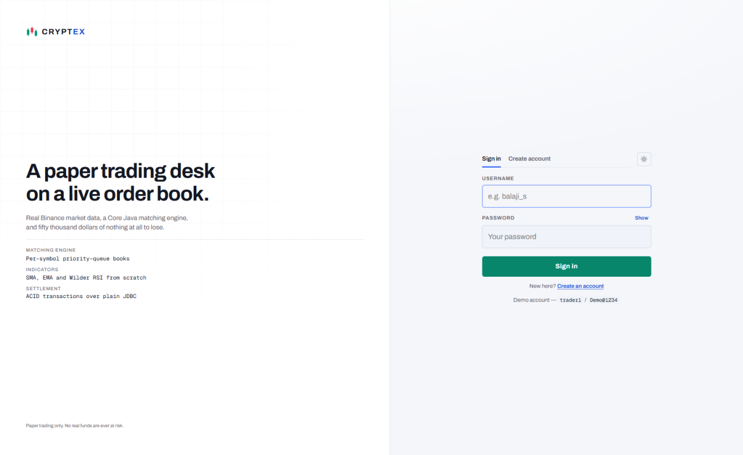
Figure 5.1 Sign-in Screen
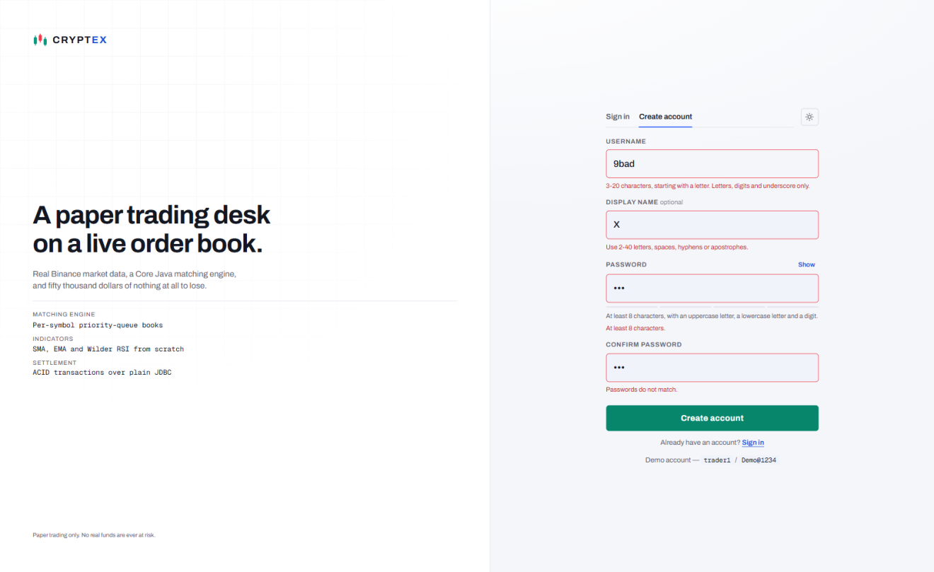
Figure 5.2 Registration Form with Inline Field Validation
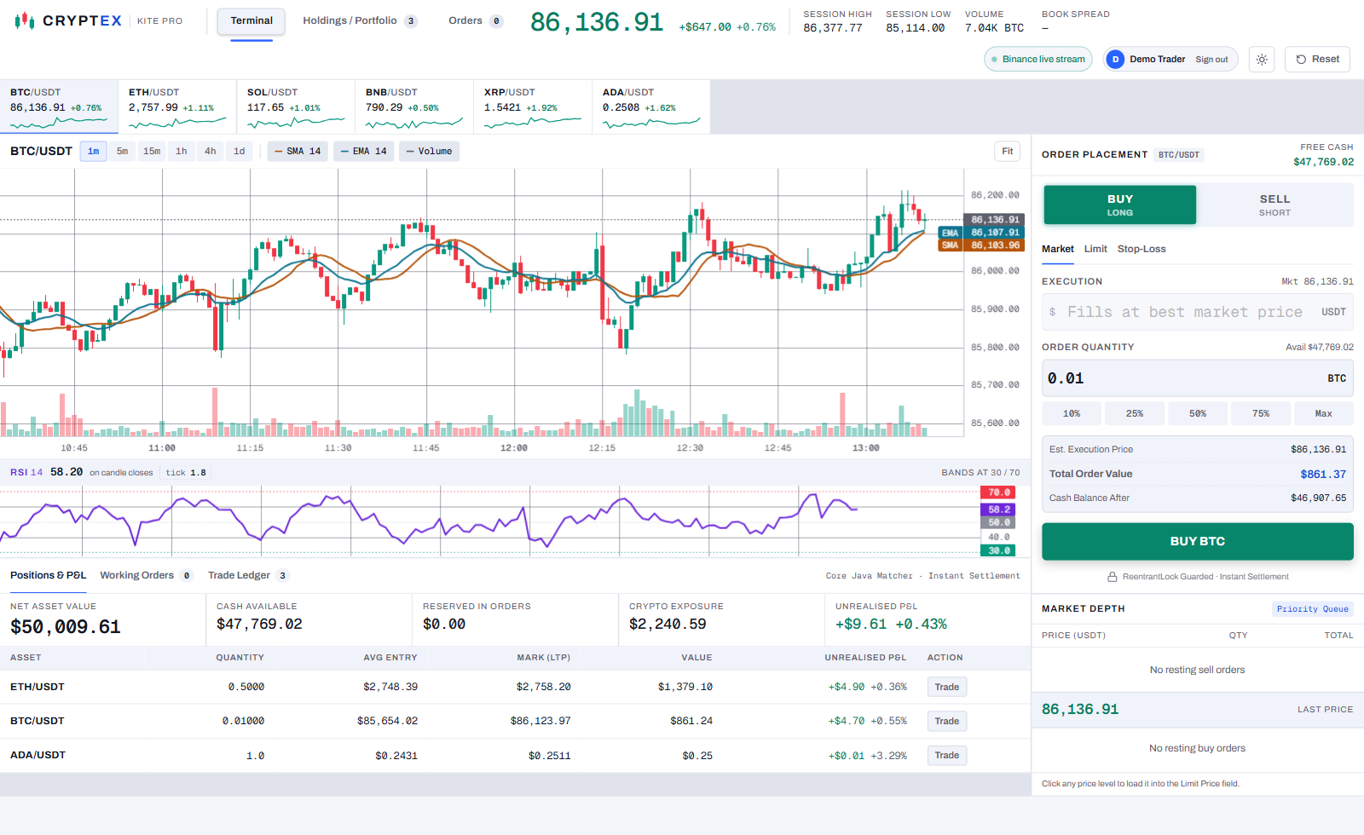
Figure 5.3 Trading Terminal Dashboard

CHAPTER 6

RESULTS AND DISCUSSION

6.1 EVALUATION METRICS
Four metrics were chosen because each answers a question that matters for this system and each is reproducible by running the project.
Unit test pass rate (JUnit 5) measures functional correctness of the engine classes, which are plain Java objects that can be tested without starting the application.
Reference conformance checks the RSI against Wilder’s published worked example, the series charting packages are calibrated against. Matching a published number is evidence; a convincing-looking chart is not.
Cross-implementation agreement compares the Java engine’s broadcast indicators with an independent browser implementation of the same formulae. A disagreement localises a defect, which is exactly how the candle data race was found.
Concurrency safety is tested by firing fifty simultaneous reservations at a balance that can satisfy only twenty. Code coverage and response time were not measured: JaCoCo was not configured and no timing instrumentation was added, so they are reported as not measured rather than estimated.

6.2 RESULTS ACROSS ITERATIONS
Table 6.1 shows the outcome of each iteration against the metrics defined in Section 6.1. It records the JUnit tests passed, the defects exposed and the difference between the engine’s indicator values and an independent browser calculation, which fell to zero in the final iteration.
Table 6.1 Test and Defect Outcomes Across Iterations
Version | JUnit Tests Passed | Defects Exposed | Engine vs Browser Indicator Delta
Baseline (Iteration 1) | 7 / 7 | — | Not comparable (tick-based series)
Project Refinement (Iteration 2) | 9 / 12, then 12 / 12 after fixes | 3 matching-engine defects | SMA 1.296, EMA 2.097, RSI 0.213
Final Approach (Iteration 3) | 17 / 17 | 1 concurrency defect (shared mutable candle) | 0.000 / 0.000 / 0.000

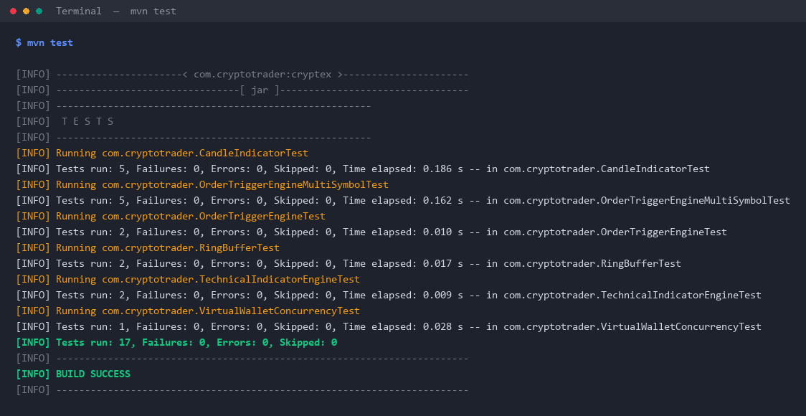
Figure 6.1 Maven Surefire Test Report (17 of 17 passing)

6.3 DISCUSSION
The results describe a project whose quality came from testing rather than inspection. Each of the three matching-engine defects in Iteration 2 had been present in a build that worked in a live demonstration; they surfaced only when a test asserted what should happen rather than observing what did.
The cross-implementation comparison proved more valuable than expected. An SMA discrepancy of 1.296 looked like rounding, but a mean of fourteen identical closes cannot differ by rounding, so the two implementations had to be reading different data. They were: the snapshot passed the live candle object into the broadcast while it was still being mutated. A defensive copy took all three deltas to exactly 0.000 — a genuine data race no single-threaded test would have caught.
The concurrency result was unambiguous: of fifty threads attempting a $500 reservation against a $10,000 balance, exactly twenty succeeded and thirty were rejected, leaving $0.00 available and no overdraft.

6.4 LIMITATIONS
Code coverage was never measured, so while all 17 tests pass there is no evidence about which branches remain unexercised; the DAO layer and ingestion service have no direct unit tests. No load testing was performed — concurrency was tested at the wallet with fifty threads, but the system as a whole was exercised by two accounts on one machine.
The matching model is a simplification with no partial fills, fees or slippage, and money is held in double rather than BigDecimal. Sessions are held in memory, so a restart signs every user out, and the demo account password ships in the properties file for evaluation only.
CHAPTER 7

TEAM REFLECTION AND LEARNING OUTCOMES

7.1 INDIVIDUAL REFLECTIONS
S BALAJI: I built the matching and indicator engines — the per-symbol PriorityQueue books, the RingBuffer and the Wilder RSI — and wrote most of the JUnit suite. The biggest lesson was that a failing test written before the fix exposes defects a live demonstration hides: all three heap-orientation bugs looked correct on screen. The hardest problem was the candle data race, which surfaced only when the engine’s output was compared with an independent implementation.
SURYA PRAKASH M: I owned the persistence and access layers — the pure JDBC DAOs with explicit commit and rollback, the ReentrantLock wallet, and the PBKDF2 login with field validation — together with the browser terminal. Writing the transactions by hand showed me exactly which failure cases an ORM would have hidden. My main challenge was keeping each trader’s balance isolated once real accounts existed, which meant routing account updates to the owning user alone.

7.2 TEAM LEARNING
Splitting the work along the path a market tick takes — engine on one side, settlement and presentation on the other — let each member test in isolation and meet at one clearly defined interface, the TradingService. Agreeing early that no fix would be merged without a failing test first kept all three iterations honest.
Feedback in the design review to prove results against an independent reference, rather than judge the chart by eye, reshaped the testing effort and led directly to the data race being found. If we restarted this PBL cycle, we would add code-coverage measurement and load testing from the first week instead of recording them as limitations at the end.

7.3 COURSE OUTCOMES — EVIDENCE SUMMARY
Evidence from this project for each outcome of the Java Programming course is summarised below.
CO1 – Object-oriented design: the system is decomposed into single-responsibility classes with encapsulated state (TechnicalIndicatorEngine, OrderTriggerEngine, VirtualWallet), Section 5.1.
CO2 – Exception handling and multithreading: a ReentrantLock-guarded wallet proven under fifty concurrent threads, and JDBC rollback on SQLException, Listings 5.3 and 5.4.
CO3 – Collections and generics: PriorityQueue order books, ArrayDeque candle history and ConcurrentHashMap per-symbol state, Listing 5.1.
CO4 – Database connectivity: pure JDBC with HikariCP pooling, PreparedStatement and explicit ACID transactions, Section 4.1.
CO5 – Application development and testing: a working web terminal backed by 17 passing JUnit tests, Figures 5.1 to 5.3 and 6.1.

CHAPTER 8

CONCLUSION AND FUTURE SCOPE

8.1 CONCLUSION
CrypteX set out to answer whether a real-time trading system could be built from Core Java primitives alone, and it can. Live trade data for six pairs is ingested with the native WebSocket client; resting orders are matched from four PriorityQueue books per symbol; SMA, EMA and Wilder RSI are computed from first principles over a custom RingBuffer; a ReentrantLock-guarded wallet prevents double-spending under fifty-thread contention; and every trade settles through a JDBC transaction that commits in full or rolls back. The objectives were demonstrated rather than asserted: 17 JUnit tests pass, the RSI matches Wilder’s series to within 0.01, and the engine agrees with an independent implementation to exactly 0.000. The most valuable outcomes were the four defects the process exposed, none of which were visible in a system that appeared to work when simply watched.
8.2 FUTURE SCOPE
- Replace the price-based fill model with true multilateral matching between users, with partial fills, fees and slippage.
- Migrate monetary fields from double to BigDecimal to remove floating-point error from the ledger.
- Add JaCoCo coverage and latency / JVM-memory instrumentation so the metrics left unmeasured in Chapter 6 can be reported.
- Persist candle history and move sessions out of memory so a restart loses neither.
- Add configurable price alerts and a backtesting mode that replays stored candles through the same matching engine.

REFERENCES

[1] | J. W. Wilder, New Concepts in Technical Trading Systems. Greensboro, NC, USA: Trend Research, 1978.
[2] | Binance, "Binance API Documentation — Market Data and WebSocket Streams," 2024. [Online]. Available: https://binance-docs.github.io/apidocs/spot/en/
[3] | SQLite Consortium, "SQLite Documentation," 2024. [Online]. Available: https://www.sqlite.org/docs.html
[4] | Oracle Corporation, "Java Platform, Standard Edition 17 API Specification," 2021. [Online]. Available: https://docs.oracle.com/en/java/javase/17/docs/api/
[5] | J. Bloch, Effective Java, 3rd ed. Boston, MA, USA: Addison-Wesley, 2018.
[6] | Oracle Corporation, "JDBC Basics — The Java Tutorials," 2021. [Online]. Available: https://docs.oracle.com/javase/tutorial/jdbc/basics/
[7] | B. Goetz, T. Peierls, J. Bloch, J. Bowbeer, D. Holmes and D. Lea, Java Concurrency in Practice. Boston, MA, USA: Addison-Wesley, 2006.
[8] | VMware, "Spring Framework Reference Documentation — WebSocket Support," 2024. [Online]. Available: https://docs.spring.io/spring-framework/reference/web/websocket.html
[9] | B. Kaliski, "PKCS #5: Password-Based Cryptography Specification Version 2.0," RFC 2898, IETF, 2000.
[10] | TradingView, "Lightweight Charts Documentation," 2024. [Online]. Available: https://tradingview.github.io/lightweight-charts/

APPENDIX
A.1 FULL SOURCE CODE
The complete Maven project — all Java sources, the SQL schema, the JUnit suite and the web terminal — is maintained in the team repository. The key listings appear in Section 5.2.
A.2 WEEKLY LOG AND MENTOR SIGN-OFFS
Table 3.1 is the complete weekly PBL log for the twelve-week cycle. The mentor’s review and approval for each milestone were completed and documented through the online review process.

A.3 SELF AND PEER ASSESSMENT
Table A.1 records the self-assessed and peer-assessed contribution of each team member to the project. Both members rated the work as an equal 50% share, and the remarks column summarises the modules each member was primarily responsible for.
Table A.1 Self and Peer Assessment
Team Member | Self-Rated Contribution (%) | Peer-Rated Contribution (%) | Remarks
S BALAJI | 50% | 50% | Matching and indicator engines, JUnit suite
SURYA PRAKASH M | 50% | 50% | JDBC settlement, security, web terminal

