**Software Development Internship**

A REPORT

submitted by

**Pranav Jayaraj (21BRS1190)**

*in partial fulfilment for the award*

of

**B. Tech. Computer Science and Engineering**

**School of Computer Science and Engineering**



**April 2024**



**School of Computer Science and Engineering**

**DECLARATION**

I hereby declare that the project entitled **“Software Development Internship”** submitted by me to the School of Computer Science and Engineering, Vellore Institute of Technology, Chennai Campus, Chennai 600127 in partial fulfilment of the requirements for the award of the degree of **Bachelor of Technology – Computer Science and Engineering** is a record of bonafide work carried out by me**.** I further declare that the work reported in this report has not been submitted and will not be submitted, either in part or in full, for the award of any other degree or diploma of this institute or of any other institute or university.

Signature



**Pranav Jayaraj (21BRS1190)**

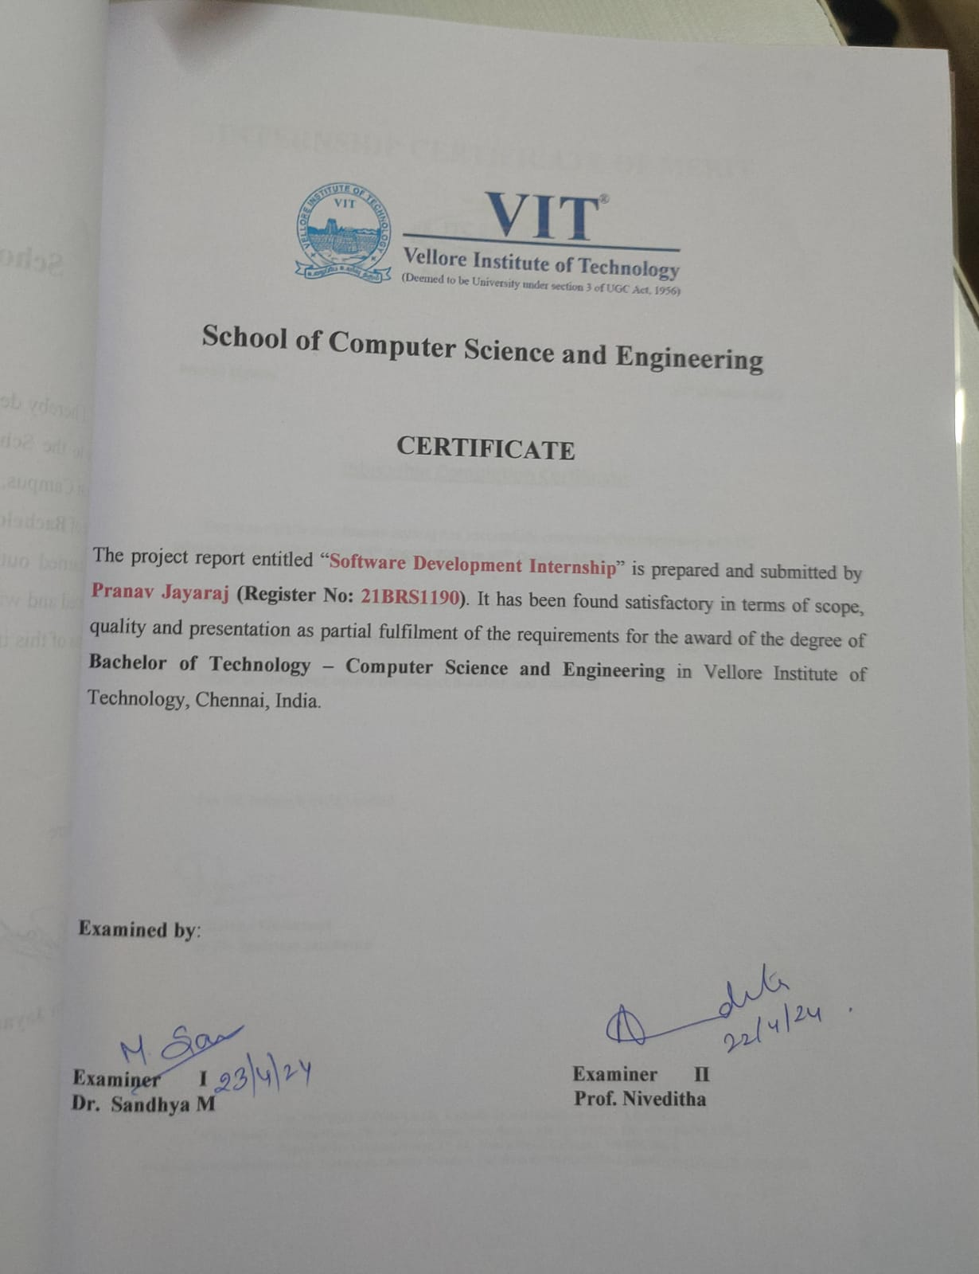

**INTERNSHIP CERTIFICATE OF MERIT**

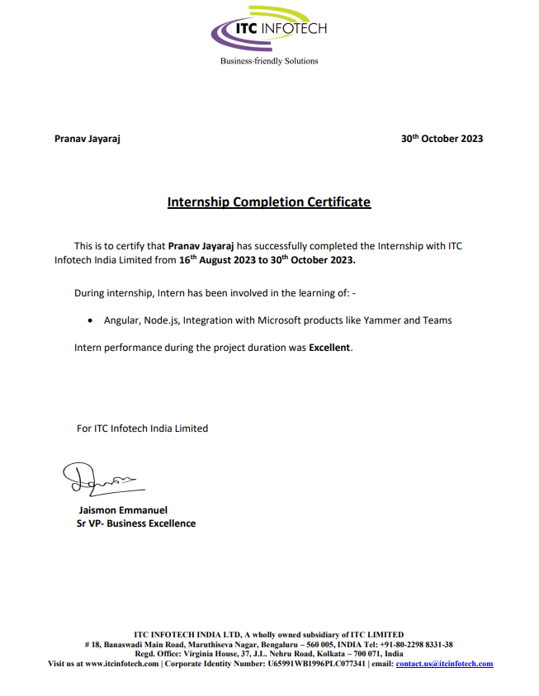

**ACKNOWLEDGEMENT**

I am deeply grateful to everyone whose contributions made my internship at ITC Infotech a truly enriching experience, marked by growth, learning, and invaluable insights.

I'm grateful to Mr. Hashhash Abdulla for his invaluable mentorship at ITC Infotech. His daily standup meetings offered clear guidance and unwavering support, shaping my professional journey. His dedication to nurturing talent has been instrumental in my development.

I am indebted to Mr. Ganesh G, the head of the design team, whose expertise in UI/UX design proved to be invaluable. Ganesh's insights into different design patterns and user interface principles not only enriched our projects but also broadened my understanding of the importance of user-centric design in software development.

A special mention goes to Mr. Jeevan, the senior developer in our team, whose guidance and mentorship during the development phase were instrumental in overcoming challenges and achieving project milestones. Jeevan's expertise, coupled with his willingness to share knowledge and provide constructive feedback, significantly enhanced my learning experience.

Furthermore, I extend my appreciation to the entire team at ITC Infotech for fostering a collaborative and supportive work environment. The opportunity to collaborate with talented professionals and work on challenging projects has been instrumental in shaping my skills and capabilities.

I also take this opportunity to thank Dr. S. Harini, Artificial Intelligence & Robotics, School of Computing Science and Engineering, VIT Chennai for extending the facilities of the School towards this internship period and for her unstinting support.

**CONTENTS**

|  |  |  |
| --- | --- | --- |
| **Chapter** | **Title** | **Page** |
|  |  |  |
|  | Title Page | 1 |
|  | Declaration | 2 |
|  | Certificate | 3 |
|  | Industry certificate | 4 |
|  | Acknowledgement | 5 |
|  | Table of contents | 6 |
|  | List of Figures | 7 |
|  | List of Abbreviation | 8 |
|  | Abstract | 9 |
|  |  |  |
| 1 | Introduction and Problem Statement | 10 |
| 2 | Yammer Integration | 11 |
| 3 | Push Notifications | 13 |
| 4 | Azure DevOps Pipelines | 15 |
| 5 | Interactive Banners | 16 |
| 6 | Conclusion | 17 |
|  | References | 18 |
|  | Appendix – I | 19 |

**LIST OF FIGURES**

|  |  |
| --- | --- |
| **Title** | **Page** |
| Fig a: Push notifications subscribe button | 16 |
| Fig b: Interactive banner | 18 |

**LIST OF ABBREVIATIONS**

|  |  |
| --- | --- |
| **Abbreviation** | **Expansion** |
| API | Application Programming Interface |
| CORS | Cross-Origin Resource Sharing |
| PWA | Progressive Web App |
| VAPID | Voluntary Application Server Identity |
| PMO | Project Management Office |

**ABSTRACT**

The project embarked upon during the internship at ITC Infotech aimed to enhance an ongoing software application by integrating cutting-edge functionalities and streamlining deployment processes. Leveraging the Angular framework with TypeScript, the project focused on incorporating external applications, enhancing user engagement, and automating deployment workflows.

One of the key objectives of the project was to integrate Yammer or Viva Engage applications seamlessly into the existing software ecosystem using APIs. This integration facilitated enhanced communication and collaboration among users, thereby enriching the overall user experience.

Furthermore, the project involved implementing web push notifications using the Web Push Notifications API. This feature enabled real-time communication with users, delivering timely updates and notifications directly to their devices, thus fostering increased user engagement and retention.

In addition to feature enhancements, the project also focused on optimizing deployment processes using Azure DevOps. By leveraging Azure DevOps pipelines, the workflow from development to deployment was streamlined, ensuring smoother and more efficient release cycles. Moreover, Microsoft Power Automate was utilized to automate the deployment of certain features, further enhancing deployment efficiency and reducing manual intervention.

An interactive banner was developed for the homepage of the software application using vanilla JavaScript, HTML, and CSS. This banner served as a visually appealing and engaging element, providing users with dynamic content and enhancing the overall aesthetics of the application.

Overall, the project encapsulated a holistic approach towards software development, encompassing feature integration, deployment optimization, and user interface enhancements. By leveraging a combination of modern technologies and best practices, the project aimed to elevate the user experience and streamline development processes, thereby contributing to the success and scalability of the software application.

**1. INTRODUCTION AND PROBLEM STATEMENT**

In today's fast-paced digital landscape, software applications play a pivotal role in facilitating communication, collaboration, and productivity across various domains. As organizations strive to stay competitive and meet evolving user expectations, there is a growing need to continuously enhance software applications with new features, streamline deployment processes, and optimize user engagement. This necessitates the integration of cutting-edge technologies, efficient deployment workflows, and user-centric design principles to deliver compelling and seamless user experiences.

During the internship at ITC Infotech, the focus was on addressing these challenges by working on an ongoing software application. Leveraging the Angular framework with TypeScript, the project aimed to enhance the functionality, user engagement, and deployment efficiency of the software application. Through the integration of external applications, implementation of web push notifications, and optimization of deployment processes, the project sought to elevate the overall user experience and streamline development workflows.

The software application under consideration faced several challenges that needed to be addressed to meet the evolving needs of users and stakeholders. One of the primary challenges was the lack of seamless integration with external communication and collaboration tools, hindering efficient information sharing and collaboration among users. Additionally, the absence of real-time communication mechanisms limited the application's ability to deliver timely updates and notifications to users, thereby impacting user engagement and retention.

Furthermore, the deployment process for the software application was manual and time-consuming, leading to delays in releasing new features and updates. The absence of an automated deployment workflow resulted in inefficiencies and increased the risk of errors during deployment, ultimately affecting the overall reliability and scalability of the application.

To address these challenges, the project aimed to integrate external applications such as Yammer or Viva Engage seamlessly into the software application, enabling enhanced communication and collaboration among users. Additionally, the implementation of web push notifications aimed to provide users with real-time updates and notifications, thereby increasing user engagement and retention.

**2. Yammer Integration**

1. **Yammer Integration**

Yammer is a social networking service used for private communication within organizations. It provides a platform for employees to collaborate, share ideas, and stay connected with colleagues. With features such as messaging, group creation, and file sharing, Yammer enhances internal communication and fosters a sense of community within organizations.

The integration of Yammer into the Angular application involved several steps to enable seamless communication and collaboration among users. The following components were developed and integrated to achieve this:

1. **Login Component:** 
   * The Login component provides users with the interface to authenticate and authorize access to the Yammer API.
   * Upon successful authentication, the user is redirected to the Yammer authentication callback component.
2. **Yammer Authentication Callback Component:**
   * This component handles the callback from the Yammer authentication process.
   * It extracts the access token from the URL fragment after authentication and stores it in the local storage for future API requests.
   * Upon obtaining the access token, the component navigates to the desired route, typically the feed component.
3. **Feed Component:**
   * The Feed component fetches and displays the Yammer feed within the Angular application.
   * It utilizes the access token stored in the local storage to authenticate API requests to fetch the user's Yammer feed.
   * The component makes HTTP requests to the Yammer API endpoints to retrieve the user's feed data.
   * Upon receiving the feed data, the component processes and formats it for display, including user names, messages, attachments, and timestamps.
   * The formatted feed data is then rendered within the Angular application, providing users with a seamless Yammer integration experience.
4. **Proxy Server:**
   * To bypass CORS restrictions and securely access the Yammer API from the Angular application, a proxy server was implemented using Express.js.
   * The proxy server forwards requests from the Angular application to the Yammer API, ensuring seamless communication between the frontend and backend.
   * It intercepts requests prefixed with '/api' and forwards them to the Yammer API endpoint, removing the '/api' prefix in the process.

**3. Push Notifications**

A **Progressive Web Application (PWA)** is a type of web application that utilizes modern web technologies to provide users with a native app-like experience directly within their web browser. PWAs are designed to be reliable, fast, and engaging, offering features such as offline functionality, push notifications, and home screen installation.

**Push notifications in PWAs** allow web applications to deliver timely updates and alerts to users, even when the application is not actively open in the browser. These notifications can be used to notify users about new messages, upcoming events, or other relevant information, increasing user engagement and retention.

**Server-Side Configuration (server.js):**

* The server-side code is responsible for handling push notification subscriptions and sending push notifications to subscribed clients.
* Express.js is used to create an HTTP server to handle incoming requests.
* Web-push library is configured with VAPID keys for secure communication with push services.
* Endpoints are defined for subscribing to push notifications (/api/subscribe) and sending push notifications (/api/send-notification).
* Upon receiving a subscription from a client, it is stored on the server for future use.

**Client-Side Implementation (notification.service.ts):**

* In the Angular PWA, the NotificationService is responsible for subscribing to push notifications.
* The SwPush service from @angular/service-worker is used to request a subscription to push notifications.
* Upon obtaining a subscription, the subscription details are sent to the server using an HTTP POST request to /api/subscribe.
* If the subscription is successful, it is resolved, otherwise, it is rejected with an error.

**Explanation of the Process:**

* When a user visits the PWA and opts in to receive push notifications, the Angular PWA requests a subscription to push notifications using the SwPush service.
* The SwPush service interacts with the browser's Push API to generate a unique subscription object containing endpoint URL, keys, and other details.

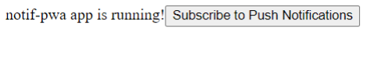

Fig. (a)

* This subscription object is then sent to the server-side endpoint (/api/subscribe) using an HTTP POST request.
* The server receives the subscription object and stores it for future use, associating it with the specific user or device.
* When there is a need to send a push notification to subscribed clients, the server constructs a notification payload containing the title, body, and optional data.
* The server then iterates over the stored subscriptions and uses the web-push library to send the notification payload to each subscribed client.
* Upon receiving the notification, the client-side service worker handles the display of the push notification, even if the PWA is not actively open in the browser.

1. **Azure DevOps Pipelines**

In the pursuit of seamless deployment, **Azure DevOps** pipelines emerged as an invaluable tool during the project. By leveraging Azure DevOps, we orchestrated a streamlined workflow from code commit to production deployment, ensuring efficiency and reliability throughout the software development lifecycle. These pipelines provided automation for building, testing, and deploying our application, enabling rapid iteration and continuous integration. With customizable stages and triggers, we tailored the pipelines to suit our project's specific requirements, whether it be deploying to development, staging, or production environments. Moreover, the integration of Azure DevOps pipelines fostered collaboration among team members, facilitating transparent communication and enabling swift resolution of any deployment issues. Ultimately, Azure DevOps pipelines played a pivotal role in optimizing our deployment process, empowering us to deliver high-quality software with speed and confidence.

* **Pipeline Design:** The pipelines were designed to automate the build, test,

and deployment processes for the software applications developed during

the internship.

* **Source Control Integration:** Integration with Git repositories hosted on

Azure DevOps was established to fetch source code for building and

deployment.

* **Build Automation:** Build pipelines were created to automate the process

of compiling source code, running unit tests, and generating artifacts.

* **Continuous Integration:** Continuous Integration (CI) pipelines were

configured to trigger automatically upon code commits, ensuring that

changes were integrated and tested regularly.

* **Deployment Automation:** Deployment pipelines were set up to automate

the deployment of applications to various environments, such as

development, staging, and production.

* **Monitoring and Feedback:** Monitoring tools were integrated into the

pipelines to track build and deployment statuses, providing feedback to

developers and stakeholders.

1. **Interactive Banner**

A dynamic banner made with standard JavaScript. This banner improved the project's overall aesthetics and user experience by acting as a visually captivating element on the site. We used interactive features like dynamic animations, hover effects, and clickable components to captivate and engage consumers by utilizing the power of JavaScript. Our goal in incorporating these features into the banner was to give users an engaging and dynamic browsing experience.

* **Design Conceptualization:** The design concepts for interactive banners

were developed based on the branding guidelines and visual identity of

the organization.

* **HTML Markup:** HTML markup was created to structure the content of

the banners, including text, images, and interactive elements.

* **Styling with CSS:** CSS styles were applied to enhance the visual appeal

of the banners, including layout, typography, colors, and animations.

* **Interactive Features with JavaScript:** JavaScript was used to implement

interactive features such as hover effects, click actions, and animated

transitions.

* **Responsive Design:** The banners were designed to be responsive,

ensuring optimal display across various screen sizes and devices.

* **Integration into the PMO Website:** Once the banners were developed and

tested, they were integrated into the PMO website, enhancing its visual

appeal and user engagement.

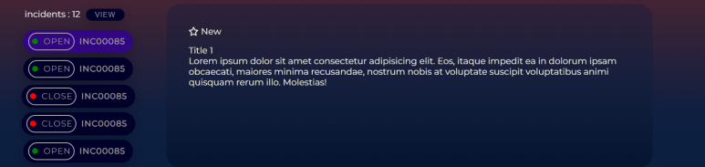

Fig. (b)

1. **CONCLUSION**

In conclusion, my internship experience at ITC Infotech was an enriching journey filled with valuable learning opportunities and hands-on experiences. Throughout the internship, I had the privilege of working with a talented team of mentors, seniors, and fellow interns who provided guidance, support, and encouragement every step of the way. From diving into cutting-edge technologies like Angular framework and TypeScript to integrating external applications like Yammer and Viva Engage, each project presented unique challenges and opportunities for growth. The implementation of web push notifications, automation of deployment workflows using Azure DevOps, and development of interactive banners showcased my ability to adapt to new technologies and deliver impactful solutions. Moreover, the collaborative environment fostered innovation, teamwork, and professional development, shaping me into a more competent and versatile software developer. As I reflect on my internship journey, I am grateful for the invaluable experiences and skills gained, which have equipped me for future endeavors in the dynamic field of software development.

**REFERENCES**

* <https://learn.microsoft.com/en-us/rest/api/yammer/rest-api-rate-limits>
* <https://learn.microsoft.com/en-us/azure/devops/pipelines/get-started/what-is-azurepipelines?view=azure-devops>
* <https://learn.microsoft.com/en-us/azure/devops/repos/get-started/what-isrepos?view=azure-devops>
* <https://www.webpushnotifications.com>

**APPENDIX I**

* Yammer integration

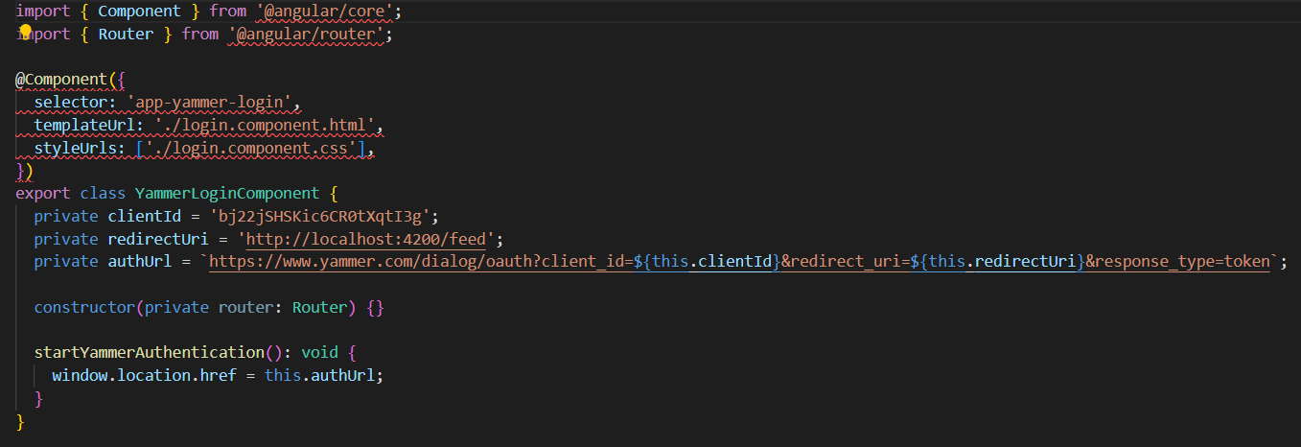

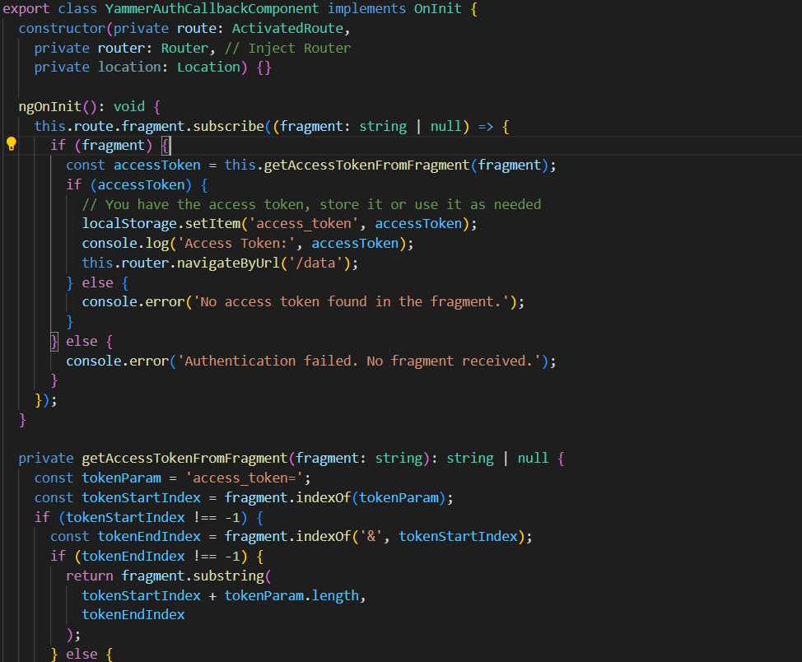

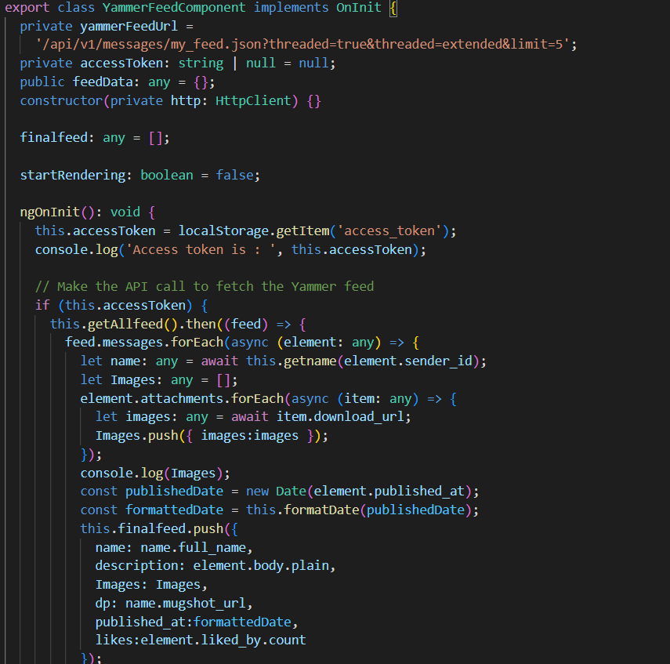

* Push notifications

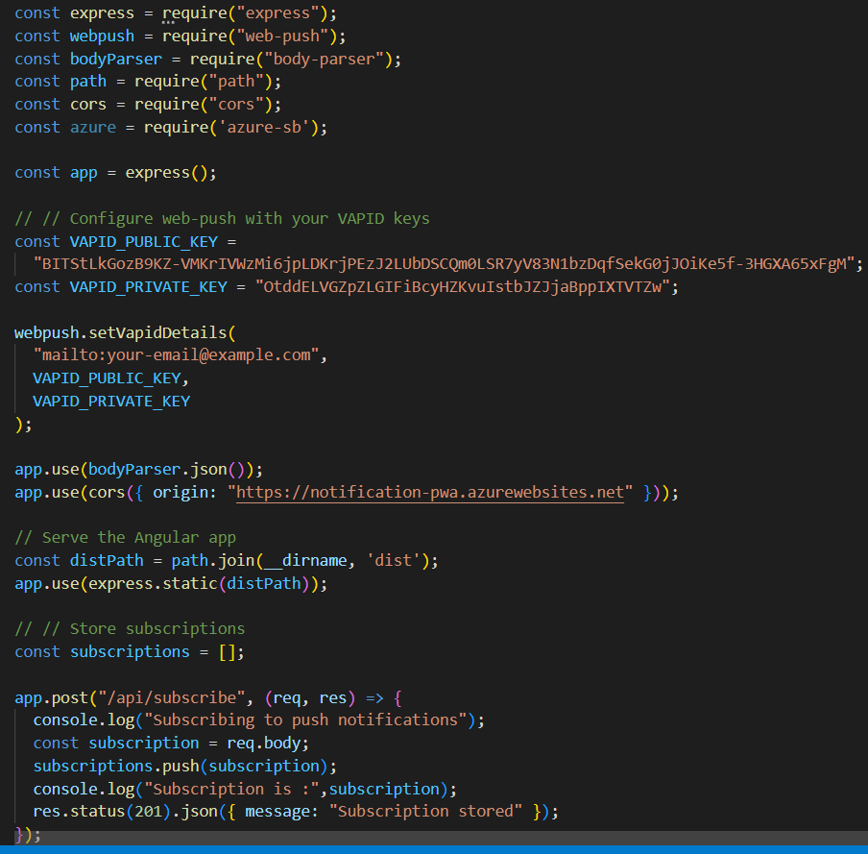

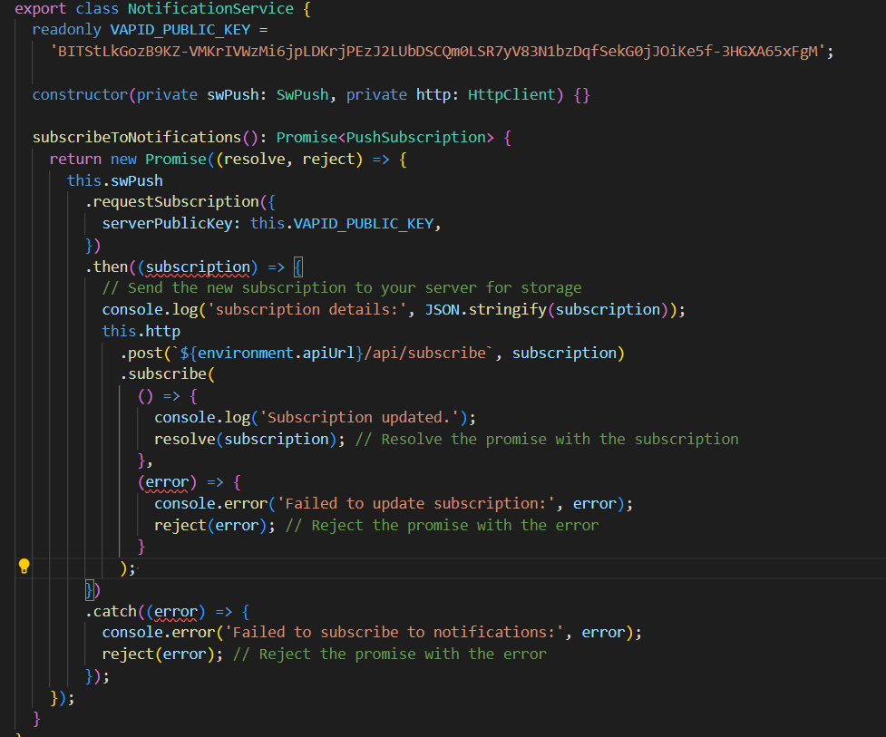

* Interactive banner

