Energy simulation and analysis of accessory dwelling units: an evolutionary approach

P. Arthur Pape

[ppape@uw.edu](mailto:ppape@uw.edu)

Abstract

Accessory dwelling units (ADUs) are surging in popularity as cities push for their construction to aid in combatting the housing crisis. In Seattle, Washington, recent survey data calls for increased focus on sustainability and cost. Lowering energy use intensity (EUI) of ADUs allows for the targeting of both desires which homeowners hold. The effect of varying window-to-wall ratios (WWRs) on EUI is simulated using EnergyPlus and Honeybee. Galapagos, a genetic solver plugin for Grasshopper, is used to vary window-to-wall ratio and optimize ADU energy use intensity on three single-family residential lots in Seattle. Site context is constructed using OpenStreetMap GIS data and zoning restrictions are incorporated into the Grasshopper definition. Future work is planned to utilize output data from this tool as the training dataset for a machine learning model. Accurate machine learning prediction of energy use intensity instead of extended simulation would increase the pragmatic use of such tools.

**Keywords:** Genetic algorithm, accessory dwelling unit, housing affordability, building simulation, energy use intensity

1. Introduction

The United States is amidst an unprecedented housing crisis, stemming from parallel crises. From neoliberal austerity spending cuts towards social benefits to the near-virtual lack of social housing and rent control programs in the US to the ever-increasing privatization of essentially every aspect of American life\cite{10.2307/26297969}, housing is becoming more of a privilege. The result is a rising population of unhoused peoples and the inability for many to become a homeowner or to even afford minimum monthly rent in most top US cities. Solutions to this dilemma are neither straightforward nor definite. However, designers and architects can only address the symptom-level problems, while advocating towards change directed at the root cause.

Seattle, Washington; Portland, Oregon; and Vancouver, British Columbia are exploring the use of accessory dwelling units (ADUs) as one method to combat surging housing prices. The use of ADUs is an effective means of increasing housing density without replacing single-family (SF) housing zones with new multi-family residential construction. Additionally, ADUs are often designed to be rented, generating supplementary income for the homeowner. Historically, homeowner’s associations and other local organizations have been resistant to any proposed density increases through zoning or other means\cite{10.2307/24392672}. However, Seattle and the other previously mentioned cities in the Pacific Northwest have succeeded in allowing for the construction of ADUs in recent decades, with these groups beginning to see ADUs as a positive. ADUs offer many positives beyond an increased housing supply such as a path for homeowners to generate income and accommodating households with multigenerational or caretaking needs.

Beginning in 2014, the City of Seattle has moved to increase production of ADUs through various resolutions and legislation, in turn removing barriers to entry and highlighting strategies for encouragement. In late 2019, a call for detached ADU (or DADU) designs was issued to designers. As a result, ten DADU designs were pre-approved by the City of Seattle and are available online to entice homeowners\cite{ADUniversePreapprovedADU}. The pre-approved designs are free, but still require standard permitting fees to be paid for approval and come with one significant downside of many other pre-designed structures: a lack of contextual design and individualization. This one-size-fits-all approach can have drastic effects upon energy consumption, reducing the appeal of such an investment. Further, these designs do not offer the scalability or energy efficiency that an ADU designed specifically per site offers.

Coincidentally, a November 2019 city survey shows that there are calls for an increased focus on sustainability and cost in the construction of ADUs\cite{seattlePreapprovedPlansAccessory2019}. This survey was positioned before the official call for submissions was broadcast. Low cost was the top ranked criteria with 48% of responses listing 'very important', followed by green building being ranked similarly at 46%. Other suggestions sourced from surveyed respondents included low environmental costs, site specific considerations, and predictability. The ability to show users the estimated annual energy consumption of a new construction DADU would have a major impact on driving construction demand based on survey responses noted. Using an optimization method such as a genetic algorithm (GA) can allow architects to arrive at the most effective design solution on a site specific basis while predictably minimizing both environmental and financial costs.

1. Literature review

Finally, an energy model is created from each individual iteration to find an estimate for overall EUI. From here, the process loops until an optimal solution is found.

1. Methods

This research explores the use of a genetic solver to find the optimal design solution of window-to-wall ratios (WWR) for a simple DADU form resulting in the lowest energy use intensity (EUI) value. Three sites in comparable neighborhoods in the city of Seattle were selected based on a combination of proximity and slight density variance. The tool adheres to zoning regulations to find estimated buildable area for a DADU on each site, creates a simple box-like form representing the DADU and then varies the WWR value for each of the four walls. A genetic solver plugin is then allowed to vary these ratios to find an optimal solution using a process largely mimicking natural genetic processes. Finally, an energy model is created from each individual iteration to find 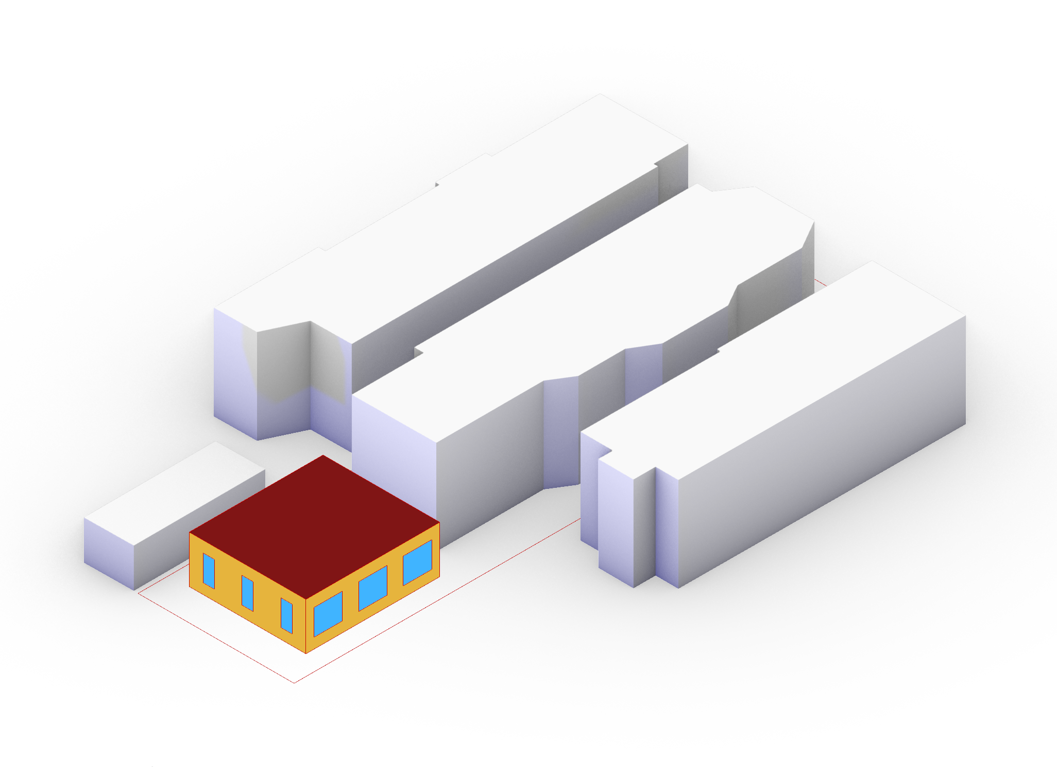an estimate for overall EUI. From here, the process loops until an optimal solution is found.

Figure 1. Isometric view of DADU, demonstrating WWR representation.

Site locations were chosen through the use of the ADUniverse tool, developed by University of Washington researchers at the eScience Institute's \textit{Data Science for Social Good} program\cite{ADUniverseToolEScience}. ADUniverse allows for users to investigate the possibility of constructing an ADU through a map-based user interface. Chosen sites are located within the Madrona, Minor, and Central District neighborhoods of Seattle, WA. All three sites are zoned under SF5000, a single family residential zoning. Site data was extracted from open source map website OpenStreetMap.org and converted into an AutoCAD .DWG file. Next, this 2D linework was imported into and extruded into three dimensions within Rhinoceros 6 (Rhino) and Grasshopper, a 3D modeling software and visual scripting tool for Rhino, respectively. Property lines (pulled from the Seattle City GIS tool) for each chosen residential site are fed into the Grasshopper definition, coupled with constraints in-line with the current land use code of Seattle \cite{SeattleLandUse2021}. Such universal constraints for ADUs on lots located within SF5000 zoning are as follows\cite{ADUniverseADURules}:

* Lot size must be at least 3200 square feet
* Minimum lot width of 25 feet
* Minimum lot length of 70 feet
* DADU can occupy *at most* 60% of rear yard
* Front yard of 20 feet, side yards of 5 feet, rear yard of 25 feet
* DADU height limit varies based on lot width:
  + 14 feet for lot widths less than 30 feet
  + 16 feet for lot widths between 40 and 50 feet
  + 18 feet for lot widths exceeding 50 feet

These constraints are built into the Grasshopper definition in such a way that the tool simply requires lot extents and the footprint of the existing residential structure to develop the buildable area for any DADU construction. Each DADU is represented as a simple 12' shoebox model with facades oriented perpendicular to the cardinal directions. Under current Seattle Residential Building Code (2018), minimum R-values for wall and ceiling assemblies are R-21 and R-49, respectively. Light wood frame construction was chosen for all three sites, as the majority of residential construction in the US and in Seattle specifically falls under this category due to price and ubiquity. For this project, total R-values were set to 26.86, 54.59, and 5.73, for wall, roof, and floor assemblies, respectively. Wall and roof assemblies are detailed in Tables \ref{table:wall-assembly} and \ref{table:roof-assembly}. Floor condition is a standard slab-on-grade with rigid insulation below an 8" concrete slab, finished with carpeting.

% Wall Assembly

% Roof Assembly

Energy model and analysis

Honeybee, part of the open-source Ladybug Tools plugin suite for Grasshopper and Rhino, has become an industry standard for daylighting simulation and energy modeling within architecture and engineering, largely due to its open source nature\cite{mackey2018tool}. Honeybee acts as a bridge between modeled Rhino geometry and the US Department of Energy's EnergyPlus simulation tool. Modeled geometry is constructed as rooms and zones within Honeybee, offering greater granularity. Importantly, EnergyPlus operates using various abstractions and simplifications\cite{EnergyPlusTMVersionDocumentation2021}. Each zone and surface is only able to hold one temperature value at a time- each singular value is averaged across the zone or surface. Each DADU simulated is represented as a single zone spanning the entire structure. Alternatively, using four zones and a core instead would have increased resolution of results, but at the cost of much longer simulation times. For building typologies larger than ADUs, this discrepancy between EUI simulation results using one or five (four and a core) zones has been studied\cite{SingleZoneVs2018}. Results showed EUI estimates experienced 4.23% variance on average for cities tested. Further, for Seattle specifically, results varied by only 2.12%.

Similarly, trees are represented as simple cylindrical solids, in order to keep energy simulation speed quick and to reduce the time necessary to reach an optimal solution. In initial tests, trees were represented as spherical meshes created using Grasshopper. These more-detailed trees varied in opaque triangulated mesh coverage to simulate foliage cover and to more accurately cast shadows. It is important to note that with access to greater computing power it could become reasonable to represent and simulate trees in the original format. Together with other context, including the associated residence and nearby residences capable of projecting shadows onto the DADU, the tree models were assigned as shades in the Honeybee model.

The final input required for the Honeybee/EnergyPlus model is a weather file, in .EPW (EnergyPlus Weather File) format. These files contain yearly climate data for a geographic location; in this case, data was collected at the King County International Airport - Boeing Field in Seattle, Washington. The American Society of Heating, Refrigerating, and Air-Conditioning Engineers (ASHRAE) defines climate zones for use with EnergyPlus and other tools/calculations. Seattle falls within the ASHRAE 169-2006 standard 4C climate, defined as \textit{Mixed - Marine}. This climate type is utilized within the Grasshopper script to define the wood frame construction type for the Seattle climate. EPW files are obtainable freely at \textit{EnergyPlus.net}, the US Department of Energy's official EnergyPlus website. Output data consists of the final, optimized site EUI value for each DADU as a sum value of cooling, heating, lighting, equipment, and hot water EUIs. Lighting, equipment, and hot water are all held constant at 1.923 kBTU/ft2, 9.645 kBTU/ft2, and 14.295 kBTU/ft2, respectively.

Genetic algorithm

Genetic algorithms operate using logic that mimics biological evolution to optimize a value. Fitness functions are the means by which to objectively evaluate the strength of individual designs. In this case, the fitness value minimized is the resultant EUI value corresponding to each set of window-to-wall ratios. Work was initially done using a purely Python-based GA script, but later pivoted to utilizing Galapagos, a genetic solver plugin that ships with Grasshopper. Utilizing Grasshopper and Galapagos offers a ‘sandbox’ environment to begin to understand genetic algorithms and to arrive at tangible design solutions faster than using a home-brewed algorithm. Further, Galapagos offers a simple user interface and a more direct integration within Grasshopper at the cost of advanced options. However, these options were not necessary for the level of optimization required within this project. Galapagos accepts Grasshopper slider components as input, with the domain set independently for each slider. As each DADU is reduced to a shoebox model, each facade is governed by one individual WWR slider, each with domain {*x* | 0 ≤ *x* ≤ 0.95}. Each Galapagos optimization was run five times for each site as a means to check for outliers and not simply a local minimum. The evolutionary solver input panel was set as follows:

* Max. Stagnant = 50
* Population = 75
* Initial Boost = 4x
* Maintain = 5%
* Inbreeding = +75%

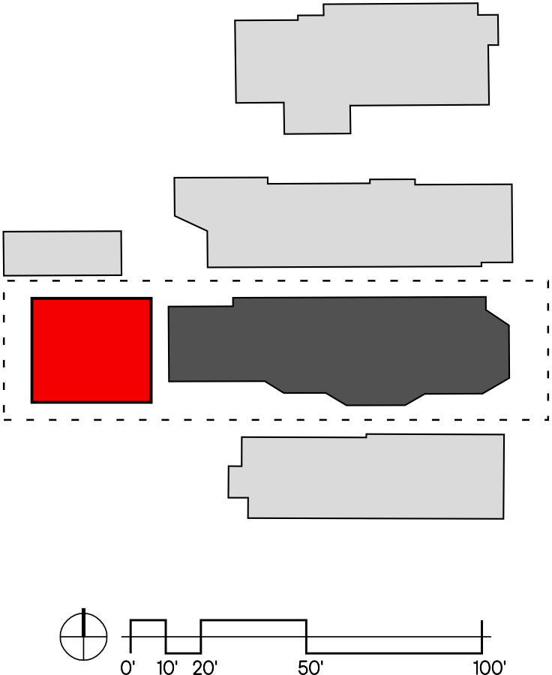Population set to 75 was found to be an effective balance between speed and reliability in initial tests. Allocating a 4 times multiplier to initial population size ensures enough design variation from the start. Each optimization run was stopped at 15 generations, with each site having been optimized 5 times. The results presented below for sites are averaged between all completed runs. Outlier EUI values were omitted and optimizations re-run. Occasionally, Galapagos may reach what is termed a *local minimum*, values which define the lowest EUI within the genetic dataset, but not the true minimal EUI attainable within constraints.

Figure 2. Site 1 Central District: 961 20th Avenue | DADU floor area: 1000 ft2.

1. Results and discussion

Site selection was primarily driven by orientation between DADU location and existing residences, with each site in a differing neighborhood of Seattle. The Central District, Minor, and Madrona neighborhoods all lie east of downtown Seattle, greatly uphill. Neighborhoods differ slightly in density, street width, and demographics but all chosen sites are within identical SF5000 zoning. Site 1 is located at 961 20th Avenue in the Central District and the DADU is bordered directly by existing structures to the north and east. This DADU is the largest explored, reaching the maximum allowable floor area of 1000 ft2, as limited by single family code\cite{ADUniverseADURules}. Site 2 resides at 328 17th Avenue in Minor and its DADU structure is adjacent to the east of the existing home. This site is unique out of the three, as there is an additional existing structure located on the lot, being a small storage shed to the south-east. DADU footprint for site 2 totals 520 ft2. Finally, site 3, located at 3413 East Pine Street within Madrona consists of the existing residence facing the street to the north, with DADU location to the south. Gross floor area of this DADU structure is 680 ft2. Neighboring residences to the east and southeast account for the majority of shading effect. One future consideration is to allow for override to WWR domain, either automatically or manually selected by user. For example, let's say the DADU at site 3 found a value of 35% for the southern facade. This may be optimal, but the majority of owners likely would opt to avoid windows facing directly into their neighbors private spaces of their dwelling. The genetic algorithm could contain a few toggles for override.

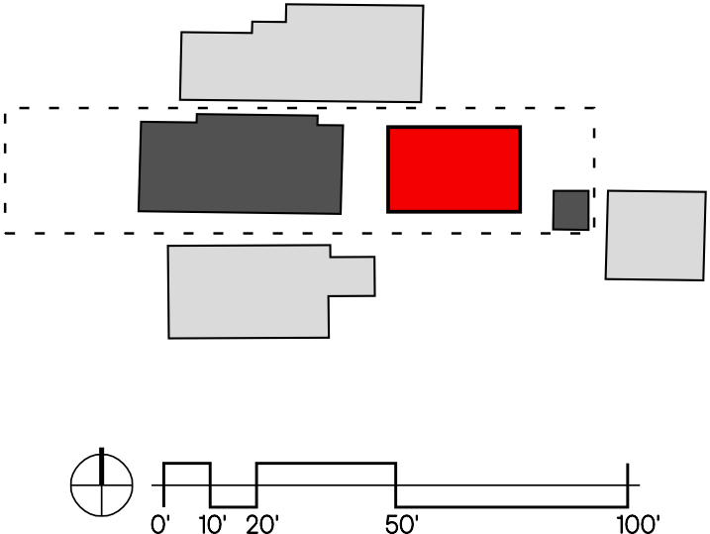

Figure 3. Site 2 Minor: 328 17th Avenue | DADU floor area: 520 ft2.

Averaged optimal total site EUI was found to differ by less than 4 kBTU/ft2 between all three sites. Total EUI was calculated to be 62.675 kBTU/ft2, 61.207 kBTU/ft2, and 64.059 kBTU/ft2 for sites 1-3, respectively. Heating, on average, constituted for about 50% of total EUI, while cooling accounted for only about 9% of total site EUI on average. Optimal WWR values were found to be greatly similar between sites, regardless of context and orientation to existing residences. North, west, and east WWR values were typically found to lower EUI when lowered almost to zero. On the other hand, the south WWR approached .25 on average. North WWR was found to fall between 0 and 0.18, with an average value of 0.08 percent glazed to opaque. East and west WWRs typically fell between 0 and 0.11, with the majority of Galapagos runs ending with zero glazing on the east and west facades. Curiously, the lowest EUI found out of any runs was located at site 2 in Minor, with WWRs of 0.06 north, 0.09 east, 0.10 south, and 0 west. This combination of window to wall ratios stands out as it was simultaneously the only resultant where north, east, and south ratios are almost identical and non-zero.

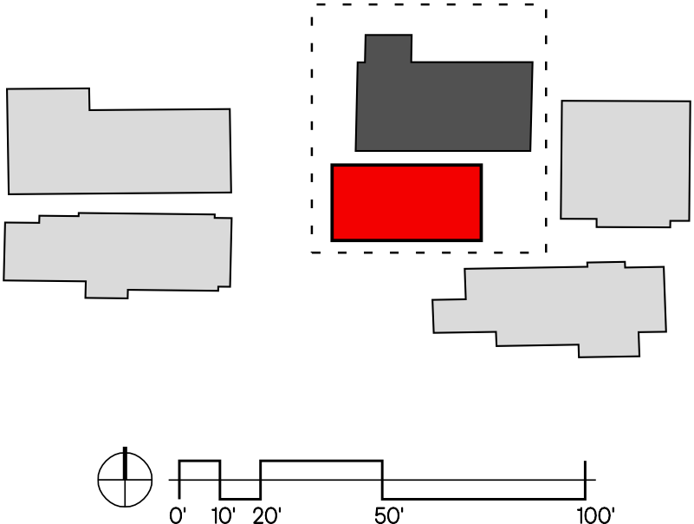

Figure 4. Site 3 Madrona: 3413 East Pine Street | DADU floor area: 680 ft2.

Table 3 displays the averaged results by site, as well as overall. Comparing these optimal values to a worst case and an educated guess demonstrates the value in using such a relatively simple design tool like Galapagos- one which is already bundled with Rhinoceros software (as of version 6). A worst case result was calculated for site 3 by maximizing the EUI using Galapagos. Total site EUI was found to be 91.048 kBTU/ft2, a 42.13% increase over the optimal solution's total site EUI value of 64.059 kBTU/ft2. North, east, south, and west WWRs were set by the solver to 0.79, 0.95, 0.95, and 0.90, respectively. An educated guess consisting of WWR settings of 0.06, 0.18, 0.59, and 0.18, in the aforementioned order leads to a total site EUI of 69.643 kBTU/ft2. In comparison to the optimal WWR arrangement, this results in only a 8.717% EUI increase. This result can be taken to mean that even for seasoned designers, this tool can still offer nearly 10% greater energy efficiency, as well as a simple way to verify hand calculations or other means of estimating.

% Results Table

1. Conclusion

ADUs are an effective way to curtail housing rental costs by increasing housing density without fundamentally changing the housing landscape. ADUs further offer homeowners a means of passive income or compelling alternative to nursing homes for elderly parents and other relatives. Reducing energy use intensity for accessory dwelling unit structures early in the design process offers the prospect to assist in increasing ADU uptake and construction rate. By automating the process using a genetic search algorithm and an energy simulation tool in tandem, experienced architects and designers can reduce total site EUI by an average of 8.018%. Inexperienced designers, or those without ballpark window to wall ratios to work with could see up to (theoretically) a 29.643% reduction in EUI based on experimental results. Regardless, such a tool can be utilized to verify EUI estimates during the schematic design stage.

Looking forward, the intention is to replace the computationally-expensive EnergyPlus simulation with a machine learning model that can predict EUI performance. This technique is essentially surrogate modeling; that is, a means to approximate/predict the energy performance without doing the thermodynamics calculations required to return a true value. Machine learning algorithms require vast troves of data to learn from in order to increase accuracy past an acceptable threshold. This tool generates the optimized energy simulation data, which in turn becomes the training dataset. Assuming the resultant tool could be hosted on the web, this theoretically increases the rate of adoption by lowering the requirement to utilize the tool.

Funding

The author(s) received no financial support for the research, authorship, and/or publication of this article.

DCI

The author(s) declared no potential conflicts of interest with respect to the research, authorship, and/or publication of this article.

Add bib

Abstract

This document contains instructions and guides for preparing Full Paper (4000 words excluding references and captions) or work in progress papers (2000 words excluding references and captions) submissions for peer review and acceptance to the 2021 ACADIA Conference. Authors should use this Word document and the information contained within it for the formatting of their submissions by making use of the ACADIA Word styles provided by this guide.

**Keywords:** This section should contain maximum 5 words separated by commas

Introduction

Papers will be double blind peer reviewed. Accepted authors will be invited to submit a final version of their paper for the conference proceedings.

Papers should be written in US English, using straight-forward jargon-free terminology. The work must be an original contribution to the body of knowledge relative to the field of computational design, and not duplicative or re-published. An individual can only be lead author on one paper submission (this does not include project and field notes submissions). Please refer to ACADIA’s Publication Ethics Guidelines for detailed policies regarding academic writing, originality, plagiarism, intellectual property, and the peer review process:

<http://acadia.org/content/conferences#publication_ethics>

1. Formatting

Papers should be organized with a clear content-oriented structure. Every paper must have a title and several headings. References follow at the end of the document. Graphics and tables should be embedded into the text. Please only use one space after the period at the end of a sentence. Adhering to the styles outlined in this guide will enable more streamlined conversion to the InDesign templates for publication.

1. Fonts and Spacing

Body text should be set using the ACADIA-Normal style (Times New Roman, 12 pt), which provides 6 pt spacing after paragraphs. Paragraphs should not be indented. Emphasis within the text, such as words to be defined or key phrases, should be italicized. Bulleted lists may be used (style: ACADIA-Bulleted List), with a simple dot for a bullet. Numbered lists may be used; we prefer Arabic numbers set off by a close parenthesis. Use only one Carriage Return/Line Feed after a paragraph. Do not insert any empty lines between paragraphs.

Headings should be capitalized. They should be sized and spaced as follows:

* Title: Use the ACADIA-Title style (14 pt, bold, 12 pt spacing before the heading and 48 pt after, centered).
* Header A: Use the ACADIA-Header A Numbered style (12 pt, bold, 6 pt spacing before the heading and 6 pt after).
* Header B: Use the ACADIA-Header B Numbered style (12 pt, 0 pt spacing before the heading and 6 pt after).

Headings should be numbered, except for Abstract and References, which use the ACADIA-Header A Not-Numbered style.

1. Margins and Layout

Your text should be laid out for 8 ½" x 11" paper. Margins should be 1" top, bottom and sides. Text should be justified.

A footer placed 1" from the bottom edge should identify the title of the paper and the page number. Its font should be Times New Roman or similar, 12 pt, italic. The footer is set off from the body by a single ruled line.

1. Content

Text should be organized clearly according to technical writing conventions. **IMPORTANT: For this submission, omit all identifying names, places, programs, institutions and firms from the paper to maintain an anonymous review process. Failure to do so will have the paper returned to the corresponding author, rejected from submission.**

Full Papers describe work that is embedded within significant bodies of research or creative practice. A Full Paper is categorized by research-based projects, design processes, and/or novel techniques and methods which contribute to the advancement of the field of computational design. Papers must be concise and follow the structure of a scientific paper providing: Abstract, Introduction, Background, Methods, Results and Reflection, and Conclusion. Full Papers must emphasize the significance of the work and its historical and/or theoretical context. Full Papers may also be entirely historical or theoretical in nature. Full Papers should be no longer than 4,000 words, excluding the abstract, captions and endnotes. Low-resolution images and captions should be embedded in the paper.

Work in Progress Papers describe developing work or an individual project which has yet to be placed within a larger context of on-going research. A Work in Progress paper is categorized by a novel project, method and/or design approach which has the potential to contribute to the advancement of the field of computational design. Papers should adhere to the following structure: Introduction (including brief description of background and precedents), Methods, Results, and Conclusion (including a reflection upon future development and potential contribution to the field). Work in Progress Papers should be no longer than 2,000 words, excluding the abstract, captions and endnotes. Low-resolution images and captions should be embedded in the paper.

* 1. Sections

**\*\*\* This section contains the structure expected for technical papers. Please adjust structure and headings to fit your paper style (theoretical, historical, technical...etc. \*\*\***

In the **Abstract** section of the paper, the position of the work in terms of contributing a theoretical approach, computational method or fabrication technique (or combinations of these) should be clearly and concisely stated. The results of the research and major contributions should be briefly stated. The abstract should be a maximum of 250 words.

In the **Introduction** section of the paper, the objectives and the hypothesis of the work are to be stated and placed within the current context. This section should include the motivation for the research and a high-level contextualisation within the general field of research.

In the **State of the Art** section a thorough contextualisation within existing research should be made. The section can reflect the author's previous work but should also cite original sources that led to the development of their specific body of work. It is expected that a Work in Progress Paper will have a more condensed description of precedent and background work, consolidated into the Introduction section. Proper references to journal articles and/or conference papers must be used when describing the precedent work.

In the **Methods** section, the novel techniques developed in the work should be introduced and described so that they can be understood and reproduced by someone in the field of computational design and digital fabrication.

For the **Results and Discussion**, the outcome of the work should be clearly described and depicted. The author's work should be placed in the context of computational design and its contribution to previously cited work must be indicated. It is expected that a Work in Progress Paper will focus more on the discrete outcomes of the work, over its larger implications to the field of computational design. Authors must provide a critical summation of their research offering successes and failures in relation to the original hypothesis.

The **Conclusion** section should describe the future development of the work and provide a reasonable outlook of the research into future applications. Such propositions should be grounded in the precedents that were originally stated in the hypothesis for the research.

While an **Acknowledgement** section should **not** be included in the paper submission, any accepted papers that are published in the Proceedings will require the author to properly attribute and credit teams, contributors, faculty, academic programs, funding bodies, etc.

Appendices may be used to provide lengthy sections of code, examples of survey forms, or other useful adjuncts to the discussion.

* 1. Figures

Figures include line drawings, charts, photographs and digital imagery. Low-resolution images and captions should be embedded in text. However, resolution should be high enough that any text that is part of the image is legible.

The figure must be placed after it is mentioned in the text. Leave an empty line above the figure but *no* empty line below the figure caption. All figures must be mentioned in the text (Figure 1). Captions are to be located *below* the figure, using the *ACADIA-Figure Caption* style.

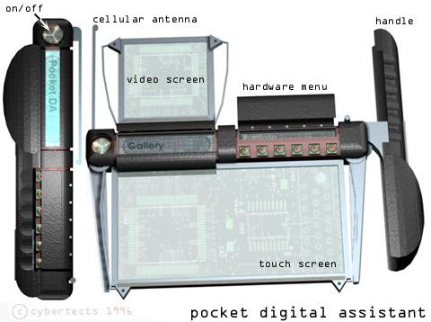

Figure 1. Jack-Knife PDA Design.

* 1. Tables

Place tables within the body of the text, in the paragraph after they are first mentioned. They should not be at the end of the document.

A smaller typeface may be used for tables (9 or 10 point font) than in the text. Use the same type size for all the tables in the document. An *ACADIA-Table Caption* style is provided in the template.

Put the table number and caption on the line *above* the table, left justified, with a capital letter for the first word only. Leave one blank line between the text above the caption, and one below the table, before the text continues. The caption should be boldfaced.

Table 4: Example of a correct layout of a simple table.

|  |  |  |  |  |
| --- | --- | --- | --- | --- |
| Building Number | Total Area (square feet) | Core Area (square feet) | Vertical Circulation | |
|  |  |  | Stairwells | Elevators |
| 1 | 20,000 | 5,000 | 2 | 1 |
| 2 | 40,000 | 3000 | 2 | 1 |
| 3 | 1,200,000 | 12,000 | 6 | 6 |

* 1. Identification and Credits

For the review submission, ensure that the document is free of any identifying names, places, programs, institutions and firms from the paper to maintain an anonymous review process.

* 1. Citations

References are cited in the text by author name and the date of publication, enclosed in parentheses. The citation is placed at the end of the sentence. Here are examples of citations as they would appear embedded into the text:

* One author: (Legrand 1994)
* Two authors: (Vanier and Lacasse 1996)
* Four or more authors: (Bazant et al. 1993)
* Two works by same author in same year: (Lacasse 1998a, 1998b)
* Several works by same author in different years: (Vanier 1996, 1998)
* Several works by different authors: (Bazant et al. 1993; Legrand 1994)

Software citation: the Chicago Manual includes instructions for citing software, and we remind all authors of the requirement to cite the intellectual work of our peers in the development of the software tools used in research. To facilitate compliance, please refer to the guides on the websites listed below. This list is not intended to be exhaustive, and where questions arise, the rules of the Chicago Manual take precedence.

<https://www.bibguru.com/g/chicago-software-citation/> <https://uark.libguides.com/CSCE/CitingCode>

<https://libguides.nps.edu/citation/chicago-nb#computer-program>

1. Use of Gendered Pronouns

Avoid using gendered pronouns unless explicitly referring to a specific person. Additionally, avoid using gendered language when referring to professions and practices; for example: o gendered pronouns ("he," "she," "he/she") may be replaced with the gender-neutral pronoun "they" and gendered professional titles and practices (i.e. "craftsman," "craftsmanship" and "chairman") may be replaced with a gender-neutral equivalent (i.e. "craftsperson," "craftspeople," "craft" and "chair" or "chairperson").

1. Submitting Your Manuscript

Reference the information on the ACADIA Conference website for details regarding the submission process: <http://2021.acadia.org/submit/>

1. Conclusions

Authors who follow these conventions will allow the reviewers to concentrate on the content of the paper rather than the formatting.

*Some of the content of these guidelines is based upon a document distributed by Dr. Michael A. Lacasse and Gerry Neville of the National Research Council and National Research Council Research Press.*

References

Include References at the end of the document. **Do not use footnotes**. Only texts that are cited in the paper should be included in the References. All works that are cited should be included in the References section. Use the *ACADIA-Reference* style to format your reference entries. The following format, based upon the [Chicago Manual of Style](http://www.chicagomanualofstyle.org/tools_citationguide.html), 16th Edition, Author-Date format, is to be used:

*Book*

Fox, Michael and Miles Kemp. 2009. Interactive Architecture. New York: Princeton Architectural Press.

*Book Chapter*

Hasdell, Peter. 2009. “Pneuma: An Indeterminate Architecture, or Toward a Soft and Weedy Architecture.” In *Design Ecologies: Sustainable Potentials in Architecture*, ed. L. Tilder and B. Bolstein. New York: Princeton Architectural Press. 92-113.

*Journal Article*

Brooks, Rodney A. 1990. “Elephants Don’t Play Chess.” *Robotics and Autonomous Systems* 6 (1): 3–15.

*Conference Paper*

Cremers, Jan. 2011. “Energy Saving Design of Membrane Building Envelope.” In *International Conference on Textile Composites and Inflatable Structures: Structural Membranes 2011*, ed. E. Oñate, B. Kröplin and K.-U.Bletzinger. 148–155. Barcelona: CIMNE.

Wu, Kaicong and Axel Kilian. 2018. “Robotic Equilibrium: Scaffoldfree Arch Assemblies.” In *ACADIA 2019: Recalibration: On Imprecision and Infidelity. Proceedings of the 38th Annual Conference of the Association for Computer Aided Design in Architecture (ACADIA)*, ed. P. Anzalone, M. del Signore and A. J. Wit. 342–349. Mexico City: ACADIA.