Pratham U-210905407

Computer Networks Lab 7:Study of Domain Name Server

1. Configure the below topology to setup DNS server. R1 will use R2 as DNS server to make
DNS resolutions.
First, lets begin with R1. We’ll setup hostname and IP related information.

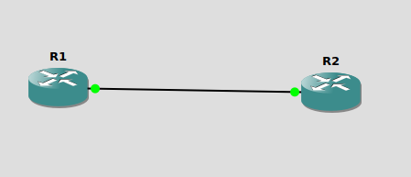

R2 IP and Hostname Configurations:
enable
config t
hostname R2
int e0/0
ip address 10.10.10.2 255.255.255.0
no shut
do wr
end
Setting up R2 as DNS Server
config t
ip dns server
ip host loopback.R2.com 2.2.2.2
R1 IP configurations:
Enable
configure terminal
hostname R1
interface e0/0
ip address 10.10.10.1 255.255.255.0
no shut
do wr
end

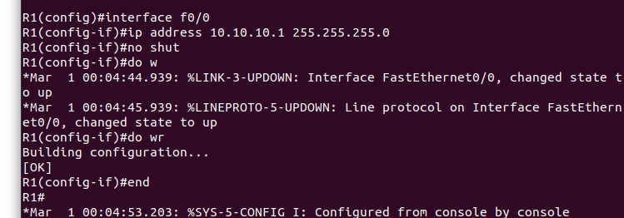

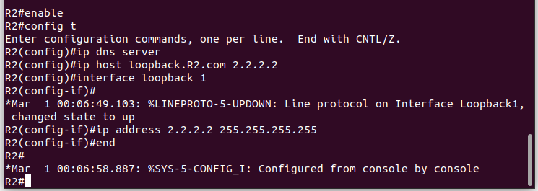

Let’s verify that loopback interface we just created is working. This will show us that the
hostname correctly setup locally on R2.
ping loopback.R2.com

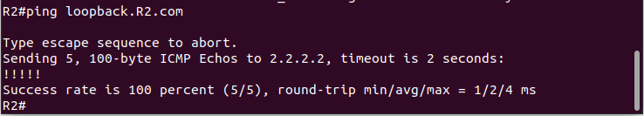
Now it’s time to setup R1 to resolve hostnames using R2. On R1 type;
config terminal
ip domain lookup
ip name-server 10.10.10.2
Set R1 to use R2 as default gateway to get to loopback interface on R2. So that after R1
resolves loopback.R2.com, it can reach 2.2.2.2 through its default route (R2).
on R1 type:
config t
ip route 0.0.0.0 0.0.0.0 10.10.10.2
end
This tells our router that to get to any network not in it’s routing table, it’s next hop is 10.10.10.2
which is our router R2.
Now on R1, do a ping to loopback.R2.com and you should get a success message.
ping loopback.R2.com repeat 3

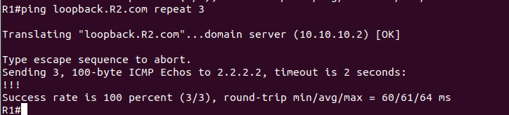

If you captured the traffic, you’ll see DNS query and Answer as shown in Wireshark capture
screen shot below.

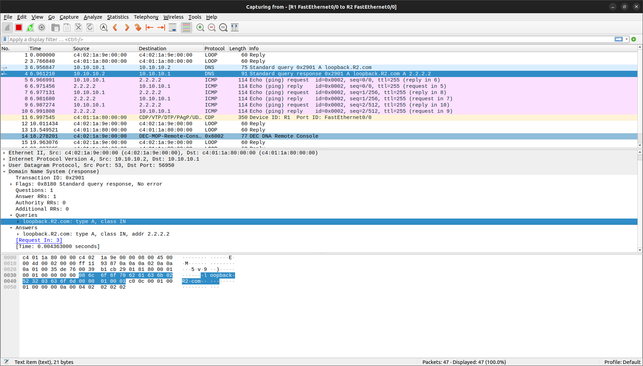

III. LAB EXERCISE
Suppose you are connecting to www.mycsemit.com to read a page, you are a
user sitting at a client's machine. You can access the www.mycsemit.com web
server. The server machine finds the page you requested and sends it to you.
Build a scenario using GNS3 to demonstrate the interaction of the DNS Server
and DNS Client. Place DNS Server behind two routers.

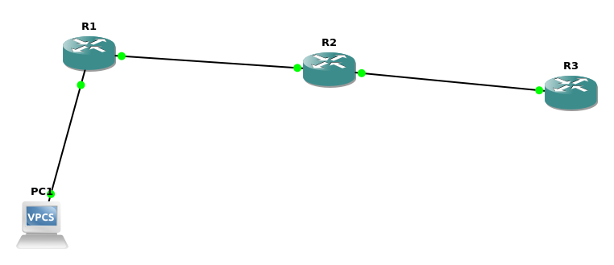

Config for R1:

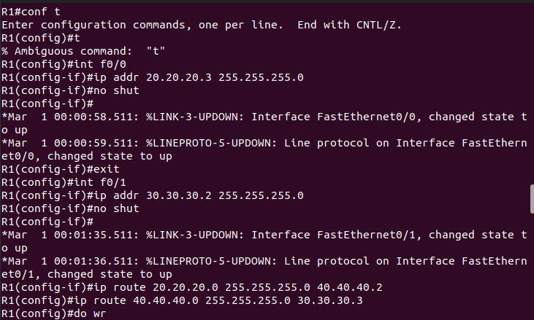
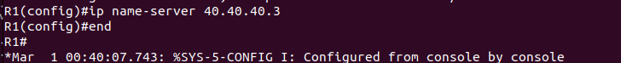
Config for R2:

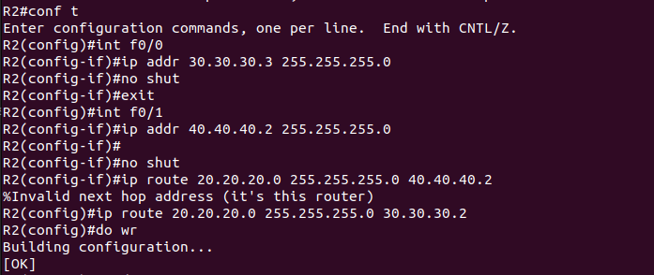

Config for R3:

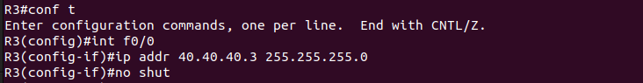

Setting up dns server on R3:
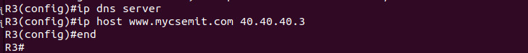
Setting up PC!:
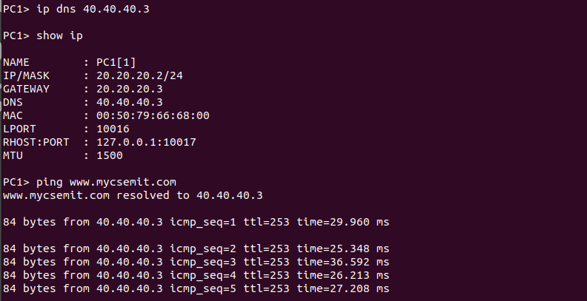

Ping from PC1 to R3

