

Social Network Analysis

## Project Report

### National Institute of Technology, Tiruchirappalli

|  |  |
| --- | --- |
| Field | Value |
| Student | Priyansh Kumar Paswan |
| Roll Number | 205124071 |
| Professor | Dr. S.R. Balasundaram |
| Department | Computer Applications |
| Institute | National Institute of Technology, Tiruchirappalli |

## 1. Dataset Overview

Email-EU-core undirected graph. The analysis below summarizes structure and degree characteristics.

|  |  |
| --- | --- |
| Metric | Value |
| Nodes | 1005 |
| Edges | 16706 |
| Density | 0.0331 |
| Avg clustering | 0.3994 |
| Connected | False |

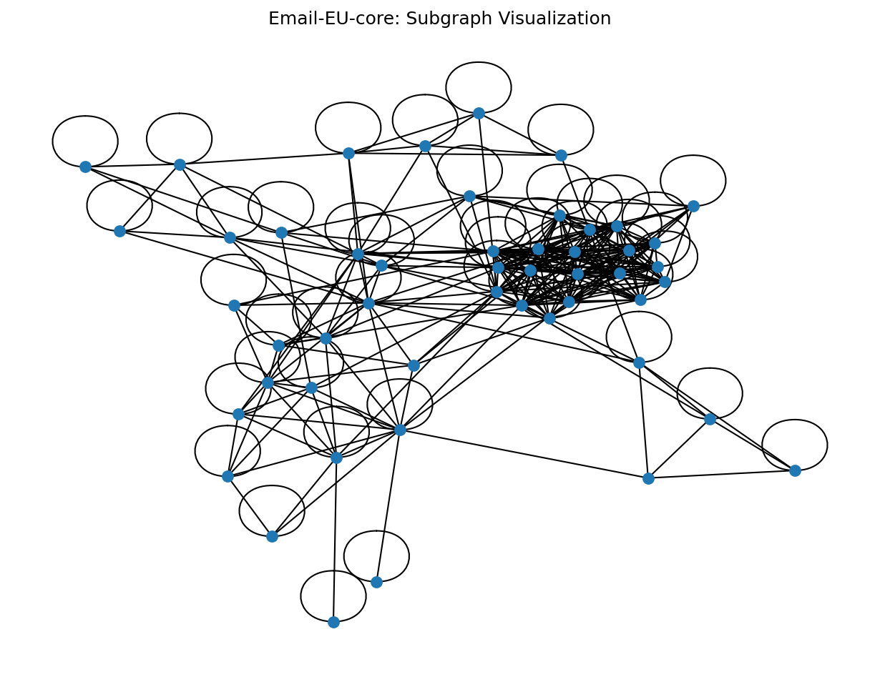

Figure 1: Subgraph visualization

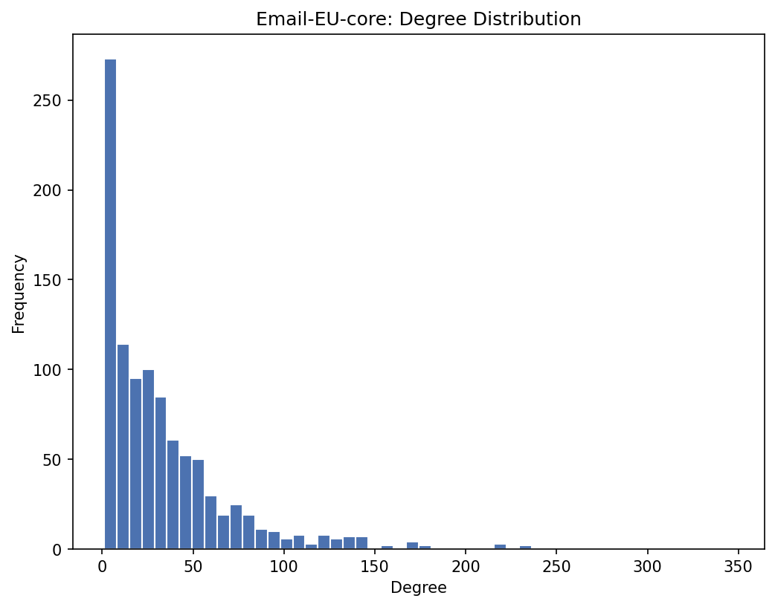

Figure 2: Degree distribution histogram

** Optional Gephi screenshot: Global layout (ForceAtlas2), color by community, size by pagerank **

## 2. Link Analysis (PageRank & Eigenvector)

Methods: PageRank for importance via random walks; Eigenvector centrality for importance via influential neighbors.

### Top-10 by PageRank

|  |  |  |  |
| --- | --- | --- | --- |
| node | pagerank | eigenvector | degree |
| 160.0 | 0.0090709484950265 | 0.1658461052562613 | 347.0 |
| 121.0 | 0.0060687854256318 | 0.1484213057175369 | 234.0 |
| 82.0 | 0.0060307053368408 | 0.145251809177294 | 233.0 |
| 107.0 | 0.0058380960432493 | 0.139876476623585 | 221.0 |
| 86.0 | 0.0057215196123223 | 0.1122173025767131 | 218.0 |
| 62.0 | 0.0054316159798508 | 0.1314982021050847 | 216.0 |
| 5.0 | 0.0049141637345112 | 0.0794635644309267 | 171.0 |
| 13.0 | 0.004589938693459 | 0.0856933490779659 | 180.0 |
| 166.0 | 0.0045516651162006 | 0.1103349118134628 | 177.0 |
| 434.0 | 0.0045327987830447 | 0.1253049110776443 | 185.0 |

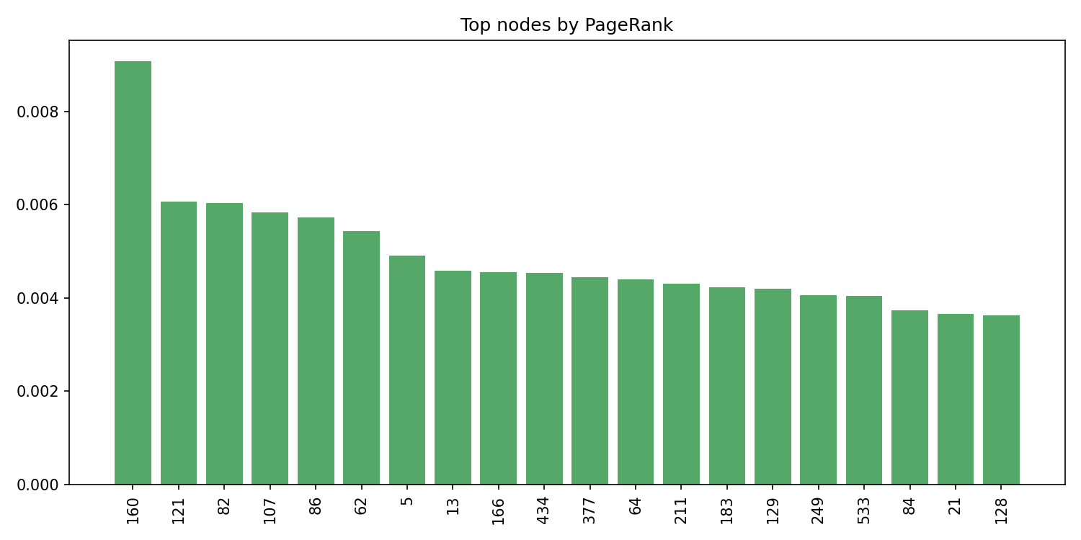

Figure 3: Top nodes by PageRank (bar chart)

** Optional Gephi screenshot: Influence view — size by pagerank, color gradient by eigenvector **

## 3. Node Classification (Label Propagation)

Method: Asynchronous label propagation to discover communities without ground truth labels.

### Communities by size (Top 15)

|  |  |
| --- | --- |
| community | size |
| 0 | 969 |
| 19 | 1 |
| 21 | 1 |
| 22 | 1 |
| 23 | 1 |
| 24 | 1 |
| 25 | 1 |
| 26 | 1 |
| 27 | 1 |
| 28 | 1 |
| 29 | 1 |
| 30 | 1 |
| 31 | 1 |
| 32 | 1 |
| 33 | 1 |

** ADD GEPHI SCREENSHOT HERE: Community visualization — color by community (categorical), size by pagerank; layout: ForceAtlas2 **

## 4. Influence Analysis (PageRank & Betweenness)

Methods: PageRank for global influence; Betweenness for brokerage across communities.

### Top-10 influencers

|  |  |  |  |
| --- | --- | --- | --- |
| node | pagerank | betweenness | degree |
| 160.0 | 0.0090709484950265 | 0.0874147349363879 | 347.0 |
| 121.0 | 0.0060687854256318 | 0.0278415388258006 | 234.0 |
| 82.0 | 0.0060307053368408 | 0.0278807411351142 | 233.0 |
| 107.0 | 0.0058380960432493 | 0.0243403121826939 | 221.0 |
| 86.0 | 0.0057215196123223 | 0.0377885326911519 | 218.0 |
| 62.0 | 0.0054316159798508 | 0.0225098451925391 | 216.0 |
| 5.0 | 0.0049141637345112 | 0.0309946865452777 | 171.0 |
| 13.0 | 0.004589938693459 | 0.0235649895706901 | 180.0 |
| 166.0 | 0.0045516651162006 | 0.0176393735896517 | 177.0 |
| 434.0 | 0.0045327987830447 | 0.0154127096447369 | 185.0 |

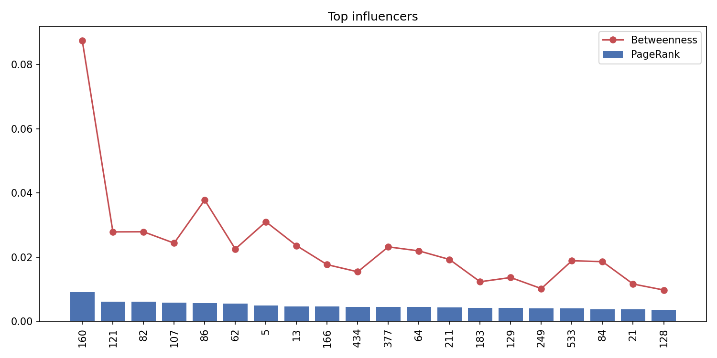

Figure 4: Top influencers (PageRank + Betweenness)

** ADD GEPHI SCREENSHOT HERE: Influencers — size by betweenness or pagerank; optionally label top nodes **

## 5. Link Prediction (Adamic-Adar, Jaccard, Preferential Attachment)

Procedure: Hold out 10% edges; score with three heuristics on the train graph; evaluate ROC/AUC.

### AUC by metric

|  |  |
| --- | --- |
| metric | auc |
| adamic_adar | 0.9468674701384132 |
| jaccard | 0.935174248697092 |
| pref_attach | 0.8597603122394544 |

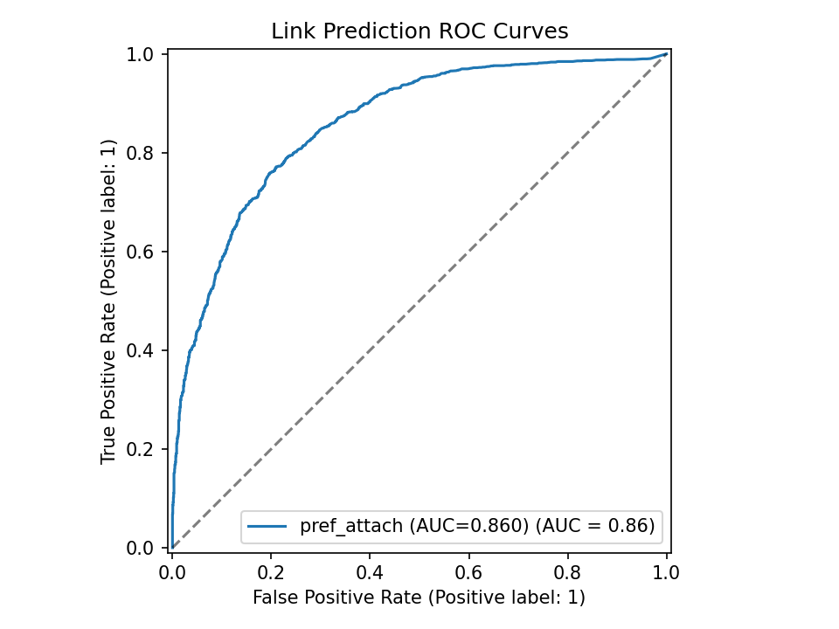

Figure 5: ROC curves for link prediction metrics

## 6. Anomaly Detection (IsolationForest on egonet features)

Features: degree, clustering, average neighbor degree, egonet edges; Model: IsolationForest (1% contamination).

### Top-10 anomalous nodes

|  |  |  |  |  |  |
| --- | --- | --- | --- | --- | --- |
| node | degree | clustering | avg_neighbor_degree | ego_edges | decision_function |
| 160.0 | 347.0 | 0.0935119649477586 | 56.73198847262248 | 6177.0 | -0.1259716934781769 |
| 121.0 | 234.0 | 0.1728989401403194 | 70.74358974358974 | 5056.0 | -0.0815577059253059 |
| 82.0 | 233.0 | 0.1660831921701487 | 69.78111587982832 | 4828.0 | -0.0814038916550311 |
| 107.0 | 221.0 | 0.1700389594068116 | 70.77828054298642 | 4462.0 | -0.0651324610742785 |
| 62.0 | 216.0 | 0.1520336975121758 | 68.41203703703704 | 3856.0 | -0.0565494375542041 |
| 86.0 | 218.0 | 0.1205857019810508 | 61.821100917431195 | 3194.0 | -0.052512605438006 |
| 434.0 | 185.0 | 0.2011049060229388 | 76.41621621621621 | 3685.0 | -0.0213113652596759 |
| 13.0 | 180.0 | 0.110899511204215 | 58.111111111111114 | 2082.0 | -0.0128058498699874 |
| 5.0 | 171.0 | 0.1070019723865877 | 57.046783625730995 | 1840.0 | -0.0072600496357142 |
| 882.0 | 2.0 | 1.0 | 262.0 | 5.0 | -0.0025955469404698 |

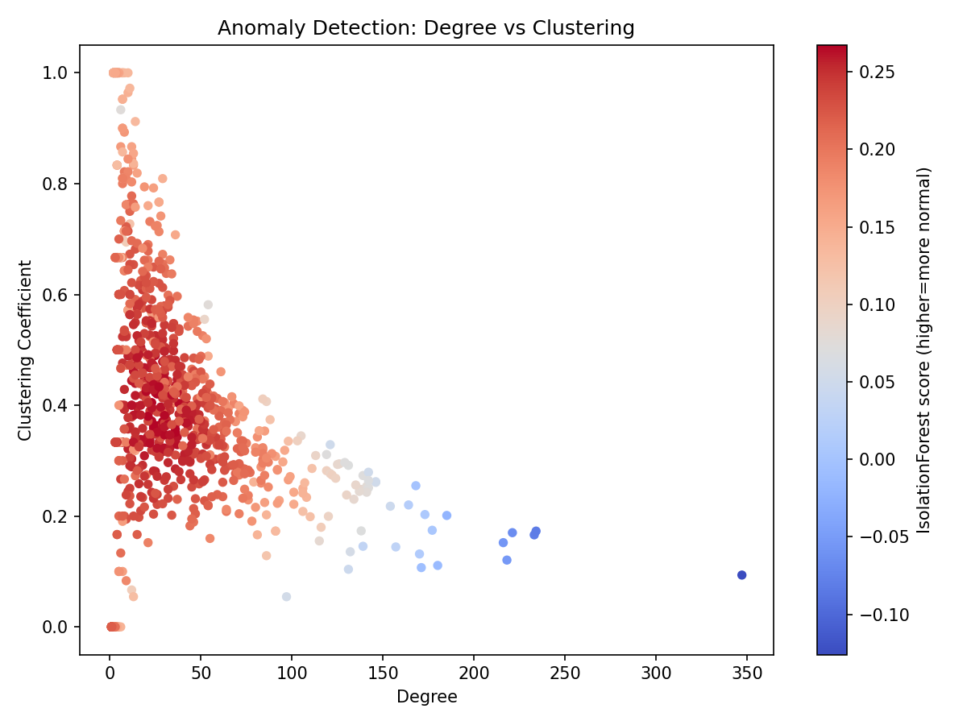

Figure 6: Anomaly scatter (Degree vs Clustering, colored by score)

** ADD GEPHI SCREENSHOT HERE: Anomaly view — color by anomaly_score (continuous), highlight top outliers **

## 7. Gephi Visualizations (What to include)

Open outputs/graph_attributes.gexf in Gephi and capture these views:

• Community view: Color by 'community' (categorical), size by 'pagerank'.

• Influence view: Size by 'betweenness' or 'pagerank'; optional color gradient by betweenness.

• Anomaly view: Color by 'anomaly_score' (continuous gradient).