Summary of learning

# RTaaS

Q- What is RTaaS?

1. It is short form for Routing and Telephony as a Service.

Q- What are some of the components in RTaaS?

1. RTaaS is composed of many components such as MWI, UCID.

Q- What is the basic working of RTaaS application?

A-

-App writes to logger.

-Monitor checks system and logger.

-Kafka collects logs from logger.

-Kafka is plugged in to a microservice that is used by numerous applications such as ELK, MaaS etc.

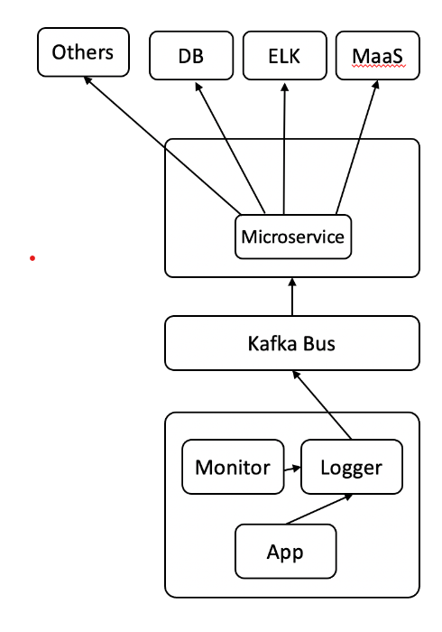

# UCID

Q- What is UCID?

UCID is short for Universal Caller ID.

It is used for displaying user calling id on TVs and mobile phones.

Q- How does UCID work?

1. CSCF sends invite request.

If Extracted details from INVITE indicate Comcast, UCID sends INVITE to Video Application Server. UCID also sends a POST request with XML data to TVNS.

CSCF sends invite request. If Extracted details from INVITE indicate Cox, UCID sends a POST request with JSON data to Cox server.

2) UCID also writes to Kafka,

3) GEM collects information from Kafka. This information is utilized by ELK, MaaS, Promethius etc.

UCID comcast call flow (Source: ICE wiki)

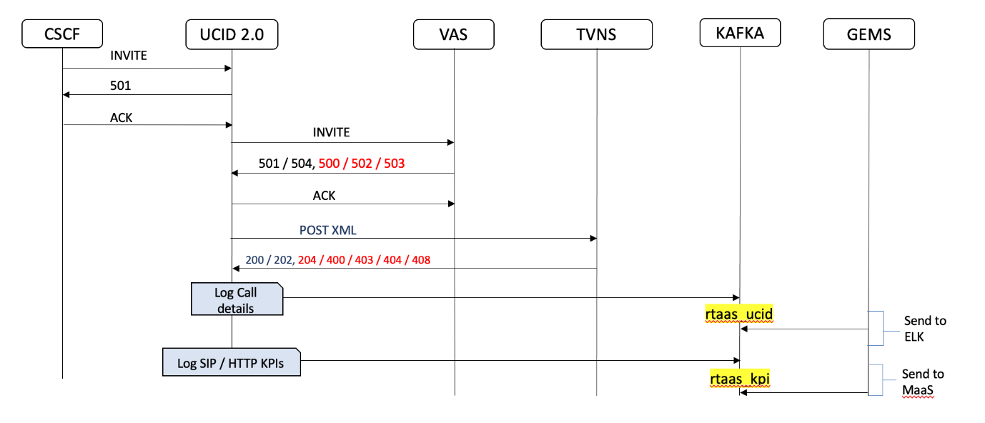

UCID cox call flow (Source: ICE wiki)

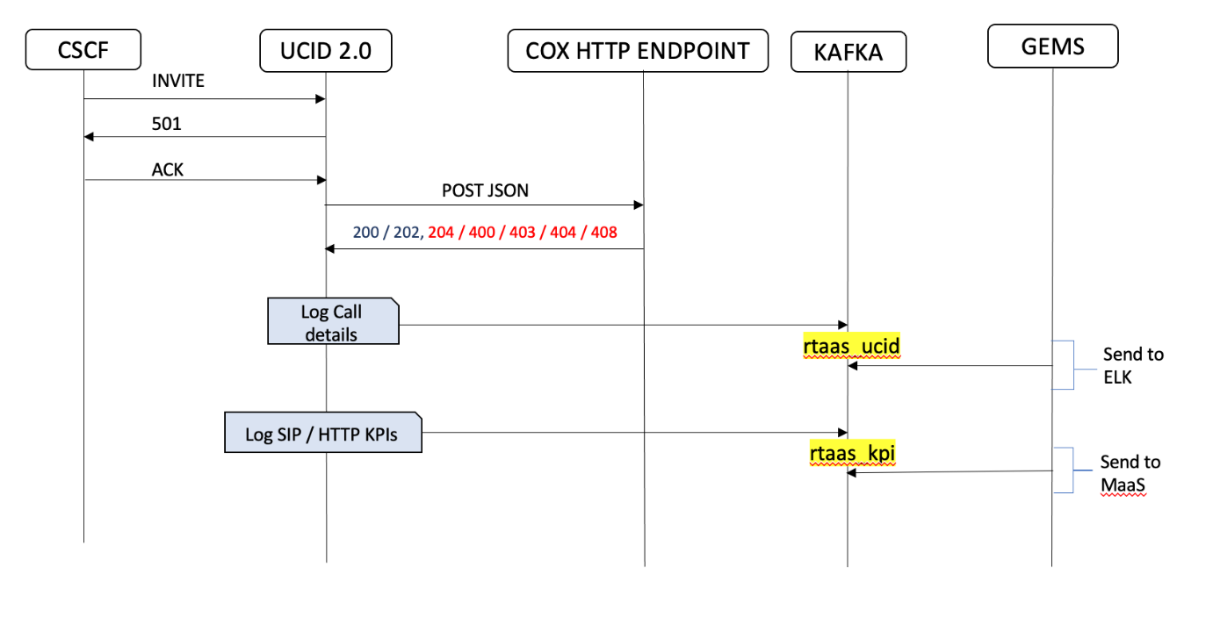

UCID error call flow (Source: ICE wiki)

# MWI

Q- What is MWI?

1. MWI is short for Message Waiting Indicator.

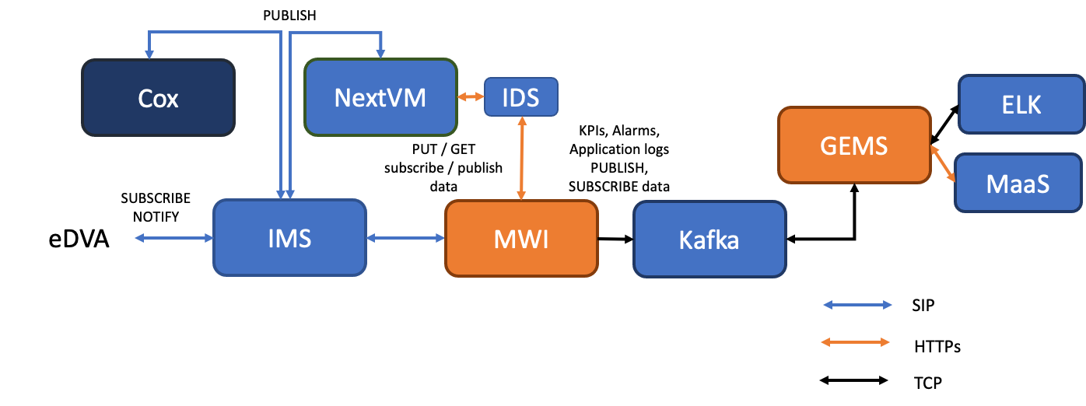

Q- What is MWI used for?

1. MWI is used as a broker between eDVA and voice mail server.

Q- Call flow for Publish

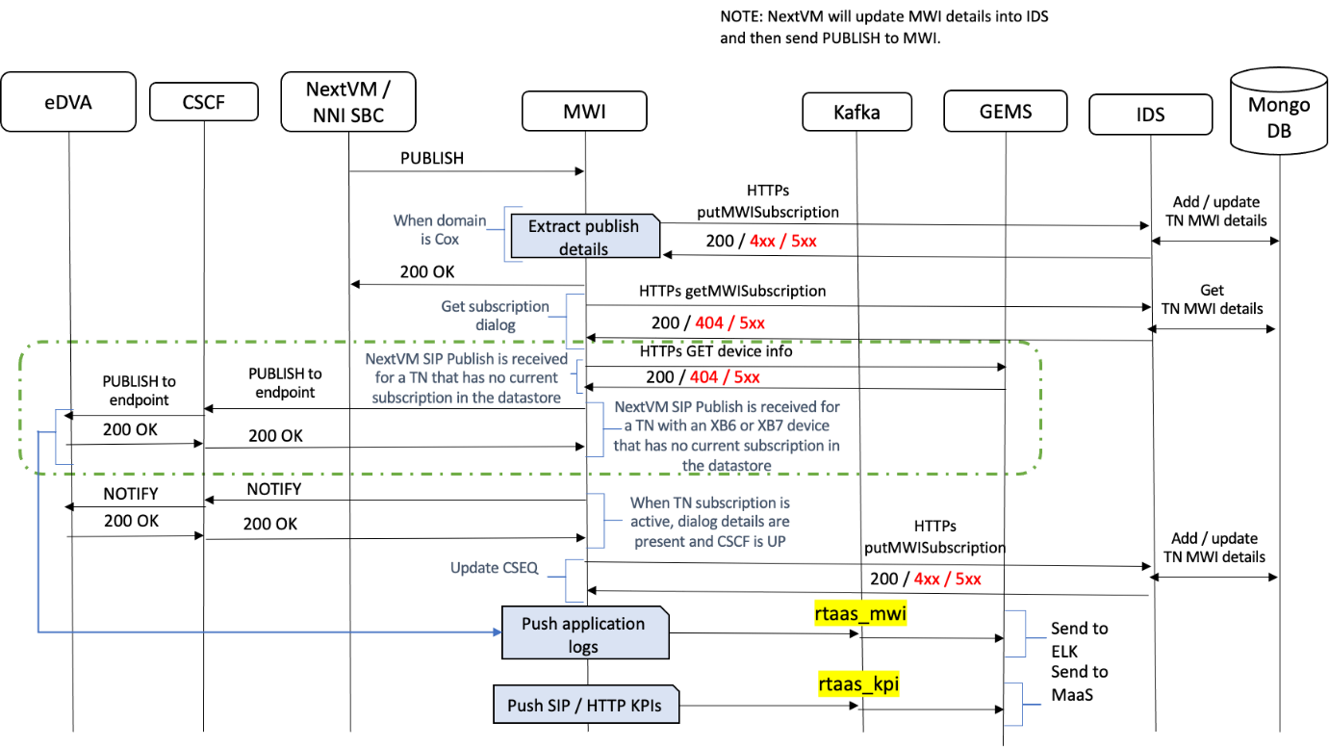

Next VM/NNI SBC > Publish to MWI > MWI sends 200 OK to Next VM

* Data to IDS and MongoDB
* Logs to Kafka
* NOTIFY to eDVA via CSCF.

# Niffler

Niffler is an automation tool to perform sanity testing of RTaaS components.

Niffler works by using a csv file and xml file as inputs. The CSV file contains the test cases and required validation parameters. The XML file contains the SIPP call flow.