肘关节方案：
https://item.taobao.com/item.htm?abbucket=5&id=882400042520&mi_id=0000-wuGr0SiIdEM6j8t-xl3FEDdaopjFd9z-uA4nxGHLCI&ns=1&priceTId=2100c80417836163794372594e0a2c&spm=a21n57.1.hoverItem.5&utparam=%7B%22aplus_abtest%22%3A%22ea8fec243c58f8394a9699487b3376ae%22%7D&xxc=taobaoSearch
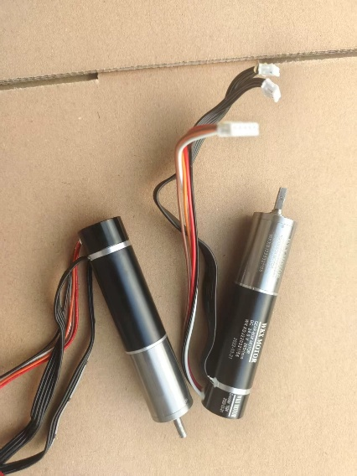
加4-1锥齿轮

