Vaccine Hesitancy for COVID-19

Priyanka gannavarapu

2021-12-10

# 1 Summary/Abstract

In past pandemics, vulnerable populations faced greater disease burden and decreased testing and treatment access. As coronavirus disease 2019 (COVID-19) spreads in the USA, concern is growing that even the early stages of this pandemic have disproportionately impacted vulnerable communities. However, the relationship between social vulnerability and ethnicity remains unknown.

# 2 KEY QUESTIONS

What is already known about this subject?

COVID-19 has disproportionally affected racial/ethnic minority groups.

What will this study add or answer?

The present analysis will attempt to estimate the percent of the population in each US region that may be heistant to get a vaccine.

Relationship between ethnicity and social vulnerability index

How might this impact clinical practice?

Identify and address barriers to COVID-19 vaccination. Continued monitoring of vaccination coverage by social vulnerability metrics is critical for developing tailored, local vaccine administration and outreach efforts to reduce COVID-19 vaccination inequities.

## 2.1 General Background Information

Coronavirus disease (COVID-19) is an infectious disease caused by a newly discovered coronavirus. Coronavirus disease 2019 (COVID-19) was declared a pandemic in March 2020. COVID-19 vaccine is the most sustainable option to manage the current pandemic.Since its discovery in February 2020 in the United States (U.S.) (and, 2020), community transmission of SARS-COV-2, which causes COVID-19, has resulted in more than 600,000 deaths and 34 million cases across the country (CDC **COVID?** Data Tracker). Across demographic characteristics such as age, race and ethnicity, and income, there are considerable variations in COVID-19 incidence Li, Cen, Cai, & Temkin-Greener (2020), severity Li, Cen, Cai, & Temkin-Greener (2020), mortality (Chen & Krieger, 2020), as well as in testing and resource allocation (Lewis et al., 2020). In order to understand the function of social vulnerability in relation to COVID-19, it is necessary to examine the evidence. Evidence indicates that populations suffering higher social vulnerability bear a disproportionate burden of COVID-19 morbidity and mortality (Dasgupta et al., 2020). Among other things, disparities in COVID-19 outcomes may be explained by differences in where people live and work (Chen & Krieger, 2020), a lack of public health initiatives, and limitations to physical distancing, such as the inability to work from home. However, vaccine hesitancy by even a small subset of the population can undermine the success of this strategy. The Social Vulnerability Index (SVI) is a tool that uses census data to identify and map places where a community may have more difficulty preventing human suffering and financial loss in a disaster.The SVI assesses the extent that 15 known vulnerabilities (indicators) are present within a community and categorizes them into four themes: socioeconomic status, household composition and disability, minority status and language minority and housing type and transportation. Indicators like poverty and transportation can highlight places where people may have difficulty accessing COVID-19 testing, treatment and vaccination(Hughes et al., 2021)

## 2.2 Description of data and data source and aquisition

The dataset used for this analysis is publicly available on CDC website. <https://data.cdc.gov/Vaccinations/Vaccine-Hesitancy-for-COVID-19-County-and-local-es/q9mh-h2tw>

The estimates of COVID-19 vaccine hesitancy rates using data from the U.S. Census Bureau’s Household Pulse Survey (HPS) are presented. It estimate hesitancy rates in two steps. First, it estimates hesitancy rates at the state level using the HPS for the collection period May 26, 2021 – June 7, 2021, which is referred to as Week 31. Then, it utilize the estimated values to predict hesitancy rates in more granular areas using the Census Bureau’s 2019 American Community Survey (ACS) 1-year Public Use Microdata Sample (PUMS). To create county-level estimates, they used a PUMA-to-county crosswalk from the Missouri Census Data Center. PUMAs spanning multiple counties had their estimates apportioned across those counties based on overall 2010 Census populations.

##How did we get this DATA?

We use the HPS survey question, “Once a vaccine to prevent COVID-19 is available to you, would you…get a vaccine?” which provides the following options: 1) “definitely get a vaccine”; 2) “probably get a vaccine”; 3) “unsure”; 4) “probably not get a vaccine”; 5) “definitely not get a vaccine.” We use three definitions to capture the strength of hesitancy to receive a vaccine.

Strongly hesitant: includes only survey responses indicating that they would “definitely not” receive a COVID-19 vaccine when available.  
  
 Hesitant: includes survey responses indicating that they would “probably not” or “definitely not” receive a COVID-19 vaccine when available.  
  
 Hesitant or unsure: includes survey responses indicating that they would “probably not” or “unsure” or “definitely not” receive a COVID-19 vaccine when available.

Full methodology for estimates of COVID-19 vaccine hesitancy is available here.(<https://aspe.hhs.gov/reports/vaccine-hesitancy-covid-19-state-county-local-estimates>)

Demographic data were obtained from the 2019 American Community Survey (ACS) 5-year estimates.

Social Vulnerability Index

Overall social vulnerability index was obtained from the 2018 CDC Social Vulnerability Index. The CDC’s Social Vulnerability Index (SVI) summarizes the extent to which a community is socially vulnerable to disaster.(Hughes et al., 2021) The factors considered in developing the SVI include economic data as well as data regarding education, family characteristics, housing language ability, ethnicity, and vehicle access. SVI values range from 0 (least vulnerable) to 1 (most vulnerable). The SVI can also be categorized as follows:

1. Very Low (0.0-0.19);
2. Low (0.20-0.39);
3. Moderate (0.40-0.59);
4. High (0.60-0.79);
5. Very High (0.80-1.0).

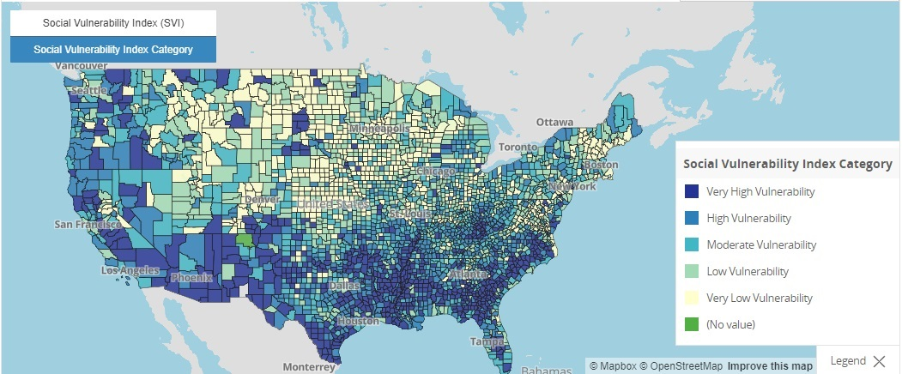

COVID-19 Vaccine Coverage Index

The Surgo Covid-19 Vaccine Coverage Index (CVAC) captures supply- and demand-related challenges that may hinder rapid, widespread COVID-19 vaccine coverage in U.S. counties, through five specific themes: historic undervaccination, sociodemographic barriers, resource-constrained healthcare system, healthcare accessibility barriers, and irregular care-seeking behaviors. The CVAC measures the level of concern for a difficult rollout on a range from 0 (lowest concern) to 1 (highest concern).The CVAC Index can also be categorized as follows:

1. Very Low (0.0-0.19);
2. Low (0.20-0.39);
3. Moderate (0.40-0.59);
4. High (0.60-0.79);
5. Very High (0.80-1.0).

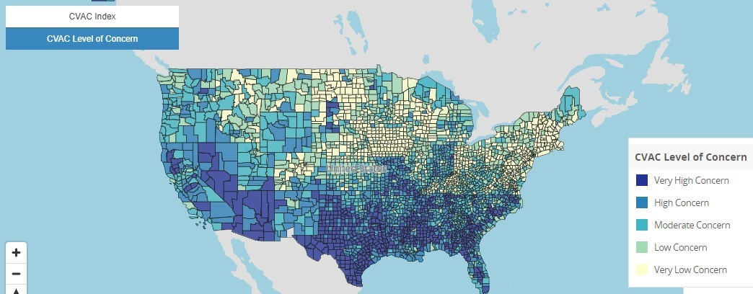

## 2.3 Questions/Hypotheses to be addressed

The present analysis will attempt to estimate the percent of the population in each county that may be vaccine hesitant

Relationship between ethnicity and vaccine hesitancy

# 3 Data analysis

Descriptive analysis on the data, producing several tables and plots and full analysis trying several different models (linear, decision tree). We use a test/train split and Cross-Validation for decision tree models.

# 4 Methods and Results

The primary outcome for this analysis is to estimate the percent of the population in each US region that may be hesitant to get a vaccine and Relationship between ethnicity and social vulnerability index .The estimates of COVID-19 vaccine hesitancy rates using data from the U.S. Census Bureau’s Household Pulse Survey (HPS) are presented. It estimate hesitancy rates in two steps. First, it estimates hesitancy rates at the state level using the HPS for the collection period May 26, 2021 – June 7, 2021

## 4.1 Data import and cleaning

## 4.2 Descriptive analysis

Descriptive statistics

After cleaning the data the sample had 3,141 observations which represent each county.. On average, vaccine coverage was approximately 2.1 and 2.9 times higher for the White population relative to the Black and Hispanic populations, respectively. Fewer states reported vaccination data for Asian, American Indian/Alaska Native, and Native Hawaiian/Pacific Islander populations. The figure 1-4 shows the social vulnerability index in all the US regions. Scatter plot between top ten counties in all the US region and percent of fully vaccinated adults in the specific county. These plots are available in supplementary file .

##BAR Charts

## 4.3 Figure 1

##Bar Chart of Frequency of Northeast states by SVI category

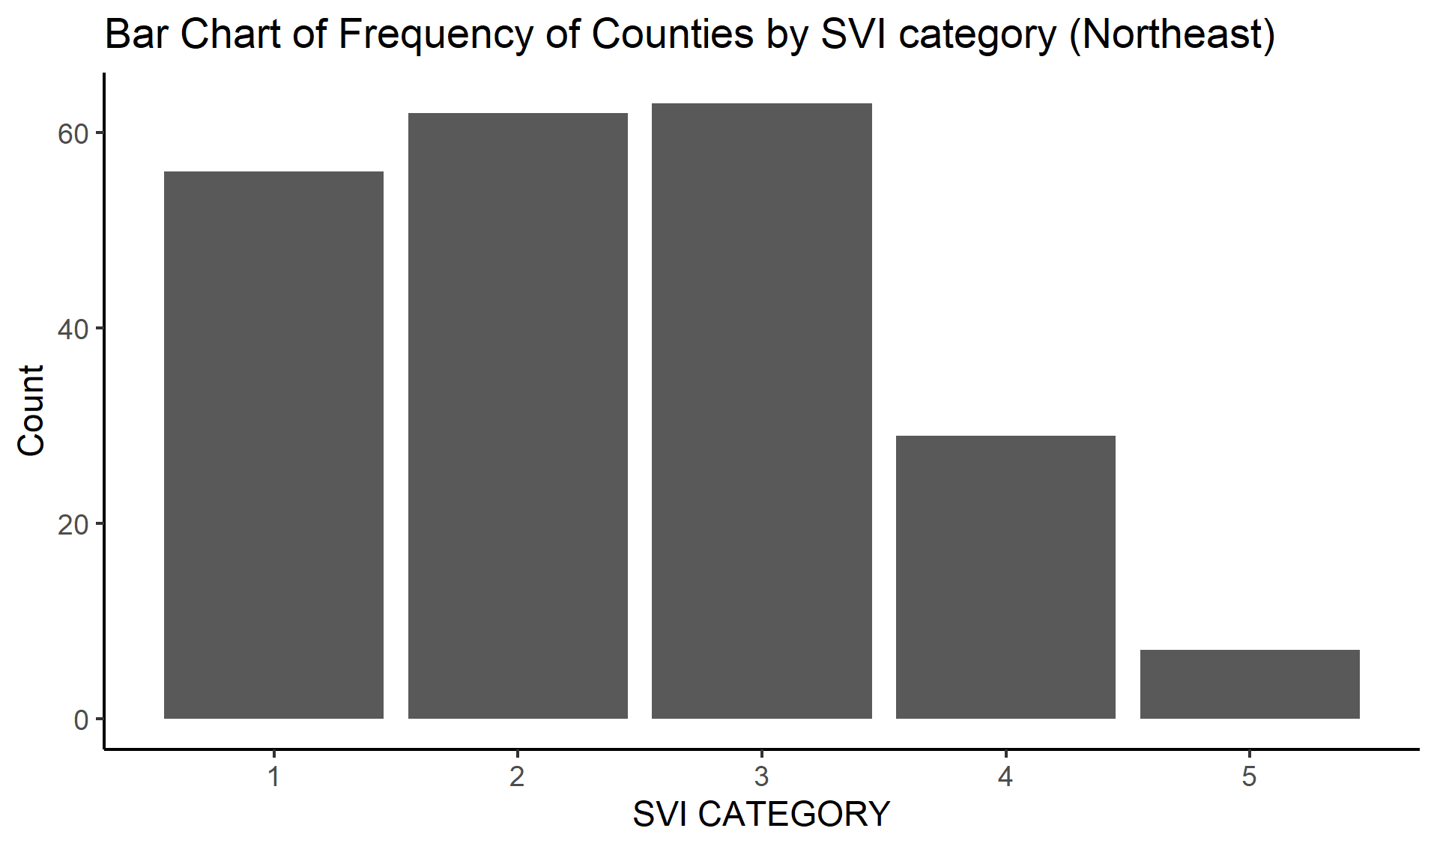

## 4.4 Figure 2

##Bar Chart of Frequency of Midwest states by SVI category

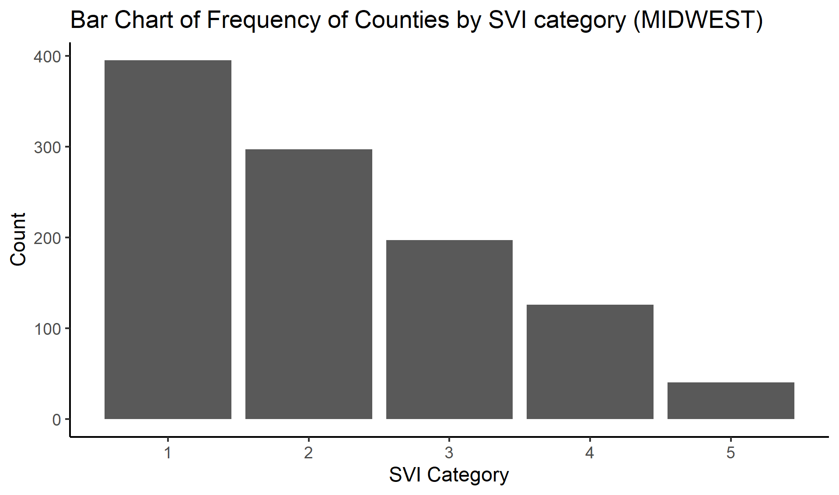

## 4.5 Figure 3

##Bar Chart of Frequency of West states by SVI category

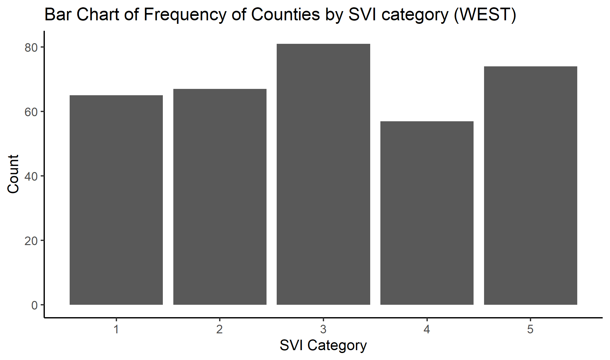

## 4.6 Figure 4

##Bar Chart of Frequency of South states by SVI category

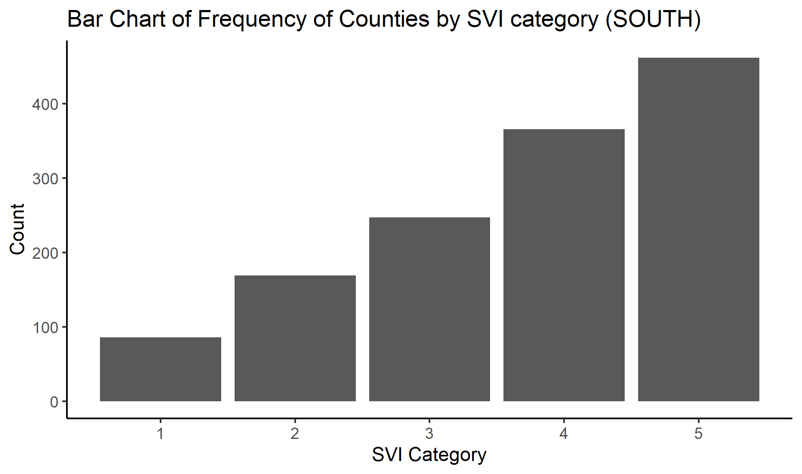

## 4.7 Full analysis

Modelling

A variety of continuous and discrete statistics were used to examine the primary outcome, including medians, interquartile ranges, minimums, maximums, and standard deviations (IQRs). With the help of linear regression overlays, we were able to see that the correlation between vaccination rates and linear regression overlays was evident. It was important that we excluded any predictors that were highly linked with our primary variable of interest to rule out collinearity. A total of 75% of all the data was used to train and test the models, while the remaining 25% was used to evaluate the models’ ability to correctly predict future outcomes.

Resampling the training data with these specifications and ran a decision tree model on the data, visualizing diagnostics and calculating RMSE for both, was done using a 5-fold cross-validation, 5 times repeated. Based on these charts and metrics, we choose our best match model.

# 5 fit linear model

# 6 Create a linear model of Percent fully vaccinated and race in all regions

Table 6.1: Linear model fit table.

|  |  |  |  |  |
| --- | --- | --- | --- | --- |
| term | estimate | std.error | statistic | p.value |
| (Intercept) | 0.7767846 | 0.0370430 | 20.969811 | 0.0000000 |
| White | -0.3913793 | 0.0408063 | -9.591156 | 0.0000000 |
| Asian | 0.4969402 | 0.1480797 | 3.355898 | 0.0008848 |
| Black | -0.8114566 | 0.4155598 | -1.952683 | 0.0517153 |
| Hispanic | -0.3163635 | 0.0489379 | -6.464595 | 0.0000000 |

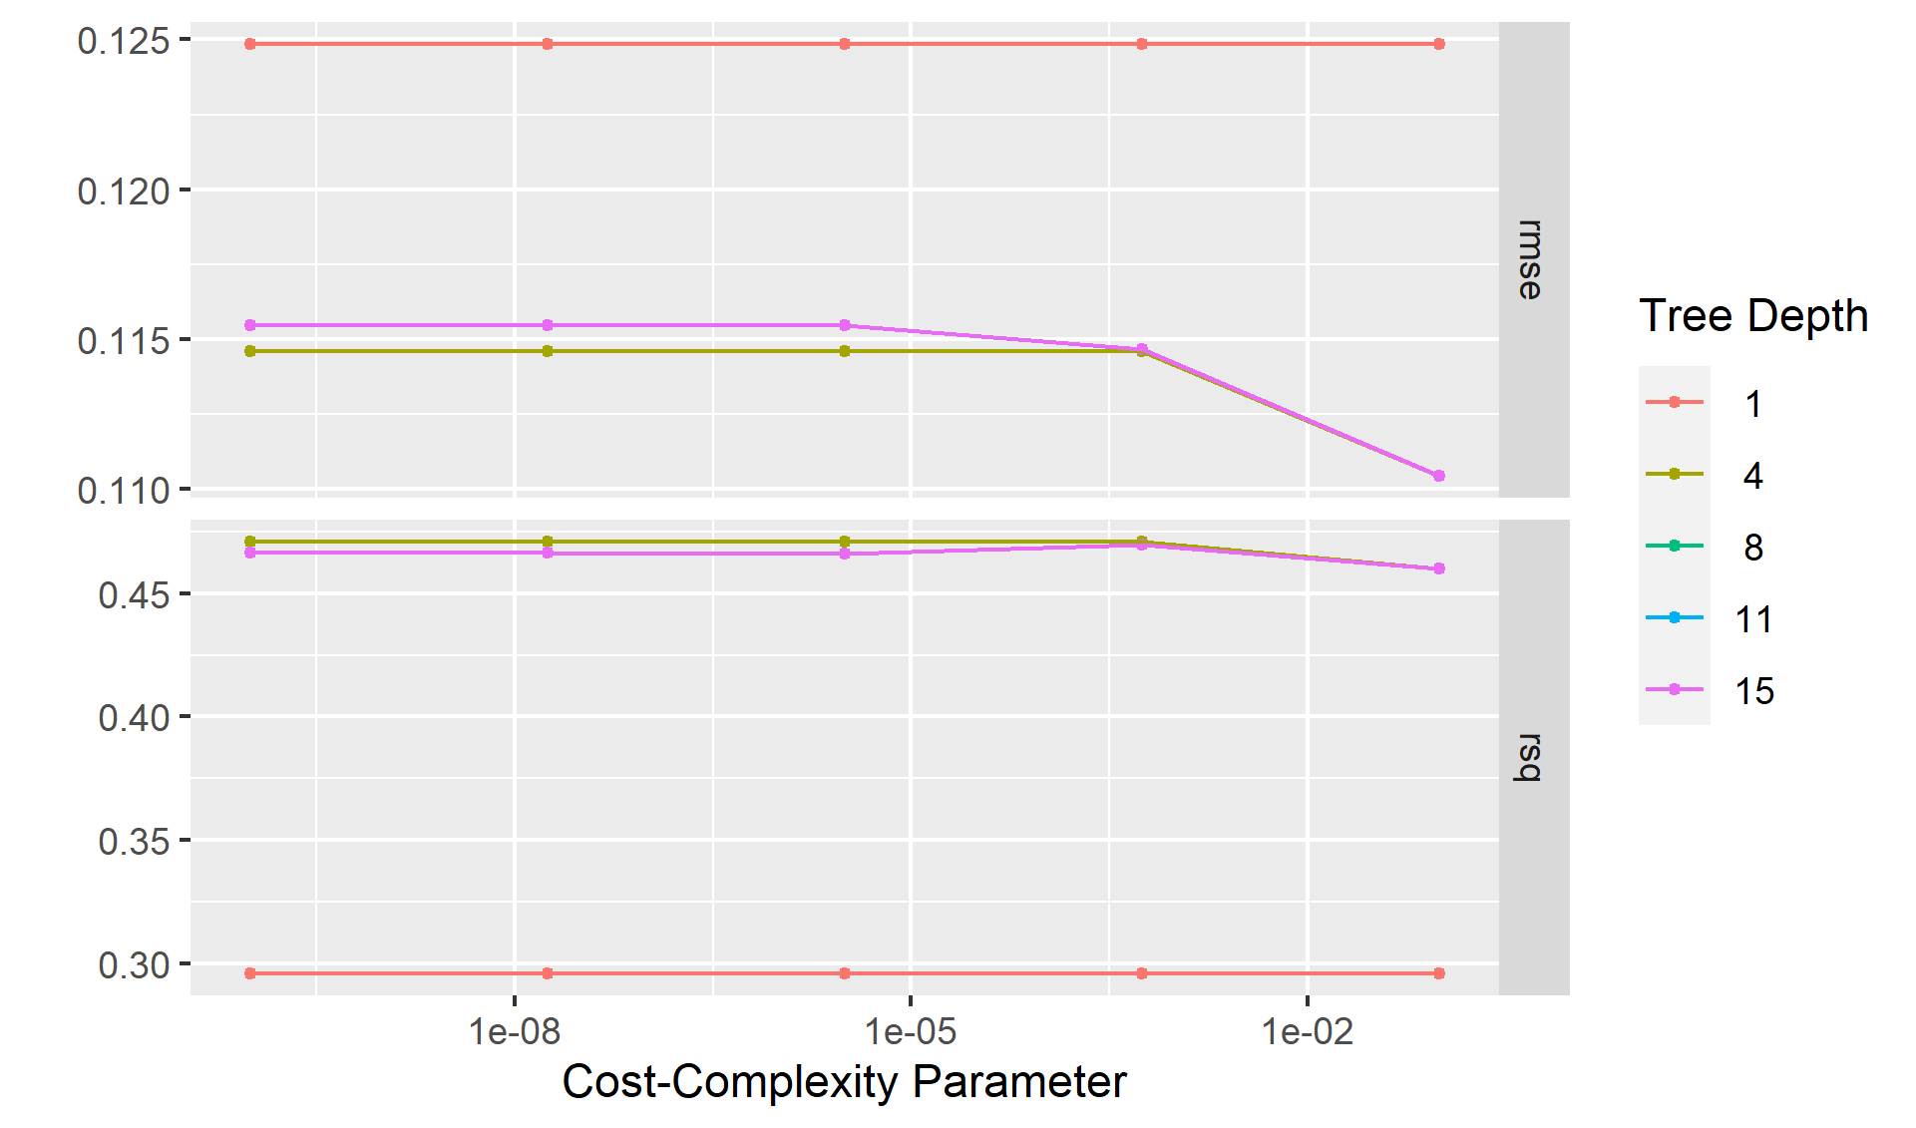

# 7 Discussion

The US COVID-19 vaccination program prioritizes ensuring fair COVID-19 vaccine access. Immunization coverage was lower in high-vulnerability areas across the country, indicating that more work is needed to ensure equity in vaccination coverage for those most affected by COVID-19 (Thakore, Khazanchi, Orav, & Ganguli, 2021). COVID-19 vaccine coverage must be improved in communities with high proportions of racial/ethnic minority groups and those who are economically and socially marginalized, because COVID-19–related illness and mortality have disproportionately affected these populations.Monitoring community-level measurements is crucial for developing personalized, local vaccine delivery strategies that could help to eliminate disparities.(Subramanian & Kumar, 2021) Access concerns (e.g., vaccine supply, vaccination clinic availability, and lack of prioritizing of vulnerable populations) or other challenges, such as vaccine hesitancy, might be investigated by public health officials. Vaccination promotion, outreach, and administration may be concentrated in counties with high sensitivity populations (e.g., providing resources to federally qualified health centers when socioeconomic disparities are identified).(Fletcher et al., 2021)

For the socioeconomic status variables (i.e., poverty, unemployment, low income, and no high school diploma), vaccination coverage was consistently lower in high vulnerability counties than in low vulnerability counties; the coverage discrepancy was greatest for the education indicatorBiggs, Maloney, Rung, Peters, & Robinson (2021). However, for the indicators relating to the percentages of people who speak English poorly and people with disabilities, equal vaccination coverage was observed in counties with low and high social vulnerability, which is encouraging given the disproportionate incidence of COVID-19 in these populations.

COVID-19 immunization coverage differed by state. In most states, low vulnerability counties had more coverage than high vulnerability counties.Jay et al. (2020) Despite this, states like Arizona and Montana have higher vaccination coverage in high-risk areas based on SVI indicators. In states with high equity, practices included: 1) prioritizing people from racial/ethnic minority groups during the early stages of vaccine program implementation, 2) actively monitoring and addressing barriers to vaccination in vulnerable communities, 3) directing vaccines to vulnerable communities, 4) providing free transportation to vaccination sites, and 5) collaborating with community partners, tribal health organizations, and the Indian Health Service.

## 7.1 Limitations

In each state, specific populations were prioritized for vaccination; the disparities seen could be attributed to prioritizing based on age, occupational exposures, and underlying health issues.

Vulnerabilities and vaccine coverage rates may differ by county; state and municipal governments may prioritize immunization efforts for high risk communities in smaller geographic entities.

## 7.2 Conclusions

COVID-19 vaccination coverage was lower in high exposure counties than in low vulnerability counties, according to the findings, which was mostly due to socioeconomic discrepancies. As vaccine supplies grow and administration expands to more priority groups, the CDC, states, and local governments should continue to track vaccination rates using SVI metrics to aid in the development of community-based efforts to improve vaccination access, outreach, and administration among COVID-19-affected populations.

# References

and, D. B. J. (2020). Update: Public health response to the coronavirus disease 2019 outbreak united states, february 24, 2020. *MMWR. Morbidity and Mortality Weekly Report*, *69*(8), 216–219. <https://doi.org/10.15585/mmwr.mm6908e1>

Biggs, E. N., Maloney, P. M., Rung, A. L., Peters, E. S., & Robinson, W. T. (2021). The relationship between social vulnerability and COVID-19 incidence among louisiana census tracts. *Frontiers in Public Health*, *8*. <https://doi.org/10.3389/fpubh.2020.617976>

Chen, J. T., & Krieger, N. (2020). Revealing the unequal burden of COVID-19 by income, race/ethnicity, and household crowding: US county versus zip code analyses. *Journal of Public Health Management and Practice*, *27*(1), S43–S56. <https://doi.org/10.1097/phh.0000000000001263>

Dasgupta, S., Bowen, V. B., Leidner, A., Fletcher, K., Musial, T., Rose, C., … Oster, A. M. (2020). Association between social vulnerability and a county’s risk for becoming a COVID-19 hotspot united states, june 1july 25, 2020. *MMWR. Morbidity and Mortality Weekly Report*, *69*(42), 1535–1541. <https://doi.org/10.15585/mmwr.mm6942a3>

Fletcher, K. M., Espey, J., Grossman, M. K., Sharpe, J. D., Curriero, F. C., Wilt, G. E., … Foster, S. (2021). Social vulnerability and county stay-at-home behavior during COVID-19 stay-at-home orders, united states, april 7april 20, 2020. *Annals of Epidemiology*, *64*, 76–82. <https://doi.org/10.1016/j.annepidem.2021.08.020>

Hughes, M. M., Wang, A., Grossman, M. K., Pun, E., Whiteman, A., Deng, L., … Toblin, R. L. (2021). County-level COVID-19 vaccination coverage and social vulnerability united states, december 14, 2020march 1, 2021. *MMWR. Morbidity and Mortality Weekly Report*, *70*(12), 431–436. <https://doi.org/10.15585/mmwr.mm7012e1>

Islam, S. J., Nayak, A., Hu, Y., Mehta, A., Dieppa, K., Almuwaqqat, Z., … Quyyumi, A. A. (2021). Temporal trends in the association of social vulnerability and race/ethnicity with county-level COVID-19 incidence and outcomes in the USA: An ecological analysis. *BMJ Open*, *11*(7), e048086. <https://doi.org/10.1136/bmjopen-2020-048086>

Jay, J., Bor, J., Nsoesie, E. O., Lipson, S. K., Jones, D. K., Galea, S., & Raifman, J. (2020). Neighbourhood income and physical distancing during the COVID-19 pandemic in the united states. *Nature Human Behaviour*, *4*(12), 1294–1302. <https://doi.org/10.1038/s41562-020-00998-2>

Khazanchi, R., Beiter, E. R., Gondi, S., Beckman, A. L., Bilinski, A., & Ganguli, I. (2020). County-level association of social vulnerability with COVID-19 cases and deaths in the USA. *Journal of General Internal Medicine*, *35*(9), 2784–2787. <https://doi.org/10.1007/s11606-020-05882-3>

Lewis, N. M., Friedrichs, M., Wagstaff, S., Sage, K., LaCross, N., Bui, D., … Dunn, A. (2020). Disparities in COVID-19 incidence, hospitalizations, and testing, by area-level deprivation utah, march 3july 9, 2020. *MMWR. Morbidity and Mortality Weekly Report*, *69*(38), 1369–1373. <https://doi.org/10.15585/mmwr.mm6938a4>

Li, Y., Cen, X., Cai, X., & Temkin-Greener, H. (2020). Racial and ethnic disparities in COVID-19 infections and deaths across u.s. Nursing homes. *Journal of the American Geriatrics Society*, *68*(11), 2454–2461. <https://doi.org/10.1111/jgs.16847>

Neelon, B., Mutiso, F., Mueller, N. T., Pearce, J. L., & Benjamin-Neelon, S. E. (2021). Spatial and temporal trends in social vulnerability and COVID-19 incidence and death rates in the united states. *PLOS ONE*, *16*(3), e0248702. <https://doi.org/10.1371/journal.pone.0248702>

Subramanian, S. V., & Kumar, A. (2021). Increases in COVID-19 are unrelated to levels of vaccination across 68 countries and 2947 counties in the united states. *European Journal of Epidemiology*. <https://doi.org/10.1007/s10654-021-00808-7>

Thakore, N., Khazanchi, R., Orav, E. J., & Ganguli, I. (2021). Association of social vulnerability, COVID-19 vaccine site density, and vaccination rates in the united states. *Healthc. (Amst.)*, *9*(4), 100583.