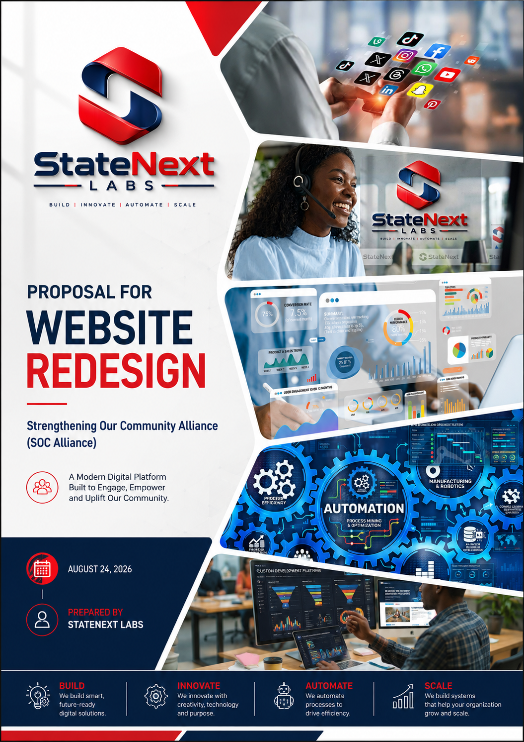

Website Redesign Proposal
Prepared for SOC Alliance
Attn: Ronald Hughes, Executive Director · Theodore Davis, Board Chair
August 24, 2026
Proposal valid for 30 days

A Website That Matches Your Impact

SOC Alliance does real, hands-on work in Woodlawn and Fuller Park — scholarships, violence prevention, mentoring, and economic development for Chicago's South Side. As part of our initial engagement, StateNext Labs completed a full discovery review of socalliance.org: every page, the donation experience, and how the site compares to strong nonprofit sites nationally and in Chicago.
The short version: the current site undersells a credible, active organization. This proposal outlines the redesign that fixes that — and what it will cost and take to build.
What We Found
- Donating sends visitors off-site with no reassurance — exactly where first-time donors hesitate and drop off.
- There's no financial transparency anywhere (no 990, no annual report, no EIN shown) — this costs larger gifts.
- The site hasn't been updated in about nine months, and a past event was still soliciting donations months later.
- There's no way for someone to volunteer — it isn't mentioned anywhere as an actual option.
- The Board of Directors — your strongest credibility asset — has no real photos, just one repeated stock image.

What This Proposal Covers
A full redesign and rebuild of socalliance.org: modern, mobile-first, fast, accessible, and organized around your four pillars — Scholarship, Economic Development, Community, and Health — with a donation experience people will actually trust, and a simple system your team can update without calling a developer.

Our Approach
We build in five stages, each ending with your sign-off before we move forward:
- Alignment — a short kickoff to confirm board roster, history, financials, and program details with you before anything is designed.
- Design — homepage and key page layouts, in your brand direction, presented for review and revision.

- Build — the full site, built and populated with your real content.
- Testing & Training — accessibility, mobile, and speed checks, plus hands-on training so your team can publish updates independently.
- Launch — we move the new site live on your existing domain and monitor the first weeks closely.
+
What's Included
- A modern, mobile-first site organized around your four pillars, with dedicated pages for every program
- A donation page donors can trust — embedded giving, tax-deductibility messaging, and a clear giving experience
- A Financials & Transparency page and a real Leadership & Board page with photos and bios
- New Volunteer and Partner pages — ways to get involved that don't exist on the site today
- A simple content system (CMS) your team can use to post news and events without our help
- Accessibility built to modern standards, and technical SEO cleanup (broken links preserved via redirects)
- A fast, secure site hosted for low, predictable ongoing cost

A full, page-by-page specification with the research behind every recommendation is available on request — this proposal keeps things to what matters for your decision.

Investment
Based on current Chicago-market rates for a custom nonprofit website of this scope, and reflecting SOC Alliance's budget as a lean, community-based organization, we've priced this project at a rate toward the accessible end of the typical range.
Total Project Investment: $2,000 (flat fee, fixed — no surprises)

Milestone | Trigger | Amount
1. Deposit | Due at signing — kicks off the Alignment stage | $1,000
2. Design Approval | Due when you approve the homepage & page designs | $500
3. Build Complete | Due when the full site is built and ready for your review | $300
4. Launch | Due when the new site goes live | $200

Optional Add-Ons (Not Included in the Fee Above)
- Professional photography session for programs, events, and board portraits — quoted separately based on scope
- E-signature platform subscription for pledge agreements (e.g., DocuSign) — billed directly to SOC Alliance, typically $15–$40/month
- Ongoing website care plan after launch (updates, monitoring, small content edits) optional monthly retainer, quoted on request

This quote assumes SOC Alliance provides content decisions and approvals promptly at each milestone (see Timeline). Scope changes requested after Design Approval may affect price and timeline and will always be discussed with you first.

Timeline
2–3 weeks from signed agreement to launch, assuming timely feedback and content from your team at each milestone.
Week 1 | Alignment — kickoff call, board/content/financials confirmed with your team
Weeks 1 | Design — homepage and key pages designed and reviewed with you
Weeks 2 | Build — full site built, content loaded, donation & forms connected
Week 2 | Testing & Training — accessibility/speed checks, your team trained on the CMS
Week 3 | Launch — new site goes live on socalliance.org

Next Steps
1. Review this proposal and let us know any questions.
2. Sign below (or reply to confirm) and submit the deposit to begin the Alignment stage.
3. We schedule your kickoff call within one week of the signed agreement.

We're glad to walk through any part of this in person or by phone before you decide.

Agreed & Accepted
For SOC Alliance:

Signature Date
For StateNext Labs:

Signature Date

