PURRFECTLY DANGEROUS
A Pixel-Art Cat Runner Adventure
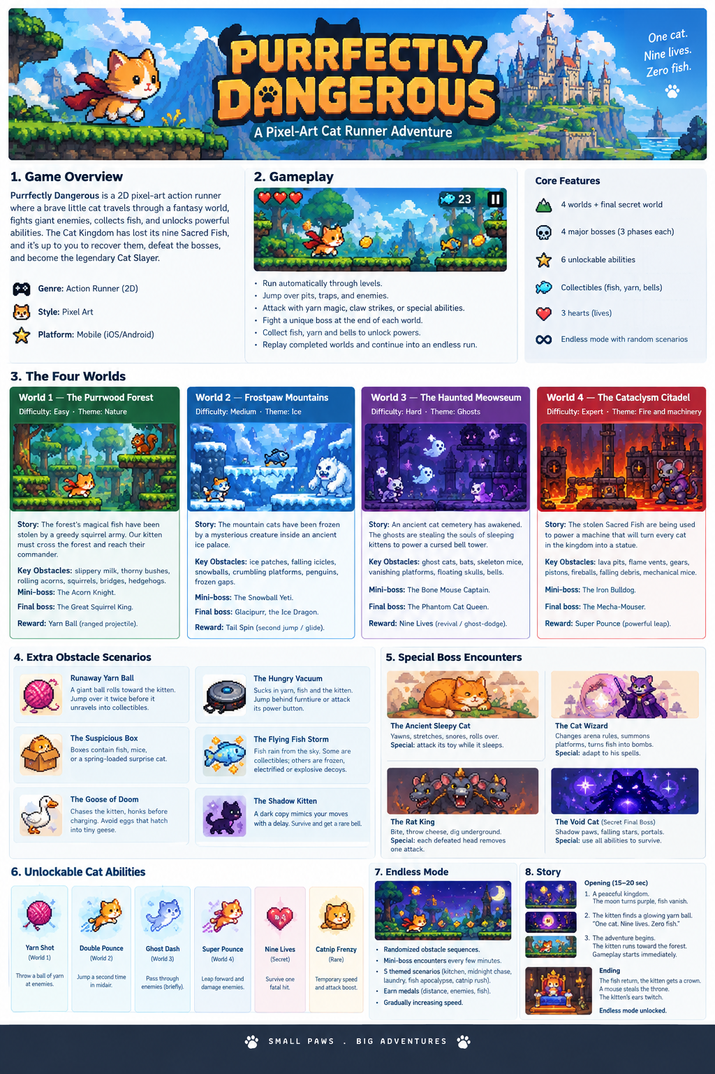
GAME CONCEPT • WORLDS • OBSTACLES • BOSSES • ABILITIES

1. High Concept
Purrfectly Dangerous is a 2D pixel-art action runner about a brave kitten crossing a fantasy kingdom, dodging traps, battling oversized enemies, and recovering the nine Sacred Fish. The tone combines cute character animation, readable arcade action, memorable boss patterns, and playful cat humor.

Core gameplay loop
- Run automatically through side-scrolling levels.
- Jump over pits, traps, and enemies; attack with claws or unlocked abilities.
- Collect fish, yarn, and bells as rewards and upgrade currency.
- Reach the end of each world and learn a multi-phase boss fight.
- Replay worlds for medals, then unlock an endless mode with mixed obstacles.

2. World and Boss Scenarios

World 1 — The Purrwood Forest
Difficulty / theme: Easy | Nature
Story: The forest's magical fish have been stolen by a greedy squirrel army. The kitten must cross the woods and reach their enormous commander.
Obstacle set: Spilled milk (slippery ground); thorny rose bushes; rolling acorns; squirrels throwing acorns from branches; broken bridges; hedgehogs that curl into spiky balls.
Mini-boss: The Acorn Knight — a squirrel in a walnut-shell helmet that charges along the ground.
Final boss: The Great Squirrel King — a crowned giant squirrel.
Boss fight phases
- Throws three acorns in a predictable arc.
- Rolls across the arena, leaving acorns behind.
- Climbs a tree and drops a giant acorn that creates a shockwave.
Reward: Yarn Shot — unlocks a ranged yarn projectile.

World 2 — Frostpaw Mountains
Difficulty / theme: Medium | Ice
Story: The mountain cats have been frozen by a mysterious creature inside an ancient ice palace.
Obstacle set: Slippery ice patches; falling icicles with a warning; rolling snowballs; crumbling ice platforms; sliding penguins; wide frozen gaps.
Mini-boss: The Snowball Yeti — creates snowballs and charges through them.
Final boss: Glacipurr, the Ice Dragon — a fluffy white dragon with crystalline whiskers and freezing breath.
Boss fight phases
- Fires ice shards in a fan pattern.
- Sweeps the arena with freezing breath; jump to avoid the ground-level attack.
- Covers the floor in ice, then dives from above.
Reward: Double Pounce — a second mid-air jump or short glide.

World 3 — The Haunted Meowseum
Difficulty / theme: Hard | Ghosts
Story: An ancient cat cemetery has awakened. Ghosts are stealing sleeping kittens' souls to power a cursed bell tower.
Obstacle set: Ghost cats that blink in and out; swooping bats; skeleton mice throwing bones; vanishing platforms; floating skull projectiles; cursed bells with sound-wave attacks.
Mini-boss: The Bone Mouse Captain — a skeleton mouse riding a tiny skeletal horse.
Final boss: The Phantom Cat Queen — a translucent royal cat with a floating crown and purple-smoke cloak.
Boss fight phases
- Summons ghost cats that chase the player.
- Teleports and sends spectral waves along the ground.
- Splits into three copies; only the glowing copy takes damage.
Reward: Ghost Dash or Nine Lives — a brief dodge through enemies, or one-time revival.

World 4 — The Cataclysm Citadel
Difficulty / theme: Expert | Fire and machinery
Story: The stolen Sacred Fish power a machine designed to turn every cat in the kingdom into a statue.
Obstacle set: Lava pits; timed flame vents; moving gears and crushing pistons; cannon fireballs; falling ceiling debris; mechanical mice that chase the kitten.
Mini-boss: The Iron Bulldog — a mechanical guard that charges and fires rockets.
Final boss: The Mecha-Mouser — a giant robotic mouse with a furnace core and metal tail.
Boss fight phases
- Fires rockets that leave temporary hazards on the ground.
- Sweeps the arena with its tail and activates flame vents.
- Armor breaks to reveal the core; dodge rapid attacks and strike during short openings.
Reward: Super Pounce — a forward leap that damages enemies and breaks special walls.

3. Extra Obstacle Encounters

The Runaway Yarn Ball
A giant yarn ball rolls toward the kitten and bounces over small obstacles. Jump over it twice; it then unravels into collectible yarn.

The Suspicious Cardboard Box
Boxes may contain fish, mice, or a spring-loaded surprise cat that launches into the air.

The Goose of Doom
A goose honks before charging. Jump over it while avoiding eggs that hatch into tiny geese.

The Hungry Vacuum
A robot vacuum sucks up yarn and fish, and can pull the kitten in at close range. Hide behind furniture or attack its power button.

The Flying Fish Storm
Fish rain from the sky. Some are collectibles; others are frozen, electrified, or explosive decoys.

The Shadow Kitten
A dark copy follows the player's movements with a short delay. Survive the chase to earn a rare bell.

4. Special Boss Encounters

The Ancient Sleepy Cat
A giant cat blocks a temple entrance. Yawns create wind blasts; stretches sweep its paws across the arena; snores launch projectiles. Attack its dangling toy while it sleeps to expose its weak spot.

The Cat Wizard
A rival magician changes arena rules, summons floating platforms, and turns fish into bouncing bombs. The player must adapt to each spell.

The Rat King
Three rats share one crown: one bites, one throws cheese, and one digs underground. Each defeated head removes one attack.

The Void Cat — Secret Final Boss
An ancient cosmic cat attacks with shadow paws, falling stars, and portals that confuse projectile direction. The final phase tests all unlocked abilities.

5. Unlockable Cat Abilities
Ability | Effect | Unlock
Yarn Shot | Throw a ball of yarn at enemies. | World 1
Double Pounce | Jump a second time in mid-air. | World 2
Ghost Dash | Briefly pass through enemies. | World 3
Super Pounce | Leap forward and damage enemies. | World 4
Nine Lives | Survive one otherwise fatal hit. | Secret challenge
Catnip Frenzy | Temporary speed and attack boost. | Rare collectible

6. Endless Mode
After the main story, combine obstacles from all four worlds into randomized sequences. Gradually increase speed and introduce a mini-boss every few minutes.
- Kitchen Nightmare — flying vegetables, slippery milk, and rolling cans.
- Midnight Chase — ghosts, bats, and shadow kittens in low visibility.
- Laundry Dimension — bouncing socks, rotating washing machines, and view-blocking sheets.
- Fish Apocalypse — collectible fish mixed with explosive decoys.
- Catnip Rush — a temporary high-speed segment with tighter jumps and bigger rewards.
Score medals by distance travelled, enemies defeated, and fish collected.

7. Opening Cutscene and Ending

Opening (15–20 seconds)
- The kitten sleeps beside a pile of fish. The moon turns purple, the ground shakes, and the Sacred Fish vanish into the sky.
- The kitten wakes, sees the empty plate, and picks up a glowing ball of yarn. Title card: “One cat. Nine lives. Zero fish.”
- The kitten runs toward the forest. Music begins, the first obstacle appears, and gameplay starts immediately.

Ending
After defeating the Void Cat, the Sacred Fish return. The kitten receives a golden crown and a mountain of fish. After one bite, the kitten walks away; a tiny mouse steals the throne. The kitten's ears twitch. Endless mode unlocks.

8. Recommended First Release Scope
- Four worlds with 5–8 obstacle patterns each.
- Four major bosses with three readable attack phases apiece.
- Three initial unlockable abilities; add the others as progression rewards.
- Collectible fish, a simple upgrade menu, and replay medals.
- Endless mode that reuses the level-generation and collision systems.

SMALL PAWS • BIG ADVENTURES

