PURRFECTLY DANGEROUS
A Pixel-Art Cat Runner Adventure
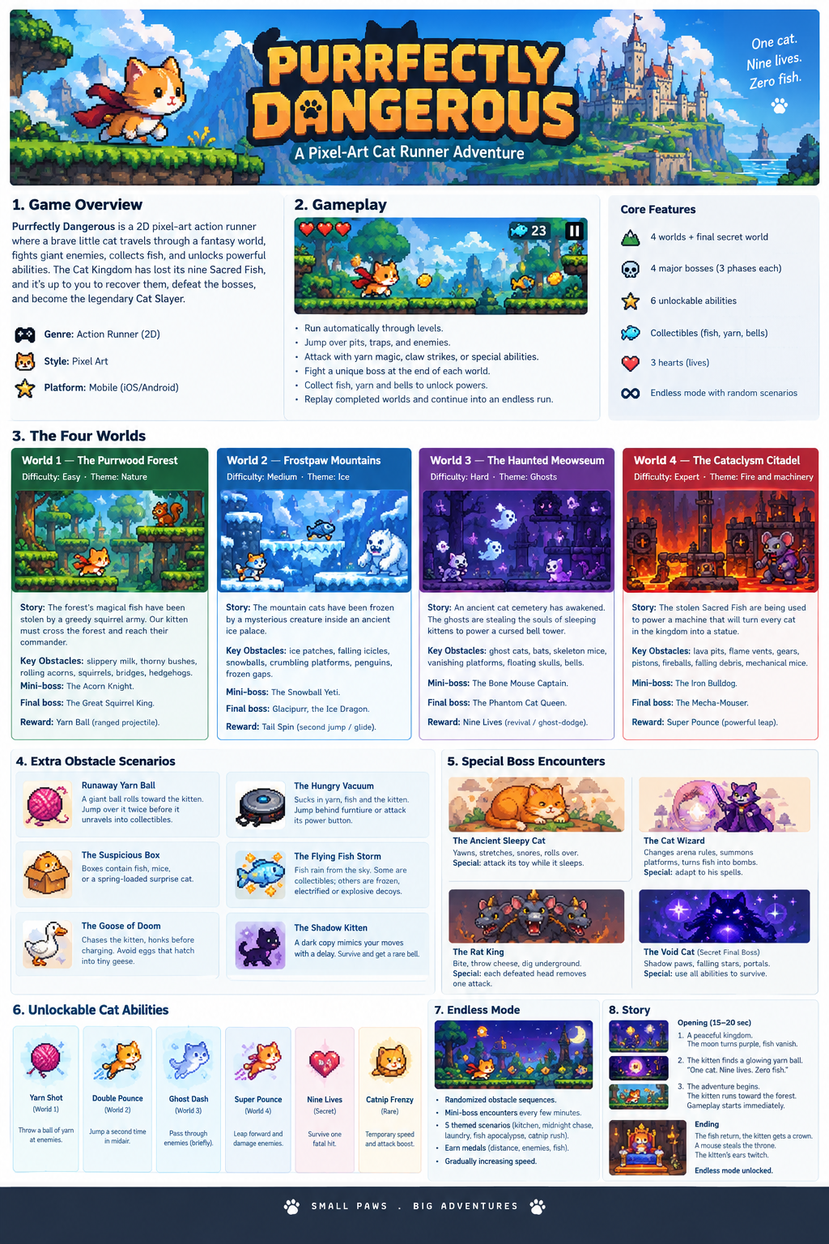
GAME CONCEPT • WORLDS • OBSTACLES • BOSSES • ABILITIES

1. High Concept
Purrfectly Dangerous is a 2D pixel-art action runner about a brave kitten crossing a fantasy kingdom, dodging traps, battling oversized enemies, and recovering the nine Sacred Fish. The tone combines cute character animation, readable arcade action, memorable boss patterns, and playful cat humor.

Core gameplay loop
- Run automatically through side-scrolling levels.
- Jump over pits, traps, and enemies; attack with claws or unlocked abilities.
- Collect fish, yarn, and bells as rewards and upgrade currency.
- Reach the end of each world and learn a multi-phase boss fight.
- Replay worlds for medals, then unlock an endless mode with mixed obstacles.

2. World and Boss Scenarios

World 1 — The Purrwood Forest
Difficulty / theme: Easy | Nature
Story: The forest's magical fish have been stolen by a greedy squirrel army. The kitten must cross the woods and reach their enormous commander.
Obstacle set: Spilled milk (slippery ground); thorny rose bushes; rolling acorns; squirrels throwing acorns from branches; broken bridges; hedgehogs that curl into spiky balls.
Mini-boss: The Acorn Knight — a squirrel in a walnut-shell helmet that charges along the ground.
Final boss: The Great Squirrel King — a crowned giant squirrel.
Boss fight phases
- Throws three acorns in a predictable arc.
- Rolls across the arena, leaving acorns behind.
- Climbs a tree and drops a giant acorn that creates a shockwave.
Reward: Yarn Shot — unlocks a ranged yarn projectile.

World 2 — Frostpaw Mountains
Difficulty / theme: Medium | Ice
Story: The mountain cats have been frozen by a mysterious creature inside an ancient ice palace.
Obstacle set: Slippery ice patches; falling icicles with a warning; rolling snowballs; crumbling ice platforms; sliding penguins; wide frozen gaps.
Mini-boss: The Snowball Yeti — creates snowballs and charges through them.
Final boss: Glacipurr, the Ice Dragon — a fluffy white dragon with crystalline whiskers and freezing breath.
Boss fight phases
- Fires ice shards in a fan pattern.
- Sweeps the arena with freezing breath; jump to avoid the ground-level attack.
- Covers the floor in ice, then dives from above.
Reward: Double Pounce — a second mid-air jump or short glide.

World 3 — The Haunted Meowseum
Difficulty / theme: Hard | Ghosts
Story: An ancient cat cemetery has awakened. Ghosts are stealing sleeping kittens' souls to power a cursed bell tower.
Obstacle set: Ghost cats that blink in and out; swooping bats; skeleton mice throwing bones; vanishing platforms; floating skull projectiles; cursed bells with sound-wave attacks.
Mini-boss: The Bone Mouse Captain — a skeleton mouse riding a tiny skeletal horse.
Final boss: The Phantom Cat Queen — a translucent royal cat with a floating crown and purple-smoke cloak.
Boss fight phases
- Summons ghost cats that chase the player.
- Teleports and sends spectral waves along the ground.
- Splits into three copies; only the glowing copy takes damage.
Reward: Ghost Dash or Nine Lives — a brief dodge through enemies, or one-time revival.

World 4 — The Cataclysm Citadel
Difficulty / theme: Expert | Fire and machinery
Story: The stolen Sacred Fish power a machine designed to turn every cat in the kingdom into a statue.
Obstacle set: Lava pits; timed flame vents; moving gears and crushing pistons; cannon fireballs; falling ceiling debris; mechanical mice that chase the kitten.
Mini-boss: The Iron Bulldog — a mechanical guard that charges and fires rockets.
Final boss: The Mecha-Mouser — a giant robotic mouse with a furnace core and metal tail.
Boss fight phases
- Fires rockets that leave temporary hazards on the ground.
- Sweeps the arena with its tail and activates flame vents.
- Armor breaks to reveal the core; dodge rapid attacks and strike during short openings.
Reward: Super Pounce — a forward leap that damages enemies and breaks special walls.

3. Extra Obstacle Encounters

The Runaway Yarn Ball
A giant yarn ball rolls toward the kitten and bounces over small obstacles. Jump over it twice; it then unravels into collectible yarn.

The Suspicious Cardboard Box
Boxes may contain fish, mice, or a spring-loaded surprise cat that launches into the air.

The Goose of Doom
A goose honks before charging. Jump over it while avoiding eggs that hatch into tiny geese.

The Hungry Vacuum
A robot vacuum sucks up yarn and fish, and can pull the kitten in at close range. Hide behind furniture or attack its power button.

The Flying Fish Storm
Fish rain from the sky. Some are collectibles; others are frozen, electrified, or explosive decoys.

The Shadow Kitten
A dark copy follows the player's movements with a short delay. Survive the chase to earn a rare bell.

4. Special Boss Encounters

The Ancient Sleepy Cat
A giant cat blocks a temple entrance. Yawns create wind blasts; stretches sweep its paws across the arena; snores launch projectiles. Attack its dangling toy while it sleeps to expose its weak spot.

The Cat Wizard
A rival magician changes arena rules, summons floating platforms, and turns fish into bouncing bombs. The player must adapt to each spell.

The Rat King
Three rats share one crown: one bites, one throws cheese, and one digs underground. Each defeated head removes one attack.

The Void Cat — Secret Final Boss
An ancient cosmic cat attacks with shadow paws, falling stars, and portals that confuse projectile direction. The final phase tests all unlocked abilities.

5. Unlockable Cat Abilities
Ability | Effect | Unlock
Yarn Shot | Throw a ball of yarn at enemies. | World 1
Double Pounce | Jump a second time in mid-air. | World 2
Ghost Dash | Briefly pass through enemies. | World 3
Super Pounce | Leap forward and damage enemies. | World 4
Nine Lives | Survive one otherwise fatal hit. | Secret challenge
Catnip Frenzy | Temporary speed and attack boost. | Rare collectible

6. Endless Mode
After the main story, combine obstacles from all four worlds into randomized sequences. Gradually increase speed and introduce a mini-boss every few minutes.
- Kitchen Nightmare — flying vegetables, slippery milk, and rolling cans.
- Midnight Chase — ghosts, bats, and shadow kittens in low visibility.
- Laundry Dimension — bouncing socks, rotating washing machines, and view-blocking sheets.
- Fish Apocalypse — collectible fish mixed with explosive decoys.
- Catnip Rush — a temporary high-speed segment with tighter jumps and bigger rewards.
Score medals by distance travelled, enemies defeated, and fish collected.

7. Opening Cutscene and Ending

Opening (15–20 seconds)
- The kitten sleeps beside a pile of fish. The moon turns purple, the ground shakes, and the Sacred Fish vanish into the sky.
- The kitten wakes, sees the empty plate, and picks up a glowing ball of yarn. Title card: “One cat. Nine lives. Zero fish.”
- The kitten runs toward the forest. Music begins, the first obstacle appears, and gameplay starts immediately.

Ending
After defeating the Void Cat, the Sacred Fish return. The kitten receives a golden crown and a mountain of fish. After one bite, the kitten walks away; a tiny mouse steals the throne. The kitten's ears twitch. Endless mode unlocks.

8. Recommended First Release Scope
- Four worlds with 5–8 obstacle patterns each.
- Four major bosses with three readable attack phases apiece.
- Three initial unlockable abilities; add the others as progression rewards.
- Collectible fish, a simple upgrade menu, and replay medals.
- Endless mode that reuses the level-generation and collision systems.

SMALL PAWS • BIG ADVENTURES

9. Complete Enemy Roster & Abilities
This section expands the combat design for every generated enemy set. Each world introduces enemies that reinforce its movement gimmicks and prepares the player for the boss.

World 1 — The Purrwood Forest
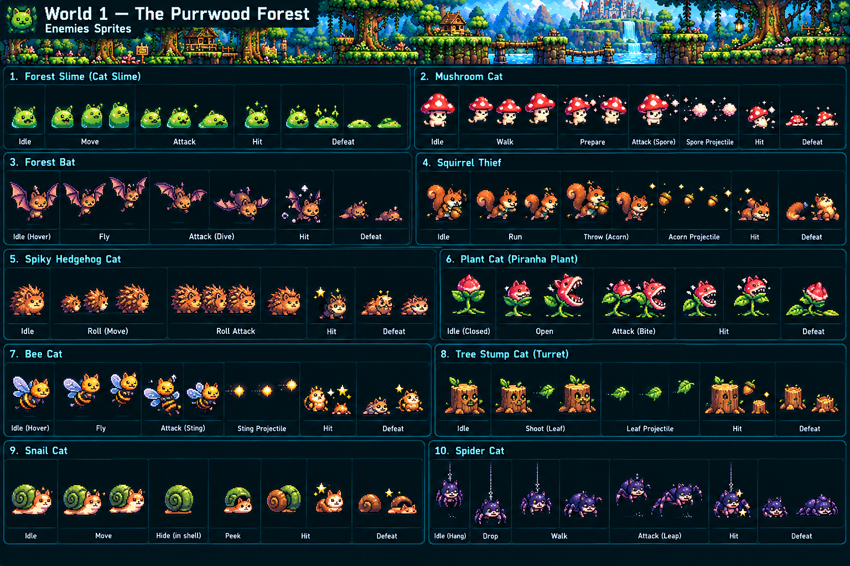
Generated enemy sprite reference
Enemy | Behavior | Main ability / attack | Threat
Forest Slime (Cat Slime) | Bounces toward the player in short hops. | Jump lunge | Low
Mushroom Cat | Waits near platforms and releases spores when the player enters range. | Spore cloud/projectile | Low
Forest Bat | Hovers above the route, then dives diagonally at the player. | Dive attack | Low
Squirrel Thief | Runs ahead and tries to steal collected fish or block the lane. | Thrown acorn | Medium
Spiky Hedgehog Cat | Curls into a ball and rolls quickly along the ground. | Rolling charge | Medium
Plant Cat (Piranha Plant) | Hides in foliage, opens when the player approaches, then snaps forward. | Bite | Medium
Bee Cat | Patrols in the air and attacks from above. | Sting / small projectile | Medium
Tree Stump Cat (Turret) | Stationary woodland turret that fires leaves across the lane. | Leaf projectile | Medium
Snail Cat | Slow armored enemy; hides in its shell when threatened. | Shell defense / body bump | Low
Spider Cat | Hangs above the path, drops down, walks briefly, then leaps. | Drop + leap | Medium

World 2 — Frostpaw Mountains
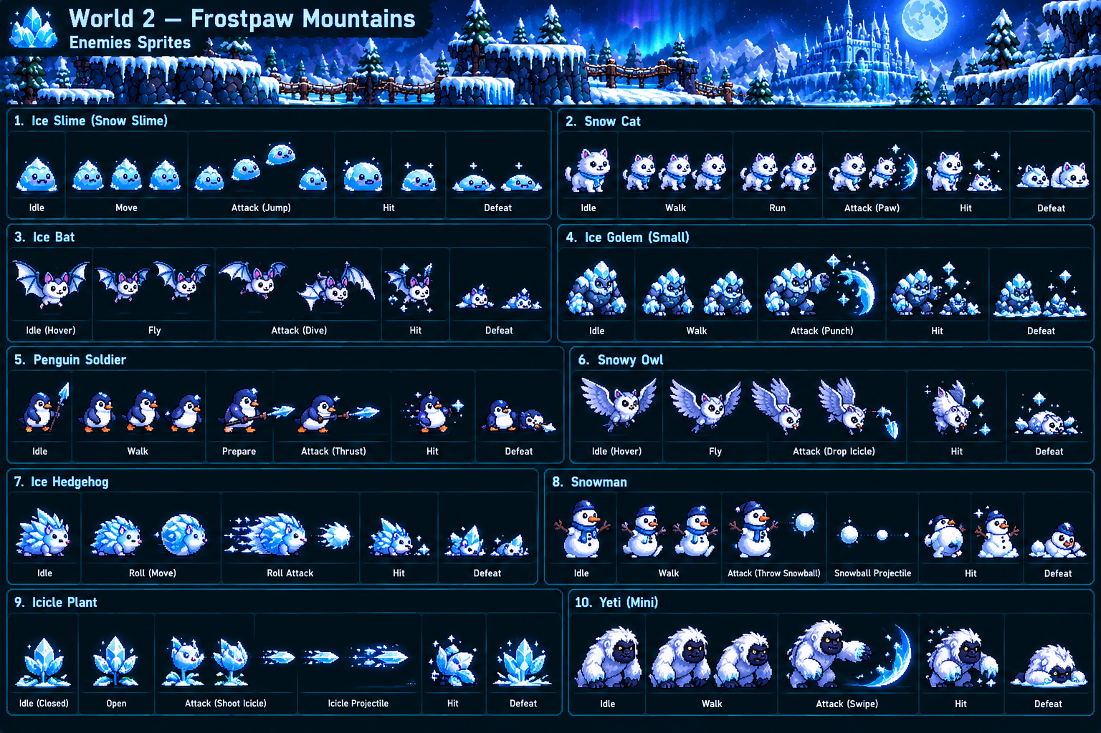
Generated enemy sprite reference
Enemy | Behavior | Main ability / attack | Threat
Ice Slime (Snow Slime) | Slides and hops unpredictably on frozen ground. | Jump attack | Low
Snow Cat | Fast melee enemy that runs toward the hero. | Paw slash | Medium
Ice Bat | Flies over gaps and dives when the player passes underneath. | Dive attack | Low
Ice Golem (Small) | Slow, durable enemy that controls narrow platforms. | Heavy ice punch | High
Penguin Soldier | Marches in short patrols and attacks from close range. | Ice spear thrust | Medium
Snowy Owl | Circles above the player before dropping a frozen projectile. | Dropped icicle | Medium
Ice Hedgehog | Rolls into a frozen ball and accelerates downhill. | Rolling charge | Medium
Snowman | Keeps distance and repeatedly throws snowballs. | Snowball projectile | Low
Icicle Plant | Opens from a crystal bud and fires along a straight line. | Icicle shot | Medium
Mini Yeti | A tougher bruiser with slow movement and a wide melee arc. | Heavy swipe | High

World 3 — The Haunted Meowseum
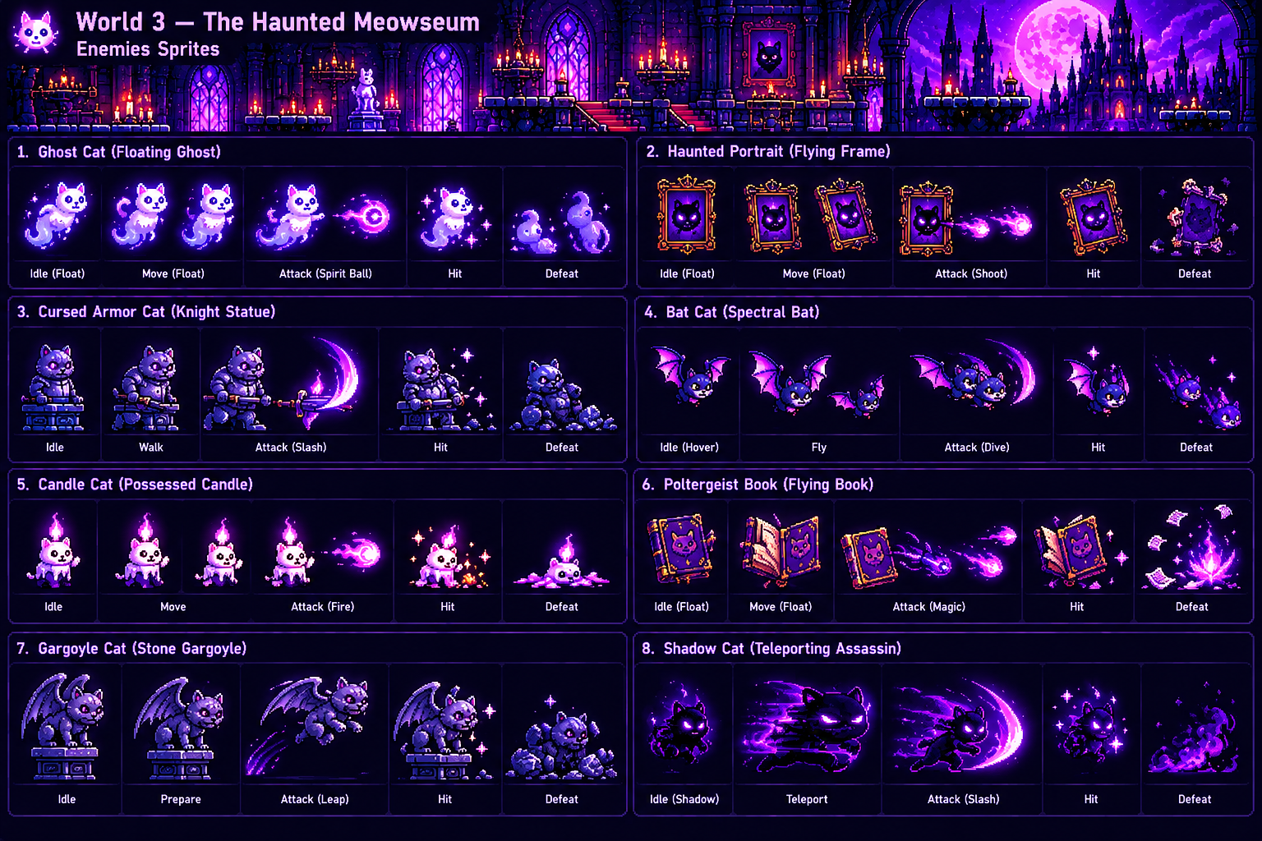
Generated enemy sprite reference
Enemy | Behavior | Main ability / attack | Threat
Ghost Cat (Floating Ghost) | Floats through parts of the environment and stalks the hero. | Spirit ball | Medium
Haunted Portrait (Flying Frame) | Detaches from the wall and follows the player at mid-height. | Magic shot | Medium
Cursed Armor Cat (Knight Statue) | Begins as a statue, awakens nearby, and blocks the route. | Spectral slash | High
Bat Cat (Spectral Bat) | Erratic flying enemy that attacks in quick arcs. | Dive slash | Medium
Candle Cat (Possessed Candle) | Small moving hazard that leaves magical flame pressure. | Fire orb | Low
Poltergeist Book (Flying Book) | Floats above platforms and casts magic from range. | Magic bolt / pages | Medium
Gargoyle Cat (Stone Gargoyle) | Remains still until triggered, then leaps from its pedestal. | Leap attack | High
Shadow Cat (Teleporting Assassin) | Teleports ahead of the runner and attacks with little warning. | Shadow slash | High

World 4 — The Cataclysm Citadel
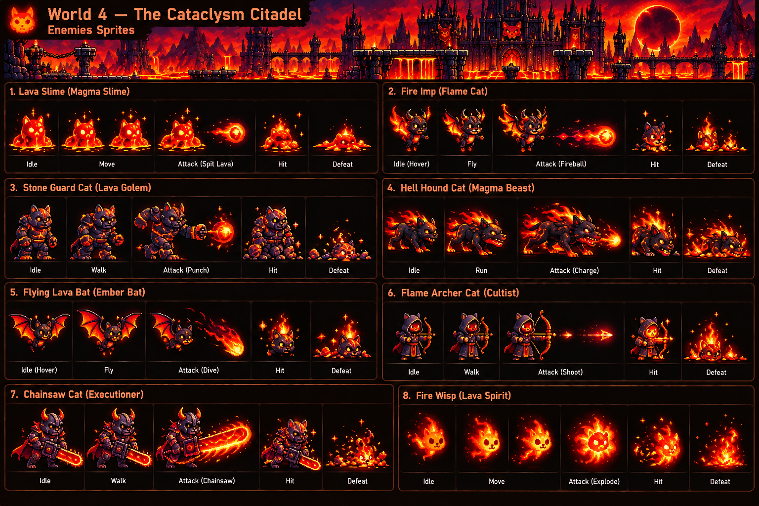
Generated enemy sprite reference
Enemy | Behavior | Main ability / attack | Threat
Lava Slime (Magma Slime) | Slow molten enemy that occupies safe ground near lava. | Spit lava | Medium
Fire Imp (Flame Cat) | Flying attacker that keeps distance from the hero. | Fireball | Medium
Stone Guard Cat (Lava Golem) | Armored fortress guard with high durability. | Heavy punch / magma blast | High
Hell Hound Cat (Magma Beast) | Fast ground enemy designed for chase sequences. | Flaming charge | High
Flying Lava Bat (Ember Bat) | Sweeps across the screen with a fiery trail. | Dive attack | Medium
Flame Archer Cat (Cultist) | Ranged enemy placed on elevated platforms. | Flaming arrow | Medium
Chainsaw Cat (Executioner) | Slow elite enemy with a dangerous close-range zone. | Chainsaw sweep | Very high
Fire Wisp (Lava Spirit) | Small floating spirit that pursues the player and becomes unstable. | Explosive burst | Medium

Final Level — The Void Cat
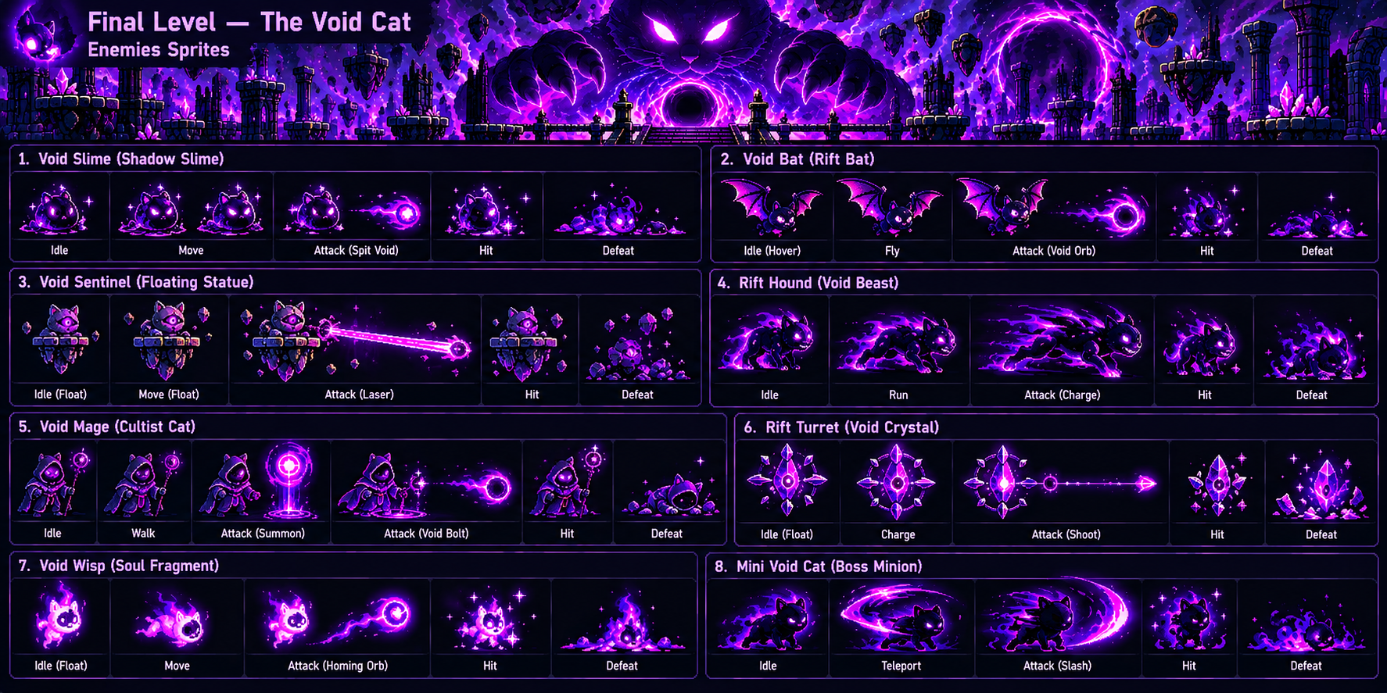
Generated enemy sprite reference
Enemy | Behavior | Main ability / attack | Threat
Void Slime (Shadow Slime) | Corrupted slime that moves in short shadowy bursts. | Spit void orb | Medium
Void Bat (Rift Bat) | Flies through the arena and attacks from unstable angles. | Void orb | Medium
Void Sentinel (Floating Statue) | Stationary/floating guardian that controls long sightlines. | Void laser | High
Rift Hound (Void Beast) | Extremely fast pursuit enemy used to force immediate reactions. | Void charge | High
Void Mage (Cultist Cat) | Supports other enemies and attacks from range. | Summon + void bolt | High
Rift Turret (Void Crystal) | Charges visibly before firing across the arena. | Crystal shot | High
Void Wisp (Soul Fragment) | Tracks the hero through the air and pressures jumps. | Homing orb | Medium
Mini Void Cat (Boss Minion) | Teleports around the hero and mimics a simplified boss attack. | Teleport + slash | Very high

10. Boss Roster & Fight Design
Bosses are designed as readable multi-phase encounters rather than large-health-bar enemies. Each fight tests the mechanics introduced by its world and awards a traversal/combat upgrade.
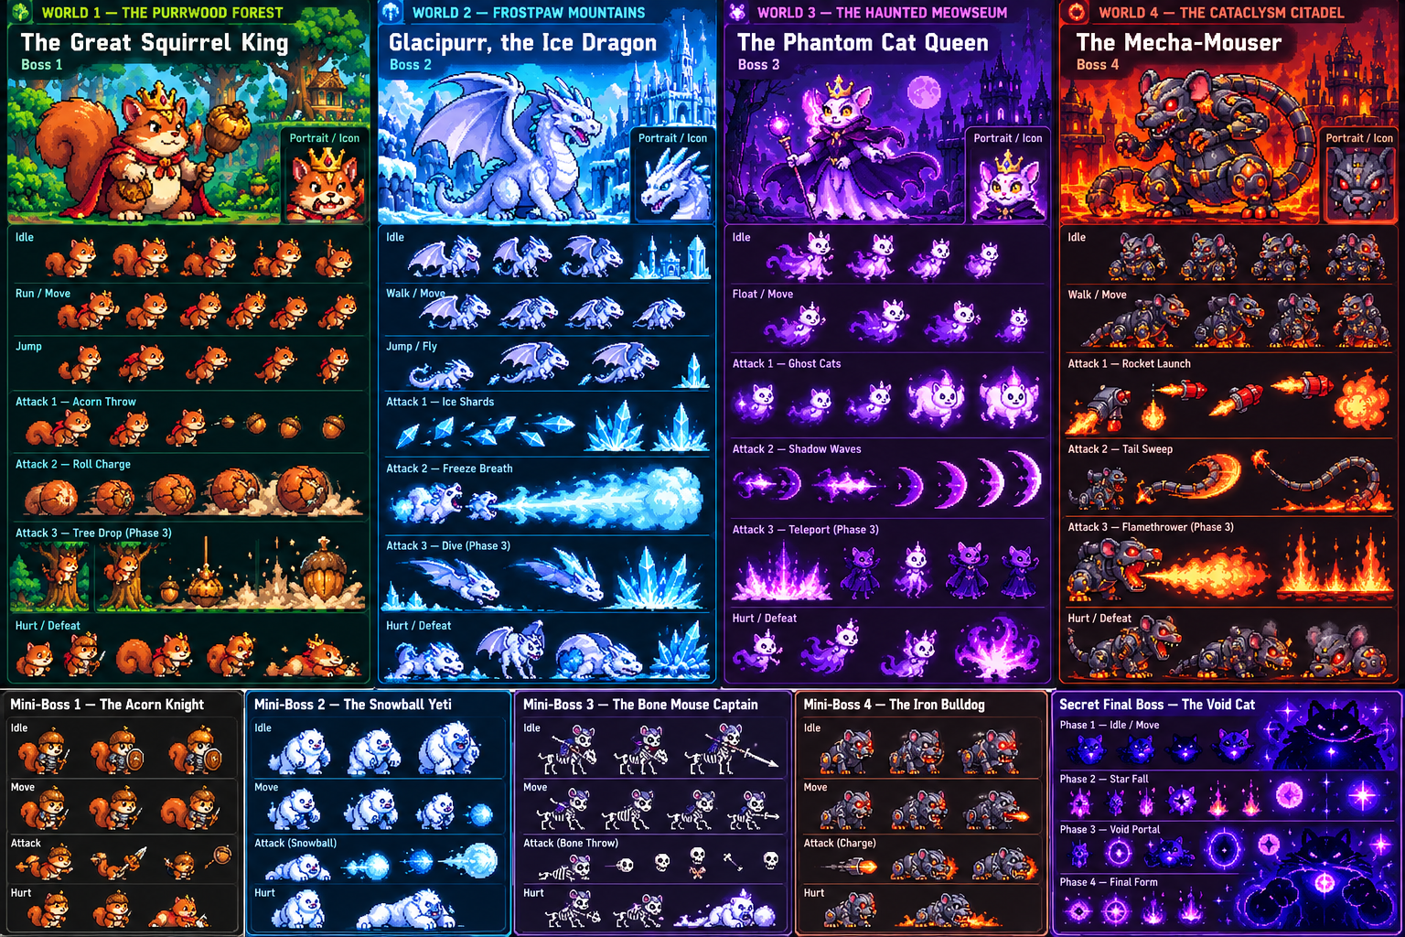
Generated boss sprite concepts

The Great Squirrel King
Encounter: World 1
A giant crowned squirrel commander who teaches the player to read attack telegraphs.
Attack phases
- Throws three acorns in an arc.
- Rolls across the arena and leaves acorns behind.
- Drops a giant acorn from a tree, creating a ground shockwave.
Reward / progression: Yarn Shot

Glacipurr, the Ice Dragon
Encounter: World 2
A fluffy crystalline ice dragon that turns movement itself into the main challenge.
Attack phases
- Fires a fan of ice shards.
- Sweeps freezing breath across the ground.
- Freezes the arena floor, then dives from above.
Reward / progression: Double Pounce

The Phantom Cat Queen
Encounter: World 3
A spectral royal cat built around teleportation, summons, and visual deception.
Attack phases
- Summons pursuing ghost cats.
- Teleports and launches spectral ground waves.
- Splits into three copies; only the glowing real queen can be damaged.
Reward / progression: Ghost Dash / Nine Lives

The Mecha-Mouser
Encounter: World 4
A giant robotic mouse powered by a furnace core and protected by mechanical armor.
Attack phases
- Launches rockets that leave temporary hazards.
- Sweeps its metal tail while flame vents activate.
- Armor breaks; the exposed core can be hit only during short openings.
Reward / progression: Super Pounce

The Void Cat
Encounter: Secret Final Level
An ancient cosmic cat and the ultimate test of every mechanic learned during the game.
Attack phases
- Creates shadow-paw strikes and falling-star patterns.
- Opens portals that redirect or reverse incoming projectiles.
- Combines arena hazards with minions and forces the player to use all unlocked abilities.
Reward / progression: Final completion / Endless Mode mastery reward

11. Enemy-to-Boss Progression
Stage | Enemy lesson | Boss payoff
Purrwood Forest | Basic jumps, ground pressure, first projectiles | Squirrel King combines projectiles, rolling pressure, and shockwave timing.
Frostpaw Mountains | Sliding movement, aerial threats, ranged ice attacks | Glacipurr combines slippery terrain, projectile fans, breath sweeps, and dives.
Haunted Meowseum | Teleportation, deceptive enemies, magic projectiles | Phantom Cat Queen turns those ideas into teleport waves, summons, and clones.
Cataclysm Citadel | High-speed charges, ranged fire, elite melee enemies | Mecha-Mouser combines persistent hazards, arena machinery, and short damage windows.
Void Realm | Homing attacks, lasers, teleporting elites, mixed pressure | Void Cat combines mechanics from the entire game into the final mastery test.

12. Playable Character Route — Sakura
Sakura is an unlockable/pickable hero for a dedicated four-level themed route. Her visual identity is white fur with pink blossom accents and a flowing pink scarf/cape. The route progresses from a bright blossom garden to sunset bridges, a moonlit temple ascent, and finally floating sky shrines.
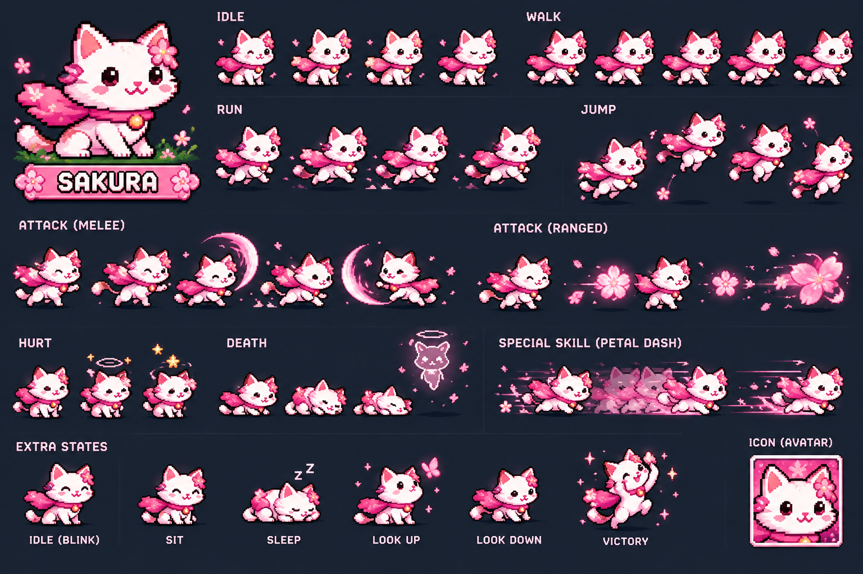
Sakura hero sprite reference — idle, run, jump, attacks, hurt/death, Petal Dash and extra states.

Sakura Core Moves
Move | Gameplay use
Run | Standard forward movement; responsive acceleration suitable for runner gameplay.
Jump | Primary obstacle-clear and platforming move; supports short and full-height jumps.
Melee Slash | Close-range blossom arc for enemies directly in front of Sakura.
Ranged Blossom | Fires a sakura-flower projectile for safer ranged interactions.
Petal Dash | Signature burst movement. Sakura dashes forward in a trail of petals; used for gap crossing, evasive movement, and advanced routing.
Hurt / Recovery | Brief hit reaction followed by a short recovery window.

Sakura 1-1 — Blossom Path
Bright spring garden and shrine approach. This is Sakura's onboarding stage: generous platforms, readable hazards, and low-pressure enemies teach her movement and Petal Dash.
Objective: Reach the first shrine gate while collecting fish and blossom tokens.
Movement focus: Run, jump, short hop, Petal Dash through narrow gaps, and use safe platforms to learn enemy timing.
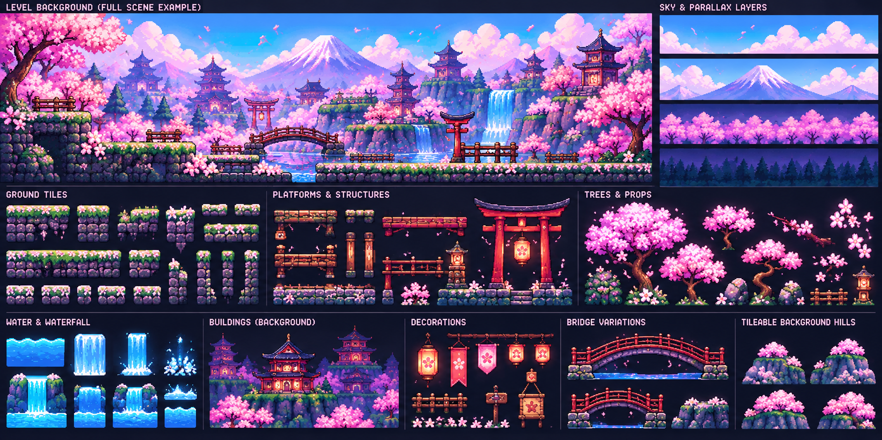
Level 1 generated background / tileset reference.

Obstacles & Movement Interactions
Obstacle | Behavior / player response
Spike Pit | Static floor hazard; jump or dash over it.
Moving Wooden Platform | Moves horizontally or vertically; requires timing rather than speed.
Falling Petals | Dense petal gust briefly obscures small hazards and enemy tells.
Wind Gust | Pushes Sakura sideways during jumps.
Bamboo Spikes | Rise from the ground on a visible rhythm.
Crumbling Platform | Breaks shortly after Sakura lands on it.

Enemies
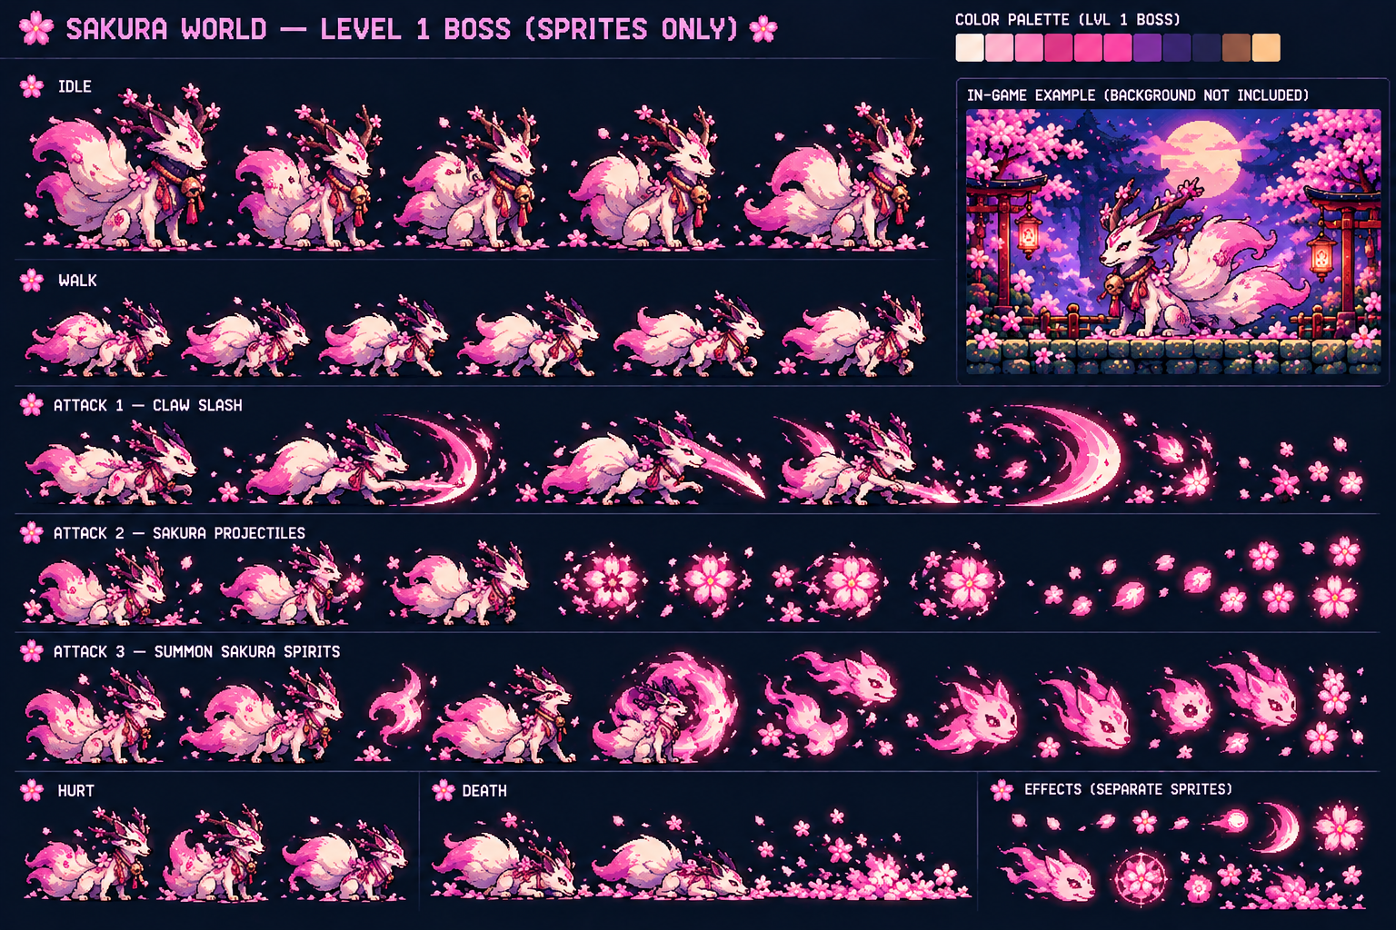
Level 1 generated enemy sprite reference.
Enemy | Movement / attack behavior
Sakura Slime | Slow basic enemy; shuffles forward and makes a short bounce attack.
Sakura Bunny | Fast melee enemy; changes direction quickly and lunges with a crescent swipe.
Lantern Spirit | Floating ranged enemy; fires slow glowing blossom shots.
Bird Crow | Flying enemy; hovers, tracks Sakura, then dives diagonally.
Spike Plant | Stationary hazard-enemy; opens before spitting a straight projectile.
Rolling Onigiri | Ground charger; curls and rolls quickly along the platform.

Boss Encounter
Blossom Kitsune Guardian
Claw Slash; Sakura Projectile bloom shots; summons small sakura spirits. The fight emphasizes readable telegraphs and basic dodge timing.

Sakura 1-2 — Petal Bridges
A sunset cliffside settlement with red bridges, lanterns, waterfalls, torii gates, and deeper gaps. The level adds more vertical movement and moving-platform chains.
Objective: Cross the lantern bridges and reach the upper temple district.
Movement focus: Longer jumps, chained moving platforms, Petal Dash across broken bridges, and controlled landings near ledges.
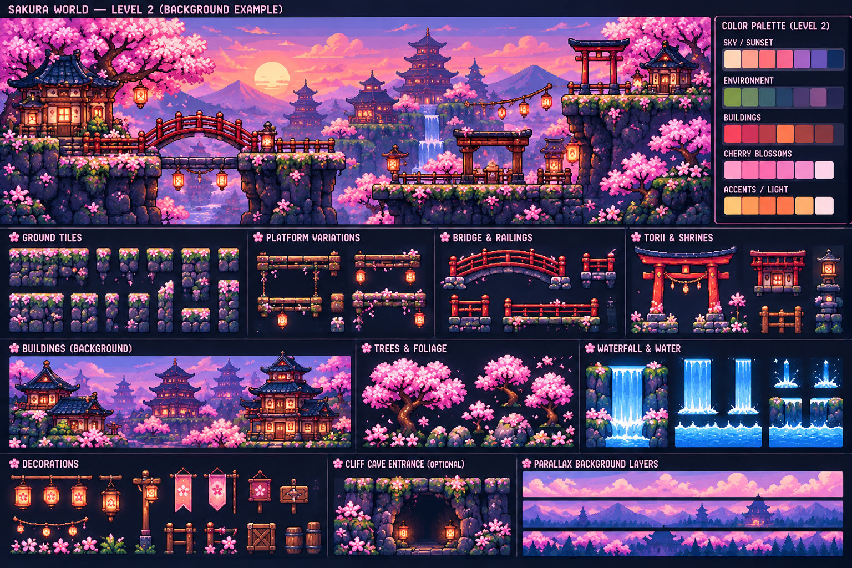
Level 2 generated background / tileset reference.

Obstacles & Movement Interactions
Obstacle | Behavior / player response
Hanging Bridge | Sways subtly and narrows the safe landing area.
Lantern Pendulum | Swings across the route; pass beneath or jump over it.
Water Current | Pushes Sakura sideways on low water sections.
Cliff Gap | Long gap requiring a full jump or Petal Dash.
Falling Lantern | Drops after a warning shake and creates a temporary hot zone.
Breakable Floor | Cracks on contact and collapses after a short delay.

Enemies
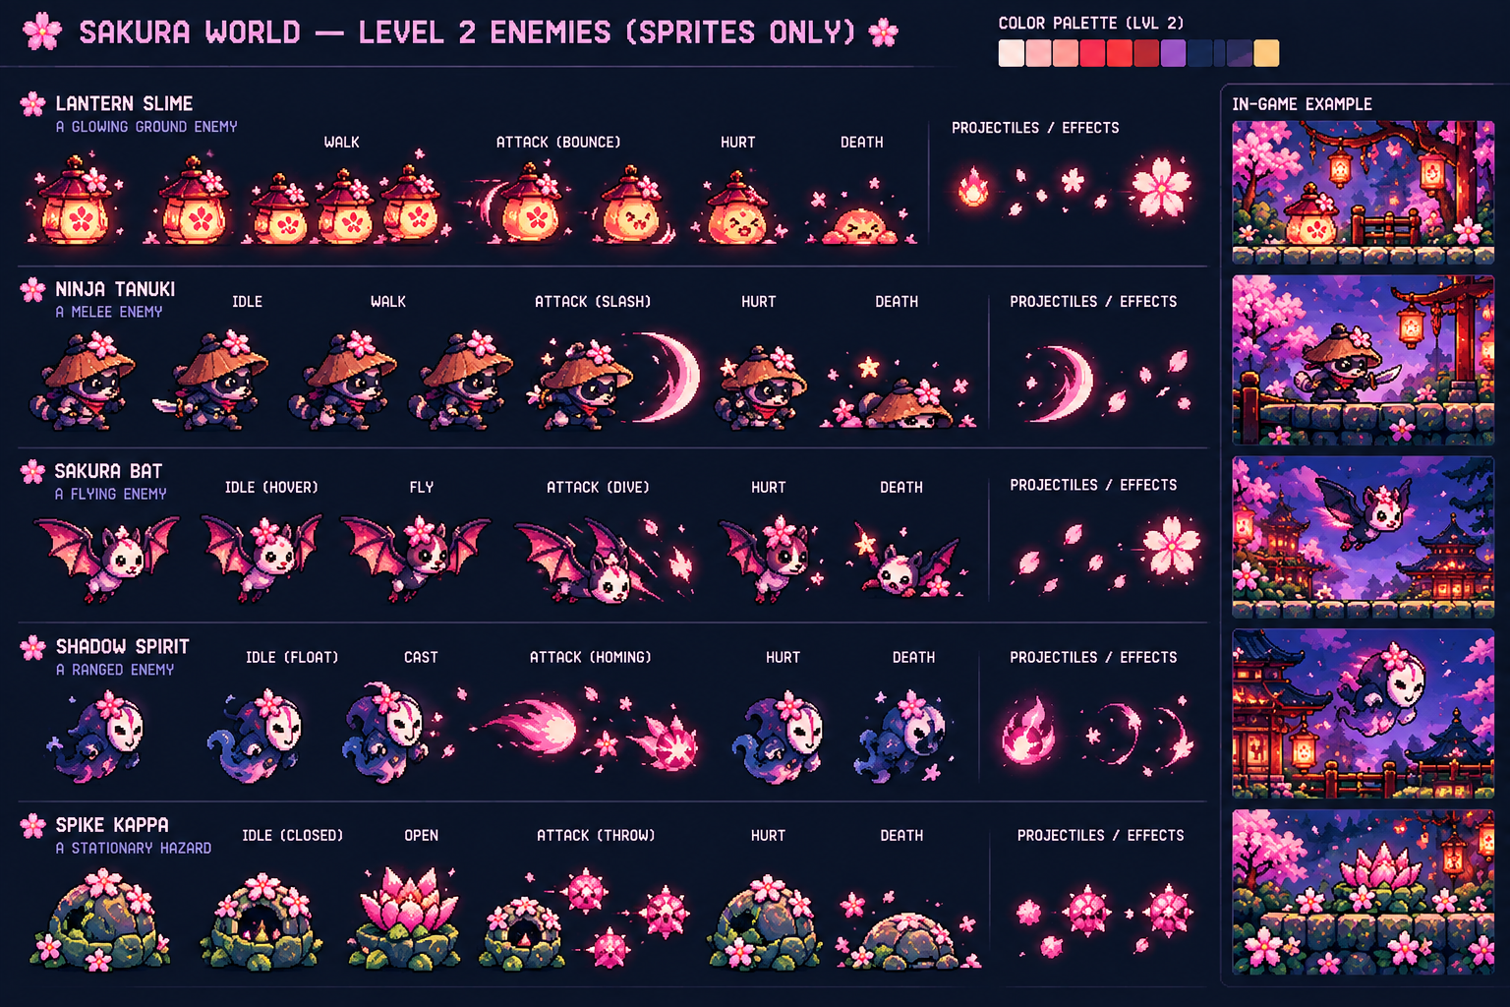
Level 2 generated enemy sprite reference.
Enemy | Movement / attack behavior
Lantern Slime | Glowing ground enemy; bounces forward and releases a small flame/blossom effect.
Ninja Tanuki | Mobile melee fighter; walks, closes distance, and performs a fast slash.
Sakura Bat | Flying attacker; hovers and then dives at Sakura.
Shadow Spirit | Ranged floating enemy; casts a homing pink spirit projectile.
Spike Kappa | Stationary armored hazard; opens and throws spiked blossom projectiles.

Boss Encounter
Lantern Toad Guardian
Long Tongue Strike; arcing Lantern Projectiles; Area Slam that throws rocks and blossom energy upward. Safe windows appear after the slam.
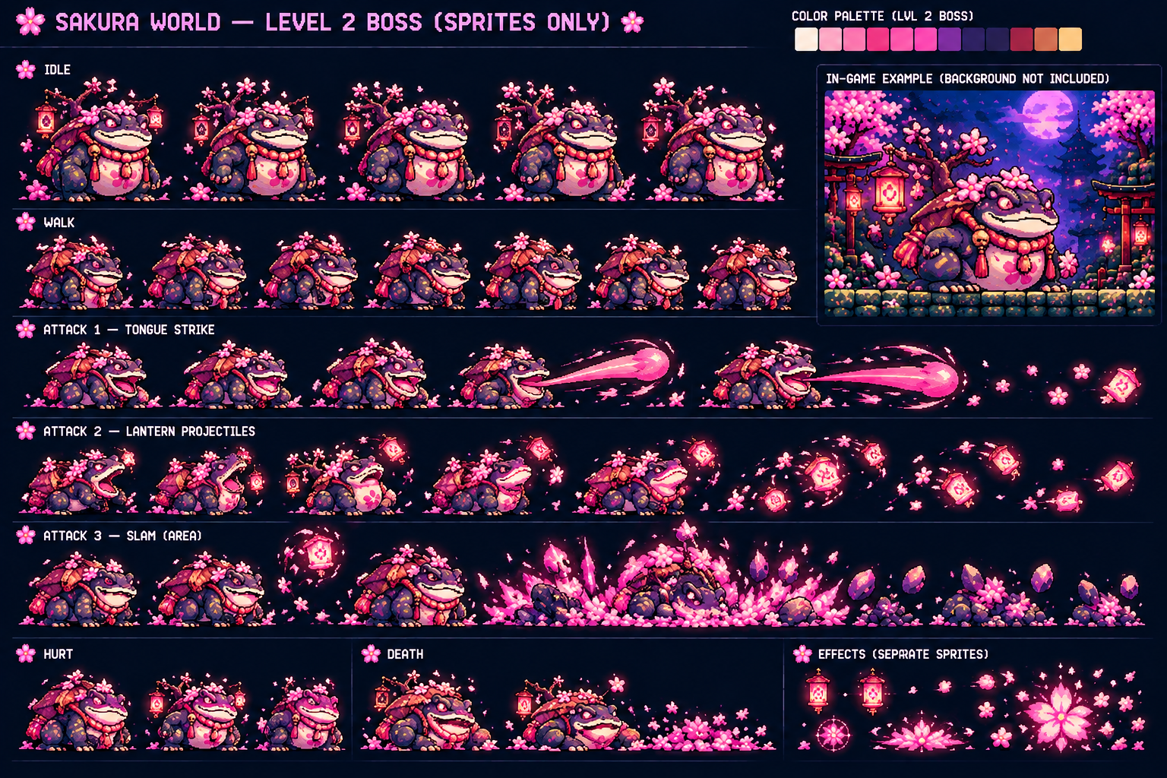
Level 2 generated boss sprite reference.

Sakura 1-3 — Moonlit Temple Ascent
A darker moonlit shrine complex with bamboo forests, waterfalls, elevated temples, mist, and tighter platforming. Combat becomes more aggressive and magical.
Objective: Climb through the shrine terraces and activate the moon gate.
Movement focus: Vertical platform chains, precise edge jumps, Petal Dash through enemy lines, and reaction jumps around magical projectiles.
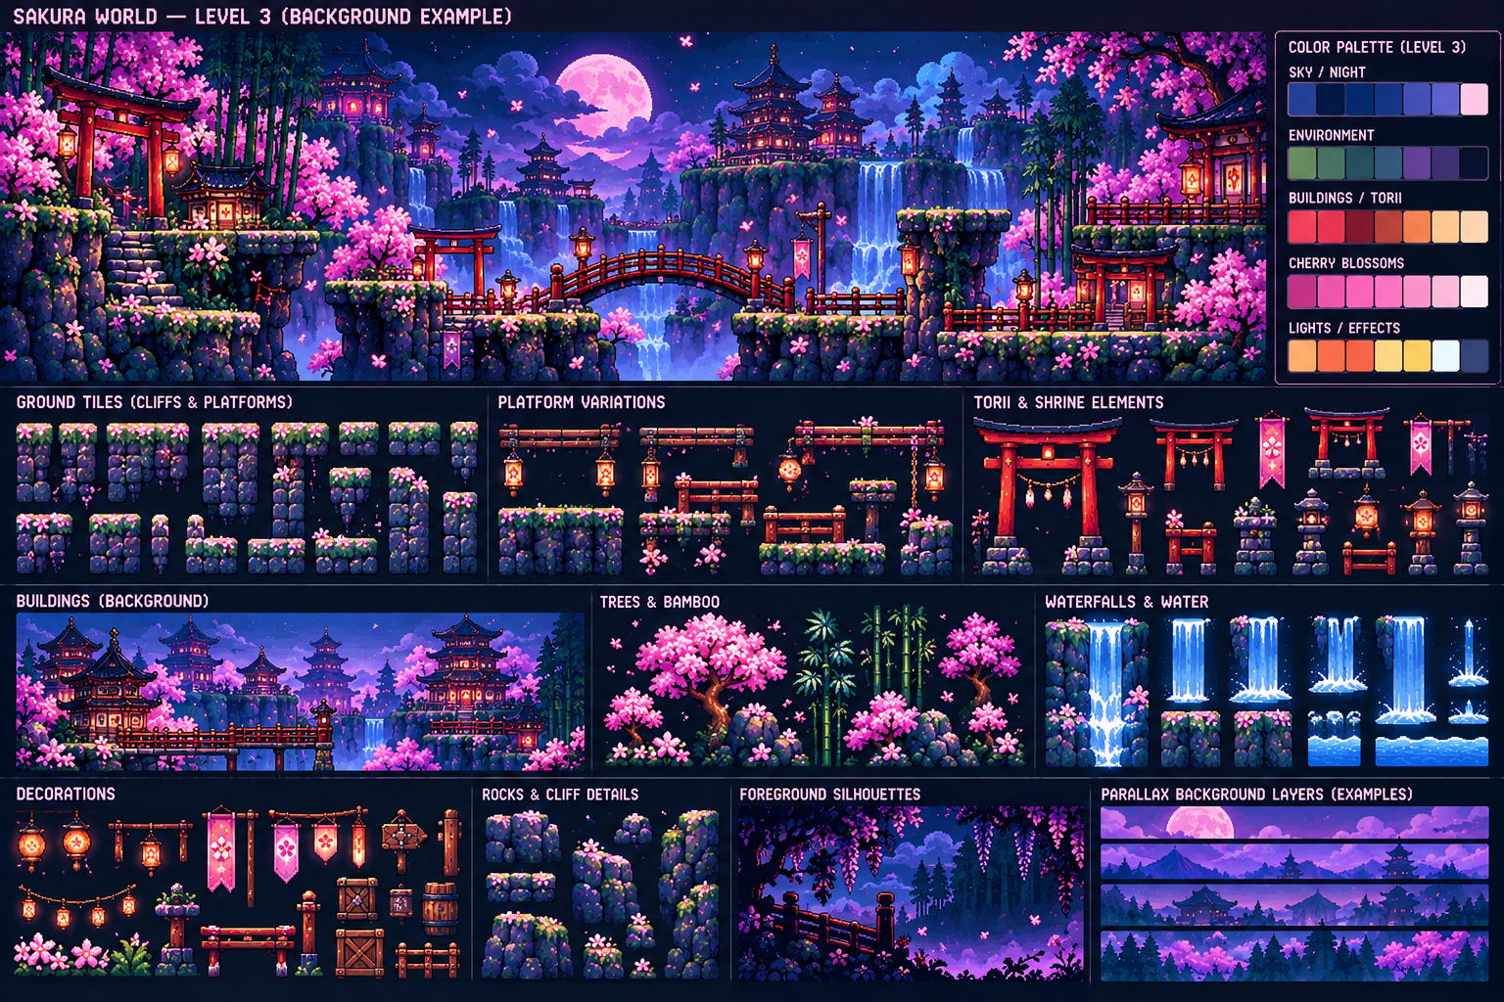
Level 3 generated background / tileset reference.

Obstacles & Movement Interactions
Obstacle | Behavior / player response
Bamboo Spear Trap | Extends from walls or floors after a short visual tell.
Crumbling Cliff | Rock edge breaks in segments after landing.
Moon Gate Pulse | Periodic energy wall; pass during its inactive interval.
Waterfall Push | Strong horizontal force while crossing wet platforms.
Swinging Shrine Bell | Large pendulum obstacle with a predictable arc.
Mist Platform | Temporarily fades, forcing the player to remember its position.

Enemies
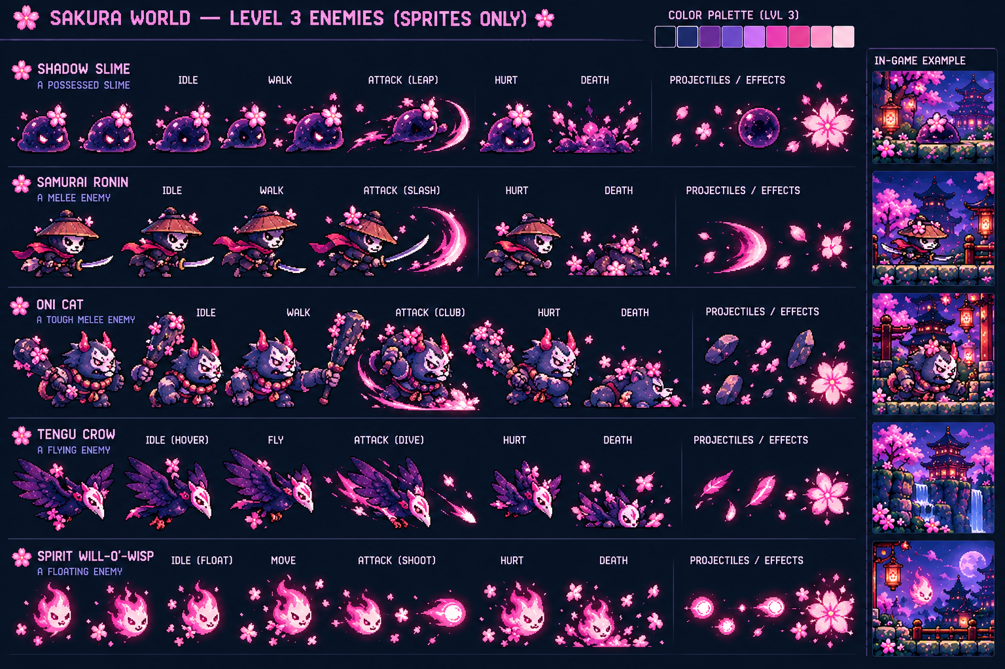
Level 3 generated enemy sprite reference.
Enemy | Movement / attack behavior
Shadow Slime | Possessed slime; leaps aggressively and leaves a short dark-petal burst.
Samurai Ronin | Melee swordsman; approaches carefully and uses a wide sakura slash.
Oni Cat | Heavy melee enemy; slow movement, high durability, powerful club smash.
Tengu Crow | Fast aerial enemy; hovers and executes a steep dive attack.
Spirit Will-o'-Wisp | Floating ranged enemy; shoots compact spirit orbs from above.

Boss Encounter
Moon Sakura Kitsune
Sakura Slash; radial Sakura Projectiles; Spirit Summon that sends spectral foxes across the arena. Later cycles shorten the gaps between patterns.
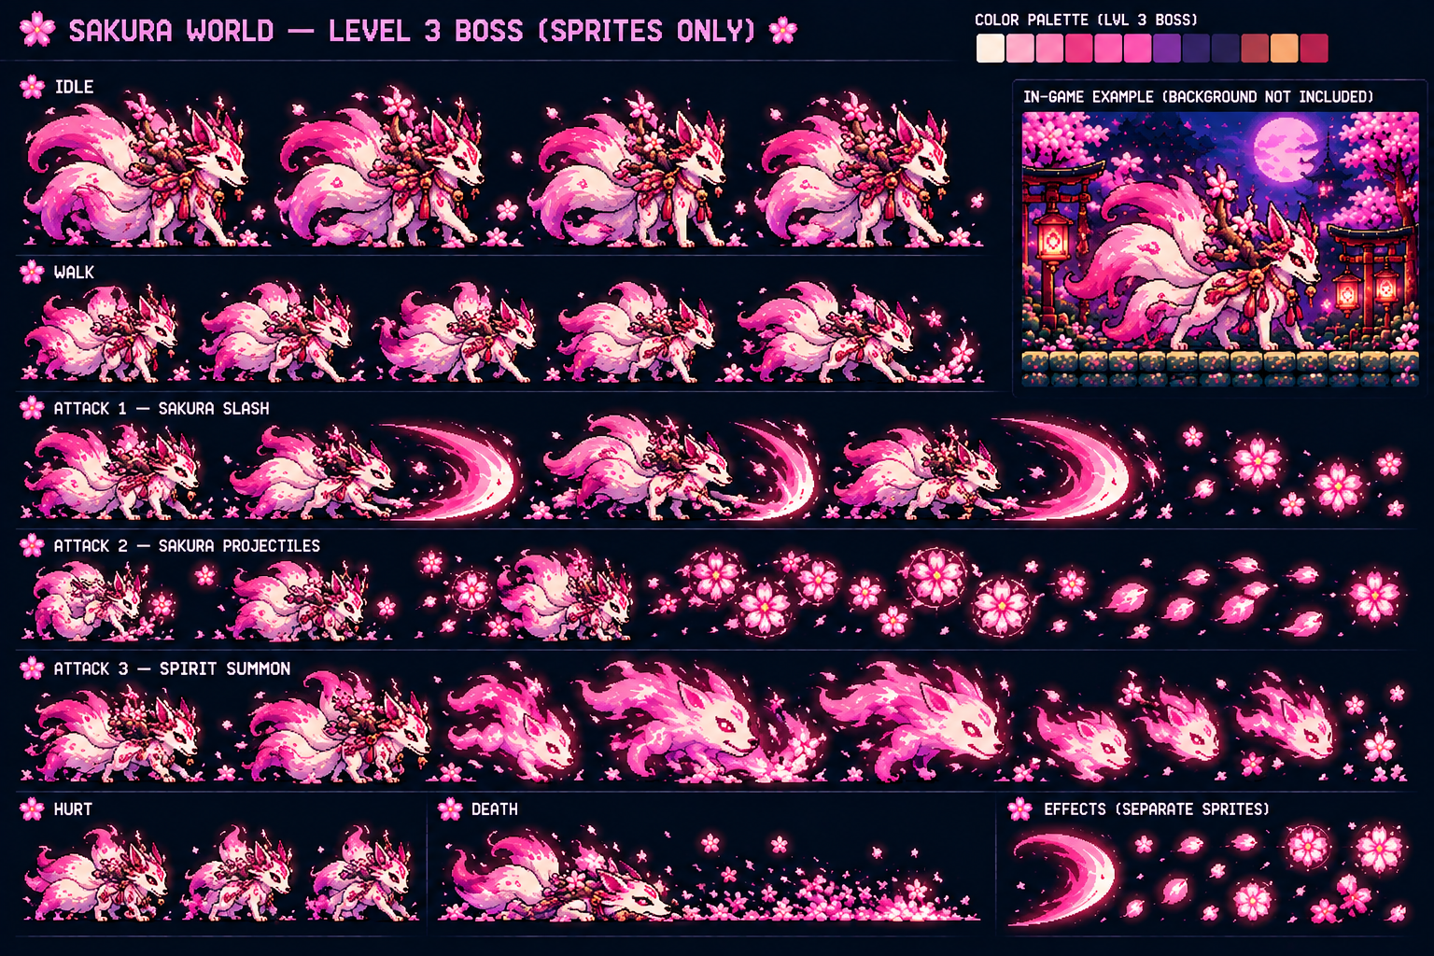
Level 3 generated boss sprite reference.

Sakura 1-4 — Sky Shrine
The climax of Sakura's route: floating islands above a glowing sunset cloud sea, suspended bridges, waterfalls, torii gates, and isolated shrine platforms.
Objective: Cross the floating shrine islands and defeat the guardian at the highest sanctuary.
Movement focus: Maximum use of Petal Dash, long airborne chains, moving/floating platforms, and rapid transitions between ground and aerial threats.
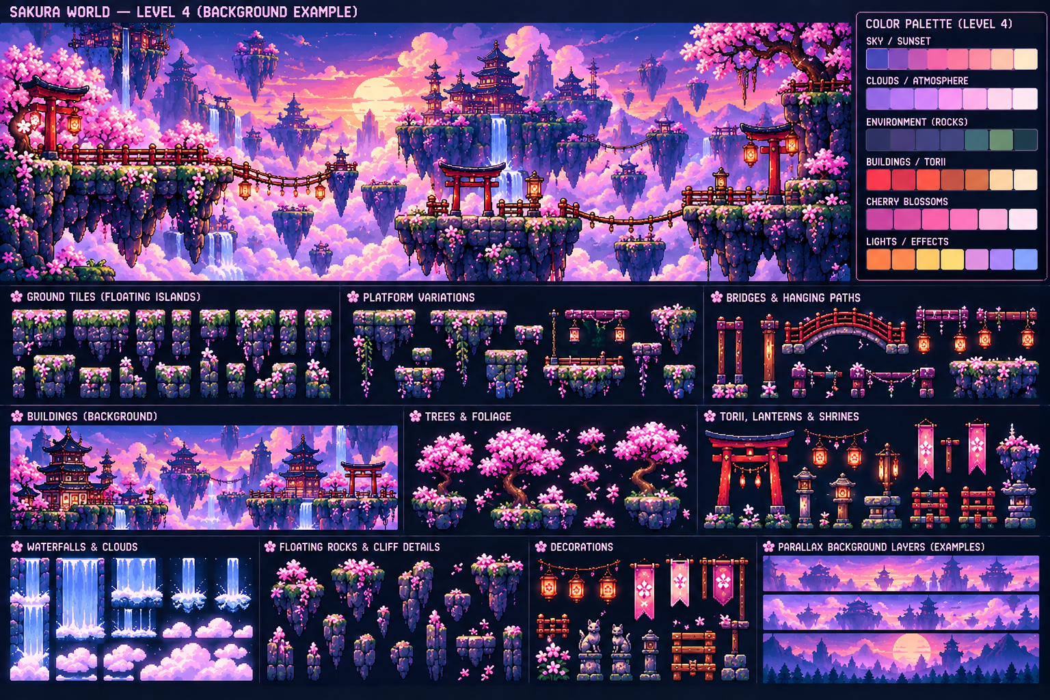
Level 4 generated background / tileset reference.

Obstacles & Movement Interactions
Obstacle | Behavior / player response
Floating Island Gap | Large gaps require committed jumps and dash conservation.
Hanging Rope Path | Narrow moving path with little recovery space.
Cloud Platform | Appears solid briefly, then dissolves and reforms.
Falling Rock | Drops from floating cliffs after a warning particle effect.
Petal Storm | Strong directional wind plus reduced visibility.
Shrine Beam | Vertical energy column activates in timed sequences.

Enemies
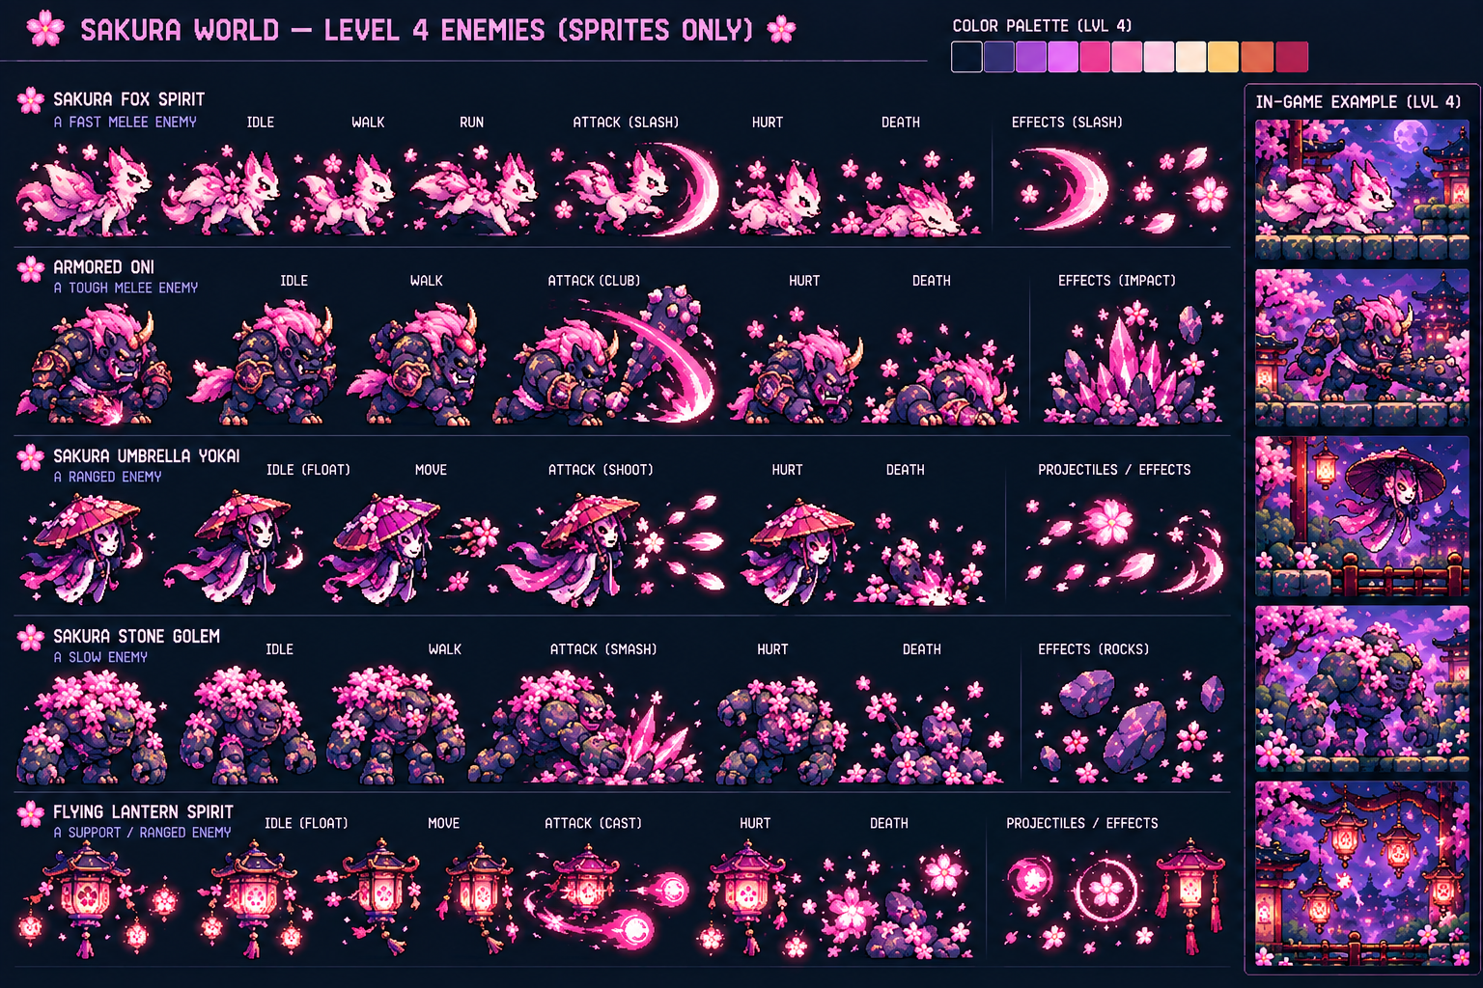
Level 4 generated enemy sprite reference.
Enemy | Movement / attack behavior
Sakura Fox Spirit | Fast melee hunter; runs, slashes, and quickly repositions.
Armored Oni | Elite tank; slow but dangerous club smash with crystal/rock impact.
Sakura Umbrella Yokai | Floating ranged enemy; shoots curved petal blades.
Sakura Stone Golem | Slow heavyweight; smashes the ground and throws rock fragments.
Flying Lantern Spirit | Support/ranged enemy; floats and casts glowing orbs while other enemies attack.

Boss Encounter
Ascended Sakura Oni-Kitsune
Sakura Slash; Bloom Projectiles; Sakura Storm area attack with repeated energy pillars. Final phase combines storm zones with faster slash pressure.
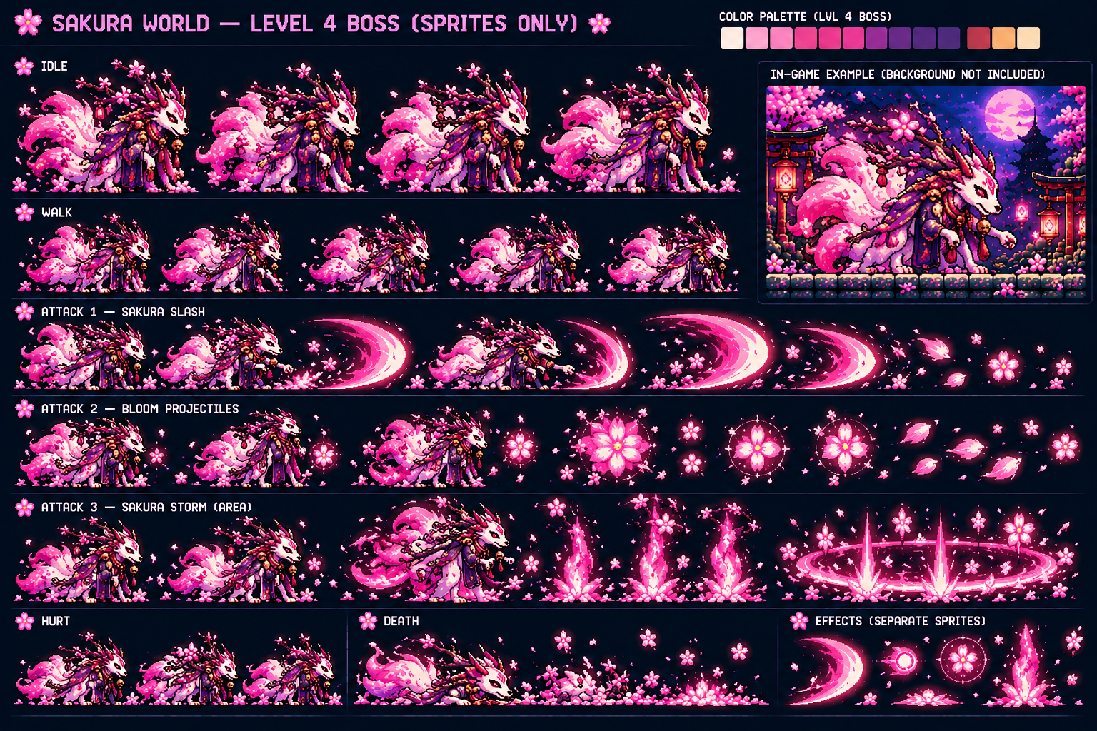
Level 4 generated boss sprite reference.

17. Sakura Route Difficulty Curve
Level | Design role | Primary test
1-1 Blossom Path | Learn | Basic jump timing, first ranged threats, Petal Dash introduction.
1-2 Petal Bridges | Combine | Moving platforms, long gaps, homing attacks, bridge hazards.
1-3 Moonlit Temple Ascent | Pressure | Vertical platforming, heavy enemies, magic patterns, disappearing terrain.
1-4 Sky Shrine | Master | Long aerial chains, elite enemies, timed beams, petal storms, multi-pattern boss.

