|  |
| --- |
|  |
| **System Name** |
| Test Summary Report |
|  |

System Name

Test Report

|  |  |  |
| --- | --- | --- |
| Description | Name | Date |
| Author |  |  |
| Reviewed by |  |  |
| Editorial Check by |  |  |
| Approved by |  |  |

Table of Revisions

|  |  |  |
| --- | --- | --- |
| **Date** | **Revision Number** | **Description of Revision** |
| 10/06/2019 | 0.1 | Initial version |
|  |  |  |
|  |  |  |

Table of Contents

1 About this document 6

1.1 Purpose 6

2 System Functional Testing 7

2.1 Test Scope 7

2.2 Out of Scope 7

3 Testing Conducted 8

3.1 Functional Test Phase Results 8

3.2 E2E Test Phase Results 9

3.3 Resolved Bugs 9

3.4 Unresolved Bugs 10

3.5 Notes 10

3.6 Exit Criteria Status 11

4 Summary 11

5 References 14

Table of Figures

Figure 1: Test Result Summary 16

List of Tables

Table 1 – Test Status 9

Table 2 – Resolved Bugs 10

Table 3 – Unresolved Bugs 10

Table 4 - References 14

# About this document

## Purpose

This document reports on the Functional Test Phases, specifically providing the following:

* An overview of the Functional and Non-Functional Testing conducted
* The results of those tests
* A list of all defects found during Functional Test and their status

This document forms part of the product planning and execution process and is to be used in conjunction with the:

* TESTED SYSTEM Test Strategy (Ref 1)
* TESTED SYSTEM UAT Test Summary (Ref 2)

The purpose of this Test Report is as follows:

* Provide the status of the System Name System functional testing

# System Functional Testing

## Test Scope

Functional and Non-Functional testing performed for the application.

|  |  |  |  |
| --- | --- | --- | --- |
| Feature | Functional Testing | Automation Testing | E2E Testing |
| Import data | To ensure System imports and validates all csv data needed for further calculations | Some | E2E scenario contained Upload Data, Triggering Stored Procedures and validating results in DW |
| TESTED SYSTEM Authorization | To ensure that only users with appropriate role can access application | API and UI automated tests were created and performed | N/A |
| User Management | To ensure that using Power Shell script appropriate user can grant or revoke access to the application | N/A | N/A |

## Out of Scope

Non-Functional Testing

# Testing Conducted

## Functional Test Phase Results

The table below shows the status of the functional tests performed for the System Name Release (Smoke Tests).

|  |  |  |  |  |  |
| --- | --- | --- | --- | --- | --- |
| **VSTS Test Plan ID** | **Feature** | **Developed in Sprint** | **VSTS Test Case ID** | **Smoke Tests Status** | **Comments** |
| Following automated test cases were executed on  Web App:  Data Warehouse:  Results: | | | | | |
| 86727 | Import Data | Sprint 73 | 86728 | **PASSED** |  |
| 86729 | Stored Procedures triggering | PI2 – Sprint 72  Sprint 4.4  Sprint 5.1 | 86730 |  | Part of E2E tests |
| 86732 | TESTED SYSTEM Authorization | Sprint 7.3 | 86733 | **PASSED** |  |
| 86734  86738 | User Management | Sprint 8.3 | 86735  86739 | **PASSED**  **PASSED** |  |

Table 1 – Test Status

## E2E Test Phase Results

|  |  |  |  |
| --- | --- | --- | --- |
| **VSTS Test Plan ID** | **VSTS Test Case ID** | **Smoke Tests Status** | **Comments** |
| Following manual test cases were executed on  Storage Account:  Data Warehouse: | | | |
| 125912 | 125851  125863 | **PASSED**  **PASSED** |  |

Table 2 – Test Status

## Resolved Bugs

| **VSTS ID** | **Functional Area** | **Defect Title** | **Severity** | **Status** |
| --- | --- | --- | --- | --- |
| 109020 | Import Data |  | High | Closed |
| 109030 | Import Data |  | Low | Closed |
| 124764 | Import Data |  | Critical | Closed |

Table 2 – Resolved Bugs

## Unresolved Bugs

| **VSTS ID** | **Functional Area** | **Defect Title** | **Severity** | **Status** |
| --- | --- | --- | --- | --- |
| 122435 | TESTED SYSTEM Landing page |  | Medium | Active |

Table 3 – Unresolved Bugs

## Notes

* Unable to link automation test cases with corresponding manual test cases.
* Automated tests are not part of the release

## Exit Criteria Status

The following are the exit criteria defined for the Functional Test Phase and E2E Test Phase:

* All planned test cases have been executed.

OUTCOME: Yes

* All defects and issues arising from test execution have been logged.

OUTCOME: Yes

# Summary

1. **No. of test cases planned vs executed (Functional Tests Phase)**

|  |  |  |  |
| --- | --- | --- | --- |
| **Test cases planned** | **Test cases executed** | **Test cases Passed** | **Test cases Failed** |
| 116 | 116 | 108 | 8 |

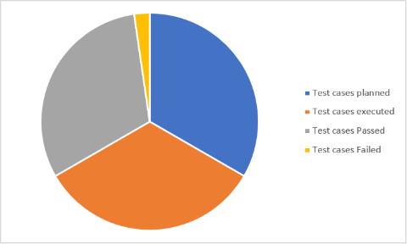

Figure 1: Test Result Summary - Functional Phase

**b) No. of test cases planned vs executed (E2E Tests Phase)**

|  |  |  |  |
| --- | --- | --- | --- |
| **Test cases planned** | **Test cases executed** | **Test cases Passed** | **Test cases Failed** |
| 20 | 20 | 19 | 1 |

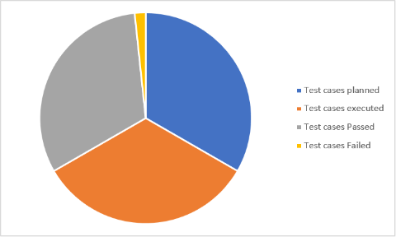

Figure 2: Test Result Summary - E2E Phase

1. **No. of defects** **identified and their Status & Severity**

|  |  |  |  |  |  |
| --- | --- | --- | --- | --- | --- |
| **Status** | **Low** | **Medium** | **High** | **Critical** | **Total** |
| **Closed** | **1** | **4** | **1** | **1** | **7** |
| **Open** | **2** | **2** | **0** | **0** | **4** |
|  | **3** | **6** | **1** | **1** | **11** |

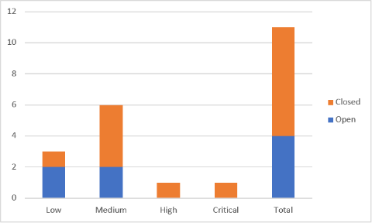

Figure 3: Defects Summary

# References

|  |  |  |
| --- | --- | --- |
| Ref | Name | Revision |
|  | TESTED SYSTEM Test Strategy | N/A |

Table 4 - References