5

3

L6

L5

L3

L2

L1

4

L4

2

1

0

L1 = 645 mm = 0.645

L2 = 330 mm = 0.33

L3 = 1350 mm = 1.35

L4 = 115 mm = 0.115

L5 = 1420 = 1.420

L6 = 215 = 0.215

|  |  |  |  |  |
| --- | --- | --- | --- | --- |
| Układ | θ | d | a | α |
| 0 -> 1 | θ | L1 | L2 | -π/2 |
| 1 -> 2 | θ | 0 | L3 | 0 |
| 2 -> 3 | θ | 0 | L4 | π/2 |
| 3 -> 4 | θ | L5 | 0 | -π/2 |
| 4 -> 5 | θ | 0 | L6 | π/2 |
| *4 -> 5 | θ | 0 | 0 | π/2 |
| *5 -> 6 | θ | 0 | L6 | 0 |

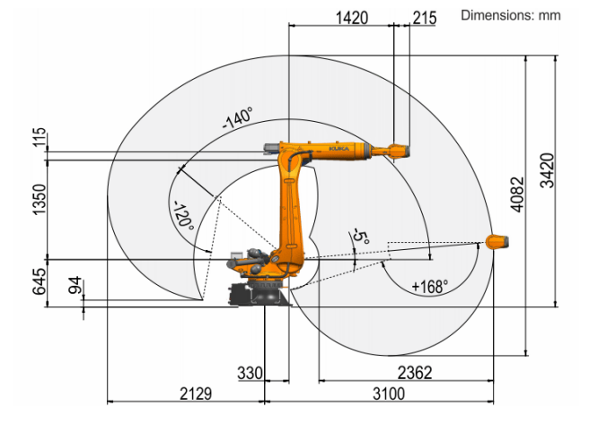 KR 120 R3100-2

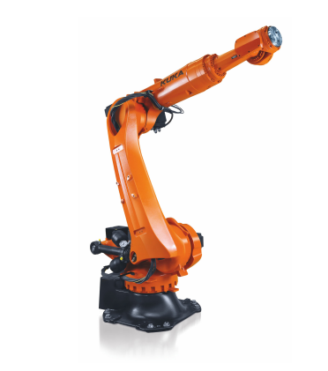<https://www.kuka.com/-/media/kuka-downloads/imported/8350ff3ca11642998dbdc81dcc2ed44c/0000325901_en.pdf?rev=74770615a157413681defe802c908b83&hash=77B2D5576220E9197071F979DC27B599>