**Report for the MPP Final Project**

Autumn Semester 2022

Author: Przemyslaw Bil, [G00398317@atu.ie](mailto:G00398317@atu.ie)

# Introduction

What is a Paradigm in computer programming? In short, paradigm is an approach or a methodology in computer programming to create a computer program or to solve a problem (1). For programming language to be successful, programs written in it need to follow a logical and coherent approach. That approach or a strategy is the paradigm. It is possible for a programming language to support more than one paradigm: Python supports both object oriented and procedural approach (2) (I have used Python in this project to build a program using both paradigms).

Although there are several types of paradigms (listed below in ), in this report I will focus on comparing two types of Imperative Programming Paradigms: Procedural and Object Oriented.

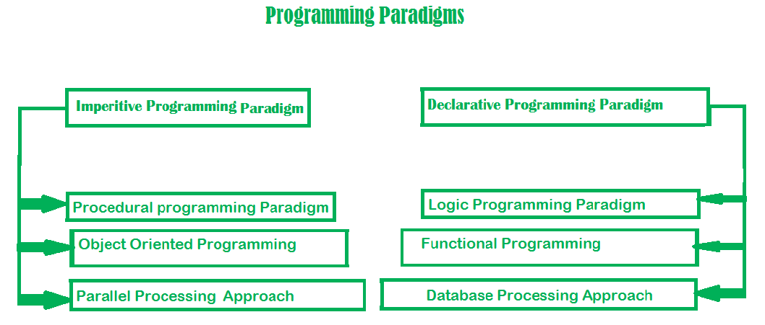

Figure Types of programming paradigms (1)