Laboratorium 6 — Kompresja stratna audio (A-law, μ-law, DPCM)
Celem jest porównanie metod kompresji stratnej audio: A-law, μ-law oraz DPCM z/bez predykcji. Zbadano wpływ kwantyzacji (8–2 bity) na jakość sygnałów z trzech plików (low/medium/high). Prezentowane są krzywe kompresji, wyniki SNR/MSE oraz ocena rozpoznawalności sygnału.

Uwagi dot. danych
Sygnały wczytywane jako float32, kwantyzacja uniform 8..2 bitów. Predykcja w DPCM: średnia z n próbek.

Walidacja kompresji
Krzywe A-law i μ-law (pełny zakres oraz zbliżenia):
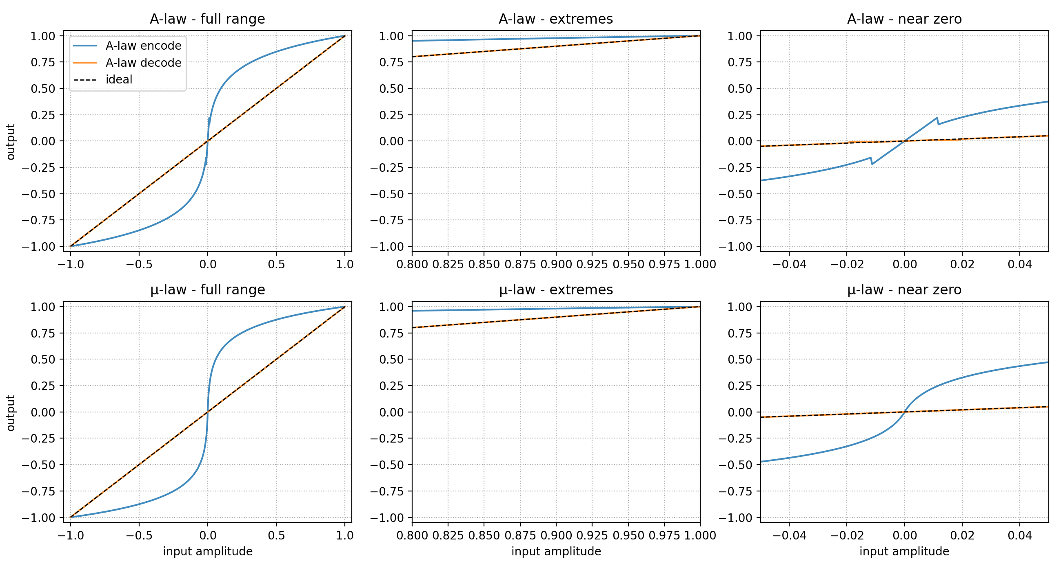
DPCM – rekonstrukcja i błąd na sinusoidzie testowej:
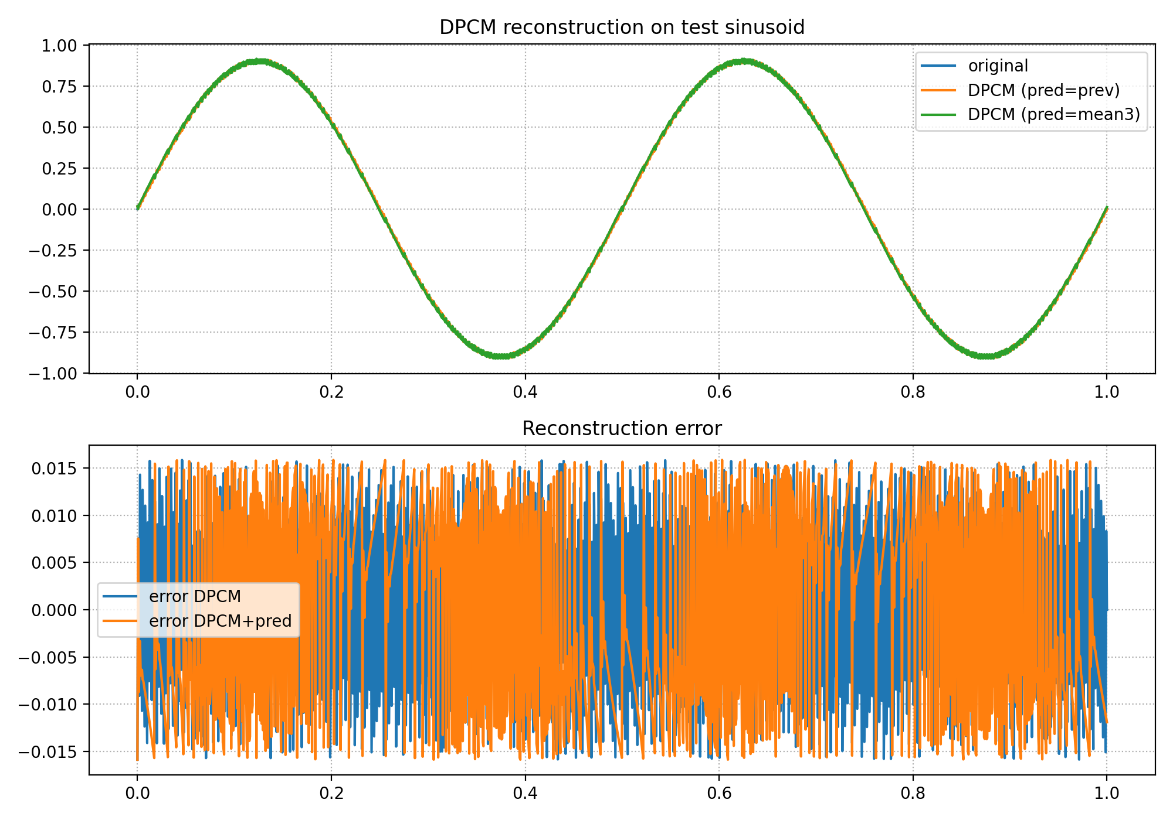

Tabela rozpoznawalności (8..2 bity)
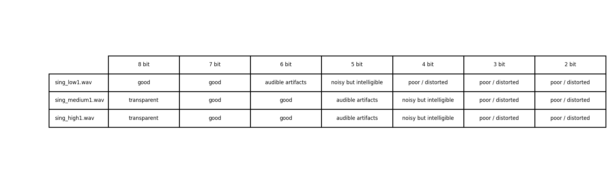

Wyniki — SNR/MSE
Plik | Bity | Metoda | SNR [dB] | MSE | Subiektywna
sing_low1.wav | 8 | a_law | 13.80 | 9.73e-07 | noisy but intelligible
sing_low1.wav | 8 | mu_law | 33.52 | 1.04e-08 | good
sing_low1.wav | 8 | dpcm_np1 | 6.52 | 5.21e-06 | poor / distorted
sing_low1.wav | 8 | dpcm_np3 | 4.26 | 8.75e-06 | poor / distorted
sing_low1.wav | 7 | a_law | 13.55 | 1.03e-06 | noisy but intelligible
sing_low1.wav | 7 | mu_law | 27.46 | 4.19e-08 | good
sing_low1.wav | 7 | dpcm_np1 | 0.40 | 2.13e-05 | poor / distorted
sing_low1.wav | 7 | dpcm_np3 | -1.87 | 3.59e-05 | poor / distorted
sing_low1.wav | 6 | a_law | 12.88 | 1.20e-06 | noisy but intelligible
sing_low1.wav | 6 | mu_law | 21.33 | 1.72e-07 | audible artifacts
sing_low1.wav | 6 | dpcm_np1 | -6.05 | 9.41e-05 | poor / distorted
sing_low1.wav | 6 | dpcm_np3 | -7.97 | 1.46e-04 | poor / distorted
sing_low1.wav | 5 | a_law | 8.73 | 3.13e-06 | poor / distorted
sing_low1.wav | 5 | mu_law | 15.10 | 7.21e-07 | noisy but intelligible
sing_low1.wav | 5 | dpcm_np1 | -12.70 | 4.34e-04 | poor / distorted
sing_low1.wav | 5 | dpcm_np3 | -14.13 | 6.04e-04 | poor / distorted
sing_low1.wav | 4 | a_law | 6.43 | 5.31e-06 | poor / distorted
sing_low1.wav | 4 | mu_law | 8.43 | 3.35e-06 | poor / distorted
sing_low1.wav | 4 | dpcm_np1 | -19.37 | 2.02e-03 | poor / distorted
sing_low1.wav | 4 | dpcm_np3 | -20.39 | 2.55e-03 | poor / distorted
sing_low1.wav | 3 | a_law | -0.67 | 2.72e-05 | poor / distorted
sing_low1.wav | 3 | mu_law | 1.64 | 1.60e-05 | poor / distorted
sing_low1.wav | 3 | dpcm_np1 | -26.21 | 9.74e-03 | poor / distorted
sing_low1.wav | 3 | dpcm_np3 | -26.98 | 1.16e-02 | poor / distorted
sing_low1.wav | 2 | a_law | -17.50 | 1.31e-03 | poor / distorted
sing_low1.wav | 2 | mu_law | -11.38 | 3.21e-04 | poor / distorted
sing_low1.wav | 2 | dpcm_np1 | -33.68 | 5.44e-02 | poor / distorted
sing_low1.wav | 2 | dpcm_np3 | -34.33 | 6.33e-02 | poor / distorted
sing_medium1.wav | 8 | a_law | 26.20 | 4.42e-06 | good
sing_medium1.wav | 8 | mu_law | 37.43 | 3.33e-07 | transparent
sing_medium1.wav | 8 | dpcm_np1 | 25.58 | 5.11e-06 | good
sing_medium1.wav | 8 | dpcm_np3 | 25.28 | 5.46e-06 | good
sing_medium1.wav | 7 | a_law | 25.35 | 5.38e-06 | good
sing_medium1.wav | 7 | mu_law | 31.35 | 1.35e-06 | good
sing_medium1.wav | 7 | dpcm_np1 | 19.51 | 2.07e-05 | audible artifacts
sing_medium1.wav | 7 | dpcm_np3 | 18.93 | 2.36e-05 | audible artifacts
sing_medium1.wav | 6 | a_law | 23.12 | 8.99e-06 | audible artifacts
sing_medium1.wav | 6 | mu_law | 25.22 | 5.55e-06 | good
sing_medium1.wav | 6 | dpcm_np1 | 13.40 | 8.43e-05 | noisy but intelligible
sing_medium1.wav | 6 | dpcm_np3 | 12.08 | 1.14e-04 | noisy but intelligible
sing_medium1.wav | 5 | a_law | 18.99 | 2.33e-05 | audible artifacts
sing_medium1.wav | 5 | mu_law | 18.99 | 2.33e-05 | audible artifacts
sing_medium1.wav | 5 | dpcm_np1 | 7.21 | 3.51e-04 | poor / distorted
sing_medium1.wav | 5 | dpcm_np3 | 5.20 | 5.57e-04 | poor / distorted
sing_medium1.wav | 4 | a_law | 12.69 | 9.93e-05 | noisy but intelligible
sing_medium1.wav | 4 | mu_law | 12.43 | 1.05e-04 | noisy but intelligible
sing_medium1.wav | 4 | dpcm_np1 | 0.89 | 1.50e-03 | poor / distorted
sing_medium1.wav | 4 | dpcm_np3 | -1.41 | 2.55e-03 | poor / distorted
sing_medium1.wav | 3 | a_law | 7.61 | 3.20e-04 | poor / distorted
sing_medium1.wav | 3 | mu_law | 5.10 | 5.70e-04 | poor / distorted
sing_medium1.wav | 3 | dpcm_np1 | -5.85 | 7.09e-03 | poor / distorted
sing_medium1.wav | 3 | dpcm_np3 | -8.06 | 1.18e-02 | poor / distorted
sing_medium1.wav | 2 | a_law | 4.43 | 6.65e-04 | poor / distorted
sing_medium1.wav | 2 | mu_law | 3.36 | 8.52e-04 | poor / distorted
sing_medium1.wav | 2 | dpcm_np1 | -13.95 | 4.58e-02 | poor / distorted
sing_medium1.wav | 2 | dpcm_np3 | -15.41 | 6.41e-02 | poor / distorted
sing_high1.wav | 8 | a_law | 37.90 | 3.12e-06 | transparent
sing_high1.wav | 8 | mu_law | 37.81 | 3.18e-06 | transparent
sing_high1.wav | 8 | dpcm_np1 | 35.72 | 5.14e-06 | transparent
sing_high1.wav | 8 | dpcm_np3 | 35.59 | 5.30e-06 | transparent
sing_high1.wav | 7 | a_law | 32.82 | 1.00e-05 | good
sing_high1.wav | 7 | mu_law | 31.74 | 1.29e-05 | good
sing_high1.wav | 7 | dpcm_np1 | 29.65 | 2.08e-05 | good
sing_high1.wav | 7 | dpcm_np3 | 29.83 | 2.00e-05 | good
sing_high1.wav | 6 | a_law | 26.97 | 3.86e-05 | good
sing_high1.wav | 6 | mu_law | 25.68 | 5.20e-05 | good
sing_high1.wav | 6 | dpcm_np1 | 23.55 | 8.47e-05 | audible artifacts
sing_high1.wav | 6 | dpcm_np3 | 23.34 | 8.89e-05 | audible artifacts
sing_high1.wav | 5 | a_law | 20.92 | 1.55e-04 | audible artifacts
sing_high1.wav | 5 | mu_law | 19.20 | 2.31e-04 | audible artifacts
sing_high1.wav | 5 | dpcm_np1 | 17.37 | 3.52e-04 | noisy but intelligible
sing_high1.wav | 5 | dpcm_np3 | 16.57 | 4.23e-04 | noisy but intelligible
sing_high1.wav | 4 | a_law | 13.79 | 8.02e-04 | noisy but intelligible
sing_high1.wav | 4 | mu_law | 13.38 | 8.82e-04 | noisy but intelligible
sing_high1.wav | 4 | dpcm_np1 | 11.04 | 1.51e-03 | poor / distorted
sing_high1.wav | 4 | dpcm_np3 | 9.71 | 2.05e-03 | poor / distorted
sing_high1.wav | 3 | a_law | 6.43 | 4.37e-03 | poor / distorted
sing_high1.wav | 3 | mu_law | 9.23 | 2.29e-03 | poor / distorted
sing_high1.wav | 3 | dpcm_np1 | 4.47 | 6.85e-03 | poor / distorted
sing_high1.wav | 3 | dpcm_np3 | 2.13 | 1.18e-02 | poor / distorted
sing_high1.wav | 2 | a_law | -3.79 | 4.59e-02 | poor / distorted
sing_high1.wav | 2 | mu_law | -11.13 | 2.49e-01 | poor / distorted
sing_high1.wav | 2 | dpcm_np1 | -2.54 | 3.45e-02 | poor / distorted
sing_high1.wav | 2 | dpcm_np3 | -5.27 | 6.46e-02 | poor / distorted

Wnioski
A-law/μ-law zachowują wysoką rozpoznawalność przy niższej liczbie bitów. Predykcja w DPCM poprawia SNR dla wolnozmiennych sygnałów. Poniżej 4 bitów jakość szybko degraduje się – odsłuch wskazany.

