**A motion sensor**

1. Wiring diagram

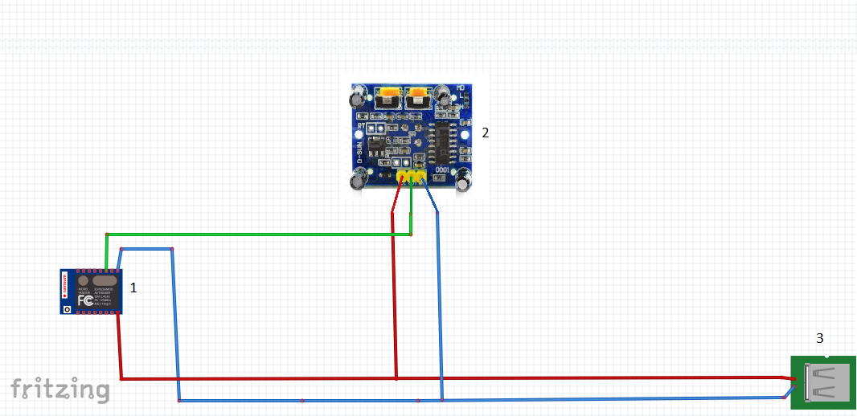

1. The necessary elements

1. ESP 12e nodemcu v3

2. PIR HC-SR501

3. USB (5V)