IP Tracker allows for locating ip addresses with its full details and store them locally in database.

Application requires Qt, spdlog, nlohmann and gtest/gmock, to build.

The app contains main functionality mentioned in the task description but still requires some work to finish.

The image below shows the application main window

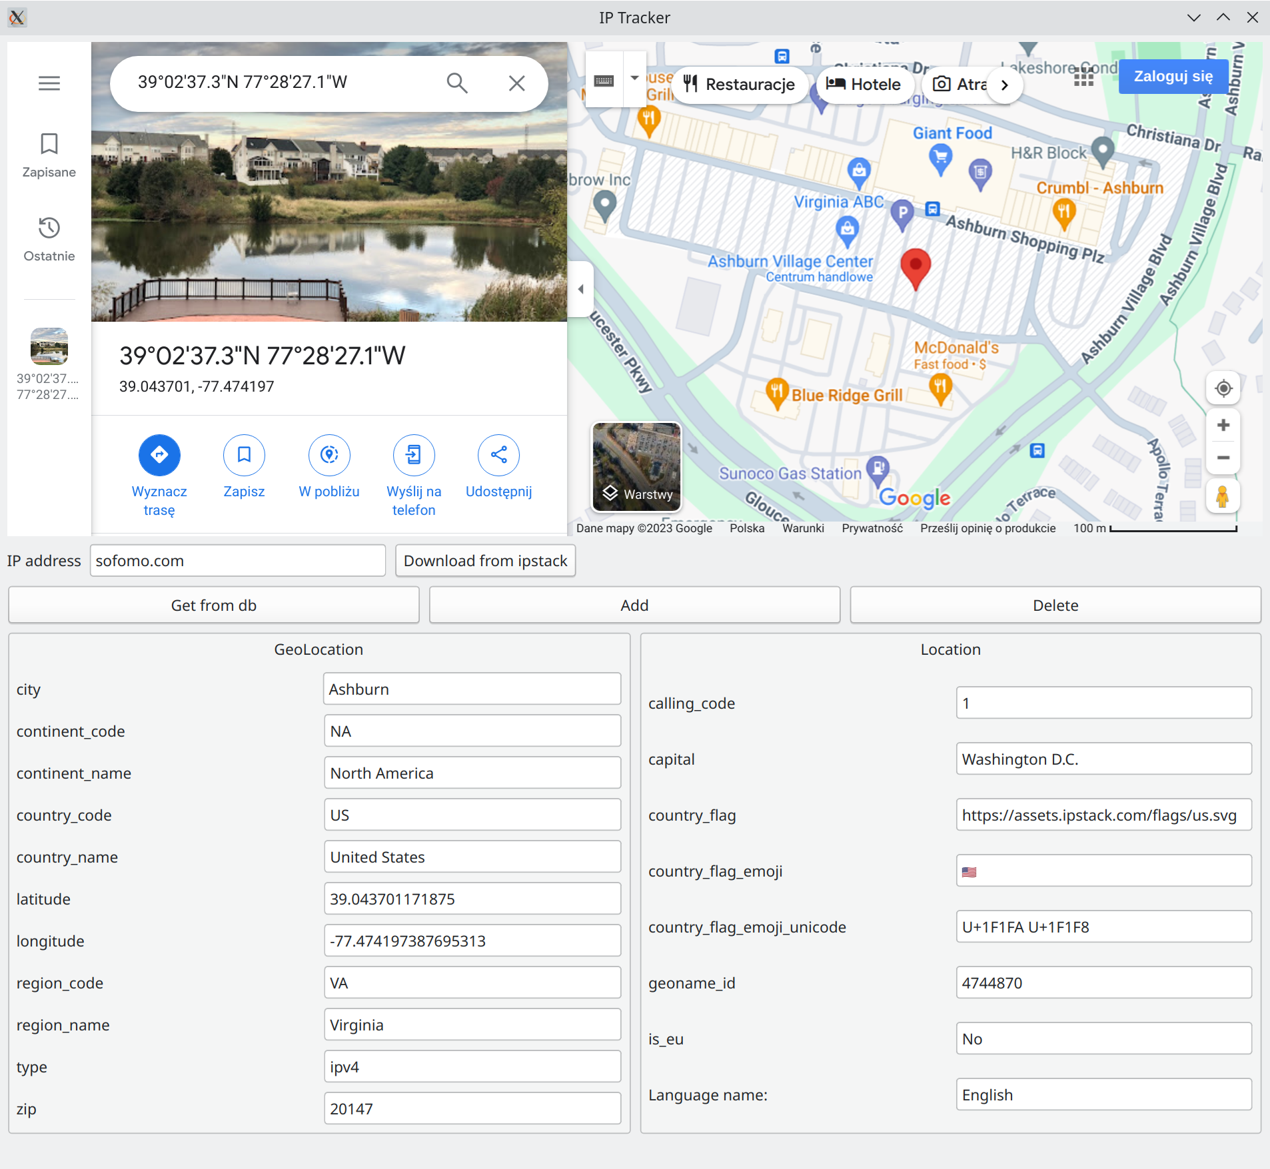

IP Tracker allows for downloading ip/url information via „Download from ipstack” button when „IP address is filled. Attibutes values are filled after successfull downloading from ipstack or from database. Map is automatically updated according to information from latitude and longtude values.

„Get from db” takes information about ip/url from db when it exists.
„Add” buttom allows to save all information to local database.
„Delete” button deletes information about ip/url from database for ip from „IP address”.

TODO
- Not everything was well tested especially manual inserting values by user.
- Normalization of database has to be improved.
- Application supports only one language but more languages can be available for the region.
- General code improvements.

