HLD
High-Level Design Document

Generated: 2026-03-25 10:41

High-Level Design — Notification Hub Service

1. Document Info
Field | Value
Author | Solution Architect
Date | 2023-10-27
Version | 1.0
Reviewers | Lead Engineer, Product Manager, DevOps Lead
Status | Draft

2. Executive Summary
This document outlines the high-level design for a centralized Notification Hub Service. This microservice will abstract the complexity of sending notifications across various channels (EMAIL, SMS, PUSH, IN-APP) for all internal systems. It will provide a unified interface via REST API and a message queue, manage templating with internationalization, handle delivery status tracking, and implement resilient delivery mechanisms like retries. The primary consumers are internal engineering teams, and the goal is to reduce duplicated effort, improve reliability, and provide a central point of control and audit for all outgoing notifications.

3. Business Context & Goals

3.1 Business Problem
Currently, the logic for sending notifications is fragmented and duplicated across multiple services (CLM Core, Billing Module, etc.). Each service implements its own integration with providers like SendGrid, leading to inconsistent error handling, templating, and tracking. This approach increases maintenance overhead, makes it difficult to audit communications, and slows down the process of adding new notification channels or changing providers. A centralized service is required to consolidate this functionality, enforce standards, and provide a single source of truth for notification delivery status.

3.2 Success Criteria / KPIs
KPI | Target | Description
Service Adoption | 4 services integrated within 6 months | CLM Core, Billing, Reporting, and Customer Portal successfully migrate to the Notification Hub.
Delivery Success Rate | > 99.5% | Percentage of notifications successfully accepted by the external provider on the first attempt.
Time to Add Template | < 1 hour | Time for an engineer to add and deploy a new notification template.
Incident Reduction | 50% reduction in notification-related incidents | Fewer production issues related to notification failures or provider changes.
Centralized Auditing | 100% of notifications logged | All notification attempts are logged and searchable by support teams via the status endpoint.

3.3 Constraints & Assumptions
Constraints:
- The service must be built using Java/Spring Boot 3.2+.
- Deployment must be on the existing Azure Kubernetes Service (AKS) infrastructure.
- The solution must integrate with existing platform tools: Kafka (Azure Event Hubs), PostgreSQL (Azure Managed), Azure Key Vault, and Kong API Gateway.
- Initial integrations must be with SendGrid (Email) and Firebase Cloud Messaging (Push).

Assumptions:
- The architecture should support a pluggable SMS provider, as the final choice between Twilio and AWS SNS is not yet made. The initial implementation can defer the SMS channel.
- "IN-APP" notifications for the Customer Portal will require a WebSocket connection, which will be managed by a dedicated component within the Notification Hub's scope.
- The specified payload size of 5-10MB is considered an extreme edge case, likely for attachments. The system will be optimized for typical notification payloads (<100KB), but the API will be designed to handle larger payloads by reference (e.g., link to a file) rather than by value.
- Internal services can be granted access to the Notification Hub's API via the internal network or authenticated through a service-to-service mechanism.
- The team possesses the necessary skills to develop and maintain Spring Boot applications with Kafka and WebSocket integrations.

4. Architectural Principles
- API-First: The service will be designed around a clear, well-documented, and consistent API for both synchronous (REST) and asynchronous (event-based) communication.
- Event-Driven & Asynchronous: The primary integration pattern will be asynchronous via Kafka to ensure high throughput, resilience, and decoupling from producers. This allows the hub to absorb spikes in load and handle provider downtime gracefully.
- Stateless Core Logic: The core processing service will be stateless, allowing for simple horizontal scaling. All state (e.g., notification status, templates) will be externalized to PostgreSQL and Redis.
- Pluggable Provider Architecture: Integrations with third-party providers (SendGrid, FCM, etc.) will be abstracted behind a common interface, allowing for easy replacement or addition of new providers without impacting consumer services.

5. System Architecture Overview

5.1 Context Diagram (C4 Level 1)
The diagram below shows the Notification Hub as a central system. It receives requests from various internal systems and the Mobile App. It then routes these notifications to the appropriate external providers, which deliver them to the End User.

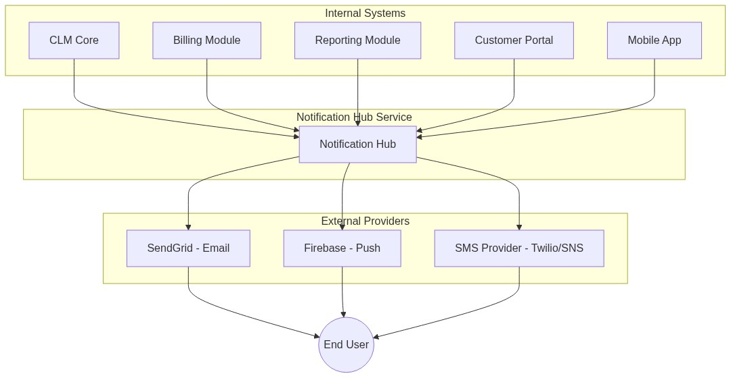

5.2 Container Diagram (C4 Level 2)
The Notification Hub Service is composed of several key containers. The Notification API is the core component, handling both REST and Kafka messages. The WebSocket Gateway manages real-time in-app notifications. Data is persisted in a PostgreSQL Database, and Kafka serves as the message bus.

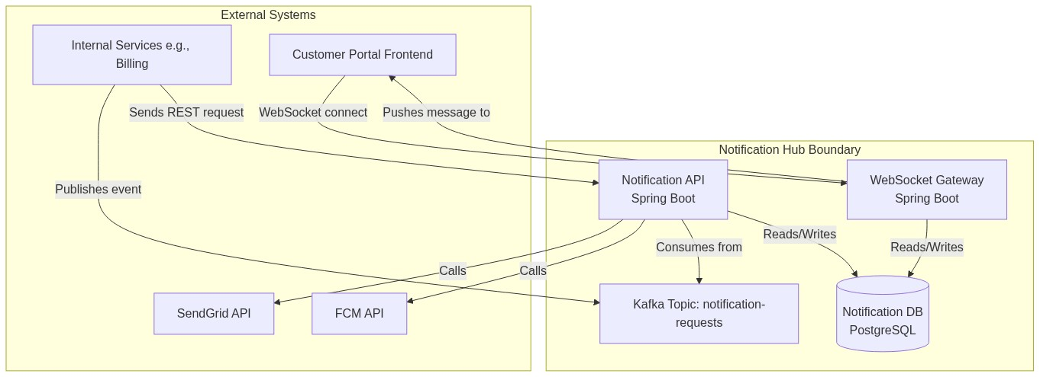

6. Component Breakdown
Component | Responsibility | Technology | Team/Owner
Notification API | Core service. Ingests requests (REST/Kafka), validates, renders templates, dispatches to providers, and logs status. | Spring Boot 3, Java 17 | Core Services
WebSocket Gateway | Manages persistent WebSocket connections for the IN-APP channel. Pushes real-time notifications to connected clients. | Spring Boot (WebFlux), WebSockets | Core Services
Notification DB | Stores notification templates, delivery logs with status (PENDING, SENT, FAILED), and configuration. | PostgreSQL 15 (Azure Managed) | DBA / Platform
Kafka Topic | notification-requests: Asynchronous entry point for notification requests from internal services. | Kafka 3.6 (Azure Event Hubs) | Platform
Provider Connectors | Internal modules within the API for integrating with specific external providers (SendGrid, FCM, etc.). | Java | Core Services

7. Integration Architecture
- Asynchronous API (Kafka):
Topic:* notification-requests
Protocol:* Kafka message.
Contract (JSON Schema):*
{
"notificationId": "uuid",
"channel": "EMAIL | SMS | PUSH | IN_APP",
"recipient": { "email": "...", "phone": "...", "userId": "..." },
"templateId": "user-welcome-email",
"templateVariables": { "user_name": "John Doe" },
"locale": "en-US"
}

- Synchronous API (REST):
Endpoint:* POST /api/v1/notifications
Protocol:* HTTPS/REST. Body is the same as the Kafka message contract.
Auth:* Service-to-service auth (e.g., OAuth 2.0 Client Credentials).
Success Response:* 202 Accepted with a location header to the status endpoint. HTTP/1.1 202 Accepted \n Location: /api/v1/notifications/status/{notificationId}

- Status Tracking API (REST):
Endpoint:* GET /api/v1/notifications/status/{notificationId}
Protocol:* HTTPS/REST.
Auth:* Requires permissions to view notification status.
Response:*
{
"notificationId": "uuid",
"status": "SENT | FAILED | PENDING",
"channel": "EMAIL",
"provider": "SendGrid",
"createdAt": "timestamp",
"lastUpdatedAt": "timestamp",
"attempts": 2,
"errorDetails": "..."
}

- Real-time API (WebSocket):
Endpoint:* ws://notification-hub/ws/v1/connect
Protocol:* WebSocket.
Auth:* The initial HTTP upgrade request will contain a Keycloak JWT from the Customer Portal session. The WebSocket Gateway will validate this token.

8. Data Flow

Happy Path (Asynchronous Email Notification)
The following sequence diagram shows a successful notification flow initiated by the Billing Service.

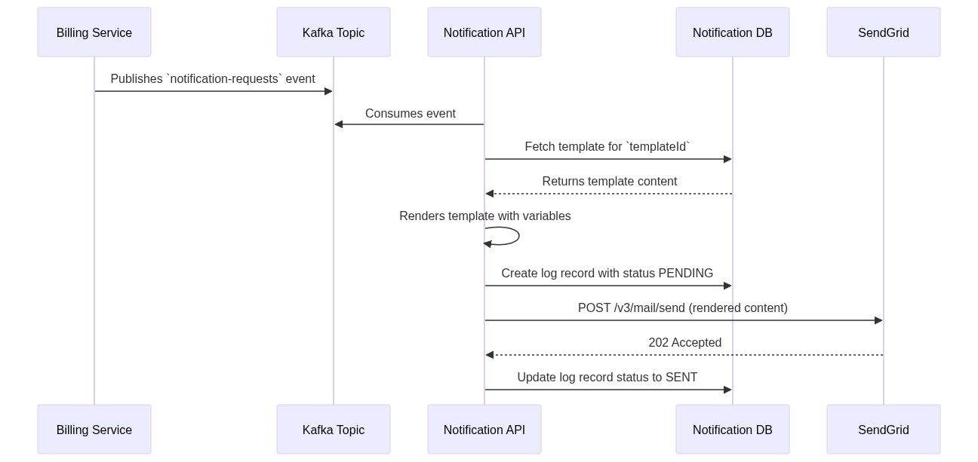

Error Path (Transient Failure with Retry)
This diagram shows how the system handles a temporary failure from a provider.

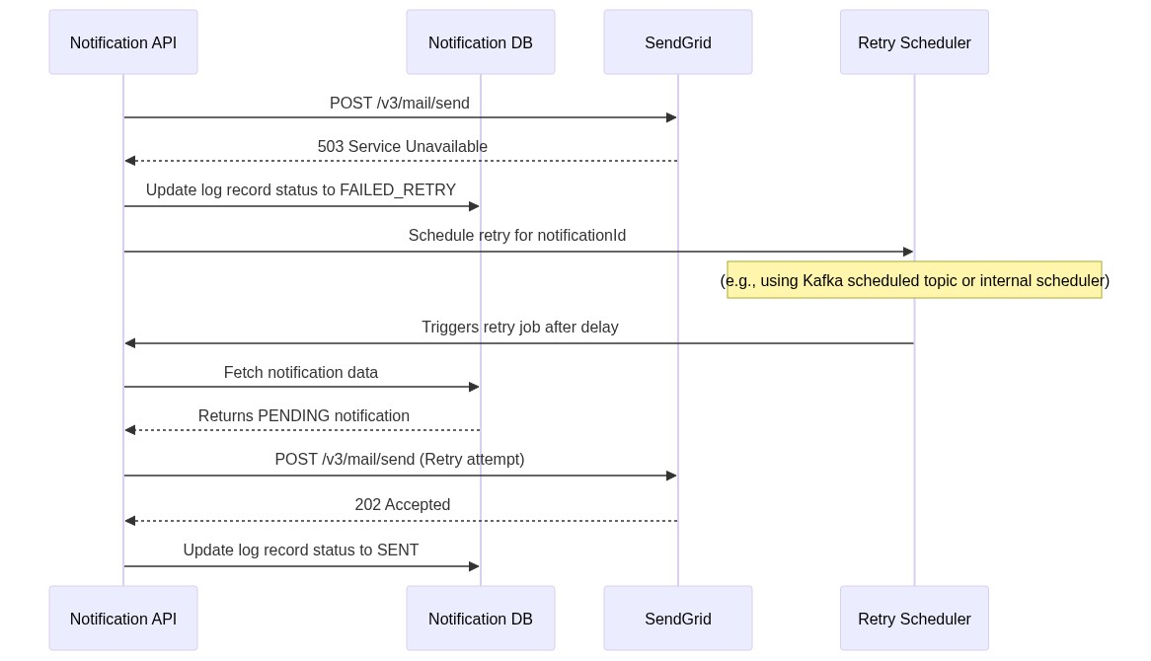

9. Non-Functional Requirements
Category | Requirement | Target
Availability | The service endpoints (API, WS) and processing loop must be operational. | 99.9%
Latency | p99 latency for API acknowledgement (POST /notifications). | < 500ms
Throughput | The system should be able to process notifications from the queue. | 300 messages/sec
Security | All endpoints must be authenticated. Secrets must be managed securely. No sensitive data in logs. | OWASP Top 10 Compliant
Scalability | The service should handle a 3x increase in traffic by scaling horizontally without code changes. | Horizontal scaling via AKS HPA
Data Retention | Notification logs must be retained for audit purposes. | 1 year (configurable)
Internationalization | Templates must support multiple languages and locales. | i18n support in templates

10. Risk & Mitigation
Risk | Likelihood | Impact | Mitigation
External Provider Outage | Medium | High | Implement circuit breakers (e.g., Resilience4j) to stop sending requests during an outage. Failed messages will be sent to a Dead-Letter Queue (DLQ) for manual or automated reprocessing. For critical notifications, a failover provider could be configured.
Performance Bottleneck | Medium | Medium | The asynchronous, event-driven architecture is designed to handle load. We will conduct extensive load testing to identify bottlenecks. The service will be deployed on AKS with Horizontal Pod Autoscaler (HPA) enabled to scale automatically based on CPU/memory or custom metrics (e.g., Kafka lag).
FCM SDK Migration Complexity | High | Medium | The migration from the deprecated FCM SDK will be performed in a dedicated feature branch and thoroughly tested in a staging environment against both iOS and Android devices. A phased rollout strategy will be considered.
Data Integrity Issues | Low | High | Use database transactions to ensure that notification log state changes are atomic. Implement idempotent consumers to prevent processing the same Kafka message multiple times in case of a consumer restart.

11. Technology Stack Decisions
- Language/Framework (Spring Boot): Chosen for its robust ecosystem, alignment with existing team skills (CLM Core, Billing Module), and excellent support for building REST APIs, Kafka consumers, and WebSocket services.
- Asynchronous Messaging (Kafka): Selected for its high throughput, scalability, and resilience, which are critical for handling large volumes of notifications. It decouples producers from the Notification Hub.
- Database (PostgreSQL): Chosen for its reliability, transactional support, and powerful JSONB capabilities, which can be leveraged for storing flexible template variables and metadata. It aligns with the team's preference and existing managed offerings in Azure.
- Containerization (AKS): Standard platform for all new microservices. Provides managed Kubernetes, enabling easy scaling, deployment, and operational management.
- Secret Management (Azure Key Vault): Standard and secure way to manage API keys for external providers, DB credentials, and other secrets. Integrates seamlessly with Spring Boot applications running in Azure.

12. Roadmap & Phasing
- Phase 1 (MVP - Q1):
* Build the core Notification API service.
* Implement REST API and Kafka ingress points.
* Integrate SendGrid for the EMAIL channel.
* Integrate FCM for the PUSH channel (including SDK migration).
* Set up PostgreSQL for template storage and notification logging.
* Implement the GET /status endpoint.
* Onboard the Billing Module (Kafka) and CLM Core (REST).

- Phase 2 (Enhancements - Q2):
* Implement the pluggable provider for the SMS channel and integrate the chosen provider (Twilio/SNS).
* Build the WebSocket Gateway for the IN-APP channel and integrate it with the Customer Portal.
* Add full internationalization (i18n) support for templates.

- Phase 3 (Future):
* Develop a UI for non-technical users to manage templates.
* Build analytics dashboards in Grafana for delivery rates, provider latency, etc.
* Implement user preference management (e.g., allowing users to opt-out of certain notifications).
* Support for A/B testing notification content.

13. Open Questions
# | Question | Owner | Status
1 | What is the final decision on the SMS provider (Twilio vs. AWS SNS) to be integrated in Phase 2? | Product Manager | Open
2 | What is the definitive retention policy for notification logs in the PostgreSQL database? | Compliance/Legal | Open
3 | Can you clarify the use case for the 5-10MB message size? Does it involve attachments, and if so, what is the expected storage/delivery mechanism? | Product Manager | Open
4 | What is the required authentication mechanism for the WebSocket connection? Will the Keycloak JWT be sufficient? | Security Team | Open

