HLD
High-Level Design Document

Generated: 2026-03-25 12:22

High-Level Design — Telco Inventory System

1. Document Info
Field | Value
Author | Gemini
Date | 2024-05-21
Version | 1.0
Reviewers
Status | Draft

2. Executive Summary
The Telco Inventory System is being built to provide a centralized, accurate, and real-time source of truth for telecommunication network resources. The system will enable network operators to view, plan, and manage their logical functions and connections. By comparing the intended state in the inventory with the actual state read from the customer network, it will proactively identify and flag discrepancies, improving operational efficiency and reducing configuration errors. This system is intended for network engineers and operations teams responsible for maintaining network health and planning its evolution.

3. Business Context & Goals

3.1 Business Problem
Currently, managing telecommunication network inventory is a significant challenge due to the lack of a single, reliable system. Data is often fragmented across different tools, spreadsheets, and legacy systems, leading to inconsistencies. This results in slow and error-prone network planning, difficult and lengthy troubleshooting processes, and a high risk of service disruption due to incorrect configuration changes. The business needs a modern, unified platform to mitigate these risks and improve operational agility.

3.2 Success Criteria / KPIs
- Time to Detect Discrepancies: Reduce the time to identify differences between inventory and the live network by 90%.
- Configuration Errors: Reduce network incidents caused by manual configuration errors by 50%.
- Planning Cycle Time: Decrease the time required for network expansion and planning activities by 40%.
- System Uptime: Achieve and maintain the defined NFR for system availability (99.5%).

3.3 Constraints & Assumptions
- Constraints:
* The technology stack is pre-defined: Java, Quarkus, GCP, PostgreSQL, Redis, Kafka, Elasticsearch.
* The system must be deployed on Google Cloud Platform (GCP).
* Initial integration with customer network devices will be via a REST API.
- Assumptions:
* The TMF (TeleManagement Forum) API specification is used as a data modeling guide and not a live runtime integration point for MVP.
* A secure network path (e.g., VPN, VPC Peering) exists between the GCP environment and the customer network devices.
* Users will be managed via an existing Identity Provider (IdP) that can be integrated for authentication and authorization.
* The initial scope focuses on reading and comparing; configuration write-back is a future phase.

4. Architectural Principles
- CQRS (Command Query Responsibility Segregation): The architecture separates write operations (Commands) from read operations (Queries). Commands are handled by a transactional service that updates a primary data store, while queries are served from a highly optimized read model built for fast lookups.
- Event-Driven Architecture: System components are loosely coupled and communicate asynchronously via a central event bus (Kafka). This promotes resilience, scalability, and extensibility.
- API-First: All system capabilities are exposed through well-defined APIs. A GraphQL endpoint serves as the primary interface for data consumption, providing clients with a flexible and efficient way to query information.
- Cloud-Native: The system is designed to leverage the full capabilities of a cloud environment, including containerization, horizontal scaling, autoscaling, and managed services to ensure high availability and operational efficiency.
- Microservices Architecture: The system is decomposed into small, independent services, each responsible for a specific business capability (e.g., Inventory Management, Configuration Reading). This allows for independent development, deployment, and scaling.

5. System Architecture Overview

5.1 Context Diagram (C4 Level 1)
The system operates within the internal network but interacts with external customer network devices to read their state. Network Engineers and Operators are the primary users who interact with the system via its user interface and APIs.

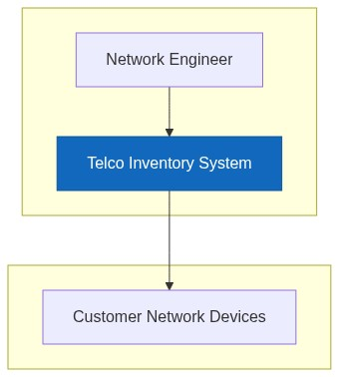

5.2 Container Diagram (C4 Level 2)
The system consists of a web frontend for users, a GraphQL API Gateway for queries, and several backend microservices. Write operations are handled by the Inventory Service, which persists data to PostgreSQL. Events are published to Kafka and consumed by a View Builder to create a denormalized read model in Elasticsearch. A dedicated Reader Service polls network devices for their current state.

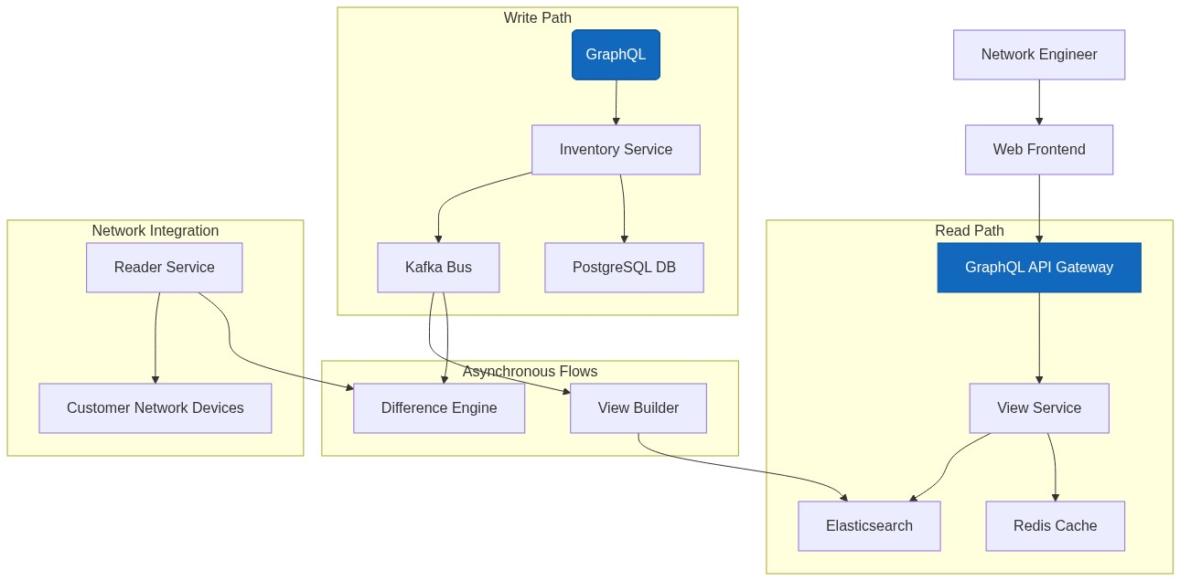

6. Component Breakdown
Component | Responsibility | Technology | Team/Owner
Web Frontend | Provides the user interface for inventory visualization, planning, and difference analysis. | React / Angular | Frontend Team
GraphQL API Gateway | Single entry point for all client queries and mutations. Routes requests to appropriate backend services. | Apollo GraphQL / Java + Quarkus | API Team
Inventory Service | Handles all command operations (create, update, delete). Manages business logic and data validation. The "write side" of the CQRS pattern. | Java, Quarkus | Core Services Team
View Service | Serves read-only data to the GraphQL Gateway from Elasticsearch. The "read side" of CQRS. | Java, Quarkus | Core Services Team
View Builder | Consumes events from Kafka and builds/updates the denormalized JSON documents in the Elasticsearch read model. | Java, Quarkus | Core Services Team
Reader Service | Connects to customer network devices via their APIs to fetch the current configuration state. | Java, Quarkus | Integration Team
Difference Engine | Compares the state reported by the Reader Service with the golden source data from the inventory and flags discrepancies. | Java, Quarkus | Core Services Team
PostgreSQL | Primary relational database. Stores the normalized "source of truth" data for the inventory. | PostgreSQL | Platform Team
Elasticsearch | Search and analytics engine used as the read-model database for serving fast, complex queries. | Elasticsearch | Platform Team
Kafka | High-throughput distributed event bus for asynchronous communication between microservices. | Apache Kafka | Platform Team
Redis | In-memory data store used for caching query results and session data to reduce latency. | Redis | Platform Team

7. Integration Architecture
- Client-Facing API (GraphQL): The primary interface for all UIs and external clients is the GraphQL API. It provides a single endpoint for querying data from the Elasticsearch read model (queries) and for submitting changes (mutations) which are routed to the Inventory Service.
- Inter-Service Communication (Kafka): Microservices communicate asynchronously by publishing and consuming events on Kafka topics. Key events include ResourceCreated, ResourceUpdated, and DiscrepancyDetected. This decouples services and ensures data is propagated eventually across the system. For synchronous request/response needs where necessary, services will use direct RESTful HTTP calls.
- Network Device Integration (REST): The Reader Service integrates with customer network devices via a REST API. The contract will specify endpoints for fetching configuration for various logical and physical resources. The integration is designed to be pluggable to accommodate other protocols (e.g., gNMI, NETCONF) in the future.

8. Data Flow

Happy Path: User Updates a Resource
This flow describes a user successfully updating an attribute of a network resource.
[Diagram — mermaid.ink unavailable. Source below:]
sequenceDiagram
participant User
participant GraphQL as GraphQL Gateway
participant InvSvc as Inventory Service
participant PG as PostgreSQL
participant KF as Kafka
participant VB as View Builder
participant ES as Elasticsearch
User->>GraphQL: mutation { updateResource(...) }
GraphQL->>InvSvc: Handle updateResource command
InvSvc->>PG: BEGIN; UPDATE resources SET ...; COMMIT;
PG-->>InvSvc: Success
InvSvc->>KF: publish(topic: "resource.updated", event: {...})
KF-->>VB: consume(event: {...})
VB->>ES: POST /resources/_update/{id}
ES-->>VB: 200 OK

Error Path: Discrepancy Detected
This flow describes the process of automatically detecting a difference between the inventory and the live network.
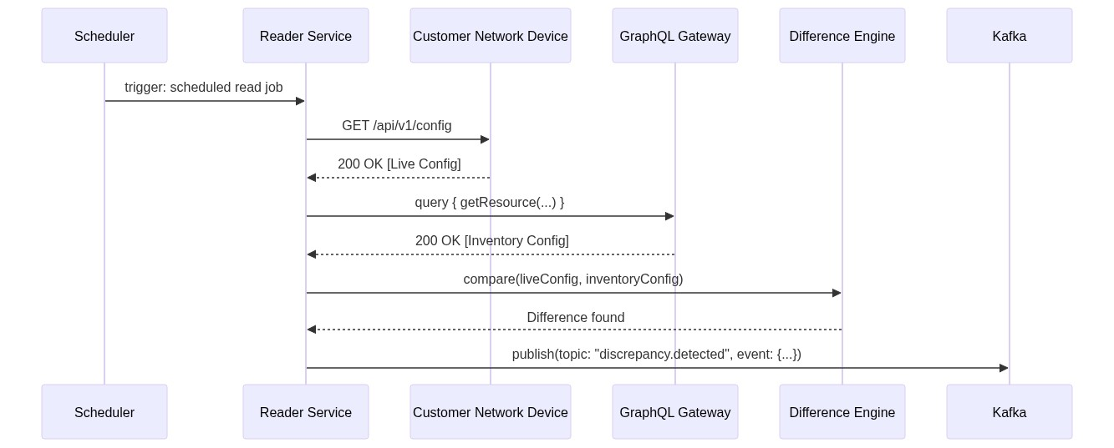

9. Non-Functional Requirements
Category | Requirement | Target
Availability | The system must be highly available for both reads and writes. | 99.5%
Latency | Read queries from the API should be fast. | p99 < 500ms
Throughput | The system must handle a high volume of concurrent reads and comparison operations. | 5000 ops/sec
Security | All API endpoints must be secured. Data must be encrypted in transit and at rest. Role-based access control (RBAC) must be enforced. | TLS 1.2+, AES-256 Encryption, OAuth 2.0 / OIDC
Scalability | All services and data stores must be able to scale horizontally to handle load. System designed to support 10 million objects. | Horizontal autoscaling on GKE

10. Risk & Mitigation
Risk | Likelihood | Impact | Mitigation
Data Consistency between Write/Read DB | Medium | High | Implement a robust dead-letter queue (DLQ) for Kafka consumer failures. Create a reconciliation service that periodically compares PostgreSQL and Elasticsearch data to fix inconsistencies.
Performance of Network Reader | High | Medium | Design the Reader Service to be stateless and horizontally scalable. Implement configurable scan schedules (full vs. incremental). Use caching where possible to avoid re-fetching unchanged configurations.
Vendor Lock-in on GCP | Medium | Medium | Use open-source technologies (Postgres, Kafka, Quarkus) and containerization (Docker/Kubernetes). This allows for portability to other cloud providers or on-premise environments if necessary, though migration would still be a significant effort.
Initial Data Migration | High | High | Develop a phased migration strategy. Create dedicated migration scripts with thorough validation and rollback capabilities. Perform multiple trial runs in a pre-production environment.

11. Technology Stack Decisions
- Java with Quarkus: Chosen for its high performance, low memory footprint, and "supersonic, subatomic" nature, making it ideal for building containerized microservices that start quickly and scale efficiently on a cloud platform like GCP.
- CQRS (PostgreSQL + Elasticsearch): This pattern was selected to meet the demanding NFRs for throughput and latency. PostgreSQL provides a robust, transactional source of truth (write model). Elasticsearch provides a powerful, highly-scalable, and flexible engine for complex queries and full-text search required by the UI (read model).
- Kafka: An event-driven architecture is critical for decoupling services and ensuring scalability. Kafka is the industry standard for building reliable, high-throughput, real-time data pipelines to propagate state changes between microservices.
- GraphQL: Selected to provide a modern, efficient API for the frontend. It allows the UI to fetch all necessary data in a single request, reducing the number of round trips and preventing over-fetching of data, which is crucial for a responsive user experience.
- GCP with GKE: Google Kubernetes Engine (GKE) provides a managed environment for deploying, managing, and scaling containerized applications. Leveraging GCP's managed services for PostgreSQL, Kafka, and Elasticsearch will reduce operational overhead and improve reliability.

12. Roadmap & Phasing
- Phase 1 (MVP):
* Implement core inventory data model based on TMF standards.
* Develop Inventory Service for manual CRUD operations.
* Build the CQRS pipeline (Kafka, View Builder, Elasticsearch).
* Develop the Reader Service for a single network device type (read-only).
* Build the Difference Engine and a basic UI to display inventory and detected differences.
- Phase 2 (Configuration & Planning):
* Introduce the Planning module to stage proposed network changes.
* Introduce the Configuration module to translate planned changes into device-specific commands.
* Implement "write" capabilities in the integration layer to apply configurations to network devices.
* Enhance UI with planning and configuration workflows.
- Phase 3 (Expansion & Analytics):
* Add support for additional network device vendors and protocols (gNMI, NETCONF).
* Develop advanced analytics dashboards on inventory data.
* Integrate with other BSS/OSS systems for automated workflow triggers.

13. Open Questions
# | Question | Owner | Status
1 | What is the detailed API contract (endpoints, authentication method, rate limits) for the customer network devices? | Integration Team | Open
2 | What are the specific user roles (e.g., Viewer, Editor, Planner, Admin) and their detailed permissions (RBAC matrix)? | Product Owner | Open
3 | What is the strategy for the initial data load? Is there an existing system to migrate from, or will this be a greenfield population? | Core Services Team | Open
4 | What are the long-term data retention policies for historical inventory snapshots and discrepancy records? | Compliance/Arch | Open

