**Hackathon Project: Identify Car Wash services**

**Framework Overview**

The given project is built using the following frameworks and libraries:

**Selenium:** Selenium is a popular open-source framework for automating web browsers.

**TestNG:** TestNG is a testing framework that provides advanced features like parallel test execution, data-driven testing, and test configuration through annotations.

**Cucumber:** Cucumber is a tool for behaviour-driven development (BDD)that allows you to write test scenarios in a human-readable format.

**Apache POI:** Apache POI is a library for working with Microsoft Office documents, including Excel files.

**Extent Reports:** Extent Reports is a powerful reporting library used for generating HTML reports in testing automation frameworks.

**Folder Structure:**

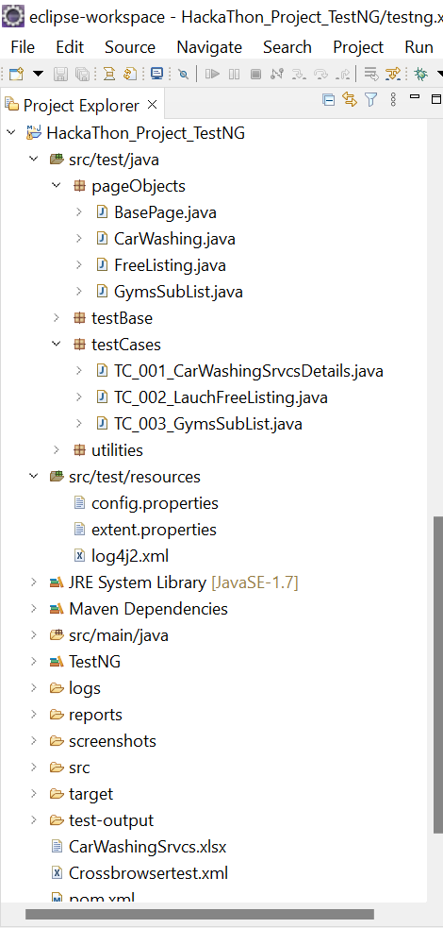

**Changes to Run the Project:**

To run the project, you need to make the following changes:

If the project asks for login, uncomment the setup method in the hooks class. Change the login method to login if it asks for both username and password. Use the login method if only the password is needed for login.

If you need to use the login or login1 method, add your credentials to the config. properties file.

To view the Cucumber report, follow the link provided in the console. To view the Extent report, go to the reports folder and open the Myreport.html file.

To view the failure screenshot, go to the test-output folder and create a readme file with instructions.

Please note that the provided instructions assume familiarity with the project structure and configuration files. Make sure to have the necessary dependencies and configurations in place before running the project.