PROCESSING WORKFLOW
Pearl Millet Yield Simulation for Rajasthan Districts
AquaCrop-OSPy sowing-date analysis · notebook: pearl_millet_yield_.ipynb
Prepared for Pushkar Gaur · 22 September 2026

1. Purpose
The notebook simulates rainfed pearl millet (kharif) yield for every district of Rajasthan with the AquaCrop-OSPy crop model. It tests seven sowing dates, from 1 June to 30 August at 15-day steps, over 31 seasons (1990–2020). For each district it writes the season-by-season results to Excel and draws a box plot of yield against sowing date.
The question it answers: which sowing window gives the highest and most stable yield in each district?

2. Workflow at a glance
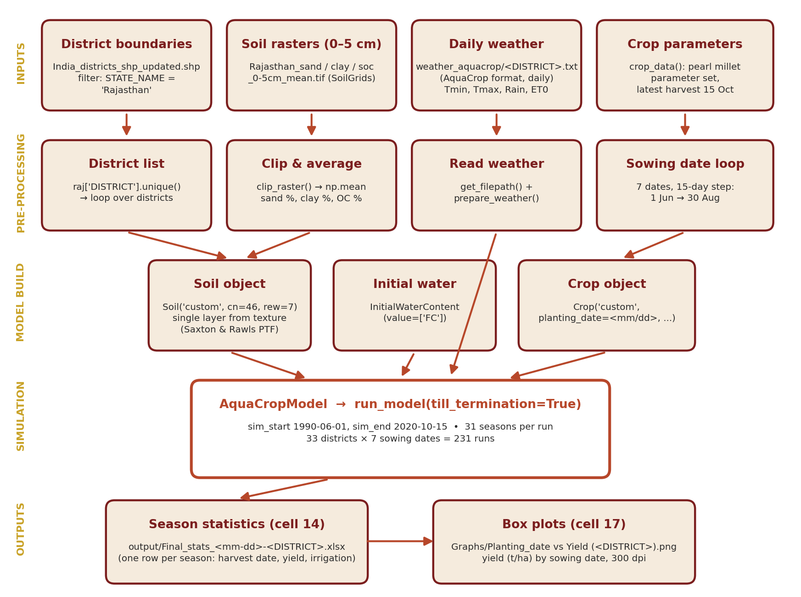
Figure 1. Data flow from inputs to outputs. One model run = one district × one sowing date × 31 seasons.
Stage | What happens
Inputs | District boundaries, SoilGrids 0–5 cm rasters, district weather files, crop parameters.
Pre-processing | Select Rajasthan districts, clip soil rasters to each district, read weather, build the sowing-date list.
Model build | Create Soil, Crop and InitialWaterContent objects and combine them in AquaCropModel.
Simulation | Run 1990–2020 for each district and sowing date (33 × 7 = 231 runs).
Outputs | One Excel file of season statistics per run; one yield box plot per district.

3. Inputs
Input | File / location | Cell | Content and units
District boundaries | India_districts_shp_updated.shp | 5 | Polygons; fields STATE_NAME, DISTRICT. Columns Crop and ID dropped.
Sand | data/soil/Rajasthan_sand_0-5cm_mean.tif | 10 | SoilGrids, g/kg. Code converts to %.
Clay | data/soil/Rajasthan_clay_0-5cm_mean.tif | 10 | SoilGrids, g/kg. Code converts to %.
Soil organic carbon | data/soil/Rajasthan_soc_0-5cm_mean.tif | 10 | SoilGrids, dg/kg. Code converts to % OC.
Daily weather | data/weather_aquacrop/<DISTRICT>.txt | 4 | AquaCrop text format: Day, Month, Year, MinTemp, MaxTemp, Precipitation, ReferenceET. Must span 1 Jun 1990 – 15 Oct 2020.
Crop parameters | Hard-coded in crop_data() | 13 | Pearl millet calendar-day parameter set (see Section 6).
File name rule: the weather file name must match the DISTRICT value in the shapefile exactly (spelling, case, spaces). Any mismatch stops the loop.

4. Processing steps

Step 1 — Set up the environment
Cells: 0–3
- Import os, numpy, datetime, rasterio, geopandas.
- Point PROJ_LIB and GDAL_DATA to the conda geo environment so rasterio and geopandas find their projection files.
- Define folders: base_loc (project root), weather_loc, soil_loc. Outputs go to base_loc/output and base_loc/Graphs.

Step 2 — Load and filter district boundaries
Cells: 5–6, 15
- Read the all-India district shapefile with gpd.read_file().
- Keep rows where STATE_NAME == 'Rajasthan' → GeoDataFrame raj.
- Build the loop list: districts = list(raj['DISTRICT'].unique()) (33 districts).

Step 3 — Derive district soil properties
Cells: 7–10
- getFeatures() converts the district GeoDataFrame to a GeoJSON geometry for masking.
- clip_raster() masks each raster to the district polygon with rasterio.mask.mask(crop=True).
- image_process() averages the clipped pixels and converts units: sand and clay × 1/1000 × 100 (g/kg → %); SOC × 1/10000 × 100 (dg/kg → %).
- get_soil() builds Soil('custom', cn=46, rew=7) and adds one layer over the full profile with add_layer_from_texture(). AquaCrop derives wilting point, field capacity, saturation and Ksat from texture (Saxton & Rawls pedotransfer functions). Penetrability = 100 %.

Step 4 — Read weather
Cells: 4
- get_weather(dist) resolves <weather_loc>/<dist>.txt with get_filepath() and parses it with prepare_weather() into the daily DataFrame AquaCrop expects.

Step 5 — Define crop and initial conditions
Cells: 11, 13
- InitWC = InitialWaterContent(value=['FC']) starts the soil profile at field capacity on 1 June 1990. Later seasons inherit the simulated off-season water balance.
- crop_data(planting_date, d) creates Crop('custom', ...) with the sowing date passed in and a fixed latest harvest date of 15 October. It then calls model_data().

Step 6 — Assemble the model
Cells: 12
- model_data(pm, dist) creates AquaCropModel with sim_start 1990/06/01, sim_end 2020/10/15, the district weather, the district soil, the crop and the initial water content.
- No irrigation or field management objects are passed, so the run is rainfed with default management.

Step 7 — Run the batch
Cells: 16
- Outer loop: each district. Inner loop: d = 0, 15, 30 … 90 days after 1 June → sowing dates 06/01, 06/16, 07/01, 07/16, 07/31, 08/15, 08/30.
- For each pair: crop_data() → model.run_model(till_termination=True) → output().
- Soil and weather are rebuilt for every sowing date (7 times per district).

Step 8 — Export season statistics
Cells: 14
- output() writes model._outputs.final_stats to output/Final_stats_<mm-dd>-<DISTRICT>.xlsx (one row per season).
- Water flux, water storage and crop growth exports exist in the code but are commented out.

Step 9 — Plot yield by sowing date
Cells: 17
- For each district, read the seven Excel files and collect the Yield (tonne/ha) column into one DataFrame (columns = sowing dates, e.g. "June 01").
- Draw a box plot (31 seasons per box), label it, and save Graphs/Planting_date vs Yield (<DISTRICT>).png at 300 dpi.

5. Simulation design
Maturity is set at 105 calendar days, but the season is forced to end on 15 October. AquaCrop stops the season on the harvest date even if the crop is not mature, and reports the yield reached so far. The table shows what this means for each sowing date.
Sowing date | Maturity (sowing + 105 d) | Days to 15 Oct | Status
1 Jun | 14 Sep | 136 | Reaches maturity
16 Jun | 29 Sep | 121 | Reaches maturity
1 Jul | 14 Oct | 106 | Reaches maturity (1 day spare)
16 Jul | 29 Oct | 91 | Cut off 14 days early
31 Jul | 13 Nov | 76 | Cut off 29 days early
15 Aug | 28 Nov | 61 | Cut off 44 days early
30 Aug | 13 Dec | 46 | Cut off 59 days early — only 11 days after yield formation starts
Run count: 33 districts × 7 sowing dates = 231 runs, each with 31 seasons → 7,161 simulated seasons.

6. Crop parameter summary
All values are from crop_data(). Calendar-day mode (CalendarType=1, SwitchGDD=0); C4 cereal (CropType=3); sown from seed (PlantMethod=1).
Group | Parameters (as coded)
Phenology (days) | Emergence 4 · Max rooting 45 · Flowering start 39 (duration FloweringCD) · HI start 35 · Yield formation 66 · Senescence 75 · Maturity 105
Temperature (°C) | Tbase 8 · Tupp 32 · Heat stress on pollination: starts 40, full failure 45 · Cold stress: starts 8, full failure 3 · GDD for transpiration cold stress: 11 / 0
Roots | Zmin 0.30 m · Zmax 1.75 m · fshape_r 1.8 · SxTopQ 0.051 · SxBotQ 0.013 · PctZmin 70
Canopy | SeedSize 5 cm² · PlantPop 55,556 plants/ha · CCx 0.95 · CGC 0.269 · CDC 0.096 · CCmin 0.05 · Kcb 1.10 · fage 0.3
Biomass and yield | WP 14 g/m² · WPy 100 % · fsink 0.5 · HI0 0.27 · HIini 0.01 · dHI0 40 % · a_HI 0.5 · b_HI 10 · Determinant 1 · exc 50 %
Water stress thresholds (p_up / p_lo / shape) | Expansion 0.32 / 0.66 / 3 · Stomata 0.75 / 1 / 3 · Senescence 0.58 / 1 / 3 · Pollination 0.92 / 1 / 4.5
Other | Aeration Aer 6 %, LagAer 3 d · beta 12 · a_Tr 1 · GermThr 0.2 · MaxFlowPct 33.3 · ETadj 1 · CO₂ bsted 0.000138, bface 0.001165
Soil (get_soil) | Curve number 46 · REW 7 mm · penetrability 100 % · initial water = field capacity

7. Outputs
File | Count | Content
output/Final_stats_<mm-dd>-<DISTRICT>.xlsx | 231 | One row per season: season number, crop type, harvest date, yield (t/ha), yield potential, seasonal irrigation (mm; zero here).
Graphs/Planting_date vs Yield (<DISTRICT>).png | 33 | Box plot of 31 seasonal yields for each of the 7 sowing dates; y-axis t/ha.

8. Review findings and fixes
The code was checked line by line against the AquaCrop-OSPy source. Items are ranked by effect on the results. High items change the yield numbers; Medium items change soil inputs; Low items affect reproducibility or speed.
# | Level | Issue | Effect | Fix
1 | High | Soil means include pixels outside the district. mask(crop=True) fills pixels inside the bounding box but outside the polygon with the nodata value (0 if unset). np.mean averages them in. | Sand, clay and OC are biased low, most for irregular districts. Hydraulic properties shift. | Use mask(..., filled=False) and average the masked array (snippet A).
2 | High | Fixed harvest date of 15 Oct cuts off the four later sowings before maturity (Section 5). | The yield drop for late sowing is partly an artefact of the cut-off, not the climate. | Set harvest per sowing date, e.g. sowing + 120 d; extend sim_end to 2020/12/31 (snippet B).
3 | Medium | SOC (%) is passed as OrgMat. The Saxton & Rawls equations used by AquaCrop expect organic matter (%). | OM is understated by ~42 %. | Multiply OC by 1.724 (van Bemmelen factor).
4 | Medium | Only the 0–5 cm layer is used for the whole 1.2 m profile. | Surface texture and OC stand in for the root zone; water holding capacity may be off. | Add SoilGrids layers 5–15, 15–30, 30–60, 60–100 cm as separate layers.
5 | Medium | getFeatures() keeps only the first row of the district selection. | Districts split into several rows lose part of their area. | Pass all geometries: list(area.geometry).
6 | Medium | No CRS check between shapefile and rasters. | If they differ, the mask fails or clips the wrong area. | Reproject: area.to_crs(src.crs).
7 | Low | Imports missing: pandas, matplotlib.pyplot, and the AquaCrop classes and utilities (AquaCropModel, Soil, Crop, InitialWaterContent, get_filepath, prepare_weather). | Notebook fails on a fresh kernel. | Add the import cell in snippet C.
8 | Low | Figures are never closed (warning after 20 figures). | Memory grows with each district. | Call plt.close(fig) after saving.
9 | Low | Column Yield (tonne/ha) was renamed Dry yield (tonne/ha) in newer AquaCrop versions. | Cell 17 fails after an upgrade. | Pin the AquaCrop version, or select the column by pattern.
10 | Low | Soil clipping and weather reading repeat for all 7 sowing dates; raster files are never closed. | About 7× slower than needed. | Build soil and weather once per district; open rasters with with.

Snippet A — correct district soil mean (fixes 1, 3, 5, 6, 10)
from rasterio.mask import mask

def district_mean(raster_path, area):
with rio.open(raster_path) as src:
geoms = list(area.to_crs(src.crs).geometry)
# filled=False -> masked array; outside-polygon and nodata
# pixels are excluded from the mean
out, _ = mask(src, geoms, crop=True, filled=False)
return float(out.mean())

def get_soil(dist):
area = raj[raj['DISTRICT'] == dist]
f = lambda v: os.path.join(soil_loc, f'Rajasthan_{v}_0-5cm_mean.tif')
sand = district_mean(f('sand'), area) / 10 # g/kg -> %
clay = district_mean(f('clay'), area) / 10 # g/kg -> %
oc = district_mean(f('soc'), area) / 100 # dg/kg -> % OC
om = oc * 1.724 # % OC -> % OM
soil = Soil('custom', cn=46, rew=7)
soil.add_layer_from_texture(thickness=soil.zSoil,
Sand=round(sand, 2), Clay=round(clay, 2),
OrgMat=round(om, 2), penetrability=100)
return soil

Snippet B — harvest date that follows sowing (fix 2)
# in crop_data(): add a harvest_date argument and pass it to Crop(...)
# pm = Crop('custom', planting_date=planting_date,
# harvest_date=harvest_date, ...)
# in model_data(): sim_end_time='2020/12/31'
# (weather files must cover this date)

for dist in districts:
soil, weather = get_soil(dist), get_weather(dist) # once per district
for k in range(7):
sow = datetime(2001, 6, 1) + timedelta(days=15 * k)
planting_date = sow.strftime('%m/%d')
# maturity 105 d + 15 d buffer
harvest_date = (sow + timedelta(days=120)).strftime('%m/%d')
...

Snippet C — full import cell (fix 7)
import os, json
from datetime import datetime, timedelta
import numpy as np
import pandas as pd
import matplotlib.pyplot as plt
import rasterio as rio
import geopandas as gpd
from aquacrop import AquaCropModel, Soil, Crop, InitialWaterContent
from aquacrop.utils import prepare_weather, get_filepath

9. Checks needed from the author
These points cannot be settled from the code alone:
- Crop parameter source. Confirm where the pearl millet values come from (published calibration, local trial, or FAO default adapted from maize/sorghum). Tupp 32 °C and HI0 0.27 should be checked against Rajasthan conditions.
- Validation. Compare simulated district yields with observed yields (e.g. district-level DES / ICRISAT data) before drawing sowing-date advice.
- Weather coverage. Confirm every district file runs to at least 15 Oct 2020 (31 Dec 2020 if fix 2 is applied) and states how ET0 was computed.
- Shapefile CRS and names. Confirm the shapefile CRS and that all 33 DISTRICT names match the weather file names.
- AquaCrop version. Record the version used for the saved outputs (the column name Yield (tonne/ha) indicates an older release).

10. Run checklist
- Activate the conda environment that has aquacrop, rasterio, geopandas, openpyxl.
- Check that output/ and Graphs/ folders exist under base_loc.
- Run the import cell, then cells 2–15 in order to load paths, functions and the district list.
- Test on one district and one sowing date first; open the Excel file and check 31 rows.
- Run cell 16 (all 231 runs), then cell 17 (33 plots).
- Spot-check two or three box plots and the soil values printed for those districts.

