

eRental

Name: Sotan Ioachim
Group: 30236

Table of Contents
Deliverable 1 3
Project Specification 3
Functional Requirements 3
Use Case 3
Use Cases Identification 3
UML Use Case Diagrams 6
Supplementary Specification 6
Non-functional Requirements 6
Design Constraints 6
Glossary 7

​
​
​
​
​
​
​
​
​
​
​
​
​
​
​
​
​
​
​
​
​
​​

​
​
​

Deliverable 1

Project Specification
The eRental is rent a car web app is an online platform that enables users to rent vehicles for a specified period. The platform allows users to search for available cars, compare prices, and make reservations.

Functional Requirements
1. User registration and authentication
2. User profile management
3. Vehicle search functionality
4. Vehicle price comparison
5. User rental
6. Admin vehicle management

Use Case
Model 1

Use Cases Identification
Use Case 1: Register a new user
Level: User Goal
Primary Actor: Unregistered User
Main success scenario:
1. Unregistered User visits the registration page.
2. Unregistered User fills out the registration form with the required information.
3. Unregistered User submits the form.
4. System validates the information and creates a new user account.
5. System sends a confirmation email to the user.

Use Case 2: Authenticate a user

Level: User Goal
Primary Actor: Registered User
Main success scenario:
1. Registered User visits the login page.
2. Registered User enters their username and password.
3. System validates the credentials.
4. System logs the user in and redirects them to their dashboard.

Use Case 3: Vehicle search listing
Level: User Goal
Primary Actor: Registered User
Main success scenario:
1. User is on the dashboard page.
2. User decides on the search criteria.
3. User fills the search bar.
4. System validates the search criteria.
5. System displays the vehicles that match the criteria.

Use Case 4: Vehicle price comparison
Level: User Goal
Primary Actor: Register User
Main success scenario:
1. User visits the vehicle listing dashboard.
2. User selects the order by price listing.
3. System sorts the vehicles by price.
4. System display the sorted vehicles.

Use Case 5: User rental
Level: User Goal
Primary Actor: User
Main success scenario:
1. User visits the vehicle listing page.
2. User selects the desired vehicle.
3. User places a rental.
4. System validates the rental.
5. System sends confirmation email to the user.

Use Case 6: Admin vehicle management
Level: Admin Goal
Primary Actor: Registered Admin
Main success scenario:
1. Admin visits the listing vehicle page.
2. Admin selects add/delete vehicle option on the admin dashboard.
3. Admin adds details of the new vehicle or updates an existing vehicle.
4. System registers the saved changes.

UML Use Case Diagrams
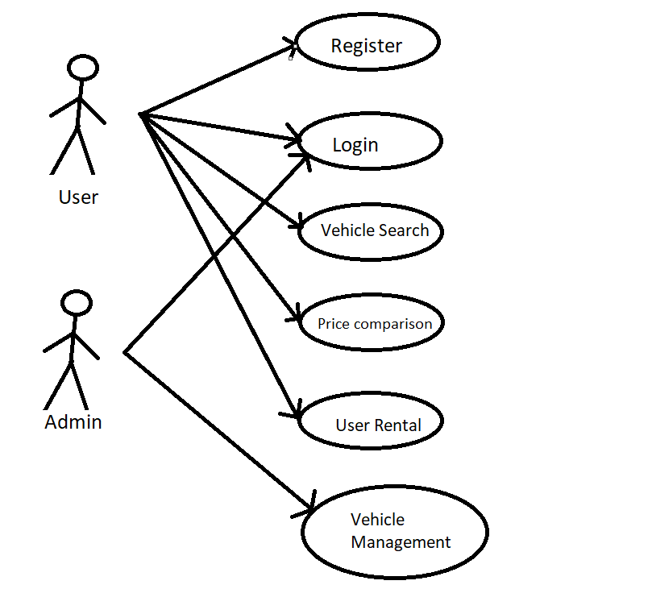

Supplementary Specification

Non-functional Requirements
- Usability: The application should have an intuitive user interface, making it easy for users to navigate and find the information they need.
- Scalability: The system should be able to handle a growing number of users and vehicle listed without significant performance degradation.
- Security: User data must be protected, and sensitive information like passwords should be securely stored using encryption and hashing techniques.
- Responsiveness: The application should provide quick response times and load times, ensuring a smooth user experience.

Design Constraints
- The project must be developed using C# and .Net Core as the back-end framework.
- Front-end development should use a modern JavaScript framework (e.g., React, Angular, or Vue.js).
- The database should be designed using a relational database management system (e.g., PostgreSQL, MySQL, or SQL Server).
- The application should follow a RESTful API design.
- Code should adhere to best practices, including proper documentation and testing.

Glossary
- Rental Seeker: A user who is looking for a vehicle to rent and applies for a rental service on the platform.
- Rental: A record of a Rental Seeker requesting a specific vehicle, including information such as the user, the vehicle, and rental duration.
- Authentication - The process of verifying a user's identity by checking their entered credentials (username and password) against the stored user information.

