The repository is created for performing data analysis related to the yearly drafts that occur in the NFL.

**Brief Intro:**

* For starters, drafts are the medium through which nations best players from colleges step into the NFL arena. Also, the team which had the worst record last year gets to pick first in the draft. Likewise, team which won a championship last year, gets to pick last in a draft. In summary, teams pick in the reverse order of the standings that they finished last season.
* There are totally 7 rounds of draft with each team picking 32 players. There are additional compensatory picks awarded to teams based on a mystery formula that NFL only knows. The prospects who are picked earlier in the drafts generally tend to have stellar college records. The teams with worst record make use of the chance to get best players from college in earlier rounds to rebuild and strengthen their rosters.
* Teams are allowed to trade their draft picks with other teams.

NFL evaluates prospect grades every year before each draft. The way that is being performed is out of scope for this repo. This repo makes use of the already available data to perform

data analysis and prediction.

Source: <https://www.nfl.com/draft/tracker/prospects?year=2020>

Below is a legend of prospect grades from NFL site:

Prospect Grade legends provided by NFL:

|  |  |
| --- | --- |
| 8.0 | The perfect prospect |
| 7.3-7.5 | Perennial All-Pro |
| 7.0-7.1 | Pro Bowl talent |
| 6.7-6.8 | Year 1 quality starter |
| 6.5 | Boom or bust prospect |
| 6.3-6.4 | Will be starter within first two seasons |
| 6.1-6.2 | Good backup who could become starter |
| 6.0 | Developmental traits-based prospect |
| 5.8-5.9 | Backup/special-teamer |
| 5.5-5.6 | Chance to make end of roster or practice squad |
| 5.4 | Priority free agent |
| 5.0-5.1 | Chance to be in an NFL training camp |
| NO GRADE | Likely needs time in developmental league |

For example, below are the grades of QB prospects in 2017.

<https://www.nfl.com/draft/tracker/prospects/QB?college=allColleges&page=1&status=ALL&year=2017>

**Set up needed for running the project:**

* Clone the project from GIT and run in an IDE environment like eclipse. Minimum of JDK 8 is required to run the project.
* The project has mysql for db operations. Ensure the connections are set up properly and corresponding properties are updated in application.yaml. Ensure that the below script is run:

<https://github.com/ps-vivek/NflDraftAnalysisService/blob/master/src/main/resources/sqls/Create_Nfl_Draft_Prospect_Info.sql>

Once above steps are performed, then run the standalone spring boot app.

**SonarQube Report:**

The repository was scanned for code quality using sonarqube sonarqube-8.3.1.34397. It met the coding standards.

Below are the reports of the latest scan run on 05/17/2020.

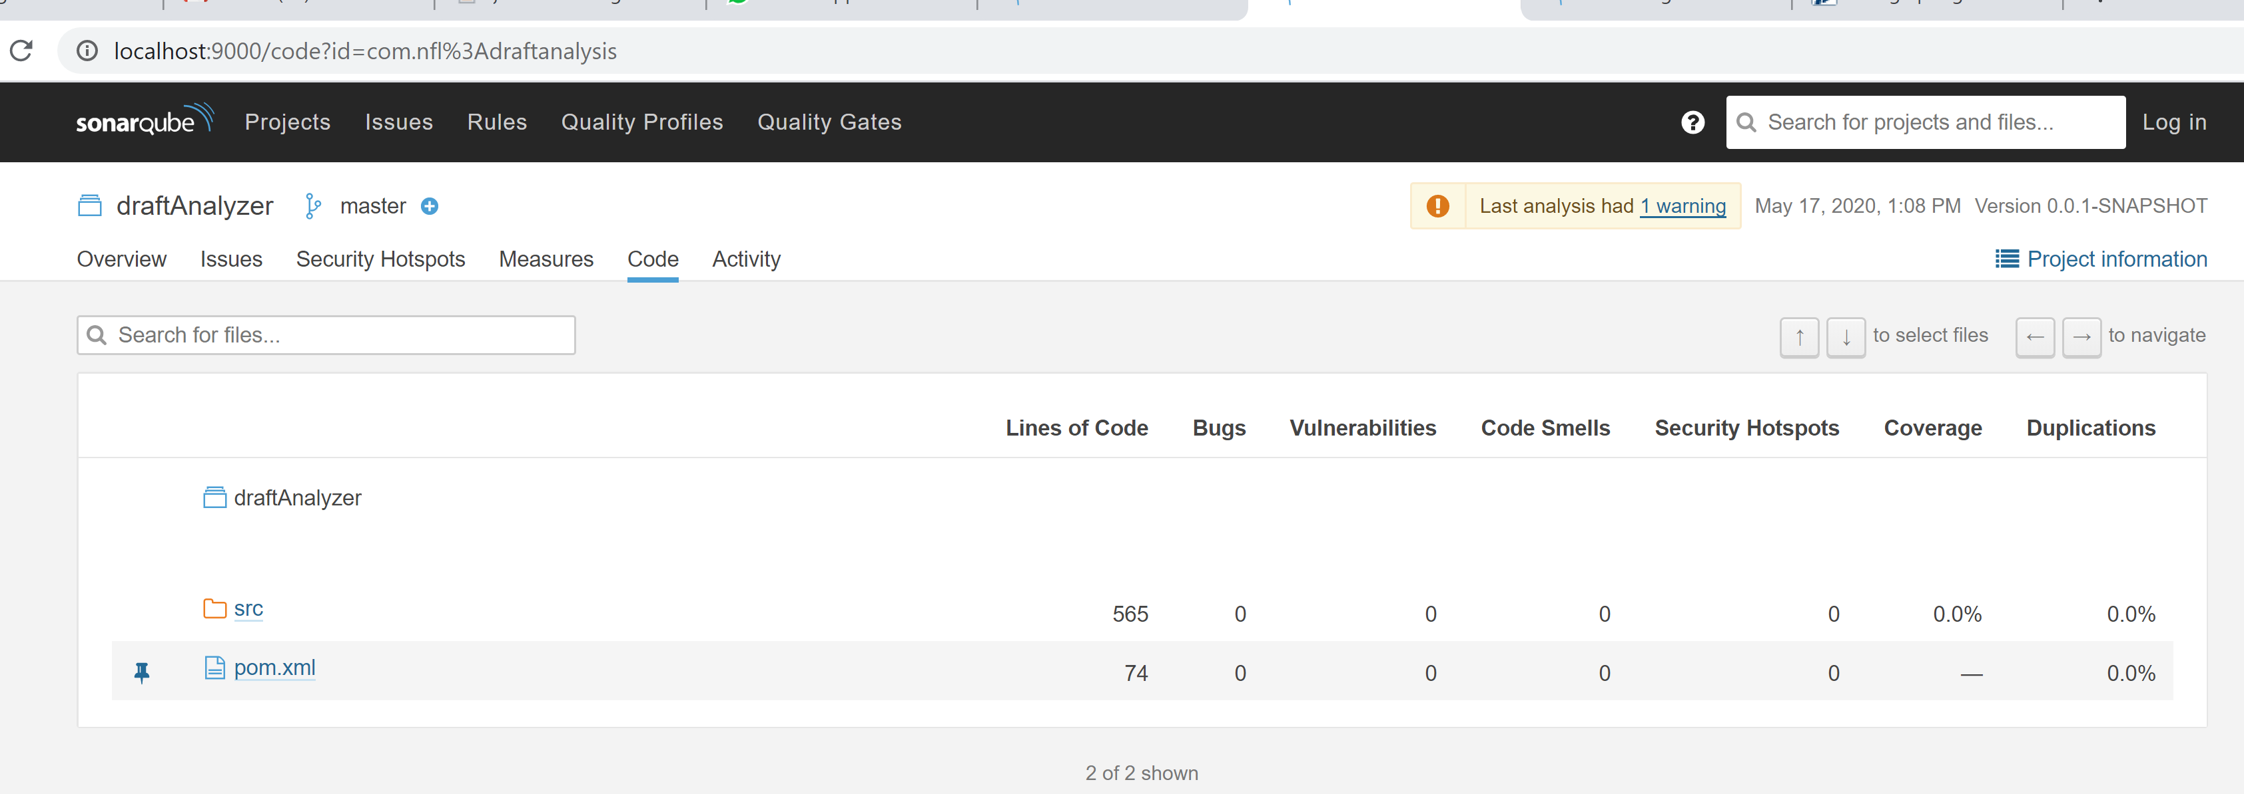

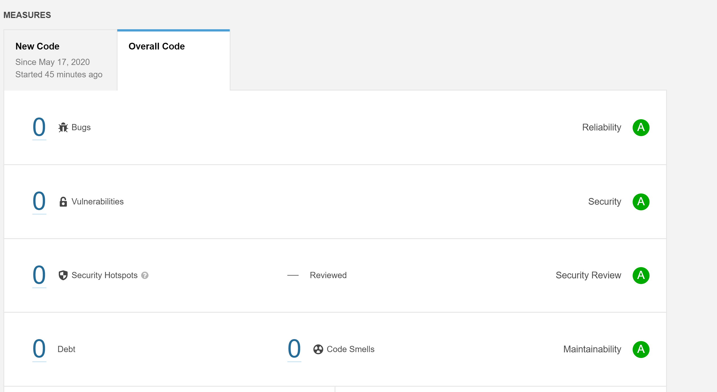

**Analysis 1 of the repository:**

Based on the year and prospect grades, calculate the average of the total prospect grades achieved by a given team in the draft. Teams with highest average prospect grade had the best draft among all teams and vice versa.

Total Prospect grade = Sum of individual prospect grades -> (1)

Average prospect grade per team = Total Prospect Grade(1)/Number Of Players Drafted by Team. -> (3)

The result is rounded to two places

**Below is the end point for achieving this purpose:**

**HTTP METHOD: GET**

Returns average prospect grades data per team for all the teams for a given year.

URI: <localhost>/draft/teamgrades/?year={year}&team={teamName}

{year} -> Mandatory

{teamName} will be assigned as “all” by default.

<http://localhost:8080/draft/teamgrades/?year=2020&team=all>

Output: A excel file will be generated.

For example, for the given end points, following excel files were generated.

|  |  |
| --- | --- |
| End Point | Excel File |
| <http://localhost:8080/draft/teamgrades/?year=2020&team=all> |  |
| <http://localhost:8080/draft/teamgrades/?year=2019&team=all> |  |
| <http://localhost:8080/draft/teamgrades/?year=2018&team=all> |  |
| <http://localhost:8080/draft/teamgrades/?year=2017&team=all> |  |
| <http://localhost:8080/draft/teamgrades/?year=2016&team=all> |  |
| <http://localhost:8080/draft/teamgrades/?year=2015&team=all> |  |
| <http://localhost:8080/draft/teamgrades/?year=2014&team=all> |  |
| http://localhost:9595/draft/teamgrades/?year=2014&team=Green Bay Packers |  |

**Constraints:**

* Currently the team names provided in the request should be an exact match to the below list for the API to provide a response.

- Arizona Cardinals

- Atlanta Falcons

- Baltimore Ravens

- Buffalo Bills

- Carolina Panthers

- Chicago Bears

- Cincinnati Bengals

- Cleveland Browns

- Dallas Cowboys

- Denver Broncos

- Detroit Lions

- Green Bay Packers

- Houston Texans

- Indianapolis Colts

- Jacksonville Jaguars

- Kansas City Chiefs

- Los Angeles Chargers

- San Diego Chargers

- Los Angeles Rams

- St. Louis Rams

- Las Vegas Raiders

- Miami Dolphins

- Minnesota Vikings

- New England Patriots

- New Orleans Saints

- New York Giants

- New York Jets

- Oakland Raiders

- Philadelphia Eagles

- Pittsburgh Steelers

- San Francisco 49ers

- Seattle Seahawks

- Tampa Bay Buccaneers

- Tennessee Titans

- Washington Redskins

* Currently, the API supports only retrieval of average grades for either single team or all teams at once.
* The system has only nfl draft prospect grade data starting 2013.
* Currently, the API doesn’t have the provision of retrieving historical data of a team with its current name in case the team had a name change previously. For ex: average prospect data for “Las Vegas Raiders” in 2015 will return empty. With only “Oakland Raiders”, their data for 2015 will return results.

**Error Handling**

|  |  |  |
| --- | --- | --- |
| **Scenario** | **Sample Request** | **Response** |
| Data is being tried to retrieve for year beyond which nfl draft prospect grade is available. | http://localhost:9595/draft/teamgrades/?year=2013&team=all | {      "message": "Draft data unavailable for the year:2013",      "httpCode": "NOT_FOUND",      "failedDateTime": "2020-05-17T01:34:21.444"  } |
| Invalid team name is entered, and year value is correctly specified | http://localhost:9595/draft/teamgrades/?year=2014&team=all1 | {      "message": "The given nfl team in request doesn't exist. Team:all1",      "httpCode": "BAD_REQUEST",      "failedDateTime": "2020-05-17T01:41:49.712"  } |
| If both year and team name are incorrectly specified | http://localhost:9595/draft/teamgrades/?year=2013&team=all1 | {      "message": "Draft data unavailable for the year:2013",      "httpCode": "NOT_FOUND",      "failedDateTime": "2020-05-17T01:46:20.264"  } |

**Analysis 2 of the repository (Obtain Avg Prospect grades including steal grades):**

**Following assumptions are made:**

**Based on the nfl draft grades available, the draft prospects are classified into following tiers:**

|  |  |  |
| --- | --- | --- |
| **Nfl prospect Grade** | **Projected Round Picks** | **Tier Name** |
| >=6.9 | **First round pick** | **Tier 1 Draft Picks** |
| 6.5-6.8 | **Second round pick** | **Tier 2 Draft Picks** |
| 6.1-6.4 | **Third round picks** | **Tier 3 Draft Picks** |
| 5.5-6 | **Fourth & Fifth round picks** | **Tier 4 Draft Picks** |
| 5-5.4 | **Sixth & Seventh round picks** | **Tier 5 Draft Picks** |

**Each individual grade will be added a steal grade based on the below formula.**

|  |  |  |  |  |  |  |  |  |  |  |  |  |  |  |  |  |
| --- | --- | --- | --- | --- | --- | --- | --- | --- | --- | --- | --- | --- | --- | --- | --- | --- |
| >=6.9 | First round pick | |  |  |  |  |  |  |  | | --- | --- | --- | --- | --- | --- | --- | | 1 | 2 | 3 | 4 | 5 | 6 | 7 | | 0 | 0.5 | 1 | 1.5 | 2 | 2.5 | 3 | |
| 6.5-6.8 | Second round pick | |  |  |  |  |  |  |  | | --- | --- | --- | --- | --- | --- | --- | | 1 | 2 | 3 | 4 | 5 | 6 | 7 | | -.5 | 0 | 1 | 1.5 | 2 | 2.5 | 3 | |
| 6.1-6.4 | Third round picks | |  |  |  |  |  |  |  | | --- | --- | --- | --- | --- | --- | --- | | 1 | 2 | 3 | 4 | 5 | 6 | 7 | | -1 | -.5 | 0 | 0.5 | 1 | 1.5 | 2 | |
| 5.5-6 | Fourth & Fifth round picks | |  |  |  |  |  |  |  | | --- | --- | --- | --- | --- | --- | --- | | 1 | 2 | 3 | 4 | 5 | 6 | 7 | | -1.5 | -.1 | -.5 | 0 | 0 | 0.5 | 1 | |
| 5-5.4 | Sixth & Seventh round picks | |  |  |  |  |  |  |  | | --- | --- | --- | --- | --- | --- | --- | | 1 | 2 | 3 | 4 | 5 | 6 | 7 | | -2.5 | -2 | -1.5 | -1 | -.5 | 0 | 0 | |

For example:

A player who has a grade of more than 6.9 is a tier 1 prospect. Here it is assumed that the player will be drafted in the first round of the draft. In case the player slips and gets drafted in subsequent rounds, it is considered as a steal for the team that is drafting the player.

**Scenario 1:**

Let’s assume that he is actually drafted in round 4 of the draft.

Total Prospect grade = 7.0(Assume this is the actual grade awarded to player) + 1.5 (steal grade) => 8.5

**Scenario 2:**

If the same player is being drafted in first round, steal grade will not be awarded.

Total prospect grade = 7.0(Assume this is the actual grade awarded to player) + 0 (steal grade) => 7.5

Similarly if a player projected to be picked later in the draft is picked in earlier rounds of the draft, a negative steal grade is awarded.

Based on the year and prospect grades, calculate the average of the total prospect grades achieved by a given team in the draft. Teams with highest average prospect grade had the best draft among all teams and vice versa.

Total Prospect grade = Sum of individual prospect grades + Steal Grade

-> (1)

Average prospect grade per team = Total Prospect Grade (1)/Number Of Players Drafted by Team(2). -> (3)

The result is rounded to two places

**Below is the end point for achieving this purpose:**

**HTTP METHOD: GET**

Returns average prospect grades data per team for all the teams for a given year.

URI: <localhost>/draft/teamgradeswithsteal/?year={year}&team={teamName}

{year} -> Mandatory

{teamName} will be assigned as “all” by default.

<http://localhost:8080/draft/teamgradeswithsteal/?year=2020&team=all>

Output: A excel file will be generated.