6 months Interview, PhD student.
ED PSIME “Physique, Sciences de l’Ingénieur, Matériaux, Energie“

Extrait de l’arrêté du 25 mai 2016 fixant le cadre national de la formation et les modalités conduisant à la délivrance du diplôme national de doctorat:"Un comité de suivi individuel du doctorant veille au bon déroulement du cursus en s'appuyant sur la charte du doctorat et la convention de formation. Il évalue, dans un entretien avec le doctorant, les conditions de sa formation et les avancées de sa recherche. Il formule des recommandations et transmet un rapport de l'entretien au directeur de l'école doctorale, au doctorant et au directeur de thèse. Il veille notamment à prévenir toute forme de conflit, de discrimination ou de harcèlement. Les modalités de composition, d'organisation et de fonctionnement de ce comité sont fixées par le conseil de l'école doctorale. Les membres de ce comité ne participent pas à la direction du travail du doctorant"

Last name, first name: Sharma Prabhat

Date of birth: July 2nd, 1999

Date of 6 months interview: March 28th, 2025

Laboratory: GANIL

Origin of Funding: University of Caen Normandy

PhD title: Explοring magicity and nuclear fοrces in ⁶⁸Νi

Start date of the PhD: October 1st, 2024

PhD Director: SORLIN Olivier

Supervisor(s): SORLIN Olivier

Names of Monitoring Committee members (CSI) :
- CSI1 : DELAUNAY Franck
- CSI2 : DE OLIVEIRA SANTOS François

Scientific Report
Recommended length: 3 pages in French or in English

I. Description of the PhD subject (including the scientific background and objectives)

The nucleus is a complex quantum mechanical many-body system bound by the nuclear force. It has been established experimentally that for a certain number of protons or neutrons nucleus is much more stable. These numbers are 2, 8, 20, 28, 50, 82, 126. Several potentials were taken as the basis to account for these numbers including the harmonic oscillator potential which successfully reproduced the first 3 magic numbers but failed to account for the rest. In 1949, for the first time, Maria Goeppert-Mayer and J. Hans D. Jensen [1-2] proposed the inclusion of spin-orbit interaction in the potential which succeeding in reproducing the remaining of the magic numbers. However, as we move farther away from the stability curve, another phenomenon called the “shell evolution” comes into picture [3] where new magic numbers (2, 8, 20, 40 etc.) governed by the Harmonic Oscillator potential are formed.
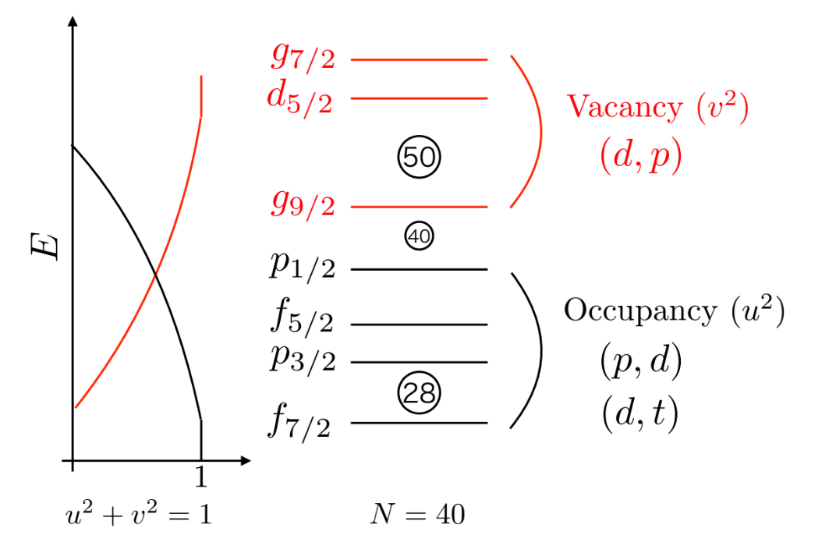
In case a nucleus is “magic nucleus”, all the orbitals up to the magic number should be filled and the valence orbitals should remain vacant and the nucleus acquires a near-spherical shape. However, in reality the occupancy of the nucleons does not strictly follow this trend and has a diffuseness which differentiates the “magicity” (Fig. 1). In other words, a nucleus with pronounced magicity has a larger shell gap indicating a robust closure of the shell. So to examine the order of magicity, a starting point is to see the occupancy of orbitals and hence evolution of the shell gap with respect to nucleon number.
Fig. 1: Occupancy and vacancy for N=40 nuclei.

Thus, one of the objectives of the current study is to apply this to ⁶⁸Ni and test the preservation of magicity at the evolved-magic number N = 40. The occupancy of fpg neutron orbitals has already been studied in the stable Ni isotopes with neutron number ranging from 30 to 36 and it was shown that the partial filling of the g_{9/2} orbital starts already at N = 34 [4].
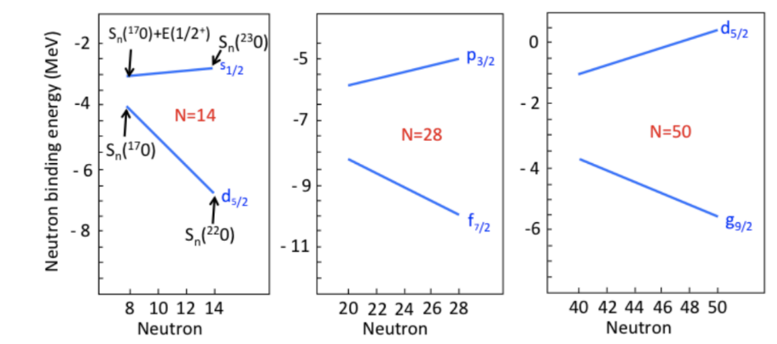
An illustration of evolution of shell gap is found in the isotopic chain of Ca where the N = 28 shell gap is seen to increase as we move from N=20 to N=28 (⁴⁰Ca to ⁴⁸Ca) (middle panel of Fig. 2). This effect is successfully explained by considering 3-body forces (3N) while gap remains almost constant if only 2-body forces are considered [5]. This evolution of shell gap is also observed for the N = 14 gap in the isotopic chain of O (left panel of Fig. 2) [6]. This analogy should be reproduced for the N=50 shell gap which can be confirmed in the isotopic chain of Ni (right panel of Fig. 2). In a recent study on ⁷⁸Ni (a benchmark nucleus with the conventional magic numbers of Z = 28 and N = 50 far from the stability line), the excitation energy of 2₁⁺ state was measured at 2.6 MeV [7] which tells that the magicity is preserved at N=50. But there has not been any study so far for the starting point at ⁶⁸Ni from where neutrons should be added to see the evolution. So another goal is to determine the N = 50 shell gap in ⁶⁸Ni as an anchor point to determine that in ⁷⁸Ni. If a systematic increase of shell gap is found then this effect must also be applied to the higher shell gaps where experimental studies are no longer possible because of low separation between orbitals.
Fig. 2: Evolution of shell gap in O (left panel), Ca (middle panel and Ni (right panel) isotopic chain [3].

Another objective is to study the spin-orbit splittings of the 2p, 1f and 1g orbitals in ⁶⁸Ni. The combination of neutron adding and neutron removing reactions should give us access to both the spin-orbit partners, here f_{7/2} - f_{5/2}, p_{3/2} - p_{1/2} and g_{9/2} - g_{7/2}.

II. Experimental and/or numerical means (including the strategy to reach objectives and the corresponding challenges)

The experiment (e843) for this PhD thesis has already been performed in the experimental campaign of 2023. A primary beam of ⁷⁰Zn @ 62 MeV/u was bombarded on a 500 µm thick Be target to produce a secondary beam of ⁶⁸Ni by fragmentation. And with this secondary beam, ⁶⁹Ni and ⁶⁷Ni nuclei were populated in inverse kinematics in three separate channels using 0.5 mg/cm² CD₂ and 5 mg/cm² CH₂ as secondary targets:
(1) ⁶⁸Ni (d,p) ⁶⁹Ni @ 18 MeV/u
(2) ⁶⁸Ni (d,t ) ⁶⁷Ni @ 18 MeV/u and
(3) ⁶⁸Ni (p,d) ⁶⁷Ni @ 40 MeV/u
For the slowed down beam (@ 18 MeV/u), another 700 µm thick Be was used as a degrader in the D4 room. To infer the contribution of Carbon, a Carbon target of thickness 4 mg/cm² was also used. The detector setup consisted of two position sensitive gas detectors “CATS1,2” to determine the beam spot on target. The transfer-like products (⁶⁷Ni and ⁶⁹Ni) are tracked by means of a set of 2 Drift Chambers, and are identified using a set of 10 Ionization chambers (coupled in pair so effectively 5) and 5 Plastic Scintillators (20 cm in length horizontally and 4cm wide vertically) put on top of each other width-wise covering a total height of 20 cm and an area of about 20x20 cm². which make the zero-degree detection system (ZDD). The light particles produced in the forward direction transfer reactions {(p,d) or (d,t)} are detected by 4 highly segmented vertical and horizontal stripped Si detectors backed by CsI crystals “MUST2” and in the backward direction {(d,p)} by the detector setup “MUGAST” to determine the energy loss and angles. A Ge-clover detector array “EXOGAM2” is used to detect the in-flight and the isomeric-delayed gamma rays along with one detector at the end of the zero-degree detection system to detect the 9/2⁺ isomeric beam content of ⁶⁷Ni as well as the production of the same isomeric state from the ⁶⁸Ni (p,d) reaction.

The ⁶⁹Ni part of this experiment is being analyzed by Dr. Özge AKTAŞ and I am learning the data analysis techniques from her in parallel to analyze the ⁶⁷Ni part. And in order to have more hands on experience I intend to get myself familiarized with the detectors that were used in my experiment over the about-to-start Mugast experimental campaign. It employs all the detectors that were used in e843. The commissioning of the same starts near to the end of April 2025 in which the same setup is used for a similar physics case as the one I study that is ³⁴Si(p,d). For the campaign, the detectors are being set up which is giving me a good opportunity to join the people in-charge (of the corresponding detectors) and handle the electronics myself.

As for the numerical means, the data we receive straight from the acquisition is in binary format so to extract human-readable information from it, the analysis relies heavily on software packages like mfm-merger, NPMFM and nptool. Mfm-merger is the first step towards the analysis, in which we merge an event by giving a particular merging window on its course from the first detector (CATS1 in my case) till the last (the Plastics). The output of this step is a binary file still. Then npmfm is used to create the “raw-data” which is in ROOT format and is human-readable. Then to apply calibrations and extracting exactly the physics information we want, nptool is used. Nptool has distinct libraries to all the detectors used for the experiment. I learned (and learning still) how to use these tools from Özge as well.

III. Summary of the first work and results (be quantitative!)

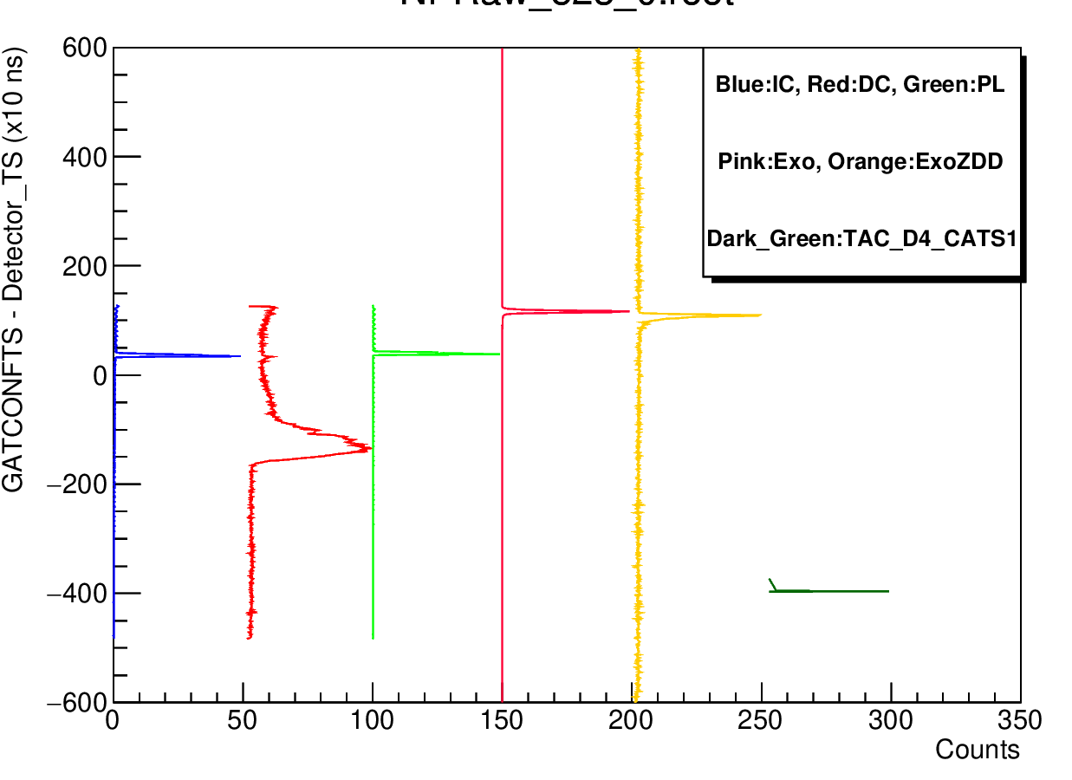
The choice of an optimum merging window is very important. Too large of a window ~10-15 µs will start merging events that have no correlation the with the previous event while too short of a window ~ 1 µs will allow an event to be correlated with neither the detectors that fall at distances farther than the corresponding flight time nor the detectors that are slow in terms of processing an event. In our case the Drift chamber is the slowest of them all. In order to select an optimum timing window, we subtract the time-stamp of all the detector modules with the time-stamp (TS) of the main trigger, which in our case is GATCONF that has 4 triggers: CATS1, CATS2, Plastics and the MUST/MUGAST (together called the MMG). I present a better idea in the following graph (Fig. 3) that represents various detectors with scaled down counts on the x-axis and TS subtraction on the y-axis (each channel represents 10 ns). The figure also shows another problem which arises if the detector modules are misaligned in terms of TS. In my case, the TAC_D4_CATS1 (dark green) module is completely off w.r.t other detectors. So my idea is to try to shift the module (my near future plan) in terms of TS (by about 400 channels * 10ns) so as to make them overlap and choose 3 µs window for the entire analysis.
Fig. 3: The time stamp subtraction of distinct detectors with respect to GATCONFTS. Y-axis is 10 ns/channel.

In the first couple of months, I worked on finding out the position resolution of the Plastic scintillators (5 in number) that lie at the end of the detection setup. They are about 20 cm long and 5 cm in area that sees the beam. For calibration purpose, a run was conducted overnight for collection of cosmic rays. The Plastics have a more lengthy than wider geometry and are equipped with 1-PMT at each of the two ends and thus 5 Plastics have 10 PMTs in all. We receive a TAC signal from the difference of the timing of the signal that is seen by the 2 PMTs when an interaction occurs. This TAC prompt is normalized to the length of plastics. The events happening at one end of the detector will give the corresponding nearest PMT a signal much earlier than the other PMT and vice versa, so we get a TAC prompt given in the picture below (Fig. 4 a). The cosmic particles come and traverse through the Plastics in a straight line, giving signals to all the PMTs and hence in all the 5 TACs. Then I reconstruct the trajectory and fit it to see the deviation that gives us the resolution (Fig. 4 b). In Fig. 4 (c) I show one such trajectory. The y-axis actually gives the horizontal length of the Plastic (20 cm) and the x-axis indicates the 5 Plastics. The final resolution that comes out is by fitting the curve for total deviation, which comes out to be 0.65 cm in x (horizontally).
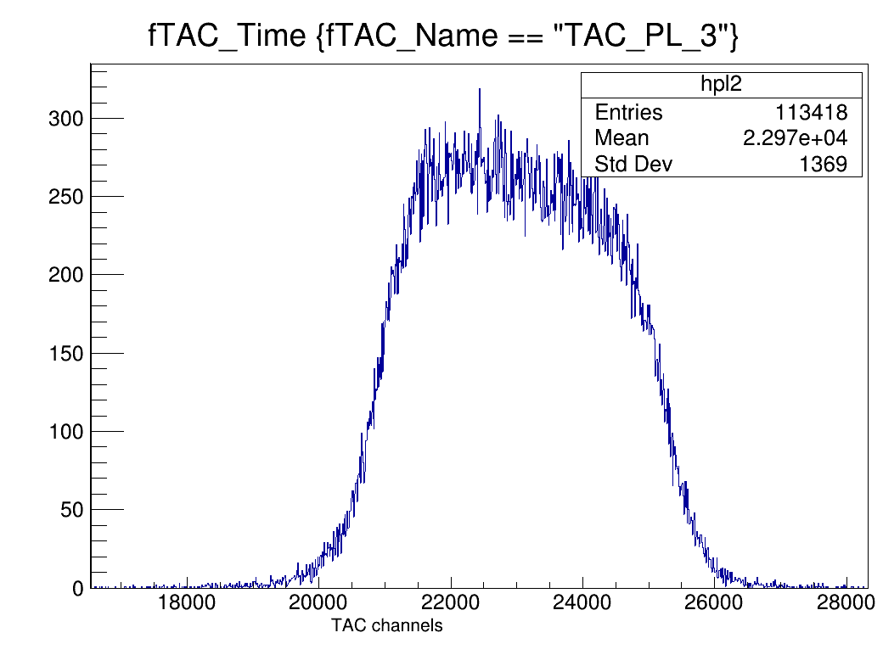
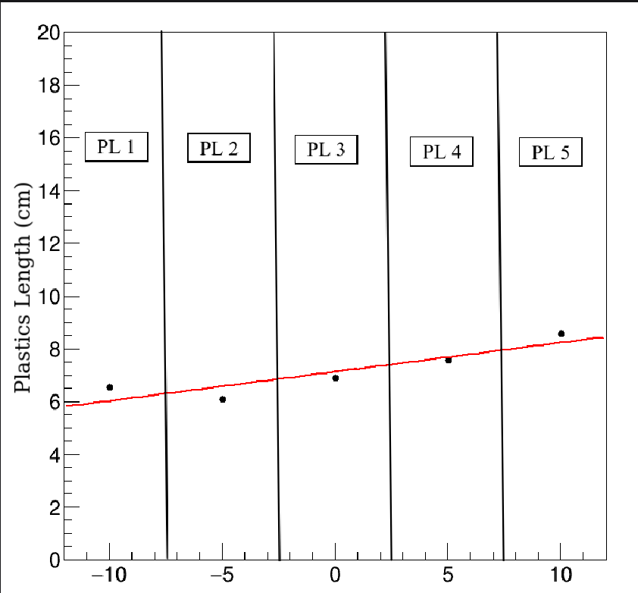
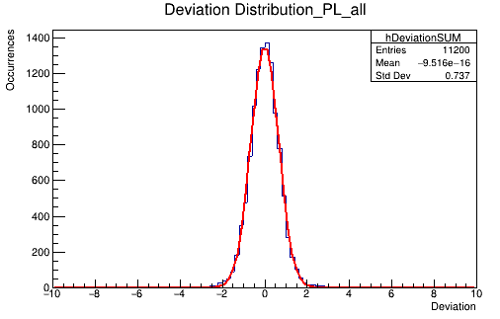
Fig. 4: (a) TAC prompt for cosmic rays in Plastics. (b) Total deviation of fitted trajectories to data points in all the Plastics summed. (c) An example of cosmic ray trajectory (figure oriented 90º anti-clockwise) and the fit. (d) Efficiency of the 5 Ionization Chambers (IC) w.r.t. counts per second in the Plastics. For ease of viewing, the y-axis starts from 0.7 and error bars are given only for the 1st IC (⁶⁸Ni(p,d)⁶⁷Ni @ 40 MeV/u channel).
(a)
(b)
(c)
(d)
I have been working on the Ionization chambers. There are 10 ionization chambers (IC) put in series one after the other and coupled in pairs so the net number of ICs is 5. For future experiments, a user can be interested in finding a balance between the efficiency of the Ionization chambers with respect to beam intensity. So to be consistent in terms of which data we are looking at, I look at the efficiency of the ICs w.r.t to the counts per second (cps) received in the GATCONF with Plastics-trigger (taking any of the remaining 3 can mean that the event didn’t reach the ICs, because CATS1,2 and MMG, all lie before the ICs) in case of the ⁶⁸Ni (p,d) ⁶⁷Ni @ 40 MeV/u channel. The efficiency is calculated as the number of events seen in the ICs w.r.t. the number of events seen in TAC of CATS-Plastic. This ensures that the event passed through the ICs as they fall between the CATS and Plastic scintillator detectors. Fig. 4 (d) presents the efficiency of all 5 ICs as a function of counts per second. For ease of viewing, I show the error bars only for the first IC as they are similar for all of the rest.

In mid-January, I also got a chance to un-cable and cable the whole ZDD electronics (under the supervision of Özge) into new crates specially made for the purpose. This was my first chance working on the electronics of such a complicated detector setup. I got to know how different modules are inter-linked to validate each other and give final data. We also made it more cleaner in terms of webs of wires. Below is a before and after shot of the electronics with the new crate. I also had the chance to make the electronic scheme for the current setup.
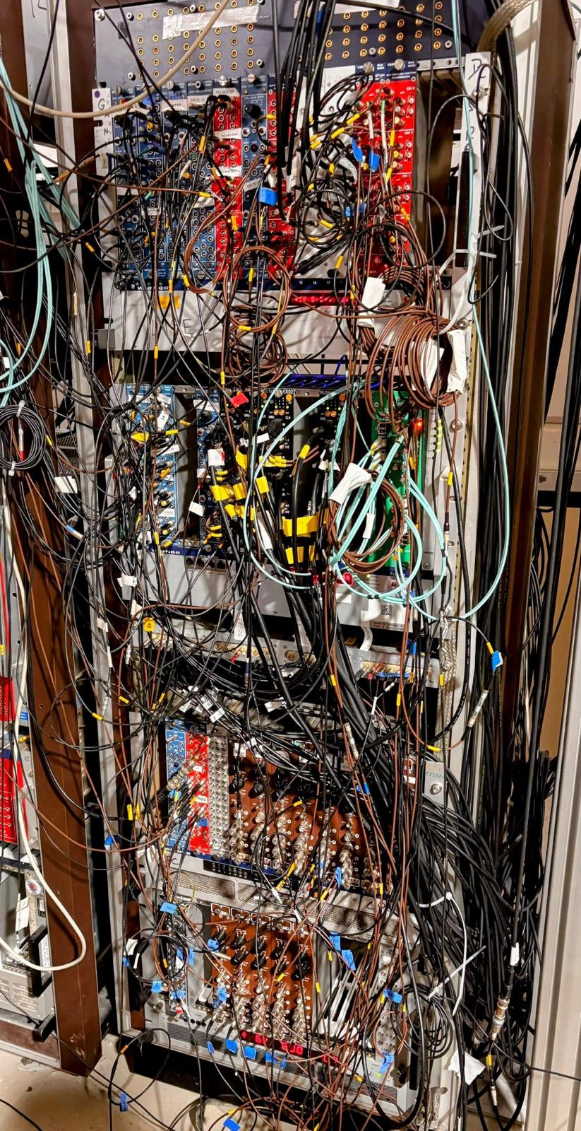
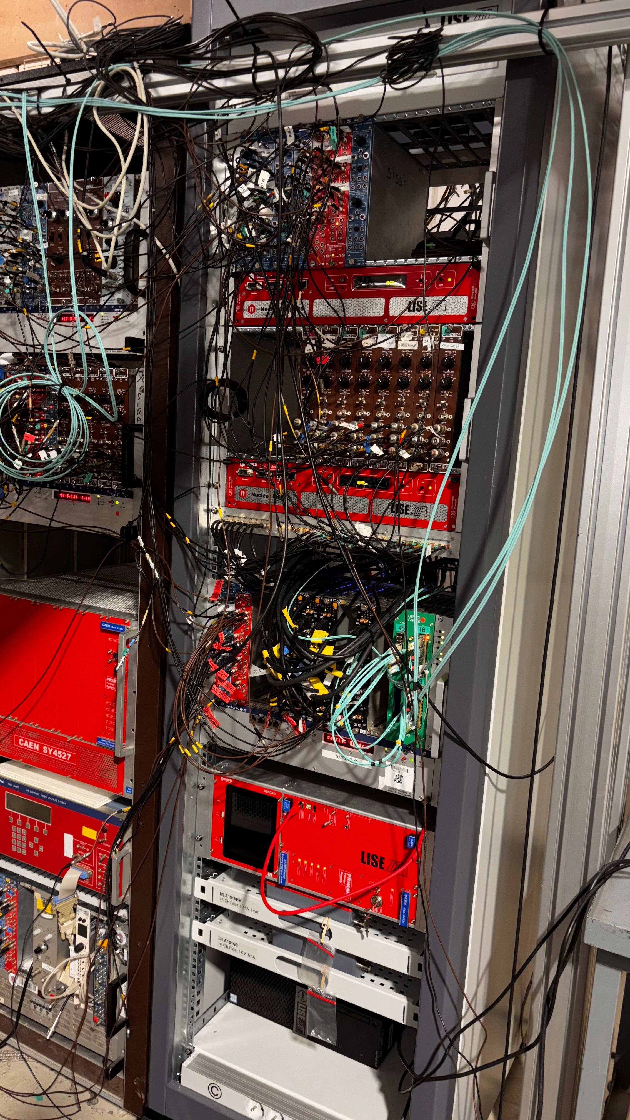

IV. Scientific communication strategy including future plans (reports, conferences, articles, communication to the general public…)

I am looking forward to attending a few schools in the upcoming months, for example the jointly held Joliot-Curie and Euroschool on Exotic Beams in September. I will be giving the “La physique dans tous ses états” the next year. I would also like to attend the European Nuclear Physics Conference but I am still unsure about the type of contribution (Oral or Poster). As for other conferences in the upcoming months, I would keep an eye on the schedules and attend after discussing with my supervisor.

References:
[1] Maria Goeppert Mayer, Phys. Rev. 78, 1 (1950).
[2] Haxel, Jensen and Suess, Phys. Rev. 75, 1766 (1949).
[3] O. Sorlin and M.G. Porquet, Prog. Part. Nucl. Phys. 61, 602–673 (2008).
[4] J.P. Schiffer et al., Phys. Rev. Lett. 108, 022501 (2012).
[5] O. Sorlin and M.G. Porquet, Phys. Scr. T152, 014003 (2013).
[6] T. Otsuka et al., Phys. Rev. Lett. 105, 032501 (2010).
[7] R. Taniuchi et al., Nature 569, 53–58 (2019).

Evolution of the PhD project
about ½ page in French or in English

I. Perspectives of the PhD work up to next interview

Currently, the work on the detector setup for the commissioning is picking up a pace so I am also spending much of my time in the INB with people from both the scientific and engineer’s side. The setup is being done detector by detector. Right now I am learning about the double validation logic of CATS detectors, along with the energy and position calibration using mask and alpha source. We also powered up the Plastic detectors and currently working on making the acquisition system ready in the new Ubuntu-based setup. The ZDD housing is also going to be opened soon so and I will get to have a better view of the inside of the detectors.

In parallel, I am working on the ZDD detectors. As the contract of Özge will end in August, my plan is to finish everything related to the beam detection before that. It includes (1) to shift the time-stamps of misaligned detectors so as to get a smaller merging window, (2) to get the energy calibration of ICs done w.r.t. the simulation in LISE++ application suite, (3) finish up the calibration of before-target detectors (CATS-1,2) and (4) to do the calibration of the after-target detectors (the MUST2, EXOGAM2 and the ZDD). The analysis of the Ionization chambers is almost finished and now I intend to move on to the Exo-ZDD detector. The time frame of this will depend on how much time I spend in the INB and how much time I get during the commissioning and experiments as I don’t have a prior specific experience.

II. Observations (Difficulties, supervision, needs, satisfaction, would you like to supervise master students, would you like to teach…)

Although I have gained a lot of knowledge so far, I am still unsatisfied by the amount of work that I have done. My first 6 months went quite slowly in terms of progress in analysis. Most of it is because the DAQ and the triggers along with the detection system are very complex. My understanding of reaction mechanisms, the scientific motivation and the production of radioactive ion beams is evolving but with a great cost in time. Having Özge here to teach me various aspects of the analysis from start till end (be it the electronics or be it the nptools) is a true asset which I am extremely grateful for. I think the mutual understanding of my supervisor is also helping me to not be demotivated as he agrees that the detection system is indeed very complicated. He also made me realize this amazing fact that writing things will make more clarity in my explanations and reasoning that I give so I would like to apply this convention with him that I give reports to him in writing which he can later correct (in speech to be efficient). I will ensure to make up for the time I spent doing things slowly in the coming months. Physics-wise I think I need to attend some theoretical classes on Nuclear Physics as well.

