SummaMove exercise instructions

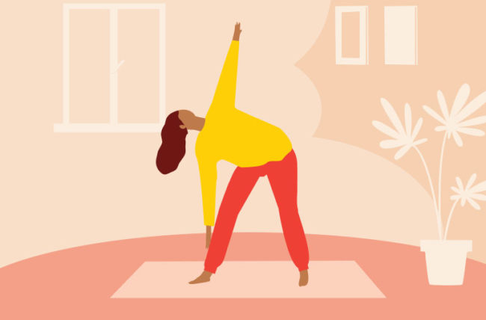

Date: 5-7-2022

Made by: Coco van Glabbeek, Ryan Hendriks, Xander van Hunen

Index

Introduction 3

Requirements 3

Warning 3

Exercise: Squat 4

Exercise: Push-up 5

Exercise: Dip 6

Exercise: Plank 7

Exercise: Donkey Kick 8

Exercise: Mountain Climber 9

Exercise: Burpee 10

Exercise: Lunge 11

Exercise: Wall sit 12

Exercise: Crunch 13

Conclusion 14

Contact Information 15

# Introduction

This instruction is made to help you out to do the exercises correctly. Each exercise explains what part of your body you improve and explained step by step how to perform it correctly.

# Requirements

* Strong Chair (without wheels)
* A straight smooth wall

# Warning

We are not responsible for any injuries that you may receive with these exercises. Do not stress yourself over the limited and always do the exercises with caution.

# Exercise: Squat

*In this exercise you will learn how to do a squat correctly. By doing squats you will shape your quads, hamstrings and glutes.*

**Step 1: Get yourself in a straight position**

First off, stand in a straight position with your feet hip-width apart and place your hands on your hips.

**Step 2: Readying yourself to lower yourself to a squad position**

After that, standing up tall and gently pull your shoulder to the back. Doing so will tighten your stomach muscles.

**Step 3: Going to the position to perform your first squad**

Now you lower yourself down and go as far down as it seem to look like you are sitting on a invisible chair, make sure your legs are in a 90 degree angle.

**Step 4: Lift yourself back up correctly**

After you lowered yourself you going to try to stand back up. You do this by straighten your legs and lift yourself up by only the strength of your legs.

Congratulations, you have performed the squad in a correct way! If you wish to incorporate this exercise into your routine, then you can repeat this exercise 10 to 15 times.

# Exercise: Push-up

*In this exercise you will learn how to do a push-up correctly. By doing push-up you will shape your pecs, shoulders, triceps and abs.*

**Step 1: Get yourself in a correct position**

First off, stand with your hands and toes close to the ground.

**Step 2: Setting your hands in the correct position**

After that, set your hands wider to the side then your shoulders.

**Step 3: Going to the position to perform your first push-up**

Now, lower your body until your torso almost hit the ground.

**Step 4: Lift yourself back up correctly**

Wait for a moment and then push yourself back up.

Congratulations, you have performed the push-up in a correct way! If you wish to incorporate this exercise into your routine, then you can repeat this exercise 5 to 10 times.

# Exercise: Dip

*In this exercise you will learn how to do a dip correctly. By doing this exercise you will improve your triceps.*

**Step 1: Preparations and setting yourself in correct position**

Take a strong chair without wheels and put your hands on the two front corners of the chair.

**Step 2: Lowering yourself**

After that keep your hands on the chair and sit on the floor, do make sure that your knees are at an angle between 45-90 degrees.

**Step 3: Lifting yourself back up**

After that, stand on the heels of your foot and straighten your arms until your elbows cannot go any further.

Congratulations, you have performed the dip in a correct way! If you wish to incorporate this exercise into your routine, then you can repeat this exercise 5 to 10 times.

# Exercise: Plank

*In this exercise you will learn how to do a plank correctly. By doing the plank you will strengthen your body from head to toe. The plank helps strengthen your core muscles, including your abdominals and lower back.*

**Step 1: Setting yourself ready**

First off, lie on the floor with your stomach.

**Step 2: Get yourself in the correct position before pushing up**

Then, put your toes on the floor together with your heels and make your hands in a form of a fist.

**Step 3: Pushing yourself back up**

Push yourself up with your elbows.

**Step 4: Placing your elbows in the correct position**

Place your elbows vertically under your shoulders.

**Step 5: Set your arms in correct degree angle**

Now keep your arms at a 80 degrees angle.

Congratulations, you have performed the plank in a correct way! If you wish to incorporate this exercise into your routine, then you should hold this position after step 5 for 20 – 60 seconds.

# Exercise: Donkey Kick

*In this exercise you will learn how to do the donkey kicks correctly. By doing donkey kicks you will work your glutes, the core, hamstrings, shoulders and back. Allowing you to work the entire back side of the body at once.*

**Step 1: Getting yourself in the begin position**

First, sit on your kneels and place your hands on the ground.

**Step 2: Check if you got your back in the correct position**

Be sure to place your back in a horizontal straight position.

**Step 3: Moving your arm and leg**

After that, Lurch your right arm forward and kick slowly but gently with your left leg to the back.

**Step 4: Swapping between both arms and legs**

At last, swap between both arms and legs to do the full exercise.

Congratulations, you have performed the donkey kick in a correct way! If you wish to incorporate this exercise into your routine, then you can repeat this exercise 5 to 10 times.

# Exercise: Mountain Climber

*In this exercise you will learn how to do a mountain climber correctly. By doing mountain climber you will work on your core and improve your endurance.*

**Step 1: Getting in the begin position**

First off, go lie on the ground with your stomach.

**Step 2: Placing your feet’s in the correct position**

After that, set your toes on the ground and keep your heels together.

**Step 3: Getting your arms in the correct position**

Now, stretch your arms out under you and keep your hands on the ground.

**Step 4: Moving with your knees**

Finally, kick forward with your right knee forward.

Congratulations, you have performed the exercise in a correct way! If you wish to incorporate this exercise into your routine, then you can repeat this exercise 10 to 15 times.

# Exercise: Burpee

*In this exercise you will learn how to do a burpee correctly. By doing a burpee you will focus on your chest, triceps, and glutes. This exercise is also amazing by improving your endurance and strengthen the legs.*

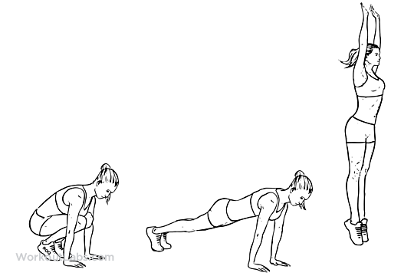

**Step 1: Kneeling down**

First off, kneel down and place your hands next to you.

**Step 2: Bringing the legs back in one movement**

After that you bring your legs back in one movement.

**Step 3: Making sure if you placed your toes correctly**

Make sure you place your toes upright on the floor and then put yourself back in the first position.

**Step 4: Jumping back up**

Finally, you jump up with outstretched arms.

Congratulations, you have performed the exercise in a correct way! If you wish to incorporate this exercise into your routine, then you can repeat this exercise 5 to 10 times.

# Exercise: Lunge

*In this exercise you will learn how to do a lunge correctly. By doing exercise you will mainly focus on the hamstring and glutes which ensures strong legs and a good proportion in the lower back.*

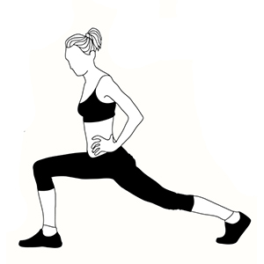

**Step 1: Putting your right foot in the correct starting position**

First, put your right foot out 60-90 centimetres in front of you.

**Step 2: Putting your left foot in the correct starting position**

After that, put your left foot at the same distance.

**Step 3: Lowering slowly to the ground**

Now that is done, you lower down slowly until your left barely touches the floor.

**Step 4: Checking if your left upper leg is in the correct position**

Make sure that the left upper leg is parallel to the floor.

**Step 5: Going back to the starting position**

Finally, go back to the starting position and switch the leg position.

Congratulations, you have performed the exercise in a correct way! If you wish to incorporate this exercise into your routine, then you can repeat this exercise 5 to 10 times.

# Exercise: Wall sit

*In this exercise you will learn how to do a wall sit correctly. By doing this exercise you focus mainly on the thigh muscles and knees. While doing this exercise you also strengthen your core.*

**Step 1:**

First, find a straight smooth wall and stand right up to it.

**Step 2:**

After that, put your feet half a step forward.

**Step 3:**

Finally, lower your torso against the wall until your knees is at a 90 degree angle.

Congratulations, you have performed the exercise in a correct way! If you wish to incorporate this exercise into your routine, then you can hold the wall sit position for 10 – 30 seconds.

# Exercise: Crunch

*In this exercise you will learn how to do a crunch correctly. By doing crunches you mainly focus on the abs. This exercise is often a good basis to start with and can provide a strong core.*

**Step 1: Lie on the ground**

First, lie with your back on the floor and place your feet hip-width apart on the floor.

**Step 2: Putting your arms in a correct position**

After that, put your hands behind your head.

**Step 3: raising your upper body**

Then, exhale and raise your upper body. Make sure your head and neck relaxed while you are doing this.

**Step 4: Lowering your upper body**

At last, inhale and go back to the starting position.

Congratulations, you have performed the exercise in a correct way! If you wish to incorporate this exercise into your routine, then you can repeat this exercise 5 to 10 times.

# Conclusion

Now that all the exercises have been completed, you can now implement them in your routine. The exercises often have several variations and can always be repeated or held several times. Always make sure that you go through the exercises safely.

# Contact Information

Organisation name: Summa College ICT

Address: Sterrenlaan 10

Postal code: 5631 KA

Place: Eindhoven

Phone number: 040 269 45 00