

eStore Project



Requirements Document

Version 1.1.3

7/29/02

Role | Individual | Signature/Date Approved
Business Sponsor
Project Manager/Analyst
Business Team Representative


www.rdacorp.com

Table of Contents
1 Introduction 1
2 eStore Project Vision 3
2.1 Business Background and Overview 3
2.2 Business Problem Statement 3
2.3 eStore Mission Statement 3
2.4 Project Objectives 3
2.5 Business Case 4
3 “To-Be” Use Case Model 5
3.1 eStore “To-Be” Use Case Context Diagram 6
3.2 ‘To-Be” Use Cases 7
3.3 System Interfaces 8
3.4 Reports 8
3.5 Use Case Object Model Example (or Scenario) 9
3.6 Use Case Object Model Class Diagram 10
4 UI Specification 12
4.1 UI Design 12
4.1.1 UI Conceptual Framework 13
4.1.2 Page Navigation Requirements (UD-001000) 14
4.1.3 UI Standards 15
4.2 UI Prototype 15
5 Detailed Requirements 16
5.1.1 Requirement Identifiers 17
5.2 System Features Supported in eStore V1.0 17
5.3 System Features Not Supported in eStore V1.0 17
5.4 Functional Requirements 18
5.4.1 Architecture and Design Constraint Requirements 18
5.4.2 System Level Business Rule Requirements 18
5.4.3 Business Automation Requirements 18
5.4.4 UI Requirements 18
5.4.4.1 General Requirements 19
5.4.4.2 eStore Home Page (Form-0001-000) 19
5.4.4.3 Display Category (Form-0002-000) 20
5.4.4.4 Display Product (Form-0003-000) 21
5.4.4.5 Display Item (Form-0004-000) 22
5.4.4.6 Maintain Cart (Form-0005-000) 23
5.4.4.7 Confirm Cart (Form-0006-000) 24
5.4.4.8 Maintain Order Billing (Form-0007-000) 25
5.4.4.9 Maintain Shipping Address (Form-0008-000) 26
5.4.4.10 Confirm Addresses (Form-0009-000) 27
5.4.4.11 Order Confirmed (Form-0010-000) 28
5.4.4.12 Sign In (Form-0011-000) 29
5.4.4.13 Maintain Account (Form-0012-000) 30
5.4.4.14 Display Help (Form-0013-000) 32
5.4.4.15 Search Products (Form-0014-000) 33
5.4.5 Reports 33
5.4.5.1 Sales Report (Report-0001-000) 33
5.4.6 System Interfaces 33
5.4.6.1 Credit Authorizer Interface 33
5.4.7 System Administration Requirements 33
5.4.8 Installation Requirements 34
5.4.9 Migration Requirements 34
5.4.10 Operational Requirements 34
5.5 Proficiency Requirements 34
5.5.1 Security Requirements 34
5.5.1.1 User Identification & Authentication Requirements 34
5.5.1.2 Authorization 35
5.5.1.3 Data Integrity and Privacy Requirements 35
5.5.1.4 Transaction Integrity and Auditing Requirements 35
5.5.2 Performance/Load Requirements 35
5.5.3 Robustness/Availability/Service-ability/Fault Tolerance Requirements 36
5.5.4 Concurrency Requirements 36
5.5.5 Internationalization Requirements 39
5.5.6 Configuration Requirements 39
6 Appendix A – Data Type Specification 40
7 Requirement Traceability Matrix (RTM) 45
7.1 Requirement to Test Suite Traceability Matrix 45

Introduction
This is the IT FlightPlan’s Requirements Document for RDA’s eStore application. Requirements are captured at three distinct levels of detail.

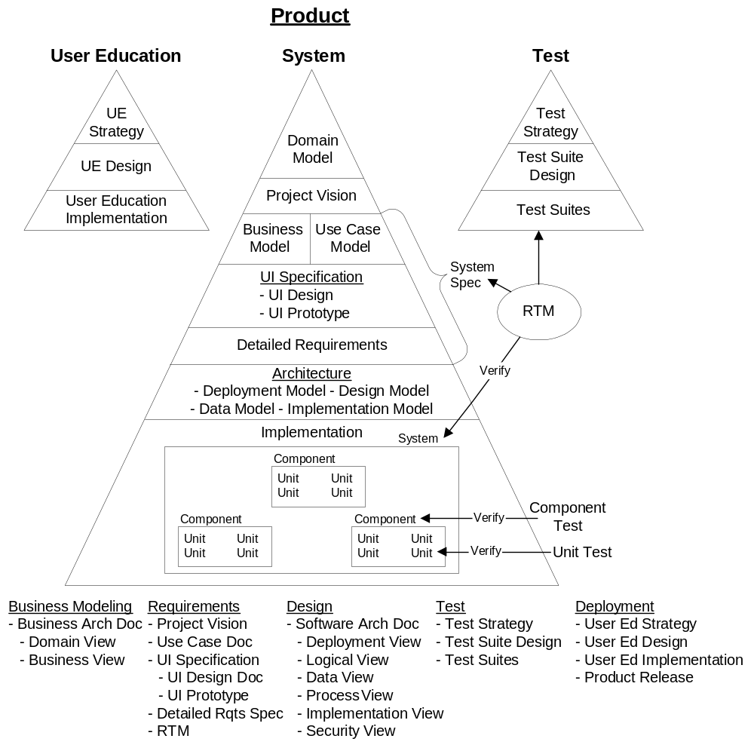
Project Vision: Communicates project decisions such as – “How does the project impact the business?” “What are the objective business success criteria for the project?” and “How much is the project worth to the business?”
Use Cases: Models the ‘To-Be’ internal business processes once the system is deployed, focusing on the interactions among the system and its actors.
UI Specification: The UI specification is captured in two forms.
- UI Design
- UI Prototype of the mainline, high risk web pages.
Detailed Requirements: Specifies the lowest level, detailed requirements of the system.
Even though the Project Vision contains the objectives and financial justification for the project, these are not classified as formal system requirements. Rather they drive the requirements, design, implementation and test. The Use Case Model, UI Specification, Detailed Requirements artifacts contain the formal system requirements. As a result, these artifacts combine to form the System Specification.
In addition, this Requirements Document includes a Requirement Traceability Matrix (RTM) that maps system requirements to system tests to ensure complete coverage.

eStore Project Vision
The purpose of the Project Vision is to define the ultimate mission for the project from a business perspective. All work performed on the project, direct or indirect, supports the objectives outlined in the Project Vision. The Project Vision is comprised of five sections:
- Business background and overview
- Business problem statement
- Project mission
- Project objectives, including their success criteria
- Business case for the project
Defining a clear, tangible mission for the project is critical. When communicated properly, the Project Vision directs the project team to the appropriate tradeoff decisions among schedule, features and cost. It is used throughout the development lifecycle to help resolve detailed requirement, design, implementation and test decisions; those that support the vision are included, others are omitted or deferred.
The Project Vision captures the ultimate motivation for investing in the project. It defines project goals in business terms, which are used to drive decisions throughout the entire development lifecycle. For example, the mission for a loan application system might be to reduce the average application processing time from 100 days to 40 days. As the team debates on which features to add to the system, they must consider how they will contribute to the Project Vision. The final section of the Project Vision quantifies how much the project is worth to the company. Understanding the project's financial motivators helps the team make the proper feature/schedule/resource tradeoff decisions.

Business Background and Overview
RDA’s Pet Food was founded in 1976 by Ralph and Ida Andersen. Ralph started selling pet food to the community from a strip mall in Bethesda, MD. In 1983, Ralph switched from selling pet food to exclusively selling pets and renamed the company to RDA Pet Store. Business grew steadily through the 80’s so RDA moved to a larger store location in Fairfax, VA. RDA incorporated in the state of Delaware in 1994.
In 2001, RDA Pet Store generated $3.1M in revenue. RDA would like to expand its business beyond its walk-in customer store to include Internet mail order customers.

Business Problem Statement
RDA would like to expand its business, but would not like to invest in another store location. So, RDA wishes to leverage the Internet as a sales and marketing tool to expand its market to the entire United States. RDA plans to expand its store revenues 10% from $3.1M in 2001 to $3.41M in 2002. In addition RDA, is launching the eStore project to expand its customer base to Internet customers in the U.S.

eStore Mission Statement
The eStore project mission is to expand its customer base to Internet customers in the U.S., increasing revenue by 25%, 33% and 50% respectively over the next three years without significantly increasing RDA’s fixed costs and annual overhead expenses.

Project Objectives
Following are the major business objectives for the first release of eStore.
Business Objectives
- Increase revenue by 25%, 33% and 50% over the next three years.
- eStore must generate additional annual revenue of $775,000 (2002), $1.163M(2003) and $1.662M(2004)
- Do not increase RDA’s fixed costs significantly
- Currently, the RDA Fairfax store has 4 fulltime employees at an annual cost of $300,000. The current staff must be able to fulfill the eStore orders through 2003, using part time labor during peak periods. The additional labor shall not exceed $30,000 annually through 2003. In 2004, RDA plans hiring an additional fulltime employee at a loaded cost of $50,000 to support the increased volume of business.
- RDA does not have a technical staff. eStore must not require fulltime support of a technical resource. System support and maintenance for eStore must not exceed $50,000 annually.
- Deploy eStore V1.0 by the 4/1/2002 busy season
  - 50% of RDA’s annual business occurs in the spring. eStoreV1.0 needs to deploy by 4/1 to in order to maximize RDA’s return on its investment. If the project misses this window of opportunity, it may be more prudent to temporarily halt investment in the web site and attempt to hit the 2003 spring season.
Technical Objectives
- The solution must integrate with RDA’s existing back office system.
  - RDA uses Great Accounting to run its financials.
- Use technology that is readily available and current; technology that has “easy to find” skills
- Occasionally, RDA will need to improve eStore. eStore must be able to find local talent at a rate less than $100/hr who can quickly and efficiently repair and enhance the eStore application.

Business Case
RDA eStore Business Justification
 | 2002 | 2003 | 2004
Additional Revenue | $775,000.00 | $1,163,000.00 | $1,662,000.00
Incremental Margin % | 0.50 | 0.50 | 0.50
Profit from Sales | $387,500.00 | $581,500.00 | $831,000.00
Additional Costs
Project Development | ($100,000.00)
Annual eStore Hosting & Ops | ($36,000.00) | ($36,000.00) | ($36,000.00)
Annual eStore Maint. & Supp. | ($10,000.00) | ($40,000.00) | ($40,000.00)
Additional labor costs | ($30,000.00) | ($30,000.00) | ($50,000.00)
Additional marketing costs | ($50,000.00) | ($60,000.00) | ($100,000.00)
Total Additional Costs | ($226,000.00) | ($166,000.00) | ($226,000.00)
Net Profit | $161,500.00 | $415,500.00 | $605,000.00
PV of Cash Flow | $161,500.00 | $403,398.06 | $570,270.53
3 Year Profits | $1,182,000.00
PV of 3 Year Profits | $1,135,168.58
Cost of Capital | 3%
In summary, assuming:
- RDA can increase revenues by 25, 33 and 50% respectively
- RDA incremental markup on these sales is 50%
- RDA can develop and deploy the project for $100,000
- RDA can contain its costs to those listed above

…RDA will net $1.338M over the next three years.

“To-Be” Use Case Model
The Use Case Model captures the highest level of detail system requirements by modeling the internal business processes when the system is deployed. It describes the internal systems and various business user roles that participate in the operation of the business and focuses on the interactions among eStore and its actors.

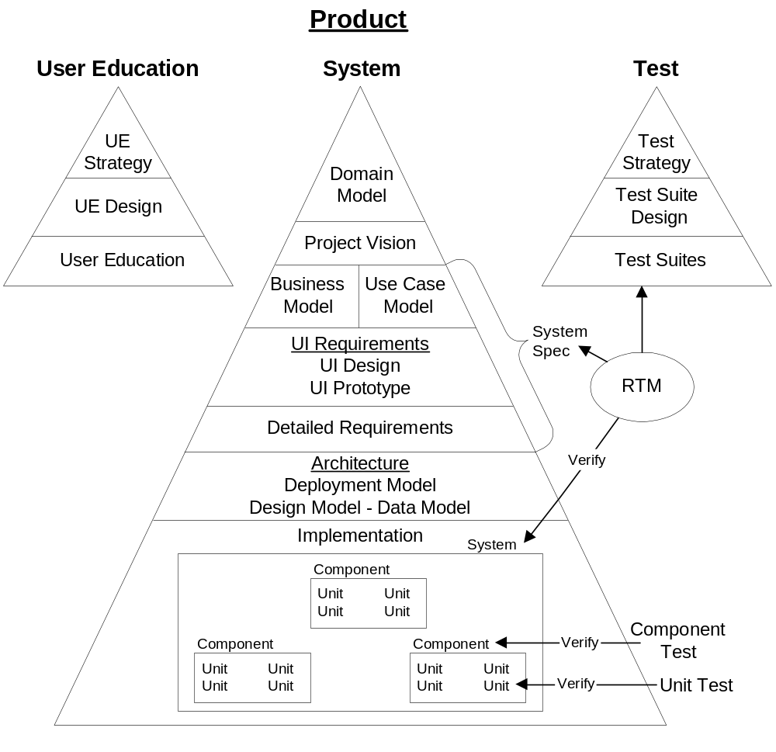
The Use Case Model serves the following purposes.
- It presents the highest level description of the system and its relationship to other systems
- It lists all of the actors involved with the system, both external and internal to the organization
- It describes how the system solves the business problem through a series of use cases
- It drives the UI design process
- It provides a high level framework for specifying detailed requirements in the Detailed Requirements

eStore “To-Be” Use Case Context Diagram

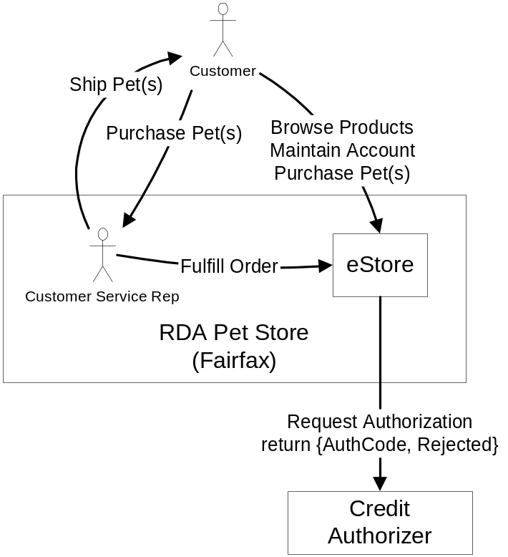
In addition to visiting RDA’s store location, customers may now visit RDA’s eStore web site to browse RDA’s products, maintain account information and purchase pets using their credit card. RDA store employees checks eStore for new, unfulfilled orders and fulfills them by removing the animal from inventory and shipping it to the customer.
[Author Notes: Obviously, there is a problem shipping live animals through the mail. We maintain this solution to be consistent with other pet store examples.]

‘To-Be” Use Cases

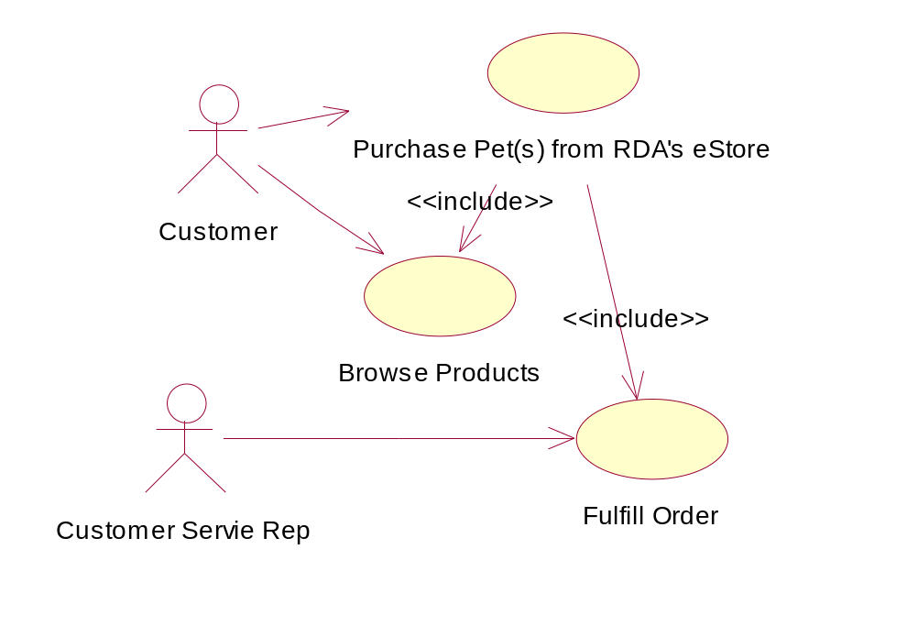
Use Case ID | Title
Primary Use Cases
UC-001000 | Purchase Pet(s) from RDA’s eStore
UC-001100 | Browse Products
UC-001200 | Fulfill Order
Secondary Use Cases
UC-010000 | Maintain Account

Purchase Pet(s) from RDA’s eStore (UC-001000)
- Customer Browses RDA’s products (UC-001100), looking for one or more items to purchase.
- Customer indicates she wishes to purchase the selected items and supplies credit card information, billing and shipping addresses to purchase the items.
- A customer service representative Fulfills the Order (UC-001200) by shipping the items to the shipping address specified on the order.
Browse Products (UC-001100)
- Customer browses RDA’s selection of products and items in one of two ways.
  - Customer navigates through the catalog, by category, then by products within each category
  - Customer searches for projects using a keyword search
- At any point, the customer may indicate items to be purchased.

Fulfill Order (UC-001200)
- A customer service representative periodically checks eStore’s unfulfilled order work queue.
- If there are any orders in the queue, the rep selects the first item in the queue.
- The rep pulls the animal(s) in the order from inventory and boxes them up.
- The rep enters the quantity shipped and the UPS tracking number into eStore.
- The rep uses eStore to print a shipping invoice for the packages.
- At the end of the day, the UPS driver picks up the outgoing packages.
Variations:
- If there is not enough inventory to fulfill the order, the rep ships what’s in stock. The shipping invoice indicates any items that are back ordered.

Maintain Account (UC-010000)
- Customer uses eStore to create a new account for herself. The customer’s email ID is used to uniquely identify the customer and her PetStoreAccount combined with a password to authenticate the user.
- Once authenticated, the customer may update her account information.
[Note: Domain Model use cases are replayed in the “To Be” Use Case Model; this time with the detail of how the actors accomplish their tasks. Additional use cases unique to the solution (such as Maintain Account) now appear in the “To Be” Use Case Model.]

System Interfaces
eStore to Credit Authorizer
During a purchase, eStore invokes the credit authorization service to obtain an authorization code for the transaction in the amount of the order. If successful, the service returns an authorization code and the order is created. Otherwise the order is not placed.
[Author Note: In reality, we probably also need some type of interface to RDA’s accounting system to transfer the rolled up sales information into RDA’s G/L.]

Reports
Sales Report by Period
At any time, certain users may generate a sales report for a specific period. It can be grouped chronologically or by category/product/item. A daily sales report is generated at the end of every business day and reconciled with the Credit Authorizer daily report.
[Author Note: In reality, this would spawn additional secondary use cases such as – reconcile daily sales, post daily sales, etc.]

Use Case Object Model Example (or Scenario)

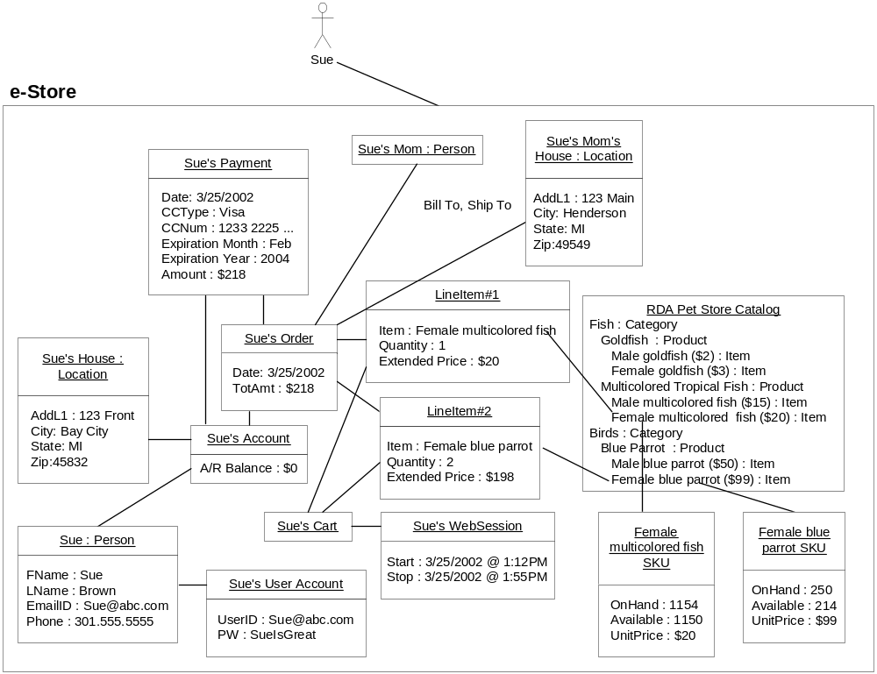
This rather busy diagram illustrates the abstractions that eStore manages during a web session where Sue purchases 1 fish and 2 parrots to bill and send to her mother in Henderson, MI.
At 1:12 PM on 3/25, Sue visited the eStore web site. She browsed the online catalog and created 2 line items for her cart, 1 fish and 2 parrots. She identified herself with her UserID and purchased the pets using her Visa. The order requested that the 3 pets and a copy of the bill be sent to her mother’s home in Henderson, MI. When Sue’s session ended at 1:55 PM, she was left with a $0 balance on her account.

The specific mechanisms of how Sue completed her purchase are now part of the use case. As such, the following have been added to Sue’s Business Model snapshot:
- Payment attributes such as credit card information
- Account owner and Account address
- Billing and shipping information
- Sue’s eStore user account
- Sue’s web session during which she created the order

[Author Note: In reality, we would need to include shipping and sales tax in the total amount of the order.]

Use Case Object Model Class Diagram
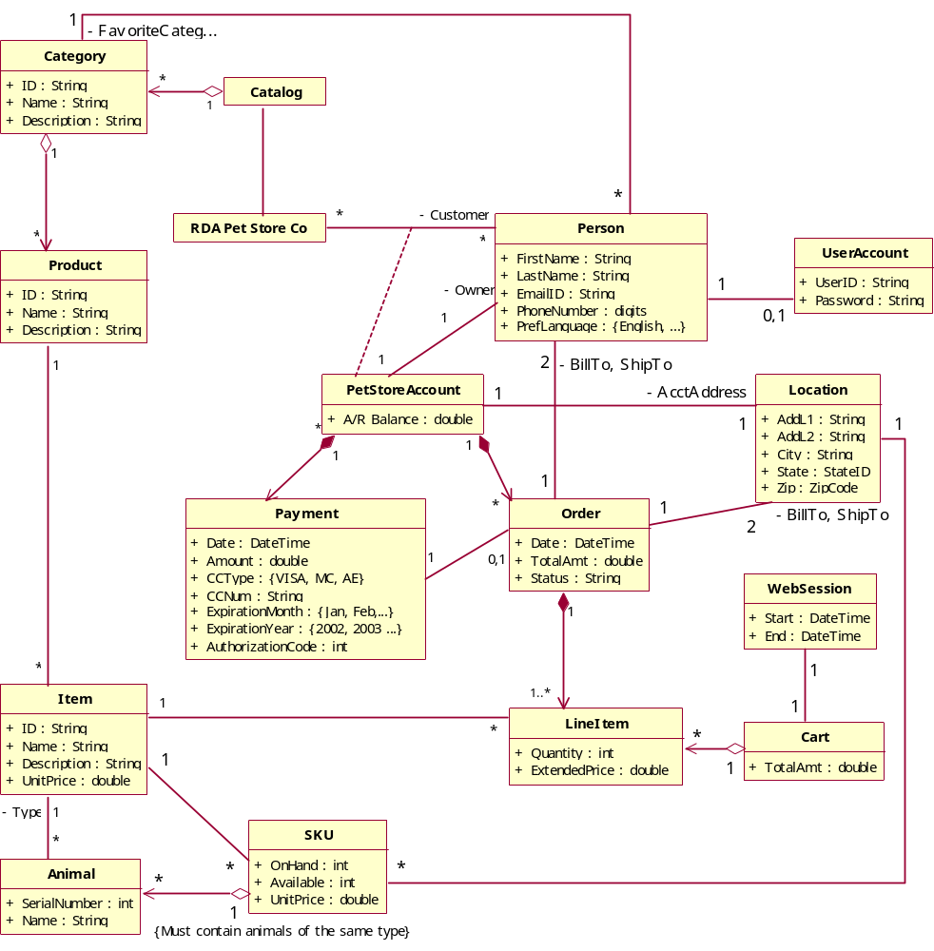
The following classes are added to the Domain Object Model class diagram to form the Use Case Object Model class diagram.
- In addition to filling the AccountOwner role, the Person class also fills the role of BillToPerson and ShipToPerson for an Order.
- Location represents a geographic point on the earth. For most business applications, Locations use the US Postal address labeling system for identifying these points. Location now serves the roles of AccountAddress, BillToAddress and ShipToAddress.
- A single UserAccount is associated with each registered eStore user. The Person’s email ID is used as the user’s userID.
- A WebSession represents a single visit to the eStore web site.
- eStore users add and remove line items to/from their Cart. Each WebSession has exactly one Cart.
- Stock Keeping Unit (SKU). A SKU represents the inventory of a specific Item at a particular Location. For example, the inventory of female blue parrots at the Fairfax store is one instance of SKU and the inventory of female blue parrots at the supplier’s warehouse is another instance. The important attributes of SKU are OnHand and Available. “OnHand” represents the physical number of animals in the inventory. “Available” typically indicates “OnHand” less the number of those items that have been sold but not yet shipped from that SKU.
[Note: The Use Case Object Model class diagram builds upon the Domain Object Model class diagram; adding classes, attributes and relationships introduced in the solution.]

UI Specification

IT FlightPlan specifies the user interface using two sub-artifacts:
- UI Design – Describes the conceptual framework for the user interface, including UI standards
- UI Prototype – An executable specification enabling the business team to test drive the UI as the team iterates on the interface.

UI Design
Using the actor and task analysis described in the Use Case Model, the UI Design defines the contextual framework and environment in which the end users will accomplish these tasks. The UI Design drives development of the UI Prototype. Whereas the UI Design specifies the overall appearance, the user experience, and the structure and flow of the user interface, the Detailed Requirements Specification then fills in the details of the UI requirements.

UI Conceptual Framework
The eStore user experience simulates the metaphor of shopping at a physical store. Users are assigned a shopping cart to place their items as they browse the store. At any point, the user may proceed to checkout to purchase the items in their cart. Users are authenticated through their userID and password. Once authenticated, they are able to update the account information associated with that ID. In addition, users must be authenticated to create an order.
When a customer enters the site, eStore automatically issues an empty cart to the session. Customers may browse products and populate the cart or they may choose to sign in their account or register an entirely new account. Once signed in, a customer may update her account information or sign out. At any point during the session, a customer may proceed to checkout.
Checkout processing first ensures the user is signed in, and if not, prompts the user to sign in or register. Once signed in, eStore collects billing and shipping information for the order and prompts the customer to submit the order. eStore charges the credit card, commits the order and presents an order confirmation to the customer. At this point, the customer remains signed in with an empty cart so the customer can continue to browse and shop within eStore.
Summarizing the end user tasks identified in eStore’s use cases, from the UI perspective the customer must perform the following tasks:
- Browse RDA’s products
  - Navigate through category, product, item
  - Search products with a key phrase
- Maintain Items in shopping cart
- Maintain account information (Create and update only. No delete.)
- Create an order
When the user enters the site, they automatically are issued an empty cart. Users may browse products and populate the cart or they may choose to sign in or register. Once signed in, they may update their account information or sign out. At any point, they may proceed to checkout. If they have not yet signed in (or registered), they will be prompted to do so. eStore collects billing and shipping information for the order. Users commit the order, which empties the cart and enables the user to continue shopping at the site.
Throughout the user’s Web session, session information is pushed and popped on the session state stack depending on the tasks that the user performs.
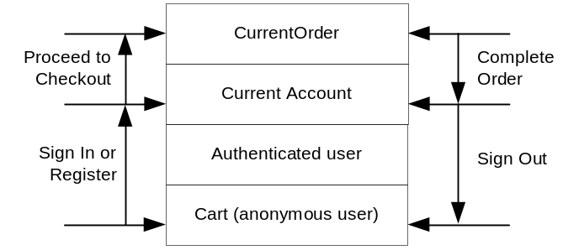
As the customer navigates through the site, eStore is gathering information. For example, as the customer adds items to her cart, the items remain in her cart as she continues to browse other products. At any point during the session, the customer can view the contents of her cart.
eStore manages the following session data, collecting it in the following dependency order:
- Cart – The collection of items the user wishes to purchase
- Authenticated user ID – The user ID for the current customer
- Current Pet Store Account – The customer’s account
- Current Order – The billing and shipping information for the current order in which the customer wishes to submit
In other words,
- eStore issues a cart to the customer as soon as the customer enters the site.
- eStore must authenticate the customer with a valid user ID before it can locate the customer’s account.
- eStore must look up the customer’s account before it can create a new order for the account.

The following stack illustrates the session data eStore maintains during a customer session. Data is pushed onto and popped from the session stack as the customer performs certain actions specified in the margins.
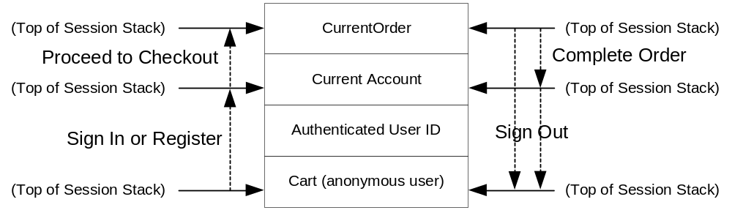

Page Navigation Requirements (UD-001000)
This design yields the following page navigation map.
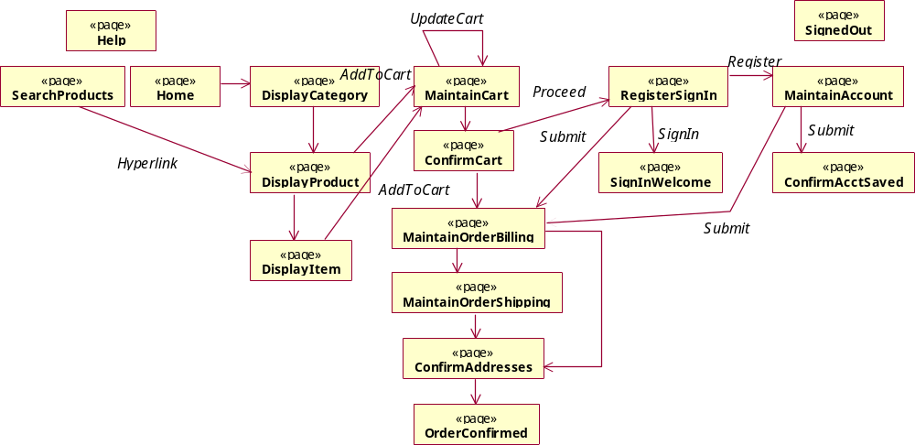
All of the pages listed in the top two rows can be navigated from virtually any point during their session (e.g., customers can navigate to “Help” or “Home” or “DisplayCategory” from pretty much any page in the application). Arrows indicate navigation flow from page to page and are labeled with their respective hyperlink or button names.

[Author Notes:
- OO Analysis typically leads to an OO UI design. UI pages are centered around searching, displaying and maintaining objects in the “To Be” Use Case Object Model class diagram. For example: SearchProducts, Display[Category, Product, Item], Maintain[Cart, Account, Order].]
- If you have not run the application, we recommend you do while studying this diagram. The navigational links will become obvious. Visit http://rdaestore.itflightplan.com/rdaestore to run the application. Alternatively, you can install and run eStore on your own development machine by following the instructions in the ReadMe document.]

UI Standards
When possible, all pages shall have the following zone layout.
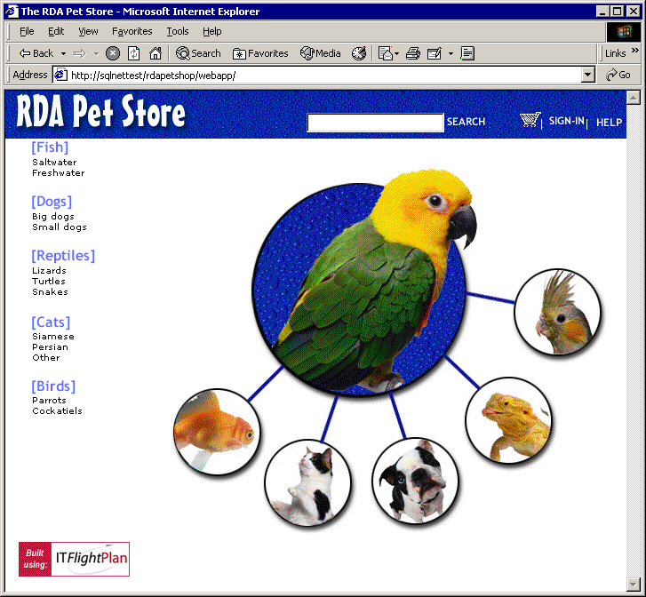
Header zone at the top. Navigation zone on the left. Content zone on the right. Footer zone at the bottom.

UI Prototype
[Author note: The other portion of the UI Specification consists of developing a UI Prototype of the mainstream and high-risk web pages. The UI Prototype is formally controlled and managed with the other requirement artifacts.]

Detailed Requirements
Building on the high-level functionality described in the UI Specification and Use Case Model, the Detailed Requirements specifies all of the low-level, detailed requirements for the system. The Detailed Requirements are not intended to be read front to back as a narrative, but is used as a reference to specify the detailed requirements.

The Detailed Requirements Specification contains all of the detailed requirements for the system. As such, it is structured and used as a reference manual. The requirements are grouped into two major categories – functional requirements and proficiency requirements. Functional requirements are written in terms of – “the system shall do X”. Proficiency requirements specify “how well the system does function X”. Requirements are further subdivided within these two categories as follows.

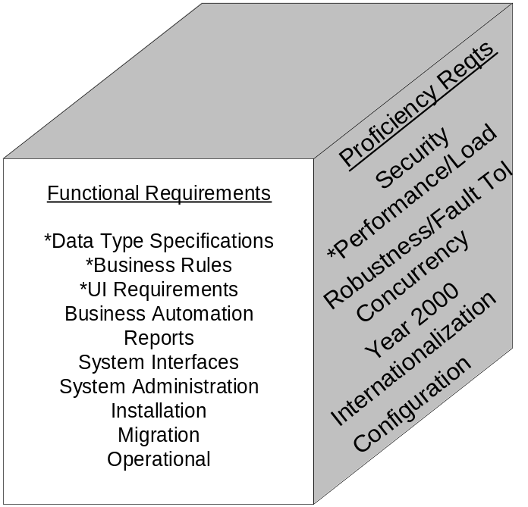
Requirement Identifiers
Each requirement is assigned a unique identifier, using the following naming convention:
DR-ss-nn-mmm: Data formatting requirement
BR-ss-nn-mmm: Business rule requirement
FR-ss-nn-mmm: Functional requirement
IR-ss-nn-mmm: Interface requirement
PR-ss-nn-mmm: Proficiency requirement (eg, security, performance, etc.)

…where ss is the section number in which the requirement appears, nn is a sequential numbering of the requirements within the section and mmm is used to insert requirements without forcing a renumbering of any adjacent requirements.

Forms and reports are not classified as requirements, but are assigned unique identifiers as they are referenced within requirements.
Form-nnnn-mmm
Report-nnnn-mmm

System Features Supported in eStore V1.0
Customers can browse products, maintain their account information and create orders.

System Features Not Supported in eStore V1.0
- RDA store employees will not be able to use eStore to fulfill orders.
- RDA store employees will not be able to use eStore to indicate a SKU has been replenished.
- The call to the credit authorizer to authorize a credit card payment is stubbed out and instead generates a random authorization code.

Functional Requirements
The purpose of the Detailed Requirements Specification is to specify the core business functions of the system – “what the system shall do.” The following major section then specifies how well it must perform these functions. Functional requirements in this section are grouped in the following subsections:
- Architecture and Design Constraint Requirements
- System Level Business Rule Requirements
- Business Automation Requirements
- UI Requirements
- Reports
- System Interface Requirements
- System Administration Requirements
- Installation Requirements
- Migration Requirements
- Operational Requirements
- Data Type Specifications (Appendix A)

Architecture and Design Constraint Requirements
None.

System Level Business Rule Requirements
This section specifies the top-level (or system level) business rules that must be automatically enforced by the system. Other requirements in this document refer to these business rules, indicating when the rules are enforced and how the external actors are notified when a rule is broken.

RqtID | Rule
BR-32-0001-0000 | Payments cannot be created if the credit card has expired.
BR-32-0002-0000 | The ExtendedPrice is calculated as the Item.UnitPrice * LineItem.Quantity
BR-32-0003-0000 | If EnableTips=true, Pet Store tips will appear on the footer of every page while the user navigates through the application
BR-32-0004-0000 | If EnableFavoriteCategory=true, the MaintainCart page will also display the list of products set in the owner.favoriteCategory
BR-32-0005-0000 | If EnableTips=true, owner.favoriteCategory must not be null.
BR-32-0006-0000 | Payment.ExpirationYear choices should be {this year.. this year+10}

[Author note: We can usually trace these rules directly to the source code. For example, perform Find-in-Files (“BR-32-0001-0000”) against the source code to locate the source code that implements the business rule. System maintainers appreciate this level of traceability.]

Business Automation Requirements
None.

UI Requirements
This section elaborates and refines the UI Specification work product, specifying the detailed requirements for the UI of the system. Whereas the UI Design and UI Prototype present the overall appearance, structure and flow of the user interface, this section specifies the detailed requirements for each frame of the interface. Screen snapshots of the UI Prototype are pasted into this section, followed by any function, data and/or business rule requirements uniquely associated with the screen.

General Requirements
FR-341-0001-000: When displaying pages of results, the previous & next buttons don’t appear if the entire set fits on the screen.

FR-341-0002-000: Page size=5 for all paging grids

FR-341-0003-000:All required fields are indicated as such with a ‘*’ next to the label.

eStore Home Page (Form-0001-000)
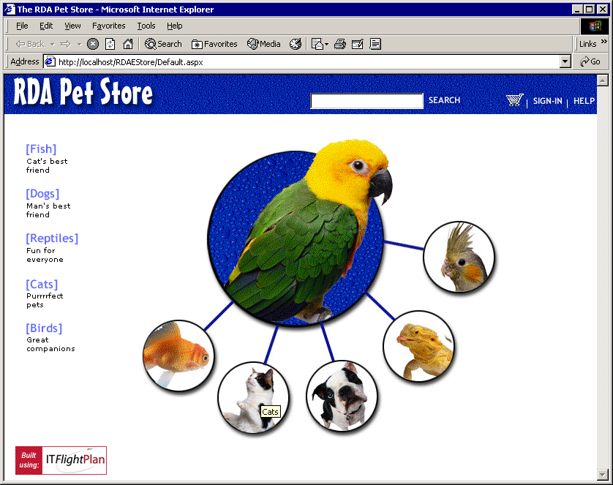

Display Category (Form-0002-000)
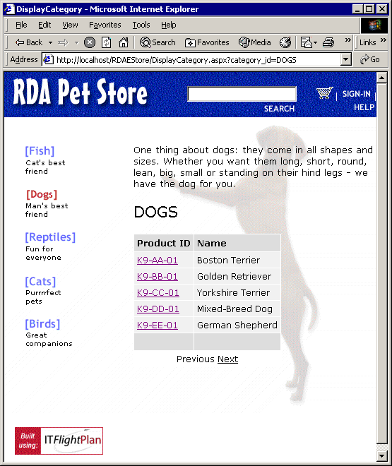

Display Product (Form-0003-000)
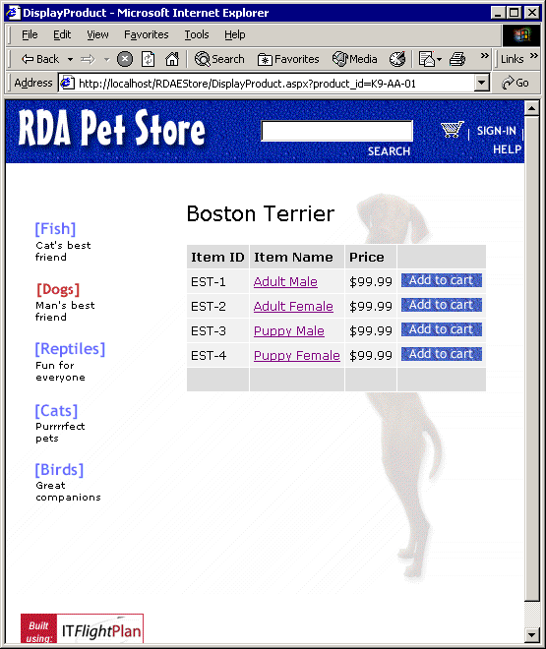

Display Item (Form-0004-000)
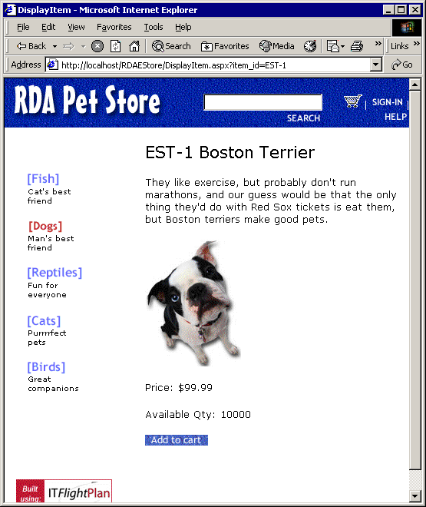

Maintain Cart (Form-0005-000)
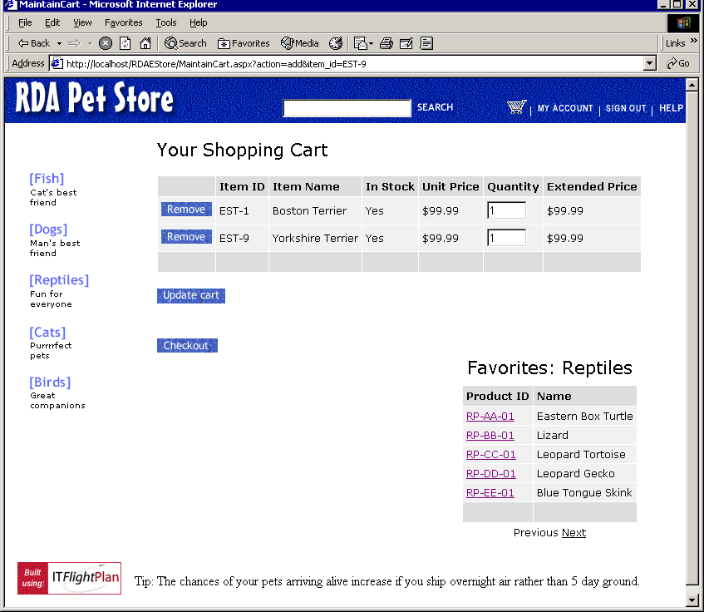

Confirm Cart (Form-0006-000)
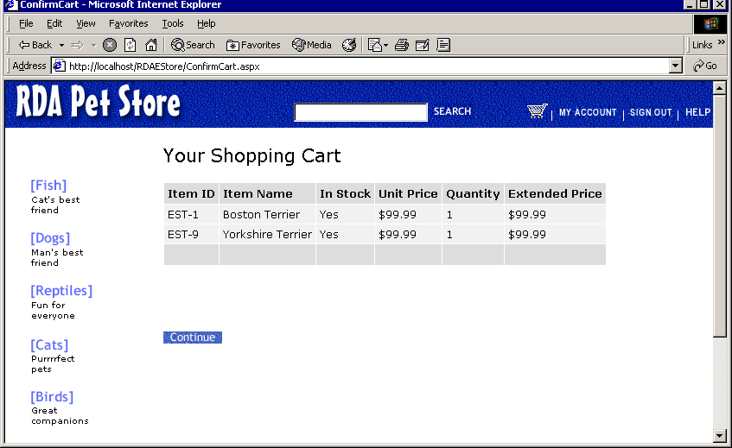

Maintain Order Billing (Form-0007-000)
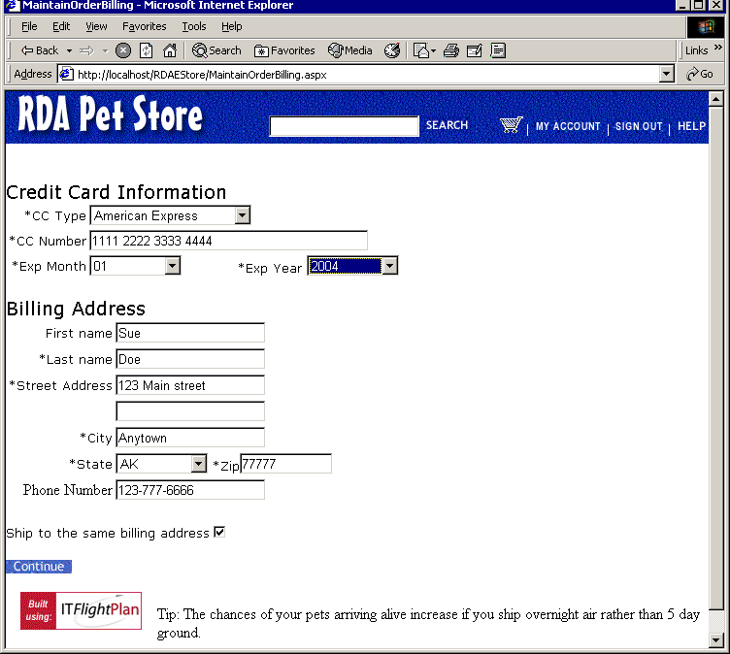

Maintain Shipping Address (Form-0008-000)
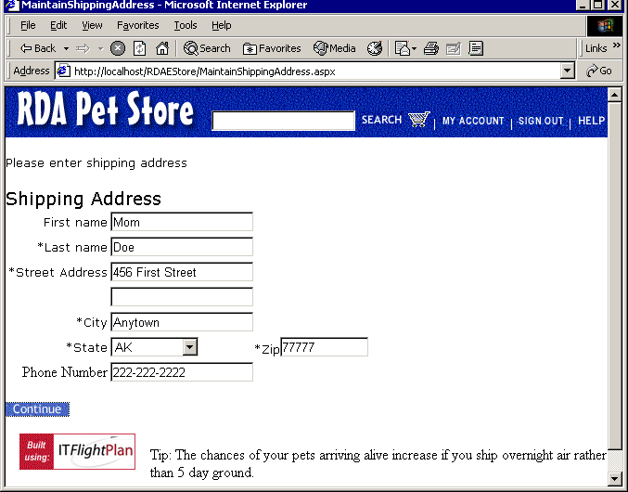

Confirm Addresses (Form-0009-000)
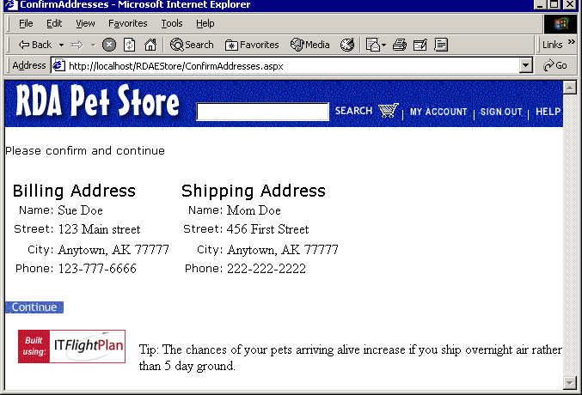

Order Confirmed (Form-0010-000)
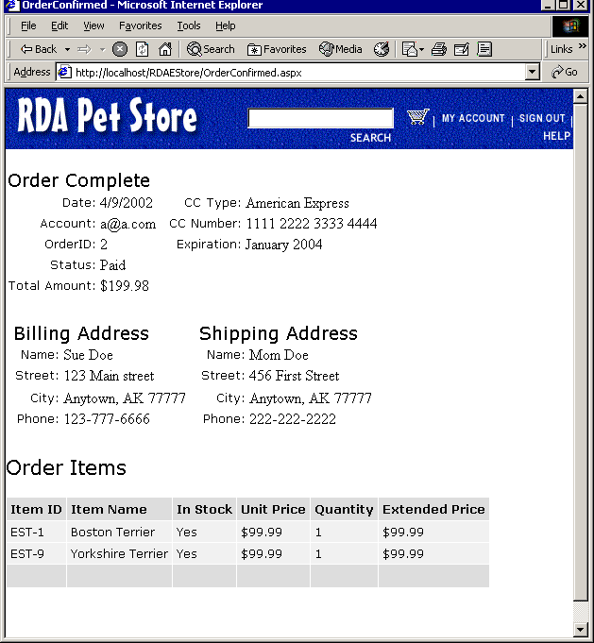

Sign In (Form-0011-000)
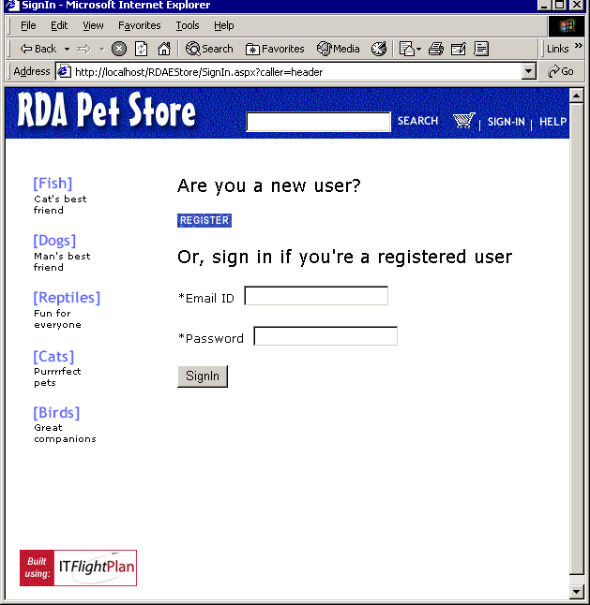

Maintain Account (Form-0012-000)
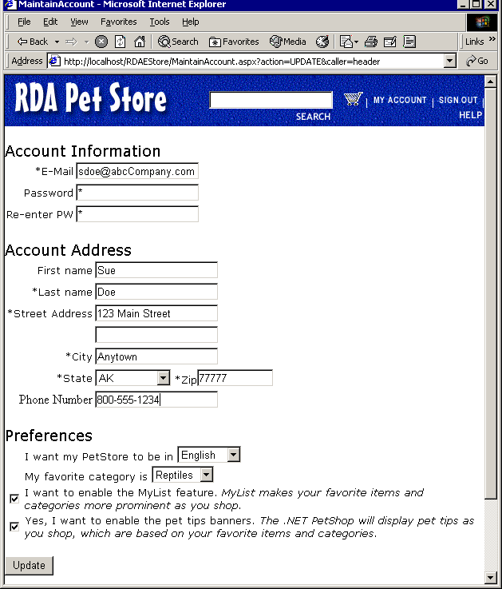

FR-3413-001-000: Field Specifications
Field Name | Business Class Attribute | Comments | Error Message
Email | owner.emailID and owner.userAccount.userID | This single field is set to both of these attributes | Enter valid email address.  Already exists. Please enter a different one.
Password | owner.userAccount.password
Re-enter PW | None. Used to compare against PW. | Only used to ensure user didn’t have a typo on their PW | Passwords much match
First Name | owner.firstName
Last Name | owner.lastName
Street Address | accountAddress.addressL1
(blank) | accountAddress.addressL2
City | accountAddress.city
State | accountAddress.state
Zip | accountAddress.zipcode |  | Must be nnnnn or nnnnn-nnnn
Phone Number | owner.phoneNumber |  | Must be nnn-nnn-nnnn
Prefs.Language | owner.languagePreference
Prefs.Favorite Category | owner.favoriteCategory
Prefs.Enable My List | owner.enableMyList
Prefs.Enable Tips | owner.enableTips

[Note: Field values on forms are mapped directly to classes in the Use Case Object Model.]

FR-3413-002-000: Form Rules
Description | Error Message

Form Actions
RqtID | Button | Description | Error Message
FR-3413-003-000 | Add or Update | Creates or updates the account information. | Save error. Another user has updated this account. Would you like to refresh and re-enter your changes?

Display Help (Form-0013-000)
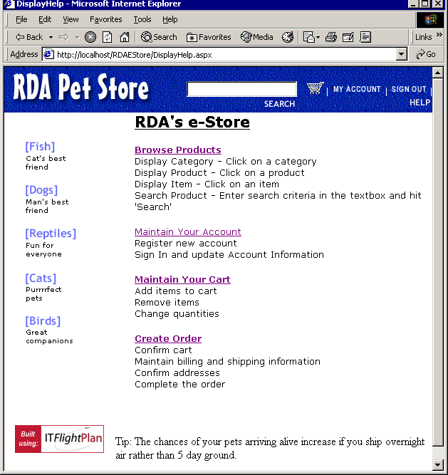

Search Products (Form-0014-000)
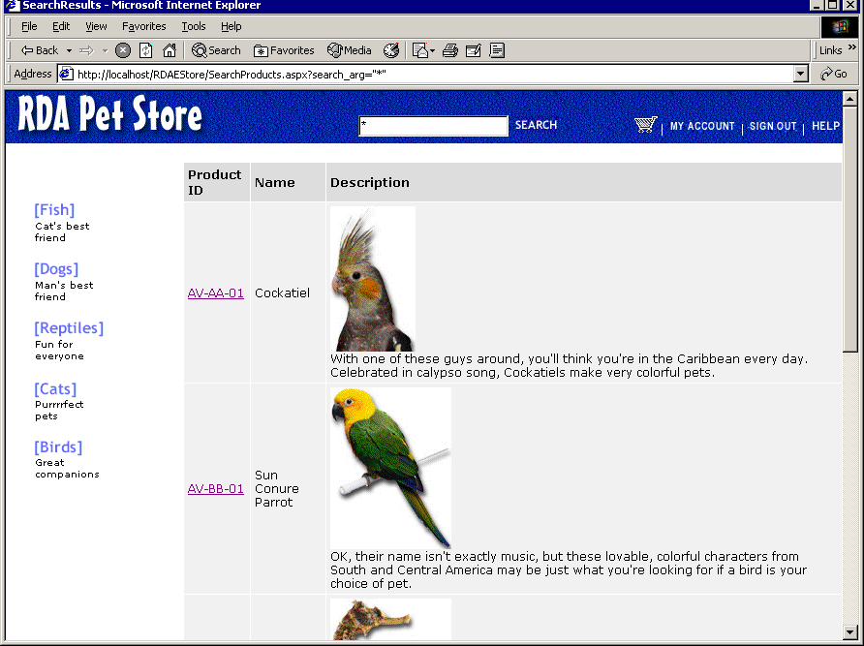

Reports

Sales Report (Report-0001-000)
[Author Note: In reality, this section would specify the format of the sales report.]

System Interfaces
This section specifies all of the system-to-system interfaces required for eStore.

Credit Authorizer Interface
IR-361-0001-000: Credit Authorizer exports the following interface:
Authorize(string CCID, string CCNumber, decimal chargeAmount) return integer.

If (resulting integer < 0) then authorization failed.
Otherwise it represents the authorization code for that request.

System Administration Requirements
This section contains requirements relating to administering the system.

FR-37-0001-000: Administer Users. [Author note: In reality, eStore would need an interface to administer userIDs and password.]

FR-37-0002-000: Administer Catalog. Categories, Products, Items, SKUs and their attributes (including unit price) are administered using SQL scripts. A UI is not required. System outage must be less than 5 minutes during this process.

FR-37-0003-000: Administer other reference data. States, Languages, Credit Card Types are administered using SQL scripts. A UI is not required. System outage must be less than 10 minutes during this process.

Installation Requirements
FR-38-0001-000: The system is to be installed by experienced, knowledgeable IT resources. The Operations Guide user education artifact must describe the steps to install and configure the system, then verify installation was successful.

Migration Requirements
eStore does not have any data migration requirements. The production database will deploy with no Accounts or Orders.

Operational Requirements
FR-310-0001-000: Backups are to be performed while the system is operational. However, they will be scheduled to run after 12:00 AM as user performance will be impacted.

FR-310-0002-000: Due to the relatively small number of registered user accounts for the next 3 years, all eStore data shall be retained in the operational database. Archiving data will be supported in a latter release when deemed necessary.

Proficiency Requirements

Security Requirements
Security requirements are grouped into 4 areas:
- User Identification & Authentication Requirements – How does the system identify users and verify it is them?
- Authorization – Once authenticated, who is allowed to do what?
- Data Integrity and Privacy – Ensure the integrity of the data is not compromised.
- Transaction Integrity and Auditing Requirements – Ensure the end user cannot cover up their tracks. Record access to the data so we know who’s done what.

User Identification & Authentication Requirements

PR-411-0001-000: The system must uniquely identify a user with a User ID/password combination before creating an order or updating an account. The UserID must be the person’s email address.

PR-411-0002-000: Once the user has logged in, she will be automatically logged out if the session is idle for 10 minutes. Subsequent requests to protected pages will force reauthentication via the SignIn page.

[Author Note: In reality, there would most likely be more authentication requirements such as – password policies, and the email ID is verified. See the Secure eStore extension.]

Authorization
Functional Entitlement Requirements

PR-412-0001-000: eStore must enforce the following functional entitlement:

UI Pages | Users
 | Anonymous User | Signed In User
Home Page, Display Category|Product|Item, Search Product, Help, SignIn, MaintainCart, ConfirmCart, SignedOut | X | X
MaintainOrderBilling, MaintainOrderShipping, ConfirmAddresses, OrderConfirmed, SignIn Welcome, MaintainAccount, ConfirmAccountSaved |  | X

If an anonymous user attempts to access a protected page, they are first detoured to the SignIn page before accessing the requested page.

Data Entitlement Requirements

PR-412-0002-000: A user may only view and update the account in which they are the owner.

Data Integrity and Privacy Requirements

PR-413-0001-000: Passwords must be encrypted when stored on disk.

PR-413-0002-000: The system must not be affected by the following list of exploits:
URL Changing
Hidden Field Hacks
Spoofing

[Author note: In reality, passwords and credit card numbers will be sent via SSL over the internet and we’ll want to protect the credit card numbers in the database. See the Highly Secure eStore extension.]

Transaction Integrity and Auditing Requirements

PR-414-0001-000: eStore must audit the last date/time when any data is added, modified, or deleted and track the last user ID that added, modified, or deleted the data.

Performance/Load Requirements
From the Project Vision, eStore needs to bring in $1.88M in 2004. Using this as a starting point for our assumptions…
- $2M in orders annually
- Average $85 per order
- 23,529 orders annually
- Average 64 orders per day
- Marketing campaigns usually cause spikes in orders and visitors
- Spikes will be 6 times the average day, therefore spike at 384 orders in a single day
- Spike appears in a 6 hour window, therefore peak at 64 orders in a single hour
- Average user mix at any point in time
  - 67% browsing products and items, help
  - 10% maintaining their cart
  - 10% maintaining their account
  - 10% creating orders
  - 3% running “search products”
- Average length of time per active user session = 10 minutes
- So 10.67 users are creating an order at any single point
- 75,000 orders, 100,000 line items and 7,500 accounts in the database

PR-42-0001-000: Therefore, eStore must support peak usage of 107 users with the average user mix listed above and sustain this load for 20 minutes. LAN response during this load must be as follows:

User Actions | Average Response Time
Browsing products and items, help | < 3 seconds
Maintaining their cart | < 3 seconds
Creating orders | < 5 seconds
Running “search products” | < 8 seconds

Robustness/Availability/Service-ability/Fault Tolerance Requirements

PR-43-0001-000: eStore must be available 23 hours every day with a maximum scheduled maintenance outage between 4-5 AM east coast time.

PR-43-0002-000: Unscheduled eStore outages must be less then 5 hours a month total.

Concurrency Requirements
PR-44-0001-000: Optimistic concurrency for multiple simultaneous users updating the same account. First one wins. Subsequent saves are presented an error message – “Would you like to refresh?”.

Example: Two users both SignIn and make changes to Sue’s account

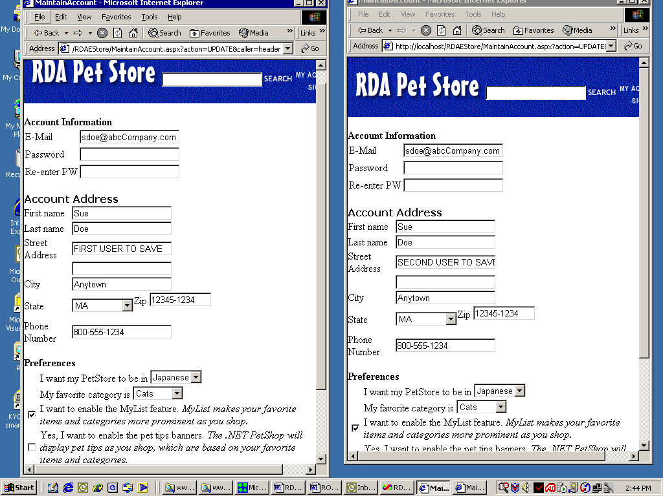

Both make changes to the Street Address line 1 field.

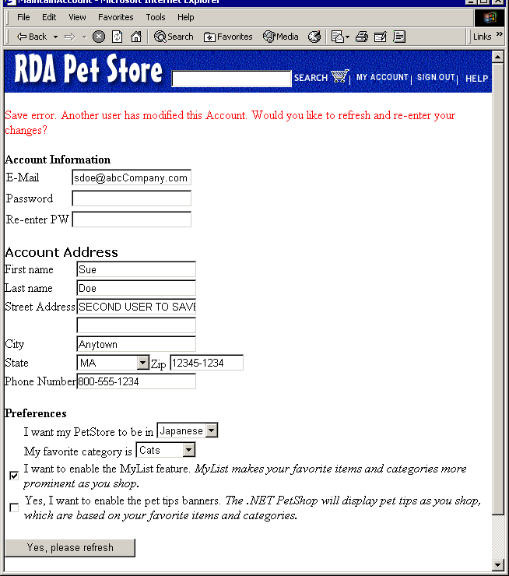

The second user is presented with the concurrency error and prompted to refresh to the most recent version of Account information. User hits – ‘Yes’, then sees –
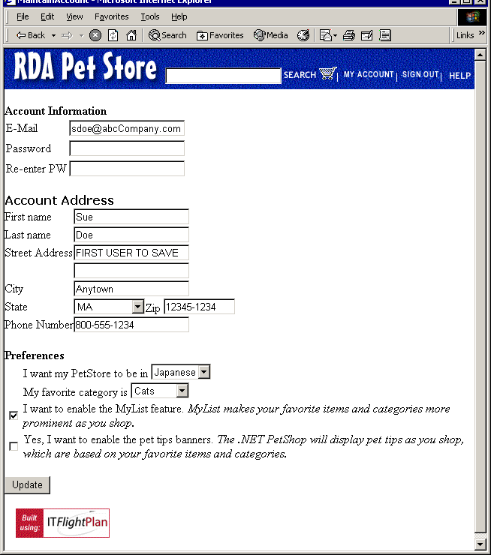

So they can now make their updates.

Internationalization Requirements
PR-45-0001-000: eStore must support US English and US date and time formats.

Configuration Requirements
PR-46-0001-000: All functionality of the system shall work with the following web browser platforms:
- Internet Explorer 5.0 SP1 or greater
- Netscape Navigator 6.0 or greater

Appendix A – Data Type Specification
The Use Case Object Model class diagram summarizes the major business entities involved with the solution. This section specifies the attributes of the solution entities in detail.

Reference the Use Case Object Model class diagram. One table is created for each class in the Use Case Object Model.

DR-7-0001-000: Category Attributes

Attr Name | Data Type* | Constraints | Mask | Required? | Default Value
ID | AN | Max Length=10  No spaces |  | Y
Name | AN | Max Length=30 |  | Y
Description | AN | Max Length=255 |  | Y

DR-7-0002-000: Product Attributes

Attr Name | Data Type* | Constraints | Mask | Required? | Default Value
ID | AN | Max Length=10  No spaces |  | Y
Name | AN | Max Length=30 |  | Y
Description | AN | Max Length=255 |  | Y

DR-7-0003-000: Item Attributes

Attr Name | Data Type* | Constraints | Mask | Required? | Default Value
ID | AN | Max Length=10  No spaces |  | Y
Name | AN | Max Length=30 |  | Y
Description | AN | Max Length=255 |  | Y

DR-7-0004-000: Person Attributes

Attr Name | Data Type* | Constraints | Mask | Required? | Default Value
FirstName | AN | Max Length=50 |  | N
LastName | AN | Max Length=50 |  | Y
EmailID  (valid email address) | AN | Max Length=128 | xx@yyy.zzz | N
PhoneNumber | N | Length=10 | (nnn) nnn-nnnn or  nnn.nnn.nnnn | N
PreferredLanguage | Languages |  |  | Y | English
FavoriteCategory | Categories |  |  | N | Null
EnableFavoriteCategory | Boolean |  |  | Y | False
EnableTips | Boolean |  |  | Y | False

DR-7-0005-000: UserAccount Attributes

Attr Name | Data Type* | Constraints | Mask | Required? | Default Value
UserID | AN | Max Length=128  Must be the same as owner.emailID | xx@yyy.zzz | Y
Password | AN | MaxLength=50  MinLength=5 |  | Y

DR-7-0006-000: Location Attributes

Attr Name | Data Type* | Constraints | Mask | Required? | Default Value
AddressL1 | AN | Max Length=50 |  | Y
AddressL2 | AN | MaxLength=50 |  | N
City | AN | MaxLength=50 |  | Y
State | States |  |  | Y
Zip | N | MaxLength=9 | nnnnn or  nnnnn-nnnn | Y

DR-7-0007-000: Order Attributes

Attr Name | Data Type* | Constraints | Mask | Required? | Default Value
Date | DateTime | Derived value | mm/dd/yy | Read only | Current DateTime when order is created
TotalAmount | Double | Derived value | $ddd.cc | Read only | Sum of LineItem.ExtendedPrice

DR-7-0008-000: LineItem Attributes

Attr Name | Data Type* | Constraints | Mask | Required? | Default Value
Quantity | Int | >= 0 |  | Y | 1
ExtendedPrice | Double | Derived value |  | Read Only | Quantity * Item.SKU.UnitPrice

DR-7-0009-000: WebSession Attributes

Attr Name | Data Type* | Constraints | Mask | Required? | Default Value
Start | DateTime |  |  | Y | Start of session
End | DateTime |  |  | Y | End of session
DR-7-0010-000: Payment Attributes

Attr Name | Data Type* | Constraints | Mask | Required? | Default Value
Date | DateTime |  |  | Y | Current DateTime when payment is created
CCType | Credit Card Types |  |  | Y
CCNumber | N | Visa, Mastercard Length=16  AmEx Length=15 | nnnn-nnnn-nnnn-nnnn or nnnn nnnn nnnn nnnn | Y
Amount | Double |  |  | Y
ExpirationMonth | Months |  |  | Y
ExpirationYear | Int |  |  | Y
AuthorizationCode | Int |  |  | Y

DR-7-0011-000: SKU Attributes

Attr Name | Data Type* | Constraints | Mask | Required? | Default Value
OnHand | Int |  |  | Y
Available | Int |  |  | Y
UnitPrice | USCurrency |  |  | Y

*Types Legend
A – Alpha [a-z],[A-Z]
N – Numeric [0-9]
AN – AlphaNumeric [a-z],[A-Z],[0-9]
ASCII – ASCII characters
UCode – Unicode 2.0 characters
Int8 – Signed, 8 bit integer
Int16 – Signed, 16 bit integer
Int32 – Signed, 32 bit integer
Int64 – Signed, 64 bit integer
USDate – mm/dd/yyyy
USDateTime – mm/dd/yyyy hh:mm:ss
USDollars - $nn,nnn
USCurrency - $nn,nnn.nn
USZip – nnnnn or nnnnn-nnnn
USPhoneNum – (nnn) nnn-nnnn
EmailAddress – typical is anananan@nananan.xxx
Regular expression ="\w+([-+.]\w+)*@\w+([-.]\w+)*\.\w+([-.]\w+)*"

Enumeration types
Boolean – Type: char(1) Values: {True=’Y’, False=’N’}
Months – Type: int, Values: {January=1, February, March, …, December}
States – Type: char 2, Values: (See Appendix A)
Languages – {English, Spanish, French, Japanese, Russian, Chinese}
Credit Card Types – {Visa, Mastercard, American Express}

States – Name : string; ID : char(2)

State Name | State Code
Alabama | AL
Alaska | AK
Arizona | AZ
Arkansas | AR
California | CA
Colorado | CO
Connecticut | CT
Delaware | DE
District of Columbia | DC
Florida | FL
Georgia | GA
Hawaii | HI
Idaho | ID
Illinois | IL
Indiana | IN
Iowa | IA
Kansas | KS
Kentucky | KY
Louisiana | LA
Maine | ME
Maryland | MD
Massachusetts | MA
Michigan | MI
Minnesota | MN
Mississippi | MS
Missouri | MO
Montana | MT
Nebraska | NE
Nevada | NV
New Hampshire | NH
New Jersey | NJ
New Mexico | NM
New York | NY
North Carolina | NC
North Dakota | ND
Ohio | OH
Oklahoma | OK
Oregon | OR
Pennsylvania | PA
Rhode Island | RI
South Carolina | SC
South Dakota | SD
Tennessee | TN
Texas | TX
Utah | UT
Vermont | VT
Virginia | VA
Washington | WA
West Virginia | WV
Wisconsin | WI
Wyoming | WY

Requirement Traceability Matrix (RTM)
The RTM ensures the system tests that verify the system cover all of the requirements.

Requirement to Test Suite Traceability Matrix
Requirement | Test Suite
All SM use cases | STS-1
GUI Design Doc -  Page Navigation Design (GS-0001-000) | STS-3
Detailed Spec –  All business rules BR-32 | STS-3
Detailed Spec –  All GUI Requirements FR-34 | STS-3
Detailed Spec –  All System Interface Requirements IR-361 | STS-1
Detailed Spec –  All System Administration Requirements FR-37 | STS-2
Detailed Spec –  Installation Requirements FR-38 | Inspection
Detailed Spec –  Operational Requirements FR-310 | STS-2
Detailed Spec –  Security Requirements PR-411 thru PR-414 | STS-2 and STS-3
Detailed Spec –  Peformance/Load Requirements PR-42 | STS-1
Detailed Spec –  Availability Requirements PR-43 | STS-2 and STS-3
Detailed Spec –  Concurrency Requirements PR-44 | STS-1
Detailed Spec –  Internationalization Requirements PR-45 | STS-1
Detailed Spec –  Configuration Requirements PR-45 | STS-3
Detailed Spec –  Data Type Requirements DR-7 | STS-3

[Author note: Scaling this to larger systems, we often trace test cases to requirement as opposed to the entire test suite.]

