

e-Store Project



Business Architecture Document

Version 1.1.3

7/29/02

Role | Individual | Signature/Date Approved
Business Sponsor
Project Manager/Analyst
Business Team Representative


www.rdacorp.com

Table of Contents
1 Introduction 1
2 Domain View 2
2.1 RDA Pet Store Domain Model Context Diagram 2
2.1.1 Domain Actors 2
2.2 Domain Use Cases 3
2.2.1 Typical Domain Use Cases 3
2.3 Domain Object Model Example 3
2.4 Domain Object Model (Class Diagram) 4
3 “As Is” Business Process View 6
3.1 RDA Pet Store “As Is” Business Context Diagram 6
3.2 “As-Is” Business Use Cases 6

Introduction
This is IT FlightPlan’s Business Architecture Document for RDA’s eStore sample application. Although the business architecture is technically not considered part of the eStore project documentation, it sets the background and context for eStore’s requirements. This business architecture serves as the enterprise business modeling for RDA Pet Store’s enterprise, so its scope expands as additional IT projects are developed.

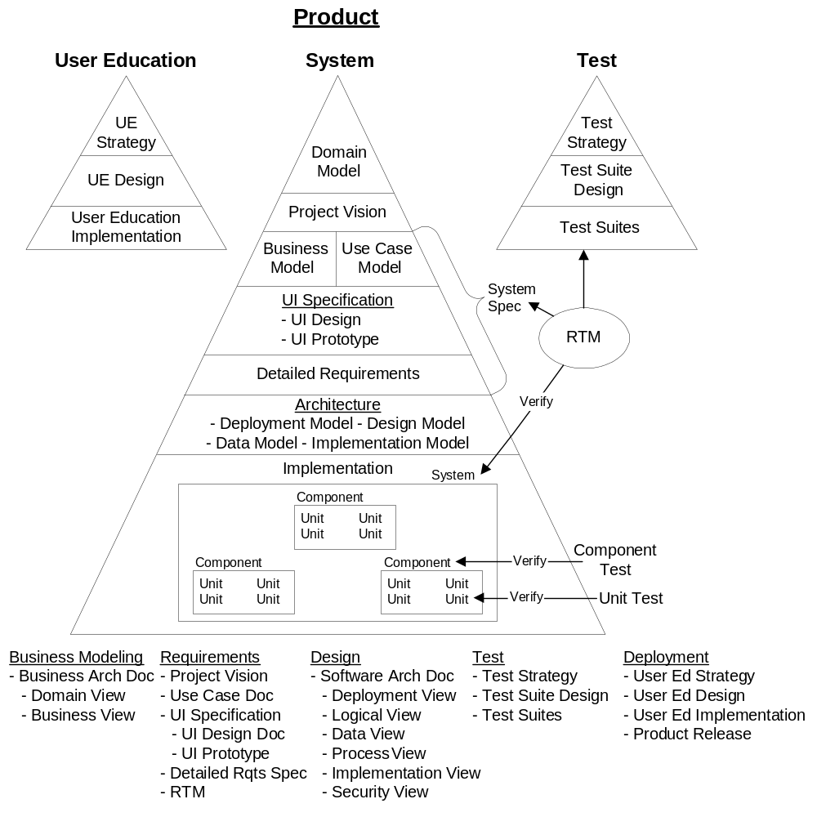
The Business Architecture Document contains two major sections -
Domain View: Model the industry context in which the solution is to perform.
Business Process View: Models the current, ‘As-Is’ internal business processes.

Domain View
The Domain Model briefly describes and narrates an object-oriented analysis of RDA Pet Store’s business environment. A Domain Model describes "what is the business problem" while the “As-Is” Business Model and “To-Be” Use Case Model describe "how the problem is to be solved". As a result, Domain Models do not include details inside the company such as employees, back office systems or mechanisms used to interact with the business. Rather, the Domain Model defines entities that are paramount to RDA’s business and models the interactions RDA has with external entities. The specific mechanisms for interacting with the business are left to the Business and Use Case Models.
The Domain Model serves three purposes:
- It confirms the analyst understands the business problem by packaging it up and echoing it back to the business community.
- It provides an effective vehicle to communicate the business problem to the rest of the project team.
- It serves as an initial starting point for the Business and Use Case Models.

RDA Pet Store Domain Model Context Diagram
This section defines the key actors involved in the business domain and defines their roles.
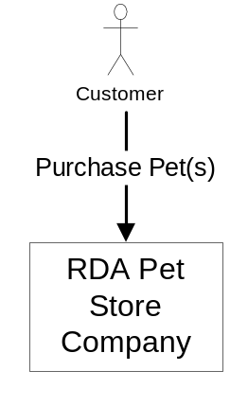
RDA Pet Store is a retail business that sells pets to the general consumer.

Domain Actors
This section describes each of the actors that participate in the domain use cases. This section introduces each actor and their role in the business domain, similar to a playbill's introduction of cast in a play.
Actor | Role
Customer | A customer is an individual who purchases pet(s) from RDA.

[Author Note: In reality, customers are individuals or companies. To keep our example “apples to apples” with the other Pet Store implementations, we constrain Customer to be strictly individuals.]

Domain Use Cases
Use Case ID | Title
Primary Use Cases
DM-001000 | Purchase Pet(s) from RDA
DM-002000 | Return Pet(s) to RDA
DM-003000 | Back order a purchase
DM-004000 | Fulfill a back order

Typical Domain Use Cases
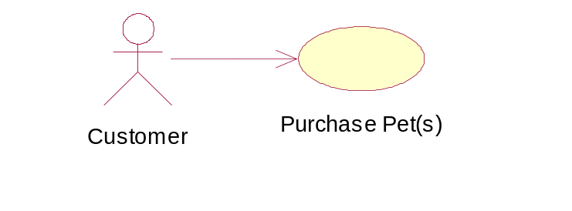
Purchase Pet(s) from RDA (DM-001000)
- Customer browses RDA’s selection of product and items, looking for one or more pets to purchase.
- Customer selects one or more items.
- Customer purchases the animals from RDA.
[Author Note: In reality, the domain use cases would include those above and more. Since e-Store V1.0 only supports the “Purchase Pet(s) from RDA” use case, it is the only one included in this version of the Domain Model.]

Domain Object Model Example
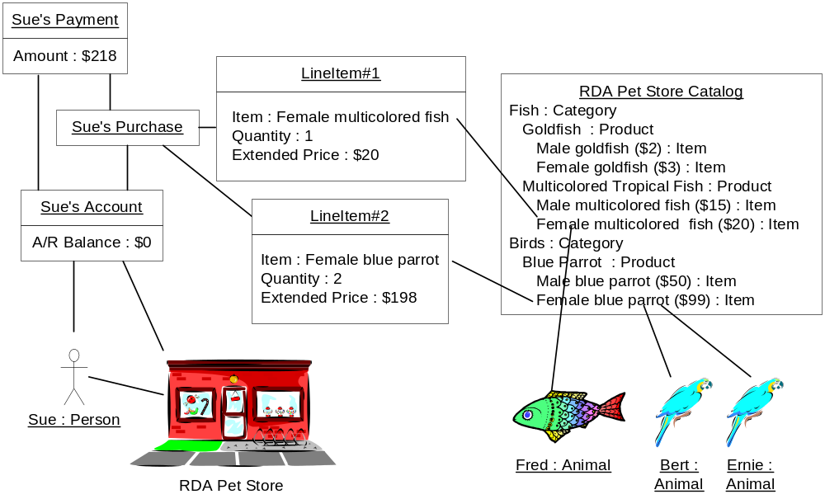
Sue is a recent RDA Pet Store customer. Sue browses RDA’s catalog that is organized by category. Each category lists the species within the category (called product). Each species can have size, gender, color and/or age variations. The specific specie type (called item) has a unique catalog ID and unit price. Sue selects and purchases 1 female multicolored tropical fish and 2 female blue parrots. She pays $218 for her 3 new pets – Fred, Bert and Ernie – leaving her account with a remaining balance of $0.
[Note: The business model does not include any mechanisms for the business interactions. “How” Sue browses and purchases pets is covered in the “As Is”Business and “To Be” Use Case Models.]

Domain Object Model (Class Diagram)
Each of the instances and relationships in Sue’s purchase snapshot are extrapolated to form the class diagram.
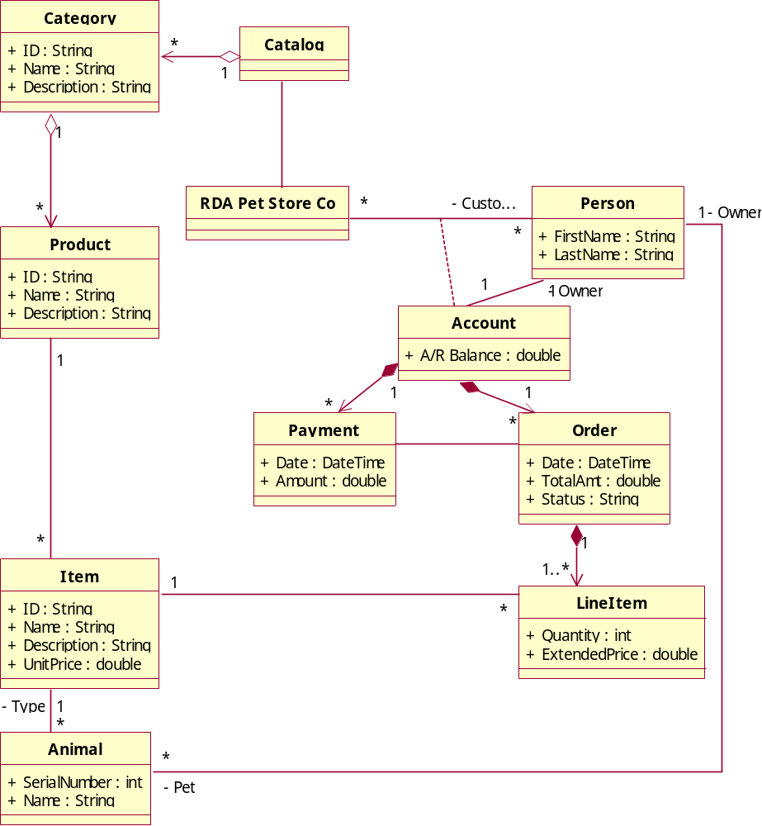
The RDA Pet Store Co lists its Items for sale in its Catalog. The Catalog is divided into Categories, each Category lists species of the same classification. Each species is listed as a Product. Each type of Animal available within a species is listed as an Item for sale. The RDA Pet Store Co sells pets to its customers, who are People. Each customer has an Account with RDA Pet Store Co and plays the role of owner on the Account. A customer purchases one or more pets by creating an Order with one or more LineItems. Each LineItem indicates the quantity of an Item that the customer wants to purchase. The Order.TotalAmt is calculated as the sum of all of its LineItem.ExtendedPrice. The customer makes a Payment on his/her Account to reduce the outstanding A/R balance of purchases. The RDA Pet Store Co delivers to the customer the proper number and type of Animals indicated in the Order.
[Author Notes:
This example illustrates the context boundary for the Domain Model – 1) Actors external to the company (RDA Pet Store) and 2) Business interactions only. Solution mechanisms on how to complete the business interactions are deferred until the Business and Use Case Models.
When extrapolating from the instance to the class diagram, we capture the Order from Sue’s purchase transaction event. At this time, we do not see any benefit from modeling the event as its own distinct class.
Notice that Customer and Pet are not classes but roles that Person and Animal play respectively.
In reality, a company can also fill the role of a customer.
Note that there is only one instance of the RDA Pet Store Co class.
In reality, we would model Quantity and U.S. Currency as something more rigorous than int and double.
This class diagram is not intended to be read by the Business Team, but is directed to the Project Management, Development and Quality teams.
An alternative way of modeling Animal would be to create an extensive class/subclass hierarchy of all classifications of species. EG, Fish is a base class of Goldfish is a base class of MaleGoldfish. Although technically correct, this approach would make our model less flexible. This approach would be more appropriate if we were building a system for a scientist who studies the intricate differences among species. Modeling Item as a product type is more appropriate for commerce applications. Adding and removing Items from RDA’s catalog doesn’t impact the class analysis. We merely need to add and remove instances of Item.]

“As Is” Business Process View
The Business Model models RDA’s current internal business processes. It describes the departments, employees, systems and underlying mechanisms used to realize the business interactions described in the Domain Model. The Business Model serves as a benchmark starting point to be compared with the “To Be” business processes described in the Use Case Model.

RDA Pet Store “As Is” Business Context Diagram

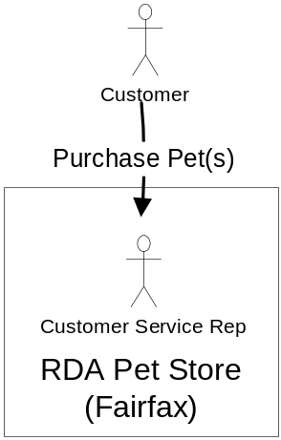
Currently, RDA is strictly a ‘brick and mortar’ retail pet store.

“As-Is” Business Use Cases
Purchase Pet(s) from on of RDA’s Pet Stores
Currently, customers are required to personally visit RDA’s store location in Fairfax, VA in order to purchase a pet.
- Customer visits RDA’s store in Fairfax and browses the current inventory or the catalog.
- Customer selects one or more items.
- Customer purchases the animals from RDA. If the animals are in stock, the customer takes the pet(s) with them. Otherwise, the animal is back ordered and RDA notifies the customer when the animal arrives.
Variations:
  - The customer may call an RDA store ahead of time to see if RDA has a particular animal in stock.
  - The customer may call an RDA store ahead of time and order an animal over the phone.

